Agreed Procedure 1: Registration | May 21  2019

Capacity Market Code
Version 2.0
Contents

1. Introduction 4
1.1. Background and Purpose 4
1.2. Scope of Agreed Procedure 4
1.3. Definitions 4
1.4. Compliance with Agreed Procedure 4
2. Overview 5
2.1. Party Registration 5
2.2. Participant and Unit Registration 5
2.2.1. Candidate Unit Registration 6
2.2.2. Combining Candidate Units into Capacity Market Units 6
2.2.3. Registration of a Unit under a Different Participant 7
2.2.4. Registration of Capacity Increases 7
2.2.5. Supplier Unit Registration 8
2.3. Registration of User Access Rights for Participants 8
2.3.1. Appointing a Data Processing Entity 8
2.3.2. User Access 8
2.4. Intermediaries 9
2.4.1. Nominating an Intermediary 9
2.4.2. Intermediaries: Registration of a Unit under a Different Participant 9
2.5. Deregistration of a Capacity Market Unit 9
2.6. Voluntary Termination of a Party 10
3. Procedural Steps 11
3.1. Party Registration 11
3.2. Provisional Registration of a Candidate Unit 14
3.3. Deregistration of a Capacity Market Unit 17
3.4. Voluntary Termination of a Party 20
Appendix 1: Definitions 22

Document History
Version | Date | Author | Comment
1.0 | 31/05/2017 | I-SEM Project Team | Issued to the Regulatory Authorities
2.0 | 21/05/2019 | Eirgrid & SONI | Capacity Market Code V2.0 update

Related Documents
Document Title | Version | Date | By
Capacity Market Code | 2.0 | 21/05/19 | Eirgrid & SONI
Agreed Procedure 2 “Default and Suspension”

- Introduction
  - Background and Purpose
This Agreed Procedure supplements the rules in relation to Participant registration administered by the System Operators, set out in the Capacity Market Code (hereinafter referred to as the “Code”). It sets out procedures with which Parties to the Code must comply.
  - Scope of Agreed Procedure
This Agreed Procedure sets out the procedural steps for:
- registration of a Party for accession to the Capacity Market;
- registration of a Candidate Unit and Capacity Market Unit for participation in the Capacity Market;
- deregistration of a Capacity Market Unit; and
- voluntary Termination of a Party.
This Agreed Procedure forms an annex to, and is governed by the Code. It sets out procedures to be followed, subject to the rights and obligations of Parties under the Code. In the event of any conflict between a Party’s obligations set out in the Code and this Agreed Procedure, the Code shall take precedence.
It is not intended that there be any inconsistency or conflict between section 2 “Overview” and section 3 “Procedural Steps”. However, in the event of any inconsistency or conflict, section 3 “Procedural Steps” shall take precedence.
In section 3 “Procedural Steps” a corresponding process flow diagram is included for each procedural steps table. Process flow diagrams are for illustrative purposes. It is not intended that there be any inconsistency or conflict between any procedural steps table and process flow diagram however, in the event of any inconsistency or conflict, a procedural steps table shall take precedence.
  - Definitions
Words and expressions defined in the Code shall, unless the context otherwise requires or unless otherwise defined herein at Appendix 1 “Definitions”, have the same meanings when used in this Agreed Procedure.
References to sections relate to sections in this Agreed Procedure unless otherwise specified.
  - Compliance with Agreed Procedure
Compliance with this Agreed Procedure is required under the terms as set out in the Code.
- Overview
The registration process consists of two steps:
- Party registration (for accession to the market): registration as a Party to the Code; and
- Unit registration (prior to Qualification for a Capacity Auction): a Party becomes a Participant by registering Unit(s).
In relation to a Generator Unit or Supplier Unit, the Participant under the Code must be the same Party that is, or will be, the Party registered in respect of that Unit under section B.7 of the Trading and Settlement Code.
In relation to an Interconnector, the Participant under the Code must be the same Party that is, or will be, the Party registered in respect of that Interconnector under section B.10 of the Trading and Settlement Code.
  - Party Registration
The procedure for registration as a Party is set out at section 3.1 below.
All Parties that adhere to the Capacity Market Framework Agreement become a Party to the Code in accordance with and subject to the accession process outlined in chapter B of the Code.
To register as a Party, an Applicant shall:
- complete the Application Form available from the System Operators’ website;
- comply with eligibility requirements set out in section B.5 of the Code and in the Application Form;
- pay the Accession Fee;
- when provided, execute an Accession Deed to adhere to the Capacity Market Framework Agreement and the Code; and
- have already registered or intend to register as a Party to the Trading and Settlement Code.
  - Participant and Unit Registration
In accordance with section B.5.2 of the Code, in order for a Party to participate in any of the arrangements under the Code, a Party shall have registered, or be deemed to have registered, or have provisionally registered a Candidate Unit.
Upon registering its first Unit, a Party shall become a Participant in the jurisdiction where the Unit is or intends to be located and shall be issued with a unique Participant ID. Note that a Party may already have a Participant ID if it has previously registered a Generator Unit or Interconnector under the Trading and Settlement Code.

    - Candidate Unit Registration
In the circumstances set out in paragraph B.5.2.2 of the Code, a Generator Unit or Interconnector under the Trading and Settlement Code is deemed to have also been registered as a Candidate Unit under the Code. The System Operators may request that the Participant in respect of that Unit provide them additional information concerning the Unit in accordance with paragraph B.5.2.5 of the Code.
If a Party intends to register a proposed Generator Unit or Interconnector under the Trading and Settlement Code, the Party may apply to provisionally register the proposed Generator Unit or proposed Interconnector as a Candidate Unit. The procedure for provisional registration of a Candidate Unit is set out at section 3.2 below. As part of this procedure, the Party shall submit the following to the System Operators for validation:
- a Participation Notice (including the information set out at paragraph B.5.2.7 of the Code) and Form of Authority (as required);
- Capacity Registration Pack;
- Participation Fee; and
- REMIT Notification Form (optional).
Upon registration under the Code, the Generator Unit or the Interconnector shall be issued with a unique Unit ID and shall be considered a Candidate Unit or a provisionally registered Candidate Unit.
In the event that a Party is registering a proposed Generator Unit or proposed Interconnector, the Candidate Unit shall remain provisionally registered until such time that the Unit is registered under the Trading and Settlement Code or is Qualified for a Capacity Auction. A Party that has provisionally registered a Candidate Unit may cancel the registration by informing the System Operators prior to submitting an Application for Qualification in respect of that Candidate Unit.
A Candidate Unit is eligible to take part in the Qualification Process for a Capacity Auction (see Agreed Procedure 3 “Qualification and Auction Process”). Once Qualified, a Candidate Unit shall become associated with a Capacity Market Unit under the Code.
    - Combining Candidate Units into Capacity Market Units
A Participant may combine one or more Candidate Units into a Capacity Market Unit. Therefore, subject to the eligibility criteria set out in section E.7.6 of the Code, a single Capacity Market Unit may be associated with more than one Candidate Unit as demonstrated in the diagram below.

Generator Unit | Candidate Unit | Capacity Market Unit  (associated with more than one Candidate Unit)
GU_401xxx | GU_401xxx | CAU_422xxx
GU_402xxx | GU_402xxx | CAU_422xxx
GU_403xxx | GU_403xxx | CAU_422xxx

Figure 1 – Many Candidate Units to One Capacity Market Unit

Alternatively a Candidate Unit may have a one-to-one relationship with a Capacity Market Unit as demonstrated in the diagram below.

Generator Unit | Candidate Unit | Capacity Market Unit
GU_401xxx | GU_401xxx | GU_401xxx

Figure 2 – One Candidate Unit to One Capacity Market Unit

The Applicant shall specify in the Participation Notice whether it shall apply for the Candidate Unit being registered to be Qualified in the Capacity Auction: (i) as a Capacity Market Unit comprising of one Candidate Unit; or (ii) as part of a Capacity Market Unit comprising a number of individual Candidate Units.
    - Registration of a Unit under a Different Participant
A Party may seek to register and become the Participant with respect to a Candidate Unit(s) (and any associated Capacity Market Unit) that is already registered by a different Participant. The registration shall be subject to the successful Deregistration of the relevant Capacity Market Unit by the existing Participant under both the Code and the Trading and Settlement Code. The new Party shall become the Participant for the Capacity Market Unit under the Code and the Trading and Settlement Code from the intended date of Deregistration.
To complete the registration the Party shall follow the Candidate Unit registration process outlined in section 3.2 below. In addition, the Party shall assume responsibility for any Awarded Capacity in respect of the Candidate Unit (as a Capacity Market Unit) and shall be required to meet the Deregistration Applicant’s obligations, outlined in section B.5.6 of the Code.
The rules in relation to the Transfer by a Party of: (i) its rights or obligations under the Code; (ii) any Awarded Capacity in respect of any of its Capacity Market Units; or (iii) a Generator Unit or Interconnector that is, or forms part of, a Capacity Market Unit, are set out at section B.21 of the Code.
    - Registration of Capacity Increases
If a Participant intends to commission an increase in capacity as a new Generator Unit pursuant to the criteria set out in the Trading and Settlement Code, then the applicant shall follow the Candidate Unit registration process, set out in section 3.2 of this Agreed Procedure.
If the Participant intends to commission the increase in capacity of an existing Generator Unit in a Capacity Auction, Agreed Procedure 3 “Qualification and Auction Process” shall apply.
    - Supplier Unit Registration
In accordance with paragraph B.5.2.4 of the Code, a Party that has registered a Supplier Unit under the Trading and Settlement Code is deemed to have registered a corresponding Supplier Unit under the Code. The System Operators may request that the Participant in respect of that Unit provide them additional information concerning the Unit in accordance with paragraph B.5.2.5 of the Code. The Applicant registering the Supplier Unit shall be required to register as a Party under the Code. The Supplier Unit shall become effective under the Code on the agreed effective date in accordance with Agreed Procedure 1 “Registration” of the Trading and Settlement Code. Supplier Units do not participate in Capacity Auctions.
  - Registration of User Access Rights for Participants
This section sets out the access roles and rights of Users following an Applicant’s registration of a Party and subsequent registration of its first Candidate Unit to a Participant.
    - Appointing a Data Processing Entity
In accordance with section L.2.1 of the Code, a Party, other than the System Operators, may appoint a Data Processing Entity to submit applicable Data Transactions. The Party shall notify the System Operators of the appointment by submitting the following information:
- Party name;
- name of person authorised to notify System Operators of a Data Processing Entity;
- name of Data Processing Entity; and
- tasks that can be carried out by the Data Processing Entity.
The System Operators shall acknowledge the submission within two Working Days of its receipt. The Party may then treat the Data Processing Entity as a User restricted to the tasks that the Party has permitted it to undertake.
The obtaining of access and permissions for the Data Processing Entity is equivalent to that of other Users in accordance with Agreed Procedure 4 “Communication Channel Qualification”.
    - User Access
There are three main types of User represented in the Capacity Market Interface:
- Main Participant User: This User shall be able to update the access permissions of other Users of the Capacity Market Interface.
- Reporting Access User (Read): This User shall have read access to the Capacity Market Interface and shall be able to view and download reports, such as Capacity Auction results.
- Trading Access User (Write): This User shall have write access to the Capacity Market Interface and shall be able to submit Capacity Auction Offers on behalf of a Capacity Market Unit registered to their Party. They shall also have the same privileges assigned to a Reporting Access User.
  - Intermediaries
    - Nominating an Intermediary
In accordance with section B.5.5 of the Code, a Unit Owner may nominate an Intermediary to become a Party to the Code and a Participant in respect of its Generator Units. The Unit Owner shall be required to provide to the System Operators: (i) a copy of the Form of Authority to the Market Operator under the Trading and Settlement Code; and (ii) a letter of consent to the appointment of the Intermediary from the Regulatory Authorities. The Intermediary shall otherwise follow the standard process for registering as a Party and registering Candidate Units in accordance with the Code and this Agreed Procedure.
    - Intermediaries: Registration of a Unit under a Different Participant
In circumstances where a Candidate Unit(s) (and associated Capacity Market Unit) is being registered under a different Participant:
- if the existing Participant is an Intermediary and the new Participant shall not be an Intermediary, the Form of Authority in respect of the Intermediary must be revoked on the intended date of Deregistration;
- if the new Participant registering the Candidate Unit is an Intermediary and the existing Participant is not an Intermediary, the nomination of the Intermediary (in accordance with section B.5.1 of the Code) must be complete before the effective date of registration; and
- if the existing and new Participant are Intermediaries a Party may seek to register to become a Participant with respect to the Candidate Unit by way of a change in Intermediary of the Candidate Unit. The Form of Authority in respect of the existing Intermediary must be revoked on the intended date of Deregistration and the nomination of the new Intermediary (in accordance with section B.5.1 of the Code) must be complete before the effective date of registration.
The registration shall be subject to the successful Deregistration of the relevant Capacity Market Unit by the existing Participant under both the Code and the Trading and Settlement Code. The new Party shall become the Participant for the Capacity Market Unit under the Code and the Trading and Settlement Code from the intended date of Deregistration.
To complete the registration the Party shall follow the Candidate Unit registration process outlined in 3.2 of this Agreed Procedure. In addition, the Party shall assume responsibility for any Awarded Capacity in respect of the Candidate Unit (as a Capacity Market Unit).
  - Deregistration of a Capacity Market Unit
In accordance with section B.5.6 of the Code a Party or Deregistration Applicant may apply at any time to Deregister any Capacity Market Unit registered in its name. The procedure for Deregistration is set out at section 3.3 below.
An application to voluntarily Deregister a Capacity Market Unit shall be reviewed in accordance with section B.5.6.3 of the Code.
Note that Candidate Units and Supplier Units cease to be registered under the Code once they cease to be registered under the Trading and Settlement Code. There is no additional process for Deregistration required to be completed under this Agreed Procedure or the Code.
  - Voluntary Termination of a Party
In accordance with section B.13.8 of the Code, a Party may apply to cease to be a Party at any time. The procedure in relation to Voluntary Termination is set out at section 3.4 below. In order to voluntarily Terminate, a Party must provide 90 Working Days’ notice to the System Operators of its intention to cease being a Party and obtain the consent of the Regulatory Authorities. If the Party complies with the conditions set out at paragraph B.13.8.3 of the Code the System Operators issue a Voluntary Termination Consent Order specifying an effective date of Termination and the Termination shall take effect at the end of the Trading Day on this date provided that the Party remains in compliance with the necessary conditions.

- Procedural Steps
  - Party Registration
Step | Step Description | Timing | Method | By / From | To
 | Obtain Application Form. | As required | Download from the System Operators’ website | Applicant | -
 | Submit completed Application Form and pay Accession Fee by Electronic Funds Transfer. A schedule of Accession Fees is published on the System Operators website. | As required | Email / Facsimile and Electronic Funds Transfer | Applicant | System Operators
 | Assess Application Form. | Within 10 WD of receipt of Application Form | Email | System Operators | -
 | If Accession Fee is not received with the Application Form, application may be withdrawn by issue of a Deemed Withdrawn Notice to the Applicant.  The Applicant may resubmit the Application Form otherwise, end process. | - | Email | System Operators | Applicant
 | If further information or clarification is required, notify the Applicant of such, including the content of the information or clarification required. | Within 10 WD of receipt of Application Form | Email | System Operators | Applicant
 | Upon receipt of notification that further information or clarification is required, provide information as requested to the System Operators.  Note: If more time than the allotted 20 WD is required to provide the information or clarification requested, contact System Operators and agree a revised submission date. If information not received within agreed revised timeline, application is deemed withdrawn. The System Operators will issue a Deemed Withdrawn Notice. | Within 20 WD of receipt of notification that further information is required | Email / Registered Post / Facsimile | Applicant | System Operators
 | On receipt of all required information and provided the Applicant fulfils the conditions for accession set out in the Code and Application Form, provide the Applicant with an Accession Deed. | Within 10 WD of final receipt of required information | Email | System Operators | Applicant
 | Applicant signs, dates and returns the Accession Deed. | Within 20 WD of receipt or such other time agreed with the System Operators | Registered Post | Applicant | System Operators
 | System Operators sign and date the Accession Deed, sending a copy to the Applicant. Applicant becomes a Party to the Code on the date specified in the Accession Deed. | Within 10 WD of receipt of signed Accession Deed | Email | System Operators | Applicant
 | System Operators publish notification that the Applicant has become a Party. | Within 2 WD of the Applicant becoming a Party | System Operators’ website | System Operators | -

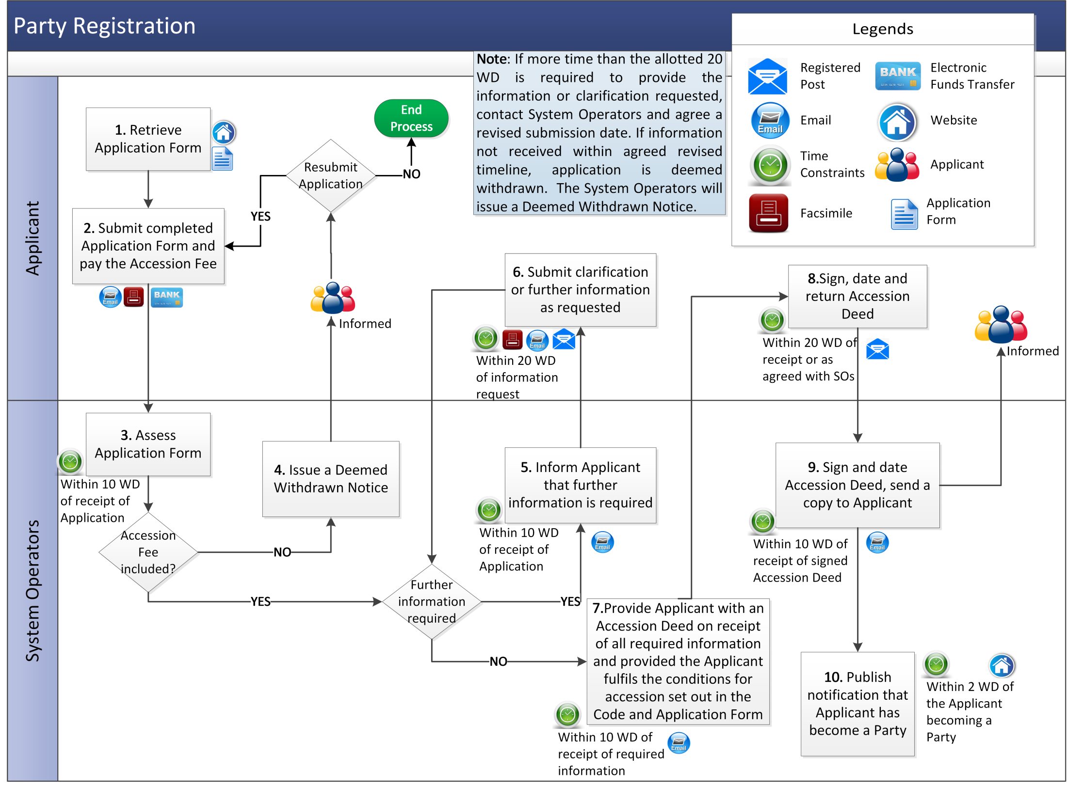

  - Provisional Registration of a Candidate Unit
The following procedure is applicable if a Party seeks to provisionally register a proposed Generator Unit or proposed Interconnector as a Candidate Unit under the Code in accordance with paragraph B.5.2.5 of the Code.

Step | Step Description | Timing | Method | By / From | To
 | Obtain Participation Notice and Capacity Registration Pack.  (This includes a REMIT Notification Form to appoint the System Operators to report REMIT Data to the European Agency for the Cooperation of Energy Regulators on its behalf). | As required | Download from the System Operators’ website | Party or Applicant | System Operators
 | Submit a completed Participation Notice and Capacity Registration Pack together with the required Participation Fee by way of Electronic Funds Transfer.  Note: Where the Unit is being registered by an Intermediary, the Party nominating the Intermediary shall submit a duly executed Form of Authority in accordance with section B.5.5 of the Code. The Capacity Registration Pack will detail how certain eligibility requirements are satisfied. | As required | Email / Facsimile and Registered Post / Electronic Funds Transfer | Party or Applicant | System Operators
 | Assess the completed Participation Notice. | Within 10 WD of receiving the Participation Notice |  | System Operators | Party or Applicant
 | If the required Participation Fee is not received with the application, the application is deemed to be withdrawn by issue of a Deemed Withdrawn Notice to the Applicant. The Applicant may resubmit the application otherwise end process. | - | Email | System Operators | Party or Applicant
 | Notify the Applicant if further information or clarification is required in order to complete the Participation Notice. | Within 10 WD of receiving the Participation Notice | Email | System Operators | Party or Applicant
 | Provide all necessary clarifications or additional information requested by the System Operators.  Note: If more time than 20 WD is required to provide the further information or clarification, contact System Operators to request a revised submission date. | Within 20 WD of notification for further information from System Operators | Email / Facsimile | Party or Applicant | System Operators
 | If the System Operators do not receive the further information or clarification, the Party shall be deemed to have withdrawn the Participation Notice and a Deemed Withdrawn Notice shall be issued to the Applicant. Those components (or part thereof) the Participation Fee for which the System Operators have not incurred any costs shall be refunded within 10 WD of having informed the Applicant, end process. | Within 20 WD of notification for further information from System Operators or date agreed with System Operators | Email | System Operators | Party or Applicant
 | On receipt of all required further information or clarification from the Applicant the System Operators shall send a notice to the Applicant as to whether or not the provisional registration has been approved, approved subject to conditions or rejected. If the application is rejected, end process, otherwise continue to step 9. | Within 10 WD of receipt of all information requested by System Operator | Email | System Operators | Party or Applicant
 | Hold registration meeting to agree the effective date of the new Unit. | Within 5 WD of receipt of complete application | Email / Telephone / Meeting | System Operators | Party and Market Operator
 | Issue Commencement Notice confirming the effective date and the Unit ID. | Within 3 WD of effective date | Email | System Operators | Party or Applicant and Market Operator

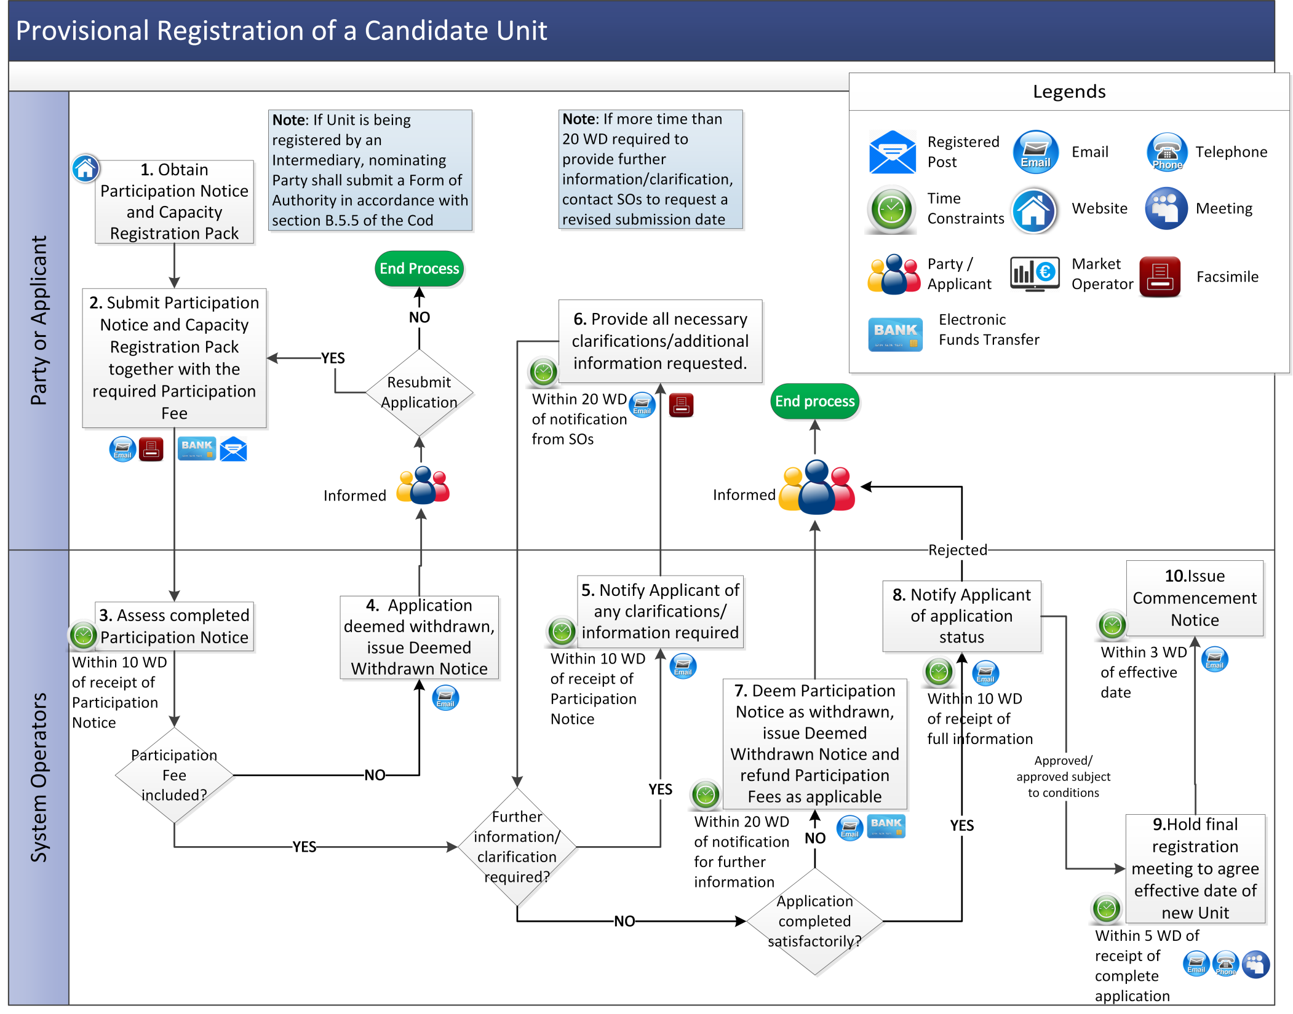

  - Deregistration of a Capacity Market Unit
Step | Step Description | Timing | Method | By/From | To
 | Download Deregistration Form from System Operators’ website. | At least 60 WD in advance of the intended date of Deregistration | System Operators website | Participant | -
 | Submit completed Deregistration Form. | At least 60 WD in advance of the intended date of Deregistration | Email / Facsimile | Participant | System Operators
 | Notify Market Operator of the Deregistration request.  Note: The Deregistration Applicant must ensure they satisfy the conditions set out in section B.5.6.3 of the Code in order for the Deregistration of the Capacity Market Unit to be approved. | Within 5 WD of receipt of Deregistration Form | Email | System Operators | Market Operator
 | Market Operator assesses the Deregistration request and notifies the System Operators of any issues that arise. | Within 20 WD of receipt of Deregistration details from System Operators | Email | Market Operator | System Operators
 | System Operators assess the Deregistration request and notify the Participant if any issues raised by the Market Operator or System Operators. | Within 25 WD of receipt of Deregistration Form | Email | System Operators | Participant
 | System Operators coordinate resolution of the issues raised. | As required | Conference Call / Meeting / Email | Participant, Market Operator, System Operators | -
 | Party raising issue confirms the outcome of the resolution and:  - if Deregistration of the Capacity Market Unit is no longer required, end process.  - if all outstanding issues resolved, continue to step 8. | - | Email | Participant, Market Operator, System Operators | System Operators
 | Organise final Deregistration meeting with all relevant Parties to determine the date of Deregistration.  If Deregistration is no longer required, end process. | Within 2 WD of confirmation of outcome of resolution | Conference Call / Meeting / Email | System Operators | Participant, Market Operator
 | Subject to the conditions set out in paragraph B.5.6.3 of the Code, issue Deregistration Consent Order. | Prior to the date of Deregistration | Registered Post to Participant. Email to Market Operator and Regulatory Authorities. | System Operators | Participant, Market Operator, Regulatory Authorities
 | If Deregistration Consent Order has been issued, update published list of registered Units as applicable. | As required | System Operators’ website | System Operators | -

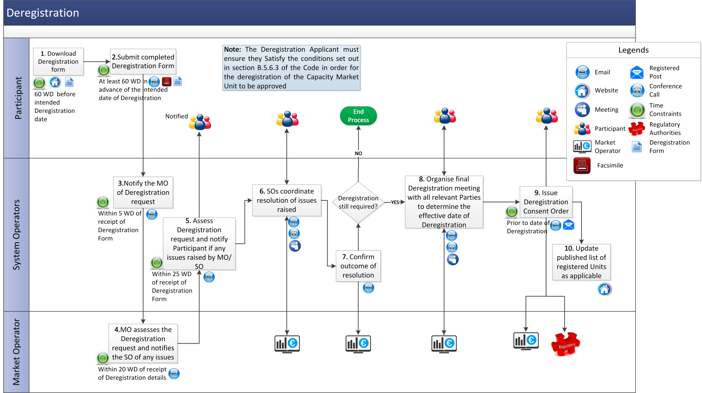

  - Voluntary Termination of a Party
Step | Step Description | Timing | Method | By/From | To
 | Download the Voluntary Termination Form from the System Operators’ website | At least 90 WD prior to the date upon which it is intended that the Termination will take effect | System Operators’ website | Party
 | Notify of intention to cease being a Party and time and date upon which it is intended that this Termination will take effect by completing and submitting the Voluntary Termination Form. | At least 90 WD prior to the date upon which it is intended that the termination will take effect | Registered post / Facsimile / Email | Party | System Operator and the Regulatory Authorities
 | Issue a Voluntary Termination Consent Order provided that:  - it has been confirmed that the relevant Party has complied with conditions set out in paragraph B.13.8.3 of the Code; and  - the Party has obtained the written consent of the Regulatory Authorities. | Following receipt of notification of Termination | Email | System Operators | Relevant Party
 | Deregister Capacity Market Units as applicable. | - | - | System Operators | -
 | Voluntary Termination takes effect (Party seeking Termination must remain in compliance with conditions set out in paragraph B.13.8.3 of the Code for Termination to take effect). | End of the Trading Day specified by the System Operators in the Voluntary Termination Consent Order | - | Party | -
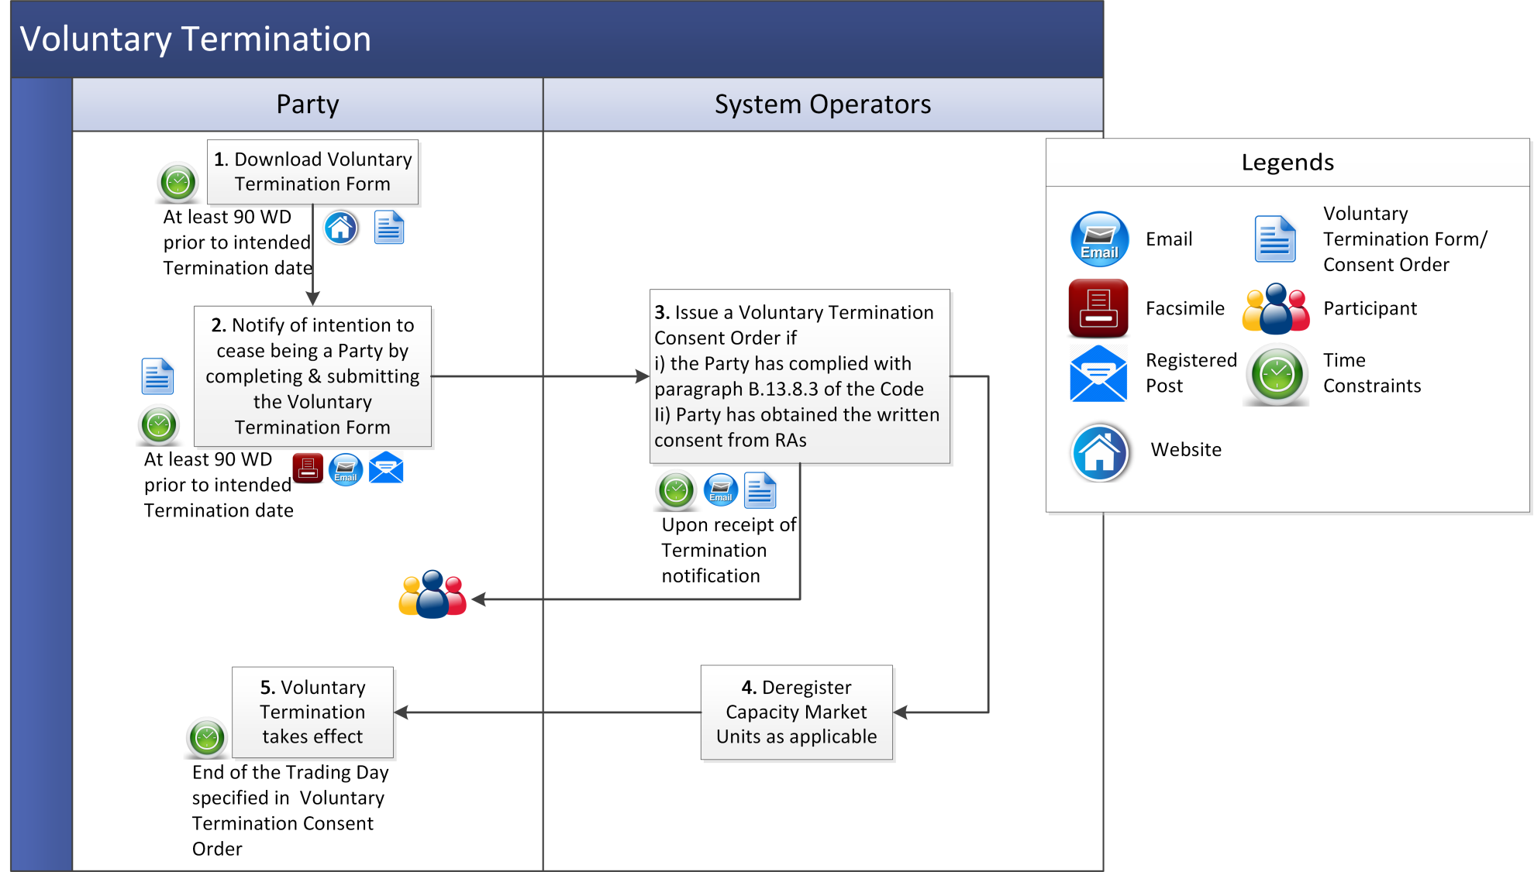

Appendix 1: Definitions
Application Form | means the form available on the System Operators’ website which is required to be completed by an Applicant to become a Party to the Code.
Capacity Market Interface | means the function within the Capacity Market Platform that interfaces to the Type 2 Channel communications in accordance with the Code.
Capacity Registration Pack | means the documentation and information that assists with Unit and Participant registration. including guides, forms and supporting information.
Deemed Withdrawn Notice | means the notification provided by the System Operators that an application for registration is being withdrawn.
Deregistration Applicant | has the meaning given to it in paragraph B.5.6.1 of the Code.
Participant ID | means the unique identifier used in the Capacity Market Platform that represents Units aggregated to a Participant under the Trading and Settlement Code.
User | means:  - in relation to a Participant: a nominated member of the Participant staff who is authorised to utilise qualified communication facilities that interact with the Capacity Market Platform; and  - in relation to the System Operators: a member of the System Operators staff who has been authorised to access specific parts of the Capacity Market Platform.
Voluntary Termination Form | means the form available on the System Operators’ website for the purposes of Voluntary Termination.

