CMC Agreed Procedure 5 - System Operation, Testing, Upgrading and Support | May 21  2019

Capacity Market Code
Version 2.0
Contents

1. Introduction 4
1.1 Background and Purpose 4
1.2 Scope of Agreed Procedure 4
1.3 Definitions 4
1.4 Compliance with Agreed Procedure 4
2. Overview 5
2.1 Helpdesk 5
2.1.1 Categorisation of Helpdesk Requests 5
2.1.2 Responding to Helpdesk Requests 5
2.1.3 Logging and Monitoring of Helpdesk Requests 6
2.2 Capacity Market Platform Modifications 6
2.2.1 Change Management 6
2.2.2 Release Management (Scheduled Releases) 6
2.2.3 Emergency Releases 7
2.2.4 Testing 7
2.2.5 Implementation Procedures 8
3. Procedural Steps 10
3.1 Helpdesk 10
3.2 Implementation Procedures 12
3.2.1 Change Management for Scheduled Releases 12
3.2.2 Maintenance, Application Releases and Emergency Releases 14
APPENDIX 1: Definitions 16

Document History
Version | Date | Author | Comment
1.0 | 31/05/2017 | I-SEM Project Team | Issued to the Regulatory Authorities
2.0 | 21/05/2019 | Eirgrid & SONI | Capacity Market Code V2.0 update

Related Documents
Document Title | Version | Date | By
Capacity Market Code | 2.0 | 21/05/19 | EirGrid & SONI
Agreed Procedure 1 “Registration”
Agreed Procedure 4 “Communication Channel Qualification”
Agreed Procedure 6 “System and Communications Failures”

- Introduction
  - Background and Purpose
This Agreed Procedure supplements the rules in the Capacity Market Code (hereinafter referred to as the “Code”) relating to Market System operation, testing, upgrading and support. It sets out procedures with which Parties to the Code must comply.

  - Scope of Agreed Procedure
This Agreed Procedure sets out procedures for:
- operation of the Helpdesk;
- change management for Scheduled Releases; and
- maintenance, Application Releases and Emergency Releases.
This Agreed Procedure forms an annex to, and is governed by the Code. It sets out procedures to be followed, subject to the rights and obligations of Parties under the Code. In the event of any conflict between a Party’s obligations set out in the Code and this Agreed Procedure, the Code shall take precedence.
It is not intended that there be any inconsistency or conflict between section 2 “Overview” and section 3 “Procedural Steps”. However, in the event of any inconsistency or conflict, section 3 “Procedural Steps” shall take precedence.
In section 3 “Procedural Steps” a corresponding process flow diagram is included for each procedural steps table. Process flow diagrams are for illustrative purposes. It is not intended that there be any inconsistency or conflict between any procedural steps table and process flow diagram however, in the event of any inconsistency or conflict, a procedural steps table shall take precedence.

  - Definitions
Words and expressions defined in the Code shall, unless the context otherwise requires or unless otherwise defined herein at Appendix 1 “Definitions”, have the same meanings when used in this Agreed Procedure.
References to particular sections refer to sections of this Agreed Procedure unless otherwise specified.

  - Compliance with Agreed Procedure
Compliance with this Agreed Procedure is required under the terms as set out in the Code.
- Overview
  - Helpdesk
The System Operators shall operate a Helpdesk through which Parties can seek technical and operational advice. The Helpdesk shall provide information on the following:
- Party / Capacity Market Unit registration;
- Communication Channels;
- Market operation and obligations of Parties; and
- Incidents affecting the Capacity Market Platform and Communication Channels.
The Helpdesk can be contacted via email or telephone. Contact details are available on the System Operators’ website.
    - Categorisation of Helpdesk Requests
There are three categories of Helpdesk Requests, as outlined in the table below.

Table 1: Helpdesk Categories
Category | Title | Description
 | Incident Reporting | The reporting of an issue by a Party that is preventing it from performing its obligations under the Code and which may require assistance from the System Operators to resolve.
 | Assistance Request | Request for technical assistance by a Party who is having issues with configuration of Communication Channels or Data Transactions.  Request for ad-hoc data reports by a Party.
 | Information Request | Request for information in relation to any issues arising under the Code. This information will usually be available on the System Operators’ website or shall be communicated via Type 2 Channel, as appropriate.
    - Responding to Helpdesk Requests
Helpdesk Requests shall be acknowledged within one Working Day of receipt.
Category 1 and category 2 Helpdesk Requests are considered to be resolved once the Helpdesk contacts the Participant to assist in resolving the issue. The timelines shall be dependent on the type of request (e.g. an issue relating to submission of bids or offers may require a response within two hours whereas assistance with configuration of Communication Channels may require more than one Working Day). Category 3 Helpdesk Requests are considered to be resolved once the requested information has been provided.

    - Logging and Monitoring of Helpdesk Requests
All Helpdesk Requests shall be logged by the System Operators with the details and resolution recorded.
The Helpdesk shall inform a Participant once a Helpdesk Request is closed.
  - Capacity Market Platform Modifications
    - Change Management
The System Operators shall implement a change management process in respect of the Capacity Market Platform to manage the identification, recording, rectification, development and Implementation of:
- any change to the production system, applications or environment;
- defects;
- approved changes through the Modification Process;
- operational improvements not requiring Modifications; and
- upgrades to system software, both core and third party.
The change management process shall include procedures to collate changes impacting the Capacity Market Platform into Releases.
Parties shall be made aware of all changes to the Capacity Market Platform with the exception of changes that relate to standard IT maintenance activities or internal process improvements which do not impact on system availability or third party interfaces. Parties shall be informed of such changes as part of the change management process.
This Agreed Procedure includes processes for the implementation of changes to the Capacity Market Platform associated with a Modification. These processes are additional to the Modifications Process under the Code.
    - Release Management (Scheduled Releases)
In line with the bi-annual Release strategy contained in the Technical Specification, each year, before the final Working Day in June, the System Operators shall provide all Parties with a Release timetable for the following year that identifies the dates for Scheduled Releases of the Capacity Market Platform. For the avoidance of doubt, this Release timetable shall not include details in relation to content of the Releases. These Releases shall be made up of system modifications as a result of Modifications directed by the Regulatory Authorities, upgrades to system software and corrections of identified defects.
The System Operators shall maintain the Technical Specification, which shall provide information required for Participants to implement Type 2 Channel to the Capacity Market platform. This documentation shall be maintained under version control by the System Operators.
Any proposed Implementation shall consider corresponding updates to the Technical Specification and the System Operators shall detail this update within the impact assessment which shall be made available to Participants and the Market Operator. The impact assessment shall assign the Implementation Classification (see Table 2 “Levels of Implementation”) and include a proposed Release plan. The Release plan shall include:
- consultation forum details;
- proposed delivery date for complete Technical Specification pertaining to the proposed Release. Where appropriate a delivery date for provision of sample files shall also be specified;
- proposed Participant interface testing start date and duration; and
- proposed Release date and Implementation window.
On receipt of the output of the impact assessment and Release plan, Participants and the Market Operator shall be given the opportunity to comment on the content of these documents. All comments must be received by the System Operators within five Working Days of the date of issue of the impact assessment and Release plan. In the event of a disagreement in relation to the content, assigned Implementation classification or Release detail, the rationale for the disagreement must be provided to the System Operators.
A consultation workshop shall be organised by the System Operators as close as is practicable to five Working Days (and no later than ten Working Days) after the issue of the impact assessment and Release plan. Attendance is voluntary. The purpose of the consultation workshop is to facilitate consultation on the key aspects of the proposed Release.
Once all comments are received (including discussions during the consultation workshop) the System Operators shall issue a revised impact assessment to the Participants and the Market Operator (including the final Implementation classification, Release content and proposed timeline). The Implementation of the planned Release shall be at least 30 days following the issuing of the revised impact assessment.
    - Emergency Releases
The System Operators may schedule an Emergency Release: (i) if they decide that there is a risk to the security or operation of the Market that requires an upgrade in system software (core or third party), security patch(es) or a defect; or (ii) if there is an Implementation of an Urgent Modification.
Where an Emergency Release does not affect the interface with Parties (i.e. there is no requirement for Parties to modify their system) the System Operators shall publish a summary of the Emergency Release as soon as practicable.
Where an Emergency Release affects the interface with Parties (i.e. there is a requirement for Parties to modify their system), this shall be agreed through an Urgent Modification. The agreement of the Urgent Modification shall include the Emergency Release timelines and the notices that the System Operators shall publish to Parties on Emergency Implementation.
    - Testing
Where the Release involves changes to the interface with Parties, the System Operators shall provide a separate Test Environment of the relevant Capacity Market Platform to allow the affected Parties to test the interface. This Test Environment shall be available for a period of not less than five Working Days prior to Implementation. The date and duration of this test phase shall be decided based on feedback received during the initial Release consultation process. If during this phase the System Operators become aware that one or more Participants are experiencing unanticipated issues during testing, the System Operators may revise the planned Release date.
Where the Release does not involve changes to the interface with Parties the System Operators shall only provide a separate Test Environment of the relevant Capacity Market Platform if this has been requested as part of an approved Modification Proposal included in the Release. The Test Environment shall be made available within the timelines approved in the Modification.
    - Implementation Procedures
Implementation of Releases containing approved Modification Proposals must be sanctioned by the Regulatory Authorities in accordance with B.12.11 of the Code.
Implementation of Releases on the production Capacity Market Platform or Communication Channels may have an effect on Parties’ interfaces with the Capacity Market Platform. The four categories of Implementation based on the operational impact on Parties are set out in the table below.

Table 2: Levels of Implementation
Implementation Classification | Description
Normal operation | Implementation of parts of the Capacity Market Platform which has no impact on Parties and does not require changes to Participants’ systems. Standard systems maintenance tasks would typically fall into this category. The Capacity Market Platform shall be fully available for the duration of the Implementation. Parties shall be notified.
Maintenance | Primarily planned maintenance activities. There is no change to Participants’ systems. If the Capacity Market Platform shall be unavailable during the Implementation, the System Operators shall provide notice detailing the planned Implementation window at least five Working Days prior to the Release date.
Application Release | Implementation of application software or system change as a result of approved Modification Proposal(s) or a change originating from the System Operators’ internal change management process. Section 2.2.2 above sets out further detail in relation to Scheduled Releases and the procedure in relation to change management for Scheduled Releases is set out at section 3.2 below.
Emergency Release | Implementation of an Emergency Release. Section 2.2.3 above sets out further details in relation to Emergency Releases. The procedure applicable to Emergency Releases is set out at section 3.3 below.

The System Operators shall remind Participants and the Market Operator of the Implementation one Working Day prior to the scheduled day for the Implementation.
On the day of the Implementation, if the Implementation is extended such that it falls outside the notified Implementation timelines and the circumstances constitute a Failure, the System Operators shall initiate the relevant procedures set out in Agreed Procedure 6 “System and Communication Failures” if applicable.
When the Implementation is complete, the System Operators shall, as soon as practicable, inform Participants and the Market Operator by publishing the information on the System Operators’ website.
For Application Releases a confirmation shall be included in the impact assessment if the Participants are required to have their Communication Channels re-qualified under Agreed Procedure 4 “Communication Channel Qualification” to allow use of a Communication Channel after the Implementation. The System Operators shall use reasonable endeavours to implement system changes in a manner which minimises impact on third party interaction with the Capacity Market Platform.

- Procedural Steps
  - Helpdesk
Step | Step Description | Timing | Method | By / From | To
 | Contact the Helpdesk with a Helpdesk Request. | As required | Email / Telephone / Facsimile | Party | System Operators
 | Log the Helpdesk Request and acknowledge receipt of the request. | Within 1 WD of receipt of Helpdesk Request | Telephone / Email | System Operators | Party
 | Consider the Helpdesk Request and provide the necessary information to the Party to resolve the Helpdesk Request. Close the Helpdesk Request. | Within the timescales that have been agreed with the Party | Telephone / Email | System Operators | Party

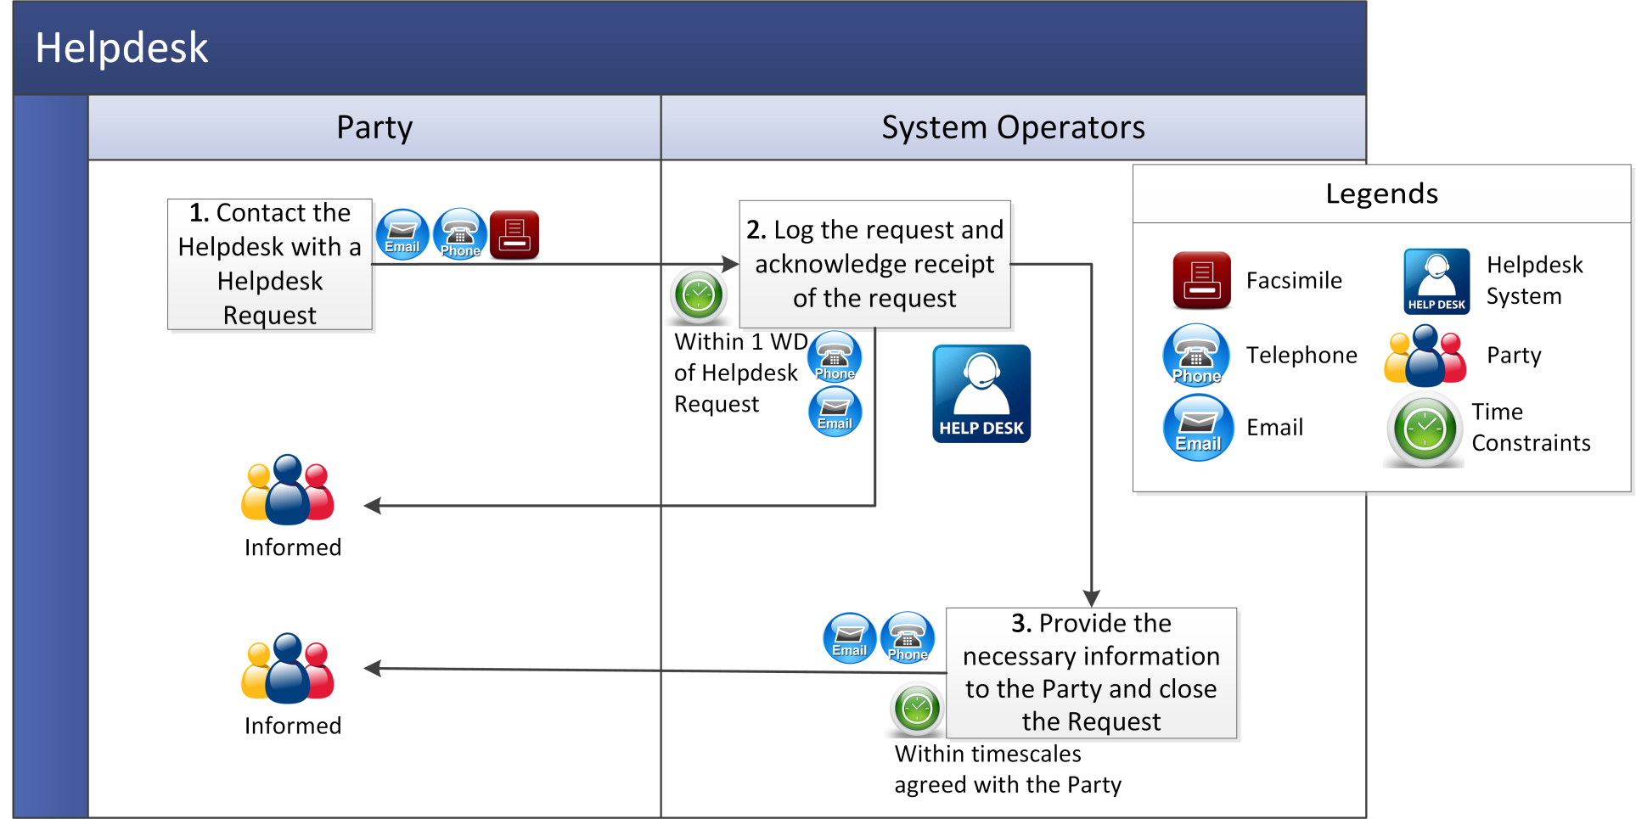

  - Implementation Procedures
    - Change Management for Scheduled Releases
Step | Step Description | Timing | Method | By / From | To
 | Issue impact assessment. | As required but at least 40 WD prior to proposed Release date | Email and System Operators’ website | System Operators | Participants
 | Provide comments on impact assessment documentation. | Within 5 WD of issue of impact assessment | Email | Participants | System Operators
 | Hold technical workshop. | Within 10 WD of issue of impact assessment | Meeting and /or Telephone | System Operators | Participants
 | Consider comments and feedback. | As required | - | System Operators | -
 | Issue revised impact assessment (including revised Release plan) if applicable. | Within 10 WD of the technical workshop | Email | System Operators | Participants
 | Issue notification of Release. | At least 1 week prior to Release date | Email and System Operators’ website | System Operators | Participants

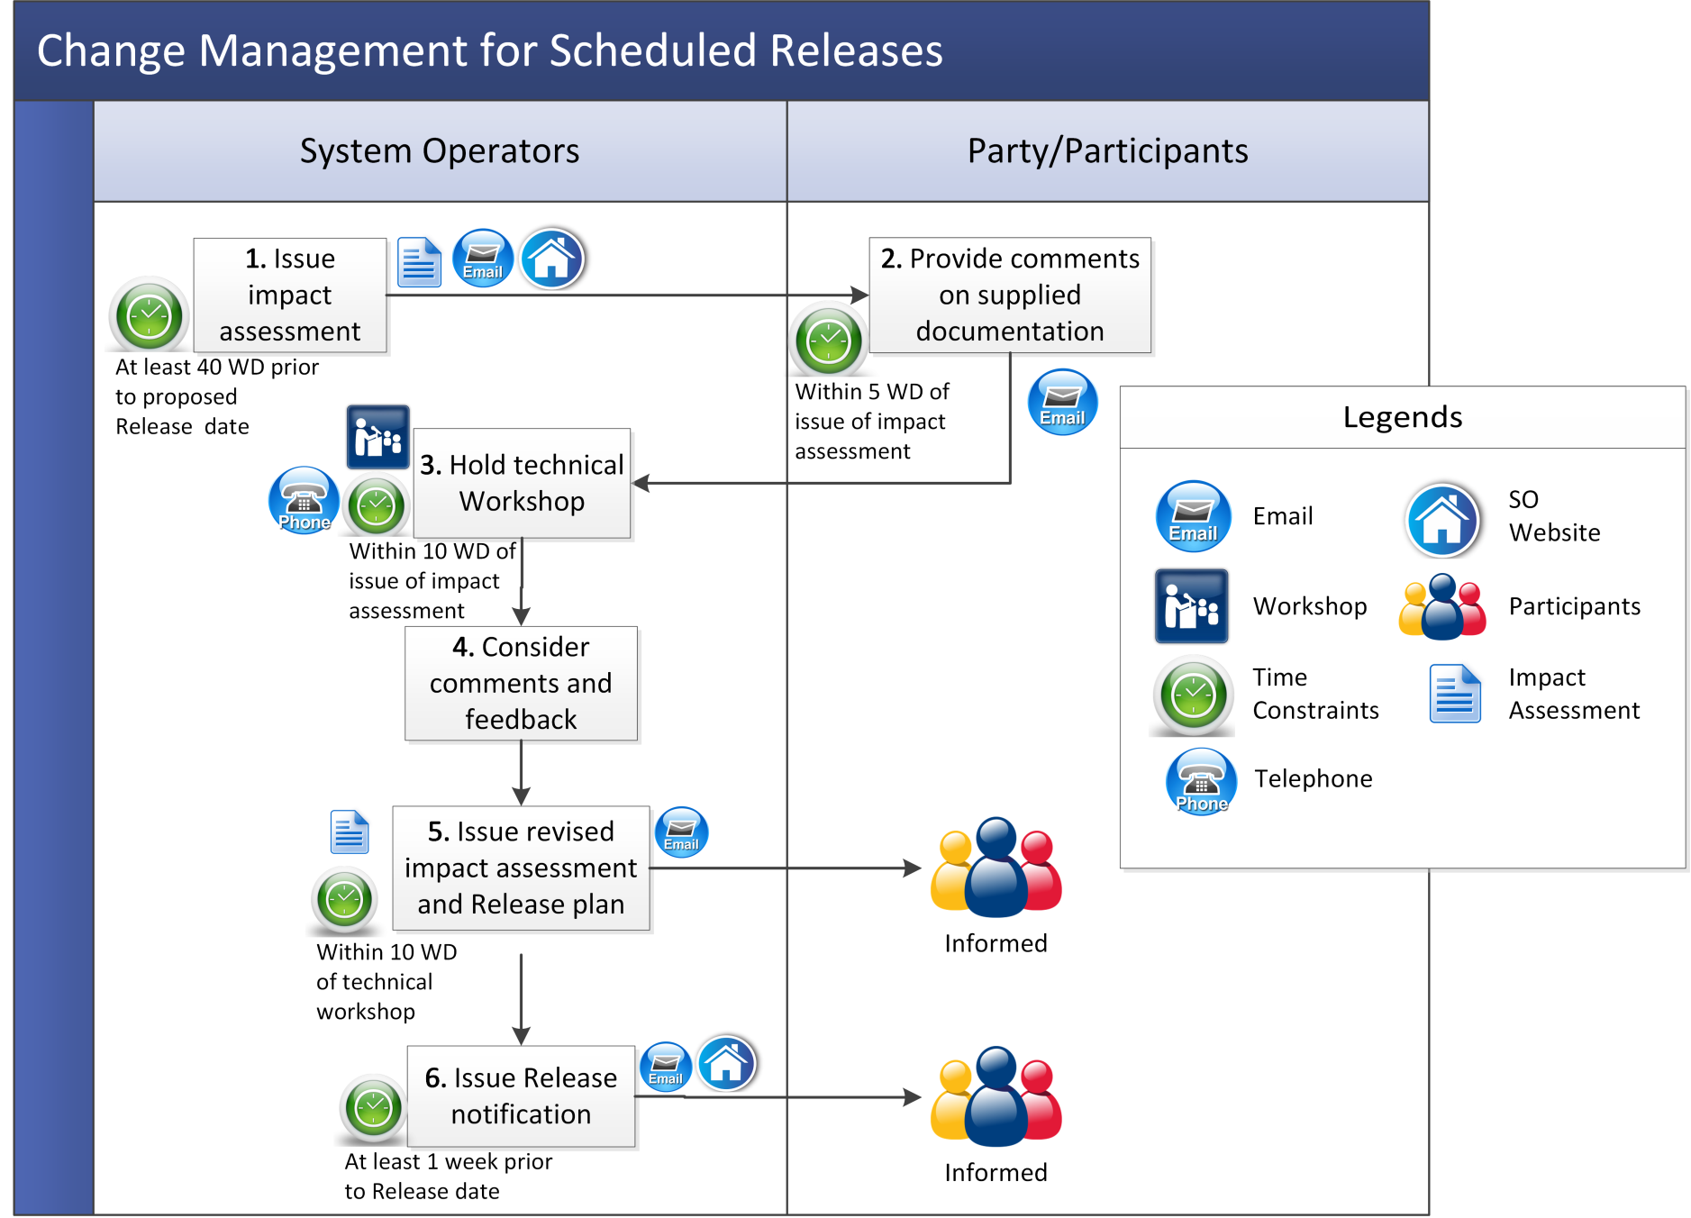
    - Maintenance, Application Releases and Emergency Releases
Step | Step Description | Timing | Method | By / From | To
 | Perform Implementation and if:  - the Capacity Market Platform cannot restore within the published timelines, go to step 2;  - the restoration of Capacity Market Platform has been completed successfully, go to step 4. | At published scheduled time for Emergency Release when required | Email / Capacity Market Platform | System Operators | Participants
 | Initiate Agreed Procedure 6 “System and Communication Failures”. | As soon as is practicable | Email, System Operators’ website and Capacity Market Platform | System Operators | Participants
 | Inform Participants of the failure to complete the Implementation within published timescales. | As soon as is practicable | Email and System Operators’ website | System Operators | Participants
 | Inform Participants of restoration of Capacity Market Platform. | As soon as is practicable | Email and System Operators’ website | System Operators | Participants
 | Participants and System Operators invoke internal procedures to return to normal operation. | After Implementation | - | Participants and System Operators | -

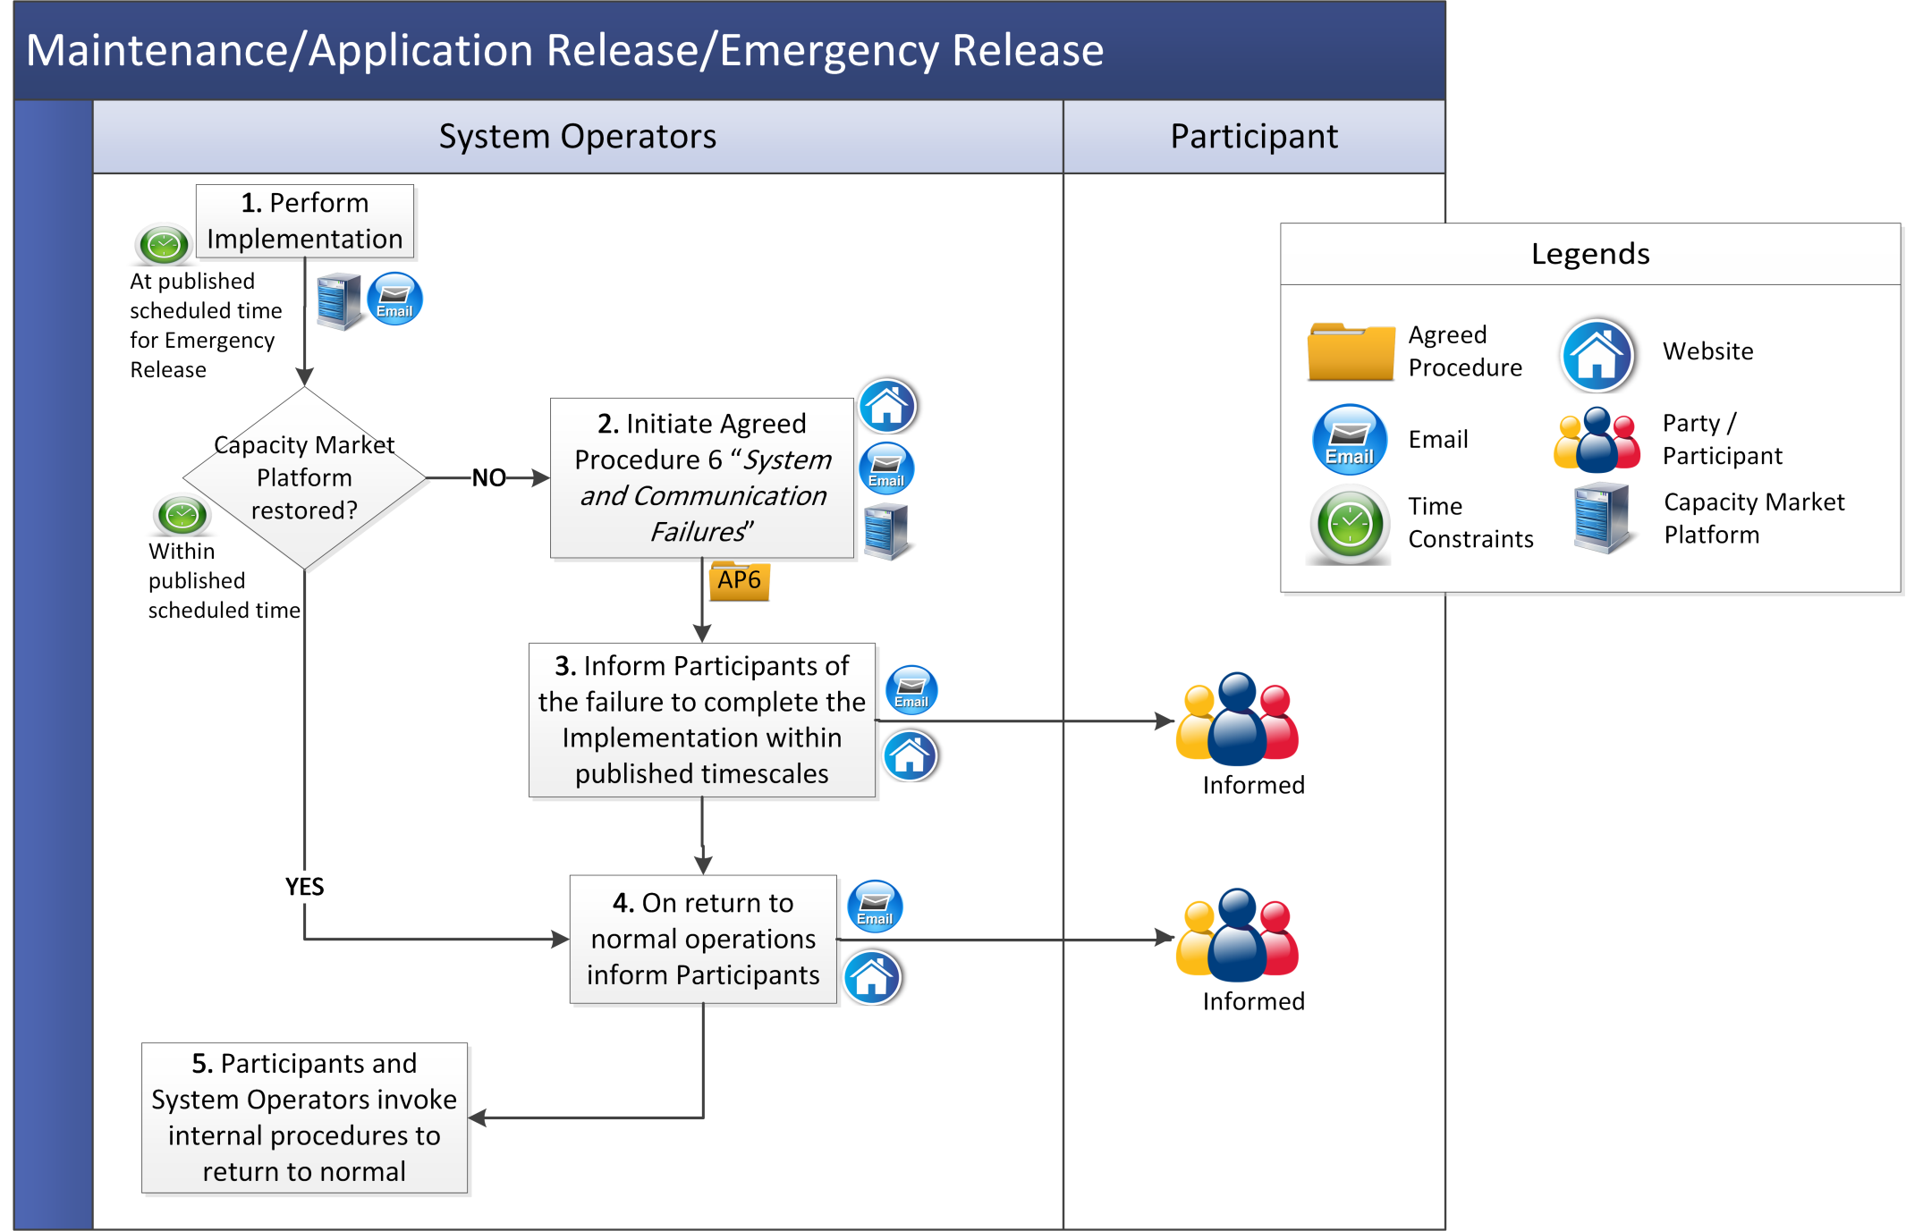

- Definitions

Application Release | has the meaning set out in Table 2 “Levels of Implementation” at section 2.2.5.
Authorisation | means the process by which a person from a Party becomes authorised to communicate with the System Operators.
Authorised Person | means the representative of a Party who is authorised by that Party to communicate with the System Operators.
Capacity Market Interface | means the function within the Capacity Market Platform that interfaces to the Type 2 Channel communications in accordance with the Code.
Emergency Implementation | means Implementation of an Emergency Release.
Emergency Release | means an upgrade in system software, a bug-fix or an Implementation of an Urgent Modification, where the System Operators consider that there is a risk to the operation of the Single Electricity Market.
Failure | means a Capacity Market System Outage, Capacity Market Communication Outage or Limited Communication Failure as the context implies. Agreed Procedure 6 “System and Communications Failures” sets out the procedures to be followed in the event of a Failure.
Helpdesk | means the facility put in place by the System Operators to enable Parties and others to seek assistance and submit requests on any issues arising under the Code.
Helpdesk Request | means a request handled by the Helpdesk as categorised in section 2.1.1.
Implementation | means delivery of Releases on the production Capacity Market Platform or Communication Channels.
Implementation Classification | means the categories of Implementation as set out in Table 2 “Levels of Implementation” at section 2.2.5.
Release | means an update to the Capacity Market Platform.
Test Environment | means a non-production version of a Capacity Market Platform used for test purposes prior to a Release.

