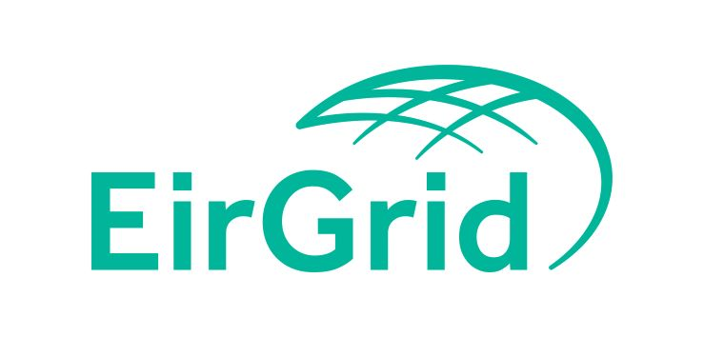


C14

Capacity Market - Form of Authority

Date 12/04/2017
Document C14
Version 1.1
FORM OF AUTHORITY FOR APPOINTMENT OF AN INTERMEDIARY

THIS FORM OF AUTHORITY dated the [ ] day of [ ] [20 ] is entered into as a deed between:

(I) [Insert name of generator (if a company, please give full corporate name)]:

(“Licensed Generator”)
having its place of business at [Insert address of Licensed Generator]

being a [registered company/partnership/sole trader etc.] registered under the laws of [insert country of registration if a company] and whose company registration number is [insert if a company];

and

(II) [Insert name of proposed intermediary (if a company, please give full corporate name)]

(“Intermediary”)
having its place of business at [Insert address of Intermediary]

being a [registered company/partnership/sole trader etc.] registered under the laws of [insert country of registration if a company] and whose company registration number is [insert if a company].

In respect of

[Insert description of generator unit or units to which this Form of Authority applies]
(“Units”)

Whereas:
1. The Licensed Generator legally controls the Units and is the subject of [a [licence/authorisation/exemption] issued by the CER to use the Units for the purpose of generation of electricity in Ireland] [and] [a [licence/authorisation/exemption] issued by the NIAUR to use the Units for the purpose of generation of electricity in Northern Ireland].
2. The Licensed Generator and the Intermediary are parties to a contract (“the Contract”) which satisfies criteria for appointment of an Intermediary pursuant to Regulatory Authorities’ Decision Paper SEM/17/025. The Licensed Generator wishes to appoint the Intermediary to act as the Participant in respect of the Units under (i) the Trading and Settlement Code, and (ii) the Capacity Market Code, and the Intermediary wishes to accept such appointment, in accordance with the following terms.
3. By letter dated [xx/xx/xxx] (“the Consent”) addressed to the Licensed Generator and the Intermediary the Regulatory Authorities consent to the appointment by the Licensed Generator of the Intermediary to act as such.

1. Interpretation
1.1 In this Form of Authority, “Trading and Settlement Code” or “TSC” means the code of that name that governs the balancing market and settlement arrangements for the capacity market in Ireland and Northern Ireland, as modified, amended, varied or replaced from time to time.
1.2 In this Form of Authority, “Capacity Market Code” or “CMC” means the code of that name that governs the capacity market in Ireland and Northern Ireland, as modified, amended, varied or replaced from time to time.
1.3 Capitalised terms which are not defined in this Form of Authority shall have the meanings ascribed thereto in the Trading and Settlement Code.

2. Authorisation under the Trading and Settlement Code
2.1 The Licensed Generator hereby appoints and authorises the Intermediary to register the Units as Generator Units for the purposes of participation in the Balancing Market, and to participate in the Balancing Market in respect of the Units, under the Trading and Settlement Code, and the Intermediary accepts such appointment.
2.2 The Licensed Generator authorises the Intermediary, subject to the Intermediary becoming a Party to the Trading and Settlement Code and successfully registering the Units under the TSC, to undertake all of the obligations, covenants, undertakings, duties and liabilities of a Participant in respect of the Units under the TSC [for the duration of the Contract] [insert alternative period], and the Intermediary agrees to such.
2.3 The Licensed Generator authorises the Intermediary, subject to the Intermediary becoming a Party to the Trading and Settlement Code and successfully registering the Units under the TSC, to benefit from all of the rights of a Participant under the TSC, including the right to receive payments in respect of the Units under the TSC [for the duration of the Contract] [insert alternative period], and the Intermediary agrees to such.

EITHER:
3. [Full Authorisation under the Capacity Market Code
3.1 The Licensed Generator hereby appoints and authorises the Intermediary to register or provisionally register the Units for the purposes of participation in the Capacity Market, and to participate in respect of the Units in the Capacity Market, under the Capacity Market Code, and the Intermediary accepts such appointment.
3.2 The Licensed Generator authorises the Intermediary, subject to (1) the Intermediary becoming a Party to the Capacity Market Code and (2)(i) successfully registering the Units under the TSC, or (2)(ii) registering or provisionally registering the Units under the CMC, to undertake all of the obligations, covenants, undertakings, duties and liabilities of a Participant in respect of the Units under the CMC [for the duration of the Contract] [insert alternative period], and the Intermediary agrees to such.
3.3 The Licensed Generator authorises the Intermediary, subject to (1) the Intermediary becoming a Party to the Capacity Market Code and (2)(i) successfully registering the Units under the TSC, or (2)(ii) registering or provisionally registering the Units under the CMC, to benefit from all of the rights of a Participant in respect of the Units under the CMC (including the right to participate in Capacity Auctions) [for the duration of the Contract] [insert alternative period], and the Intermediary agrees to such.]

OR:
3. [Restricted Authorisation under the Capacity Market Code
The Licensed Generator hereby appoints and authorises the Intermediary to register the Units for the purposes of the Capacity Market Code, but does not authorise the Intermediary to participate in Capacity Auctions or Secondary Trade Auctions under the CMC in respect of the Units.]

4 Other matters
4.1 This Form of Authority, and any disputes arising under, out of, or in relation to, this Form of Authority shall be interpreted, construed and governed in accordance with the laws of Northern Ireland.
4.2 The parties hereby submit to the jurisdiction of the Courts of Ireland and the Courts of Northern Ireland (and no other court) for all disputes arising out of, under or in relation to this Form of Authority.
4.3 The Market Operator under the TSC and the System Operators under the CMC are entitled to rely on this Form of Authority.
4.4 The Registered Generator may revoke this Form of Authority by giving [20] Working Days’ notice in writing.
4.5 Where the Regulatory Authorities consider that the basis on which the Regulatory Authorities gave the Consent no longer applies, they may revoke the Consent and this Form of Authority by giving 20 Working Days’ notice in writing to the Registered Generator and the Intermediary. If the Regulatory Authorities revoke this Form of Authority, the Intermediary shall promptly notify the Market Operator under the TSC and, if applicable, the System Operators under the CMC.
[To be executed as a Deed and (where appropriate to the legal form of the Licensed Generator) under seal]

[To be executed as a Deed and (where appropriate to the legal form of the Intermediary) under seal]

