|  |  |  |  |  |  |
| --- | --- | --- | --- | --- | --- |
| **MODIFICATION PROPOSAL FORM** | | | | | |
| **Proposer**  *(Company)* | **Date of receipt**  *(assigned by Secretariat)* | | **Type of Proposal**  *(delete as appropriate)* | | **Modification Proposal ID**  *(assigned by Secretariat)* |
| **SEMO** | **17 January 2012** | | **Standard** | | **Mod_06_12** |
| **Contact Details for Modification Proposal Originator** | | | | | |
| **Name** | | **Telephone number** | | **Email address** | |
| **Nigel Thomson** | | **012370322** | | **Nigel.thomson@sem-o.com** | |
| **Modification Proposal Title** | | | | | |
| **Improved Efficiencies in LCF Process** | | | | | |
| **Documents affected**  *(delete as appropriate)* | | **Section(s) Affected** | | **Version number of T&SC or AP used in Drafting** | |
| **AP 7** | | **AP7 – Entire AP** | | **V10.0 (with Mod_18_10)** | |
| **Explanation of Proposed Change**  *(mandatory by originator)* | | | | | |
| Where a Limited Communication Failure (LCF) occurs for Participants submitting Commercial Offer Data (COD) and Validation Data Set Number (VDSN), this Modification Proposal seeks to streamline the acceptance and upload of the data submission into the Central Market Systems via an alternative communication channel. The current process requires Participants to submit the following by Gate Closure via fax:   1. Transaction Notification Form 2. applicable Emergency Communication Pack Form 3. Limited Communication Failure Form   The Emergency Communication Pack consists of four different types of form:  **LCF COD form for Generator Units:**  Section A - Forecast details: Availability Profile, Minimum Stable Generation, Minimum Profile and Fuel Use Details  Section B - Price Maker Details: Start Up Costs, No Load Costs and Price Quantity Curve  Section C - Price Taker Details: Nomination Profile and Decremental Prices  Section D - Pump Storage Details: Reservoir Levels, Spin Costs and Minimum Generation Cost  Section E - Energy Limited Details: Energy Limited Period Flags  **LCF COD form for Interconnector Units:**  Section A - Capacity details: Maximum Import MW and Maximum Export MW  Section B - Price curve details: Price quantity curve  **LCF COD form for Demand Units:**  Section A - Forecast details: Availability Profile, Fuel Use Details, Minimum Stable Generation, Minimum Profile and Fuel Use Details.  Section B - Price maker details: Shutdown Costs and Price Quantity Curve  **LCF VDSN Form:**  Participant ID Resource Name, Trade Date and VDSN (1-6)  In summary the Modification Proposal contains the following changes:  Where the LCF is related to submission of COD or VDSN during the next scheduled Gate Window and the Gate Window is due to close within the next hour, the following process should be followed.   1. Contact the MO emergency number to make them aware of the LCF. 2. Submit the offer data using Emergency Communication Pack in xml file format via the MO website, or manually enter the offer data via the MO website offer submission form. Once completed, a reference number will be generated. 3. Before the Gate Window Closure, fax the Transaction Notification Form with Participant details, Authorised Person Name, Password, Signature and Reference number obtained from submission to MO website. 4. SEMO will then load the offer data (using the more efficient xml loading tool) – rather than manually entering the bids in the market system, which is both time consuming and open to error. 5. SEMO will then respond via fax to confirm whether the offer data have been successfully loaded or not.   In the event that the MO website is also unavailable than the existing fax based submission of the bids will be accepted. | | | | | |
| **Legal Drafting Change**  *(Clearly show proposed code change using* ***tracked*** *changes, if proposer fails to identify changes, please indicate best estimate of potential changes)* | | | | | |

Agreed Procedure 7 “emergency Commmunications”

* 1. Limited Communication Failure
     1. Overview

A “Limited Communication Failure” is a situation where one or more Parties, but not all Parties and none of those Parties being the Market Operator, a System Operator or Meter Data Provider, fail to comply with the data submission requirements because of a technical, communication or IT systems error outside of the Market Operator’s Isolated Market System.

All Parties are required under Agreed Procedure 5 “Data Storage and IT Security” to maintain a redundant and fault-tolerant network configuration of sufficient capacity to meet their peak communication needs. Whenever there is a Limited Communication Failure the impacted Party should initially attempt to rectify the problem or utilise other facilities to enable it to use its normal Communication Channels.

In the event that an impacted Party is unable to re-establish its normal Communication Channel and the impacted Party incurs a Limited Communication Failure, the impacted Party will notify the Market Operator that they have communication problems and will operate their alternative Communication Channel process for the specified Data Transactions. The impacted Party will provide regular (i.e. not less than daily) status updates to the Market Operator of progress in their attempts to restore their normal Communication Channel.

A Limited Communication Failure shall not affect the obligations of any impacted Party to submit Data Transactions.

Where a Limited Communication Failure concerns submission of data other than Commercial Offer Data and Validation Data Set Number, the impacted Party should follow the procedural steps set out in Section 5.3 – Standard Limited Communication Failure.

Where a Limited Communication Failure relates to Commercial Offer Data (COD) or Validation Data Set Number submission for a Gate Window scheduled to close within 1 hour, then the procedural steps set out in Section 5.4 - Commercial Offer Data (COD) and Validation Data Set Number Limited Communication Failure shall be followed. This involves the use of the MO website to submit the data electronically in order to allow the information to be more efficiently entered into the market Central Market System and to reduce the likelihood of publication delays.

* 1. Swimlane – standard Limited Communication Failure

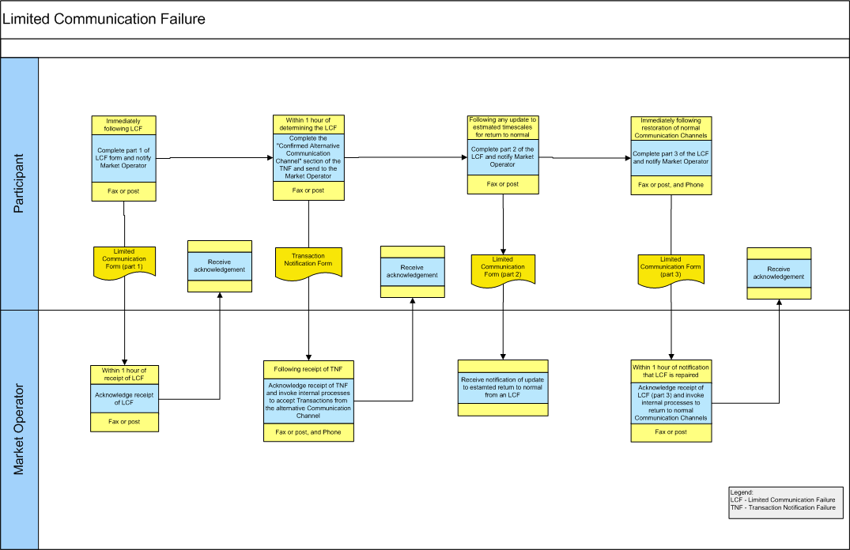

* 1. Swimlane - Commercial Offer Data and Validation data Set Number Limited Communication Failure



* 1. standard Limited Communication Failure

| **#** | **Procedural Step** | **Timing** | **Method** | **By / From** | **To** | **Linkage** |
| --- | --- | --- | --- | --- | --- | --- |
| 1 | Complete Part 1 of the Limited Communication Failure Form and fax or post the form to the Market Operator. Additionally, contact the Market Operator by telephone to inform that there is a Limited Communication Failure and that alternative Communication Channels are being enacted.  Proceed from Step 2 and Step 3 | Immediately following the Limited Communication Failure becomes apparent | Fax or post | Impacted Party | Market Operator |  |
| 2 | Acknowledge receipt of Limited Communication Failure Form | Within 1 hour of receipt | Fax or post | Market Operator | Impacted Party |  |
| 3 | Complete the “Alternative Communication Method” section of Part A of the Transaction Notification Form and send to the Market Operator to confirm the Communication Channels to be used for each of the Data Transactions  Proceed to Step 4 and Step 5 | Within 1 hour of notifying Market Operator of the Limited Communication Failure | Fax or post | Impacted Party | Market Operator |  |
| 4 | Acknowledge receipt of Transaction Notification Form | Within 1 hour of receipt | Fax or post | Market Operator | Impacted Party |  |
| 5 | Invoke internal processes to accept Data Transactions from the alternative Communication Channel as notified on the Transaction Notification Form | Following receipt of the Transaction Notification Form | - | Market Operator |  |  |
| 6 | If there is any change to the estimated timescales for the disruption to normal operation complete part 2 of the Limited Communication Failure Form to the Market Operator. | Immediately following any change to the previous estimate given for expected return to normal operation | Fax or post | Impacted Party | Market Operator |  |
| 7 | On restoration of normal Communication Channels complete part 3 of the Limited Communication Failure Form and send to the Market Operator by fax or post. Additionally, notify the Market Operator by telephone that normal Communication Channels have been restored. | Immediately following restoration of normal Communication Channels | Fax or post | Impacted Party | Market Operator |  |
| 8 | Acknowledge receipt of Limited Communication Failure Form – restoration to normal | Within 1 hour of receipt | Fax or post | Market Operator | Impacted Party |  |
| 9 | Invoke internal processes to revert back to normal Communication Channels for this Party | On receipt of fax confirmation of the return to normal Communication Channels | - | Market Operator |  |  |

* 1. Commercial Offer Data (COD) and Validation Data Set Number Limited Communication Failure

Where the Limited Communication Failure relates to Commercial Offer Data (COD) and Validation Data Set Number submission for the next schedule gate window scheduled Gate Window Closure and the gate is due to close within one hour then the following process will apply:

| **#** | **Procedural Step** | **Timing** | **Method** | **By / From** | **To** | **Linkage** |
| --- | --- | --- | --- | --- | --- | --- |
| 1 | Contact the Market Operator emergency operations number by telephone to inform them that there is a Limited Communication Failure which relates to Commercial Offer Data (COD) or Validation Data Set Number submission for the next scheduled Gate Window Closure. | Where a Limited Communication Failure for Commercial Offer Data (COD) or Validation Data Set Number becomes apparent within one hour of the gate window Gate Window Closure. | Telephone | Impacted Party | Market Operator |  |
| 2 | Submit bids via the online query section of the MO website by providing a correctly formatted xml Commercial Offer Data (COD) of Validation Data Set Number submission file, or alternatively manually entering bid submission data, via the MO website online bid submission form.  A reference ID will be returned when the information has been submitted to the MO. | Immediately when Limited Communication Failure for bid submission becomes apparent | MO website | Impacted Party | Market Operator |  |
| 3 | Submit a Transaction Notification Form via fax. The form should include the authorised user, signature and password and the reference id from the MO website submission. | Must be completed before gate window Gate Window Closure. | Fax | Impacted Party | Market Operator |  |
| 4 | The MO will confirm, via fax ,receipt of the transaction notification Transaction Notification Form (and the Commercial Offer Data (COD) or Validation Data Set Number submission via the MO website) and inform the Participant if the Commercial Offer Data (COD) or Validation Data Set Number submission has been successfully entered into the market Central Market System. | Within 1 hour of receipt | Fax | Market Operator | Impacted Party |  |

Note: in the event that the MO website is unavailable for Commercial Offer Data (COD) or Validation Data Set Number submission during an LCF then the Commercial Offer Data (COD) or Validation Data Set Number should be submitted via fax along with the Transaction Notification Form.

Appendix 1 Definitions and Abbreviations

|  |  |
| --- | --- |
| **Emergency Transaction Timeline** | The timeline for Data Transactions in the event of a communication failure |
| **Gate Window Closure** | As defined in the Code |
| **General Communication Failure** | As defined in the Code |
| **Trading Day** | As defined in the Code |
| **Transaction Notification Form** | The template for specifying alternative Communication Channels for a specified set of Data Transactions to be used during a General System Failure, a General Communication Failure or a Limited Communication Failure. |
| **Type 1 Channel** | As defined in the Code |

|  |  |
| --- | --- |
| **Modification Proposal Justification**  *(Clearly state the reason for the Modification)* | |
| As part of Working Group 10 for Intraday Trading (IDT) SEMO raised concerns over the existing LCF process and its impact on pricing runs once Intraday Trading is implemented.  With the introduction of IDT, the following circumstances may arise more frequently:   * Likelihood is that there will be more LCFs, due to multiple gates. * Shorter timeframes to submit COD or VDSN will likely increase the number of LCFs. * The 08:00 WD1 Gate Window Closure is outside of normal business hours, putting pressure on Participants’ systems/processes and SEMO’s ability to handle LCFs by the rapid deployment of staff, diverting them from their normal duties. * The 90 minute timelines for MSP Software Runs for IDT do not allow for LCF events.   Based on the above, SEMO highlighted in Working Group 10 that there is a high likelihood that LCFs will cause delays in publishing and subsequent MSP Software Run Cancellation once IDT goes live.  Participants were asked for their feedback on options to change or remove the LCF process. The majority of the feedback received was in favour of retaining the LCF process, but the majority of Participants wanted to change the process to allow more efficient processing of LCFs and reduce the likelihood of delays in publishing and MSP Software Run cancellations.  This Modification Proposal defines a separate LCF process for time critical COD or VDSN submission that will streamline the processing of the offer data and reduce the likelihood of delays in publishing and cancellations.  The most inefficient part of the LCF COD and VDSN submission process is the manual entry of offer data by the MO into the Central Market Systems based on faxed values from Participants.  No Central Market Systems changes are required to facilitate the acceptance of xml files for the COD and VDSN submission. Therefore, having the LCF COD and VDSN submissions available in this format would greatly decrease the time and effort required for the MO to deal with an LCF. This Modification Proposal looks to use the MO website as the means to submit the xml files directly, or alternatively for the COD and VDSN submission to be available in a form on the website and for the xml files to then automatically be generated for upload by the MO. | |
| **Code Objectives Furthered**  *(State the Code Objectives the Proposal furthers, see Section 1.3 of T&SC for Code Objectives)* | |
| This Modification Proposal furthers the Code objectives by allowing LCFs to be processed more efficiently (1.3.1 & 1.3.2) and reducing the likelihood of needing to cancel subsequent runs, therefore, increasing the opportunities for trading (1.3.3) | |
| **Implication of not implementing the Modification Proposal**  *(State the possible outcomes should the Modification Proposal not be implemented)* | |
| With the introduction of IDT and the associated 90min processing times should the Modification Proposal not be implemented, the likelihood of pricing run publishing being delayed when a LCF occurs is significant and may result in the associated cancellation of subsequent runs. | |
| **Working Group**  *(State if Working Group considered necessary to develop proposal)* | **Impacts**  *(Indicate the impacts on systems, resources, processes and/or procedures)* |
|  | No changes to CMS |
| ***Please return this form to Secretariat by email to*** [***modifications@sem-o.com***](mailto:modifications@sem-o.com) | |

**Notes on completing Modification Proposal Form:**

1. **If a person submits a Modification Proposal on behalf of another person, that person who proposes the material of the change should be identified on the Modification Proposal Form as the Modification Proposal Originator.**
2. **Any person raising a Modification Proposal shall ensure that their proposal is clear and substantiated with the appropriate detail including the way in which it furthers the Code Objectives to enable it to be fully considered by the Modifications Committee.**
3. **Each Modification Proposal will include a draft text of the proposed Modification to the Code unless, if raising a Provisional Modification Proposal whereby legal drafting text is not imperative.**
4. **For the purposes of this Modification Proposal Form, the following terms shall have the following meanings:**

**Agreed Procedure(s): means the detailed procedures to be followed by Parties in performing their obligations and functions under the Code as listed in Appendix D “List of Agreed Procedures”.**

**T&SC / Code: means the Trading and Settlement Code for the Single Electricity Market**

**Modification Proposal: means the proposal to modify the Code as set out in the attached form**

**Derivative Work: means any text or work which incorporates or contains all or part of the Modification Proposal or any adaptation, abridgement, expansion or other modification of the Modification Proposal**

**The terms “Market Operator”, “Modifications Committee” and “Regulatory Authorities” shall have the meanings assigned to those terms in the Code.**

**In consideration for the right to submit, and have the Modification Proposal assessed in accordance with the terms of Section 2 of the Code (and Agreed Procedure 12), which I have read and understand, I agree as follows:**

**1. I hereby grant a worldwide, perpetual, royalty-free, non-exclusive licence:**

* 1. **to the Market Operator and the Regulatory Authorities to publish and/or distribute the Modification Proposal for free and unrestricted access;**
  2. **to the Regulatory Authorities, the Modifications Committee and each member of the Modifications Committee to amend, adapt, combine, abridge, expand or otherwise modify the Modification Proposal at their sole discretion for the purpose of developing the Modification Proposal in accordance with the Code;**
  3. **to the Market Operator and the Regulatory Authorities to incorporate the Modification Proposal into the Code;**

**1.4 to all Parties to the Code and the Regulatory Authorities to use, reproduce and distribute the Modification Proposal, whether as part of the Code or otherwise, for any purpose arising out of or in connection with the Code.**

**2. The licences set out in clause 1 shall equally apply to any Derivative Works.**

**3. I hereby waive in favour of the Parties to the Code and the Regulatory Authorities any and all moral rights I may have arising out of or in connection with the Modification Proposal or any Derivative Works.**

**4. I hereby warrant that, except where expressly indicated otherwise, I am the owner of the copyright and any other intellectual property and proprietary rights in the Modification Proposal and, where not the owner, I have the requisite permissions to grant the rights set out in this form.**

**5. I hereby acknowledge that the Modification Proposal may be rejected by the Modifications Committee and/or the Regulatory Authorities and that there is no guarantee that my Modification Proposal will be incorporated into the Code.**