

Single Electricity Market

Working Group 1 Report
Mod_11_12 Proposal to extend the definition of special units to include caes

06 September 2012

Hilton Hotel, Belfast

COPYRIGHT NOTICE
All rights reserved. This entire publication is subject to the laws of copyright. This publication may not be reproduced or transmitted in any form or by any means, electronic or manual, including photocopying without the prior written permission of EirGrid plc and SONI Limited.

DOCUMENT DISCLAIMER
Every care and precaution is taken to ensure the accuracy of the information provided herein but such information is provided without warranties express, implied or otherwise howsoever arising and EirGrid plc and SONI Limited to the fullest extent permitted by law shall not be liable for any inaccuracies, errors, omissions or misleading information contained herein.

Table of Contents

1 Summary 5
2 Background 6
3 Presentations & Discussion 7
4 Actions & Conclusions 11

Document History

Version | Date | Author | Comment
0.5 | 13 September 2012 | Modifications Committee Secretariat | Issued to attendees at the meeting for review, Modifications Committee copied for information purposes
1.0 | 26 September 2012 | Meeting Attendees & Modifications Committee Secretariat | Final draft published

Distribution List

Name | Organisation
Modifications Committee Members | SEM Modifications Committee
Working Group Attendees | Various
Reference Documents

Document Name | Document Reference
Trading and Settlement Code | V11.0
Modification Proposal | Mod_11_12 Proposal to extend the definition of special units to include CAES
Presentation Slides | Meeting 42
Modifications Committee Meeting Minutes | Meeting 42 V3.0
Modifications Committee Meeting Minutes | Meeting 43 V2.0
Terms of Reference | V4.0
Presentation Slides | Working Group 1
Working Group Agenda | V0.1

In Attendance
Name | Company
Aisling O’Donnell - Chair | SEMO
Angela Blair | Power NI
Brian Kennedy | Gaelectric
Brian Mongan | AES
Colin Spain | Gaelectric
Eimear O’ Flaherty | SONI
Emeka Chukwureh | Airtricity
Eoin Murphy | Gaelectric
Gill Bradley | ESBI
Gregory Ewing | ESBI
Hugh Mullany | Mullany Engineering Consultancy
Jody O’Boyle | UREGNI
Julie Anne Hannon | Bord Gáis
Karen Creighton | SONI
Karol O’ Kane | ESB PG
Mark Gormley | SONI
Michael Preston | SONI
Niamh Delaney | SEMO
Sherine King | SEMO
Sinead O’ Hare | Power NI
Siobhan McHugh | EirGrid
Simon Street | CER Consultant
William Carr | Electric Ireland

Summary

Secretariat presented the background of the proposal and the expected progression of the Working Groups (WGs). Secretariat advised that the dates were provisional and any necessary changes to the timetable of WGs can be incorporated.
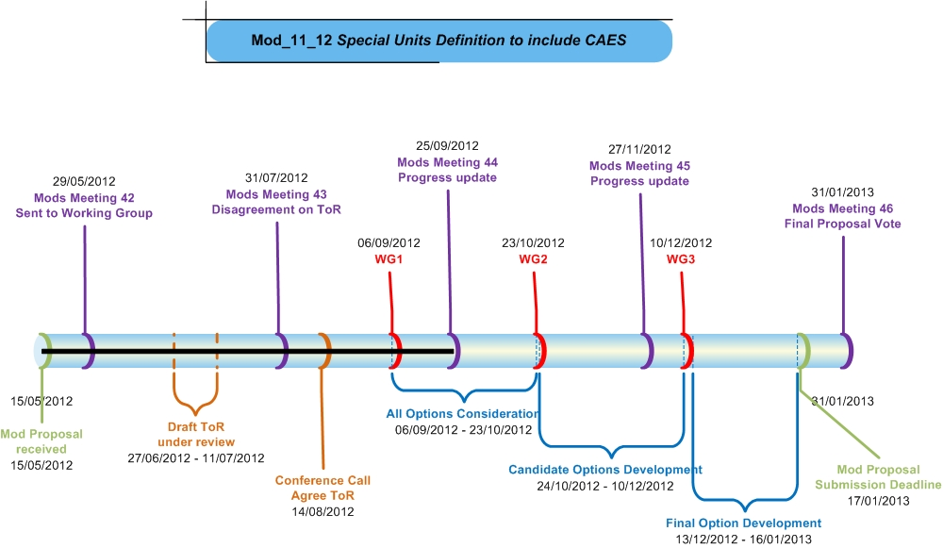
Chair drew attention to actions recorded at the conference call which was held to agree the Terms of Reference (ToR).
Action | Comments
RA Consultant (Simon Street) to ascertain list of potential entrants, particularly in relation to the hybrid unit issue | - Closed- RA Consultant advised that at this time the RAs feel that is not appropriate to invite potential entrants to the WG as this may divert the focus of the WG. Further advised that the relevant material can be issued to potential entrants at a later date if necessary
Secretariat to draft timeline of expected progression of Working Groups | - Closed
Secretariat to reflect changes discussed at conference call and publish the updated Terms of Reference on SEMO website | - Closed

Chair provided overview of the ToR. Chair drew attention to its objectives and the possible risks and restraints.

Background
Mod_11_12 Proposal to extend the definition of Special Units to include CAES was received by the Secretariat on 15 May 2012. The proposal was discussed at Meeting 42 of the Modifications Committee on 29 May where it was deferred and an action was placed for a WG to be convened. The proposal was again discussed at Meeting 43 where an action was placed for final comments on the Terms of Reference (ToR) to be submitted to the Secretariat. Many dissenting views on the ToR were received from Participants; a conference call with the Modifications Committee was convened in order to seek agreement on the ToR.

Presentations & Discussion

Proposer presented overview of CAES unit; Gaelectric consultant presented slides.
Gaelectric consultant advised of the following Gaelectric objectives:
- Long-term: a method for registering storage technologies in the SEM that allows them to recover their short-run costs and compete equitably within the market schedule
- At the WG:
- A restatement of SEM Policy, becoming the first set of agreed evaluation criteria for our discussions
- Evaluation of existing SEM options against those criteria
- Agreement that existing options are not sufficient
- Listing/workshop alternative structures, agreeing next steps

RA consultant advised that what is included in short run costs is not a T&SC matter; it is a matter for the licence, further advising that the Modifications Committee cannot propose changes to the Bidding Code of Practice (BCOP). Gaelectric consultant acknowledged this, however expressed the view that as a principle within the SEM design of a Central Dispatch market where constraints exist, a firm Generator Unit should be able to recover its cost within the current structures. Also questioned why WG objective was to examine the current rules and investigate if it is possible to amend the existing rules to facilitate the CAES Unit, as opposed to creating a new Special Unit. SEMO Member agreed that the principle of the market does allow all Generators to recover their costs. Further advised that the WG objective did not rule out creating a new Special Unit, but to examine in the first instance if it is possible to amend the existing rules to facilitate the CAES Unit and to incorporate the unit into the Market rules in a cost effective manner.

Gaelectric consultant presented the existing options as follows:
- Option 1: “The Split Unit”
  - Demand Side Unit plus Energy Limited Generator Unit
  - Potentially “negative generator” instead of DSU
- Option 2: Pumped Storage
  - With adjusted efficiency to capture running costs
- Gaelectric’s Assumptions
  - Generators, “negative generators” and pumped storage demand subject to full central dispatch
  - Demand Side Units subject to demand reduction dispatch from a nominated schedule
Gaelectric Consultant advised of the following issues with the above options:
- Split Unit:
  - Generator and Demand need to forecast SMP
  - Struggles with BCOP compliance
  - Revenue not independent of SO Dispatch
  - Generator not guaranteed to recover its costs (worse with negative generator)
  - Restrictive offer reduces value in reduction of production costs (for DSU)
  - Energy Limited Plant required to correct energy limit in TOD to minimize cost of constraints
- Pumped Storage
  - BCOP compliance again difficult
  - Market revenue dispatch independent: good
  - Generator not guaranteed to recover its costs under constraint scenarios
  - Enshrining increased constraint costs on consumers, and unfair MSQ pressures on other generators
  - Makes minimisation of cost of production difficult with non-technically accurate offers
  - Pumped Storage is not paid constraint payments

. Generator Alternate noted that the split unit option (Option 1) is comparable to other Generator Units. Gaelectric Consultant restated the issues outlined in slides previously that differentiate it from other Generator Units.

Gaelectric consultant presented the following slide on SEM Policy Evaluation Criteria:
- Apart from the market structures allowing the recovery of appropriate costs, insofar as possible …
  - Market schedule should reflect generator characteristics to lower constraint costs for consumers
  - System operator should have correct data to minimise cost of production in SO dispatch
  - Commercial offer structures should allow transparent compliance demonstrable to RAs under BCOP
  - Market revenues earned by generators are independent of SO dispatch, based on the context of the COD and TOD

Gaelectric consultant commented that the System Operator may dispatch a Generator and that Generator may not be able to recover its cost due to generators technical characteristics not being represented correctly with the MSP software. MO Member noted that the MSP Software has a Single Ramp Rate resulting in the approximation of Generator characteristics but it is part of the design and applicable to all Generators. Gaelectric consultant agreed that its part of the restrictions of the solver of the software and added that even though Generators share the risk the aim should be to resolve or remove the inaccuracies.
Gaelectric consultant advised that Gaelectric are accepting of the fact that the above expectations are “in so far as possible”. RA consultant advised that Gaelectric are assuming that the units are Price Makers, not Price Takers; further advising that the assumption is not wrong however Gaelectric are assuming that the units won’t get priority and Price Taker status.
Supplier Alternate queried as to why the split unit option (Option 1) is proposed as being a Demand Side Unit plus Energy Limited Generator Unit, and not a Supplier Unit for instance. Gaelectric consultant expressed the view that this option provides benefits to the wider system. TSO member clarified that Supplier Units are not dispatchable by the System Operator. Dispatch of a DSU impacts on an Energy Limited Unit and split unit. The challenge for Gaelectric in this case is to pitch an offer relative to prices in the market in order to obtain a commercially profitable position. In order to achieve such an outcome GES would have to correctly forecast the SMP. Gas price is not known for four days after purchase. RA consultant noted that the option exists for GES to have a retail agreement in place to mitigate the risk.
Supplier Alternate expressed concern that a storage device linked to a Generator Unit may be overly restrictive. Gaelectric consultant advised that Gaelectric’s preference is for demand to be fully dispatchable. Gaelectric consultant clarified that the presentation was focusing on looking at including CAES in the existing rules and that the Grid Code could also be examined, however that is not within the scope of the ToR.
Supplier Alternate drew attention to the below diagrams, expressing the view that they are artificial examples as there is no link between the revenue and cost. Supplier Alternate advised that if the running cost was modified to €15, the costs would be recovered. Gaelectric consultant advised that it is a hypothetical example illustrating that there is no guarantee that the cost would be recovered and stressed that, based on the existing rules, Pumped Storage technologies are not guaranteed to recover their Short Run Marginal Costs in SEM. Further added that the inclusion of a gas input cost would result in non-recovery of costs if the Pumped Storage option was pursued for CAES.

SEMO Member queried as to whether Gaelectric had studied whether including gas costs in the efficiency with current SMP values in the market would allow them to recover their costs. Gaelectric representative confirmed that it had been looked at and based on current SMP levels, costs would not be recovered when gas price are factored in. SEMO further questioned if it could be factored into the efficiency.
Gaelectric consultant sought agreement from Working Group members, following presentation and discussion of examples, that no existing structure is fit for purpose. Working Group Members acknowledged the intention of the statement, however expressed preference for the below alternative wording as suggested by Gaelectric consultant:
- Existing structures need to algebraically evolve
Supplier Alternate advised of no disagreement to the above statement, however explicated that it would not prevent existing structures (such as Pumped Storage) from being revisited.
Gaelectric consultant put forward the following two options as potential viable options:
- “Interconnector Unit” style unit, with
  - similar flexibility to manage COD as IU, e.g. participant is allowed to manage offer to procure “storage”
  - similar to IU procuring BETTA energy
- Pumped Storage Unit, with
  - explicit commercial costs considered in MSQ schedule
  - Constraint payments
SEMO Member advised that Interconnector Units are not bound by the BCOP while all other thermal units are required to comply with the BCOP. Gaelectric advised that the option will require additional consideration. SEMO Member advised that the second option of developing the Pumped Storage Unit option could merit further investigation as it would require development of an existing technology type in the Code. Gaelectric asked SEMO if it would be possible to assess the options put forward. MO Member advised that the normal procedure is that a recommendation is put forward by the Working Group and agreement sought from the Modifications Committee to Impact Assess the option or preferred options.
Supplier Alternate queried as to whether all options had been examined. Gaelectric consultant called for any other options to be put forth by WG Members. Generator Alternate noted that an option may exist for the Unit to be treated as a Generator independent of the gas input eliminating the Demand Side Participation element in the Market. Gaelectric questioned if this would conflict with the Code objectives. Gaelectric stated that this was simply a fuel production facility with a Generator as an option. The TSO member stated that if the CAES plant was operated as a split unit i.e. a large independent demand and a generator, the TSO wouldn’t have full dispatch capability and the plant would therefore in essence not be a storage device.
Generator Alternate advised that the two options as presented by Gaelectric are straight forward commercial arbitrage, or Pumped Storage, and that the slides state that Pumped Storage doesn’t work commercially. Generator Alternate expressed ambiguity as to why Pumped Storage would not work for CAES. SEMO Member advised that the issue is gas input costs. Gaelectric representative drew attention to the Trading & Settlement Code objectives advising that they are clear in terms of discrimination; further advising that it is against the objectives to treat one Pumped Storage Unit differently to another, by requiring CAES to purchase demand at demand price, and not negative generation price under some of the proposed split unit options.
Observer queried whether it would be possible to impact assess the option of combining Pumped Storage with Make Whole Payments.
Chair concluded that all options plus Airtricity’s proposed option (i.e. split unit, potentially with demand treated as some form of a negative autonomous generator unit as opposed to a supplier unit yielding a potential compromise regarding the demand SEM price faced by such a unit relative to existing pumped storage) are still open for investigation. Chair advised that for the next WG, ideally the WG members should have an inclination as what the preferred option will be. Secretariat advised that the timeline outlining the expected progression of WG’s will be published on the SEMO website and asked for feedback on whether the provisional dates suit participants.

Actions & Conclusions

Action
- Gaelectric to further investigate all options presented, and proposed Negative Generator option as put forward by Supplier Alternate (Airtricity) as described above.
- Participants to submit all possible options to be examined to the Secretariat in advance of the second WG

Conclusion

- WG Members acknowledged that “Existing structures need to algebraically evolve”

