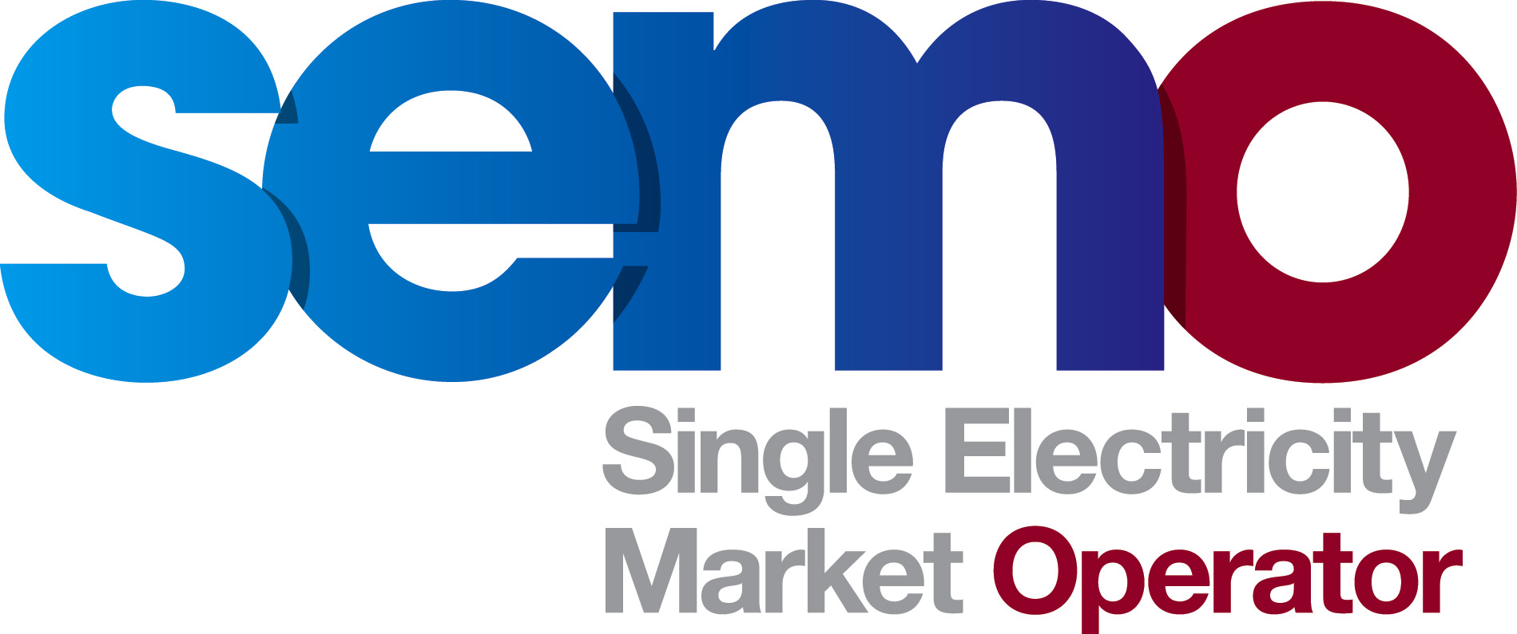 Conference Call Agenda

Meeting ID: Make Whole Payments (Mod_09_14 – Mod_13_14)
Details: No: 0818 301 111/ (01) 664 8888 Pin: 687761
Date: 10 February 2015
Time: 14:30-16:00
Item | Title | Timing / Presenter
 | Introduction | 14.30
 | Attendee Check | Secretariat
 | Action Review | Secretariat
 | Overview of Proposals/Feedback | 14:35
 | RAs Response | RAs
 | Electroroute Response | Electroroute
 | ElectroRoute Legal Advice | Arthur Cox (Electroroute External Counsel)
 | Participant feedback on responses received | All
 | General Discussion | 15.15
i. | Discussion | All
 | Close | 16:00
i. | Actions Recorded, Next Steps | Secretariat

