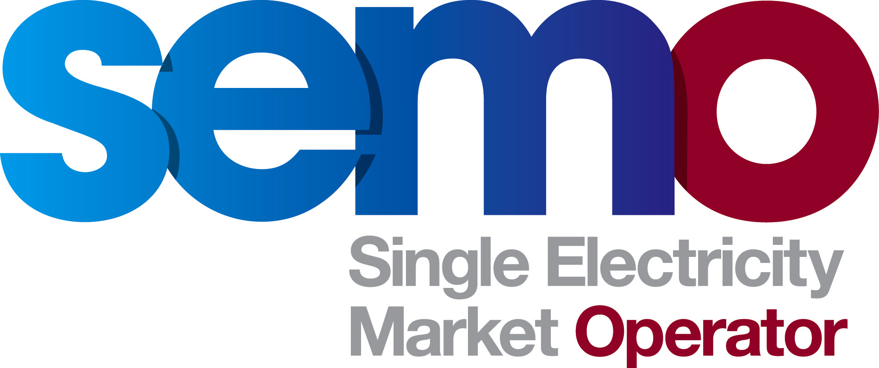 Terms of Reference
Credit Requirement Eligibility

INTRODUCTION

A Modification Proposal Mod_16_11 Credit Worthiness Test for the SEM Bank and Credit Cover Provider banks was presented by NIE PPB at Meeting 36 of the Modifications Committee on 09 June 2011. The proposal sought a revised debt rating for SEM Bank and Provider.

The Committee agreed at the Meeting that further consideration regarding the scope of issues associated with the proposal be pursued and feedback circulated via the Secretariat in advance of Meeting 37. Three responses were received and the Modifications Committee requested at Meeting 37 on 09 August 2011 that a Working Group be established to review the Modification Proposal. It was agreed by the Committee that it would be important that the Working Group be attended by Market Participants’ finance representatives to ensure an informed discussion.

Objectives

The objectives of the Credit Requirement Eligibility Modification Working Group are to:

- Provide an overview of the background of the existing rules with regard to SEM banking arrangements.
- Gain an understanding of the implications a change to the existing rules would have on Participants and new entrants.
- Consider any alternatives to that of Mod_16_11.
- Recommend to the Modifications Committee a preferred option to pursue.
- Make any necessary amendments to the legal drafting text of Mod_16_11 in the form of an alternative version.

Scope

The Working Group will:

- Review and provide feedback with regard to the suitability of the existing banking ratings in SEM.
- Identify and address any changes to the text of the proposal that is considered necessary by the Working Group.
- Assess the impacts of a change to the bank rating for SEM bank and Credit Cover provider banks.
- Make a recommendation to the Modifications Committee.

Deliverables

- Working Group report detailing the discussion and outcome of the meeting.
- Recommendation to the Modifications Committee of how to best proceed.
- Finalised drafting of the Modification Proposal (if necessary).

Stakeholders

Market Operator, Market Participants both Generators and Suppliers, Regulatory Authorities, other interested parties.

Roles and Responsibilities

- Working Group Chair – to be confirmed at Meeting
- Market Participants’ finance representatives – to provide input to the impacts of changes on Participant credit cover arrangements
- Other Stakeholders to provide input - review, issue identification, progress reporting and recommendations.

Resources

- Chair to be confirmed in advance of meeting
- SEMO Secretariat
- Market Participant finance representatives
- SEMO Finance representatives/advisors

Work Breakdown Structure

- NIE PPB to present proposal.
- SEMO to provide overview of current credit cover in the SEM.
- Market Participants to provide their view on impact of proposed change on their credit arrangements.
- SEMO Secretariat to produce Working Group report to Modifications Committee.

Schedule

A half day Working Group meeting took place on 15 September 2011 which addressed the objectives of the meeting and considered the final drafting of the Modification Proposal. Following the circulation of suggested alternative wording by SEMO, Working Group Members indicated that a second Working Group meeting would be necessary to further progress the proposal. The second half-day Working Group meeting is scheduled for 13 December 2011.

Risks and Restraints

There is a risk that the discussion strays to wider issues which may not be associated with the Modification Proposal and terms of reference of the Working Group.

