Final Recommendation Report of the Modifications Committee
Report  Reference | FRR_ 24_08 | Modification Proposal Reference: | Mod_24_08 Initial Credit Cover and Revised Effective Date Timelines for New Participants
Date of Issue: | Draft 16/06/2008 | Category: | Standard
Mod Originator : | SEM-O | Meeting No(s): | Meeting 14
Reason for Issue: | For Regulatory Authority Decision
Section 1
(a) Summary of Modification Committee Determination
& detail of Proposal Development
Mod 24_08 seeks to amend Agreed Procedure 1 and to amend Section 8 entries of the code around timelines for credit cover for new participants.

Recommendation Summary
Having considered the Proposed Modification at the above Meeting, the Modification Committee recommends
- The Proposed Modification should be made.
- With an Implementation date of 1 Working Day after the date of issue of the RA Decision

(b) Rationale behind Modification Committee Recommendations
If a new participant did not post initial credit cover prior to the effective date of their units and the effective date had to be moved, then the Parties (TSO/MDP/MO/IA) would have significant difficulty in accommodating the change in effective date given short notice. This could lead to an increased risk of incorrect pricing/scheduling and settlement of the market as ex-ante market schedules may have already been produced.

(c) Impact on Code Objectives
(which objectives are better facilitated and how)
This modification aims to facilitate the objectives of Section 1.3.1 and 1.3.2 of the T&SC.
1.3.1 to facilitate the efficient discharge by the Market Operator of the obligations imposed upon it by its Market Operator Licences; and 1.3.2. to facilitate the efficient, economic and coordinated operation, administration and development of the Single Electricity Market in a financially secure manner;
As it will lead to improved processes around posting of credit cover for Parties and allow parties (TSO/MDP/MO/IA) time to accommodate a change in effective date for new participants if this occurs at short notice. If this was not approved, could lead to an increased risk of incorrect pricing/scheduling and settlement of the market as ex-ante market schedules may have already been produced. This would be contrary to the code objectives above.

Section 2  (a) Summary of Impacted Parties |  |  |  |  | Detail of impact
Generators |  |  | N
Demand Side Units |  |  | N
Interconnector Units |  |  | N
Suppliers |  |  | N
Intermediaries |  |  | N
MDP |  |  | Y
TSO |  |  | Y
MO |  |  | Y
(b) Summary of Impacted Documents/Systems |  |  |  |  | Detail of impact
Code Provisions |  |  | Y |  | T&SC V4.2, Clauses 2.43, 2.47 & 2.48 (and proposed new clauses 2.43A and 2.43B) ;  AP1 V4.2
Business Processes |  |  | Y |  | For SEMO, TSOs, MDP and IA
Legal Requirements |  |  | N
Grid Code |  |  | N
Other Code |  |  | N
Systems |  |  | N
- Proposed Modification (Original Draft)
This section contains the text of the original draft of the modification proposal
Amendment to AP1 Section 3.2.5 Procedural Steps
# | Procedural Step | Timing | Method | By/From | To
29 | Post Required Credit Cover using Agreed Procedure 9 “Management of Credit Cover and Credit Default” | 5 working days pPrior to the Effective Date | - | Party | Market Operator
30 | If Required Credit Cover is posted prior to Effective Date then end of process  Otherwise go to step 31 | Effective Date – 51 WD

Amendment to AP1 Section 3.2.6 Swimlane - Unit Registration

Existing swimlane diagram:
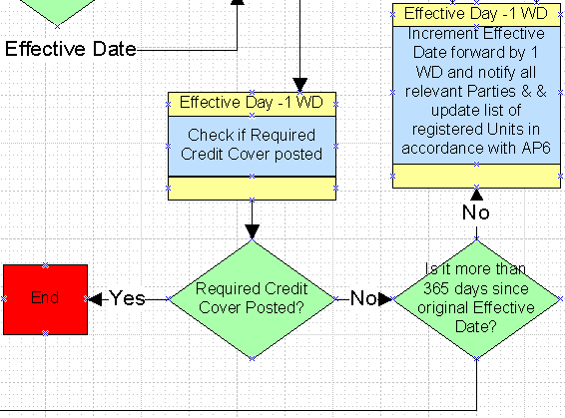
Proposed revised swimlane diagram (Red text updated)
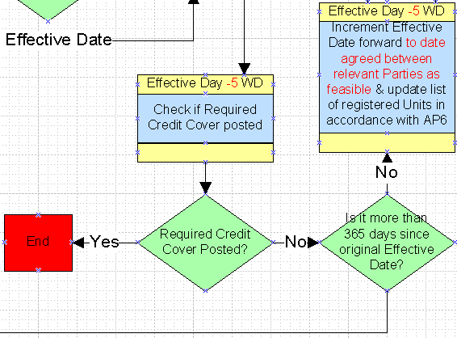
Amendments and additions to Section 2 of the T&SC
2.43 On receipt of a Participation Notice, the Participation Fees and any additional clarification or information requested by the Market Operator from a Party (or an Applicant, as applicable) within the timelines provided for in paragraph 2.42, the Market Operator shall within 5 Working Days send a notice to the Party (or Applicant as applicable) informing the Party (or Applicant as applicable) of any conditions for registration of each Unit which was the subject of the Participation Notice from the following list as applicable:
- the amount of Credit Cover required to be put in place by the proposed Participant 5 working days prior to the Effective Date in respect of each such Unit calculated with effect from the Effective Date;
- any qualification requirements pursuant to Agreed Procedure 3 “Communication Channel Qualification” for the Participant’s designated Communication Channels;
- the requirement for the satisfactory provision of the Registration Data set out in Agreed Procedure 1 “Participant and Unit Registration and Deregistration” (if not already provided); and
- the requirement that the relevant facilities are Connected to the Distribution System or Transmission System.
2.43A The Market Operator, if necessary, may by notice to the relevant Participant, revise such Initial Required Credit Cover up to 8 Working Days prior to the Effective Date.
2.43B Notwithstanding paragraph 6.238, the Initial Required Credit Cover shall not take into account any Settlement Reallocation Agreement unless this has been lodged with the Market Operator at least 9 Working Days prior to the Effective Date
2.47 Where the Party (or Applicant, as applicable) concerned:
- has supplied all information required and satisfied all such conditions as notified to the Party (or Applicant, as applicable) pursuant to paragraphs 2.43.2 to 243.4;
has paid the Participation Fees; and
is not otherwise in breach of the Code or the Framework Agreement;
then the Market Operator shall issue a Commencement Notice to the Participant as soon as reasonably practicable. The Commencement Notice shall specify the Effective Date, being the Trading Day on which, from the start of the first Trading Period on that Trading Day, registration of the Units concerned shall be effective, provided that the Required Credit Cover has been put in place 5 working days prior to the Effective Date.
2.48 Where a Party (or Applicant, as applicable) has not put in place the Required Credit Cover 5 working days before the Effective Date specified in a Commencement Notice, the Effective Date shall be deferred to commence on the first Trading Period of the first Trading Day agreed by all Parties the Required Credit Cover is put in place, provided that such Trading Day is within twelve months of the initial effective date specified in the relevant Commencement Notice. Otherwise the Participation Notice shall be deemed to have been withdrawn and none of the Participation Fee shall be refunded.
Modification Proposal Justification
This modification has three justifications:
1) AP1 specifies that the new participants have until the day before the effective date of the new units to post credit cover. This does not, however, provide sufficient time for Parties (TSO/MDP/MO/IA) to adjust processes and data feeds should the effective date be delayed due to insufficient credit cover being in place. Also, if the effective date is delayed the day before the effective date, the market systems such as ex-ante pricing and scheduling will already have included the new participant.

2) AP1 automatically moves the effective date to the next working day if there is a revision needed to the effective date. As for the credit cover issue above, this does not provide sufficient time for Parties (TSO/MDP/MO/IA) to accommodate the change in effective date.

3) Guidance on the timelines around initial credit cover for New Participants was provided in section 8.33 to 8.39 of the T&SC, but this section has now lapsed. The enduring T&SC does not provide the same level of guidance and this modification aims to clarify the enduring T&SC.

In order to ensure adequate time to adjust the effective date should credit cover not be in place and to clarify timelines in the T&SC for providing initial credit cover requirements, this modification looks to:
1) amend AP1 to require posted credit cover to be in place 5 working days before the effective date.
2) amend AP1 to allow a revised effective date to be agreed by the Parties, rather than defaulting to the next working day.
2) amend and include paragraphs from section 8 of the T&SC into the enduring T&SC in section 2.

This modification aims to facilitate the objectives of Section 1.3.1 and 1.3.2 of the T&SC.
Implication of not implementing the Modification
If a new participant did not post initial credit cover prior to the effective date of their units and the effective date had to be moved, then the Parties (TSO/MDP/MO/IA) would have significant difficulty in accommodating the change in effective date given short notice. This could lead to an increased risk of incorrect pricing/scheduling and settlement of the market as ex-ante market schedules may have already been produced.
.
- Proposed Modification (Recommended for Approval by Committee)
This section contains the text of the Approved version of the modification proposal, if different from above
N/A
- Details of Alternative or Combined proposal raised
If appropriate, a later version or a resubmitted Modification Proposal details should be entered here
N/A

- Dissenting or Other Associated Opinions/Actions
This section contains a summary of any objections to the approved modification proposal/ if appropriate, or feedback from the following: MO, TSO, Industry Expert or Consultant opinions
N/A

(g) Legal review
The outcome of any legal review of the proposed drafting changes
N/A

Section 3
Modification Consultation Outcome
(what consultation was undertaken either formally or by representative members)
Q. | Consultation Question |  |  |  |  | Yes | No |  | Neutral
 | N/A
Section 4
(a) Committee’s Final Recommendation to the Regulatory Authority
Result of Vote: The Committee Recommended this Modification for Approval : (Unanimous)
Votes in favour: I Luney, W Steele, E McAuley, G Blaney, I Wright, T Gill, D O'Connor

The Committee makes a UNANIMOUS Recommendation to the RAs that this Proposed Modification SHOULD be made, on the basis of the Proposal which incorporates the ORIGINAL wording as detailed in Section 2.

(b) The Committee Recommends the following Implementation Approach and Timelines
This modification should be made on a Settlement Day basis.
The Implementation Date of the Proposal should be 1 Working Day after the date of issue of the RA decision.

(c) Proposed Modification Implementations Cost
This section contains a summary of the cost associated with implementing the proposed modification.
Cost (€) |  | Participant |  | Vendor |  | SEMO |  | Total Cost (€)
 |  | N/A |  | N/A |  | N/A |  | N/A
(d) Proposed Modification Estimated Effort Time
This section contains details of the effort time required to design and develop the proposed modification. Include Detailed description of long it will take to perform each change
Effort Time (man days)  (list each change below) |  | Participant |  | Vendor |  | SEMO |  | Total Effort Time
Update to Code |  | N/A |  | N/A |  | ½ day |  | ½ day
Update to Business Processes |  | N/A |  | N/A |  | 1 day |  | 1 day
Please complete this form and return it to Secretariat by e-mail to Modifications@sem-o.com

Note: These man days and costs may need to reflect a combination of Vendor costs and SMO additional costs. Any further modifications to the outline rules may have an impact both on the estimated costs and the estimated implementation date of the change.

