MODIFICATION PROPOSAL FORM

Proposal Submitted by: | Date Proposal received by Secretariat: |  | Type of Proposal |  |  | Number:
TSO | 19 November 2009 |  | Standard |  |  | Mod_41_09
Contact Details for Modification Proposal Originator
Name:  Vivienne Price |  | Telephone number:  +44 (0)28 9070 7514 |  | e-mail address:  Vivienne.Price@soni.ltd.uk
Modification Proposal Title:
Aggregated Generator Unit capacity change
Trading and Settlement Code and/or Agreed Procedure change? |  |  |  |  | T&SC & AP4
Section(s) affected by Modification Proposal: |  |  |  |  | T&SC 5.193  AP4 Section 2.2
Version Number of the Code/Agreed Procedure used in Modification drafting: |  |  |  |  | V6.0  AP4 V6.0
Modification Proposal Description
(Clearly show proposed code change using tracked changes & include any necessary explanatory information)
  - If a Participant submits a change to an Aggregated Generator Unit’s Maximum Generation or Registered Capacity under Agreed Procedure 4 “Transaction Submission and Validation” that is related to a change in the number of Generators within the Aggregated Generator Unit, the Participant must first submit an update to the Aggregated Generator Unit’s Participation Notice which records the change in the number of Generators in the Generator Aggregator System Operator Agreement, under Agreed Procedure 1 “Participant and Unit Registration and Deregistration”

Agreed Procedure 4, Section 2.2

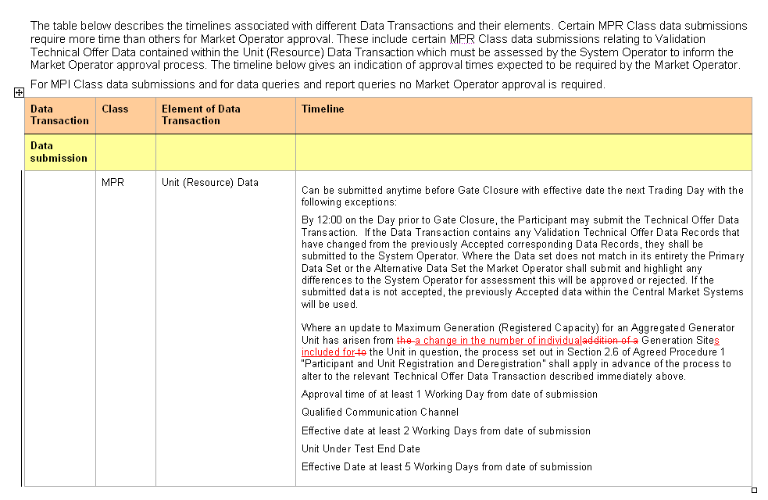

Modification Proposal Justification
(Clearly state the reason for the Modification & how it furthers the Code Objectives)
The modification allows for a decrease or increase in the number of individual Generators into the Aggregated Generator Unit which was previously not allowed for.

The modification furthers Code Objective 1.3.2 to facilitate the efficient, economic and coordinated operation, administration of the Single Electricity Market.
Implication of not implementing the Modification
(Clearly state the possible outcomes should the Modification not be made , or how the Code Objectives would not be met)
If this modification is not implemented a Participant will only be allowed to increase and not decrease the number of individual Generators into the Aggregated Generator Unit.
Please return this form to Secretariat by e-mail to modifications@sem-o.com

Notes on completing Modification Proposal Form:
- If a person submits a Modification Proposal on behalf of another person, that person who proposes the material of the change should be identified on the Modification Proposal Form as the Modification Proposal Originator.
- Any person raising a Modification Proposal shall ensure that their proposal is clear and substantiated with the appropriate detail including the way in which it furthers the Code Objectives to enable it to be fully considered by the Modifications Committee.
- Each Modification Proposal will include a draft text of the proposed Modification to the Code.
- For the purposes of this Modification Proposal Form, the following terms shall have the following meanings:

Code: means the Trading and Settlement Code for the Single Electricity Market
Modification Proposal: means the proposal to modify the Code as set out in the attached form
Derivative Work: means any text or work which incorporates or contains all or part of the Modification Proposal or any adaptation, abridgement, expansion or other modification of the Modification Proposal

The terms “Market Operator”, “Modifications Committee” and “Regulatory Authorities” shall have the meanings assigned to those terms in the Code.

In consideration for the right to submit, and have the Modification Proposal assessed in accordance with the terms of Section 2 of the Code (and Agreed Procedure 12), which I have read and understand, I agree as follows:

1. I hereby grant a worldwide, perpetual, royalty-free, non-exclusive licence:

  - to the Market Operator and the Regulatory Authorities to publish and/or distribute the Modification Proposal for free and unrestricted access;

  - to the Regulatory Authorities, the Modifications Committee and each member of the Modifications Committee to amend, adapt, combine, abridge, expand or otherwise modify the Modification Proposal at their sole discretion for the purpose of developing the Modification Proposal in accordance with the Code;

  - to the Market Operator and the Regulatory Authorities to incorporate the Modification Proposal into the Code;

1.4 to all Parties to the Code and the Regulatory Authorities to use, reproduce and distribute the Modification Proposal, whether as part of the Code or otherwise, for any purpose arising out of or in connection with the Code.

2. The licences set out in clause 1 shall equally apply to any Derivative Works.

3. I hereby waive in favour of the Parties to the Code and the Regulatory Authorities any and all moral rights I may have arising out of or in connection with the Modification Proposal or any Derivative Works.

4. I hereby warrant that, except where expressly indicated otherwise, I am the owner of the copyright and any other intellectual property and proprietary rights in the Modification Proposal and, where not the owner, I have the requisite permissions to grant the rights set out in this form.

5. I hereby acknowledge that the Modification Proposal may be rejected by the Modifications Committee and/or the Regulatory Authorities and that there is no guarantee that my Modification Proposal will be incorporated into the Code.

