Final Recommendation Report of the Modifications Committee
Report  Reference | FRR_27_07 | Modification Proposal Reference: | Mod_27_07 Exclusion of Demand Side Units (MO)
Date of Issue: | 28-Aug-07 | Category: | Urgent
Report Created By: | Modification Committee | Meeting No(s): | Meeting 02
Reason for Issue: | For Regulatory Authority Decision
Section 1
(a) Summary of Modification Committee Recommendations
Mod_27_07 seeks to revise the Code sections 4.91 & 7.12

Metered generation for Demand Side units should not be added in for the Jurisdictional error supply unit. This Mod ensures Jurisdictional error supply unit is not picking up demand that does not exist.

The purpose of the Jurisdictional error supply unit is to pick up the difference between what is physically metered and what is consumed. MO believes that the Code at present double counts the reduction in demand from Demand Side Units.

Target for MSP software does take metered generation including demand side units. This Mod does not propose to change this.

Recommendation Summary
Having considered the Proposed Modification at the abovementioned Meeting, the Modification Committee recommends
- The Proposed Modification should be Made
- With Implementation date of 30 September 2007

(b) Rationale behind Modification Committee Recommendations
Participants felt that the Code was not correct where calculations of Jurisdictional error supply unit were concerned.
This change was felt to be an improvement to the current wording.

Section 2  (a) Summary of Impacted Parties |  |  | Detail of impact
Generators |  | N
Suppliers |  | N
TSO |  | N
MO |  | Y | If Approved, Secretariat must make the required Code Updates
PES |  | N
(b) Summary of Impacted Documents/Systems |  |  | Detail of impact
Code Provisions |  | Y | 4.91 & 7.12
Business Processes |  | N
Legal requirements |  | N
Grid Code |  | N
Other |  | N
Systems |  | N | N/A if approved, as the systems have been built to the Proposed Modified version of the Code
- Proposed Modification (Original Draft)
This section contains the text of the original draft of the modification proposal
4.91 The Market Operator shall procure that, for each Error Supplier Unit v’, each of which is associated with a Jurisdiction e, the Loss-Adjusted Net Demand (NDLFv’h) shall be calculated as follows:
$\begin{aligned}\text{NDLFv}'h=\sum_{u \text{in} e}{(\text{MGuh})}−\sum_{v \text{in} e}{(\text{MDvh}})+\text{NIJIeh} \\ −\left(\sum_{u}{(\text{MGuh})−\sum_{u}{(\text{MGLFuh})}}+\sum_{v}{(\text{MDLFvh})−\sum_{v}{(\text{MDvh})}}\right)×\left(\frac{\sum_{u \text{in} e}{(\text{MGuh})+\text{NIJIeh}}}{\sum_{u}{\text{MGuh}}}\right)\end{aligned}$
Where
- MG is the Metered Generation of Generator Unit u in Trading Period h;
- MGLFuh is the Metered Generation, Loss-Adjusted, of Generator Unit u in Trading Period h;
- $\sum_{u \text{in} e}{}$ is a summation over all Generator Units u within Jurisdiction e excluding Netting Generator Units; and Demand Side Units
- MDvh is the total Metered Demand of Supplier Unit v in Trading Period h;
- MDLFvh is the total Metered Demand, Loss-Adjusted, of Supplier Unit v in Trading Period h;
- $\sum_{v \text{in} e}{}$ is a summation over all Supplier Units v within Jurisdiction e excluding the Error Supplier Unit;
- NIJIeh is the Net Inter-Jurisdictional Import to Jurisdiction e in Trading Period h, expressed in MWh.

  - Until the date that is 12 months after the Market Start Date, paragraph 4.91 shall be replaced with:
“4.91 For each Error Supplier Unit v’, each of which is associated with a Jurisdiction e, the Loss-Adjusted Net Demand (NDLFv’h) shall be calculated as follows:
$$\text{NDLFv}'h=\sum_{u \text{in} e}{\text{MGLFuh}}−\sum_{v \text{in} e}{\text{MDLFvh}}+\text{NIJIeh}$$
Where $\sum_{u \text{in} e}{\text{MGLFuh}}$ is the total Metered Generation, Loss-Adjusted, of all Generator Units u within Jurisdiction e excluding Netting Generator Units; and Demand Side Units
Modification Proposal Justification
Not all of the demand in the SEM is metered. The demand that is not physically metered is to be settled in each region to the Jurisdictional Error Supplier Unit. The net demand outlined in Section 4.91 and Section 7.12 of the Code should represent the total amount of demand that is not metered in each jurisdiction. If Demand Side Units are not excluded from this calculation, then it will not accurately represent the demand that is not metered on the system.
Like the Netting Generator Units, the Metered Generation (MGuh) for Demand side Units is not based on physical metering and instead is calculated by the formula in Section 5.167 of the Code:
The Metered Demand of the Supplier Unit on the Trading Site of the Demand side Unit is included in error supplier unit calculation. This demand is the actual demand on the site. As such, it already incorporates the reduction in demand represented by generated volume of the Demand Side Unit. To include the Metered Generation of the Demand Side Unit would be to overstate the actual generation and hence overstate the demand that is not metered.
Implication of not implementing the Modification
The loss adjusted net demand will be overstated. MSP Software will not be aligned with the Code and a software change will need to be implemented prior to Market Start to align the systems with the Code.

- Proposed Modification (Recommended for Approval by Committee)
This section contains the text of the Approved version of the modification proposal, if different from above
N/A

- Details of Alternative proposal raised
If appropriate, a later version or a resubmitted Modification Proposal details should be entered here
N/A

- Dissenting or Other Opinions
This section contains a summary of any objections to the approved modification proposal/ if appropriate, or feedback from the following: MO, TSO, Industry Expert or Consultant opinions
N/A

Section 3
Results of Modification Consultation
Q. | Consultation Question |  |  | Yes | No | Neutral
 | N/A

Section 4
(a) Committee’s Final Recommendation to the Regulatory Authority
On the basis of the above discussions, the Committee agreed a UNANIMOUS/MAJORITY Recommendation to the RA’s that this Proposed Modification SHOULD/ SHOULD NOT be made

On the basis of the Proposal which incorporates the ORIGINAL/REVISED wording as detailed in Section 2.

(b) The Committee Recommends the following Implementation Approach and Timelines
The Implementation Date of the Proposal should be on: 30th September 2007
Assuming the RA Decision is made on/before [DATE]: N/A
Or no earlier than: [DATE]
Or no later than: [DATE]
(c) Proposed Modification Implementations Cost
This section contains a summary of the cost associated with implementing the proposed modification.
Cost (€) | Vendor | SMO | Total Cost (€)
(d) Proposed Modification Estimated Effort Time
This section contains details of the effort time required to design and develop the proposed modification.Include Detailed description of long it will take to perform each change
Effort Time (man days)  (list each change below) | Vendor | SMO | Total Effort Time
Update T & S Code |  | ½ day | ½ day
Please complete this form and return it to Secretariat by e-mail to Modifications@allislandmarket.com

Appendix 1 – Slide from MO on Mod 27
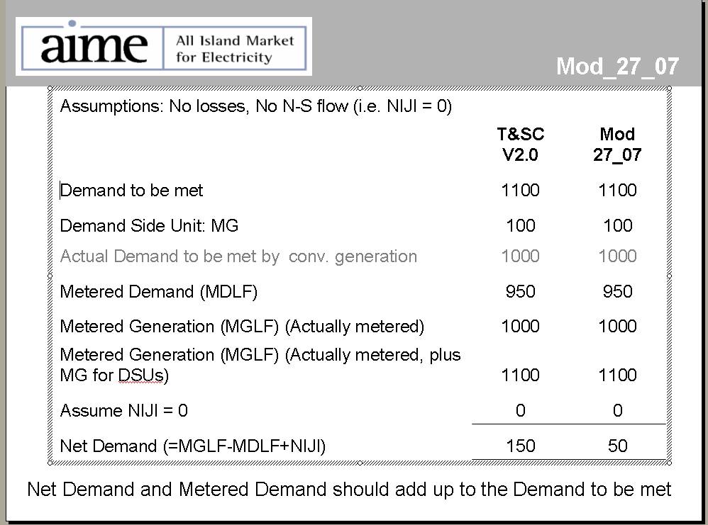

Note: These man days and costs may need to reflect a combination of Vendor costs and SMO additional costs. Any further modifications to the outline rules may have an impact both on the estimated costs and the estimated implementation date of the change.

