SEM Establishment Programme

Title: | Clarification – Requirement for Hot and Warm Cooling Boundary data
Version: | 1.0
Date: | 28th August 2007

Document History

Version | Date | Author | Comment
1.0 | 28-08-07 | SEM Programme | Drafted for clarification.

Related Documents

Document Title | Version | Date | By
Trading and Settlement Code | V2.0 | 31-05-2007 | Regulatory Authorities

Introduction

Modification MOD 31_07 was discussed at the last Modifications Committee meeting. This Modification was approved, subject to confirmation that the data is required by the MPUD and Registration Data require this field.

Confirmation

The Registration Data collected requires these two fields as follows:

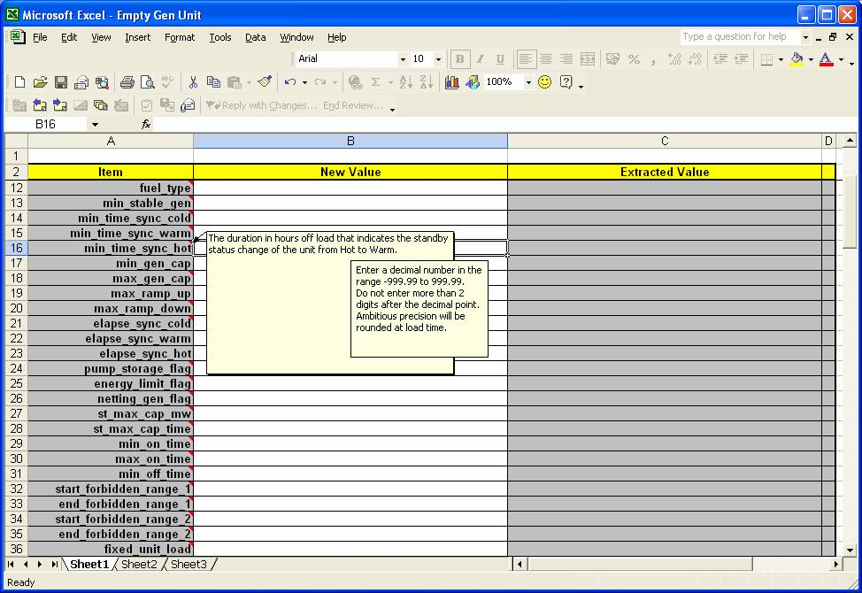 | 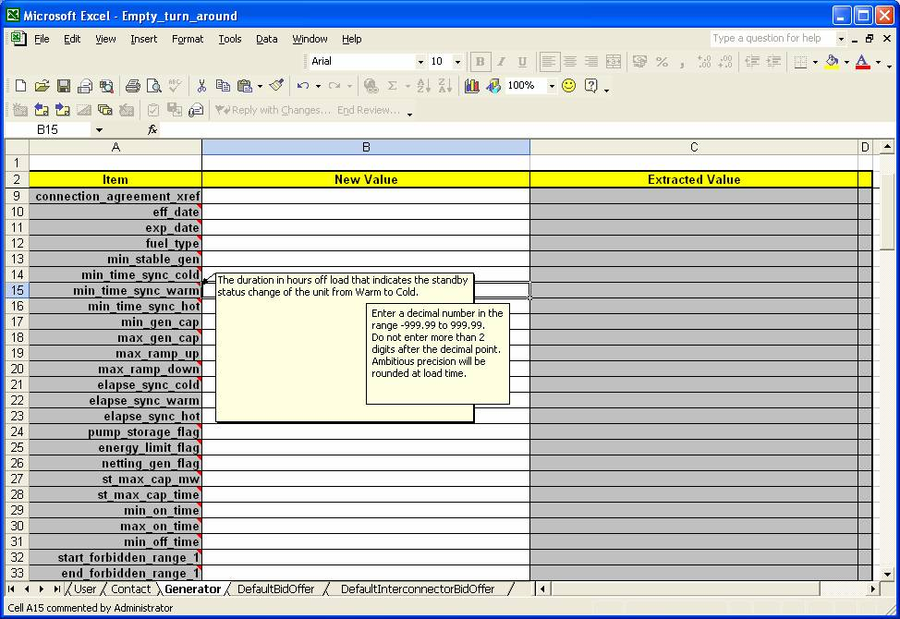

In addition, the following is an extract from the MPUD document, showing that the information is required.

