Final Recommendation Report of the Modifications Committee
Report  Reference | FRR_44_07 | Modification Proposal Reference: | Mod_44_07 version 3  Required strengthening of procedure to modify banking details.
Date of Issue: | 28 September 2007 | Category: | Urgent
Mod Originator : | ESB PG | Meeting No(s): | Meeting 04
Reason for Issue: | For Regulatory Authority Decision
Section 1
(a) Summary of Modification Committee Recommendations
Mod_44_07 version 3 seeks to revise the Code to strengthen the procedure to modify banking details and involves changes to AP 4 and AP 1.

Recommendation Summary
Having considered the Proposed Modification at the abovementioned Meeting, the Modification Committee recommends
- The Proposed Modification should be made
- With Implementation date of 1st November 2007
- Subject to receipt of information by the RA’s (from SMO) on smaller participants for the purpose of an RA determination that this Modification is not an undue burden on smaller players in the market

(b) Rationale behind Modification Committee Recommendations
At present, AP 4 allows for any user, who has access to make registration updates for an MP using the MPR, to modify bank account details. AP4 (Page 8) makes reference to ‘approval time of up to 2 Working Days from date of submission’ for such updates, however, no further interaction with the MP is detailed.

A manual step should be introduced to the Agreed Procedure where a user in the SMO must contact two named signatories in the impacted Market Participant organisation to confirm this change in writing before it is applied.

Section 2  (a) Summary of Impacted Parties |  |  |  | Detail of impact
Generators |  | Y |  | This mod may prove prohibitive to smaller players in the market who may not have two signatories in the organisation to confirm the change in banking details.  However, if this mod is not implemented, there is concern that Bank Account details will be updated incorrectly causing significant impact to the MP and subsequently to the Market as a whole.
Suppliers |  | Y |  | As above
TSO |  | N
MO |  | Y |  | Secretariat is required to implement this change in the Code
PES |  | Y |  | As above
(b) Summary of Impacted Documents/Systems |  |  |  | Detail of impact
Code Provisions |  | Y |  | AP 4 and AP 1
Business Processes |  | Y |  | Extra step in MO business process.
Legal requirements |  | N
Grid Code |  | N
Other |  | N
Systems |  | N
- Proposed Modification (Original Draft)
This section contains the text of the original draft of the modification proposal
At present, AP 4 allows for any user, who has access to make registration updates for an MP using the MPR, to modify bank account details. AP4 (Page 8) makes reference to ‘approval time of up to 2 Working Days from date of submission’ for such updates, however, no further interaction with the MP is detailed.

A manual step should be introduced to the Agreed Procedure where a user in the SMO must contact two named signatories in the impacted Market Participant organisation to confirm this change in writing before it is applied.

- Proposed Modification (Recommended for Approval by Committee)
This section contains the text of the Approved version of the modification proposal, if different from above
The current rules for banking details are as follows;

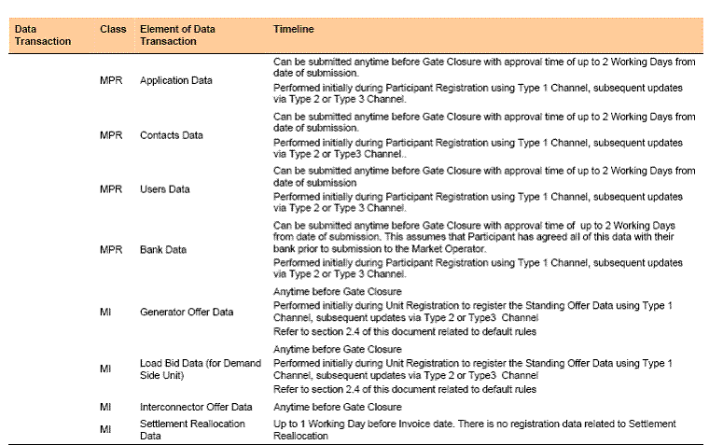

The proposed change to the table entry for MPR is;

Can be submitted anytime before Gate Closure with approval time of up to 5 Working Days
from date of receipt of confirmation. This assumes that Participant has agreed all of this data with their
bank prior to submission to the Market Operator. Additionally the Market Operator must confirm the authorisation to change the details by completing the steps in table 1A – Authorisation to change Banking Details.
Performed initially during Participant Registration using Type 1 Channel, subsequent updates
via Type 2 or Type 3 Channel, which will be confirmed via Type 1 Channel by MO and verified by MP by way of a hard copy submission. Initial Authorised signatories will be notified to MO during Participant Registration, changes to authorised signatories will be notified with the submission of a hard copy and the format specified in Appendix 4 and the steps outlined in Table 1A will be followed.

Insert new Table 1A – Authorisation to change Banking Details

Step | MO Action | MP Action
Step 1 |  | MP sends in revised banking details using type 2 or type 3 channel
Step 2 | MO faxes the proposed revised banking details, to the fax number specified in the appendix 4 document, for authorisation to MP using type 1 channel (template fax in Appendix 3)
Step 3 |  | MP verifies that banking details on fax match revised banking details by adding A and B signatures of authorised personnel and submits this document in its original form to MO by registered post.
Step 4 | MO verifies that signatures on fax (returned by registered post) match their copy of authorised signatures  (hardcopy of template in Appendix 4)
Step 5 | MO faxes or emails MP (as specified on Appendix 4) to confirm Banking details have been verified and will be changed on the effective date provide in the banking details.
Step 6 | MO changes Banking details within 5 working days of the banking details being verified. With effect from the effective date provided in the banking detail changes.
Step 7 |  | If MP wants to change Authorised signatories then they must re-submit the details with the form shown in Appendix 4 by submitting it in its original form by registered post.
Step 8 | MO faxes or emails MP (as specified on Appendix 4) to confirm receipt of updated Authorised signatories. MO uses latest authorised signatures for any future change to banking details.

Insert new Appendix 3

Template of fax for MO to request authorisation to change in banking details from MP as per step 2 of table 1A.

MARKET OPERATOR HEADED PAPER
Screen / T&SC Name | Copy of revised Banking Details element
Bank Name
Bank Number
Bank Account Name
Account Number
Bank Account Description
Bank Branch Type
Bank Branch Name
Bank Branch Number of Sort Code
Bank Branch Description
Bank Branch Address line 1
Bank Branch Address line 2
Bank Branch City
Bank Branch County
Bank Branch Postal Code
Bank Branch Country
Bank Branch Phone
Bank Branch Fax
SWIFT BIC
IBAN
Bank Account Currency jurisdiction
Notification Comment
External ID
Effective Start Date
Expiration Date

Authorised Signatures;

__________________ _____________________

Authorised Signatory A Authorised Signatory B
Date: Date:

Please confirm the implementation of changes having received and verified this signed fax (as a hardcopy) by contacting us in the manner specified (fax and/or email) on the list of Authorised Signatories.

Insert new Appendix 4

COMPANY HEADED PAPER

To: Market Operator

We hereby confirm that two of the following can authorise instructions (one signature from Panel A and one signature from Panel B) to the MO to amend the bank account details. Proof of identity is supplied with this documentation for each Signature (Copy of Passport and recent Utility Bill certified by a practicing solicitor).

Implementation of instructions to amend bank account details by the Market Operator is contingent on receiving the original signature of two personnel, one from Panel A and one signature Panel B listed below on the fax request from the Market Operator that details the proposed bank account amendments.

The request for this authorisation is sent by fax to the following fax number:
Primary fax number +
Secondary fax number +

PANEL A:
Personnel Authorised To Amend Bank Account Details (Block Capitals) | Sample Signature

COMPANY HEADED PAPER

PANEL B
Personnel Authorised To Amend Bank Account Details (Block Capitals) | Sample Signature

The Market Operator has agreed to implement changes within 5 working days of receiving the appropriate confirmation. Having verified the proposed changes to bank account information the accepted changes must be confirmed by the Market Operator by fax/email communication to the contact details below two business days before implementation. Any future changes to this list of authorised signatories must also be confirmed by fax/email to the contact details below.

Primary Fax +
Secondary Fax +
Email 1
Email 2
Email 3
Email 4

__________________ _____________________

Authorised Signatory Authorised Signatory
Date: Date:

Market Operator Guidelines for Authorised Signatories:

In the case of limited companies, reasonable evidence of authority should be provided which would include a certified copy of a board minute of a company naming certain individuals as having authority with respect to banking arrangements. This could be a power of attorney granted to certain individuals with respect to banking arrangements. This could be a standing authority of the board (which would have to be produced by way of a certified copy of the relevant resolution setting up the authority) showing that certain officers in the company have authority to conduct business including the operation of company bank accounts. In the case of an individual, then evidence of that individual’s identity should be sufficient.

- Details of Alternative proposal raised
If appropriate, a later version or a resubmitted Modification Proposal details should be entered here
N/A

- Dissenting or Other Opinions
This section contains a summary of any objections to the approved modification proposal/ if appropriate, or feedback from the following: MO, TSO, Industry Expert or Consultant opinions
Unanimous Vote in Favour, Subject to this mod not being an undue barrier to entry on smaller participants. JO’S to disclose information on smaller players to the RAs.

Section 3
Results of Modification Consultation
Q. | Consultation Question |  |  |  | Yes | No |  | Neutral
 | N/A
Section 4
(a) Committee’s Final Recommendation to the Regulatory Authority
On the basis of the above discussions, the Committee agreed a UNANIMOUS/MAJORITY Recommendation to the RA’s that this Proposed Modification SHOULD/ SHOULD NOT be made

On the basis of the Proposal which incorporates the ORIGINAL/REVISED wording as detailed in Section 2.

(b) The Committee Recommends the following Implementation Approach and Timelines
The Implementation Date of the Proposal should be on: 1ST November 2007
Assuming the RA Decision is made on/before [DATE]
Or no earlier than: [DATE]
Or no later than: [DATE]
(c) Proposed Modification Implementations Cost
This section contains a summary of the cost associated with implementing the proposed modification.
Cost (€) |  |  | Vendor |  | SMO |  | Total Cost (€)
 |  |  | N/A
(d) Proposed Modification Estimated Effort Time
This section contains details of the effort time required to design and develop the proposed modification.Include Detailed description of long it will take to perform each change
Effort Time (man days)  (list each change below) |  |  | Vendor |  | SMO |  | Total Effort Time
Update to Trading and Settlement Code |  |  |  |  | ½ day |  | ½ day
Please complete this form and return it to Secretariat by e-mail to Modifications@allislandmarket.com

Note: These man days and costs may need to reflect a combination of Vendor costs and SMO additional costs. Any further modifications to the outline rules may have an impact both on the estimated costs and the estimated implementation date of the change.

