Final Recommendation Report of the Modifications Committee
Report  Reference | FRR_49_07 | Modification Proposal Reference: | Mod_49_07  Addition of Participant Change Management Requirements to AP11
Date of Issue: | 28 September 2007 | Category: | Urgent
Mod Originator : | Airtricity | Meeting No(s): | Meeting 04
Reason for Issue: | For Regulatory Authority Decision
Section 1
(a) Summary of Modification Committee Recommendations
Mod_49_07 originally seeked to revise AP11 Section 2 of the Code.

Recommendation Summary
Having considered the Proposed Modification at the abovementioned Meeting, the Modification Committee recommends
- An Alternative Approach should be adopted with a forum to be set up for SEM IT and Participants to partake in discussions around system releases
- With final resolution date of 30th of April 2008

(b) Rationale behind Modification Committee Recommendations
Participants seek to have a mechanism to control the MO’s release of system-impacting changes into the market environment and must be able meaningfully influence changes made to market systems and interfaces.
Implication of not implementing the Modification
Participants will have no means of controlling release of late changes to interface systems in the runup to market go-live. Some Participants have already experienced significant interface difficulties in the market trialling environment and experience shows the length of time it can take to track down the caused of communication failures. It is essential that Participants have the mechanisms to exercise control over issues that could affect their commercial survival.

Section 2  (a) Summary of Impacted Parties |  |  | Detail of impact
Generators |  | Y | Any market participants interfacing to the market systems are impacted.
Suppliers |  | Y | Any market participants interfacing to the market systems are impacted.
TSO |  | Y | Any market participants interfacing to the market systems are impacted.
MO |  | Y | SMO IT to include extra steps in change control process.
PES |  | Y | Any market participants interfacing to the market systems are impacted.
(b) Summary of Impacted Documents/Systems |  |  | Detail of impact
Code Provisions |  | N | No Code or AP11 changes agreed.
Business Processes |  | Y | MO IT business processes to be updated.
Legal requirements |  | N
Grid Code |  | N
Other |  | N
Systems |  | Y
- Proposed Modification (Original Draft)
This section contains the text of the original draft of the modification proposal
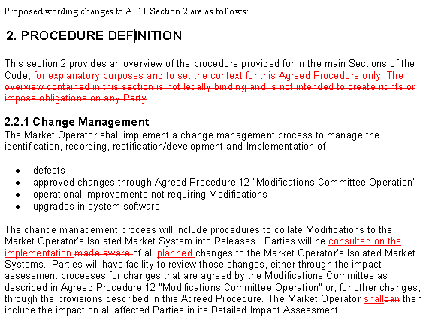

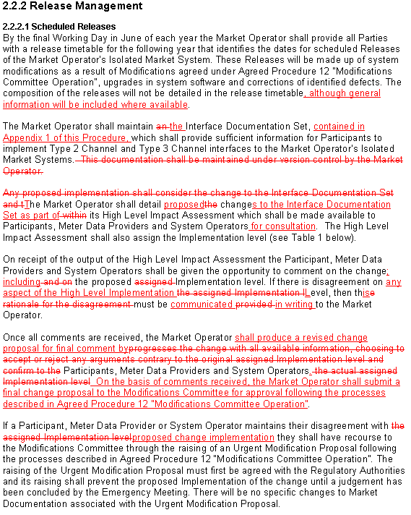

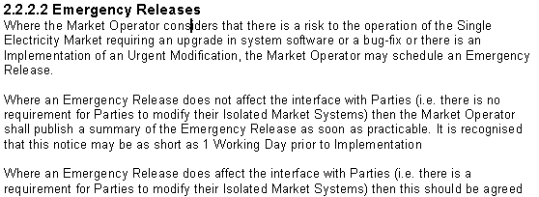
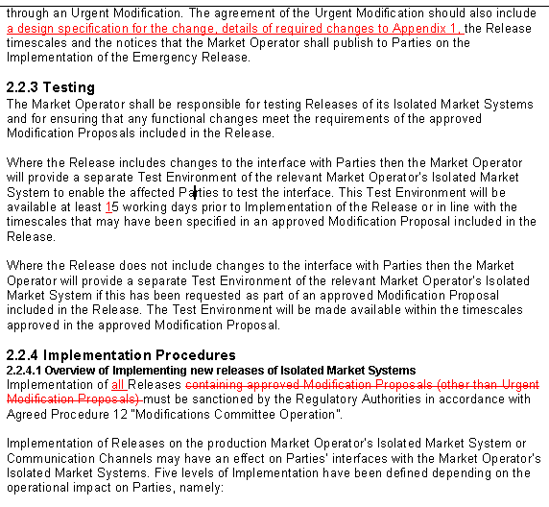

- Proposed Modification (Recommended for Approval by Committee)
This section contains the text of the Approved version of the modification proposal, if different from above
N/A

- Details of Alternative proposal raised
If appropriate, a later version or a resubmitted Modification Proposal details should be entered here
Following the modifications forum, it was agreed that John O’ Sullivan would contact the chair/vice chair to arrange a meeting with representatives to come up with high level Change Control objectives with a view to fleshing them out by the end of March, with a drop-dead date of April ’08

- Dissenting or Other Opinions
This section contains a summary of any objections to the approved modification proposal/ if appropriate, or feedback from the following: MO, TSO, Industry Expert or Consultant opinions
Niamh Delaney: From MO perspective, the IT side would make process prescriptive; normal operations would be impossible e.g. security patches etc. Not sure what above section 2.1 means;
John O’ Sullivan: The principal is well founded. We need to create a workable and clear process and doesn’t give anyone undue stalling power. Mod is ambiguous; no timelines provided. The SMO never refused to give information of changes, so the justification is factually inaccurate. What Participants need is a forum whereby implementation issues with market interfaces or operation etc are appropriately discussed. This does not need to be under the code. SMO is happy to engage in developing a workable solution, 2 or 3 people to meet with the IT panel. Agreement in principle to a properly adjudicated Change Control forum. Who has authority over releases?
Garrett Blaney: Any impact or change to MPUD has impacts on participants and systems.
Chair (Iain Wright):: Having it under the code ensures that there is clear route to decision making in timely fashion.
John O’ Sullivan: The SMO is bedding down the SMO IT org and can’t commit to something that impacts IT processes before Business Processes are bedded down.
Chair (Iain Wright): If we get a group together soon to look at the issues of CC and out of the group there may then be a recommendation as to whether it’s under the code.

Section 3
Results of Modification Consultation
Q. | Consultation Question |  |  | Yes | No | Neutral
 | N/A

Section 4
(a) Committee’s Final Recommendation to the Regulatory Authority
On the basis of the above discussions, the Committee agreed a UNANIMOUS/MAJORITY recommendation to the RA’s that an Alternative Approach should be adopted with a forum to be set up for SEM IT and Participants to partake in discussions around system releases.

(b) The Committee Recommends the following Implementation Approach and Timelines
The Implementation Date of the Proposal should be on: 30TH April 2008
Assuming the RA Decision is made on/before [DATE] n/a
Or no earlier than: [DATE] ] n/a
Or no later than: [DATE] ] n/a
(c) Proposed Modification Implementations Cost
This section contains a summary of the cost associated with implementing the proposed modification.
Cost (€) | Vendor | SMO | Total Cost (€)
Cost (€) | n/a
(d) Proposed Modification Estimated Effort Time
This section contains details of the effort time required to design and develop the proposed modification.Include Detailed description of long it will take to perform each change
Effort Time (man days)  (list each change below) | Vendor | SMO | Total Effort Time
n/a
Please complete this form and return it to Secretariat by e-mail to Modifications@allislandmarket.com

Note: These man days and costs may need to reflect a combination of Vendor costs and SMO additional costs. Any further modifications to the outline rules may have an impact both on the estimated costs and the estimated implementation date of the change.

