Final Recommendation Report of the Modifications Committee
Report  Reference | FRR_59 | Modification Proposal Reference: | Mod_59_07 Version 4  Appendix E - Publication
Date of Issue: | 28 September 2007 | Category: | Urgent
Mod Originator : | Gill Lalor, MO | Meeting No(s): | Meeting 05 Emergency Call
Reason for Issue: | For Regulatory Authority Decision
Section 1
(a) Summary of Modification Committee Recommendations
Mod_59_07 seeks to revise the Code Appendix E & AP6 – Appendix 2 - Data Publications Table to bring it into line with possible SMO timelines.
Recommendation Summary
Having considered the Proposed Modification at the abovementioned Meeting, the Modification Committee recommends
- a revised version of the Modification should be Made to the Code
- With Implementation date of 01 November 2007
- Subject to the revised Mod reflecting agreed Changes at Meeting 05: ie

1.Remove all changes to timing changes in E7
2. Move into E7 from E6 and maintain timings for:
- Ex Post Indicative values of eligible availability:
- Ex Post Initial Values of eligible availability:
3. Removal of Initial variable capacity payments weighting factor
4. E7 to be presented as part of Mod_71_07
5. Data Publications table to mirror these changes as appropriate

(b) Rationale behind Modification Committee Recommendations
The timelines in the current Code on the modified publications were undeliverable by the SMO.
The impacts of a revised Version 4 Modification was acceptable to Participants.

Section 2  (a) Summary of Impacted Parties |  |  | Detail of impact
Generators |  | Y | Impact on delivery of publications
Suppliers |  | Y | Impact on delivery of publications
TSO |  | N | Impact on delivery of publications
MO |  | Y | business process impact: No impact if Mod if Approved
PES |  | Y | Impact on delivery of publications
(b) Summary of Impacted Documents/Systems |  |  | Detail of impact
Code Provisions |  | Y | Appendix E & AP6 – Appendix 2 - Data Publications Table
Business Processes |  | Y | As above
Legal requirements |  | N
Grid Code |  | N
Other |  | N
Systems |  | N
- Proposed Modification (Original Draft)
This section contains the text of the original draft of the modification proposal
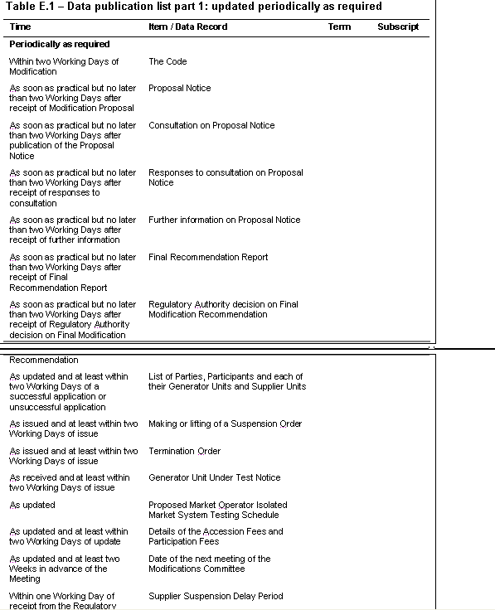

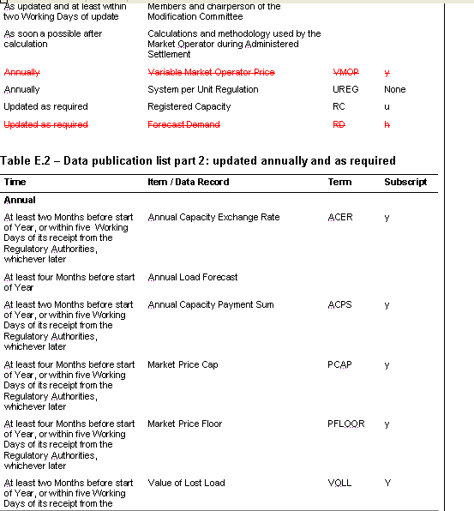

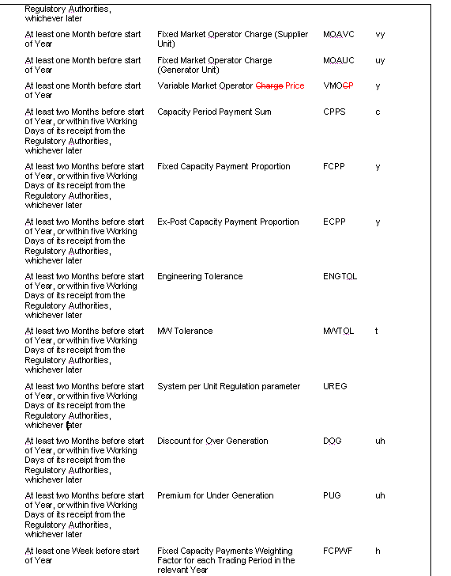

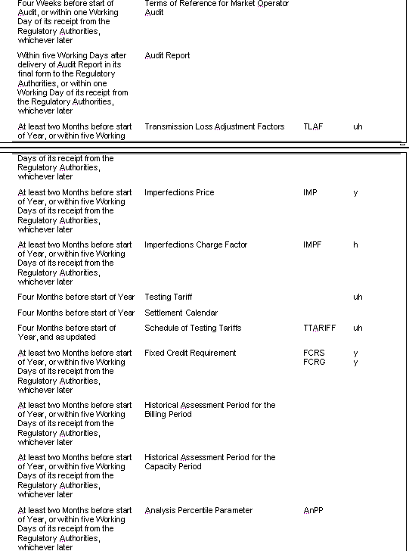

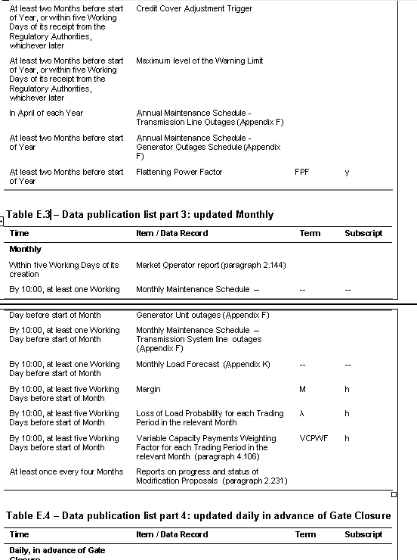

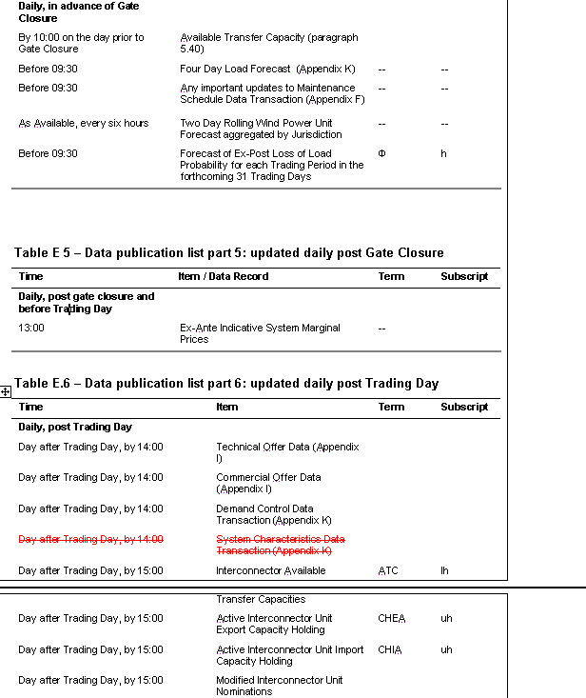

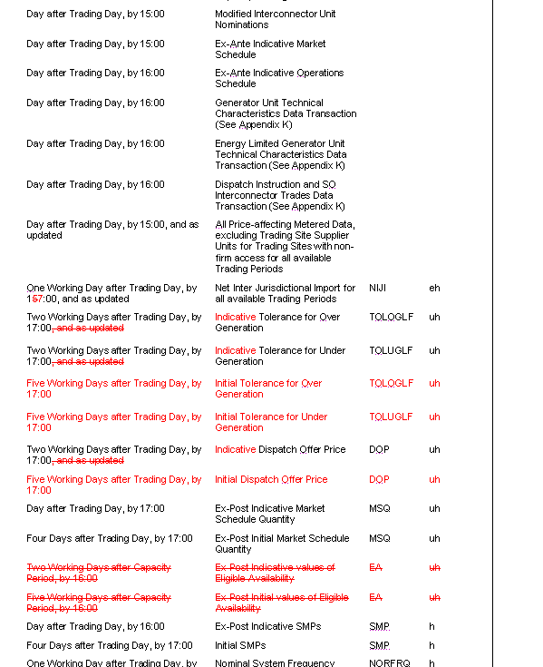

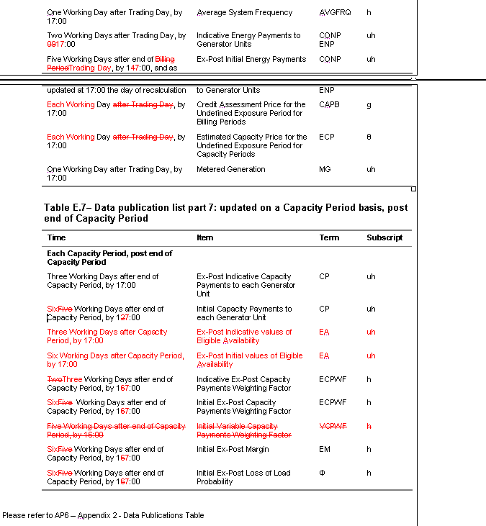
Modification Proposal Justification Clearly state the reason for the Modification. Attach further information if necessary

The Market Operator Website project will be developing the publications as outlined in the change request above.
From Trading and Settlement Code – Appendix E
Table E.1 – Data publication list part 1: updated periodically as required
The duplicate version of the ‘Variable Market Operator Price’ publication is a report has been deleted from the table as it will be more correctly shown as an annual report in Table E.2 as seen below.
The ‘Forecast Demand’ report does not exist, and has been deleted from the table. An annual report containing ‘Annual Load Forecast’ is available and provides the information required.
Table E.2 – Data publication list part 2: updated annually and as required
The ‘Variable Market Operator Charge’ has been corrected to reflect the proper terminology as ‘Variable Market Operator Price’.
Table E.6 – Data publication list part 6: updated daily post Trading Day
The ‘System Characteristics Data Transaction (Appendix K)’ is a duplicate report which is represented more correctly as the ‘Nominal System Frequency’ and ‘Average System Frequency’, and has been deleted from the table.
The ‘Net Inter Jurisdictional Import for all available Trading Periods’ timing has been updated to reflect when it will be published from ‘15:00’ to ‘17:00’.
The ‘Tolerance for Over Generation’ and ‘Tolerance for Under Generation’ have been updated to include the new reports of ‘Indicative Tolerance for Over Generation’, ‘Indicative Tolerance for Under Generation’, ‘Initial Tolerance for Over Generation’, and ‘Initial Tolerance for Under Generation’
The ‘Ex-Post Indicative values of Eligible Availability’ has been deleted from this table, and put into the proper Table E.7 – Data publication list part 7: updated on a Capacity Period basis, post end of Capacity Period.
The ‘Ex-Post Initial values of Eligible Availability’ has been deleted from this table, and put into the proper Table E.7 – Data publication list part 7: updated on a Capacity Period basis, post end of Capacity Period.
The ‘Indicative Energy Payments to Generator Units’ timing has been updated to reflect when it will be published from ‘09:00’ to ‘17:00’.

The ‘Ex-Post Initial Energy Payments’ timing has been updated to reflect when it will be published from ‘Five Working Days after end of Billing Period by 14:00, and as required’ to ‘Five Working Days after end of Trading Day, by 17:00, and as required’.
The ‘Credit Assessment price for the Undefined Exposure Period for Billing Periods’ timing has been updated to reflect when it will be published from ‘Day after Trading Day, by 17:00’ to ‘Each Working Day by 17:00’.
The ‘Estimated Capacity Price for the Undefined Exposure Period for Capacity Periods’ timing has been updated to reflect when it will be published from ‘Day after Trading Day, by 17:00’ to ‘Each Working Day by 17:00’.
Table E.7 – Data publication list part 7: updated on a Capacity Period basis, post end of Capacity Period
The ‘Initial Capacity Payments to each Generator Unit’ timing has been updated to reflect when it will be published from ‘Five Working Days after end of Capacity Period, by 12:00’ to ’Six Working Days after end of Capacity Period, by 17:00’.
The ‘Ex-Post Indicative values of Eligibility Availability’ has been taken from Table E.6 and properly placed in this table.
The ‘Ex-Post Initial values of Eligible Availability’ has been taken from Table E.6 and properly placed in this table. Also the timing has been updated to reflect when it will be published from ‘Five Working Days after end of Capacity Period, by 17:00’ to ‘Six Working Days after end of Capacity Period, by 17:00’.
The change from 5 Working Days to 6 Working Days in Table E.7 are due to SMP input data in Section 5.138 (where we calculate the Pumped Storage Unscheduled Capacity Daily Price) not being available until D+5 as the MO requires initial SMP for the Day after Trading Day to complete the calculations. Additionally, the processing time is such that D+6 is the only option.
The ‘Indicative Ex-Post Capacity Payments Weighting Factor’ timing has been updated to reflect when it will be published from ‘Two Working Days after end of Capacity Period, by 16:00’ to ‘Three Working Days after end of Capacity Period, by 17:00’.
The ‘Initial Ex-Post Capacity Payments Weighting Factor’ timing has been updated to reflect when it will be published from ‘Five Working Days after end of Capacity Period, by 16:00’ to ’Six Working Days after end of Capacity Period, by 17:00’.
The ‘Initial Variable Capacity Payments Weighting Factor’ has been removed. This report is already included under Table E.3 (VCPWF).

The ‘Initial Ex-Post Margin’ timing has been updated to reflect when it will be published from ‘Five Working Days after end of Capacity Period, by 16:00’ to ’Six Working Days after end of Capacity Period, by 17:00’.
The ‘Initial Ex-Post Loss of Load Probability’ timing has been updated to reflect when it will be published from ‘Five Working Days after end of Capacity Period, by 16:00’ to ’Six Working Days after end of Capacity Period, by 17:00’.
The changes above from 5 Working Days to 6 Working Days in Table E.7 are due to SMP input data in Section 5.138 (where we calculate the Pumped Storage Unscheduled Capacity Daily Price) not being available until D+5 as the MO requires initial SMP for the Day after Trading Day to complete the calculations. Additionally, the processing time is such that D+6 is the only option.
AP6 Changes
From Appendix 2 – Data Publications Table
The ‘Forecast Demand’ report does not exist, and has been deleted from the table. An annual report containing ‘Annual Load Forecast’ is available and provides the information required.
The ‘Variable Market Operator Charge’ has been corrected to reflect the proper terminology as ‘Variable Market Operator Price’.
The duplicate version of the ‘Variable Market Operator Price’ is a report has been deleted from the table.
The ‘Daily Four Day Rolling Load forecast and Assumptions’ timing has been updated to reflect when it will be published from ‘Four days before Trading Day by 14:00’ to ‘By 09:30 pre Gate Closure on TD-1’.
The ‘System Characteristics Data Transaction’ report is a duplicate report which is represented more correctly as the ‘Nominal System Frequency’ and ‘Average System Frequency’, and has been deleted from the table.
The ‘Daily Interconnector Capacity Holdings’ report does not exist, and has been deleted from the table.
The ‘Net Inter Jurisdictional Import for all available Trading Periods’ timing has been updated to reflect when it will be published from ‘15:00’ to ‘17:00’.
The ‘Initial Eligibility Availability’ and ‘Indicative Eligible Availability’ reports have been moved from this section of the table (Class G) to the section to when it will be published (Class H).
The ‘Ex-Post Indicative Energy payments to Generator Units’ timing has been updated to reflect when it will be published from ‘Five Working Days after end of Billing Period, by 14:00, and as updated at 17:00 the day of recalculation’ to ‘Six Working Days after end of Trading Day, by 17:00, and as updated at 17:00 the day of recalculation’.
The ‘Capacity Adjustment Factor applicable for Undefined Exposure Period for the Billing Periods’ timing has been updated to reflect when it will be published from ‘Day after Trading Day at 17:00’ to ‘Each Working Day by 17:00’.
The ‘Credit Assessment Price for the Undefined Exposure for the Billing Periods’ timing has been updated to reflect when it will be published from ‘Day after Trading Day at 17:00’ to ‘Each Working Day by 17:00’.
The ‘Estimated Capacity Price for the Undefined Exposure Period for Capacity Periods, ECP’ timing has been updated to reflect when it will be published from ‘Day after Trading Day at 17:00’ to ‘Each Working Day by 17:00’.
The ‘Indicative Interconnector Flows and Residual Capacity’ is a report that provides Metered MW for the Interconnector, which is duplicate information which is not required on the General Public website and so has been deleted from this table and included in the Data Reports table in Agreed Procedure 6.
The ‘Initial Interconnector Flows and Residual Capacity’ is a report that provides Metered MW for the Interconnector, which is duplicate information which is not required on the General Public website and so has been deleted from this table and included in the Data Reports table in Agreed Procedure 6.
The ‘Indicative Eligibility Availability’ timing has been updated to reflect when it will be updated from ‘16:00’ to ’17:00’.
The ‘Indicative Ex-Post Capacity Payments Weighting Factor’ timing has been updated to reflect when it will be published from ‘Two Working Days after end of Capacity Period, by 16:00’ to ‘Three Working Days after end of Capacity Period, by 17:00’.
The changes below to publications relating to the initial Capacity Period timing in Table AP6 are due to data in Section 5.138 not being available until D+5 as the MO requires initial SMP for the Day after Trading Day to complete the calculations. Additionally, the processing time is such that D+6 is the only option.
The ‘‘Initial Eligibility Availability’ timing has been updated to reflect when it will be updated from ’Five Working days after Capacity Period, by 16:00’ to ’Six Working days after Capacity Period 17:00’.
The ‘Initial Ex-Post Capacity Payments Weighting Factor’ timing has been updated to reflect when it will be published from ‘Five Working days after Capacity Period, by 16:00’ to ’Six Working days after Capacity Period 17:00’.

The ‘Initial Variable Capacity Payments Weighting Factor’ has been removed. This report is already included under Type C Publications.
The ‘Initial Ex-Post Margin’ timing has been updated to reflect when it will be published from ’Five Working days after Capacity Period, by 16:00’ to ’Six Working days after Capacity Period 17:00’.
The ‘Initial Ex-Post Loss of Load Probability’ timing has been updated to reflect when it will be published from ‘Five Working days after Capacity Period, by 16:00’ to ’Six Working days after Capacity Period 17:00’.

- Proposed Modification (Recommended for Approval by Committee)
This section contains the text of the Approved version of the modification proposal, if different from above
The Modification as above was accepted with an amended proposal for table E7:

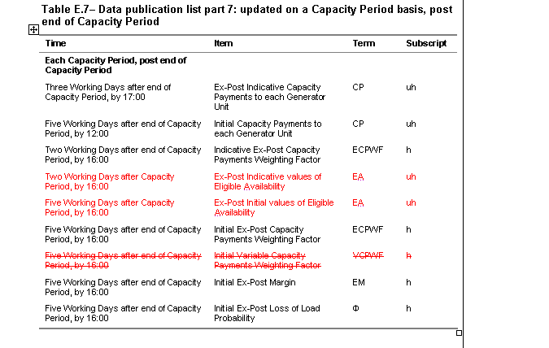

- Details of Alternative proposal raised
If appropriate, a later version or a resubmitted Modification Proposal details should be entered here
See above.

- Dissenting or Other Opinions
This section contains a summary of any objections to the approved modification proposal/ if appropriate, or feedback from the following: MO, TSO, Industry Expert or Consultant opinions
Table E7 – Timing changes in this section needed to be amended in order for Mod to be acceptable to Participants as there would be serious implications to their business processes otherwise.

Section 3
Results of Modification Consultation
Q. | Consultation Question |  |  | Yes | No | Neutral
 | N/A

Section 4
(a) Committee’s Final Recommendation to the Regulatory Authority
On the basis of the above discussions, the Committee agreed a UNANIMOUS/MAJORITY Recommendation to the RA’s that this Proposed Modification SHOULD/ SHOULD NOT be made

On the basis of the Proposal which incorporates the ORIGINAL/REVISED wording as detailed in Section 2.

(b) The Committee Recommends the following Implementation Approach and Timelines
The Implementation Date of the Proposal should be on:01 November 07
Assuming the RA Decision is made on/before [DATE] NA
Or no earlier than: [DATE] NA
Or no later than: [DATE] NA
(c) Proposed Modification Implementations Cost
This section contains a summary of the cost associated with implementing the proposed modification.
Cost (€) | Vendor | SMO | Total Cost (€)
Cost (€) | NA
(d) Proposed Modification Estimated Effort Time
This section contains details of the effort time required to design and develop the proposed modification.Include Detailed description of long it will take to perform each change
Effort Time (man days)  (list each change below) | Vendor | SMO | Total Effort Time
½ DAY CODE UPDATE |  |  | ½ DAY
Please complete this form and return it to Secretariat by e-mail to Modifications@allislandmarket.com

Appendix I

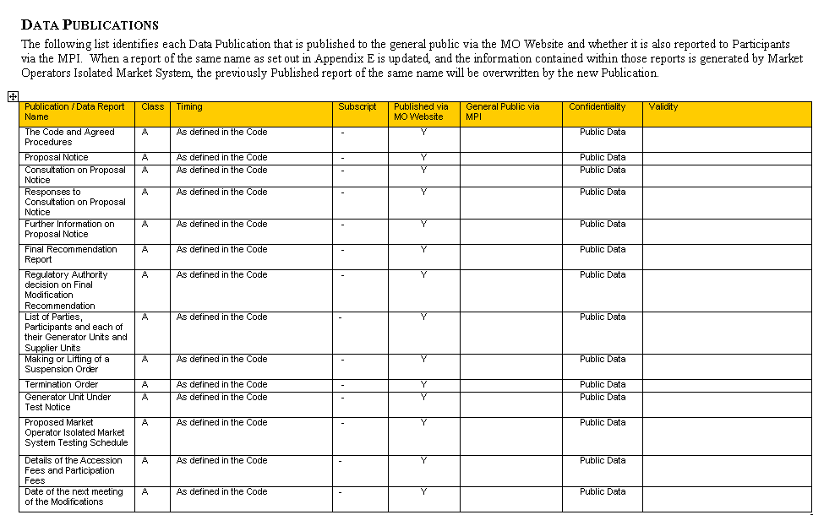

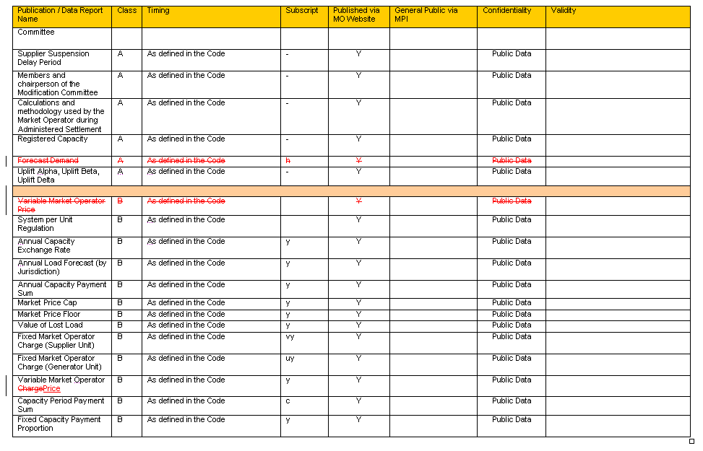

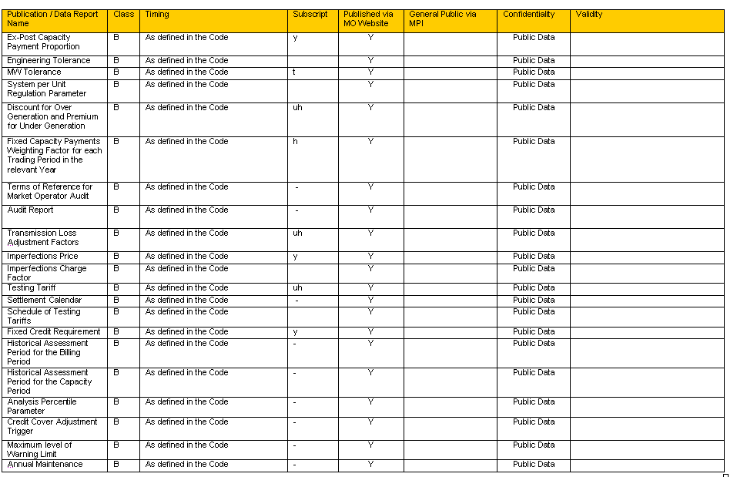

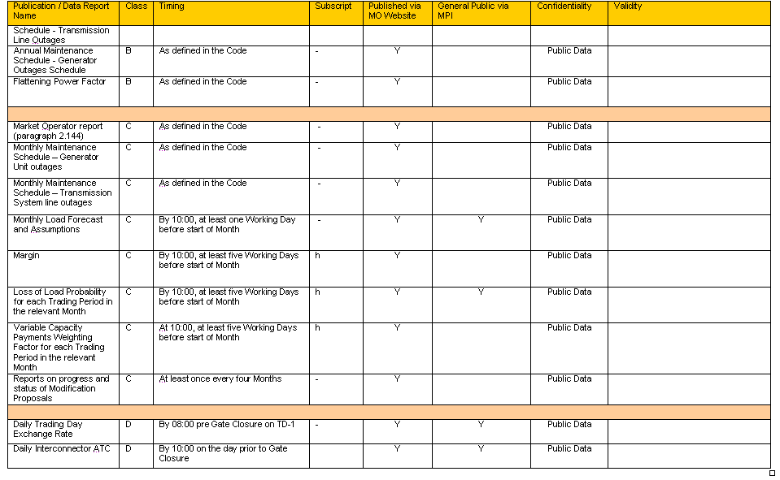
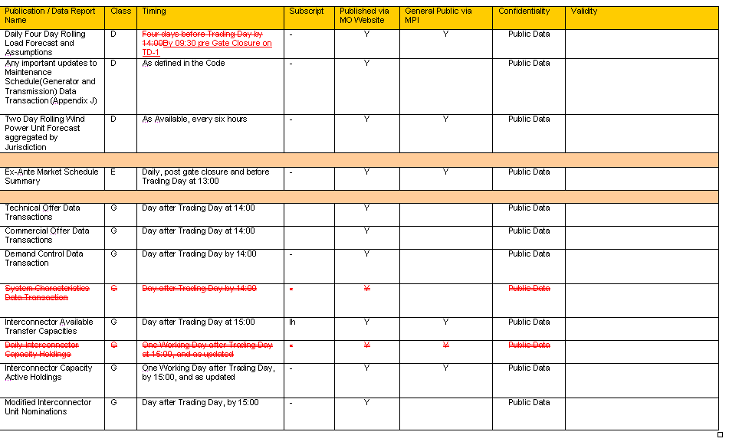

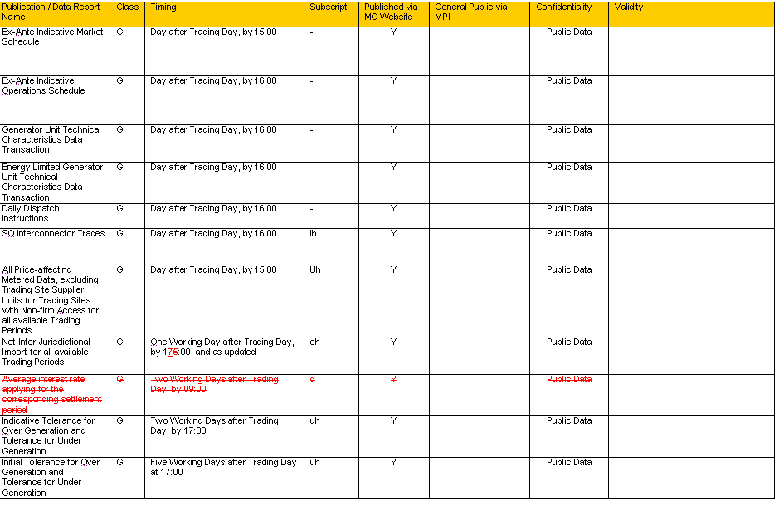
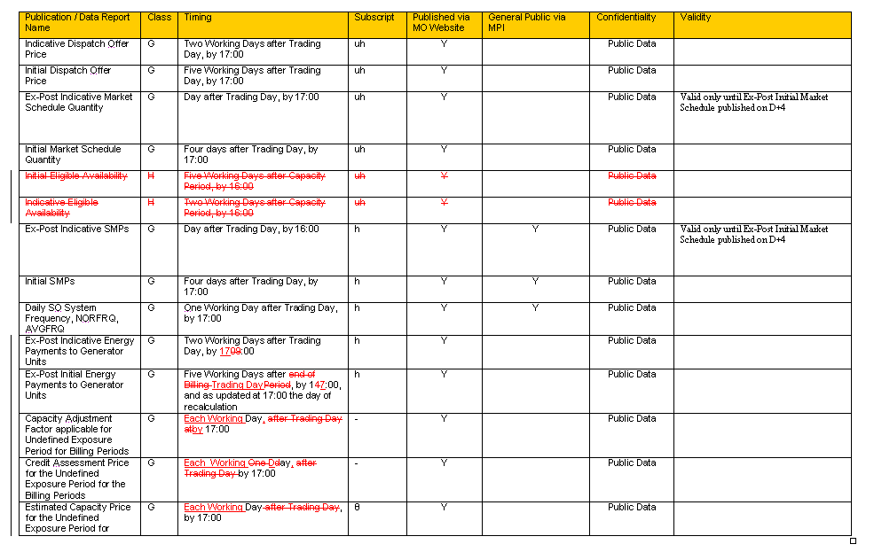

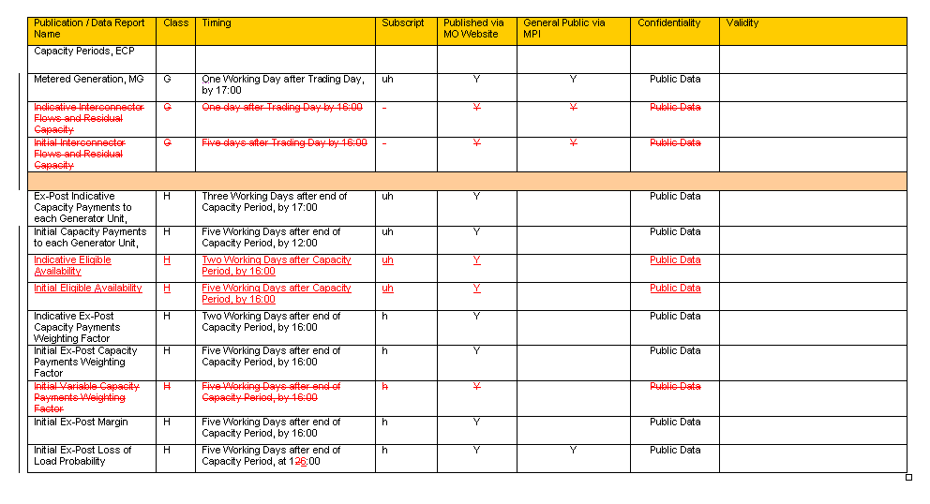

Note: These man days and costs may need to reflect a combination of Vendor costs and SMO additional costs. Any further modifications to the outline rules may have an impact both on the estimated costs and the estimated implementation date of the change.

