Final Recommendation Report of the Modifications Committee
Report  Reference | FRR_65_07 | Modification Proposal Reference: | Mod_65_07  Section 6
Date of Issue: | 28 September 2007 | Category: | Urgent
Mod Originator : | SMO | Meeting No(s): | Meeting 04
Reason for Issue: | For Regulatory Authority Decision
Section 1
(a) Summary of Modification Committee Recommendations
Mod_65_07 seeks to revise Sections 6.63 and 6.64 of the Code, deleting the requirement to adjust over and under payments by use of Invoices and replacing with a requirement to issue notices.

Recommendation Summary
Having considered the Proposed Modification at the abovementioned Meeting, the Modification Committee recommends
- The Proposed Modification should be made
- With Implementation date of November 1st, 2007.

(b) Rationale behind Modification Committee Recommendations
There are three separate issues:

First, the addition of interest in 6.63.1. If a Participant has been overpaid, then even if this is due to a mistake by the Market Operator, having had the benefit of the overpayment sum, interest should be due and paid back into the relevant clearing account. Such interest will benefit all Participants as it will ultimately be credited to the MO Charge account, thereby reducing the MO charge.

Second with respect to the changes removing the requirement to issue an Invoice or Self Billing Invoice in the case of rectifying under or over payments. The requirement is replaced by a requirement to issue a notice in respect of which payment has to be made within the invoicing timeframes under the Code. The reason for this is that otherwise, the accounting treatment will be wrong. The sums concerned have already been invoiced, with VAT. However the wrong amount has been paid. There is nothing more to invoice for, this is merely correcting an error. If new invoices are issued, then the accounting treatment will be incorrect as the new invoices would also be shown as additional turnover. For example, an Invoice for £100 is issued but only £80 is paid. A new invoice is issued (as per the existing Code) for £20. The issuing party is then shown as having issued invoices for the relevant transaction of £120 when all that was ever due was £100.

Lastly, the definition of “Interest” should not refer to Shortfall as this attracts “Default Interest” which is separately defined.

Implication of not implementing the Modification

This will result in incorrect accounting treatment in the event of any under or over-payments arising in the market.

Section 2  (a) Summary of Impacted Parties |  |  |  | Detail of impact
Generators |  | N
Suppliers |  | N
TSO |  | N
MO |  | Y |  | Secretariat is required to implement this change in the Code
PES |  | N
(b) Summary of Impacted Documents/Systems |  |  |  | Detail of impact
Code Provisions |  | Y |  | Sections 6.63 and 6.64, deleting the requirement to adjust over and under payments by use of Invoices and replacing with a requirement to issue notices.
Business Processes |  | N
Legal requirements |  | N
Grid Code |  | N
Other |  | N
Systems |  | Y
- Proposed Modification (Original Draft)
This section contains the text of the original draft of the modification proposal
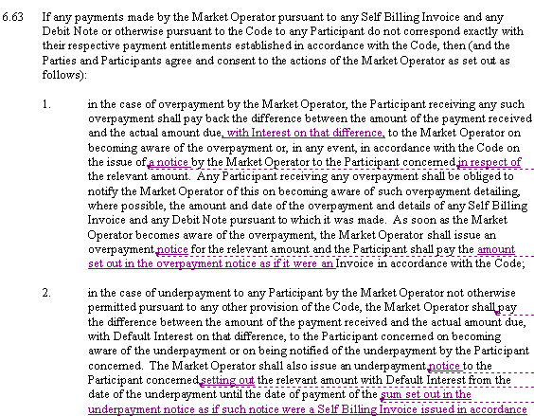
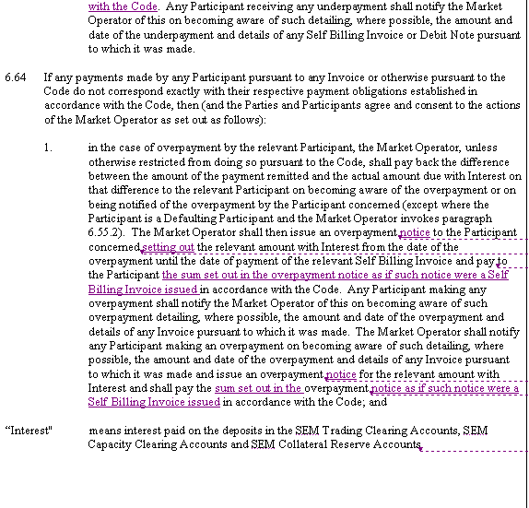
- Proposed Modification (Recommended for Approval by Committee)
This section contains the text of the Approved version of the modification proposal, if different from above
N/A

- Details of Alternative proposal raised
If appropriate, a later version or a resubmitted Modification Proposal details should be entered here
N/A

- Dissenting or Other Opinions
This section contains a summary of any objections to the approved modification proposal/ if appropriate, or feedback from the following: MO, TSO, Industry Expert or Consultant opinions
In Favour subject to Robin Woolnough clarification on invoice definition.
Section 3
Results of Modification Consultation
Q. | Consultation Question |  |  |  | Yes | No |  | Neutral
 | N/A
Section 4
(a) Committee’s Final Recommendation to the Regulatory Authority
On the basis of the above discussions, the Committee agreed a UNANIMOUS/MAJORITY Recommendation to the RA’s that this Proposed Modification SHOULD/ SHOULD NOT be made

On the basis of the Proposal which incorporates the ORIGINAL/REVISED wording as detailed in Section 2.

(b) The Committee Recommends the following Implementation Approach and Timelines
The Implementation Date of the Proposal should be on: November 1st, 2007.
Assuming the RA Decision is made on/before [DATE] N/A
Or no earlier than: [DATE] N/A
Or no later than: [DATE] N/A
(c) Proposed Modification Implementations Cost
This section contains a summary of the cost associated with implementing the proposed modification.
Cost (€) |  |  | Vendor |  | SMO |  | Total Cost (€)
 |  |  | N/A
(d) Proposed Modification Estimated Effort Time
This section contains details of the effort time required to design and develop the proposed modification.Include Detailed description of long it will take to perform each change
Effort Time (man days)  (list each change below) |  |  | Vendor |  | SMO |  | Total Effort Time
Update to Trading and Settlement Code |  |  |  |  | ½ day |  | ½ day
Please complete this form and return it to Secretariat by e-mail to Modifications@allislandmarket.com

Note: These man days and costs may need to reflect a combination of Vendor costs and SMO additional costs. Any further modifications to the outline rules may have an impact both on the estimated costs and the estimated implementation date of the change.

