Final Recommendation Report of the Modifications Committee
Report  Reference | FRR_70 | Modification Proposal Reference: | Mod_70_07  Currency Cost Charge in Actual Exposure
Date of Issue: | 28 September 2007 | Category: | Urgent
Mod Originator : | Jon O’Sullivan, SMO | Meeting No(s): | Meeting 05
Reason for Issue: | For Regulatory Authority Decision
Section 1
(a) Summary of Modification Committee Recommendations
Mod_70_07 seeks to revise the Code as The drafting in 6.186/7 doesn’t include currency cost that would go on invoices and that feeds into actual exposure calculations as set out in AP09.

Recommendation Summary
Having considered the Proposed Modification at the abovementioned Meeting, the Modification Committee recommends
- The Proposed Modification should be Made
- With Implementation date of 01 November 2008

(b) Rationale behind Modification Committee Recommendations
There is a gap in the Code with regards to these Currency Cost Charge in Actual Exposure and Participants were in general agreement that in this case, the Code could be amended to correct the gap.

Currently AP09 does reflect the understanding at the time and the systems are built to this understanding.

Section 2  (a) Summary of Impacted Parties |  |  | Detail of impact
Generators |  | Y | No impact if Mod is approved as systems have been built in accordance with Mod as drafted
Suppliers |  | Y | No impact if Mod is approved as systems have been built in accordance with Mod as drafted
TSO |  | Y | No impact if Mod is approved as systems have been built in accordance with Mod as drafted
MO |  | Y | No impact if Mod is approved as systems have been built in accordance with Mod as drafted
PES |  | Y | No impact if Mod is approved as systems have been built in accordance with Mod as drafted
(b) Summary of Impacted Documents/Systems |  |  | Detail of impact
Code Provisions |  | Y | 6.136  6.139  6.186  6.187
Business Processes |  | N
Legal requirements |  | N
Grid Code |  | N
Other |  | N
Systems |  | N | No impact if Mod is approved as systems have been built in accordance with Mod as drafted
- Proposed Modification (Original Draft)
This section contains the text of the original draft of the modification proposal
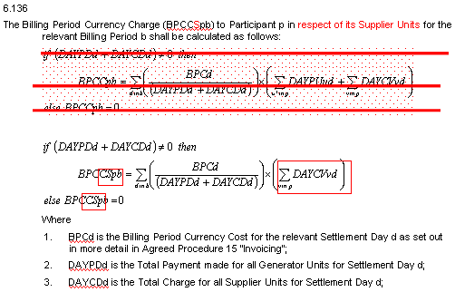
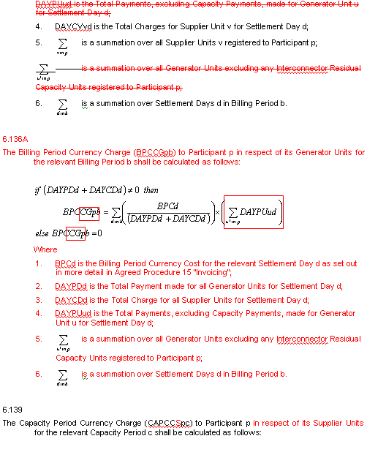
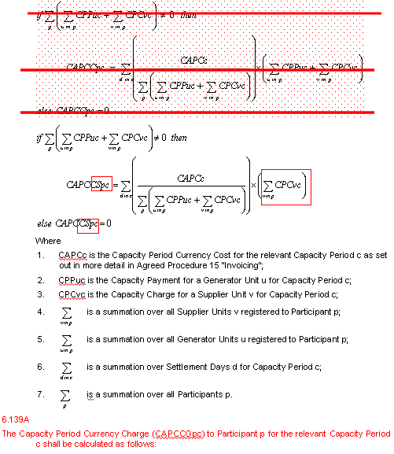
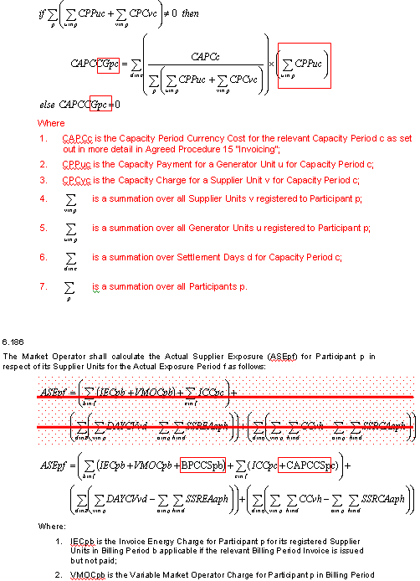
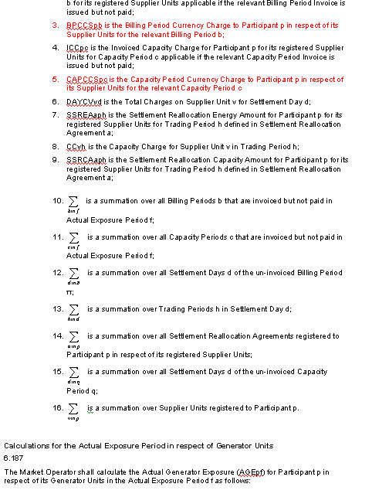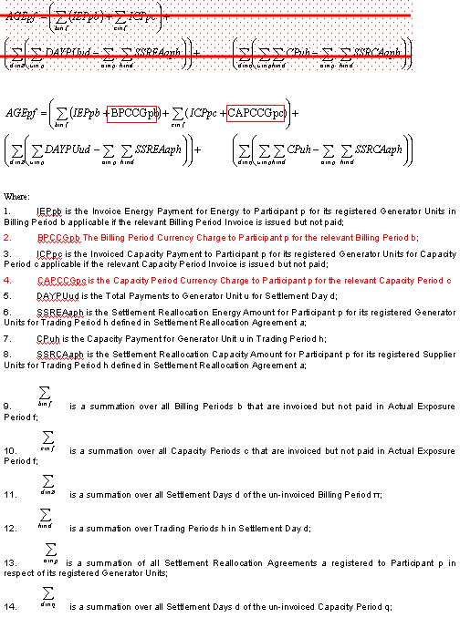

Modification Proposal Justification Clearly state the reason for the Modification. Attach further information if necessary
As stated in the release “Currency Costs and Credit Cover”, the Actual Exposure component of the calculation of Required Credit Cover was extracted from the Invoice total and therefore included relevant Currency Costs, whereas the calculation of Actual Exposure in paragraphs 6.186 and 6.187 in the TSC do not include such costs.
Further changes are required to the “Recovery of the Billing Period Currency Cost” and “Recovery of the Capacity Period Currency Cost” sections to split the Currency Charge between a Participants Generator and Supplier Units
Implication of not implementing the Modification
The implementation of The SEM Central Market Systems will not be clear in terms of the provisions of the Code and the calculation of the costs may be conducted in error.

- Proposed Modification (Recommended for Approval by Committee)
This section contains the text of the Approved version of the modification proposal, if different from above
n/a

- Details of Alternative proposal raised
If appropriate, a later version or a resubmitted Modification Proposal details should be entered here
n/a

- Dissenting or Other Opinions
This section contains a summary of any objections to the approved modification proposal/ if appropriate, or feedback from the following: MO, TSO, Industry Expert or Consultant opinions
J Traynor asked if this would result in an increase in credit cover. T Morrow:it would result in a small increase. Q on the timing of the Appendix to the Mod, this was clarified by Simon Street whereby the timing of the paper was end June, when the issue was identified between RA s and MO and the Proposed Mod under discussion now was the result of that paper. At the time, the AP09 was deemed to be the correct way to design the systems going forward. The Code is now proposed to be brought into alignment with the AP.

Q from T Gill on Invoice Amounts (6.130 – 6.133): Does the IEP or the IEC include currency cost? No, the invoice amounts as per 6.130 – 6.133 do not include currency costs. They do include the energy market payments or charges and settlement reallocation but neither include Currency Costs

G Blaney made the point that the AP’s normally are overwritten by the Code. If systems are misaligned with the Code, the Code should only be changed if there was a material error in the Code. In this case there was an relatively small impact. D Naughton concurred that this was the overriding principle..

Section 3
Results of Modification Consultation
Q. | Consultation Question |  |  | Yes | No | Neutral
 | N/A

Section 4
(a) Committee’s Final Recommendation to the Regulatory Authority
On the basis of the above discussions, the Committee agreed a UNANIMOUS/MAJORITY Recommendation to the RA’s that this Proposed Modification SHOULD/ SHOULD NOT be made

On the basis of the Proposal which incorporates the ORIGINAL/REVISED wording as detailed in Section 2.

(b) The Committee Recommends the following Implementation Approach and Timelines
The Implementation Date of the Proposal should be on: 01 November 2007
Assuming the RA Decision is made on/before [DATE] n/a
Or no earlier than: [DATE] n/a
Or no later than: [DATE] n/a
(c) Proposed Modification Implementations Cost
This section contains a summary of the cost associated with implementing the proposed modification.
Cost (€) | Vendor | SMO | Total Cost (€)
Cost (€) | n/a
(d) Proposed Modification Estimated Effort Time
This section contains details of the effort time required to design and develop the proposed modification.Include Detailed description of long it will take to perform each change
Effort Time (man days)  (list each change below) | Vendor | SMO | Total Effort Time
½ day for code update |  |  | code update
Please complete this form and return it to Secretariat by e-mail to Modifications@allislandmarket.com

Note: These man days and costs may need to reflect a combination of Vendor costs and SMO additional costs. Any further modifications to the outline rules may have an impact both on the estimated costs and the estimated implementation date of the change.

