The Single Electricity Market (SEM)
Agreed Procedure 7: Emergency Communications
Version TBC

TBC
SEM Agreed Procedure

Title | Agreed Procedure 7: Emergency Communications
Version | TBC
Date | TBC

Table of Contents

1. Introduction 5
1.1 Background and Purpose 5
1.2 Scope of Agreed Procedure 5
1.3 Definitions 5
1.4 Compliance with Agreed Procedure 5
2. Descriptive Overview 6
2.1 Emergency Communications 6
2.2 Alternative Forms of Communication 6
3. Procedure Definition 8
3.1 General System Failure 8
3.2 General Communication Failure 8
3.3 Limited Communication Failure 9
4. Swimlane Diagrams 10
4.1 Swimlane – General System Failure & General Communication Failure 10
4.2 Swimlane – Limited Communication Failure 11
5. Procedural Steps 12
5.1 General System Failure 12
5.2 General Communication Failure 15
5.3 Limited Communication Failure 17
APPENDIX 1: Definitions and Abbreviations 19
Definitions 19
Abbreviations 20
APPENDIX 2: FORMS 21
Transaction Notification Form 22
Emergency Communication Form 24
Limited Communication Failure Form 24
Limited Communication Failure Form 25

DOCUMENT HISTORY
Version | Date | Author | Comment
2.0 | 03/11/2006 | SEM Implementation Team | Issue to Regulatory Authorities
3.0 | 17/05/2007 | Regulatory Authorities | Consultation Version
3.2 | 22/06/2007 | Regulatory Authorities | Approved for Go-Active by Regulatory Authorities and TSO/SEM Programme
RELATED DOCUMENTS
Document Title | Version | Date | By
Trading and Settlement Code | V2.0 | 30/05/2007 | Regulatory Authorities
Agreed Procedure 1 "Participant and Unit Registration and Deregistration"

Agreed Procedure 4 “Data Transaction Submission and Validation”

Agreed Procedure 5 “Data Storage and IT Security”

Agreed Procedure 6 “Data Publication and Data Reporting”

Agreed Procedure 11 “Market System Operation, Testing, Upgrading and Support”

- Introduction
  - Background and Purpose
This Agreed Procedure describes the specific procedures and directives for Emergency Communications with which Parties to the Trading and Settlement Code (the “Code”) must comply.
  - Scope of Agreed Procedure
This Agreed Procedure defines the process requirements for communication of data required for Settlement outside of normal operation of the IT systems.
All allowable forms of non-standard communication listed in order of preference that may be necessary in the event of a General Communication Failure, a General System Failure or a Limited Communication Failure are detailed in the procedure
The procedure also includes the process to be followed by the Market Operator in notifying the market that a General Communication Failure or a General System Failure is in effect, the responsibilities of impacted Parties when this state is declared and updates issued by the Market Operator during the emergency situation.
This Agreed Procedure forms an annexe to, and is governed by, the Code. This document is a statement of process and procedure. Parties’ rights and obligations are set out in the Code.
  - Definitions
Save as expressly defined, words and expressions defined in the Code shall have the same meanings when used in this Agreed Procedure.
References to particular sections relate internally to this Agreed Procedure unless specifically noted.
  - Compliance with Agreed Procedure
Compliance with this Agreed Procedure is required under the terms as set out in the Code.
- Descriptive Overview
The details of Emergency Communications are set out in the Code, and this Section 2 of this Agreed Procedure provides a non-legally binding overview of those provisions, for information purposes only, as context for the remaining provisions of this Agreed Procedure.
  - Emergency Communications
There are three possible declared states that indicate communications may be conducted outside of normal operating conditions. They are:
- A General System Failure
- A General Communication Failure
- A Limited Communication Failure
A General System Failure is a declared state made by the Market Operator that the Market Operator’s Isolated Market System is not functional preventing the processing of data leading to a failure in the required timescales of:
- the calculation and publication of SMP; or
- the Settlement of any Unit for a Billing Period; or
- calculation or publication of Capacity Payments or issuance of Settlement Statement for Capacity Payments and Capacity Charges. (See the Code for a full definition)
A General Communication Failure is a declared state made by the Market Operator that all computer related communication interfaces are unavailable save the System Operators or the Meter Data Providers. (See the Code for a full definition)
A Limited Communication Failure is a declared state made by an impacted Party that they are unable to submit Data Transactions in electronic form that is, using Type 3 Channel or Type 2 Channel, due a technical, communication or IT systems failure. (See the Code for a full definition)
In the event that a communications failure or any error affecting the System Operator, Interconnector Administrator, or Meter Data Provider outside of the Market Operator’s Isolated Market System such that a System Operator and Interconnector Administrator CMS Data Transaction (Appendix K of the Code) or a Meter Data Provider CMS Data Transaction (Appendix L of the Code) has not been received by the Market Operator, such CMS Data Transactions shall be submitted within one day of the specified submission deadline. This Agreed Procedure sets out the emergency protocols for the submission of Data Transactions for Meter Data Providers when the Meter Data Provider Type 3 interface is not operational.
All other Data Transactions will be required to be submitted in their normal timelines using alternative forms of communication, if applicable, unless the Market Operator notifies impacted Parties that, due to the communication failure, certain Data Transaction submissions required for Settlement are given an Emergency Transaction Timeline.
  - Alternative Forms of Communication
In the event of a communication failure alternatives to the normal method of communication will be employed for the submission of Data Transactions. The three Communication Channels available are:
- Type 1 Channel;
- Type 2 Channel, and;
- Type 3 Channel,
Generally the preferred alternative method of communication will cascade from the most automatic to the most manual. However, in the event that the web server is interrupted it is clearly possible that both Type 3 Channel and Type 2 Channel will not be available for communication.
The preferred order of communication with the Market Operator is as follows:
If Type 3 Channel is affected by a communication fault then:
- Type 2 Channel
If Type 2 Channel affected then:
- Type 1 Channel – fax
- Type 1 Channel – post
- Type 1 Channel – hand
During a General Communication Failure the response given by a Market Operator confirming receipt of a Data Transaction, whether by fax, post or hand, shall be sent by fax. The Market Operator shall act prudently in the event of a General Communication Failure and shall prioritise Data Transactions necessary for the calculation of System Marginal Prices, Market Schedule Quantities, Trading Charges, Trading Payments, and Settlement. It is recognised that in the event of a General Communication Failure some of the Market Operator’s obligations cannot be reasonably fulfilled.
In the event of issues with CMS Data Transactions, an impacted Party may also contact the Market Operator helpdesk as defined in Agreed Procedure 11 “Market System Operation, Testing, Upgrading and Support”.
When the Meter Data Provider Type 3 Channel is not operational, the Meter Data Provider shall provide the appropriate Meter Data Transaction as specified under Appendix L via an electronic means alternative to the Type 3 Channel. If this alternative electronic means is email, the Meter Data Provider shall support email communications with a Type 1 Channel – fax.
    - Transaction Notification Form
Part A of the Transaction Notification Form in FORMS allows a Participant to list each Data Transaction and its preferred method of communication following a Limited Communication Failure. Part B of the form allows the Market Operator to list each Data Transaction, its preferred method of communication, whether it is a vital Data Transaction and the Emergency Transaction Timeline following notification of a General System Failure or a General Communication Failure.
In the event of a communication failure the Market Operator, in the case of a General System Failure or a General Communication Failure or the impacted Party, in the case of a Limited Communication Failure will issue the relevant part of the form to confirm the method of communication that will be followed for each relevant Data Transaction during that event. If there is any change to the timeline of Data Transactions following a General Communication Failure or a General System Failure the form shall be resent by the Market Operator with the new information only.
This form does not apply to Meter Data Providers.
    - Notification Communication
In the event of a General System Failure or a General Communication Failure the Market Operator must communicate the notice of the failure immediately they become aware of such an emergency. The preferred communication method would be fax. Where fax is not available the communication will be by telephone. Notification of the failure and notification of return to normal communication will require acknowledgement. Where the notification is by fax, any acknowledgements not received will require a follow up telephone call by the Market Operator informing each impacted Party of the failure. The Market Operator will also publish the information on the Market Operator Website and MPI as available and appropriate, as soon as possible.

- Procedure Definition
  - General System Failure
    - Overview
“General System Failure” is a situation where the Market Operator’s Isolated Market System can no longer process market data under normal operation and has missed a deadline, or will cause the Market Operator to miss a deadline, for calculation or publication of System Marginal Price, or any components thereof, for any Trading Day, Settlement of any Unit for any Billing Period, or calculation or publication of Capacity Payments, or the issuance of a Settlement Statement for Capacity Payments and Capacity Charges for any Capacity Period.
In the event that a deadline under a General System Failure is missed or in the opinion of the Market Operator is expected to be missed, the Market Operator will notify impacted Parties of the situation immediately. The Market Operator will inform impacted Parties whether or not Administered Settlement is expected to be implemented and notify them of Communication Channel alternatives in the same manner as if a General Communication Failure has occurred.
Following notification of a General System Failure the Market Operator will provide regular (i.e. not less than daily) status updates to each impacted Party of the General System Failure. Each status update will include the original notification and will provide each impacted Party of an estimate of the restoration time and when the Market Operator’s Isolated Market System will be available again. Restoration time will be categorised in one of five bands namely; less than 1 hour, 1-4 hours, 4-12 hours, 0.5-2 days, greater than 2 days from the date of the original notification. Should the restoration category change then a further notification will be made by the Market Operator.
  - General Communication Failure
    - Overview
A “General Communication Failure” is a situation where the Market Operator’s Isolated Market System is operational but the normal communication interfaces between all Parties, (other than the System Operators or the Meter Data Providers) and the Market Operator are unavailable, leading to a failure of all such Parties to comply with the data submission requirements.
In the event of a General Communication Failure the Market Operator will notify each impacted Party of the General Communication Failure and issue instructions to each impacted Party how each relevant Data Transaction should be communicated to the Market Operator. Additionally, the Market Operator will highlight those Data Transactions that are vital for Settlement and detail the allowed timeline for each of these Data Transactions (the “Emergency Transaction Timeline”).
Where the failure also prevents the Market Operator receiving Data Transactions from the System Operators and Meter Data Providers, the Market Operator will also notify the System Operator and Meter Data Provider that submissions of Market Operator System Data Transactions and Meter Data Transactions will need to be submitted within 1 day of the specified submission deadline.
Following notification of a General Communication Failure the Market Operator will provide regular (i.e. not less than daily) status updates to all impacted Parties of the General Communication Failure. Each status update will include the original notification and will provide all impacted Parties of an estimate, if known, of when normal communication with the Market Operator’s Isolated Market System will be available again. Whenever the Market Operator receives information that significantly (in the opinion of the Market Operator) changes the expected time when normal communication will be restored, the Market Operator shall issue a status update.
  - Limited Communication Failure
    - Overview
A “Limited Communication Failure” is a situation where one or more Parties, but not all Parties and none of those Parties being the Market Operator, a System Operator or Meter Data Provider, fail to comply with the data submission requirements because of a technical, communication or IT systems error outside of the Market Operator’s Isolated Market System.
All Parties are required under Agreed Procedure 5 “Data Storage and IT Security” to maintain a redundant and fault-tolerant network configuration of sufficient capacity to meet their peak communication needs. Whenever there is a Limited Communication Failure the impacted Party should initially attempt to rectify the problem or utilise other facilities to enable it to use its normal Communication Channels.
In the event that an impacted Party is unable to re-establish its normal Communication Channel and the impacted Party incurs a Limited Communication Failure, the impacted Party will notify the Market Operator that they have communication problems and will operate their alternative Communication Channel process for the specified Data Transactions. The impacted Party will provide regular (i.e. not less than daily) status updates to the Market Operator of progress in their attempts to restore their normal Communication Channel.
A Limited Communication Failure shall not affect the obligations of any impacted Party to submit Data Transactions.

  - FAILURE OF METER DATA PROVIDER TYPE 3 CHANNEL
    - Overview
A failure of a Meter Data Provider Type 3 Channel may affect all Meter Data Providers or just a single Meter Data Provider. If the failure of the Type 3 Channel originates from the Market Operator and impacts all Meter Data Providers, the Market Operator shall notify all Meter Data Providers of the issue as soon as possible as per Section 2.2.2. If the failure of the Type 3 Channel originates from one Meter Data Provider, the Meter Data Provider shall inform the Market Operator, utilising the same forms of Type 1 Channel communications detailed in Section 2.2.2.
Following notification of a Type 3 Channel failure, the Market Operator or the relevant Meter Data Provider (as appropriate) will provide regular (i.e. not less than daily) status updates to all impacted Parties of the failure.
The Meter Data Providers shall provide the required Meter Data Transaction electronically to the Market Operator within one day, i.e. for the avoidance of doubt the next calendar day. Where this Meter Data Provider has provided the Meter Data Transaction using a format that does not allow the Market Operator to confirm that the Meter Data Provider was the sender of the Transaction, e.g. email, the Meter Data Provider shall support this electronic communication via a Type 1 Channel fax. This Type 1 Channel fax must unambiguously identify the Meter Data Transaction clearly stating on the fax the identifier embedded in Meter Data Transaction as per Section 3.25 of the Code, and the total number of rows and energy contained within the file as checksums.
The Type 1 Channel fax must be of the form in Section 7.4 of this Agreed Procedure, sent from an Authorised Person with the appropriate password. The selection of the Authorised Person and the password are described in Agreed Procedure 11 “Market System Operation, Testing, Upgrading and Support”.

- Swimlane Diagrams
These swimlanes are provided as an illustration of the Procedural Steps. The Procedural Steps take precedence, in the event of conflict between the swimlanes and the Procedural Steps.
  - Swimlane – General System Failure & General Communication Failure
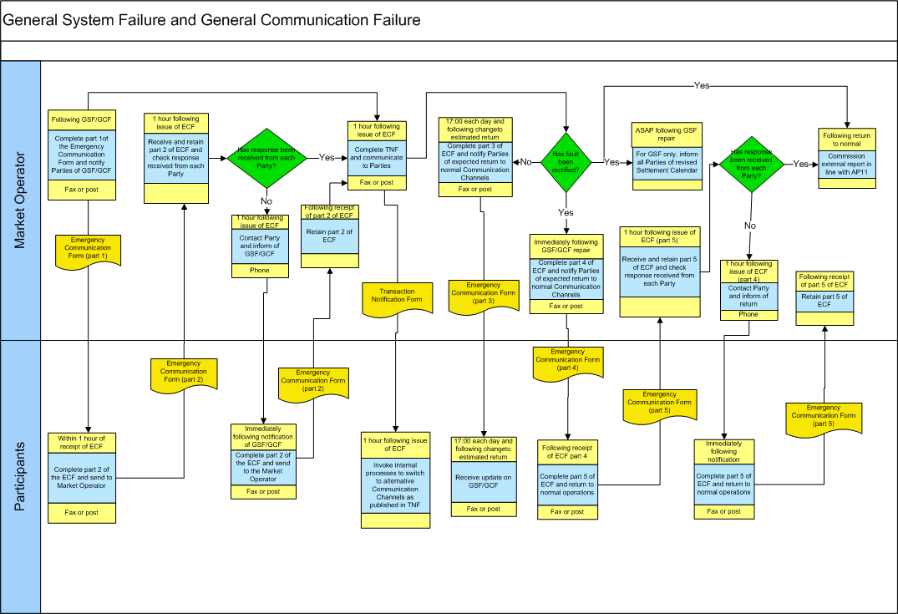
  - Swimlane – Limited Communication Failure
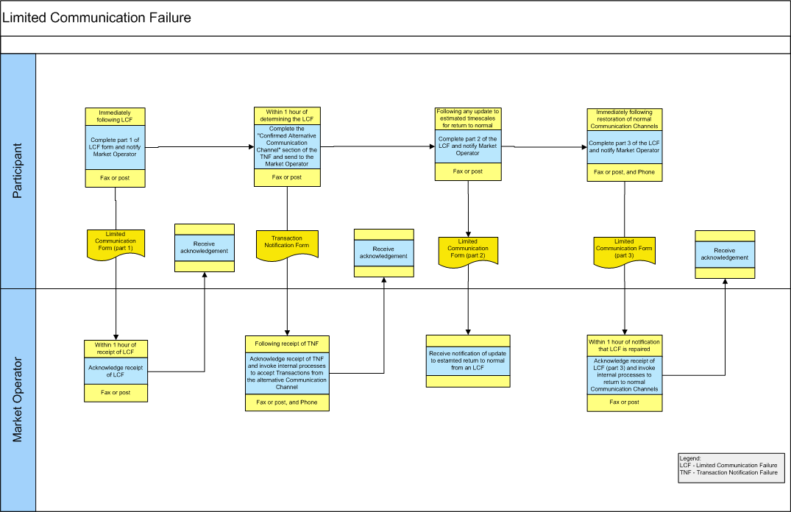
  - Swimlane – Meter Data Provider Type 3 Channel Failure
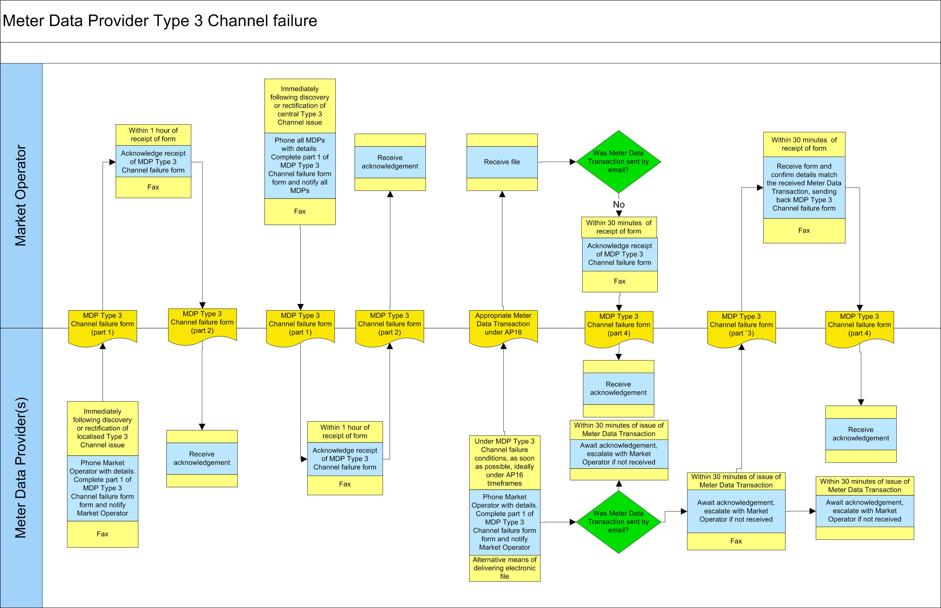

- Procedural Steps
  - General System Failure
# | Procedural Step | Timing | Method | By / From | To | Linkage
1 | Attempt restoration of the Market Operator’s Isolated Market System to the timelines and standards under Agreed Procedure 11 “Market System Operation, Testing, Upgrading and Support” | Immediately following determination of a General System Failure | - | Market Operator |  | Agreed Procedure 11 “Market System Operation, Testing, Upgrading and Support”
2 | Complete part 1 of the Emergency Communication Form and notify impacted Parties of the General System Failure and list which of the following deadlines have been missed or are about to be missed:  - calculation or publication of the System Marginal Price or any component thereof for any Trading Period;  - Settlement of any Unit for any Billing Period;  - calculation or publication of Capacity Payments or the issuance of a Settlement Statement for Capacity Payments and Capacity Charges for any Capacity Period.  Inform impacted Parties whether or not Administered Settlement has been invoked.  Proceed from Step 3 and Step 6 | Immediately following the missing of one of the deadlines. | Fax or post | Market Operator | All impacted Parties
3 | Acknowledge receipt of notification of the General System Failure using part 2 of the Emergency Communications Form | Within 1 hour of notification of the General System Failure | Fax or post | All impacted Parties | Market Operator
4 | Receive acknowledgements from those Parties notified of the failure. Identify missing acknowledgements and contact Parties by telephone that have not sent an acknowledgement and inform them of the General System Failure. | 1 hour following sending of Emergency Communication Form | Telephone | Market Operator | All notified Parties who have not acknowledged
5 | Acknowledge receipt of notification of General System Failure using Part 2 of the Emergency Communication Form | Immediately following telephone call notification of General System Failure | Fax or post | All impacted Parties | Market Operator
6 | Complete the “Alternative Communication Method” and, if necessary, update the “Emergency Transaction Timeline” sections in Part B of the Transaction Notification Form and communicate to impacted Parties using the notified communication method  Proceed from Step 7 and Step 8. | Within 1 hour of determination of General System Failure | Fax or post | Market Operator | All impacted Parties
7 | Receive Transaction Notification Form and invoke internal procedures to switch to alternative communication methods | Immediately following receipt of Transaction Notification Form | - | All impacted Parties
8 | Notify all impacted Parties of best estimate of when the Market Operator Isolated Market System will become available using part 3 of the Emergency Communication Form. | Following change to best estimate of recovery or at 17:00 hours each day | Fax or post | Market Operator | All impacted Parties
9 | Notify all impacted Parties of restoration of the Market Operator’s Isolated Market System using Part 4 of the Emergency Communication Form and revoke the Transaction Notification Form. Communicate with impacted Parties using the notified communication method  Proceed from Step 10, Step 13 and Step 14 | Immediately following restoration of the Market Operator’s Isolated Market System | Fax or post | Market Operator | All impacted Parties
10 | Acknowledge receipt of notification of return to normal Communication Channels using Part 5 of the Emergency Communication Form | Within 1 hour of receipt of notification of restoration of the Market Operator’s Isolated Market System | Fax or post | All impacted Parties | Market Operator
11 | Receive acknowledgements from impacted Parties. Identify missing acknowledgements and contact the relevant Parties by telephone that have not sent an acknowledgement and inform them of the restoration of the Market Operator’s Isolated Market System | 1 hour following sending of Emergency Communication Form | Telephone | Market Operator | All impacted Parties
12 | Acknowledge receipt of notification of return to normal Communication Channels using Part 5 of the Emergency Communication Form | Immediately following telephone call notification of restoration of the Market Operator’s Isolated Market System | Fax or post | All impacted Parties | Market Operator
13 | Recommence processing and restore operation to normal timescales and inform all impacted Parties of the changes to the Settlement Calendar as a result of the General System Failure. | As soon as reasonably possible following the restoration of the Market Operator’s Isolated Market System | Fax or post | Market Operator | All impacted Parties
14 | Commission an externally audited report in line with Agreed Procedure 11 “Market System Operation, Testing, Upgrading and Support” | Within timescales defined in AP11 | - | Market Operator |  | Agreed Procedure 11 “Market System Operation, Testing, Upgrading and Support”
  - General Communication Failure
# | Procedural Step | Timing | Method | By / From | To | Linkage
1 | Complete part 1 of the Emergency Communication Form and notify impacted Parties of the General Communication Failure using the notification communication method  Proceed from Step 2 and Step 5 | Immediately following determination of a GCF | Fax or post | Market Operator | All impacted Parties
2 | Acknowledge receipt of notification of General Communication Failure using Part 2 of the Emergency Communication Form | Within 1 hour of receipt of Emergency Communication Form | Fax or post | All impacted Parties | Market Operator
3 | Receive acknowledgements from impacted Parties. Identify missing acknowledgements and contact impacted Parties by telephone that have not sent an acknowledgement and inform them of the GCF. | 1 hour following sending of Emergency Communication Form | Telephone | Market Operator | All impacted Parties
4 | Acknowledge receipt of notification of General Communication Failure using Part 2 of the Emergency Communication Form | Immediately following telephone call notification of GCF | Fax or post | All impacted Parties | Market Operator
5 | Complete the “Alternative Communication Method” and, if necessary, update the “Emergency Transaction Timeline” sections of Part B of the Transaction Notification Form and communicate to impacted Parties using the notification communication method  Proceed from Step 6 and Step 7 | Within 1 hour of determination of GCF | Fax or post | Market Operator | All impacted Parties
6 | Receive Transaction Notification Form and invoke internal procedures to switch to alternative communication methods | Immediately following receipt of Transaction Notification Form | - | All impacted Parties
7 | Notify all impacted Parties of best estimate of when the Market Operator Isolated Market System will be available via the normal Communication Channels using Part 3 of the Emergency Communication Form. | Following change to best estimate of recovery or at 17:00 hours each day | Fax or post | Market Operator | All impacted Parties
8 | Notify all impacted Parties of restoration of Communication Channels using Part 4 of the Emergency Communication Form and revoke the Transaction Notification Form. Communicate with impacted Parties using the method as set out in section 2.2.2 Notification Communication.  Proceed from Step 9 and Step 12 | Immediately following restoration of Communication Channels | Fax or post | Market Operator | All impacted Parties
9 | Acknowledge receipt of notification of return to normal Communication Channels using Part 5 of the Emergency Communication Form | Within 1 hour of receipt of notification of restoration of normal Communication Channels | Fax or post | All impacted Parties | Market Operator
10 | Receive acknowledgements from impacted Parties. Identify missing acknowledgements and contact impacted Parties by telephone that have not sent an acknowledgement and inform them of the restoration of normal Communication Channels | 1 hour following sending of Emergency Communication Form | Telephone | Market Operator | All impacted Parties
11 | Acknowledge receipt of notification of return to normal Communication Channels using Part 5 of the Emergency Communication Form | Immediately following telephone call notification of restoration of normal Communication Channels | Fax or post | All impacted Parties | Market Operator
12 | Commission an externally audited report in line with Agreed Procedure 11 “Market System Operation, Testing, Upgrading and Support” | Within timescales defined in AP11 | - | Market Operator |  | Agreed Procedure 11 “Market System Operation, Testing, Upgrading and Support”
  - Limited Communication Failure
# | Procedural Step | Timing | Method | By / From | To | Linkage
1 | Complete Part 1 of the Limited Communication Failure Form and fax or post the form to the Market Operator. Additionally, contact the Market Operator by telephone to inform that there is a Limited Communication Failure and that alternative Communication Channels are being enacted.  Proceed from Step 2 and Step 3 | Immediately following the Limited Communication Failure becomes apparent | Fax or post | Impacted Party | Market Operator
2 | Acknowledge receipt of Limited Communication Failure Form | Within 1 hour of receipt | Fax or post | Market Operator | Impacted Party
3 | Complete the “Alternative Communication Method” section of Part A of the Transaction Notification Form and send to the Market Operator to confirm the Communication Channels to be used for each of the Data Transactions  Proceed to Step 4 and Step 5 | Within 1 hour of notifying Market Operator of the Limited Communication Failure | Fax or post | Impacted Party | Market Operator
4 | Acknowledge receipt of Transaction Notification Form | Within 1 hour of receipt | Fax or post | Market Operator | Impacted Party
5 | Invoke internal processes to accept Data Transactions from the alternative Communication Channel as notified on the Transaction Notification Form | Following receipt of the Transaction Notification Form | - | Market Operator
6 | If there is any change to the estimated timescales for the disruption to normal operation complete part 2 of the Limited Communication Failure Form to the Market Operator. | Immediately following any change to the previous estimate given for expected return to normal operation | Fax or post | Impacted Party | Market Operator
7 | On restoration of normal Communication Channels complete part 3 of the Limited Communication Failure Form and send to the Market Operator by fax or post. Additionally, notify the Market Operator by telephone that normal Communication Channels have been restored. | Immediately following restoration of normal Communication Channels | Fax or post | Impacted Party | Market Operator
8 | Acknowledge receipt of Limited Communication Failure Form – restoration to normal | Within 1 hour of receipt | Fax or post | Market Operator | Impacted Party
9 | Invoke internal processes to revert back to normal Communication Channels for this Party | On receipt of fax confirmation of the return to normal Communication Channels | - | Market Operator

  - Failure of a Meter Data Provider Type 3 Channel
# | Procedural Step | Timing | Method | By / From | To | Linkage
1 | If Meter Data Provider Type 3 Channel issue lies with Market Operator, notify impacted Meter Data Providers of the failure by telephone to inform that there is a failure of the Type 3 Communication Channel. Fax the Meter Data Provider Type 3 Channel failure form with Part 1 completed to all Meter Data Providers  Proceed from Step 3 and Step 4 | Immediately following determination of a failure of a Meter Data Provider Type 3 Channel | Fax , Phone | Market Operator | All Meter Data Providers | 7.4 of this Agreed Procedure
2 | If Meter Data Provider Type 3 Channel issue lies with the Meter Data Provider, contact the Market Operator by telephone to inform that there is a failure of the Type 3 Communication Channel. Fax the Meter Data Provider Type 3 Channel failure form with Part 1 completed to all Meter Data Providers  Proceed from Step 3 and Step 4 | Immediately following the discovery of the failure of a Meter Data Provider Type 3 Channel | Fax , Phone | Impacted Meter Data Provider | Market Operator | 7.4 of this Agreed Procedure
3 | Acknowledge receipt of notification failure using Part 2 of the received form | Within 1 hour of receipt of the relevant form | Fax | Receiver of form | Sender of form | 7.4 of this Agreed Procedure
4 | Send Meter Data Transaction. If sent by email (or any form of communication utilising electronic media where the Market Operator cannot confirm that the file was sent by the Meter Data Provider) continue to step 5. Otherwise continue from step 6. | As soon as possible, before the delivery deadline under Agreed Procedure 16 if possible | Email, hand delivery of electronic media | Meter Data Provider | Market Operator
5 | If sent by email, confirm by fax utilising Part 3 of the Meter Data Provider Type 3 Channel failure form, identifying the Meter Data Transaction that should be utilised | Within 30 minutes of issue of Meter Data Transaction, before the delivery deadline under Agreed Procedure 16 if possible | Fax | Meter Data Provider | Market Operator | 7.4 of this Agreed Procedure, Agreed Procedure 16
6 | Acknowledge receipt of Meter Data Transaction utilising Part 4 of the Meter Data Provider Type 3 Channel failure form | Within 30 minutes of receipt of Meter Data Transaction | Fax | Market Operator | All impacted Meter Data Providers | 7.4 of this Agreed Procedure
7 | Repeat step 4 to step 6 for all days while the failure of the Meter Data Provider Type 3 Channel continues for each Meter Data Transaction.
8 | On restoration of normal operation, complete part 1 of the Meter Data Provider Type 3 Channel failure form and send to the affected Parties by fax. Additionally, notify the Market Operator by telephone that normal Communication Channels have been restored. | Immediately following restoration of normal Communication Channels | Fax , Phone | Party who has rectified the issue | Affected Parties | 7.4 of this Agreed Procedure
9 | Acknowledge receipt of the form indicating return to normal operations utilising Part 2 of the Form | Within 1 hour of receipt | Fax | Affected Parties | Party who has rectified the issue | 7.4 of this Agreed Procedure

- Definitions and Abbreviations
6.1 Definitions
Administered Settlement | As defined in the Code
Agreed Procedure | As defined in the Code
Authorised Person | As defined in Agreed Procedure 11 "Market System Operation, Testing, Upgrading and Support"
Autonomous Generator Unit | As defined in the Code
Billing Period | As defined in the Code
Capacity Payment | As defined in the Code
Capacity Period | As defined in the Code
Code | As defined in the Code
Commercial Offer Data | As defined in the Code
Communication Channel | As defined in the Code
Data Transaction | As defined in the Code
Dispatch Instruction | As defined in the Code
Emergency Transaction Timeline | The timeline for Data Transactions in the event of a communication failure
General Communication Failure | As defined in the Code
General System Failure | As defined in the Code
Generator Unit | As defined in the Code
Isolated Market System | As defined in the Code
Limited Communication Failure | As defined in the Code
Market Operator | As defined in the Code
Market Operator Website | As defined in Agreed Procedure 1 “Participant and Unit Registration and Deregistration”
Market Participant Interface | As defined in Agreed Procedure 1 “Participant and Unit Registration and Deregistration”
Meter Data Provider | As defined in the Code
Participant | As defined in the Code
Party | As defined in the Code
Regulatory Authorities | As defined in the Code
SEM | As defined in the Code
Settlement | As defined in the Code
System Marginal Price | As defined in the Code
System Operator | As defined in the Code
Trading Day | As defined in the Code
Type 1 Channel | As defined in the Code
Type 2 Channel | As defined in the Code
Type 3 Channel | As defined in the Code
Unit Registration | As defined in the Code
6.2 Abbreviations
LCF Ref | Limited Communication Failure reference
Related ECF | Related Emergency Communication Form
GCF | General Communication Failure
SEM | Single Electricity Market
MPI | Market Participant Interface
- FORMS
The following forms are required in the event of a General System Failure, a General Communication Failure or a Limited Communication Failure:
7.1 Transaction Notification Form
7.2 Emergency Communication Form
7.3 Limited Communication Failure Form
7.4 Limited Communication Failure Form
7.1 Transaction Notification Form
From Party (Name) / Market Operator: From Party Id:
To Party (Name) / Market Operator: Related ECF/LCF Reference:
Authorised Person (if being sent by a Party)
Name: Signature: Password:

Part A – to be completed by a Participant (Not IA/SO) in the event of an LCF
Date/time effective from: Date/time effective to:
The transactions, methods used and revised timeline for each communication are detailed below:
Data Transaction | Alternative Communication Method
The full list of Data Transactions are described in Agreed Procedure 4 “Data Transaction Submission and Validation”
The preferred order of communication in the event of an LCF is described in section 2.2
Communications not described on this form shall be sent in normal timescales
Acronyms – ECF (Emergency Communication Failure), LCF (Limited Communication Failure), IA (Interconnector Administrator), SO (System Operator)

Part B – to be completed by the Market Operator in the event of a GSF/GCF
Date/time effective from: Date/time effective to:
The transactions, methods used and revised timeline to communicate information as a result of the General System Failure or General Communication Failure are as follows:
Data Transaction | Alternative Communication Method | Is it a vital Transaction  (Y/N) | Emergency Transaction Timeline
The full list of communications are described in Agreed Procedure 4 “Data Transaction Submission and Validation” and Agreed Procedure 6 “Data Publication and Data Reporting”
The preferred order of communication in the event of a GSF or a GCF is described in section 2.2
The Emergency Communication Timeline shall identify the revised timings of the communication
Communications not described on this form shall be sent in normal timescales
Acronyms – GSF (General System Failure), GCF (General Communication Failure)

7.2 Emergency Communication Form

Date / Time of Failure:

Restoration Category: 1 hr / 1-4hrs / 4-12hrs /
(delete as appropriate) 0.5-2 days / >2days

Date / Time of Failure:

Restoration Category: 1 hr / 1-4hrs / 4-12hrs /
(delete as appropriate) 0.5-2 days / >2days

Emergency Communication Form ECF Reference:

GENERAL SYSTEM FAILURE / GENERAL COMMUNICATION FAILURE (delete as appropriate)
PART 1 – Notification of Failure Date Issued:
If a GENERAL SYSTEM FAILURE list the deadline(s) missed that gave rise to this Emergency Communication:
Calculation and Issue of market prices and costs for the Trading Day - Trading Day missed ______________

Settlement of Supplier Unit energy volumes for that Billing Period – Billing Period missed _______________

Calculation of Capacity Payments for that Capacity Period – Capacity Period missed ____________________

Has Administered Settlement been invoked Y/N
Within 1 hour of this communication a Transaction Notification will be sent to inform of preferred alternative Communication Channels for each Transaction
PART 2 – Acknowledgement of Notification
Complete PART 2 of this form immediately and return to: Fax Number __________________________

I acknowledge receipt of the emergency notification:
Party Name: Party Id: Date:

Authorised Person (Name): Signature: Password:

PART 3 – Update Estimate of return to normal Communication Channels

Date / Time of Update:

PART 4 – Notification of return to normal Communication Channels
With effect from <<date/time>> Transactions of Submissions and Issues shall return to normal Communication Channels. Therefore, Transaction Notification Form <<id>> will be revoked from this <<date/time>>

Complete PART 5 of this form immediately and return to: Fax Number _________________________

PART 5 – Acknowledgement of Return to normal Communication Channels
I acknowledge receipt of the notification to return to normal Communication Channels:
Party Name: Party Id: Date:

Authorised Person (Name): Signature: Password:

7.3 Limited Communication Failure Form
LIMITED COMMUNICATION FAILURE NOTIFICATIONLCF Ref:
PART 1 – Notification of Failure
Estimated Date and Time of return to normal communication
Within 1 hour of this communication a Transaction Notification will be sent to inform of preferred alternative Communication Channels for each Transaction
PART 2 – Update Estimate of return to normal Communication Channels
DateTime

Is this a change to the previous best estimate of return to normal Communication Channels Y/N

PART 3 – Notification of return to normal Communication Channels
With effect from <<date/time>> Transactions of Submissions and Issues shall return to normal Communication Channels. Therefore, Transaction Notification Form <<id>> will be revoked from this <<date/time>>

Participant Name:Participant Id:Date:

Authorised Person (Name):Signature:Password:

Date:

Authorised Person (Name):Signature:Password:

7.4 Meter Data Provider Type 3 Channel Failure Form
Estimated Date and Time of return to normal communication

Please update the Estimated Date and Time of return to normal communication as superior information becomes available. If used to notify a return to normal operation, enter “NOW” in the box above.

I acknowledge receipt of the emergency notification:
Party Name: Party Id: Date:

Authorised Person (Name): Signature: Password:

Party Name: Party Id (if appropriate): Date:

Authorised Person (Name): Signature: Password:

External Identifier in Meter Data Transaction:
Time of Issue of Meter Data Transaction to Market Operator:
Total Number of Units within Meter Data Transaction as per Transaction checksum:
Total Quantity of Energy within Meter Data Transaction as per Transaction checksum:

PART 4 – Acknowledgement of Receipt of Meter Data Transaction
Party Name: Party Id (if appropriate): Date:

Authorised Person (Name): Signature: Password:

External Identifier in Meter Data Transaction:
Time of Issue of Meter Data Transaction to Market Operator:
Total Number of Units within Meter Data Transaction as per Transaction checksum:
Total Quantity of Energy within Meter Data Transaction as per Transaction checksum:

Meter Data Provider Type 3 Failure Form Reference:

PART 1 – Notification of Failure Date Issued:
PART 2 – Acknowledgement of Notification
PART 3 – Confirmation of Meter Data Transaction to be Utilised

Complete this part of the form for every Meter Data Transaction that is sent by a form of communication that does not allow the Market Operator to unambiguously identify the sender of the Transaction, e.g. email.
Complete PART 2 of this form immediately and return to: Fax Number __________________________

Party Name: Party Id (if appropriate): Date:

Authorised Person (Name): Signature: Password:

