The Single Electricity Market (SEM)
Agreed Procedure 16
Provision of Meter Data
Version 3.2

25th June 2007

SEM Agreed Procedure

Title | Agreed Procedure 16: Provision of Metered Data
Version | 3.2
Date | 25th June 2007

Table of Contents

1. Introduction 5
1.1 Background & Purpose 5
1.2 Scope of Agreed Procedure 5
1.3 Definitions 5
1.4 Compliance with Agreed Procedure 5
2. Descriptive Overview 6
2.1 Business Requirements for Meter Data 6
2.2 What Data Are Required for Each of these Business Processes 6
2.3 Grouping Individual Data Records into Data Transactions 10
3. Procedural Steps 13
4. Swimlane Diagram 19
APPENDIX 1: DEFINITIONS and abbreviations 22
Definitions 22
APPENDIX 2: File Format Overview 26
Introduction 26
General Description of the SEM-MDP message format 26

Document History
Version | Date | Author | Comment
0.1 | 31/08/2006 | Regulatory Authorities | Initial Draft, based on documentation provided by SEMIT
0.2 | 12/09/2006 | Regulatory Authorities | Draft for base-lining following clarification session on Tuesday 5th September. Changes marked up.
0.3 | 12/09/2006 | Regulatory Authorities | Certain typos discovered in the Glossary.
1.0 | 14/09/2006 | SIMDRACS Board | Final Baselined Version
2.1 | 28/02/07 | Regulatory Authorities | Updated with comments from review of Terminology across all APs and TSC
2.2 | 28/03/07 | Regulatory Authorities | Updated aligning with Version 1.3 of the Code
3.0 | 29/04/07 | Regulatory Authorities | Post-workshop version for JCCP
3.0a | 11/05/07 | Regulatory Authorities | Consultation Version
3.1 | 18/06/07 | Regulatory Authorities | Draft Go-Active Version
3.2 | 25/06/07 | Regulatory Authorities | Approved for Go-Active by Regulatory Authorities and TSO/SEM Programme

Related Documents
Document Title | Version | Date | By
Trading and Settlement Code (T&SC) | V2.0 | 30/05/07 | Regulatory Authorities
Agreed Procedure 1 “Participant and Unit Registration and Deregistration”
Agreed Procedure 7 “Emergency Communications”
Agreed Procedure 13 “Query Generation”
Agreed Procedure 14 “Disputes”
Settlement Calendar

- Introduction

  - Background & Purpose
The Code contains certain provisions for the delivery of Meter Data to the Market Operator (MO). Meter Data Providers, who are Parties to the Code, are contractually bound to deliver Meter Data to the MO under the terms of the Code. This document expands on the high-level provisions in the Code in order to leave no ambiguity for the Meter Data Providers in the fulfillment of their contractual obligations.

  - Scope of Agreed Procedure
This Agreed Procedure deals with the provision of Meter Data for Supplier Units, Trading Site Supplier Units, Associated Supplier Units, Generator Units, Pumped Storage Units, Demand Side Units (collectively known as “Units” under the Code), and Net Inter-Jurisdictional Import. This includes the high-level requirements to respond to Data Queries, Settlement Queries and Disputes, but not the timelines as these are detailed under Agreed Procedure 13 "Query Generation" and Agreed Procedure 14 "Disputes".
This Agreed Procedure does, in its background sections, provide a description of the meaning of the various Units’ Demand.
This Agreed Procedure specifically does not cover which Meter Data Provider is responsible for the delivery of what types of Meter Data in either Jurisdiction. This is set out in Appendix G. Furthermore, it does not cover the detail of any interaction or co-operation between the Meter Data Providers to provide that data.
This Agreed Procedure does not cover detail of the operation of any Interconnector connection with other markets, or the requirements for that data to be sent to the Market Operator.
The Agreed Procedure only refers to the requirements under the Code for Meter Data. Therefore it does not deal with any Meter Data that does not describe Active Power, or any agreement between the System Operators, Retail Market Operators, and any Meter Data Provider to provide data for the purposes of transmission or distribution use of system charging.
This Agreed Procedure forms an annexe to, and is governed by, the Code. This document is a statement of process and procedure. Parties’ rights and obligations are set out in the Code.

  - Definitions
Save as expressly defined in the definitions section (Appendix 1), words and expressions defined in the Code shall have the same meanings when used in this Agreed Procedure.

  - Compliance with Agreed Procedure
Compliance with this Agreed Procedure is required under the terms of the Code.

- Descriptive Overview
This section 2 provides an overview of the procedure provided for in the main Sections of the Code, for explanatory purposes and to set the context for this Agreed Procedure only. The overview contained in this section is not legally binding and is not intended to create rights or impose obligations on any Party.

  - Business Requirements for Meter Data
Meter Data Providers are required to send certain Unit Meter Data and/or Net Inter-Jurisdictional Import (always grouped by Settlement Day, midnight to midnight) to facilitate the following time critical processes:
- Ex-Post Indicative Price Setting (Every Calendar Day + 1 Calendar Day after Settlement Day)
- Ex-Post Indicative Settlement (Every Week Day + 1 Week Day after Settlement Day)
- Initial Price Setting (Every Calendar Day + 3 Calendar Days after Settlement Day)
- Initial Settlement (Every Week Day + 4 Week Days after Settlement Day)
- First Resettlement (Every Week Day + 4 months)
- Second Resettlement (Every Week Day + 13 months)
- Query generation process (As under Agreed Procedure 13 “Query Generation”)
- Dispute process (As under Agreed Procedure 14 “Disputes”)
There are no requirements for a Settlement Day’s Meter Data before the end of the Settlement Day. All other requirements by the Market Operator for Meter Data, such as for the calculation of Capacity Payments and Charges, and updating Credit Cover, will be satisfied if timely delivery of Meter Data for the above business requirements is met.

  - What Data Are Required for Each of these Business Processes
The table below sets out what Meter Data is required for each business process listed in Section. The Meter Data is grouped by Data Transaction. Data Transactions which contain the same Data Records but are sent under different timeframes are given the same identifier, which populates the TRANSMISSION_ID field in the file sent to the Market Operator. Each Data Transaction from a Meter Data Provider must be complete. Each Data Record in the Data Transaction describes the Unit Metered Generation, Unit Meter Demand, or Net Inter-Jurisdictional Import. Each Data Record name in this Agreed Procedure aligns directly with the definitions of Units and Net Inter-Jurisdictional Import in the Code.

To summarise, in this Agreed Procedure:
Data Transaction = the file that must be complete when sent to the MO. Each Data Transaction will contain specific Data Records.
Data Record = a section of that file that describes a Unit or a Net Inter-Jurisdictional Import

Data Transaction | Identifier | SEM Business Process Supported | Frequency, including latest time of delivery | Data Records containing best available data
Indicative Price Effecting Generation Metering | PEG | Ex-Post Indicative Price Setting & Ex-Post Indicative Settlement | Each Calendar Day, by 14:00 on the next Calendar Day (D+1) | Price Maker Generator Units and/or Price Taker Generator Units)
Initial Price Effecting Generation Metering | PEG | Initial Price Setting & Initial Settlement | Each Calendar Day, by 14:00 on the third next Calendar Day (D+3) | Price Maker Generator Units and/or Price Taker Generator Units)
Revised Price Effecting Generation Metering | PEG | Query generation process & Dispute process | Ad-hoc, as material data changes are identified. Timelines under Agreed Procedure 13 “Query Generation” and Agreed Procedure 14 “Disputes” | Price Maker Generator Units and/or Price Taker Generator Units)
Indicative Non Price Effecting Generation Metering | NPEG | Ex-Post Indicative Settlement | Each Week Day, by 14:00 on the next Week Day (D+1) | Autonomous Generator Unit
Initial Non Price Effecting Generation Metering | NPEG | Initial Settlement | Each Week Day, by 17:00 on the fourth next Week Day (D+4) | Autonomous Generator Unit
Revised Non Price Effecting Generation Metering | NPEG | Query generation process & Dispute process | Ad-hoc, as material data changes are identified. Timelines under Agreed Procedure 13 “Query Generation” and Agreed Procedure 14 “Disputes” | Autonomous Generator Unit
Resettlement 1 Non Price Effecting Generation Metering | NPEG | Resettlement 1 | On a Week Day, by 14:00 in time for the M+4 Resettlement as defined in the Settlement Calendar | Distribution Connected Autonomous Generator Unit
Resettlement 2 Non Price Effecting Generation Metering | NPEG | Resettlement 2 | On a Week Day, by 14:00 in time for the M+13 Resettlement as defined in the Settlement Calendar | Distribution Connected Autonomous Generator Unit
Indicative Aggregated Inter Jurisdiction Metering | CJF | Ex-Post Indicative Settlement | Each Week Day, by 14:00 on the next Week Day (D+1) | Net Inter Jurisdictional Flow
Initial Aggregated Inter Jurisdiction Metering | CJF | Initial Settlement | Each Week Day, by 17:00 on the fourth next Week Day (D+4) | Net Inter Jurisdictional Flow
Revised Aggregated Inter Jurisdiction Metering | CJF | Query generation process & Dispute process | Ad-hoc, as material data changes are identified. Timelines under Agreed Procedure 13 “Query Generation” and Agreed Procedure 14 “Disputes” | Net Inter Jurisdictional Flow
Indicative Aggregated Demand Metering | NPED | Ex-Post Indicative Settlement | Each Week Day, by 14:00 on the next Week Day (D+1) | Supplier Unit  Demand Side Unit  Associated Supplier Unit  Trading Site Supplier Unit
Initial Aggregated Demand Metering | NPED | Initial Settlement | Each Week Day, by 17:00 on the fourth next Week Day (D+4) | Supplier Unit  Demand Side Unit  Associated Supplier Unit  Trading Site Supplier Unit
Resettlement 1 Aggregated Demand Metering | NPED | Resettlement 1 | Each Week Day, by 14:00 on the Week Day closest to four months away (M+4) | Supplier Unit  Demand Side Unit  Associated Supplier Unit  Trading Site Supplier Unit
Resettlement 2 Aggregated Demand Metering | NPED | Resettlement 2 | Each Week Day, by 14:00 on the Week Day closest to thirteen months away (M+13) | Supplier Unit  Demand Side Unit  Associated Supplier Unit  Trading Site Supplier Unit
Revised Aggregated Demand Metering | NPED | Query generation process & dispute process | Ad-hoc, as material data changes are identified. Timelines under Agreed Procedure 13 “Query Generation” and Agreed Procedure 14 “Disputes”. | Supplier Unit  Demand Side Unit  Associated Supplier Unit  Trading Site Supplier Unit

  - Grouping Individual Data Records into Data Transactions
As described above, Units’ data (and Net Inter-Jurisdictional Import described by the Net Inter Jurisdictional Flow Data Records) are required under different timeframes to fulfil certain SEM business processes. An overview of the file sent to the Market Operator is detailed in Appendix 2.
.
Each Meter Data Provider is uniquely responsible for the final delivery of certain Unit Meter Data and the Net Inter-Jurisdictional Import to the Market Operator as described in Appendix G.

The following process will apply:
- Each Meter Data Provider will be registered with the Market Operator as described in Agreed Procedure 1, to be responsible for the delivery of Meter Data for particular Units;
- Each Meter Data Provider, may, if it so chooses, combine Data Transactions that fulfil the same business process into a single Data Transaction with agreement with the Market Operator, as long as:
  - The Data Transaction is delivered under the most stringent of the timeframes if a Data Transaction fulfils more than one business requirement.
  - A Data Transaction identifier of “ALL” is used in the TRANSMISSION_ID in the file, and contains all Units for which the Meter Data Provider is responsible for providing to fulfil the relevant business process.
For example, a Meter Data Provider is responsible for the following three Data Transactions, all related to the same business requirement – Ex-Post Indicative Settlement.

Data Transaction | Identifier | Business Process Supported | Frequency, including latest time of delivery | Data Records containing best available data
Indicative Price Effecting Generation Metering | PEG | Ex-Post Indicative Price Setting & Ex-Post Indicative Settlement | Each Calendar Day, by 14:00 on the next Calendar Day (D+1) | Price Maker Generator Units  Price Taker Generator Units
Indicative Non Price Effecting Generation Metering | NPEG | Ex-Post Indicative Settlement | Each Week Day, by 14:00 on the next Week Day (D+1) | Autonomous Generator Unit
Indicative Aggregated Inter Jurisdiction Metering | CJF | Ex-Post Indicative Settlement | Each Week Day, by 14:00 on the next Week Day (D+1) | Net Inter Jurisdictional Flow
Through suitable registration with the Market Operator, the Meter Data Provider may compress these three Data Transactions (each a different file send) into one file to support Ex-Post Indicative Settlement (and Ex-Post Indicative Price Setting as a consequence) as follows:
Data Transaction | Identifier | Business Process Supported | Frequency, including latest time of delivery | Data Records containing best available data
All data required from Meter Data Provider | ALL | Ex-Post Indicative Price Setting & Ex-Post Indicative Settlement | Each Calendar Day, by 14:00 on the next Calendar Day (D+1) | Price Maker Generator Units  Price Taker Generator Units  Autonomous Generator Unit  Net Inter Jurisdictional Flow

- Subject to how they are grouped in step 2, Data Transactions will be required to be complete with regard to:
  - All Data Records for Units or for Net Inter-Jurisdictional Import for which the Meter Data Provider is uniquely responsible; and
  - Data Records containing all fields as required in the file sent to the Market Operator
- There will be a unique relationship between a Meter Data Provider and the specific Unit or Net Inter-Jurisdictional Import;
  - For example, if the wrong Meter Data Provider sends an Indicative Non Price Effecting Generation Data Transaction, and it contains an Autonomous Generator Unit which is not registered as that specific Meter Data Provider’s responsibility, that entire file will be rejected.
  - If one Meter Data Provider agrees to act as “back-up” for a Data Record of Meter Data, e.g. Net Inter Jurisdictional Flow, then the registration process must allow quick re-registration of that Data Record of Meter Data to the “back-up” Meter Data Provider if necessary.
- Once a Meter Data Provider sends in Transactions with aggregated Meter Data in respect to a Settlement Day, the Units contained within those Transactions, must be identical when submitting Data Transactions for that same Settlement Day for all other relevant processes listed in Section 3.1.
  - Note that the Meter Data Provider may change the number of Transactions, i.e. (PEG / NPEG / CJF / or (ALL) for a given Settlement Day as long as all Units are included in the full set of Transactions, or Transaction.

- Procedural Steps
# | Procedural Step | Timing | Auto/Manual | Who | Linkage
1 | Determine what Data Records (Unit, Net Inter Jurisdictional Flow, etc.) are due to be included in Data Transaction(s) to MO for that Settlement Day. If this is not the Indicative file-send to the MO, ensure that the full set of Data Records in the Indicative file-send are included | Every Working Day:  3 Working Days before the relevant Settlement Day | Manual | Meter Data Provider | PRECEDING:  Agreed Procedure 1 “Participant & Unit Registration and Deregistration” (Where updates to Unit registration are communicated)  FOLLOWING: 2
2 | Determine the division of Data Records among the Data Transactions | Every Working Day:  3 Working Days before the relevant Settlement Day | Manual | Meter Data Provider | PRECEDING:  Agreed Procedure 1 “Participant & Unit Registration and Deregistration” (Where the Meter Data Provider updates their own registration with the MO for the Data Records in the Data Transaction (ALL or PEG / NPEG / CJF / NPED))  FOLLOWING:  3, 4, 5, 6, 7, 8, 9, 10
3 | Does the Meter Data Provider have a responsibility to deliver a Data Transaction to support Ex-Post Indicative Price Setting for the Trading Day? | Every Working Day:  3 Working Days before the relevant Settlement Day | Automatic or manual (at the discretion of the Meter Data Provider) | Meter Data Provider | PRECEDING:  1,2  FOLLOWING:  3.1, 3.2
3.1 | If yes, create the appropriate Data Records over the Settlement Data containing Price Setting Data determined in steps 1 and 2 | By 14:00 the Calendar Day after the Settlement Day | Automatic or manual (at the discretion of the Meter Data Provider) | Meter Data Provider | PRECEDING:  3  FOLLOWING:  4
3.2 | If no, do nothing |  |  |  | PRECEDING:  3  FOLLOWING:  4
4 | Does the Meter Data Provider have a responsibility to deliver a Data Transaction to support Ex-Post Indicative Settlement for the Settlement Day that have not been covered by Step 3.1? | Every Working Day:  3 Working Days before the relevant Settlement Day | Automatic or manual (at the discretion of the Meter Data Provider) | Meter Data Provider | PRECEDING:  3.1, 3.2  FOLLOWING:  4.1, 4.2
4.1 | If yes, create the appropriate Data Records for the Settlement Data containing Non-Price Effecting Data determined in steps 1 and 2 | If Price Effecting Data included in step 3.1, by 14:00 the Calendar Day after the Settlement Day, otherwise by 14:00 the Week Day after the Settlement Day | Automatic or manual (at the discretion of the Meter Data Provider) | Meter Data Provider | PRECEDING: 4  FOLLOWING:  5
4.2 | If no, do nothing |  |  |  | PRECEDING:  4  FOLLOWING:  5
5 | If Data Records created in step 3.1 or step 4.1 send the Data Records in the Transaction(s) determined in step 1 to the Market Operator | If Price Effecting Data included, by 14:00 the Calendar Day after the Settlement Day, otherwise by 14:00 the Week Day after the Settlement Day | Automatic Type 3 Channel | Meter Data Provider | PRECEDING:  4.1, 4.2  FOLLOWING:  6, 17
6 | Does the Meter Data Provider have a responsibility to deliver a Data Transaction to support Initial Price Setting for the Settlement Day? | Every Working Day:  3 Working Days before the relevant Settlement Day | Automatic or manual (at the discretion of the Meter Data Provider) | Meter Data Provider | PRECEDING:  5  FOLLOWING:  6.1, 6.2
6.1 | If yes, update the appropriate Data Records for the Settlement Data containing Price Effecting Data determined in steps 1 and 2 | By 14:00 three Calendar Days after the Settlement Day | Automatic or manual (at the discretion of the Meter Data Provider) | Meter Data Provider | PRECEDING:  6  FOLLOWING:  7
6.2 | If no, do nothing |  |  |  | PRECEDING:  6  FOLLOWING:  7
7 | Does the Meter Data Provider have a responsibility to deliver a Data Transaction to support Initial Settlement for the Settlement Day? | Every Working Day:  3 Working Days before the relevant Settlement Day | Automatic or manual (at the discretion of the Meter Data Provider) | Meter Data Provider | PRECEDING:  1,2  FOLLOWING:  6.1, 6.2
7.1 | If yes, update the appropriate Data Records for the Settlement Data containing Non-Price Effecting Data determined in steps 1 and 2 | If Price Effecting Data included, by 14:00 three Calendar Days after the Settlement Day, otherwise by 17:00 four Week Days after the Settlement Day | Automatic or manual (at the discretion of the Meter Data Provider) | Meter Data Provider | PRECEDING:  7  FOLLOWING:  8
7.2 | If no, do nothing |  |  |  | PRECEDING:  7  FOLLOWING:  8
8 | If Data Records created in step 6.1 or step 7.1 send the collated Data Records in the Transaction(s) determined in step 1 to the Market Operator | If Price Effecting Data included, by 14:00 three Calendar Days after the Settlement, otherwise by 17:00 four Week Days after the Settlement Day | Automatic Type 3 Channel | Meter Data Provider | PRECEDING:  7.1, 7.2  FOLLOWING:  9, 17
9 | Does the Meter Data Provider have a responsibility to deliver a Data Transaction to support Resettlement 1 for the Settlement Day? | Before deadline for the first Data Transaction submission to MO for that Settlement Day | Automatic or manual (at the discretion of the Meter Data Provider) | Meter Data Provider | PRECEDING:  8  FOLLOWING:  9.1, 9.2
9.1 | If yes, update the appropriate Data Records for the Resettlement 1 containing Non-Price Effecting Data determined in steps 1 and 2 | Before deadline for the first Data Transaction submission to MO for that Settlement Day | Automatic or manual (at the discretion of the Meter Data Provider) | Meter Data Provider | PRECEDING:  9  FOLLOWING:  10
9.2 | If no, do nothing |  |  |  | PRECEDING:  9  FOLLOWING:  10
10 | If Data Records created in step 9.1 send the Data Records in the Transaction(s) determined in step 1 to the Market Operator | By 14:00 on the Day of the Resettlement 1 indicated in the Settlement Calendar | Automatic Type 3 Channel | Meter Data Provider | PRECEDING:  9.1, 9.2  FOLLOWING:  11, 17
11 | Does the Meter Data Provider have a responsibility to deliver a Data Transaction to support Resettlement 2 for the Settlement Day? | Before deadline for the first Data Transaction submission to MO for that Settlement Day | Automatic or manual (at the discretion of the Meter Data Provider) | Meter Data Provider | PRECEDING:  10  FOLLOWING:  11.1, 11.2
11.1 | If yes, update the appropriate Data Records for the Resettlement 2 containing Non-Price Effecting Data determined in steps 1 and 2 | Before deadline for the first Data Transaction submission to MO for that Settlement Day | Automatic or manual (at the discretion of the Meter Data Provider) | Meter Data Provider | PRECEDING:  11  FOLLOWING:  12
11.2 | If no, do nothing |  |  |  | PRECEDING:  11  FOLLOWING:  12
12 | If Data Records created in step 11.1 send the Data Records in the Transaction(s) determined in step 1 to the Market Operator | By 14:00 on the Day of the Resettlement 2 indicated in the Settlement Calendar | Automatic Type 3 Channel | Meter Data Provider | PRECEDING:  11.1, 11.2  FOLLOWING:  13, 17
13 | Does the Meter Data Provider have a responsibility to deliver a Data Transaction to support a Data Query or Settlement Query for the Settlement Day? | As soon as possible, within the timelines for a data query | Manual | Meter Data Provider | PRECEDING:  12  FOLLOWING:  13.1, 13.2
13.1 | If yes, update the appropriate Data Records for the Data Query or Settlement Query containing Non-Price Effecting Data determined in steps 1 and 2 | As soon as possible, within the timelines for a data query | Automatic or manual (at the discretion of the Meter Data Provider) | Meter Data Provider | PRECEDING:  13  FOLLOWING:  14
13.2 | If no, do nothing |  |  |  | PRECEDING:  13  FOLLOWING:  14
14 | If Data Records created in step 13.1 send the Data Records in the Transaction(s) determined in step 1 to the Market Operator | As soon as possible, within the timelines for a data query | Automatic Type 3 Channel | Meter Data Provider | PRECEDING:  13.1, 13.2  FOLLOWING:  15, 17
15 | Does the Meter Data Provider have a responsibility to deliver a Data Transaction to support a Dispute for a single Settlement Day? | As soon as possible, within the timelines for a data query | Automatic | Meter Data Provider | PRECEDING:  14  FOLLOWING:  15.1, 15.2
15.1 | If yes, update the appropriate Data Records for the Data Query or Settlement Query containing Non-Price Effecting Data determined in steps 1 and 2 | As soon as possible, within the timelines for a data query | Automatic or manual (at the discretion of the Meter Data Provider) | Meter Data Provider | PRECEDING:  15  FOLLOWING:  16
15.2 | If no, do nothing |  |  |  | PRECEDING:  15  FOLLOWING:  16
16 | If Data Records created in step 15.1 send the Data Records in the Transaction(s) determined in step 1 to the Market Operator | As soon as possible, within the timelines determined by the Dispute Resolution Board | Automatic Type 3 Channel | Meter Data Provider | PRECEDING:  15.1, 15.2  FOLLOWING:  17
17 | In all cases, check that the Transaction has been received, otherwise call Market Operator to resolve problem | Within appropriate timescales | Automatic Type 3 Channel | Meter Data Provider | PRECEDING:  5, 8, 10, 12, 14, 16  FOLLOWING:  18
18 | If acknowledgement received, end. If not, resolve issue, potentially utilising AP7 | As required | Type 1 Channel | Meter Data Provider | PRECEDING:  17  FOLLOWING:  Potentially AP7

- Swimlane Diagram
These swimlanes are provided as an illustration of the Procedural Steps. The Procedural Steps take precedence, in the event of conflict between the swimlanes and the Procedural Steps.

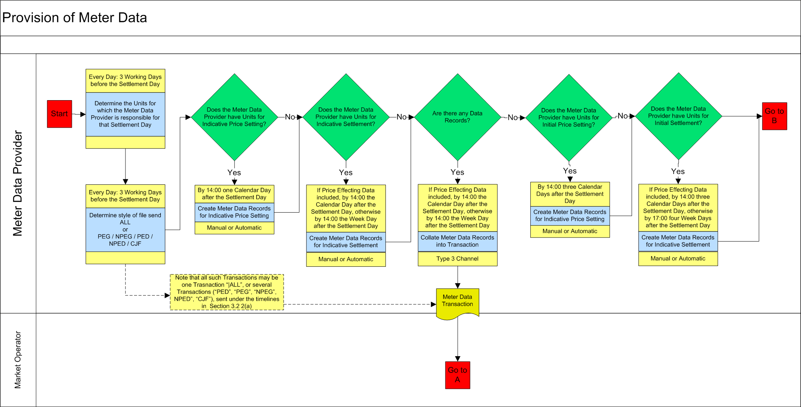

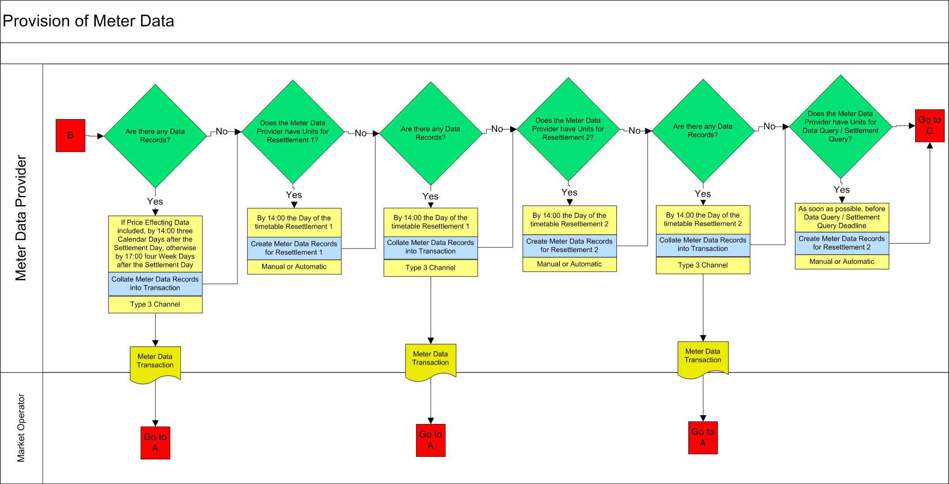

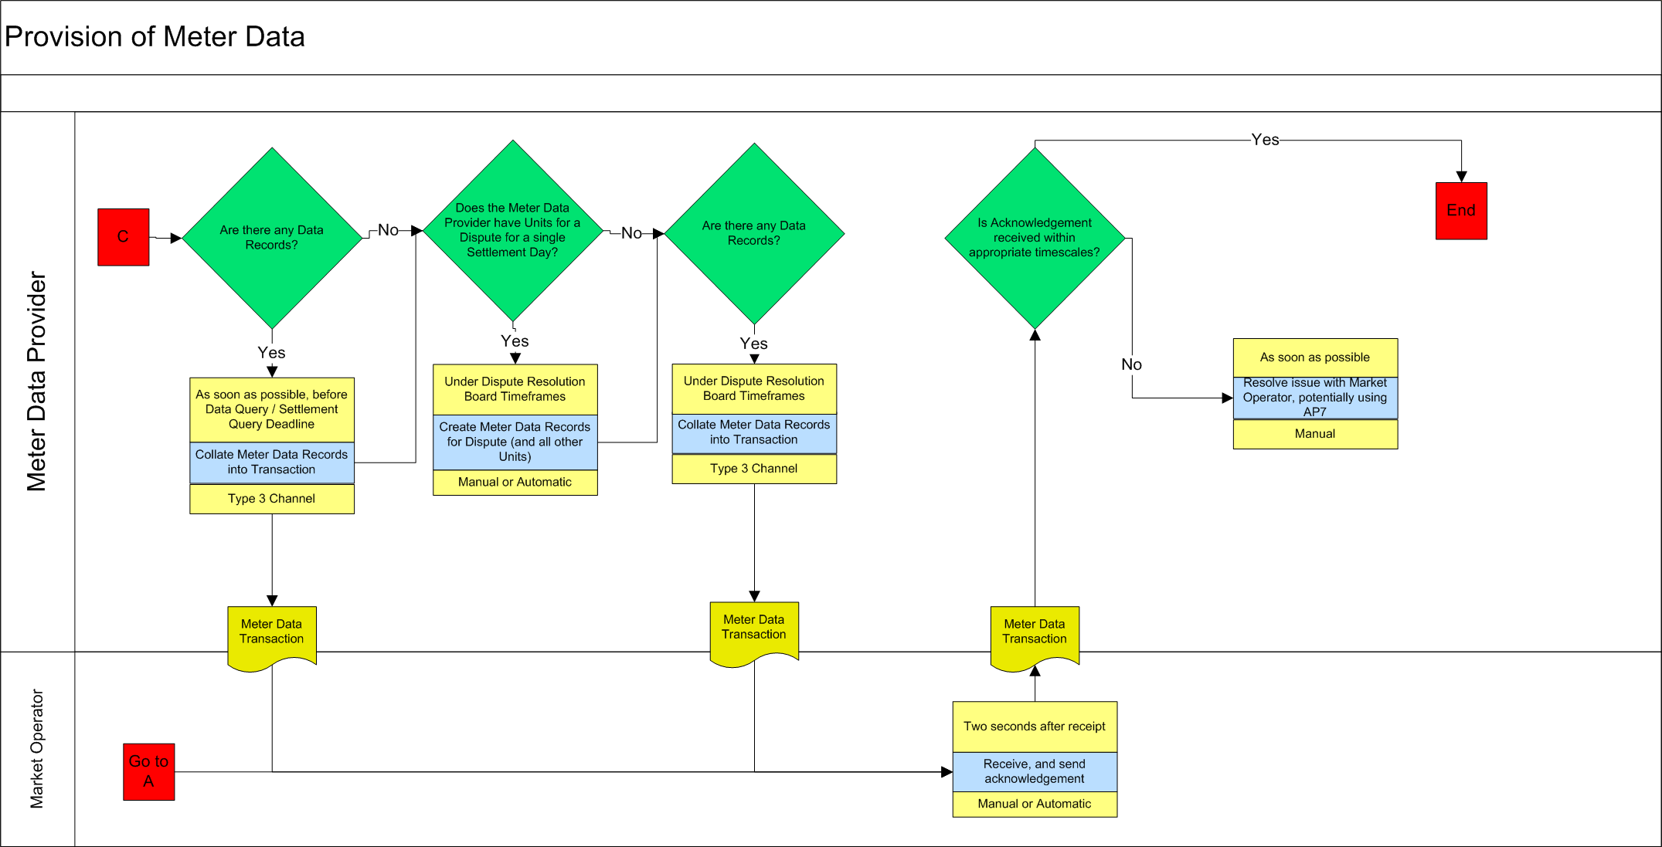

APPENDIX 1: DEFINITIONS and abbreviations

Definitions

Active Power | As defined in the Code
Agreed Procedure | As defined in the Code
Associated Supplier Unit | As defined in the Code
Autonomous Generator Unit | As defined in the Code
Availability Profile | As defined in the Code
Calendar Day | Every day of every year, including bank holidays, from the start of the wholesale Single Electricity Market.
Code | As defined in the Code
Commercial Offer Data | As defined in the Code
Connection Agreement | As defined in the Code
Credit Cover | As defined in the Code
Data Query | As defined in the Code
Data Record | As defined in the Code
Data Transaction | As defined in the Code
Demand | As defined in the Code
Demand Side Unit | As defined in the Code
Dispatch Instruction | As defined in the Code
Dispatch Quantity | As defined in the Code
Dispatchable | As defined in the Code
Dispute | As defined in the Code
Dispute Resolution Board | As defined in the Code
Distribution System | As defined in the Code
Ex-Post Indicative Settlement | As defined in the Code
Generator | As defined in the Code
Generator Unit | As defined in the Code
Indicative Aggregated Demand Metering | A complete set of Supplier Unit Demand for which a Meter Data Provider is responsible, for all Trading Periods in the Settlement Day for which each Unit is registered, sent by that Meter Data Provider to the Market Operator by 1400 on the next Week Day after the Settlement Day in question.
Indicative Aggregated Inter Jurisdiction Metering | The complete set of Net Inter Jurisdictional Flow for which a Meter Data Provider is responsible, for all Trading Periods in the Settlement Day for which the Import is registered, sent by the Meter Data Provider to the Market Operator by 1400 on the next Week Day after the Settlement Day in question.
Indicative Non Price Effecting Generation Metering | The complete set of Autonomous Generator Units for which a Meter Data Provider is responsible, for all Trading Periods in the Settlement Day for which each Unit is registered, sent by the Meter Data Provider to the Market Operator by the next Week Day after the Settlement Day in question.
Indicative Price Effecting Generation Metering | The complete set of Variable Price Taker Generator Unit Metered Generation, Predictable Price Taker Generator Unit Metered Generation and Price Maker Generator Unit Metered Generation for which a Meter Data Provider is responsible, for all Trading Periods in the Settlement Day for which each Unit is registered, sent by that Meter Data Provider to the Market Operator by 1400 on the next Calendar Day after the Settlement Day in question.
Initial Aggregated Demand Metering | A complete set of Supplier Unit Demand for which a Meter Data Provider is responsible, for all Trading Periods in the Settlement Day for which each Unit is registered, sent by that Meter Data Provider to the Market Operator by 1700 on the fourth next Week Day after the Settlement Day in question.
Initial Aggregated Inter Jurisdiction Metering | The complete set of Net Inter Jurisdictional Flow for which a Meter Data Provider is responsible, for all Trading Periods in the Settlement Day for which the Import is registered, sent by the Meter Data Provider to the Market Operator by 1400 on the fourth next Week Day after the Settlement Day in question.
Initial Non Price Effecting Generation Metering | The complete set of Autonomous Generator Unit Metered Generation for which a Meter Data Provider is responsible, for all Trading Periods in the Settlement Day for which each Unit is registered, sent by that Meter Data Provider to the Market Operator by 1700 on the fourth next Week Day after the Settlement Day in question.
Initial Price Effecting Generation Metering | The complete set of Variable Price Taker Generator Unit Metered Generation, Predictable Price Taker Generator Unit Metered Generation and Price Maker Generator Unit Metered Generation for which a Meter Data Provider is responsible, for all Trading Periods in the Settlement Day for which each Unit is registered, sent by that Meter Data Provider to the Market Operator by 1400 on the third next Calendar Day after the Settlement Day in question.
Initial Settlement | As defined in the Code
Interconnector | As defined in the Code
Interval Metering | As defined in the Code
Jurisdiction | As defined in the Code
Jurisdictional Boundary | The boundary agreed between the Transmission System in Northern Ireland and the Transmission System in Ireland by the System Operators.
Market Operator | As defined in the Code
Market Schedule Quantity | As defined in the Code
Meter Data Provider | As defined in the Code
Meter Data | As defined in the Code
Demand | As defined in the Code
Metered Generation | As defined in the Code
Net Inter Jurisdictional Flow | The Data Records describing the Net Inter-Jurisdictional Import from Northern Ireland to Ireland. The Net Inter-Jurisdictional Import from Ireland to Northern Ireland are the negatives of these Meter Data
Net Inter-Jurisdictional Import | As defined in the Code
Participant | As defined in the Code
Party | As defined in the Code
Price Maker Generator Unit | As defined in the Code
Price Setting | A run of the MSP Software
Price Taker Generator Unit | As defined in the Code
Pumped Storage Unit | As defined in the Code
Regulatory Authorities | As defined in the Code
Resettlement | As defined in the Code
Resettlement 1 | The Resettlement carried out within the fourth month of the Settlement Day as defined in the Settlement Calendar
Resettlement 1 Aggregated Demand Metering | A complete set of Supplier Unit Demand for which a Meter Data Provider is responsible, for all Trading Periods in a Settlement Day, sent by that Meter Data Provider to the Market Operator by 14:00 on a Week Day as close to within four months of that Settlement Day as practically possible, the exact Week Day of delivery to be determined by the Settlement Calendar.
Resettlement 2 | The Resettlement carried out within the thirteenth month of the Settlement Day as defined in the Settlement Calendar
Resettlement 2 Aggregated Demand Metering | A complete set of Supplier Unit Demand for which a Meter Data Provider is responsible, for all Trading Periods in a Settlement Day, sent by that Meter Data Provider to the Market Operator by 14:00 on a Week Day as close to within four months of that Settlement Day as practically possible, the exact Week Day of delivery to be determined by the Settlement Calendar.
Retail Market Operator | As defined in Agreed Procedure 1 “Participant and Unit Registration and Deregistration”
Revised Aggregated Demand Metering | A complete set of Supplier Unit Demand for which a Meter Data Provider is responsible, for all Trading Periods in the Settlement Day, sent by that Meter Data Provider to the Market Operator ad hoc as required by the Market Operator following the output of the Data Query (Agreed Procedure 12) or dispute process (Agreed Procedure 13).
Revised Aggregated Inter Jurisdiction Metering | The complete set of Net Inter Jurisdictional Flow for which a Meter Data Provider is responsible, for all Trading Periods in the Settlement Day for which the Import is registered, sent by the Meter Data Provider to the Market Operator ad hoc as required by the Market Operator following the output of the Data Query (Agreed Procedure 12) or dispute process (Agreed Procedure 13).
Revised Price Effecting Generation Metering | The complete set of Variable Price Taker Generator Unit Metered Generation, Predictable Price Taker Generator Unit Metered Generation and Price Maker Generator Unit Metered Generation for which a Meter Data Provider is responsible, for all Trading Periods in the Settlement Day for which each Unit is registered, sent by the Meter Data Provider to the Market Operator ad hoc as required by the Market Operator following the output of the Data Query (Agreed Procedure 12) or dispute process (Agreed Procedure 13).
Settlement | As defined in the Code
Settlement Day | As defined in the Code
Settlement Calendar | As defined in the Code
Single Electricity Market | As defined in the Code
Supplier Unit | As defined in the Code
System Operator | As defined in the Code
Trading Period | As defined in the Code
Trading Site | As defined in the Code
Trading Site Supplier Unit | As defined in the Code
Transmission System | As defined in the Code
Type 1 Channel | As defined in the Code
Type 3 Channel | As defined in the Code
Unit | As defined in the Code
Week Day | Every week day (Monday to Friday inclusive), including bank holidays, from the start of the wholesale Single Electricity Market. Note that for maintenance of IT systems, the Meter Data Providers may be informed by the Market Operator that certain bank holidays are not Week Days as set out in the Settlement Calendar.
Working Day | As defined in the Code

APPENDIX 2: File Format Overview

Introduction
This section gives an overview of some rules regarding the file format to be used in exchanging data between the Meter Data Providers and the SEM systems.

General Description of the SEM-MDP message format
The message format includes the following types of data:
- Header details, containing the username and password and other security details from the digital certificate
- Unit level information, including the Unit name
- Time period Meter Data at a half-hourly resolution
- Trailer details, including a checksum to verify the integrity of the file

The following principles apply to the file format:
- The message is formatted via XML
- Full stop is used in fractional numbers, e.g. 12.34 or 0.34.
- Negative numbers should be prefixed by a minus sign, e.g. -12.34 or -0.34.
- Numbers (for meter data) should be expressed to a maximum of three decimal places
- Meter Data for energy entering the Transmission System (i.e. generation) should be positive (there is no requirement for a “+” sign), and Meter Data for energy exiting the Transmission System (i.e. demand) should be signed negative (there is a requirement for “-” sign). Zero values are not signed positive or negative. Please note that this is a file-transfer convention only. Demand variables in the Code algebra, for example, Metered Demand MDvh are positive for the purposes of the Code algebra.

