MODIFICATION PROPOSAL FORM

Proposer  (Company) | Date of receipt  (assigned by Secretariat) |  | Type of Proposal  (delete as appropriate) |  | Modification Proposal ID  (assigned by Secretariat)
PPB | 06/02/20 |  | Standard |  | Mod_01_20
Contact Details for Modification Proposal Originator
Name |  | Telephone number |  | Email address
Joe Devlin |  |  |  | joseph.devlin2@powerni.co.uk
Modification Proposal Title
Setting the price of the marginal energy action when there are no energy actions in the same direction as the NIV
Documents affected  (delete as appropriate) |  | Section(s) Affected |  | Version number of T&SC or AP used in Drafting
T&SC Part B |  | E.3.4.2 |  | Version 21.0
Explanation of Proposed Change
(mandatory by originator)
This modification seeks to expand the current T&SC logic for handling instances when there are no energy actions in the entirety of the ranked set to also cover scenarios where there are no energy actions in the same direction as the NIV. The modification utilises both the PMEA and PRBO functionality to ensure imbalance price formation is reflective of the underlying system conditions and the associated price of balancing actions taken to resolve the NIV.

Due to the highly constrained nature of the SEM, instances where there are no energy actions in the ranked set have been frequently observed. The T&SC contains logic to handle these instances by setting PMEA to the price cap/price floor when the NIV is positive/negative. This functionality works well and ensures an imbalance price can be produced.

The current drafting of the algebra only requires a single energy action to be present in the stack to set PMEA. However, due to the constrained nature of the system, it is common to have ranked sets where there are no energy actions in the same direction as the NIV. Therefore, PMEA in these periods is set by an energy action in the opposite side of the stack i.e. a dec action setting PMEA when the NIV is positive and an inc action setting PMEA when the NIV is negative. This leads to prices which are not reflective of the actions on the NIV side of the stack.

This has been an almost ever-present and volatile issue in the balancing market since go live:

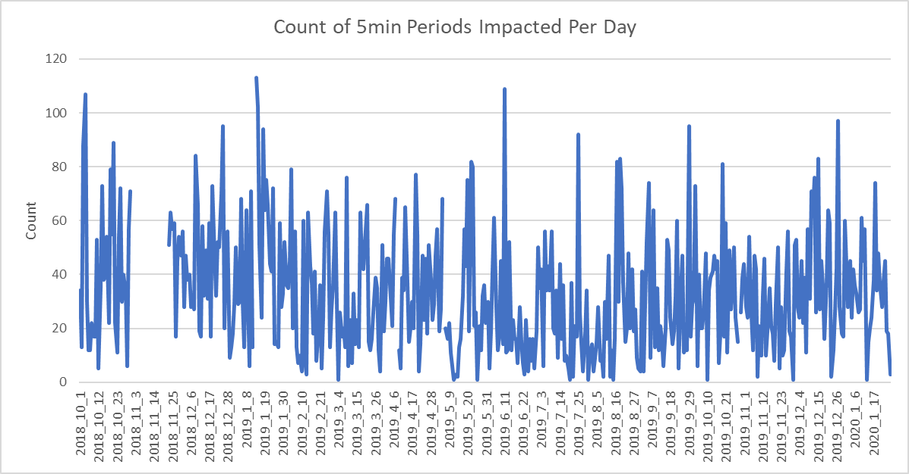

Which has had a large impact on imbalance pricing:

Total IPPs impacted | 11%
Total ISPs impacted | 33%

Having no energy actions in the same direction as the NIV occurs mainly during periods where the system is short (i.e. positive NIV) overnight:

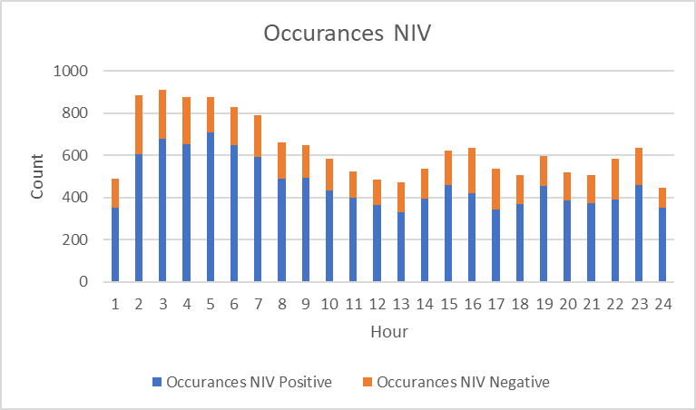

However, the average price during positive NIV periods where the issue occurs is relatively static. The issue has a much bigger impact during periods where the NIV is negative, causing significant 5 minute price volatility especially leading up to the morning peak:

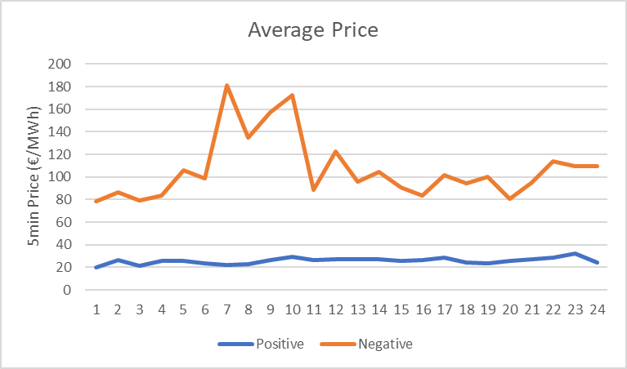

However, significant volatility can be introduced during both positive and negative NIV periods. Trade Day Jan 24th 2020 is an illustrative example, showing how impacted periods deviate from what would normally be expected given the bid offer stack at the time:
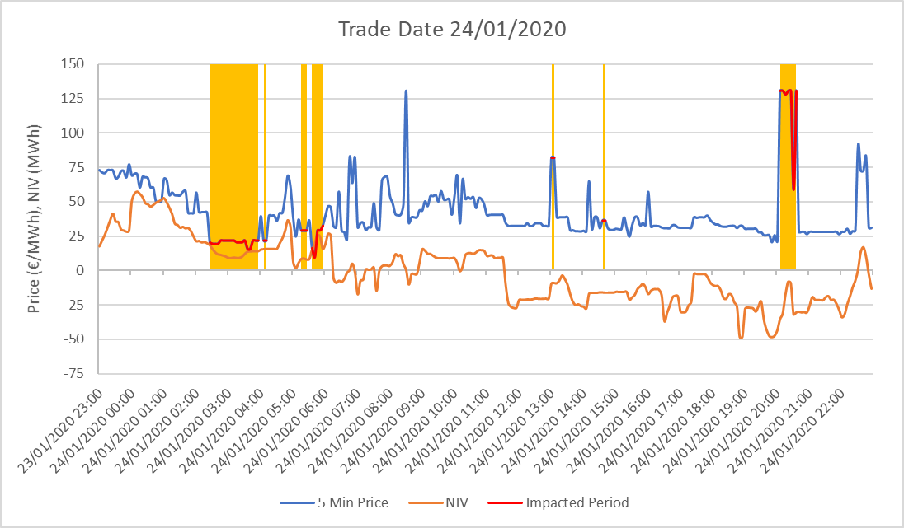

It is clear that a major driver of volatility on this day relates directly to having no energy actions in the same direction as the NIV and the associated handling of these instances by the current algebra to give a pricing outcome which is not reflective of the correct side of the bid/offer stack.

Extending the logic already present in the T&SC to set PMEA to price cap/floor when there are no energy actions in the same direction as the NIV is a narrow, targeted improvement to the algebra. Leveraging the replacement bid offer price functionality ensures that there are no unintended consequences on subsequent stages of the imbalance pricing process, as only the prices of the actions in the final PIIMB calculation are changing, not their volumes or tags.

Legal Drafting Change
(Clearly show proposed code change using tracked changes, if proposer fails to identify changes, please indicate best estimate of potential changes)

E.3.4.2 For each Imbalance Pricing Period, φ, the Market Operator shall calculate the Marginal Energy Action Price (PMEA_{φ}) as follows:

If QNIVφ>0 and there are no PBOukφ in the same direction as the NIV where FIPukφ=1, PMEAφ=PCAP; or
If QNIVφ>0 and there is at least one PBOukφ in the same direction as the NIV where FIPukφ=1, PMEAφ=MaxPBOukφ for all values of PBOukφ where FIPukφ=1; or

If QNIVφ<0 and there are no PBOukφ in the same direction as the NIV where FIPukφ=1, PMEAφ=PFLOOR; or
If QNIVφ<0 and there is at least one PBOukφ in the same direction as the NIV
$where {FIP}_{ukφ}=1, {PMEA}_{φ}=Min\left({PBO}_{ukφ} for all values of {PBO}_{ukφ} where {FIP}_{ukφ} =1\right)$

where:
        - QNIV_{φ} is the Net Imbalance Volume Quantity;
        - PBO_{ukφ} is the Bid Offer Price for Generator Unit, u, and rank, k;
        - FIP_{ukφ} is the Imbalance Price Flag for Generator Unit, u, and rank, k;
        - PCAP is the Market Price Cap; and
        - PFLOOR is the Market Price Floor.

E.3.4.3 For each Imbalance Pricing Period, φ, the Market Operator shall calculate Replaced Bid Offer Prices (PRBO_{ukφ}) for Generator Unit, u, and rank, k, as follows:

$$If {QNIV}_{φ}>0, {PRBO}_{ukφ}=Min\left({PBO}_{ukφ}, {PMEA}_{φ}\right);or$$
$$If {QNIV}_{φ}<0, {PRBO}_{ukφ}=Max\left({PBO}_{ukφ}, {PMEA}_{φ}\right)$$

where:
        - QNIV_{φ} is the Net Imbalance Volume Quantity;
        - PMEA_{φ} is the Marginal Energy Action Price; and
        - PBO_{ukφ} is the Bid Offer Price for Generator Unit, u, and rank, k.

Modification Proposal Justification
(Clearly state the reason for the Modification)
It is acknowledged that theoretically it is possible to have the true marginal energy action on the opposite side of the stack to the NIV. However, this modification seeks only to ensure that the replacement bid offer price of each action is not more expensive than any action taken in the direction of the NIV. This is to reduce the impact of junk volatility due to the highly constrained nature of the power system and the resulting high level of flagged actions in the ranked set.

The proposed modification strengthens the balance responsibility signal for market participants by delivering a price outcome that is reflective of the bid offer stack and underlying market fundamentals in specific instances where the flagging process has introduced unnecessary volatility.

Consider the following notional ranked set where QNIV= -0.5 (long system):

PBOA | QBOA | FIP | PRBO as per TSC | PRBO with Mod
490 | 7 | 0 | 490 | 490
250 | 6 | 1 | 250 | 250
120 | 0.5 | 0 | 250 | 120
80 | 3 | 0 | 250 | 80
35 | -4 | 0 | 250 | 35
30 | -8 | 0 | 250 | 30
29 | -0.5 | 0 | 250 | 29
27 | -3 | 0 | 250 | 27
-2 | -1.5 | 0 | 250 | -2

As a generalisation, it would be expected that the price in this period would be set somewhere between €35 MWh and -€2/MWh, given the prices of the dec actions in a long system. However, PMEA in our example cannot be set in the dec price range since there are no energy action on this side of the stack.

In this instance, as per the current drafting, PMEA will be set as the minimum price of the actions with FIP=1. In this case, €250/MWh. The next stage of the pricing process then uses this PMEA as part of the bid offer replacement price functionality. Given the negative NIV and the algebra in E.3.4.3, each dec action in our notional ranked set gets its price replaced from its original dec price to the PRBO price of €250/MWh. This results in an imbalance price of €250/MWh. Given the prices of the dec side of the stack, €250/MWh is not reflective of those actions or the state of the system at that time.

However, if the setting of PMEA was conducted in a manner which respected the direction of the NIV then the primary driver of junk volatility in the imbalance pricing process would be eliminated. Extending the already present functionality for handling instances where there are no energy actions in the entirety of the stack achieves this goal in a targeted manner, minimising the risk of unintended consequences and improving balancing market pricing outcomes.

In our example pricing period above, setting PMEA to price floor (which is what would happen if there were no energy actions in the ranked set when the NIV is negative) ensures that the prices of dec actions are retained at their original level and an imbalance price which is more reflective of system fundamentals (€35/MWh).

Code Objectives Furthered
(State the Code Objectives the Proposal furthers, see Section 1.3 of Part A and/or Section A.2.1.4 of Part B of the T&SC for Code Objectives)
(b) to facilitate the efficient, economic and coordinated operation, administration and development of the Single Electricity Market in a financially secure manner;
(c) to facilitate the participation of electricity undertakings engaged in the generation, supply or sale of electricity in the trading arrangements under the Single Electricity Market;
(d) to promote competition in the Single Electricity Market;
(e) to provide transparency in the operation of the Single Electricity Market;
(g) to promote the short-term and long-term interests of consumers of electricity on the island of Ireland with respect to price, quality, reliability, and security of supply of electricity.

Implication of not implementing the Modification Proposal
(State the possible outcomes should the Modification Proposal not be implemented)
Pricing outcomes may not follow market fundamentals in periods where there are a large number of flagged actions, and will have a distortive impact on imperfections charges driven by the premium and discount components in settlement.
Working Group  (State if Working Group considered necessary to develop proposal) |  |  | Impacts  (Indicate the impacts on systems, resources, processes and/or procedures; also indicate impacts on any other Market Code such as Capacity Market Code, Grid Code, Exchange Rules etc.)
Please return this form to Secretariat by email to balancingmodifications@sem-o.com

