|  |  |
| --- | --- |
| Agreed Procedure 1: Registration | November 8  2024 |

Trading and Settlement

Code

Version 30.0

Contents

1. Introduction 1

1.1. Background and Purpose 1

1.2. Scope of Agreed Procedure 1

1.3. Definitions 1

1.4. Compliance with Agreed Procedure 1

2. Overview 2

2.1. Party Registration 2

2.2. Unit Registration 2

2.3. Units as Part of Trading Sites 3

2.4. Nominating an Intermediary 4

2.5. Naming Conventions 4

2.6. Registration of User Access Rights for Participants 5

2.6.1. Appointing a Data Processing Entity 5

2.6.2. Updating Registration Data 5

2.6.3. Updating Registration Data to Controllable / Dispatchable 6

2.6.4. Validation of Registration Data by External Organisations 6

2.7. Registration of Special Units 9

2.7.1. Registration of an Interconnector 9

2.7.2. Registration of Supplier of Last Resort 9

2.7.3. Registration of an Aggregated Generator Unit 9

2.7.4. Registration of a Trading Unit 10

2.7.5. Registration of an Assetless Unit 10

3. Procedural Steps 11

3.1. Party Registration 11

3.2. Unit Registration 14

3.2.1. Stage 1: Application 14

3.2.2. Stage 2: Review and Validation 17

3.2.3. Stage 3: Participant Readiness 20

3.2.4. Stage 4: Go Live 23

3.3. Registration of Supplier of Last Resort 26

APPENDIX 1: Definitions and Abbreviations 29

APPENDIX 2: Access Roles and Rights of Users 31

APPENDIX 3: Registration Information communicated to Meter Data Operator Parties by the Market Operator 34

APPENDIX 4: Deed of Charge and Account Security 42

DOCUMENT HISTORY

|  |  |  |  |
| --- | --- | --- | --- |
| Version | Date | Author | Comment |
| 20.0 | 07/04/2017 | I-SEM Project Team |  |
| 21.0 | 12/04/2019 | SEMO | Baseline Documentation at V21.0 |
| 21.0 | 12/04/2019 | SEMO | Mod_20_18 Agreed Procedure Updates |
| 22.0 | 29/04/2020 | SEMO | Baseline Documentation at V22.0 |
| 23.0 | 03/11/2020 | SEMO | Baseline Documentation at V23.0 |
| 24.0 | 01/07/2021 | SEMO | Baseline Documentation at V24.0 |
| 25.0 | 09/11/2021 | SEMO | Baseline Documentation at V25.0 |
| 26.0 | 17/05/2022 | SEMO | Baseline Documentation at V26.0 |
| 27.0 | 07/12/2022 | SEMO | Baseline Documentation at V27.0 |
| 28.0 | 18/08/2023 | SEMO | Baseline Documentation at V28.0 |
| 29.0 | 30/07/2024 | SEMO | Baseline Documentation at V29.0 |
| 30.0 | 08/11/2024 | SEMO | Baseline Documentation at V30.0 |

RELATED DOCUMENTS

|  |  |  |  |
| --- | --- | --- | --- |
| **Document Title** | **Version** | **Date** | **By** |
| Trading and Settlement Code | 30.0 | 08/11/2024 | SEMO |
| Agreed Procedure 3 “Communication Channel Qualification” |  |  |  |
| Agreed Procedure 4 “Data “Transaction Submission and Validation” |  |  |  |
| Agreed Procedure 6 “Data Publications and Data Reporting” |  |  |  |
| Agreed Procedure 9 "Management of Credit Cover and Credit Default" |  |  |  |
| Agreed Procedure 11 "Market System Operation, Testing, Upgrading and Support" |  |  |  |
| Agreed Procedure 14 “Disputes” |  |  |  |

2. Introduction
   1. Background and Purpose

This Agreed Procedure supplements the rules in relation to Participant and Unit registration administered by the Market Operator, set out in chapter B of the Trading and Settlement Code (hereinafter referred to as the “**Code**”). It sets out procedures with which Parties to the Code must comply.

* 1. Scope of Agreed Procedure

This Agreed Procedure sets out the procedural steps for:

1. registration of a Party for accession to the market;
2. registration of a Unit for participation in the market; and
3. registration of Supplier of Last Resort.

It also sets out information in relation to nominating intermediaries, appointing a Data Processing Entity, naming conventions, updating Registration Data and validation of Registration Data by the System Operator, Distribution System Operator and / or Meter Data Provider.

This Agreed Procedure forms an annex to, and is governed by the Code. This document sets out procedures to be followed subject to the rights and obligations of Parties under the Code. In the event of any conflict between a Party’s obligations set out in the Code and this Agreed Procedure, the Code shall take precedence.

It is not intended that there be any inconsistency or conflict between section 2 “Overview” and section 3 “Procedural Steps”. However, in the event of any inconsistency or conflict, section 3 “Procedural Steps” shall take precedence.

In section 3 “Procedural Steps” a corresponding process flow diagram is included for each procedural steps table.  Process flow diagrams are for illustrative purposes.  It is not intended that there be any inconsistency or conflict between any procedural steps table and process flow diagram however, in the event of any inconsistency or conflict, a procedural steps table shall take precedence.

* 1. Definitions

Words and expressions defined in the Code shall, unless the context otherwise requires or unless otherwise defined herein at Appendix 1 “Definitions and Abbreviations”, have the same meanings when used in this Agreed Procedure. In the event of any conflict between a Party’s obligations set out in the Code and this Agreed Procedure, the Code shall take precedence.

References to particular paragraphs relate internally to this Agreed Procedure unless otherwise specified.

* 1. Compliance with Agreed Procedure

Compliance with this Agreed Procedure is required under the terms as set out in the Code.

1. Overview

The Market Operator operates the arrangements that allow Participants to trade energy, as set out in the Code. All Parties intending to participate in the Single Electricity Market must complete the Participant registration process required under the Code and this Agreed Procedure.

The registration process consists of two important steps:

1. **Party registration (for accession to the market)**: registration as a Party to the Code; and
2. **Unit registration (for participation in the market)**: a Party becomes a Participant by registering Unit(s).

Party and Unit Deregistration are facilitated by the Market Operator in accordance with the Code and Agreed Procedure 18 “Suspension and Termination”.

* 1. Party Registration

The procedural steps for registration of a Party are set out at section 3.1below.

To register with the Market Operator as a Party (for accession to the Code), an Applicant shall:

1. complete the Application Form available from the Market Operator website (which includes accession conditions);
2. comply with eligibility requirements set out in section B.5 of the Code and in the Application Form;
3. pay the Accession Fee; and
4. execute the Accession Deed.

All of the required information shall be submitted to the Market Operator and shall be validated by the Market Operator.

A Party shall only be permitted to participate in the SEM through a registered Unit. Registration of Units cannot take effect until the Applicant has become a Party to the Code. An Applicant may submit an application to register Units prior to becoming a Party, provided that a completed Participation Notice has been submitted to the Market Operator.

* 1. Unit Registration

The procedural steps for registration of a Unit are set out at section 3.2 below.

Upon registering its first Unit, a Party becomes a Participant in the jurisdiction where the Unit is located and will receive a Participant ID. A Participant ID is a unique identifier pursuant to which Units are aggregated for the purposes of:

1. calculating the Required Credit Cover;
2. Settlement Statements;
3. Settlement Reports;
4. Settlement Documents; and,
5. Settlement Reallocation Agreements.

A Party shall not register as more than one Participant save as provided for in paragraph B.7.6.2 of the Code.

In order to register a Unit, Registration Data must be submitted to the Market Operator by the Party or Applicant and will be assessed by the Market Operator to ensure that the Registration Data is complete and fulfils the eligibility requirements set out in the Code. A completed REMIT Notification Form should also be provided by the Participant should they wish to appoint the Market Operator to report Balancing Market REMIT Data for the appropriate Units to the European Agency for the Cooperation of Energy Regulators on its behalf.

Once the Market Operator has confirmed that the Registration Data is complete and meets the eligibility requirements (and taking into account Table 2 “Provision of Data (Roles and Responsibilities of External Data Providers)”) any questions or clarifications shall be progressed by the relevant Parties (Participant, Meter Data Provider, System Operators and / or Distribution System Operator) at the initial Unit registration meeting.

Once Registration Data has been validated by the Market Operator and provided that the Party is not in breach of the Code or the Framework Agreement, a Commencement Notice shall be issued to the Party with a copy sent to each System Operator and the relevant External Data Provider. When the Commencement Notice is issued, the Participant shall be registered. The Units registered to the Participant will be eligible for trading from the start of a Trading Day which corresponds with the relevant Effective Date.

A unique Digital Certificate will be assigned to persons that have been nominated by the Party as Users (in accordance with Agreed Procedure 3 “Communication Channel Qualification”). The Digital Certificate permits access to the Balancing Market Interface on behalf of the registered Participant and Unit, subject to the relevant system access permissions outlined in Appendix 2 “Access Roles and Rights of Users”.

If the Applicant fails to satisfy any part of the timelines or provision of required information under the registration process, the Market Operator may withdraw the application by issuing a Deemed Withdrawn Notice to the Party and a refund of the relevant portion of the Participation Fees.

* 1. Units as Part of Trading Sites

Each Generator Unit (excluding Pumped Storage Units, Battery Storage Units, Interconnector Residual Capacity Units, Interconnector Error Units, Assetless Units), including Trading Units and Demand Side Units shall be registered as part of a Trading Site. The following rules apply to registering Units as part of Trading Sites:

1. Each Trading Site shall contain at least one Generator Unit (except where the Generator Unit is registered as a Trading Unit).
2. Where the Generator Unit registered on a Trading Site is a Demand Side Unit, no other Generator Unit can be registered on that site.
3. All Trading Sites must record to it an Associated Supplier Unit or a Trading Site Supplier Unit.
4. Any Party registering an Autoproducer Site must register a Trading Site Supplier Unit as part of the relevant Trading Site.
5. A Trading Unit can only be registered on a Trading Site that is an Autoproducer Site. Each Unit registered as part of a Trading Site shall be registered to the same Participant except where the Party does not intend to register a Trading Site Supplier Unit.
6. A Trading Site containing an Aggregated Generator Unit must record to it an Associated Supplier Unit.
7. This Associated Supplier Unit may be registered by a different Participant to the Participant registering the Generator Unit.
8. A Supplier Unit can be registered as an Associated Supplier Unit for multiple Trading Sites.
9. A Trading Site Supplier Unit can only contain Demand related to the Trading Site to which it is registered.
10. The Firm Access Quantity of a Trading Site shall be recorded within the Participation Notice, where a Generator Unit operates under a Connection Agreement which provides for a Firm Access Quantity which is less that the Maximum Export Capacity of the relevant site.
    1. Nominating an Intermediary

In accordance with section B.6.2 of the Code, a Unit Owner may nominate an Intermediary to become a Party to the Code and a Participant in respect of its Generator Units (with the exception of the Interconnector Residual Capacity Unit and the Interconnector Error Unit which will be registered to the relevant Party as set out in the Code).

The Unit Owner is required to complete a Form of Authority for the Intermediary and the Intermediary must obtain Regulatory Authority consent in respect of the arrangement. The Intermediary will provide this Form of Authority and proof of Regulatory Authority consent to the Market Operator. The Intermediary shall otherwise follow the standard process for registering as a Party and registering Units.

* 1. Naming Conventions

The naming convention for Parties, Participants and Units is set out in the table below:

|  |  |
| --- | --- |
| Role | Naming Convention |
| Party | PY_nnnnnn |
| Participant | PT_nnnnnn |
| Trading Site | TS_nnnnnn |
| Supplier Unit  (also for Trading Site Supplier Units and Associated Supplier Units) | SU_nnnnnn |
| Generator Unit | GU_nnnnnn |
| Demand Side Unit | DSU_nnnnnn |
| Capacity Market Unit | GU/DSU_nnnnnn etc  CAU_nnnnnn[1] |
| Assetless Unit | AU_nnnnnn |
| Trading Unit | TU_nnnnnn |
| Interconnector Error Unit | IEU_nnnnnn |
| Interconnector Residual Capacity Unit | IRCU_nnnnnn |
| System Operator | TSO_aaaaaaaa |
| Meter Data Provider | MDP_aaaaaaaa |
| Interconnector | I_JJaaaaaaaa[2] |
| Interconnector Administrator | IA_aaaaaaaa |

**Table 1: Naming Conventions**

* 1. Registration of User Access Rights for Participants

Appendix 2 “Access Roles and Rights of Users” sets out the registration of access rights and roles of Users following an Applicant’s registration of a Party and subsequent registration of its first Unit to a Participant.

* + 1. Appointing a Data Processing Entity

In accordance with section C.1.2 of the Code a Party, other than the Market Operator, may appoint a Data Processing Entity to submit applicable Data Transactions, raise Settlement Queries and view Settlement Statements.

If a Party appoints a Data Processing Entity it shall notify the Market Operator by submitting the following information:

1. Party name;
2. name of person authorised to notify Market Operator of a Data Processing Entity;
3. name of Data Processing Entity; and
4. tasks that can be carried out by the Data Processing Entity.

The Market Operator shall acknowledge the submission within 2 Working Days of its receipt. The Party may then treat the Data Processing Entity as a User restricted to the tasks that the Party has permitted it to undertake.

The obtaining of access and permissions for the Data Processing Entity is equivalent to that of other Users, in accordance with Agreed Procedure 3 “Communication Channel Qualification”.

* + 1. Updating Registration Data

Updates to the Registration Data of registered Units are completed in accordance with this agreed procedure and Agreed Procedure 4 “Data Transaction Submission and Validation”.

Participants may submit updates and modifications to Registration Data via the Balancing Market Interface using the Communication Channel(s) for which they have been previously qualified (with the exception of changes to the Registered Capacity or maximum Generation of an Aggregated Generator Unit, the Firm Access Quantity of Trading Site(s) for each Trading Day (t)). Such update requests shall be submitted at least 3 Working Days before the update becomes effective.

All updates and requests submitted by the Participant shall be validated by the Market Operator (with agreement from the System Operators or Meter Data Providers as appropriate) before being approved and applied. Rejection and acceptance notifications are described in Agreed Procedure 4 "Transaction Submission and Validation".

In the case of a change to the Registered Capacity or maximum Generation of an Aggregated Generator Unit, the Participant must first send a Registration Pack with updated information for the Aggregated Generator Unit to the Market Operator, in accordance with the procedure in section 3.2.1, with no requirement for any Registration fee to be paid. Once the Registration Pack has been received and validated, the change in Registration Data will be approved.

In the case of a change to the Firm Access Quantity of Trading Site, the Participant shall inform the Market Operator of the change by completing and submitting the appropriate form which can be downloaded from the Market Operator website. The form shall be provided to the relevant System Operator and shall be validated in accordance with section B.9.3 of the Code.

* + 1. Updating Registration Data to Controllable / Dispatchable

In accordance with paragraph B.7.2.4 (b) of the Code, a Participant may apply to register a Generator Unit as a non-Controllable Unit until such time as its Operational Readiness Confirmation has been granted. The Participant must, upon receipt of this Operational Readiness Confirmation, apply to change its Registration Data to Controllable via the Balancing Market Interface. A Participant may apply to change their Registration Data from Controllable to Dispatchable, subject to any necessary Grid Code qualification requirements being met.

Any proposed change to Registration Data, must be submitted to the Balancing Market Interface, at least 19 Trading Days prior to the effective date of the change. The Participant must also submit an email confirmation (by an approved Registration User) of this change request no later than 1 Working Day after the request has been submitted to the system. The Market Operator will confirm the change with the relevant External Data Provider. Once approved, the Market Operator will commit the change in the system no later than 5 Working Days prior to the effective date, and inform, via email, all relevant Parties that the change is completed.

* + 1. Validation of Registration Data by External Organisations

The following table details those organisations external to the Market Operator i.e. the System Operator, Distribution System Operator and / or Meter Data Provider, which will facilitate registration by:

1. supporting the Applicant in providing the Registration Data; and
2. validating the information provided to the Market Operator within the timelines specified in this Agreed Procedure.

The Applicant should liaise with the System Operator and / or Meter Data Provider (as appropriate) prior to the submission of the Registration Pack to facilitate the validation of the Registration Data within 20 Working Days by the relevant external organisations. Alternatively, the System Operator shall require Units to be compliant with the Grid Code and / or Distribution Code (as appropriate).

The table below summarises the roles and responsibilities of External Data Providers with respect to the provision of data under this agreed procedure. This table shall act as a guide with respect to the provision of Meter Data and there may be exceptions to these categories. In each instance the Market Operator will confirm with the Meter Data Providers for the relevant jurisdiction who shall record the Meter Data with respect to the registering Unit. Once confirmed, the Meter Data Providers will be bound by the timelines and obligations as set out further in this document.

| **Unit Type** | **Registration Configuration** | **Provision of Market Data** |
| --- | --- | --- |
| **Supplier Unit** | Meter Data Provider confirms retail market eligibility | Meter Data Provider: QMvy |
| **Generator Unit (Transmission Connected)** | Transmission System Operator confirms that the relevant Registration Data and Technical Offer Data of Generator Unit matches the equivalent data held by the System Operator | Transmission System Operator: Dispatch Instructions, Availability  System Operator as Meter Data Provider: QMuy |
| **Generator Unit (Transmission Connected, Non-Controllable)** | Transmission System Operator confirms that the relevant Registration Data and Technical Offer Data of Generator Unit matches the equivalent data held by the System Operator | Transmission System Operator as Meter Data Provider: QMuy |
| **Trading Site: Generator Unit / Supplier Unit configurations (Transmission Connected)** | Transmission System Operator confirms configuration of Registration Data matches with the Connection Agreement | See requirements for Transmission Connected Generator Unit; and Supplier Unit |
| **Generator Unit (Distribution Connected)** | Distribution System Operator confirms that the relevant Registration Data and Technical Offer Data of Generator Unit matches the equivalent data held by the System Operator | Transmission System Operator: Dispatch Instructions, Availability  Meter Data Provider: QMuy |
| **Generator Unit (Distribution Connected, Non-Controllable** | Meter Data Provider confirms relationship between Generator and Generator Unit.  Distribution System Operator confirms that the relevant Registration Data and Technical Offer Data of Generator Unit matches the equivalent data held by the Distribution System Operator | Meter Data Provider: QMuy |
| **Trading Site: Generator Unit / Supplier Unit configurations (Distribution Connected)** | Distribution System Operator confirms configuration of Registration Data matches with the Connection Agreement | See requirements for Distribution Connected Generator Unit; and Supplier Unit |
| **Aggregated Generator Unit Transmission and / or Distribution Connected)** | System Operator confirms relationship between relevant Generators, Aggregated Generator Unit, and Generator Aggregator as contained in the Generator Aggregator System Operator Agreement | Transmission System Operator: Dispatch Instructions, Availability  NI: System Operator as Meter Data Provider: QMuy  ROI: To be included in a later version of this Agreed Procedure. |
| **Demand Side Unit** | System Operator confirms that the relevant Registration Data and Technical Offer Data of Generator Unit matches the equivalent data held by the System Operator | System Operator: Dispatch Instructions, Availability |
| **Interconnector** | Transmission System Operator confirms that the relevant Registration Data and Technical Offer Data of Interconnector ~~Unit~~ matches the equivalent data held by the System Operator | Transmission System Operator as Meter Data Provider: QMuy |
| **Trading Unit** | Market Operator, as required by the Applicant registering an Autoproducer Site. | n/a |

**Table 2: Provision of Data (Roles and Responsibilities of External Data Providers)**

**Note**: For all Units registered in the Balancing Market and participating with a SEM NEMO, the relevant Scheduling Agent will provide Contracted Quantities as required under section F.2.2 of the Code

* 1. Registration of Special Units
     1. Registration of an Interconnector

A Party may register an Interconnector pursuant to the Code and in accordance with the Unit registration procedure set out at section 3.2 below. As part of the data provided in its Participation Notice, the registering Party shall provide the Interconnector Registration Data.

* + 1. Registration of Supplier of Last Resort

The procedural steps for registration of a Supplier of Last Resort are set out at section 3.3 below.

This Supplier of Last Resort procedure details:

1. the manner in which a Supplier Unit ceases trading following the expiration of the Supplier Suspension Delay Period; and
2. the requirements for Meter Data Providers to facilitate this process.

A single Supplier Unit representing the Supplier of Last Resort will be registered in each jurisdiction by the Participant designated or directed to carry out this role by the relevant Regulatory Authority.

This registration will follow the same procedure as a Participant registering any Supplier Unit with the exception that the Supplier Unit representing the Supplier of Last Resort will not be effective until a Supplier of Last Resort Direction has been issued by the relevant Regulatory Authority. Therefore, the Supplier of Last Resort will not receive Settlement Statements or Settlement Reports in respect of this Supplier Unit until the Supplier of Last Resort Direction has been issued and the relevant unit is made effective by the Market Operator. This occurs as set out in the process below.

In the event that there are multiple defaults occurring at or around the same time resulting in multiple Supplier of Last Resort Directions within the same jurisdiction, all retail customers affected by these default events and directions will be managed under one Supplier Unit representing the Supplier of Last Resort for that jurisdiction.

The provisions for an Adjusted Participant in Agreed Procedure 9 "Management of Credit Cover and Credit Default" will apply to the Supplier Unit representing the Supplier of Last Resort once it becomes effective.

* + 1. Registration of an Aggregated Generator Unit

A Generator Aggregator may register or procure the registration of an Aggregated Generator Unit if the criteria set out in paragraph B.7.2.10 of the Code are met.

In relation to paragraph B.7.2.10 (a) of the Code, the Generator Aggregator will provide proof of the Regulatory Authority consent to the Market Operator together with the Registration Pack (see step 1.1 in section 3.2.1 below).

If the agreement referred to in paragraph B.7.2.11 of the Code is required, the Regulatory Authority consent notification will set out the details of when the agreement will come into effect, being before the Effective Date for the Aggregated Generator Unit to commence operation in the Single Electricity Market.

Subject to the above, a Party may register an Aggregated Generator Unit pursuant to the Code and in accordance with the Unit registration procedure set out at section 3.2 below.

* + 1. Registration of a Trading Unit

A Participant registering Generator Units which form part of an Autoproducer Site may also register a separate Trading Unit to facilitate participation in the day ahead and intraday markets as a single Unit.

* + 1. Registration of an Assetless Unit

SEM NEMO(s) must register an Assetless Unit with the Market Operator to account for imports to and exports from the NEMO’s Market Area, as set out in section B.8 of the Code.

A SEM NEMO shall also register an Assetless Unit for the purposes of the calculation of payments and charges relating to quantities determined under paragraph F.5.2.10 of the Code.

The Shipping Agent in respect of an Interconnector shall register an Assetless Unit in respect of that Interconnector to facilitate the notification of cross border positions on the Interconnector, in accordance with B.8.2.3 of the Code.

1. Procedural Steps
   1. Party Registration

| Step | Procedural Step | Timing | Method | By/From | To |
| --- | --- | --- | --- | --- | --- |
|  | Retrieve Application Form. | As required | Download from the Market Operator website | Applicant | - |
|  | Submit completed Application Form and pay Accession Fee. A schedule of Accession Fees is published on the Market Operator website. | As required | Email / EFT | Applicant | Market Operator |
|  | Assess Application Form and:   1. if Accession Fee is not received with the Application form, application may be withdrawn by issue of a Deemed Withdrawn Notice, **end process**. The Applicant may resubmit the Application Form and return to step 1; 2. if further information or any clarification is required, notify the Applicant that further information is required, including the content of the information. | Within 10 WD of receipt of Application Form | Email | Market Operator | Applicant |
|  | Upon receipt of notification that further information or clarification is required, provide information as requested to Market Operator.  **Note:** If more time than the allotted 20 WD is required to assess the response contact Market Operator and agree a revised submission date. If information not received within agreed revised timeline, application is deemed withdrawn. The Market Operator will issue a Deemed Withdrawn Notice. | Within 20 WD of receipt of notification that further information is required | Email / Post / Facsimile | Applicant | Market Operator |
|  | On receipt of all required information and provided the Applicant fulfils the conditions for accession, provide the Applicant with an Accession Deed. | Within 10 WD of final receipt of required information | Email | Market Operator | Applicant |
|  | Applicant executes and dates the Accession Deed and returns it to the Market Operator. | Within 20 WD of receipt or such other time agreed with the Market Operator | Registered post | Applicant | Market Operator |
|  | Market Operator executes and dates the Accession Deed and sends a copy to the Applicant. Applicant becomes a Party to the Code on the date specified in the Accession Deed. | Within 10 WD of receipt of signed Accession Deed | Email | Market Operator | Applicant |
|  | Market Operator publishes notification that the Applicant has become a Party. | Within 2 WD of the completed Accession Deed | Market Operator website | Market Operator | - |

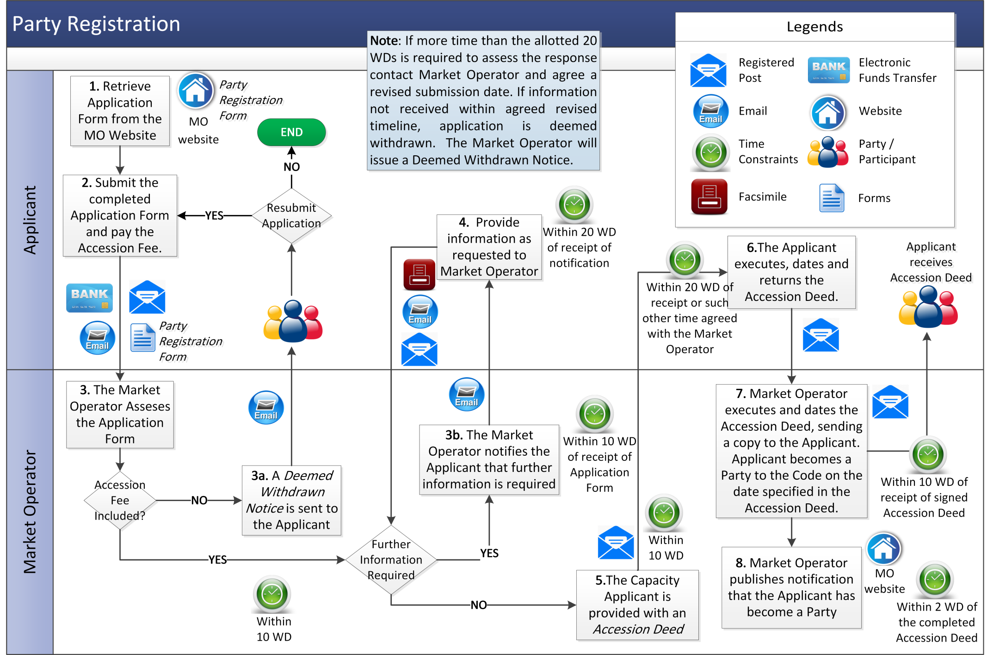

* 1. Unit Registration
     1. Stage 1: Application

The ‘Application’ phase of the Unit registration process captures the process and timelines associated between submission of the Registration Pack by the Applicant, and the subsequent review and acceptance by the Market Operator. An Applicant will not progress to Stage 2 of the process, until this stage has been completed.

| Step | Step Description | Timing | Method | By / From | To |
| --- | --- | --- | --- | --- | --- |
| 1.1 | Retrieve Registration Pack (this includes the Participation Notice which can be used to register a Unit and a REMIT Notification Form to appoint the Market Operator to report REMIT Data to the European Agency for the Cooperation of Energy Regulators on its behalf). Confirm required information with external organisations with reference to Table 2 “Provision of Data (Roles and Responsibilities of External Data Providers)” in section 2.6.4. | As required | Download from the Market Operator website, Communication with external organisation | Party or Applicant | System Operator, Meter Data Providers |
| 1.2 | Submit Participation Notice and completed Registration Pack together with the required Participation Fees by way of Electronic Funds Transfer.  Note: Where the Unit is being registered by an Intermediary the Party nominating the Intermediary shall submit a duly executed Form of Authority. The Registration Pack will detail how to satisfy certain eligibility requirements. | As required | Email / EFT | Party or Applicant | Market Operator |
| 1.3 | Assess Registration Pack and:   1. If no Participation Fee, or partial Participation Fee is received with the application for registration, the application is deemed to be withdrawn by the issue of a Deemed Withdrawn Notice, **end process**. 2. if further clarification or information is required notify the Applicant. | As required | Email | Market Operator | Party or person |
| 1.4 | Upon receipt of notification that further information or clarification is required, provide information to Market Operator as requested. | As soon as practicable | Email / Post / Facsimile | Applicant | Market Operator |
| 1.5 | Where the application is completed satisfactorily, issue confirmation of receipt of application and continue to stage 2 of the Unit registration process at section 3.2.2 below. | Within 2 WD of receipt of Registration Pack | Email | Market Operator | Party or Applicant |
| 1.6 | Where the Application is not completed satisfactorily and no additional information has been received by the Market Operator, advise Applicant that the Registration Pack has been rejected and refund any Participation Fees entitled to be refunded within 10 WD of having informed the Applicant. Cancel Unit registration and **end process**. | Within 10 WD of receipt of Registration Pack | Email | Market Operator | Party or Applicant |

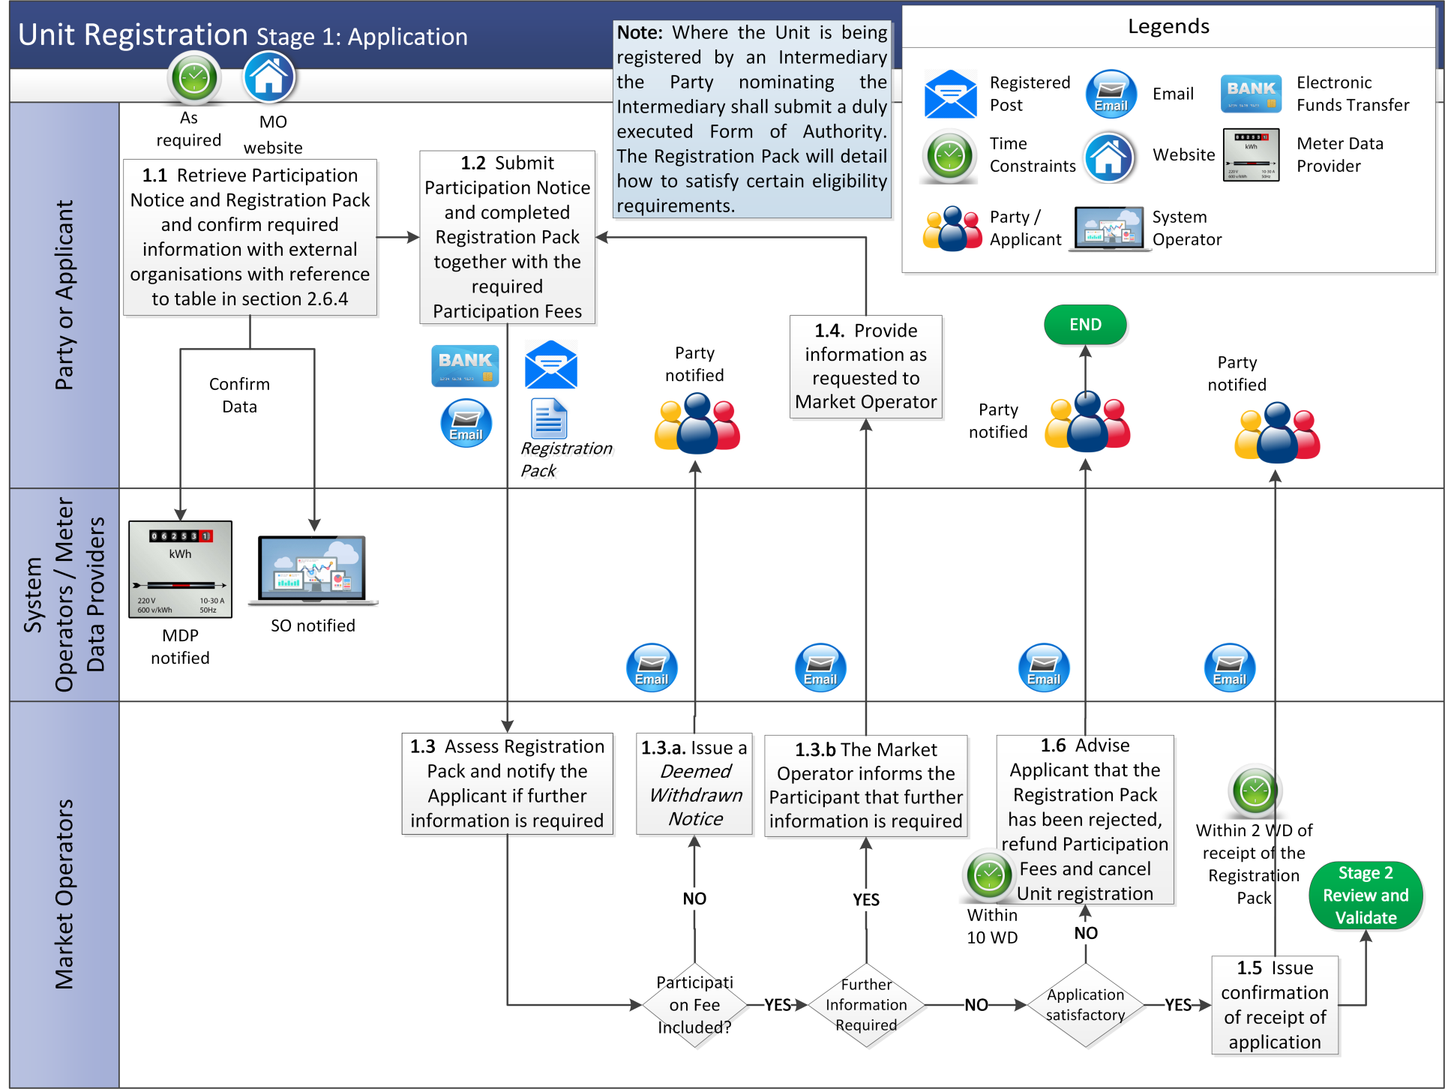

* + 1. Stage 2: Review and Validation

Once Stage 1 (application) of the Unit registration process is complete, the application for registration will be sent for review and validation by the External Data Providers. This phase of the Unit registration process details the process and timelines associated with reviewing the Unit data contained within the application, as well as confirming all necessary agreements are in place.

| **Step** | **Procedural Step** | **Timing** | **Method** | **By / From** | **To** |
| --- | --- | --- | --- | --- | --- |
| **2.1** | Inform Applicant of Participant ID and Unit ID and of any agreements that need to be in place before a Unit can participate in the market. | Within 3 WD of Stage 2 commencing | Email | Market Operator | Party or Applicant |
| **2.2** | Send completed Registration Pack and all relevant Participant IDs and Unit IDs to the relevant System Operator, and / or Meter Data Provider (as appropriate). | Within 3 WD of Stage 2 commencing | Email | Market Operator | System Operator / Meter Data Provider |
| **2.3** | Issue initial Required Credit Cover amount and Authorised Signatory Form. | Within 3 WD of Stage 2 commencing | Email | Market Operator | Party or Applicant |
| **2.4** | Issue banking details confirmation letter. | Within 2 WD of receipt of completed Authorised Signatory Form | Email / Post | Market Operator | Party or Applicant |
| **2.5** | The Applicant confirms the following (where applicable):   1. TUoS / DUoS application in progress; 2. Contact with TSO regarding Credit Cover requirements; 3. Submission of EDIL Data in progress; and 4. Metering is in place or in progress. | As available, notification of agreements that need to be in place prior to Unit participate in the market | Email | Party or Applicant | System Operators / Meter Data Provider |
| **2.6** | Check Registration Data provided by Participant in the Registration Pack and:   1. if there are any issues or clarifications required in relation to the information provided notify the Market Operator and continue to step 2.7; 2. if no further information is required, confirm the Registration Data is complete, and commence work on Meter Data Provider / System Operator systems and processes to complete Unit Registration. | Within 15 WD (or as soon as is possible) of receipt of Registration Pack from Market Operator | Email | System Operator / Meter Data Provider | Market Operator |
| **2.7** | Inform Applicant of any clarifications or information needed. | Within 2 WD of request for clarification from System Operators / Meter Data Provider | Email | Market Operator | Party or Applicant |
| **2.8** | Provide all necessary clarifications or additional information requested. | Within 5 WD of request for clarification from Market Operator | Email | Party or Applicant | Market Operator |
| **2.9** | Send information received under step 2.8 to the relevant System Operator and relevant Meter Data Provider as appropriate.  Return to step 2.6 until all requirements have been met and review and validation is complete. | Within 1 WD of receipt of clarifications from the Applicant | Email | Market Operator | System Operator / Meter Data Provider |

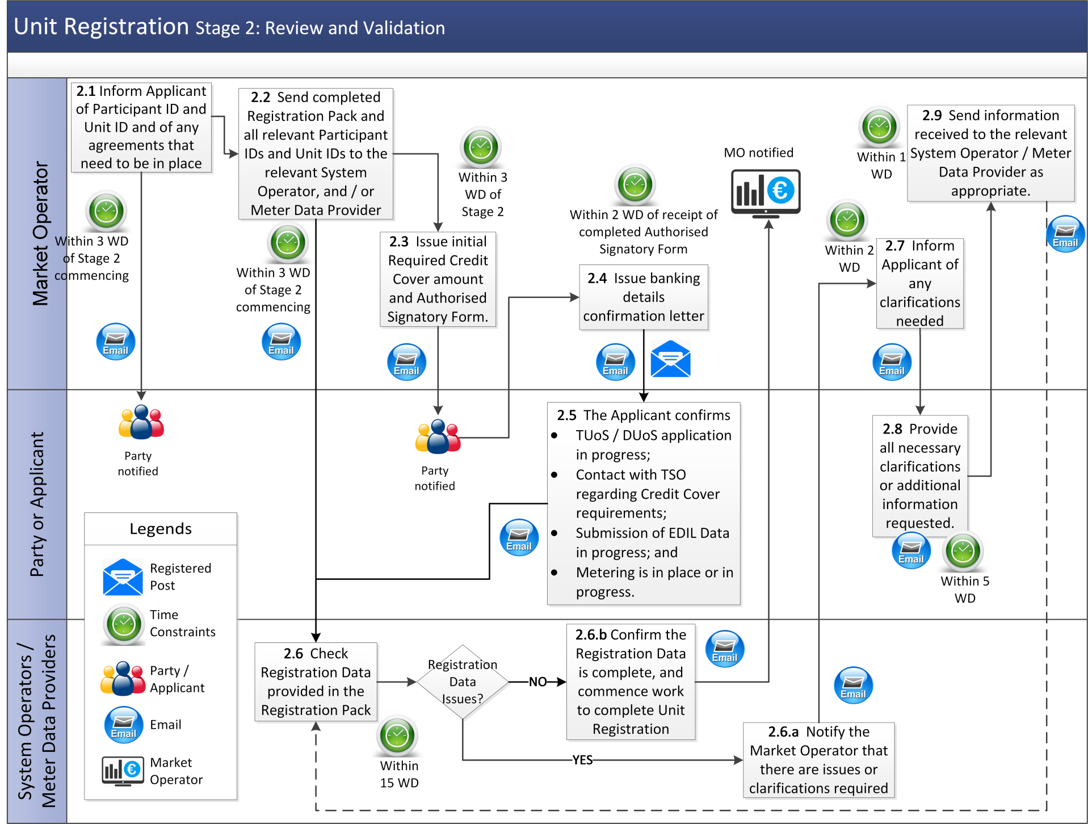

* + 1. Stage 3: Participant Readiness

The Participant readiness phase of the Unit registration process details the process and timelines in identifying a possible Effective Date for the Unit registration, as well as outlining the timelines for completing any outstanding requirements. In practice, stage 3 may commence subject to agreement from the Market Operator and External Data Providers that steps 2.4 and 2.5 in stage 2 are sufficiently progressed by the Participant. An Applicant shall not progress to Stage 4 (Go-Live) of the process, until stage 3 has been completed.

| **Step** | **Procedural Step** | **Timing** | **Method** | **By / From** | **To** |
| --- | --- | --- | --- | --- | --- |
| **3.1** | Organise and hold initial Unit registration meeting for the purposes of identification of a possible Meter Data Export Date.  Agree a target Effective Date. | Within 1 WD of completion of Stage 2 | Conference Call / Meeting | Market Operator | System Operator, External Data Provider(s),  Party or Applicant |
| **3.2** | Request any outstanding requirements, data and documents relating to the Unit registration. | Within 1 WD of the meeting at step 3.1 | Email | Market Operator | System Operators, External Data Provider(s),  Party or Applicant |
| **3.3** | Provide written confirmation of any outstanding requirements, data or documents to the Market Operator, as requested. | Within 20 WD of request at step 3.2 | Email | System Operators, External Data Provider(s),  Party or Applicant | Market Operator |
| **3.4** | Commence work on operational and system(s) readiness. | Within 1 WD of the meeting at step 3.1 | - | System Operators | - |
| **3.5** | Check written confirmation of any outstanding issues. If any outstanding issues remain return to step 3.2 until adequate information is received, otherwise continue to Stage 4 (Go Live) at section 3.2.4 below. | Within 20 WD of written confirmation of outstanding issues | Email / Telephone | Market Operator | - |

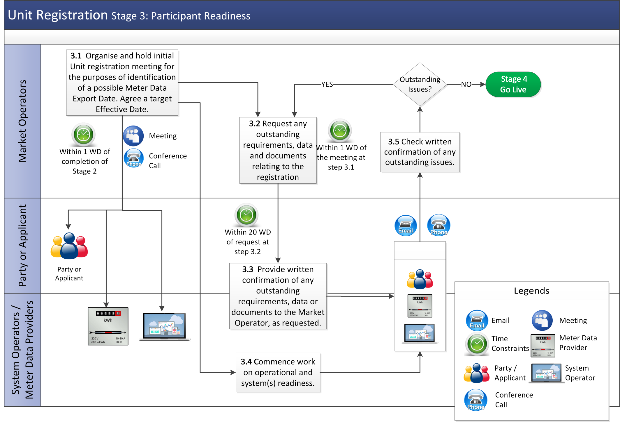

* + 1. Stage 4: Go Live

Once Stage 3 is complete, the Unit registration application will enter the final stage of the application process, the ‘Go Live’ phase. This phase of the application is to confirm an Effective Date for the Unit registration with the Market Operator and the External Data Providers. This stage also outlines the readiness activities required to be completed by the Market Operator and External Data Providers, as applicable, prior to, and subsequent to, the agreed Effective Date.

| **Step** | **Procedural Step** | **Timing** | **Method** | **By/From** | **To** |
| --- | --- | --- | --- | --- | --- |
| **4.1** | Organise and hold final registration meeting with all relevant Parties to determine the Effective Date and discuss any outstanding clarifications or issues.  If there are outstanding issues the Party (or Applicant), System Operator and Meter Data Provider work together to resolve the issue, with the Market Operator co-ordinating and facilitating meetings and communication contacts. The Unit registration process is on hold until issue resolved.  If the Unit registration is withdrawn, inform all relevant parties and end process. | 1 WD after completion of stage 3 | Conference call, Meeting or Email | Market Operator | Participant, System Operator, Meter Data Provider |
| **4.2** | Post required Credit Cover based on Agreed Procedure 9 “Management of Credit Cover and Credit Default”  If Credit Cover is not posted according to timelines, return to step 4.1 | As early as possible but at least 10 WD prior to the Effective Date | - | Party | Market Operator |
| **4.3** | Issue written confirmation that all outstanding actions are complete and confirm Effective Date. | Within 5 WD prior to the Effective Date | Email | Market Operator | Party or Applicant, System Operator, Meter Data Provider |
| **4.4** | If the Unit is a Generator Unit, the System Operator provides DLAFs, TLAFs and CLAFs from the Effective Date. | As early as possible but at least 2 WD prior to the Effective Date | Type 3 Channel | System Operator | Market Operator |
| **4.5** | Issue a Commencement Notice to the Party and a copy to System Operators and External Data Provider(s). | As early as possible but at least 4 WD prior to the Effective Date | Email | Market Operator | Party, each System Operator, the appropriate External Data Provider(s) |
| **4.6** | Maintain and publish list of the registered Units in accordance with Agreed Procedure 6 “Data Publication and Data Reporting”. | As early as possible prior to the Effective Date | Market Operator website | Market Operator |  |
| **4.7** | Validate Meter Data and notify of Effective Date. | Subsequent to Effective Date (as set out in the Code) | Email | Meter Data Provider | Market Operator, Party (or Applicant) |
| **4.8** | Update Meter Data if required, in accordance with chapter F of the Code and Agreed Procedure 13 “Settlement Queries” and resubmit Meter Data to the Market Operator | Ad hoc | Email | Meter Data Provider | Market Operator |

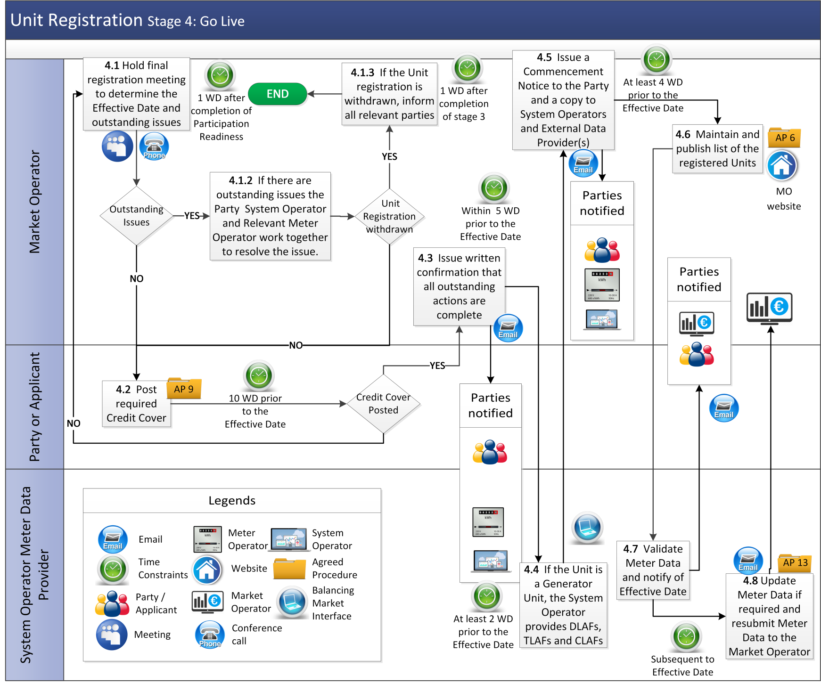

* 1. Registration of Supplier of Last Resort

| **Step** | **Procedural Step** | **Timing** | **Method** | | **By/From** | **To** |
| --- | --- | --- | --- | --- | --- | --- |
|  | Relevant Regulatory Authority directs that all demand represented by that Supplier Unit shall be met by a Supplier of Last Resort (“**SoLR**”) | On receipt of SoLR direction from Regulatory Authorities | Email | | Regulatory Authorities | Meter Data Provider, Market Operator |
|  | Set the Supplier Unit representing the SoLR to be effective for trading on the day on which the retail SoLR procedure begins | Date as confirmed with relevant Meter Data Provider | Update in Central Market Systems | | Market Operator | - |
|  | Inform Meter Data Provider of the effective Supplier Unit representing the SoLR | On completion of step 2 | | Email | Market Operator | Meter Data Providers |
|  | Initiate applicable retail market procedures for implementation of the SoLR which will include the transfer of the customers of the defaulting Supplier Unit(s) to the Supplier Unit representing SoLR. | On completion of step 1 |  | | Meter Data Providers | - |
|  | Send Meter Data for defaulting Supplier Unit(s) (with decreasing volumes) and data for the Supplier Unit representing the SoLR (with increasing volumes) to the Market Operator for Indicative Settlement | As per timelines in Agreed Procedure 16 “Provision of Meter Data” | In accordance with Agreed Procedure 16 “Provision of Meter Data” | | Meter Data Providers | Market Operator |
|  | Confirm that all Supplier Units subject to the Suspension Order now contain zero data | By the day before the Supplier Suspension Order takes effect | Email | | Meter Data Providers | Market Operator |
|  | Market Operator deregisters Supplier Unit(s) which are subject to the Suspension Order. | Date as confirmed with relevant Meter Data Provider | Manual in CMS/ automated retail processes | | Market Operator | - |
|  | Market Operator reconfigures all Trading Site configurations where the deregistered Supplier Unit(s) were recorded as the Associated Supplier Unit so that the Supplier Unit representing the SoLR is an Associated Supplier Unit. | On completion of step 6 | Manual in CMS/ automated retail processes | | Market Operator | - |
|  | Market Operator confirms wholesale market registration changes to Meter Data Providers | On completion of step 7 | Email | | Market Operator | Meter Data Providers |
|  | Affected Meter Data Provider deregisters the relevant Supplier Units from the retail systems | Date as confirmed with relevant Meter Data Provider | Manual / Automated Process | | Meter Data Providers | - |

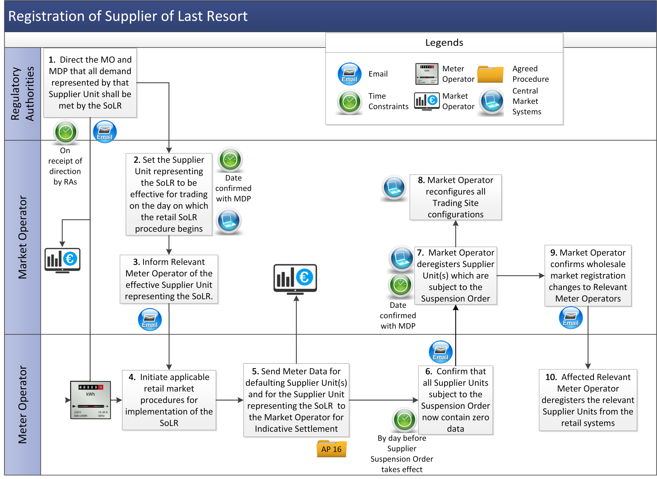

1. Definitions and Abbreviations

Definitions

|  |  |
| --- | --- |
| **Application Form** | means the form available on the Market Operator Website which is required to be completed by an Applicant to become a Party to the Code. |
| **Authorised Signatory Form** | means the form received from the Market Operator during the registration process described in Agreed Procedure 1”Registration” which nominates the persons who are authorised to confirm changes to Participant bank account details. |
| **Balancing Market Interface** | means the function within the Market Operator’s Isolated Market System that interfaces to the Type 2 Channel and Type 3 Channel communications in accordance with the Code. |
| **Capacity Market Unit** | has the meaning given to it in the Capacity Market Code. |
| **Deemed Withdrawn Notice** | means the notification provided by the Market Operator that an application for registration is being withdrawn |
| **Digital Certificate** | has the meaning given to it in Agreed Procedure 5 “Data Storage and IT Security”. |
| **Functional Area** | means the different parts of the Market Participant Interface that Users may be provided access as set out in this Agreed Procedure. |
| **Participant ID** | means the identifier that represents the unique grouping of Generator and/or Supplier Units to the entity defined as a Participant in the Code and is used in the Central Market Systems to calculate Required Credit Cover. |
| **Registration Pack** | means the documentation and information that assists with Unit and Participant registration |
| **Retail Market Operator** | means the business group within ESB Networks or NIE Networks responsible for managing the retail market data, registrations, and deregistration between final consumers and Supplier Units. |
| **Supplier of Last Resort Direction** | means a direction by the Regulatory Authority to the Meter Data Provider and Supplier of Last Resort of a jurisdiction that all demand represented by a defaulting Supplier Unit shall be met by the Supplier Unit representing the Supplier of Last Resort as per relevant Retail Market Processes. |
| **User** | means:   1. in relation to a Party: a nominated member of the Party staff who is authorised to utilise qualified communication facilities that interact with the Market Operator’s Isolated Market System; and 2. in relation to the Market Operator: a member of the Market Operator staff who has been authorised to access specific parts of the Market Operator Isolated Market System. |

Abbreviations

|  |  |
| --- | --- |
| **a** | Alphabetical indicator in naming convention |
| **EFT** | Electronic Funds Transfer |
| **MDP** | Meter Data Provider |
| **MO** | Market Operator |
| **MPRN** | Meter Point Registration Number |
| **n** | Numerical indicator in naming convention |
| **PAU** | Party Administrative User |
| **RU** | Registration User |
| **OSU** | Other System User |
| **SoLR** | Supplier of Last Resort |

1. Access Roles and Rights of Users

Access Roles Overview

The Party, via the Party Administrative User (“**PAU**”) defines the access roles and rights of its Users. The Party is responsible for designating the read and write privileges of its Users to each of the Functional Areas of the Balancing Market Interface. It is the Market Operator who approves all new Users and amendments to existing Users. All updates to User information should be made to the Balancing Market Interface.

A User must have a Digital Certificate obtained under Agreed Procedure 3 “Communication Channel Qualification” to access the Balancing Market Interface, which will enable data submission by Type 2 Channel or Type 3 Channel. Each User will have a Digital Certificate which is tied to a Party and an application password allowing the User access to the Balancing Market Interface. For a User to be eligible to submit or view data for a Participant, each User will need appropriate system access for each relevant Market Participant.

Contact Types

A Party may assign a number of key contacts for different market functions. At a minimum a Party will have to define one key contact for each of the following contact types, as appropriate. If there is one key contact for all these contact types, then only a “Main Contact” should be recorded. This information must be updated by the PAU, once submitted the changes are automatically approved.

|  |  |
| --- | --- |
| **Contact Type** | **Role Description** |
| Main | Main Contact |
| Registration | Registration Contact |
| Balancing Trading | Balancing Trading Contact |
| Capacity Trading | Capacity Trading Contact |
| Settlement | Balancing and Capacity Settlement and Billing Contact |
| Payments | Balancing and Capacity Payments Contact |
| Credit Cover | Balancing and Capacity Credit Cover Contact |
| NEMO Trading | NEMO Trading Contact |
| NEMO Settlement | NEMO Settlement Contact |
| AoLR | AoLR Trading Contact |

User Types

There are three distinct User Types, each User Type will have unique roles that can be performed within specific Functional Areas. Each Party may identify more than one User for each User type. There shall be no requirement for the Market Operator to approve this information.

|  |  |
| --- | --- |
| **User Type** | **Role Description** |
| Party Administrative User (PAU) | The role of the PAU is to create and maintain the User information pertaining to a Party. |
| Registration User (RU) | The role of the RU is to create and maintain registration data pertaining to the Party, including all entities underneath the Party (E.G. Participant, Unit etc). |
| Other System User (OSU) | A User that is not configured as a PAU or an RU, but is given system access within the Balancing Market Interface is an OSU.  The role of the OSU is to perform other Read or Write tasks within the Balancing Market Interface. System access is administered at a Participant level. |

Note: A single User can be any combination of a Party Administrative User, Registration User and Other System User, enabling the user to perform all the required functions on behalf of the Party.

Access Rights for each Functional Area

User can be given “Read”, “Write” or “No Access” to the following functional areas.

|  |  |  |
| --- | --- | --- |
|  | **Access Right** | |
| **Functional Area** | **Read-Only** | **Read-Write** |
| Registration | No | Yes |
| Balancing Trading | Yes | Yes |
| Balancing and Capacity Market Settlement | Yes | No |
| NEMO Auction Trader (DAM) | Yes | Yes |
| NEMO Continuous Trader (IDM) | Yes | Yes |

Registration Users are provided Read-Write access to “Registration” and will be able to access data for all Participants and Units for the relevant Party. To access registration a User must be set up as a Registration User. There shall be no requirement for the Market Operator to approve this information.

System access relating to NEMO systems (Trading and Settlement) and Capacity Market systems (Trading) is captured within the Balancing Market Interface, only. These functions will not be performed within the Balancing Market Interface.

Read-Only Access

A User with Read-Only access:

1. Is restricted only to that Participant’s data.
2. Can only view that Participant’s information in the relevant Functional Area but cannot submit any changes to the database.
3. Cannot view details of other Participants.

Read-Write Access

A User with Read-Write access:

1. Is restricted only to data relevant to this Participant.
2. Can view/add/edit only information relevant to this Participant.
3. Cannot view details of other Participants.
4. Registration Information communicated to Meter Data Provider Parties by the Market Operator

Overview

All communication of registration events between the Market Operator and the Meter Data Providers (MDP) will follow the same timeline process outlined below:

1. **Working Day 1** – On behalf of the Participant, the Market Operator will contact the MDP via email to confirm that the Unit being referred to is correctly managed by that MDP. This communication will contain information for the particular type of registration event, including a proposed effective date, if known. This occurs during the validation of the eligibility requirements associated with the registration or deregistration of a Unit.
2. **Working Day 5** – Confirmation email sent from the MDP to the Market Operator noting that the information relating to the registration event is understood. The MDP will commence their process for system and operational readiness with respect to that Unit.
3. **Prior to Final Registration Meeting** – Final email confirmation from MDP to Market Operator that the proposed effective day is achievable. If the proposed effective day cannot be met, the MDP must identify the reason why the proposed effective day is not possible. The application will not progress to step 4.1 of section 3.2.4 of this Agreed Procedure until the final confirmation is sent through confirming the earliest achievable effective date that the MDP must target as their readiness date.
4. **Final Registration Meeting** – The Market Operator, Participant, MDP and relevant System Operator (where applicable) agrees to the effective date associated with the particular type of registration event.
5. **Effective Date** – This represents the Trading Day that the Unit will go live in the Market. This is the first date that the MDP must submit Meter Data on behalf of the registered Unit. In the case of a Deregistration, the effective date represents the first Trading Day that the MDP must stop submitting Meter Data on behalf of the Deregistering Unit. For the registration of a new Generator Unit the Meter Data Provider will complete the Meter Data validation, as set out in steps 4.7 to 4.8 of section 3.2.4 of this Agreed Procedure.

There are nine standard registration events, summarised in the below table. The timelines for these events follow the process set out above.

|  |  |
| --- | --- |
| **Event Number** | **Registration Event** |
| 1 | New Generator Unit Registered |
| 2 | New Supplier Unit Registered |
| 3 | Deregister a Generator Unit |
| 4 | Deregister a Supplier Unit |
| 5 | Change of Trading Site Demand from Trading Site Supplier Unit to different Trading Site Supplier Unit |
| 6 | Change of Trading Site Demand from Trading Site Supplier Unit to an Associated Supplier Unit |
| 7 | Change of Trading Site Demand from Associated Supplier Unit to a Trading Site Supplier Unit |
| 8 | Change of Trading Site Demand from an Associated Supplier Unit to a different Associated Supplier Unit |
| 9 | Deregistration of Supplier Units due to a Termination Order (SoLR Process)[3] |

Registration Event Detail

The section below describes each of the eight registration events, specifically detailing the prerequisite checks required to be carried out, as well as the communication process to be followed by the Market Operator or Meter Data Provider in the scenario where any of these events have been triggered.

## Registration Event 1: New Generator Unit

The following registration event described is the process associated with the registration of a Generator Unit. The following prerequisite checks must be carried out to ensure the correct registration events are followed with respect to this request.

|  |  |
| --- | --- |
| **Prerequisite Check** | |
| Existing Trading Site | Is the Generator Unit registering as part of an existing Trading Site?  If ‘Yes’, registration of new Generator Unit at Trading Site does not trigger any direct changes to the Demand allocation. |
| New Trading Site | Is the Generator Unit Registering as part of a new Trading Site?  If ‘Yes’ the Participant must specify the Associated Supplier Unit that will record the Trading Site Demand; or the Participant must register a new Trading Site Supplier Unit. |

The following communication will be issued by the Market Operator to the MDP upon receipt of a valid application pack to register a Generator Unit.

|  |  |
| --- | --- |
| **Content of Communication – Email** | |
| **Field Name** | **Field Description** |
| **Generator Unit Name** | This is the actual name of the Generator Unit. |
| **Generator Unit ID** | Must include the ID of the Generator Unit, including any Generator Units registered to the relevant Trading Site. |
| **MPRN or Connection Agreement Reference** | the MPRN of the Trading Site (or equivalently a Connection Agreement reference where the MPRN can be identified). |
| **Supplier Unit Name** | This is the actual name of the Supplier Unit noted below. |
| **Supplier Unit ID** | The ID of the Supplier Unit to which Demand quantities at this Trading Site are to be aggregated. |
| **Trading Site Supplier Unit Flag** | This will indicated if a Supplier Unit is a Trading Site Supplier Unit. Indicated as ‘Y’ ‘N’.  *Note: Each Demand Side Unit registered must also register a Trading Site Supplier Unit.* |
| **Associated Supplier Unit** | This will indicated if a Supplier Unit is an Associated Supplier Unit. Indicated as ‘Y’ ‘N’.  *Note: The Demand for an Aggregated Generator Unit must be recorded by an Associated Supplier Unit.* |
| **Trading Site ID** | Identifier by which the Trading Site is known (i.e. TS_nnnnnn) |
| **Trading Site Name** | The External name of the Trading Site |
| **Proposed Effective Date** | This will detail an indicative effective date for registration of the Generator Unit, if known. |
| **Comment** | |
| All Generator Units must be registered as part of a Trading Site. | |

**Additional Communications:**

1. **Meter Data Export Date**: The relevant Meter Data Provider will send an email communication to the Market Operator, confirming the Meter Data Export Date.
2. **Meter Validation Date:** The relevant Meter Data Provider must send a notification to the Market Operator confirming the Meter Validation Date for a new Unit registration, this date signifies the date in which the meter data has been validated by the Meter Data Provider, as defined in the Code.

## Registration Event 2: New Supplier Unit

**Standard Supplier Unit**

The following registration event described is the process associated with the registration of a Supplier Unit. For any Supplier Unit that does not record the Demand associated with a Trading Site, the following communication will be issued to the Meter Data Provider by the Market Operator.

|  |  |
| --- | --- |
| **Content of Communication – Email** | |
| **Field Name** | **Field Description** |
| **Supplier Unit Name** | This is the actual name of the Supplier Unit. |
| **Supplier Unit ID** | The ID of the Supplier Unit to which Demand quantities at this Trading Site are to be aggregated. |
| **Proposed Effective Date** | This will detail an indicative effective date for registration of the Supplier Unit, if known. |

**Associated Supplier Unit and Trading Site Supplier Unit**

If a Participant is registering an Associated Supplier Unit or a Trading Site Supplier Unit, the following process should be followed. The following prerequisite checks must be carried out to ensure the correct registration events are followed with respect to this request.

|  |  |
| --- | --- |
| **Prerequisite Check** | |
| New Trading Site | Is the Participant registering a Supplier Unit intending to record Trading Site Demand for a new Trading Site, then;   * The Participant must register an Associated Supplier Unit or a Trading Site Supplier Unit, as appropriate under the Code. * The Participant must specify the Trading Site for which Demand is intended to be recorded for. * The effective dates associated with the Generator Unit and Supplier Unit registrations must align. |
| Existing Trading Site | Is the Supplier Unit being registered is intending to record Demand associated with an existing Trading Site? Then registration events 5 to 8 may need to be considered. The participant must specify the Trading Site that the Supplier Unit is intending to record the Trading Site Demand on behalf of. |

The following communication will be issued by the Market Operator to the Meter Data Provider upon receipt of a valid application pack to register a Supplier Unit.

|  |  |
| --- | --- |
| **Content of Communication – Email** | |
| **Field Name** | **Field Description** |
| **Supplier Unit Name** | This is the actual name of the Supplier Unit. |
| **Supplier Unit ID** | The ID of the Supplier Unit to which Demand quantities at this Trading Site are to be aggregated. |
| **Trading Site Supplier Unit Flag** | This will indicated if a Supplier Unit is a Trading Site Supplier Unit. Indicated as ‘Y’ ‘N’. – If ‘Y’ see below |
| **Associated Supplier Unit Flag** | This will indicated if a Supplier Unit is a Trading Site Supplier Unit. Indicated as ‘Y’ ‘N’. If ‘Y’ see below |
| **MPRN or Connection Agreement Reference** | The MPRN of the Trading Site (or equivalently a Connection Agreement reference where the MPRN can be identified). |
| **Trading Site ID** | Identifier by which the Trading Site is known (i.e. TS_nnnnnn) |
| **Trading Site Name** | The External name of the Trading Site |
| **Generator Unit ID** | In the event of deregistering a Trading Site Supplier Unit this will include any Generator Units registered to the relevant Trading Site. |
| **Proposed Effective Date** | This will detail an indicative effective date for registration of the Supplier Unit, if known. |
| **Comment** | |
| Where a Supplier Unit is a Trading Site Supplier Unit, there can be no further MPRNs included in the Supplier Unit aggregation. This means that if the Retail Market Operator receives an application for a new MPRN under the Trading Site Supplier Unit, it will be rejected. | |

## Registration Event 3 – Generator Unit Deregistration

The following registration event described is the process associated with the Deregistration of a Generator Unit. The following prerequisite checks must be carried out to ensure the correct registration events are followed with respect to this request.

|  |  |
| --- | --- |
| **Prerequisite Check** | |
| Is it the last Generator Unit on the Trading Site | Is the Generator Unit that is deregistering the last Generator Unit on the relevant Trading Site?  If ‘Yes’ and a Trading Site Supplier Unit records the Demand on that Trading Site, then Registration Event 4 for Supplier Unit Deregistration must be triggered. The Generator Unit and the Supplier Unit must deregister on the same Effective Date.  **Note**: For an Autoproducer Site where generation is deregistered but not the Demand, the Supplier Unit may change category from a Trading Site Supplier Unit to a standard Supplier Unit.  If ‘Yes’ and an Associated Supplier Unit records the Demand on that Trading Site, then confirm this is not the last MPRN associated with that Supplier Unit. If it is then Registration Event 4 for Supplier Unit Deregistration must be triggered; or alternatively the Participant may apply to change their category to a standard Supplier Unit. If deregistering, the Generator Unit and the Supplier Unit (as applicable) must deregister on the same effective date. |

The following communication will be issued by the Market Operator to the Meter Data Provider upon receipt of a valid application pack to deregister a Generator Unit.

|  |  |
| --- | --- |
| **Content of Communication – Email** | |
| **Field Name** | **Field Description** |
| **Generator Unit Name** | This is the actual name of the Generator Unit. |
| **Generator Unit ID** | Must include the ID of the Generator Unit, including any additional Generator Units registered to the relevant Trading Site. |
| **Supplier Unit Name** | This is the actual name of the Supplier Unit. |
| **Supplier Unit ID** | The ID of the Supplier Unit to which Demand quantities at this Trading Site are to be aggregated. |
| **Trading Site Supplier Unit Flag** | This will indicated if a Supplier Unit is a Trading Site Supplier Unit. Indicated as ‘Y’ ‘N’. |
| **Associated Supplier Unit** | This will indicated if a Supplier Unit is an associated Supplier Unit. Indicated as ‘Y’ ‘N’. |
| **Trading Site ID** | Identifier by which the Trading Site is known (i.e. TS_nnnnnn) |
| **Trading Site Name** | The External name of the Trading Site |
| **Proposed Effective Date** | This will detail an indicative effective date for deregistration of the Generator Unit, if known. |
| **Comment** | |
| The RMO should maintain the capability of providing the revised data for the Generator Unit for updates related to past activities for a duration of 14 months into the future, as required for Resettlement.  Once the Effective Date for deregistration has been agreed, the Unit will be deregistered in the SEM systems and it will be required that any future meter data files for the relevant Transmission ID will not include quantities for this Generator Unit, from this date of deregistration. | |

## Registration Event 4 – Supplier Unit Deregistration

The following registration event described is the process associated with the Deregistration of a Supplier Unit. This event will occur when a Demand customer in the retail market chooses to effect a change of Supplier Transaction or no longer has any Demand customers. The following prerequisite checks must be carried out to ensure the correct registration events are followed with respect to this request.

|  |  |
| --- | --- |
| **Prerequisite Check** | |
| Supplier Unit does not record Trading Site Demand | If Supplier Unit does not record Demand associated with a Trading Site, then the Supplier Unit may be deregistered. This is subject to confirmation by the Meter Data Provider that there are no MPRNs registered to that Supplier Unit.  There are no additional Registration Events that need to be followed. |
| Supplier Unit records Trading Site Demand | Does the Supplier Unit that is deregistering record the Demand on any Trading Sites? If ‘Yes’ then;   * Registration Event 2 “Registration of a Supplier Unit” may need to be followed. The deregistration of the existing Supplier Unit should align with the registration of the new Supplier Unit intended to record the Demand on the Trading Site. Or; * Registration Events 5 to 8 may need to be followed, as the Demand on the Trading Site may need to be recorded under a different Supplier Unit   If ‘No’, then the unit can be deregistered, subject to confirmation by the relevant Meter Data Provider that there are no additional MPRNs registered to that Supplier Unit. |

The following communication will be issued by the Market Operator to the Meter Data Provider upon receipt of a valid application pack to deregister a Supplier Unit.

|  |  |
| --- | --- |
| **Content of Communication – Email** | |
| **Field Name** | **Field Description** |
| **Supplier Unit Name** | This is the actual name of the Supplier Unit. |
| **Supplier Unit ID** | The ID of the Supplier Unit to which Demand quantities at this Trading Site are to be aggregated. |
| **Trading Site Supplier Unit Flag** | This will indicated if a Supplier Unit is a Trading Site Supplier Unit. Indicated as ‘Y’ ‘N’. |
| **Associated Supplier Unit Flag** | This will indicated if a Supplier Unit is a Trading Site Supplier Unit. Indicated as ‘Y’ ‘N’. |
| **Trading Site ID** | Identifier by which the Trading Site is known (TS_nnnnnn) |
| **Trading Site Name** | The External name of the Trading Site |
| **Generator Unit ID** | In the event of deregistering a Trading Site Supplier Unit this will include any Generator Units registered to the relevant Trading Site. |
| **Proposed Effective Date** | This will detail an indicative effective date for deregistration of the Supplier Unit, if known. |
| **Comment** | |
| The MDP should maintain the capability of providing the revised data for the Supplier Unit for updates related to past activities for a duration of 14 months into the future, (as per the invoice timeframe).  Once the Effective Date for deregistration has been agreed, the Unit will be deregistered in the SEM systems and it will be expected that any future meter data files for the relevant Transmission ID will not include quantities for this Generator Unit. | |

## Registration Events 5, 6, 7 & 8 - Confirmation of Change of Supplier for Trading Site

The following registration event described is the process associated with the change of Supplier Unit for a Trading Site. The following prerequisite checks must be carried out to ensure the correct registration events are followed with respect to this request.

|  |  |
| --- | --- |
| **Prerequisite Check** | |
| **Registration Event 5:**  Change of a Trading Site Demand from a Trading Site Supplier Unit to a different Trading Site Supplier Unit | The same Party that registers a Generator Unit and Trading Site must also register the Trading Site Supplier Unit. The Trading Site Supplier Unit can only record Trading Site Demand. Therefore this can only occur where the Generator Units are re-registered by another Party.  The change in Demand must occur on the effective date associated with the registration and deregistration of the relevant Generator Units and Supplier Units. |
| **Registration Event 6:**  Change of Trading Site Demand from a Trading Site Supplier Unit to an Associated Supplier Unit | Check that the Associated Supplier Unit is not another Trading Site Supplier Unit. If it is not, then;  Confirm the Associated Supplier Unit is registered, or is going through the registration process.  If the same Party is not intending to record the Trading Site Demand, then the Trading Site Supplier Unit must be deregistered. This transfer of Trading Site Demand must happen on the same day as the deregistration of the Trading Site Supplier Unit.  If the same Party is intending to become the Associated Supplier Unit, then this will be a change in characteristics of the Supplier Unit. No deregistration is required. The Effective Date for change in characteristics must be agreed by the Market Operator and relevant Meter Data Provider. |
| **Registration Event 7:**  Change of Trading Site Demand from an Associated Supplier Unit to a Trading Site Supplier Unit | Check that an application to register a Trading Site Supplier Unit has been submitted. This Trading Site Supplier Unit must be registered by the same Party that has registered the Generator Units that make up the Trading Site.  If the Party that registered the Generator Units also records the Trading Site Demand under the Associated Supplier Unit, then this will be a change in characteristics of the Supplier Unit. No new registration will be required. |
| **Registration Event 8:**  Change of Trading Site Demand from an Associated Supplier Unit to a different Associated Supplier Unit | Check that the new Associated Supplier Unit is an existing unit. If not, then a new Supplier Unit will need to be registered, or be in the process of being registered.  The date of the change in Trading Site Demand and the registration of the new Associated Supplier Unit must align. |

The following communication will be issued by the Meter Data Provider to the Market Operator upon receipt of a request to change the Supplier Unit that records the Trading Site Demand.

|  |  |
| --- | --- |
| **Content of Communication - Email** | |
| **Field Name** | **Field Description** |
| **MPRN or Connection Agreement Reference** | The MPRN of the Trading Site (or equivalently a Connection Agreement reference where the MPRN can be identified). |
| **Old Supplier Unit ID** | The ID of the old Supplier Unit whose aggregated quantities included Demand quantities for this Trading Site. |
| **New Supplier Unit ID[4]** | The ID of the new Supplier Unit whose aggregated quantities will include Demand quantities for this Trading Site. |
| **Proposed Effective Date** | The date from which this information is effective. |
| **Comment** | |
| In normal events, Demand customers can change from one Supplier to the next in the retail market with no visible effect in the wholesale markets. The Retail Market Operator will manage details of what MPRN values are to be included in what aggregations and the wholesale market takes these aggregations as accurate and settles accordingly.  If a Demand customer associated with a Trading Site wishes to change their Supplier, this might trigger the parallel initiation of one or more of the other listed registration events. The Market Operator must be notified by the Meter Data Provider of an intended change in Supplier Unit for a Demand customer linked to a Trading Site. | |

1. Deed of Charge and Account Security

|  |
| --- |
| **DEED of CHARGE and ACCOUNT SECURITY**  between  **[the Participant]**  and  **EirGrid p.l.c. and SONI Limited**  **Dated [ ] 20[●]** |

1 definitions and interpretation 1

1.1 Definitions 1

1.2 Interpretation 3

1.3 Headings 4

1.4 Construction 4

2 CREATION OF security 4

2.1 Payment 4

3 Protection of security 4

3.1 Continuing security 4

3.2 No prejudice 5

3.3 No waiver 5

3.4 Severability 5

3.5 Non impairment 5

3.6 Further assurance 6

4 power of attorney 6

4.1 Appointment 6

4.2 Ratification 6

4.3 Exercise of power 6

5 representationS, warranties AND UNDERTAKINGS 6

5.1 Representations and warranties 6

5.2 Undertakings 7

6 operation of account[s] 8

7 ENFORCEMENT 8

7.1 Event of Default 8

7.2 Security enforceable 9

7.3 Law of Property Act, Conveyancing and Law of Property Acts and Irish Act 9

7.4 Rights upon enforcement 10

7.5 Application of proceeds 11

7.6 Balance 11

7.7 Third parties 11

7.8 Redemption of prior securities 11

8 RELEASE 12

8.1 Release 12

8.2 Avoidance of payments 12

8.3 Retention of Security 12

9 LIABILITY OF MARKET OPERATOR 12

9.1 Liability 12

10 MISCELLANEOUS 12

10.1 Assignment 12

10.2 Entire agreement 13

10.3 Non-reliance 13

10.4 Amendments 13

10.5 Third party rights 13

10.6 Counterparts 13

10.7 Expenses 13

11 NOTICES 13

11.1 Notices and deemed receipt 13

11.2 Addresses for notices 14

11.3 No electronic service 14

12 GOVERNING LAW AND JURISDICTION 14

SCHEDULES

SCHEDULE 1 The Account[s] and Account Bank[s] 17

SCHEDULE 2 Part 1: Notice of charge to Account Bank(s) 18

SCHEDULE 2 Part 2: Acknowledgement from Account Bank(s) 20

**DEED of CHARGE and ACCOUNT SECURITY** dated the [ ] day of [ ] 20[ ] between:

1. **[ ] LIMITED [PLC ]** incorporated in [England][Scotland] [Northern Ireland] [Ireland] (Registered Number [ ]) whose registered office is at [ ] (the "**Participant**"); and
2. **EirGrid p.l.c.** incorporated in Ireland (Registered Number 338522) whose registered office is situated at Block 2, The Oval, 160 Shelbourne Road, Ballsbridge, Dublin 4 and **SONI Limited** incorporated in Northern Ireland (Registered Number NI038715) whose registered office is situated at Castlereagh House, 12 Manse Road, Belfast together trading as the Single Electricity Market Operator (the "**Market Operator**").

**RECITALS**

(A) The Market Operator and the Participant are parties to the Single Electricity Market Trading and Settlement Code governing the wholesale sale and purchase of electricity on the island of Ireland (the "**Code**").

1. Pursuant to the Code, the Participant is obliged to put in place Credit Cover to secure the Participant's payment obligations under the Code and has elected as permitted by the Code to open SEM Collateral Reserve Account(s) within the meaning of the Code, being the Account(s) referred to in this Deed, to provide such security.
2. The parties hereby acknowledge and agree that the Market Operator is the legal account holder of the SEM Collateral Reserve Account(s) for the purposes of discharging any payment obligations of the Participant under the Code and subject to that on trust for the Participant beneficially.
3. Pursuant to paragraph G.1.5.2 of the Code, the Participant has agreed to create in favour of the Market Operator a first fixed charge over its equitable and beneficial interest arising in the credit balances held in such Account(s) and all funds held to the credit thereof from time to time and has agreed to execute this Deed for that purpose.
4. It is intended that this document takes effect as a deed notwithstanding the fact that a party may only execute this document under hand.
5. definitions and interpretation
   1. Definitions

Capitalised terms or expressions defined in the Code shall, except where the context otherwise requires and save where otherwise defined herein, have the same meanings in this Deed.

In addition, in this Deed:

"**Account[s]**" means the collateral bank account[s] specified in Schedule 1 (as [that account][any such account] may from time to time be re-designated or re-numbered or replaced), including any successor or replacement account of [that account][any such account];

"**Account Bank[s]**" means the bank[s] with which the Account[s] [is] [are] held being, as at the date of this Deed, as specified in Schedule 1, which shall include reference to any successor [of any] thereof;

"**Credit Call**" has the meaning given to this term under the Code;

"**Credit Cover**" means the credit cover required of and provided by the Participant in a form that meets the requirements of the Code;

"**Debit Note**" has the meaning given to this term under the Code;

"**Debit Note Excess**" has the meaning given to this term under the Code;

"**Default Interest**" has the meaning given to this term under the Code;

"**Event of Default**" has the meaning given to this term in Clause 7.1 of this Deed;

"**Interest**" has the meaning given to this term under the Code;

"**Irish Act**" means the Land and Conveyancing Law Reform Act 2009 of Ireland;

"**Law of Property Act**" means the Law of Property Act 1925;

"**parties**" means the parties to this Deed and "party" means either of them;

“**Payment Due Date**” has the meaning given to this term under the Code;

"**Regulatory Authorities**" has the meaning given to this term under the Code;

"**Required Credit Cover**" means the Credit Cover calculated by the Market Operator in accordance with the Code;

"**Rights**" means all present and future right, equitable title and beneficial interest of the Participant in respect of the Account[s], including (without limitation):

the benefit of all covenants, undertakings, representations, warranties and indemnities;

all powers and remedies of enforcement and/or protection;

all rights to receive payment of all amounts assured or payable (or to become payable), all rights to serve notices and/or to make demands and all rights to take such steps as are required to cause payment to become due and payable; and

all causes and rights of action in respect of any breach and all rights to receive damages or obtain other relief in respect thereof;

"**Schedule[s]**" means any one or more of the Schedules to this Deed;

"**Secured Obligations**" means all or any monies, liabilities and payment obligations, whether actual or contingent and whether owed jointly or severally or as principal debtor, guarantor, surety or otherwise, which are now or may at any time hereafter (whether before or at any time after demand) be or become due in any manner by the Participant to any SEM Creditor and/or to the Market Operator under the Code including interest which the Market Operator may in the course of its business charge or incur in respect of any of those matters in accordance with the Code as well as after as before any demand made or decree or judgement obtained under this Deed or the Security, and all or any monies, liabilities and payment obligations due under the Code or under this Deed;

"**Security**" means all or any of the Security Interests now or at any time hereafter created by or pursuant to this Deed;

"**Security** **Assets**"means the Account[s] and the debt[s] thereby represented and all sums, whether principal or interest, accrued or accruing, which are now or may at any time hereafter be deposited in or otherwise standing to the credit of the Account[s], together with all the Rights in connection therewith;

"**Security Interest**" means any mortgage, charge, pledge, lien, retention of title arrangement (other than in respect of goods purchased in the ordinary course of business), hypothecation, encumbrance or security interest of any kind, or any agreement or arrangement having substantially the same economic or financial effect as any of the foregoing (including any "*hold back*" or "*flawed asset*" arrangement);

"**SEM Creditor**"has the meaning given to this term under the Code;

"**Shortfall**" has the meaning given to this term under the Code;

"**this Deed**" means these presents (including the Schedules) as amended, amended and restated, varied, supplemented, novated, extended or restated from time to time;~~and~~

"**Unsecured Bad Debt**" has the meaning given to this term under the Code;

"**Variable Market Operator Charge**" has the meaning given to this term under the Code; and

"**Working Day**" means a day (other than a Saturday or Sunday) on which commercial banks are open for business in:

1. for the purpose of clause 11.1, the place specified in the address for notice provided by the recipient; and
2. for all other purposes:

insofar as the Security Assets are located in England or Northern Ireland, London and Belfast; or

insofar as the Security Assets are located in Ireland, Dublin.

* 1. Interpretation

In this Deed, unless the context requires otherwise:

* + 1. words importing the singular shall include the plural and vice versa;
    2. references to this Deed or any other document shall be construed as references to this Deed or such other document as amended, supplemented, novated, extended or restated from time to time;
    3. references to any statute or statutory provision (including any subordinate legislation) shall include any statute or statutory provision for the time being in force which amends, extends, consolidates or replaces the same and shall include any orders, regulations, instruments or other subordinate legislation made under the relevant statute or statutory provision;
    4. references to a "**person**" shall include any individual, firm, company, corporation, body, trust or foundation, or any association, partnership or unincorporated body (whether or not having separate legal personality);
    5. any reference to a party includes its permitted successors, transferees and assignees;
    6. references to a document "**in** **the** **agreed** **form**" means a document in a form agreed by the Participant and the Market Operator and initialled by, or on behalf of, each of them for the purpose of identification as such; and
    7. "**tax**" means all forms of taxation, duties, imposts and levies whatsoever in the nature of taxation whenever and wherever imposed, including (but without limitation) all stamp duties, imposts, duties, capital and revenue taxes and value added tax, and "**taxes**" and "**taxation**" shall be construed accordingly.
  1. Headings

The table of contents and the headings in this Deed are included for convenience only and shall be ignored in construing this Deed.

* 1. Construction

The parties hereby acknowledge and agree that this Deed is entered into pursuant to Chapter G of the Code. In the event that any of the defined terms used in this Deed are ambiguous, they must be construed in accordance with the Code.

1. CREATION OF security
   1. Payment

The Participant undertakes to the Market Operator that it will pay and discharge the Secured Obligations on the due date therefor.

* 1. General

All the Security:

* + - * 1. is created in favour of the Market Operator for itself as the Market Operator under the Code or as a security trustee on behalf of the other SEM Creditors, in both cases to secure the Participants' compliance and performance of their payment obligations under the Code;
        2. is created over all the Participant's Security Assets; and
        3. is security for the payment or discharge of the Secured Obligations.
  1. Security

As continuing security for the payment and discharge of the Secured Obligations, the Participant as beneficial owner hereby charges by way of first fixed chargeto the Market Operator the Security Assets (including, for the avoidance of doubt, all the Rights in connection therewith).

2.4. **Notices**

Immediately after delivery of this Deed, the Participant shall give notice to the Account Bank in the form set out in Part 1 of Schedule 2. The Market Operator shall procure the Account Bank's acknowledgement and agreement in the form set out in Part 2 of Schedule 2.

1. Protection of security
   1. Continuing security

The Security shall be a continuing security notwithstanding any intermediate payment or satisfaction of the Secured Obligations and shall remain in force until the Secured Obligations have been fully and unconditionally paid and/or discharged (as appropriate) under the Code.

* 1. No prejudice

The Security shall be in addition to and shall not in any way prejudice or be prejudiced by any other Security Interest, right or remedy which the Market Operator may now or at any time hereafter hold for all or any part of the Secured Obligations.

* 1. No waiver

Failure or delay on the part of the Market Operator in exercising any right, power or discretion under or pursuant to this Deed shall not operate as a waiver thereof, nor will any single or partial exercise of any such right, power or discretion preclude any other or further exercise thereof. The rights, powers and discretions contained in this Deed are in addition to and not substitution for any right of set-off, compensation, retention, combination of accounts, lien or other right or remedy provided by law.

* 1. Severability

The provisions of this Deed shall be severable and distinct from one another and if at any time one or more of such provisions is or becomes or is declared void, invalid, illegal or unenforceable in any respect, the validity, legality and enforceability of the remaining provisions of this Deed shall not in any way be affected or impaired thereby.

* 1. Non impairment

The Participant agrees that none of its obligations or the Market Operator's rights, powers and discretions under this Deed shall be reduced, discharged or otherwise adversely affected by:

* + - * 1. any variation, extension, discharge, compromise, dealing with, exchange or renewal of any Security Interest or any right or remedy which the Market Operator or any other person may have now or in the future from or against the Participant or any other person in respect of any of the Secured Obligations; or
        2. any failure, act or omission by the Market Operator or any other person in taking up, perfecting or enforcing any Security Interest or guarantee from or against the Participant or any other person in respect of the Secured Obligations; or
        3. any increase in or waiver or discharge of any of the Secured Obligations or any termination, amendment, variation, supplement, restatement, novation or replacement of any deed, document or agreement relating thereto; or
        4. any grant of time, indulgence, waiver or concession to the Participant or any other person; or
        5. any of the administration, receivership, examinership, liquidation, winding-up, insolvency, bankruptcy, incapacity, limitation, disability, discharge by operation of law or any change in the constitution, name or style of the Participant or any other person; or
        6. any invalidity, illegality, unenforceability, irregularity or frustration of any of the Secured Obligations; or
        7. any renumbering, redesignation or replacement of the Account[s] or its [their] being transferred to another branch or department of the Account Bank[s]; or
        8. anything done or omitted to be done by the Market Operator or any other person which but for this provision might operate to exonerate or discharge or otherwise reduce or extinguish the liability of the Participant under this Deed or the Security.
  1. Further assurance

Without prejudice to the provisions of Clause 2 (*Creation of Security*), the Participant shall promptly after being requested to do so by the Market Operator, do all such acts and things, give such instructions (in material or dematerialised form) and sign, seal and execute and deliver all such deeds and other documents as the Market Operator may require for perfecting or protecting the Security in respect of the Security Assets or its priority or for facilitating the operation of the Account[s] and the realisation or application of the Security Assets and the exercise of the rights, powers and discretions conferred on the Market Operator under this Deed. The obligations of the Participant under this Deed shall be in addition to and not in substitution for the covenants for further assurance deemed to be included herein by virtue of the Law of Property (Miscellaneous Provisions) Act 1994.

1. power of attorney
   1. Appointment

The Participant by way of security hereby irrevocably appoints the Market Operator as its attorney on its behalf and in its name or otherwise, at such times and in such a manner as the Market Operator may think fit to do anything which the Participant is obliged to do (but has not done) under this Deed and/or the Code including, without limitation, to sign, seal, execute and deliver all deeds, documents, notices, further securities, transfers or assignments of and other instruments relating to, and give instructions (in material or dematerialised form) in respect of, the Security Assets.

* 1. Ratification

The Participant hereby ratifies and confirms and agrees to ratify and confirm whatever its attorney may do or purport to do in the exercise or purported exercise of the power of attorney given by the Participant under this Clause.

* 1. Exercise of power

The appointment effected under Clause 4.1 (*Appointment*) shall take effect immediately, but the powers conferred shall only become exercisable upon the Security becoming enforceable or if the Participant does not fulfil any of its obligations under Clause 3.6 (*Further assurance*) within two Working Days of notice from the Market Operator to do so.

1. representationS, warranties AND UNDERTAKINGS
   1. Representations and warranties

The Participant represents and warrants to the Market Operator that:

* + - * 1. it is duly incorporated and validly existing under the law of [England] [Scotland] [Northern Ireland] [Ireland] [other]*;

*Please delete as appropriate

* + - * 1. it has the capacity and power to enter into this Deed and perform its obligations hereunder and to create the Security;
        2. it has taken all necessary corporate action to authorise the execution and delivery of the Deed and the performance of its obligations hereunder and the creation of this Security;
        3. its entering into this Deed and the performance of its obligations hereunder and the creation of the Security will not contravene any law, regulation, agreement or judicial or official order to which it is a party or by which it is bound, or cause any limitation on any of its powers however imposed, or the right or ability of its directors to exercise any of such powers, to be exceeded;
        4. all actions, authorisations and consents required or advisable in connection with the creation, performance, validity and enforceability of this Deed and the Security and the transactions hereby contemplated and to ensure that (subject to all necessary registrations being made) the Security constitutes a valid, legal, binding and enforceable first fixed Security Interest over the Security Assets ranking in priority to the interests of any liquidator, administrator or creditor of the Participant have been obtained or effected and are and shall remain in full force and effect;
        5. it is and will be the sole absolute unencumbered beneficial owner of the Security Assets free of any other Security Interest or third party claims or interests, other than any such Security Interest, claim or interest that has been or may from time to time be created in favour of the Market Operator and/or any other person pursuant to the Code;
        6. it has not (otherwise than pursuant to this Deed or otherwise in favour of the Market Operator and/or any other person pursuant to the Code) granted or created any Security Interest over or sold, transferred, lent, assigned, parted with its interest in, disposed of, or granted or created any option or other right to purchase or otherwise acquire the Security Assets or any interest therein, or agreed, conditionally or unconditionally, to do so;
        7. the Participant's obligations under this Deed and (subject to all necessary registrations being made) the Security are and until fully and unconditionally discharged will be valid, legal, binding and enforceable and the Security constitutes and will remain a valid, legal, binding and enforceable first fixed Security Interest over the Security Assets ranking in priority to the interests of any liquidator, administrator or creditor of the Participant; and
        8. each of the above representations and warranties will be correct and complied with in all respects at all times during the continuance of the Security as if repeated by reference to the circumstances existing at such times.
  1. Undertakings

The Participant undertakes to the Market Operator that it shall:

* + - * 1. Not, save as permitted by paragraph G.1.6.6 of the Code, make or attempt to make any withdrawal from the Account[s] or create, attempt to create or permit any Security Interest (other than the Security or any Security Interest in favour of the Market Operator and/or any other person created pursuant to the Code) to subsist over or in respect of any of the Security Assets;
        2. not sell, transfer, lend or otherwise dispose of, or grant or create any other Security Interest over, or any option or other right to purchase or otherwise acquire, the Security Assets or any interest therein (other than any Security Interest in favour of the Market Operator and/or any other person created pursuant to the Code) or agree, conditionally or unconditionally, to do so;
        3. not take or omit to take any action which would prejudice the Security or impair the Security Assets and shall, at its own cost, promptly take all action which is at any time necessary or which the Market Operator may request, to protect the interests of the Participant and the Market Operator in the Security Assets;
        4. not vary or abrogate any of the rights attached to the Security Assets or take or omit to take any action which would have that result;
        5. ensure that no monies or liabilities are outstanding in respect of any of the Security Assets;
        6. take all action within its power to procure, maintain in effect and comply with all the terms and conditions of all approvals, authorisations, consents and registrations necessary or advisable under or in connection with this Deed and the Security; or
        7. procure that the Security shall at all times be a valid, legal, binding and enforceable first fixed security interest over the Security Assets ranking in priority to the interests of any liquidator, administrator, examiner or creditor of the Participant.

1. operation of account[s]

**Withdrawals**

The Participant shall only be entitled to seek any withdrawals from the Account[s] provided that:

* + - * 1. the Participant is not in default in respect of any amount owed to a SEM Creditor;
        2. the other conditions as set out in paragraphs G.1.6.5 and G.1.6.6 of the Code apply; and
        3. the Security under this Deed has not been enforced.

1. ENFORCEMENT
   1. Event of Default
      1. An "**Event of Default**" shall occur in the event that:
      2. the Participant has not paid a Settlement Document or invoice in full on the Payment Due Date, leading to:
         * 1. the Participant having a Shortfall; and
           2. the Market Operator becoming obliged to make a Credit Call in respect of the Shortfall in accordance with paragraph G.2.6.1 of the Code; and/or
      3. the Participant has not paid an amount set out in an overpayment notice as if it were a Settlement Document in accordance with paragraph G.2.8.1 of the Code, leading to:
         * 1. the Participant having a Shortfall; and
           2. the Market Operator becoming obliged to make a Credit Call in respect of the Shortfall in accordance with paragraph G.2.6.1 of the Code; and/or
      4. the Participant has not paid the amount of a Debit Note Excess after the second Working Day following receipt of a relevant Debit Note in accordance with paragraph G.2.7.7 of the Code, leading to:
         * 1. the Participant having a Shortfall; and
           2. the Market Operator becoming obliged to make a Credit Call in respect of the Shortfall in accordance with paragraph G.2.6.1 of the Code; and/or
      5. the Participant has not paid its Variable Market Operator Charge on the Working Day on which such charge becomes due in accordance with the Code, leading to the Market Operator becoming entitled to make a Credit Call, subject always to the Code.
   2. Security enforceable
      1. Upon or at any time after the occurrence of an Event of Default:
         * 1. the Security shall become enforceable; and
           2. the following power of sale and other powers, in each case as varied and extended by this Deed, shall be exercisable:

in respect of Security Assets which are located in England, the power of sale and other powers conferred by Section 101 of the Law of Property Act;

in respect of Security Assets which are located in Northern Ireland, the power of sale and other powers conferred by Section 19 of the Conveyancing Act 1881 and Section 4 of the Conveyancing Act 1911;

in respect of Security Assets which are located in Ireland, power of sale and other powers conferred by the Irish Act.

* + 1. For the avoidance of doubt, Clause 7.2.1 shall be without prejudice to the power and right of the Market Operator to:
       - 1. in accordance with paragraph G.2.7.1 of the Code, withhold, deduct or set off payment of any amount due to the Participant pursuant to the Code until the amount of any Unsecured Bad Debt and any applicable Default Interest has been recovered in full from the Participant; and/or
         2. in accordance with paragraph G.2.7.3 of the Code, in order to recover the amount of any Unsecured Bad Debt of the Participant, reduce the amount payable to each SEM Creditor affected by such Unsecured Bad Debt pro-rated in accordance with the Code.
  1. Law of Property Act, Conveyancing and Law of Property Acts and Irish Act

Insofar as the Security Assets are located in:

* + - * 1. England, Clause 7.3.2 below in relation to the Law of Property Act shall apply;
        2. Northern Ireland, Clause 7.3.3 below in relation to the Conveyancing and Law of Property Acts shall apply; and
        3. Ireland, Clause 7.3.4 below in relation to the Irish Act shall apply.
    1. Law of Property Act

The powers conferred by Section 101 of the Law of Property Act as varied and extended by this Deed, shall be deemed to have arisen immediately upon execution of this Deed, and Sections 93, 103 and 109 of the Law of Property Act shall not apply to this Deed.

* + 1. Conveyancing and Law of Property Acts

The powers conferred by Section 19 of the Conveyancing Act 1881 and Section 4 of the Conveyancing Act 1911, as varied and extended by this Deed, shall be deemed to have arisen immediately upon execution of this Deed, and Sections 17, 20 and 24 of the Conveyancing Act 1881 shall not apply to this Deed.

* + 1. Irish Act
       1. In the event that:
          1. the laws of Ireland apply to:

the Security Assets or any of them; or

the Security or any of it; or

* + - * 1. in the event of the appointment in Ireland of a liquidator, examiner or similar officer to the Participant or over any or all of its assets,

the provisions of Chapter 3 (Obligations, powers and rights of mortgagee) of Part 10 (Mortgages) of the Irish Act, save as specified in Clauses 7.3.4.2 to 7.3.4.4, inclusive, below, shall apply to this Deed notwithstanding anything to the contrary contained in this Deed.

* + - 1. The provisions of sections 96(1)(c) (Powers and rights generally), 97 (Taking possession), 99(1) (Mortgagee in possession), 101 (Applications under sections 97 and 100), 103(2) (Obligations on selling), 106(3) (Application of mortgagee’s receipts), 107 (Application of proceeds of sale), 108(1) (Appointment of receiver), 108(7) (Remuneration of receiver), 109 (Application of money received by a receiver) and 110(2) (Insurance) of the Irish Act shall not apply to this Deed.
      2. The restrictions and any requirements to give notice to the Participant contained in section 108(1) (Appointment of Receiver) of the Irish Act shall not apply to this Deed.
      3. The Participant shall not be entitled to take any action in respect of the Security Assets pursuant to section 94 (Court order for sale) of the Irish Act.
      4. The restrictions and any requirements to give notice to the Participant contained in section 100 (Power of sale) of the Irish Act shall not apply to this Deed.
  1. Rights upon enforcement
     1. Powers of Market Operator

At any time after the Security has become enforceable, the Market Operator shall be entitled, without any notice to, demand on or consent of the Participant, either in its own name or in name of the Participant or otherwise, and in such manner and on such terms and conditions as it thinks fit, to take possession of and realise the Security Assets and apply the proceeds of realisation in or towards payment or satisfaction of the Secured Obligations in accordance with Clause 7.5 (Application of proceeds), and in particular, without limiting the generality:

* + - * 1. to call in and/or uplift or withdraw the sums standing to the credit of the Account[s] in whole or part (and whether or not any deposit period may be broken by so doing);
        2. to do all things it may consider necessary or expedient for the realisation of the Security Assets or incidental to the exercise of any of the rights conferred on it under or in connection with this Deed, the Law of Property Act , the Conveyancing and Law of Property Acts or the Irish Act; and
        3. generally to exercise all the rights powers and discretions in respect of the Security Assets it would be entitled to exercise if it were the absolute owner of the Security Assets, provided that any monies recovered under this Deed shall be applied in accordance with Clause 7.5.
  1. Application of proceeds

All monies realised or otherwise arising from the enforcement of the Security shall be applied by the Market Operator in or towards payment of any Secured Obligations in accordance with the terms of the Code, and in particular:

* + - * 1. firstly, towards payment of any Shortfall (excluding any Market Operator Charge) together with any applicable Interest or Default Interest;
        2. secondly, towards payment of any Unsecured Bad Debt;
        3. thirdly, towards payment of any Variable Market Operator Charges together with any applicable Interest; and
        4. fourthly, towards payment of any surplus to the Participant;

***provided that*** prior to the enforcement of the Security, any credit balances held in the Account[s] shall be applied in accordance with paragraphs G.1.6.3 and G.1.6.6 of the Code.

This Clause is subject to the settlement of any claims which have priority over the Security and shall not prejudice the Market Operator's right to recover any shortfall from the Participant in accordance with the provisions of the Code.

* 1. Balance

The rights powers and discretions conferred on the Market Operator (subject to the terms of the Code) under this Deed are subject only to its obligation to account to the Participant for any balance of the Security Assets or their proceeds remaining in its hands after the Secured Obligations have been fully and unconditionally paid and discharged.

* 1. Third parties
     1. No person dealing with the Market Operator in relation to the Security Assets shall be concerned to enquire whether any event has occurred upon which any of the rights, powers and discretions conferred under or in connection with this Deed or (in the case of Security Assets located in England) the Law of Property Act or (in the case of Security Assets located in Northern Ireland) the Conveyancing and Law of Property Acts or (in the case of Security Assets located in Ireland) the Irish Act is or may be exercisable, or whether any of the rights, powers and discretions exercised or purported to be exercised by it hereunder has otherwise become exercisable, whether any of the Secured Obligations remains outstanding, or generally as to the propriety or validity of the exercise or purported exercise of any right, power or discretion hereunder. All the protection to purchasers and other persons contained in Sections 104 and 107 of the Law of Property Act (in respect of Security Assets located in England), Sections 21 and 22 of the Conveyancing and Law of Property Act 1881 (in respect of Security Assets located in Northern Ireland) and sections 104, 105 and 106(1) of the Irish Act (in respect of Security Assets located in Ireland) shall apply to any person purchasing from or dealing with the Market Operator as if the Secured Obligations had become due and the statutory powers of sale in relation to the Security Assets had arisen on the date of this Deed.
     2. The receipt or discharge of the Market Operator shall be an absolute discharge to any purchaser or other person dealing with the Market Operator in relation to the Security Assets and any such purchaser or other person shall not have any obligation to enquire after or see to the application of any payments made by it to the Market Operator or at its direction.
  2. Redemption of prior securities
     1. The Market Operator shall be entitled at any time:
        + 1. to redeem any prior Security Interest over the Security Assets; and/or
          2. to procure the transfer of such Security Interest to itself or its nominee; and/or
          3. to settle and pass the accounts of the person or persons entitled to any such prior Security Interest and any accounts so settled and passed shall, save for manifest error, be conclusive and binding on the Participant.
     2. The Participant shall pay the Market Operator, immediately on demand, the costs and expenses incurred by the Market Operator in connection with any such redemption and/or transfer, including the payment of any principal or interest, and these shall be subject to the terms of Clause 10 (Miscellaneous) and shall be Secured Obligations.

1. RELEASE
   1. Release

When the Market Operator confirms in writing to the Participant that the Secured Obligations have been fully and unconditionally paid or discharged the Market Operator shall at the Participant's request, and at its expense, discharge the Security and retransfer to the Participant so much of the Security Assets as has not been realised or applied in or towards satisfaction of the Secured Obligations. Any payment or realisation in respect of the Secured Obligations which in the reasonable opinion of the Market Operator is liable to be avoided or otherwise invalidated or adjusted by law, including any enactment or rule of law relating to insolvency, shall not be regarded as having been irrevocably effected until the expiry of the period during which it may be challenged on any such ground.

* 1. Avoidance of payments

The Market Operator's right to recover the Secured Obligations in full shall not be affected or prejudiced by any payment or realisation which is avoided or otherwise invalidated or adjusted by law, including any enactment or rule of law relating to insolvency, or by any release or discharge given by the Market Operator on the faith of any such payment or realisation.

* 1. Retention of Security

If any payment or realisation in respect of the Secured Obligations is, in the Market Operator's reasonable opinion, liable to be avoided or otherwise invalidated or adjusted by law, including any enactment or rule of law relating to insolvency, the Market Operator shall be entitled to retain this Deed and the Security undischarged and shall not be obliged to retransfer the Security Assets until the expiry of the period during which it may be challenged on any such ground.

1. LIABILITY OF MARKET OPERATOR
   1. Liability

The Market Operator shall not in any circumstances be liable to the Participant or any other person as mortgagee in possession or otherwise for any losses, damages, liabilities or expenses arising from or in connection with the application or enforcement of the Security or any realisation, appropriation or application of the Security Assets or from any act, default or omission of the Market Operator in relation to the Security Assets or otherwise in connection with this Deed and the Security except to the extent caused by reckless or wilful misconduct.

1. MISCELLANEOUS
   1. Assignment
      1. The Market Operator may at any time, with the prior written consent of the Regulatory Authorities (but without notice to or consent of the Participant), assign or transfer the benefit of this Deed and the Security or any of its rights or obligations thereunder, provided that such assignment and transfer is in compliance with any applicable requirements of the Code. The Market Operator shall, with the prior written consent of the Regulatory Authorities, be entitled to impart any information concerning the Participant to any assignee, transferee or proposed assignee or transferee or to any person who may otherwise enter into contractual relations with the Market Operator in relation to this Deed, the Secured Assets or the Secured Obligations.
      2. The Participant may not assign, transfer or otherwise deal with the benefit or burden of this Deed or the Security or any of its rights or obligations thereunder.
      3. This Deed shall be binding upon and inure to the benefit of each of the parties hereto and the Market Operator’s respective permitted successors, transferees and assignees and references in this Deed to any of them shall be construed accordingly.
   2. Entire agreement

This Deed constitutes the entire agreement and understanding of the parties in relation to the security interests created herein in furtherance of the provisions in Chapter G of the Code and supersedes any previous agreement between the parties relating to the subject matter of this Deed.

* 1. Non-reliance

Each of the parties acknowledges and agrees that in entering into this Deed it does not rely on, and shall have no remedy in respect of, any statement, representation, warranty or undertaking (whether negligently or innocently made) of any person (whether a party or not) other than as expressly set out in this Deed.

* 1. Amendments

No amendment or variation of this Deed shall be effective unless it is in writing and executed by or on behalf of each of the parties.

* 1. Third party rights

The Contracts (Rights of Third Parties) Act 1999 shall not apply to this Deed and only the parties hereto may enjoy its benefit or enforce its terms.

* 1. Counterparts

This Deed may be executed in any number of counterparts, and by one or more parties hereto in separate counterparts, each of which shall be deemed to be an original, but all such counterparts shall together constitute one and the same instrument.

* 1. Expenses
     1. Each Party shall pay its own costs incurred in connection with the negotiation, preparation and execution of this Deed.
     2. The Market Operator shall pay any costs incurred in connection with the registration of this Deed.

1. NOTICES
   1. Notices and deemed receipt
      1. Any demand or notice to be given under this Deed shall be in writing signed by or on behalf of the party giving it and shall be served by delivering it personally or sending it by pre-paid recorded delivery or registered post or by facsimile to the address and for the attention of

the relevant party set out in Clause 11.2 (or as otherwise notified by that party thereunder). Any such notice shall be deemed to have been received:

* + - * 1. if delivered personally, at the time of delivery or attempted delivery;
        2. in the case of pre-paid recorded delivery or registered post, at the time of delivery or attempted delivery; and
        3. in the case of facsimile, at the time of transmission, where in order to prove transmission it shall be sufficient to produce confirmation of uninterrupted transmission by a transmission report,

provided that if deemed receipt occurs before 9am on a Working Day the notice shall be deemed to have been received at 9am on that day and if deemed receipt occurs after 5pm on a Working Day, or on a day which is not a Working Day, the notice shall be deemed to have been received at 9am on the next Working Day.

* 1. Addresses for notices

The addresses and facsimile numbers of the parties for the purposes of this Clause 11.2 are:

**The Market Operator**

Address: [ ]

For the attention of: [ ]

Fax number: [ ]

**The Participant**

Address: [ ]

For the attention of: [ ]

Fax number: [ ]

or such other address or facsimile number as may be notified in writing from time to time by the relevant party to the other.

* 1. No electronic service

For the avoidance of doubt no demand or notice given under this Deed shall be validly given if sent by e-mail.

1. GOVERNING LAW AND JURISDICTION

12.1 This Deed (including any non-contractual obligations arising out of or in connection with it) shall be governed by and construed in accordance with: (i) insofar as the Security Assets are located in England, the laws of England; insofar as the Security Assets are located in Northern Ireland, the laws of Northern Ireland; and (iii) insofar as the Security Assets are located in Ireland, the laws of Ireland.

12.2 The parties irrevocably submit: (i) insofar as the Security Assets are located in England, to the non-exclusive jurisdiction of the English Courts; (ii) insofar as the Security Assets are located in Northern Ireland, to the non-exclusive jurisdiction of the Northern Irish Courts; and (iii) insofar as the Security Assets are located in Ireland, to the non-exclusive jurisdiction of the Irish Courts.

**EXECUTED AND DELIVERED** as a deed on the date first above stated.

**SCHEDULES**

**SCHEDULE 1**  
**The Account[s] and Account Bank[s]**

|  |  |  |
| --- | --- | --- |
| **Name of Account** | **Number of Account** | **Bank, Branch and sort code where Account held** |
| [ ] | [ ] | [ ] |

**SCHEDULE 2**  
**Part 1: Notice of charge to Account Bank(s)**

**[On letterhead of Participant]**

To: Name of Account Bank (the “**Account Bank**”)

Branch: [ ]

Address: [ ]

Attention: [ ]

Date: [ ]

Dear Sirs

**Account number[s]: [specify] (the "Account[s]")**

We ([*insert name*] (the "**Participant**") hereby give notice that by a Deed of Charge and Account Security between us and EirGrid p.l.c. and SONI Limited together trading as the Single Electricity Market Operator (the "**Market Operator**") dated the [ ] day of [ ] 200[ ] (the "**Account** **Security**") we have charged by way of first fixed charge to the Market Operator our whole right, equitable title and beneficial interest present and future in the Account[s], the debt(s) thereby represented, and all sums, whether principal or interest, now or hereafter deposited in or otherwise standing to the credit of the Account[s]. A copy of the Account Security is annexed.

We irrevocably instruct and authorise you, without further reference to, or enquiry or permission from, us:

1. to disclose to the Market Operator any information about the Account[s] which it may request;
2. to comply with the terms of any written notice or instruction relating to the Account[s] which you may receive from the Market Operator;
3. to hold all sums standing at credit of the Account[s] to the order of the Market Operator;
4. to pay or release any sum standing at credit of the Account[s] only in accordance with the written instructions or with the written consent of the Market Operator.

For the avoidance of doubt, any notice, instruction or authorisation from the Market Operator may validly be given by fax or email.

The instructions and authorisations in this letter may not be revoked or amended without the prior written consent of the Market Operator.

Please confirm that you have not received notice or are otherwise aware of any other assignment, charge, encumbrance or third party interest in respect of the Account[s] or the sums standing at credit of or any rights or benefits relating to the Account[s] and that you have not claimed or exercised, and will not claim or exercise any right of set-off, counterclaim, deduction, lien or combination of accounts or security interest in respect thereof.

In the absence of gross negligence or wilful misconduct on its part, the Account Bank shall not be liable to the Participant, Market Operator or any other person with respect to any act or omission in connection with the services provided. Provided that it has complied with the terms of the written acknowledgement by it of this notice and, to the extent not inconsistent with such acknowledgment, with the mandate relating to, and terms and conditions applicable to the Account[s], under no circumstances shall the Account Bank be liable to the Participant, Market Operator or any other person for indirect or consequential damages and the Account Bank shall not in any event be liable for the following direct losses: loss of profits, loss of contracts, loss of goodwill, whether or not foreseeable, even if the Account Bank has been advised of the likelihood of such loss or damage and regardless of whether the claim for loss or damage is made in negligence, for breach of contract or otherwise.

This letter is governed by [Northern Irish/Irish/English] law*.

Please acknowledge receipt and confirm your agreement to the terms hereof by sending the attached acknowledgement to the Market Operator with a copy to us.

Yours faithfully

For and on behalf of [Participant]

……………………………………………….

Authorised Signatory

*Please delete as appropriate

**SCHEDULE 2  
Part 2: Acknowledgement from Account Bank(s)**

**[On letterhead of [each] Account Bank]**

To: EirGrid p.l.c.

and SONI Limited

Address: [ ]

Attention: [ ]

Date: [ ]

Dear Sirs

**Account number[s]: [specify] (the "Account[s]")**

We hereby acknowledge receipt from [Participant] of a notice of charge dated [ ] (the "**Notice**") of its whole right, equitable title and beneficial interest, present and future, in and to the Account[s], the debt(s) thereby represented, and all sums, whether principal or interest, now or hereafter deposited in or otherwise standing to the credit of the Account[s]. We also acknowledge receipt of a copy of the Deed of Charge and Account Security dated [ ] 200[ ] between you and the Participant (the “**Account Security**”).

We confirm that:

a we accept the instructions contained in the Notice and undertake to comply with its terms;

b we have not received nor are we aware of any other assignment, charge, encumbrance or third party interest in the Account[s] or the sums standing at credit of or, any rights and benefits relating to the Account[s];

c we have not claimed or exercised, nor will we claim or exercise, any right of set-off, counterclaim, deduction, lien, combination of accounts or security interest in respect of the Account[s]; and

d we will not permit any amount to be withdrawn from the Account[s] except on your written instructions or with your prior written consent in accordance with the provisions of Clause 6 (Withdrawals) of the Account Security (which instructions or consent appear on their face to be validly given and Danske Bank A/S has not nor is it required to verify or confirm with any person whether such notice or consent was actually given by any person authorised to do so or the circumstances which would entitle such notice to be given had actually occurred) or otherwise (to the extent not inconsistent with the foregoing) in accordance with any bank mandate in relation to the Accounts.

We are aware that you will rely on this letter in respect of your rights under the Account Security.

This letter is governed by [Northern Irish/Irish/English] Law*.

Yours faithfully

For and on behalf of [Account Bank]

………………………………………………………..

Authorised Signatory

Copied to: [Participant]

Address:

Attention:

*Please delete as appropriate

[Appropriate execution blocks for Participant to execute as a deed to be included]

**THE COMMON SEAL** of

**EirGrid p.l.c.**

**was affixed hereto**

**and this Deed was delivered:**

Director

Director/Secretary

**EXECUTED and DELIVERED as a**

**DEED by SONI Limited**

**acting by:**

Director

Full Name

Director

Full Name

1. Denotes a Capacity Market Unit that is associated with a group of Units.
2. Where “JJ” is an identifier for the Jurisdiction in which the Interconnector injection point resides (i.e.. NI or ROI as applicable).
3. The Supplier of Last Resort timelines are covered in section 3.3 of this Agreed Procedure.
4. This may be a Participant going through the process for registering a new Supplier Unit.