|  |  |
| --- | --- |
| Agreed Procedure 3: Communication Channel Qualification | November 8  2024 |

Trading and Settlement

Code

|  |
| --- |
| Version 30.0 |

Version 29.0

Version Draft

Version Draft

Version Draft

Contents

1. Introduction 1

1.1 Background and Purpose 1

1.2 Scope of Agreed Procedure 1

1.3 Definitions and Interpretation 1

1.4 Compliance with Agreed Procedure 1

2. Overview 2

2.1 Qualification for Communication Channels 2

2.2 Communication Channel Qualification Testing 2

2.3 Guidelines Governing Communication Channel Testing 2

2.4 Obtaining a Digital Certificate 3

2.5 Guidelines Governing Digital Certificate Use 3

2.6 Accessing the Market Operator’s Isolated Market System 3

2.7 Maintaining a Communication Channel 4

2.7.1 IT Security Requirements 4

2.7.2 Maintaining a Type 2 Channel 4

2.7.3 Maintaining a Type 3 Channel 4

2.8 Communication Channel Suspension 5

3. Procedural Steps 6

3.1 Communication Channel Qualification Testing 6

3.2 Obtaining A Digital Certificate 9

3.3 Digital Certificate Cancellation 12

3.4 Communication Channel Suspension 14

APPENDIX 1: Definitions 18

**DOCUMENT HISTORY**

|  |  |  |  |  |
| --- | --- | --- | --- | --- |
| Version | Date | Author | | Comment |
| 20.0 | 07/04/2017 | I-SEM Project Team | Baseline Documentation at V20.0 | |
| 21.0 | 12/04/2019 | SEMO | Baseline Documentation at V21.0 | |
| 22.0 | 29/04/2020 | SEMO | Baseline Documentation at V22.0 | |
| 23.0 | 03/11/2020 | SEMO | Baseline Documentation at V23.0 | |
| 24.0 | 01/07/2021 | SEMO | Baseline Documentation at V24.0 | |
| 25.0 | 09/11/2021 | SEMO | Baseline Documentation at V25.0 | |
| 26.0 | 17/05/2022 | SEMO | Baseline Documentation at V26.0 | |
| 27.0 | 07/12/2022 | SEMO | Baseline Documentation at V27.0 | |
| 28.0 | 18/08/2023 | SEMO | Baseline Documentation at V28.0 | |
| 29.0 | 30/07/2024 | SEMO | Baseline Documentation at V29.0 | |
| 30.0 | 08/11/2024 | SEMO | Baseline Documentation at V30.0 | |

**RELATED DOCUMENTS**

|  |  |  |  |
| --- | --- | --- | --- |
| Document Title | Version | Date | By |
| Trading and Settlement Code | 30.0 | 08/11/2024 | SEMO |
| Agreed Procedure 1 “Registration” |  |  |  |
| Agreed Procedure 4 “Transaction Submission and Validation” |  |  |  |
| Agreed Procedure 5 "Data Storage and IT Security" |  |  |  |
| Agreed Procedure 7 “Emergency Communications” |  |  |  |
| Agreed Procedure 11 "Market System Operation, Testing, Upgrading and Support" |  |  |  |
| Agreed Procedure 14 “Disputes” |  |  |  |

1. Introduction
   1. Background and Purpose

This Agreed Procedure supplements the rules set out in the Trading and Settlement Code (hereinafter referred as the “**Code**”) relating to the qualification, set-up and maintenance of Type 2 Channels and Type 3 Channels. It sets out procedures with which Parties to the Code must comply.

* 1. Scope of Agreed Procedure

This Agreed Procedure sets out procedures in relation to:

1. Obtaining a Digital Certificate;
2. Communication Channel testing;
3. Digital Certificate cancellation; and
4. Communication Channel suspension.

This Agreed Procedure forms an annex to, and is governed by, the Code. It sets out procedure to be followed subject to the rights and obligations of Parties under the Code. In the event of any conflict between a Party’s obligations set out in the Code and this Agreed Procedure, the Code shall take precedence.

It is not intended that there be any inconsistency or conflict between section 2 “Overview” and section 3 “Procedural Steps”. However, in the event of any inconsistency or conflict, section 3 “Procedural Steps” shall take precedence.

In section 3 “Procedural Steps” a corresponding process flow diagram is included for each procedural steps table.  Process flow diagrams are for illustrative purposes.  It is not intended that there be any inconsistency or conflict between any procedural steps table and process flow diagram however, in the event of any inconsistency or conflict, a procedural steps table shall take precedence.

* 1. Definitions and Interpretation

Words and expressions defined in the Code shall, unless the context otherwise requires or unless otherwise defined herein at Appendix 1 “Definitions”, have the same meanings when used in this Agreed Procedure.

References to particular sections relate internally to this Agreed Procedure unless specifically noted.

* 1. Compliance with Agreed Procedure

Compliance with this Agreed Procedure is required under the terms of the Code.

1. Overview
   1. Qualification for Communication Channels

The Market Operator shall establish and maintain three types of Communication Channel in accordance with paragraph C.2.1.1 of the Code.

To qualify for access to the Market Operator’s Isolated System through Type 2 Channel or Type 3 Channel, a Party must:

1. obtain a Digital Certificate for the Party Certification Environment (Test Environment) and successfully complete a series of data transfer tests in the Test Environment using Type 2 Channel or Type 3 Channel (as applicable);
2. obtain a Digital Certificate for the production environment; and
3. obtain full access to the production Market Operator’s Isolated Market System.

Type 1 Channel is used:

1. during the initial registration process as set out in Agreed Procedure 1 “Registration”;
2. where there is problem with the use of Type 2 Channel and Type 3 Channel as set out in Agreed Procedure 7 “Emergency Communications”; and
3. for all Data Transactions not supported by Type 2 Channel or Type 3 Channel.
   1. Communication Channel Qualification Testing

The procedural steps in relation to Communication Channel Qualification testing are set out at section 3.1 below. These steps apply to both Type 2 Channel and Type 3 Channel testing. The Market Operator shall issue the Party with the security access credentials (including a Digital Certificate) for the Market Operator Party Certification Environment to perform testing

As part of the procedure, the Party connects to the Market Operator’s Party Certification Environment. In the case of a Type 2 Channel this involves accessing a web-based portal, whereas a Type 3 Channel involves Web Services interaction. Note that this Party Certification Environment is a Test Environment distinct from the Market Operator’s Isolated Market System.

A number of tests must be successfully performed. Where appropriate these may include:

1. upload / submit bid data / Offer Data;
2. download / request bid data / Offer Data;
3. download a report;
4. update Registration Data; or
5. the Market Operator evaluates all the transaction results.
   1. Guidelines Governing Communication Channel Testing

The Communication Channel testing procedure set out at section 3.1 below shall only be conducted once per Party per Communication Channel. If a User is added at a later date, Communication Channel testing shall not be repeated.

Testing is Communication Channel specific. Separate tests are required for each Communication Channel.

* 1. Obtaining a Digital Certificate

The procedural steps in relation to obtaining a Digital Certificate for full access to the Market Operator’s Isolated Market System are set out at section 3.2 below. This procedure applies to Parties, via Users seeking to access the Market Operator’s Isolated Market System through Type 2 Channel and Type 3 Channel only.

Digital Certificates issued by the Market Operator for the purposes of Communication Channel testing relate only to the Market Operator’s Party Certification Environment.

A Digital Certificate obtained in accordance with this Agreed Procedure for access to the Balancing Market Interface shall also provide certification for access to the Capacity Market. One Digital Certificate is required for access to both the Balancing Market and Capacity Market.

A Digital Certificate may be cancelled in accordance with the procedure set out at section 3.3 below.

* 1. Guidelines Governing Digital Certificate Use

One Digital Certificate is required for each User and is associated with that User’s profile. For Type 3 Channel, note that a User may represent a machine rather than an individual person.

A single Digital Certificate can allow the User to access any or all of the Functional Areas specified when the User is set-up for access to the Market Operator’s Isolated Market System.

A User is given system access at a Participant level (as set out in Agreed Procedure 1 "Registration"). A User can be associated with the Units of one Participant or multiple Participants, depending on their allocated system access.

Digital Certificates are environment specific i.e. a separate Digital Certificate is required when accessing Test Environments and production environments.

* 1. Accessing the Market Operator’s Isolated Market System

In order to obtain full access to the Market Operator’s Isolated Market System, the Market Operator shall verify:

1. that Communication Channel testing has been completed successfully; and
2. that the Party has demonstrated compliance through self-certification with the IT security guidelines set out in Agreed Procedure 5 "Data Storage and IT Security".

The Market Operator shall allow access to the Market Operator’s Isolated Market System once it is satisfied that these steps are complete. The Party shall be notified by email that they are granted access to the Market Operator‘s Isolated Market System via the Communication Channel for which testing has been successfully completed.

* 1. Maintaining a Communication Channel
     1. *IT Security Requirements*

Parties shall ensure that interfaces to their Type 2 Channels and Type 3 Channels comply with the IT security requirements set out in Agreed Procedure 5 “Data Storage and IT Security” as required under the Code. Any significant deviation from these requirements may result in a Communication Channel suspension in accordance with section 2.8 below.

* + 1. *Maintaining a Type 2 Channel*

In order for a Party to maintain a Type 2 Channel, the Party shall satisfy the following requirements:

1. there must be a valid User per Functional Area, with access to administer the required functionality, except where this access to this Functional Area is covered under a qualified Type 3 Channel;
2. a valid Digital Certificate is required per User;
3. each User shall obtain a valid Balancing Market Interface password (as enforced by the Market Operator’s systems);
4. adequate internet access is required;
5. each User shall access the production Market Operator’s Isolated Market System using their assigned Digital Certificate and Balancing Market Interface password; and
6. Parties are required to notify the Market Operator, via the Helpdesk in accordance with Agreed Procedure 11 "Market System Operation, Testing, Upgrading and Support", of transaction malfunction issues due to Communication Channel failure.

A Party that has qualified for Type 2 Channel is obliged to remain qualified for the duration of its participation in the Balancing Market.

* + 1. *Maintaining a Type 3 Channel*

In order for a Party to maintain a Type 3 Channel, the Party shall satisfy the following requirements:

1. there must be a valid User per Functional Area, with access to administer the required functionality, except where this access to this Functional Area is covered under a qualified Type 2 Channel;
2. a valid Digital Certificate is required per User;
3. adequate internet access is required;
4. Parties are required to notify the Market Operator, via the Helpdesk in accordance with Agreed Procedure 11 "Market System Operation, Testing, Upgrading and Support", of transaction malfunction issues due to Communication Channel failure; and
5. Parties shall monitor their operations to ensure that required submissions are made, and error messages are acted upon in an appropriate and timely manner.

A Party that has qualified for Type 3 Channel is obliged to remain qualified for the duration of its participation in the Balancing Market unless the Party has also qualified for Type 2 Channel. The Market Operator may instruct a Party to perform a Communication Channel re-test at any time in accordance with Agreed Procedure 5 “Data Storage and IT Security”.

* 1. Communication Channel Suspension

The procedural steps in relation to Communication Channel suspension are set out at section 3.4 below.

A Party may be suspended from using Type 2 Channel or Type 3 Channel by the Market Operator. This shall be a temporary measure that shall be reversed once the Market Operator is satisfied that appropriate action has been taken to resolve the issues that led to suspension. The following circumstances may lead to Communication Channel suspension:

1. The Party requests for a particular Communication Channel to be temporarily suspended. This could arise when the Party becomes aware of a security breach.
2. The Party does not have valid Users with the appropriate access rights to operate in the SEM.
3. The Party Type 2 Channel password has expired (this only relates to Type 2 Channel access. If the Party also has Type 3 Channel access, this is not affected).
4. The Party is deemed by the Market Operator to be non-compliant with the required IT standards as specified in Agreed Procedure 5 "Data Storage and IT Security" and this could affect the security / performance of the Market Operator’s Isolated Market System.
5. The Market Operator has evidence of an IT security breach in a Party’s Isolated Market System and this could affect the security / performance of the Market Operator’s Isolated Market System.
6. The Market Operator has evidence that a Party’s interaction with the Market Operator’s Isolated Market System is having a performance impact.

Where the Market Operator has suspended a Communication Channel for a particular Party, the Party shall be immediately notified by email and provided with the reason(s) for the suspension. The Market Operator may specify the steps for that Party to take to resolve the issue. Due to the time restrictions involved it is not possible to make the suspension dependent on an appeals process. Any disagreement with a temporary suspension must be dealt with through the Dispute process in accordance with Agreed Procedure 14 “Disputes”. A Party shall inform the Market Operator of any security breach of its systems (see Agreed Procedure 5 “Data Storage and IT Security”) as soon as it becomes aware of such breach.

1. Procedural Steps
   1. Communication Channel Qualification Testing

|  |  |  |  |  |  |
| --- | --- | --- | --- | --- | --- |
| Step | Procedural Step Description | Timing | Method | By / From | To |
| **1** | Request Communication Channel testing.  **Note**: The Market Operator shall issue the Party with the security access credentials (including a Digital Certificate) for the Party Certification Environment to perform testing. | As required | Facsimile / Email / Telephone | Party | Market Operator |
| **2** | Notify Party of tests required and fixed scripted schedule of test. | Within 3 WD | Facsimile / Email | Market Operator | Party |
| **3** | Prepare tests, connect to Party Certification Environment and execute tests. | Under fixed script in step 2 | Party Certification Environment website | Party | - |
| **4** | Validate tests. If acceptable go to step 7, otherwise continue to step 5. | Under fixed script in step 2 | - | Market Operator | - |
| **5** | Inform Party of failed tests. | Within 3 WD | Facsimile / Email | Market Operator | Party |
| **6** | If Party requires re-test (after correction of Party’s systems complete) return to step 1, otherwise **end process**. | As required | - | Party | - |
| **7** | Inform of successful tests and set Communication Channel Qualification flag. | Within 3 WD | Facsimile / Email | Market Operator | Party |
| **8** | Go to procedural step 1 of section 3.2 below to obtain a Digital Certificate for the production environment. | Within 3 WD | Facsimile / Email | Market Operator | Party |

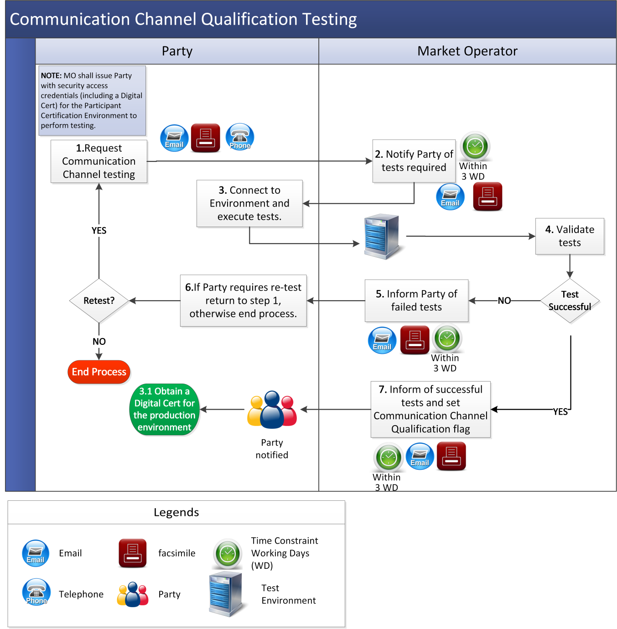

* 1. Obtaining A Digital Certificate

| Step | | | Procedural Step Description | Timing | Method | | By / From | To |
| --- | --- | --- | --- | --- | --- | --- | --- | --- |
| **1** | This procedure shall be commenced following:   1. the creation of a new User via the Balancing Market Interface and requesting a Digital Certificate for the new User   or   1. successful completion of Communication Channel Qualification testing (as set out in section 3.1 above) and setting up of authorising Digital Certificates for Users requested during the registration process set out in Agreed Procedure 1 "Registration” | | As required | In accordance with Agreed Procedure 1 “Registration” | Party | | Market Operator |
| **2** | Inform the Certificate Authority that the Party User has been authorised to receive a Digital Certificate | | Within 2 WD | Certificate Authority website | Market Operator | | Certificate Authority |
| **3** | Notify the User of authorisation to obtain a Digital Certificate and provide link to the Certificate Authority’s enrolment webpage | | Within 2 WD | Facsimile / Email | Market Operator | | Party |
| **4** | Access Certificate Authority’s enrolment webpage and enter required information | | As required | Certificate Authority website | Party | | - |
| **5** | Check that the Party User is authorised and issue PIN and URL | | Within 1 WD of completion of step 4 | Email | Certificate Authority | | Party |
| **6** | Download and install Digital Certificate using URL and PIN | | As required | Certificate Authority website | Party | | - |
| **7** | Send a link to Balancing Market Interface and the random system generated string. | | - | Email | Market Operator | | Party |
| **8** | After accessing the link provided at step 7, enter random system generated string in the Balancing Market Interface window displayed. | | - | Certificate Authority website | Party | | - |
| **9** | Validate string entered at step 8. | | - | Certificate Authority website / Balancing Market Interface | Balancing Market Interface | | - |
| **10** | Log-in to the Balancing Market Interface and change password as prompted. | | - | Certificate Authority website / Balancing Market Interface | Party | | - |

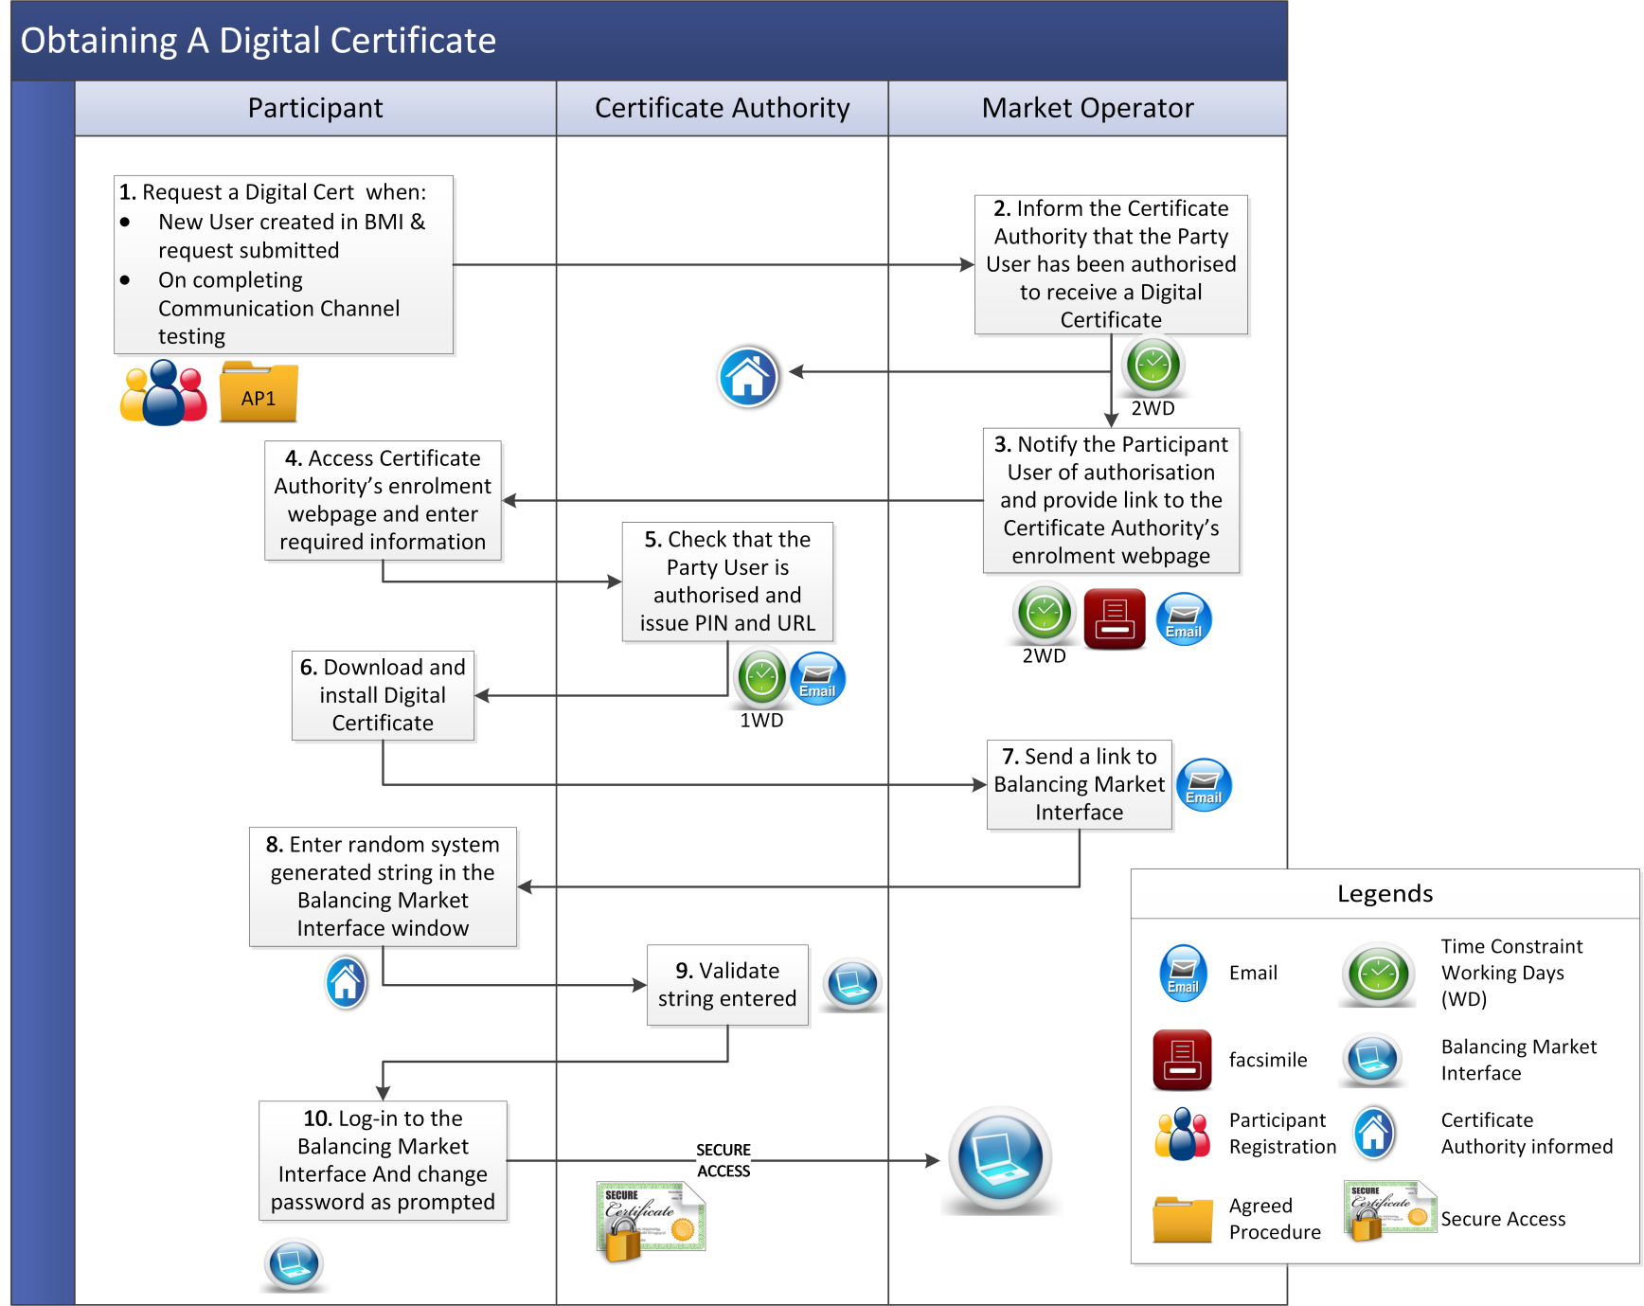

* 1. Digital Certificate Cancellation

|  |  |  |  |  |  |
| --- | --- | --- | --- | --- | --- |
| Step | Procedural Step Description | Timing | Method | By / From | To |
| **1** | Request the cancellation of Digital Certificate.  Note: Cancellation of a Digital Certificate shall revoke access to both the Balancing Market and Capacity Market (as applicable) | As required | Facsimile / Email | Party | Market Operator |
| **2** | Validate the request assessing whether it has all the required information and is from an appropriate Authorised Person (see Agreed Procedure 11 "Market System Operation, Testing, Upgrading and Support"). If valid go to step 4, otherwise continue to step 3 | Within 2 WD | - | Market Operator | - |
| **3** | Inform Party User of reasons for invalidity, **end process.** | Within 2 WD | Facsimile / Email | Market Operator | Party |
| **4** | Notify Certificate Authority of Digital Certificate cancellation | Within 2 WD | Certificate Authority website | Market Operator | Certificate Authority |
| **5** | Update revocation list to include Digital Certificate | - | Certificate Authority website | Certificate Authority | - |
| **6** | Notify Party User of cancellation of Digital Certificate | Within 2 WD | Facsimile / Email | Market Operator | Party |

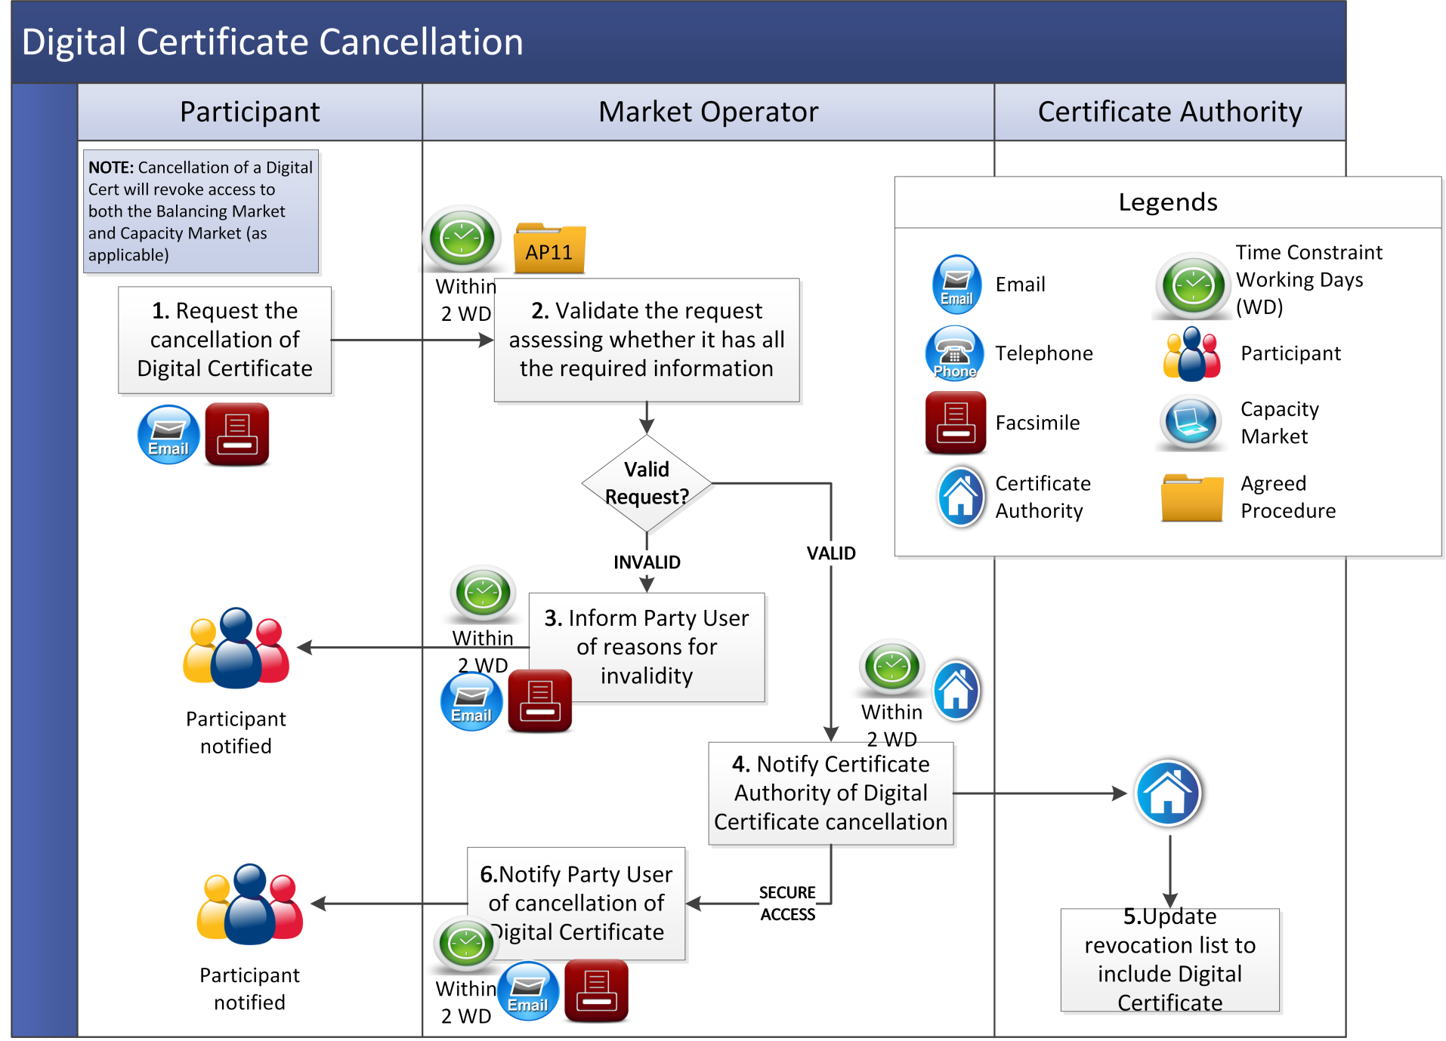

* 1. Communication Channel Suspension

|  |  |  |  |  |  |
| --- | --- | --- | --- | --- | --- |
| Step | Procedural Step Description | Timing | Method | By / From | To |
|  | If:   1. a Party requests suspension of Communication Channel, go to step 2; or 2. the Market Operator identifies a requirement to suspend a Party’s Communication Channel, go to step 4. | As required | Facsimile / Email and Telephone | Party  Market Operator | Market Operator |
|  | Validate the suspension request assessing whether it has the required information is from an appropriate Authorised Person (see Agreed Procedure 11 "Market System Operation, Testing, Upgrading and Support"). If valid go to step 5, otherwise continue to step 3. | - | - | Market Operator | - |
|  | Inform Party of reasons for invalidity, **end process**. | Within 1 WD | Facsimile / Email | Market Operator | Party |
|  | If suspension is required immediately, continue to step 5. Otherwise go to step 13. | - | - | Market Operator | - |
|  | Suspend Communication Channel and inform Party of suspension. | Within 1 WD | Facsimile / Email and Telephone | Market Operator | Party |
|  | Notify Market Operator of planned corrective action. | Within 1 WD | Facsimile / Email | Party | Market Operator |
|  | Notify Market Operator when planned corrective action completed. | Within timelines notified to the Market Operator in step 6 | Facsimile / Email | Party | Market Operator |
|  | Verify that corrective action is complete. If corrective action is not complete, notify Party and return to step 6. If corrective action is complete, continue to step 9. | As soon as practicable following notification at step 7 | Facsimile / Email | Market Operator | Party |
|  | Decide if Party is required to undergo Communication Channel Qualification. If re-qualification is not necessary continue to step 10. If qualification is required, go to step 11 | - | - | Market Operator | - |
|  | Restore Communication Channel and inform Party, **end process**. | Within 1 WD | Facsimile / Email | Market Operator | Party |
|  | Inform Party of the need to re-qualify for Communication Channel. | Within 1 WD | Facsimile / Email | Market Operator | Party |
|  | Commence Communication Channel Qualification testing procedure at section 3.2, **end process**. | - | - | Party | - |
|  | Inform Party of potential Communication Channel suspension and request Party to take corrective action. | Within 1 WD | Facsimile / Email | Market Operator | Party |
|  | Notify Market Operator of planned corrective action. | Within 1 WD | Facsimile / Email | Party | Market Operator |
|  | Notify Market Operator when planned corrective action completed. | As specified in step 14 | Facsimile / Email | Party | Market Operator |
|  | Decide if Party corrective action is sufficient to prevent Communication Channel suspension. If corrective action sufficient, **end process**. If corrective action is insufficient then return to step 4. | - | - | Market Operator | - |

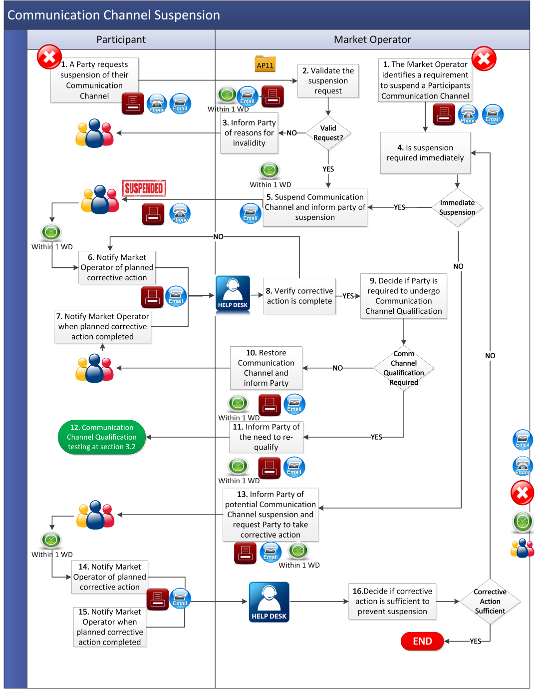

1. Definitions

Definitions

|  |  |
| --- | --- |
| **Balancing Market Interface** | means the function within the Market Operator’s systems that interfaces to Type 2 Channel and Type 3 Channel in accordance with the Code. |
| **Certificate Authority** | means an entity which issues Digital Certificates for use by other parties. The Certificate Authority validates the data contained in the Digital Certificate and correctly identifies the party to which it issues the Digital Certificate. |
| **Digital Certificate** | means an electronic credential issued and digitally signed by a Certificate Authority. The international standard upon which most commercial certificates are based is the ITU-T X.509 certificate. The digital certificate represents the certification of an individual, business, or organizational public key. |
| **Functional Area** | means the different parts of the Balancing Market Interface that Users may be provided access to as set out in in Agreed Procedure 1 "Registration". |
| **Party Certification Environment** | means a Test Environment which allows the Party to test their ability to interact with Market Operator’s Isolated Market System functionality. |
| **Test Environment** | means a non-production version of a Market Operator‘s Isolated Market System used for test purposes prior to an update to the Market Operator’s Isolated Market System. |
| **User** | means,   1. in relation to a Party, a nominated member of a Party’s staff who is authorised to utilise qualified Communication Channels that interact with the Market Operator’s Isolated Market System; and 2. in relation to the Market Operator: a member of the Market Operator staff who has been authorised to access specific parts of the Market Operator Isolated Market System. |
| **Web Services** | means the automated communication consisting of an XML-based programmatic interface. |