|  |  |
| --- | --- |
| Agreed Procedure 7: Emergency Communications | November 8  2024 |

Trading and Settlement Code

Version 30.0

Contents

1. Introduction 1

1.1 Background and Purpose 1

1.2 Scope of Agreed Procedure 1

1.3 Definitions 1

1.4 Compliance with Agreed Procedure 1

2. Overview 2

2.1 Communication and system failures 2

2.1.1 General System Failure 2

2.1.2 General Communication Failure 2

2.1.3 Limited Communication Failure 3

2.2 Alternative Forms of Communication 3

3. Procedural Steps 5

3.1 General System Failure 5

3.2 General Communication Failure 8

3.3 Offer Data Limited Communication Failure 10

3.4 Standard Limited Communication Failure 13

Appendix 1 Definitions 16

**DOCUMENT HISTORY**

|  |  |  |  |
| --- | --- | --- | --- |
| Version | Date | Author | Comment |
| 20.0 | 07/04/2017 | I-SEM Project Team | Baseline Documentation at V20.0 |
| 21.0 | 12/04/2019 | SEMO | Baseline Documentation at V21.0 |
| 22.0 | 29/04/2020 | SEMO | Baseline Documentation at V22.0 |
| 23.0 | 03/11/2020 | SEMO | Baseline Documentation at V23.0 |
| 24.0 | 01/07/2021 | SEMO | Baseline Documentation at V24.0 |
| 25.0 | 09/11/2021 | SEMO | Baseline Documentation at V25.0 |
| 26.0 | 17/05/2022 | SEMO | Baseline Documentation at V26.0 |
| 27.0 | 07/12/2022 | SEMO | Baseline Documentation at V27.0 |
| 28.0 | 18/08/2023 | SEMO | Baseline Documentation at V28.0 |
| 29.0 | 30/07/2024 | SEMO | Baseline Documentation at V29.0 |
| 30.0 | 08/11/2024 | SEMO | Baseline Documentation at V30.0 |

**RELATED DOCUMENTS**

|  |  |  |  |
| --- | --- | --- | --- |
| Document Title | Version | Date | By |
| Trading and Settlement Code | 30.0 | 08/11/2024 | SEMO |
| Agreed Procedure 1 "Registration" |  |  |  |
| Agreed Procedure 4 “Data Transaction Submission and Validation” |  |  |  |
| Agreed Procedure 5 “Data Storage and IT Security” |  |  |  |
| Agreed Procedure 6 “Data Publication and Data Reporting” |  |  |  |
| Agreed Procedure 11 “Market System Operation, Testing, Upgrading and Support” |  |  |  |

1. Introduction

* 1. Background and Purpose

This Agreed Procedure supplements the rules set out in the Trading and Settlement Code (hereinafter referred as the “**Code**”) in relation to communication and system failures. It sets out procedures with which Parties to the Code must comply.

* 1. Scope of Agreed Procedure

This Agreed Procedure sets out procedures in relation to:

1. a General System Failure;
2. a General Communication Failure; and
3. a Limited Communication Failure.

For the avoidance of doubt, this Agreed Procedure does not apply to REMIT Data however, the Market Operator will comply with all requirements set out by the European Agency for the Cooperation of Energy Regulators where events which relate to communication channels and system performance will impact on REMIT Data Transactions.

This Agreed Procedure forms an annex to, and is governed by, the Code. It sets out procedures to be followed subject to the rights and obligations of Parties under the Code. In the event of any conflict between a Party’s obligations set out in the Code and this Agreed Procedure, the Code shall take precedence.

It is not intended that there be any inconsistency or conflict between section 2 “Overview” and section 3 “Procedural Steps”. However, in the event of any inconsistency or conflict, section 3 “Procedural Steps” shall take precedence.

In section 3 “Procedural Steps” a corresponding process flow diagram is included for each procedural steps table.  Process flow diagrams are for illustrative purposes.  It is not intended that there be any inconsistency or conflict between any procedural steps table and process flow diagram however, in the event of any inconsistency or conflict, a procedural steps table shall take precedence.

* 1. Definitions

Words and expressions defined in the Code shall, unless the context otherwise requires or unless otherwise defined herein at Appendix 1 “Definitions”, have the same meanings when used in this Agreed Procedure.

References to particular sections relate internally to this Agreed Procedure unless specifically noted.

* 1. Compliance with Agreed Procedure

Compliance with this Agreed Procedure is required under the terms of the Code.

1. Overview
   1. Communication and system failures

There are three types of communication and system failure defined in the Code:

1. General System Failure;
2. General Communication Failure; and
3. Limited Communication Failure.

In the event that a communications failure or any error affecting a System Operator or Interconnector Administrator, outside the Market Operator’s Isolated Market System such that a System Operator and Interconnector Administrator CMS Data Transaction (Appendix K “Other Market Data Transactions” of the Code) has not been received by the Market Operator, such CMS Data Transactions shall be submitted as soon as practicable following the specified submission deadline.

All other Data Transactions shall be required to be submitted in accordance with the timelines set out in the Code using alternative forms of communication, if applicable, unless the Market Operator notifies impacted Parties that, due to the communication failure, certain Data Transaction submissions required for Settlement are given an Emergency Transaction Timeline.

* + 1. *General System Failure*

In the event that the Market Operator fails to meet its obligations under the Code in relation to calculation of payments and charges and Settlement under a General System Failure or in the opinion of the Market Operator it is expected to fail to meet such obligations due to a General System Failure, the Market Operator shall notify impacted Parties of the situation as soon as practicable. The Market Operator shall also notify impacted Parties of Communication Channel alternatives.

Following notification of a General System Failure the Market Operator shall provide regular (not less than daily) status updates to impacted Parties of the General System Failure. Each status update shall include the original notification and shall provide each impacted Party of an estimate of when the Market Operator’s Isolated Market System will be restored. Restoration time shall be categorised in one of five bands namely: (i) less than 1 hour; (ii) 1-4 hours; (iii) 4-12 hours; (iv) 0.5 - 2 days; or (v) more than 2 days, from the date of the notification. If the restoration category changes in relation to a General System Failure, the Market Operator shall notify each impacted Party.

Notification of a General System Failure and status updates shall be provided to Market Participants via the Market Operator website and email. The website email alerts are subscribed to by Participants as part of the website functionality. If the Market Operator website is unavailable the Market Operator shall use email to notify Participants. In the unlikely event that both the Market Operator website and email are unavailable, the Market Operator may use any other available means to notify and update Participants.

* + 1. *General Communication Failure*

In the event of a General Communication Failure the Market Operator shall notify each impacted Party of the General Communication Failure (via Market Operator website or email) and issue instructions to each impacted Party in relation to how each relevant Data Transaction should be communicated to the Market Operator.

In addition, the Market Operator shall highlight those Data Transactions that are required for Settlement and detail the allowed timeline for each of these Data Transactions (the Emergency Transaction Timeline).

Where the failure also prevents the Market Operator receiving Data Transactions from the System Operators, the Market Operator shall also notify the System Operators and that submission of Data Transactions will need to be submitted as soon as practicable following the specified submission deadline.

Following notification of a General Communication Failure, the Market Operator shall provide regular (i.e. not less than daily) status updates to all impacted Parties of the General Communication Failure. Each status update shall include the original notification and will provide all impacted Parties of an estimate, if known, of when the system shall be restored. Whenever the Market Operator receives information that significantly (in the opinion of the Market Operator) changes the expected time when normal communication shall be restored, the Market Operator shall notify the impacted Participants.

* + 1. *Limited Communication Failure*

Where a Limited Communication Failure relates to Offer Data for a Gate Window scheduled to close within five minutes, the impacted Party should follow the procedural steps set out in section 3.3 (Offer Data Limited Communication Failure). Otherwise, the impacted Party should follow the procedural steps set out in section 3.4 (Standard Limited Communication Failure).

All Parties are required under Agreed Procedure 5 “Data Storage and IT Security” to maintain a redundant and fault-tolerant network configuration of sufficient capacity to meet their peak communication needs. Whenever there is a Limited Communication Failure the impacted Party should initially attempt to rectify the problem or utilise other facilities to enable it to use its normal Communication Channels.

In the event that an impacted Party is unable to re-establish its normal Communication Channel and the impacted Party incurs a Limited Communication Failure, the impacted Party shall notify the Market Operator as soon as practicable following becoming aware that they have communication problems and they shall operate their alternative Communication Channel method for the specified Data Transactions.

In the event of a Limited Communication Failure, a Participant shall inform the Market Operator of its preferred method of communication and provide the Market Operator with any information required in this regard. If there is any change to this information the Participant shall notify the Market Operator.

The impacted Party shall provide regular (i.e. not less than daily) status updates to the Market Operator in relation their attempts to restore their normal Communication Channel.

A Limited Communication Failure shall not affect the obligations of any impacted Party to submit Data Transactions.

* 1. Alternative Forms of Communication

In the event of a communication failure, alternatives to the normal method of communication will be employed for the submission of Data Transactions. The three Communication Channels available are set out at paragraph C.2.1.1 of the Code namely: (i) Type 1 Channel; (ii) Type 2 Channel; and (iii) Type 3 Channel.

Generally the order of preferred alternative method of communication will run from the most automatic to the most manual. However, in the event that the web server is interrupted it is possible that both Type 3 Channel and Type 2 Channel will not be available for communication.

The preferred order of communication with the Market Operator is as follows:

1. If Type 3 Channel is affected by a communication fault, then Type 2 Channel; or
2. If Type 2 Channel affected then, Type 1 Channel.

The Market Operator uses e-fax (Type 1 Channel) which is a software based facsimile solution. The application takes inbound faxes, converts them to e-mail and then sends them directly to an e-mail address or a distribution list. It also converts all received faxes to PDFs and stores them in a local directory.  E-fax allows the Market Operator to send faxes via the application interface to single or multiple recipients without the need to manually send a fax using a traditional fax machine setup. From a Participant perspective, the interface is the same as sending and receiving fax information by traditional means.

During a General Communication Failure the response given by a Market Operator confirming receipt of a Data Transaction, whether by e-fax, or hand, shall be sent by e-fax or email. The Market Operator shall act prudently in the event of a General Communication Failure and shall prioritise Data Transactions necessary for the calculation of Imbalance Price, Trading Payments, Trading Charges and Settlement. It is recognised that in the event of a General Communication Failure some of the Market Operator’s obligations cannot be reasonably fulfilled.

In the event of issues with CMS Data Transactions, an impacted Party may also contact the Helpdesk in accordance with Agreed Procedure 11 “Market System Operation, Testing, Upgrading and Support”.

1. Procedural Steps
   1. General System Failure

| Step | Procedural Step Description | Timing | Method | From / By | To |
| --- | --- | --- | --- | --- | --- |
| **1** | Attempt restoration of the Market Operator’s Isolated Market System in accordance with Agreed Procedure 11 “Market System Operation, Testing, Upgrading and Support”. | Immediately following determination of a General System Failure | - | Market Operator | - |
| **2** | Notify all impacted Parties of General System Failure. | Immediately following the failure to meet a deadline in accordance with the Code | Market Operator website / Email | Market Operator | All impacted Parties |
| **3** | Notify all impacted Parties of alternative communication method and any associated timelines. | Within 1 hour of determination of General System Failure | Market Operator website / Email | Market Operator | All impacted Parties |
| **4** | Invoke internal procedures to switch to alternative communication methods. | Immediately following receipt of alternative Communication Channel details. | - | All impacted Parties | - |
| **5** | Notify all impacted Parties of best estimate of when the Market Operator’s Isolated Market System shall be restored. | Following any change to best estimate of restoration of the Market Operator’s Isolated Market System or at 17:00 hours each day | Market Operator website / Email | Market Operator | All impacted Parties |
| **6** | Notify all impacted Parties of restoration of the Market Operator’s Isolated Market System. | Immediately following restoration of the Market Operator’s Isolated Market System | Market Operator website / Email | Market Operator | All impacted Parties |
| **7** | Recommence processing and restore operation to normal timelines in accordance with the Code and inform all impacted Parties of any changes to the Settlement Calendar as a result of the General System Failure. | As soon as practicable following the restoration of the Market Operator’s Isolated Market System | Market Operator website / Email | Market Operator | All impacted Parties |
| **8** | Commission an externally audited report in accordance with Agreed Procedure 11 “Market System Operation, Testing, Upgrading and Support”. | In accordance with Agreed Procedure 11 “Market System Operation, Testing, Upgrading and Support” | Agreed Procedure 11 “Market System Operation, Testing, Upgrading and Support” | Market Operator | - |

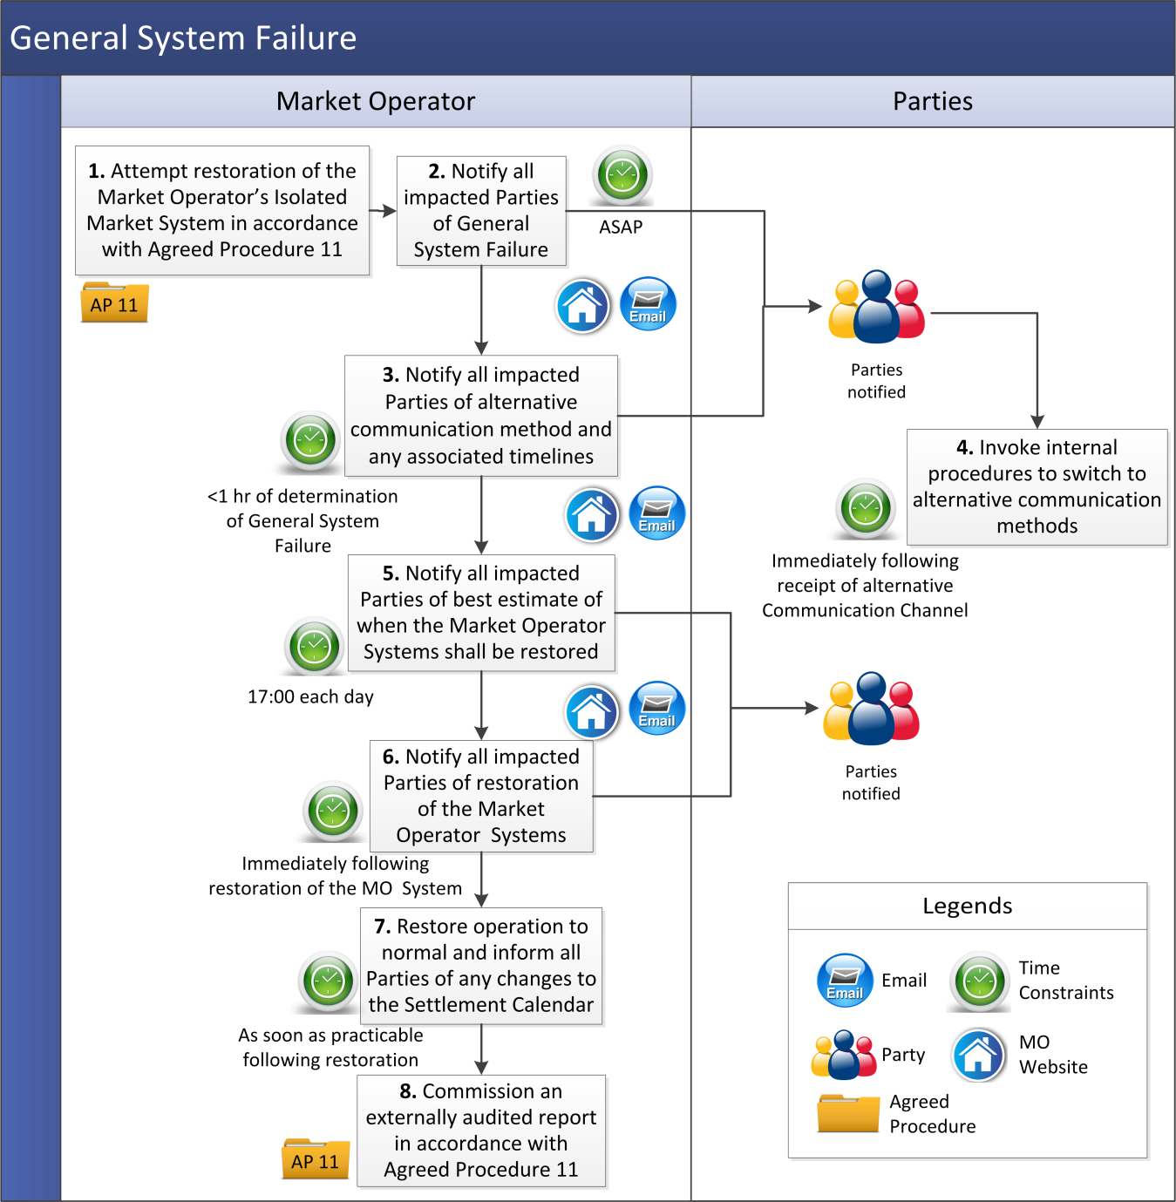

* 1. General Communication Failure

|  |  |  |  |  |  |
| --- | --- | --- | --- | --- | --- |
| Step | Procedural Step Description | Timing | Method | From / By | To |
| **1** | Notify impacted Parties of the General Communication Failure. | Immediately following determination of a General Communication Failure | Market Operator’s website / Email | Market Operator | All impacted Parties |
| **2** | Impacted Parties contact the Market Operator with any questions that arise. | - | Helpdesk / emergency communication’s telephone / Email / Facsimile | All impacted Par ties | Market Operator |
| **3** | Notify all impacted Parties of the alternative communication method to be used and if necessary the Emergency Transaction Timeline. | Within 1 hour of determination of General Communication Failure | Market Operator website / Email | Market Operator | All impacted Parties |
| **4** | Notify all impacted Parties of best estimate of when the Market Operator’s Isolated Market System shall be restored. | Following change to best estimate of recovery or at 17:00 hours each day | Market Operator website / Email | Market Operator | All impacted Parties |
| **5** | Notify all impacted Parties of restoration of Market Operator’s Isolated Market System. | Immediately following restoration of Communication Channels | Market Operator website / Email | Market Operator | All impacted Parties |
| **6** | Commission the external audit report in accordance with Agreed Procedure 11 “Market System Operation, Testing, Upgrading and Support”. | In accordance with Agreed Procedure 11 “Market System Operation, Testing, Upgrading and Support” | Agreed Procedure 11 “Market System Operation, Testing, Upgrading and Support” | Market Operator | - |

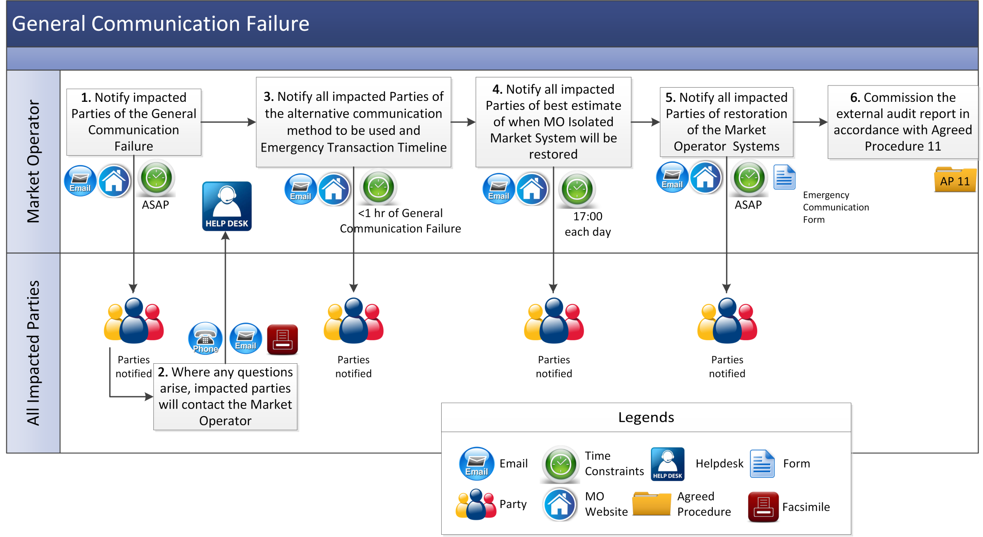

* 1. Offer Data Limited Communication Failure

| Step | Procedural Step Description | Timing | Method | From / By | To | |
| --- | --- | --- | --- | --- | --- | --- |
| **1** | Notify the Helpdesk that there is a Limited Communication Failure which impacts submission of Offer Data for the next scheduled Gate Closure. | Immediately on becoming aware of Limited Communication Failure and at least five minutes prior to next scheduled Gate Closure | Email / Facsimile and Telephone | Party | Market Operator |
| **2** | Confirm receipt of notification of Limited Communication Failure. | As soon as practicable following completion of step 1 | Email | Market Operator | Party |
| **3** | Assess if Limited Communication Failure is valid and notify Impacted Party of outcome. If Limited Communication Failure is not valid, **end process**. | As soon as practicable following completion of step 1 | - | Market Operator | Party |
| **4** | Submit bids by providing a correctly formatted xml file of containing the Offer Data for all relevant units. Submission should include Party Authorised User, applicable password and the reference number received at step 2. | At least five minutes before next scheduled Gate Closure | Email / Facsimile | Party | Market Operator |
| **5** | If Offer Data is received at least five minutes before next scheduled Gate Closure, the Market Operator shall use reasonable efforts to submit the Offer Data to the Balancing Market Interface before the next scheduled Gate Closure. | Immediately on completion of step 4 | - | Market Operator | - |
| **6** | If the Offer Data is received less than five minutes before next scheduled Gate Closure, the Market Operator shall not submit the Offer Data to the Balancing Market Interface and shall notify the Party that the Offer Data was not provided to the Market Operator with the required timelines. | As soon as practicable on completion of step 4 | Email | Market Operator | Party |
| **7** | Confirm receipt of the Offer Data and,   1. inform the Party that Offer Data has been successfully submitted to the Balancing Market Interface before the next scheduled Gate Closure; or 2. inform the Party that the Offer Data was not able to be submitted to the Balancing Market Interface before the next scheduled Gate Closure. | As soon as practicable following completion of step 5 | Email | Market Operator | Party |

1. 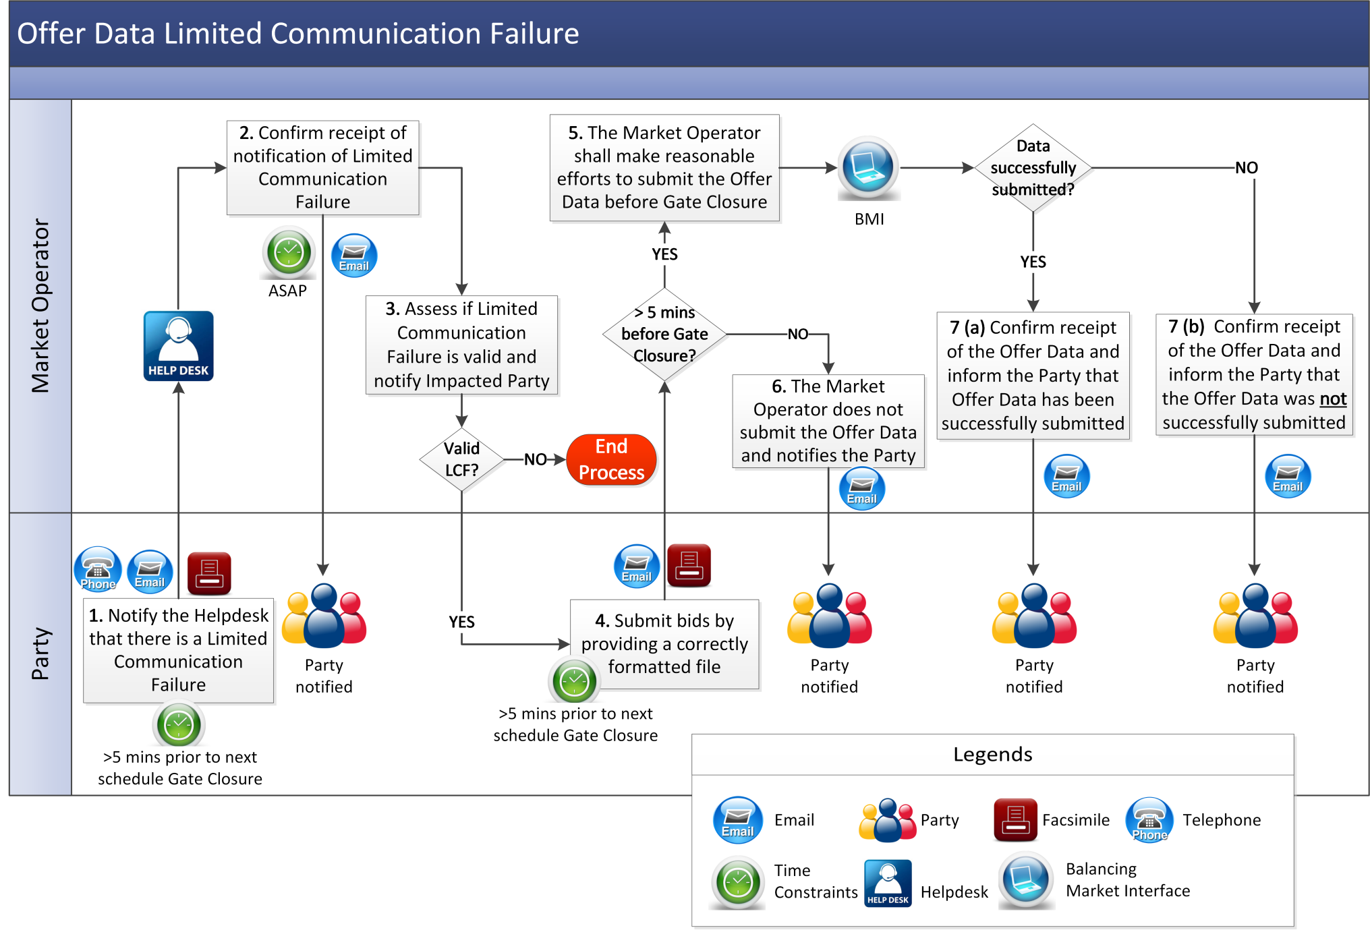
   1. Standard Limited Communication Failure

|  |  |  |  |  |  |
| --- | --- | --- | --- | --- | --- |
| Step | Procedural Step Description | Timing | Method | From / By | To |
| **1** | Notify the Helpdesk that there is a Limited Communication Failure. | Immediately on becoming aware of Limited Communication Failure | Email / Facsimile / Telephone | Impacted Party | Market Operator |
| **2** | Confirm receipt of notification at of Limited Communication Failure. | Within 1 hour of receipt | Email / Facsimile | Market Operator | Impacted Party |
| **3** | Assess if Limited Communication Failure is valid and notify impacted Party of outcome. If Limited Communication Failure is not valid**, end process**. | As soon as practicable following notification of the Limited Communication Failure | Email | Market Operator | Impacted Party |
| **4** | Notify Market Operator of: (i) alternative Communication Channels to be used for each of the Data Transactions; and (ii) the estimated timeline of the Limited Communication Failure. | Within 1 hour of notifying Market Operator of the Limited Communication Failure | Email / Facsimile | Impacted Party | Market Operator |
| **5** | Acknowledge receipt of notification at step 4 | Within 1 hour of receipt | Email / Facsimile | Market Operator | Impacted Party |
| **6** | Invoke internal processes to accept Data Transactions from the alternative Communication Channel notified at step 4. | As soon as practicable following step 4 | - | Market Operator | - |
| **7** | If required, advise if there is any change to the estimated timescales for the disruption to normal operation. | Immediately following any change to the previous estimate given for expected return to normal operation | Email / Facsimile | Impacted Party | Market Operator |
| **8** | Notify Market Operator of restoration of normal Communication Channels. | Immediately following restoration of normal Communication Channels | Facsimile / Email and Telephone | Impacted Party | Market Operator |
| **9** | Acknowledge receipt of notification of restoration to normal Communication Channels. | Within 1 hour of receipt of notification at step 8 | Facsimile / Email | Market Operator | Impacted Party |
| **10** | Invoke internal processes to revert to normal Communication Channels for the Party. | As soon as practicable following receipt of notification at step 8 | - | Market Operator |  |

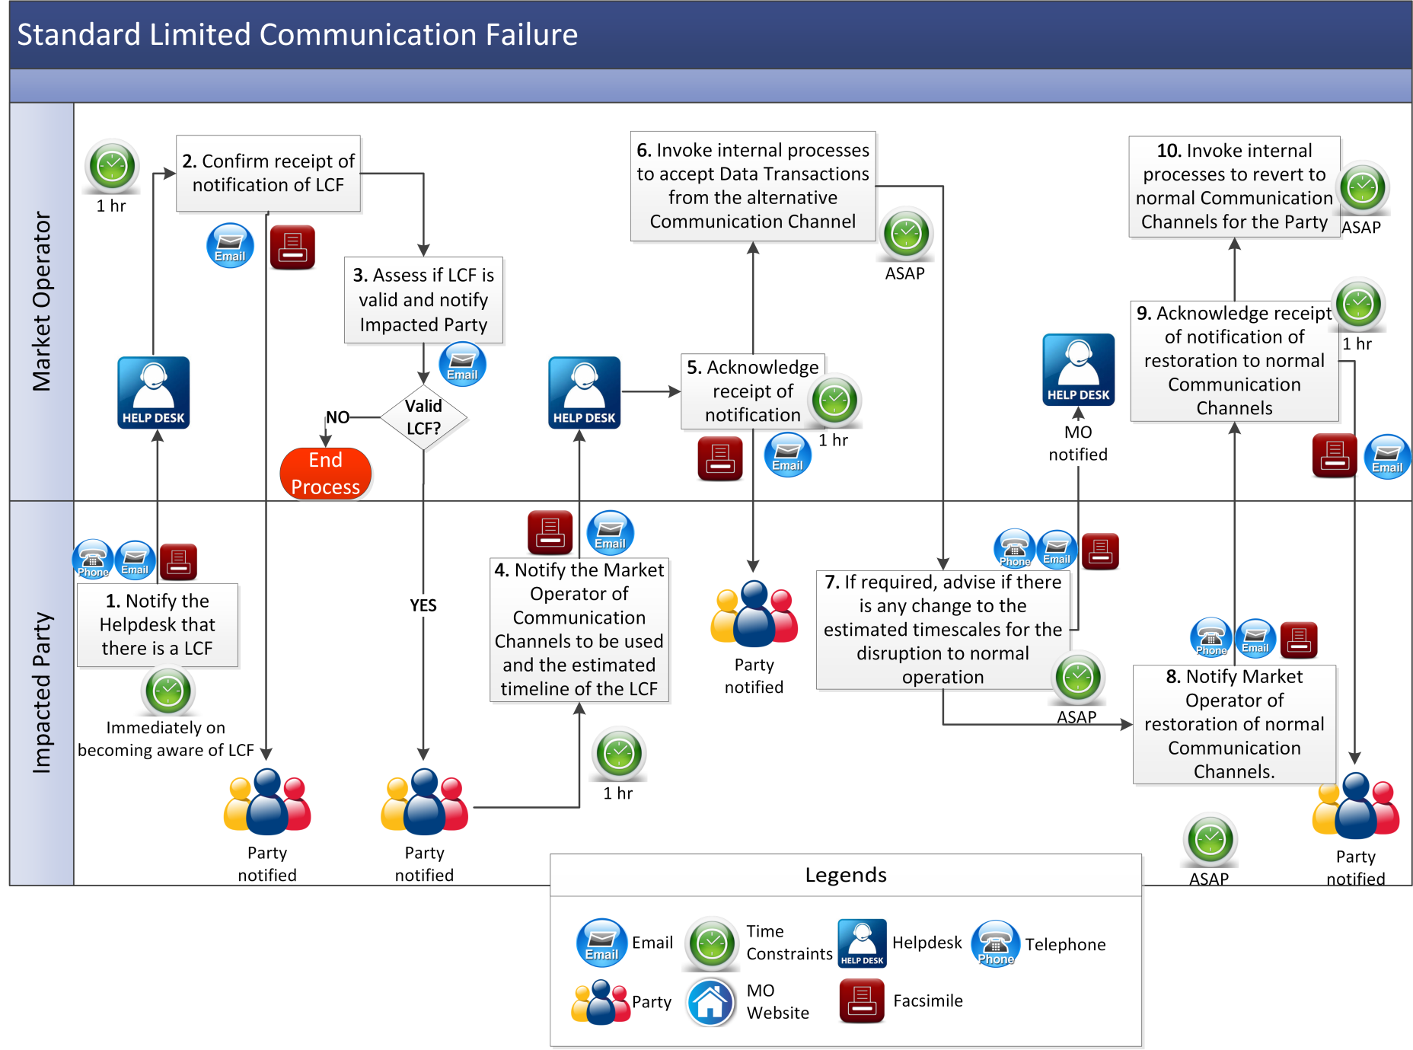

Appendix 1 Definitions

|  |  |
| --- | --- |
| **Authorised Person** | means the representative of a Party who is authorised by that Party to communicate with the Market Operator. |
| **Balancing Market Interface** | means the function within the Market Operator’s systems that interfaces to the Type 2 Channel and Type 3 Channel in accordance with the Code. |
| **Emergency Transaction Timeline** | means the timeline for Data Transactions in the event of a General System Failure or General Communication Failure. |

**PART 4 – Acknowledgement of Receipt of Meter Data Transaction**