

The Single Electricity Market (SEM)

Part A Agreed Procedure 11: Market System Operation, Testing, Upgrading and Support

Version 28.0

18 August 2023

SEM Part A Agreed Procedure

|  |  |
| --- | --- |
| Title | Part A Agreed Procedure 11: Market System Operation, Testing, Upgrading and Support |
| Version | 28.0 |
| Date | 18 August 2023 |

Table of Contents

1. Introduction 6

1.1 Background and Purpose 6

1.2 Scope of Agreed Procedure 6

1.3 Definitions 6

1.4 Compliance with Agreed Procedure 6

2. Procedure Definition 7

2.1 Customer Services Function 7

2.2 Market Operator’s Isolated Market System Modifications 8

2.3 Problem Management 12

2.4 Post Event Reporting 13

2.5 Authorised Persons 14

3. Swimlane Diagrams 16

3.1 Help Desk 16

3.2 Problem Management 17

3.3 Authorised Persons 18

4. Procedural Steps 20

4.1 Help Desk 20

4.2 Implementation Procedures 22

4.3 Problem Management 24

4.4 Authorised Persons 26

APPENDIX 1: Definitions and Abbreviations 28

Definitions 28

Abbreviations 31

APPENDIX 2: Forms 33

Emergency Implementation Form 33

Standard Implementation Proposal Form 34

Standard Implementation Notification Form 35

Level 3 Alternative Communication Form 36

Authorisation Amendment Form 37

Authorisation Confirmation Form 40

APPENDIX 3: Potential Failures and Typical Corrective Actions 41

APPENDIX 4: Authorisation Categories 43

**DOCUMENT HISTORY**

|  |  |  |  |
| --- | --- | --- | --- |
| Version | Date | Author | Comment |
| 2.0 | 03/11/2006 | SEM Implementation Team | Issue to Regulatory Authorities |
| 3.0a | 11/05/2007 | Regulatory Authorities | Consultation Version |
| 3.2 | 22/06/2007 | Regulatory Authorities | Approved for Go-Active by Regulatory Authorities and TSO/SEM Programme |
| 3.3 | 12/03/2008 | SEMO IT | Modified to align with actual release practices and formalise concept of Participant consultation. |
| 5.0 | 07/04/2009 | SEMO | SEMO Design Baseline Documentation at V5.0 |
| 6.0 | 30/10/2009 | SEMO | SEMO Design Baseline Documentation at V6.0 |
| 7.0 | 28/05/2010 | SEMO | SEMO Design Baseline Documentation at V7.0 |
| 8.0 | 19/11/2010 | SEMO | SEMO Design Baseline Documentation at V8.0 |
| 9.0 | 06/05/2011 | SEMO | SEMO Design Baseline Documentation at V9.0 |
| 10.0 | 21/10/2011 | SEMO | SEMO Design Baseline Documentation at V10.0 |
| 11.0 | 21/07/2012 | SEMO | SEMO Design Baseline Documentation at V11.0 |
| 11.0 | 21/07/2012 | SEMO | Mod_18_10 Intra-Day Trading |
| 12.0 | 16/11/2012 | SEMO | SEMO Design Baseline Documentation at V12.0 |
| 13.0 | 10/05/2013 | SEMO | SEMO Design Baseline Documentation at V13.0 |
| 14.0 | 15/11/2013 | SEMO | SEMO Design Baseline Documentation at V14.0 |
| 15.0 | 16/05/2014 | SEMO | SEMO Design Baseline Documentation at V15.0 |
| 16.0 | 14/11/2014 | SEMO | SEMO Design Baseline Documentation at V16.0 |
| 17.0 | 15/05/2015 | SEMO | SEMO Design Baseline Documentation at V17.0 |
| 18.0 | 02/10/2015 | SEMO | SEMO Design Baseline Documentation at V18.0 |
| 19.0 | 17/05/2017 | SEMO | SEMO Design Baseline Documentation at V19.0 |
| 20.0 | 23/05/2017 | SEMO | SEMO Design Baseline Documentation at V20.0 |
| 20.0 | 23/05/2017 | SEMO | Mod_01_17 Changes to enable I-SEM (Part A) |
| 21.0 | 12/04/2019 | SEMO | SEMO Design Baseline Documentation at V21.0 |
| 22.0 | 29/04/2020 | SEMO | SEMO Design Baseline Documentation at V22.0 |
| 23.0 | 03/11/2020 | SEMO | SEMO Design Baseline Documentation at V23.0 |
| 24.0 | 01/07/2021 | SEMO | SEMO Design Baseline Documentation at V24.0 |
| 25.0 | 09/11/2021 | SEMO | SEMO Design Baseline Documentation at V25.0 |
| 26.0 | 17/05/2022 | SEMO | SEMO Design Baseline Documentation at V26.0 |
| 27.0 | 07/12/2022 | SEMO | SEMO Design Baseline Documentation at V27.0 |
| 28.0 | 18/08/2023 | SEMO | SEMO Design Baseline Documentation at V28.0 |

**RELATED DOCUMENTS**

|  |  |  |  |
| --- | --- | --- | --- |
| Document Title | Version | Date | By |
| Trading and Settlement Code | V28.0 | 18/08/2023 | SEMO |
| Agreed Procedure 1 “Participant and Unit Registration and Deregistration” |  |  |  |
| Agreed Procedure 3 “Communication Channel Qualification” |  |  |  |
| Agreed Procedure 7 “Emergency Communications” |  |  |  |
| Agreed Procedure 9 “Credit Risk Management” |  |  |  |
| Agreed Procedure 10 “Settlement Reallocation” |  |  |  |
| Agreed Procedure 12 "Modifications Committee Operation" |  |  |  |
| Agreed Procedure 13 "Query Generation" |  |  |  |
| Agreed Procedure 14 "Disputes" |  |  |  |

1. Introduction
   1. Background and Purpose

This Agreed Procedure describes the specific procedures and directives for Market System Operation, Testing, Upgrading and Support with which Parties to the Trading and Settlement Code (the “Code”) must comply.

* 1. Scope of Agreed Procedure

This Agreed Procedure defines how the Market Operator:

* Provides advice to Parties in relation to the market operation and Communication Channels;
* Provides a facility for Parties to report incidents;
* Coordinates and facilitates Implementation of the Market Operator’s Isolated Market Systems and its interfaces to the Communication Channels;
* Schedules testing and down-time of the Market Operator’s Isolated Market Systems or its interfaces to Communication Channels; and
* Commissions an externally audited report in the event of a General Communication Failure, General System Failure, or MSP Failure.

The Agreed Procedure will also set out the timescales and standards for the Market Operator to restore the Market Operator’s Isolated Market Systems in the event of a General System Failure.

This Agreed Procedure forms an annexe to, and is governed by, the Code. This document is a statement of process and procedure. Parties’ rights and obligations are set out in the Code.

* 1. Definitions

Save as expressly defined, words and expressions defined in the Code shall have the same meanings when used in this Agreed Procedure.

References to particular sections relate internally to this Agreed Procedure unless specifically noted.

* 1. Compliance with Agreed Procedure

Compliance with this Agreed Procedure is required under the terms as set out in the Code.

1. Procedure Definition

This section 2 provides an overview of the procedure provided for in the main Sections of the Code, for explanatory purposes and to set the context for this Agreed Procedure only.  The overview contained in this section is not legally binding and is not intended to create rights or impose obligations on any Party.

* 1. Customer Services Function

The Market Operator will operate a Help Desk where Parties can seek technical and operational advice. The Help Desk will provide information and advice on the following:

* Party / Unit Registration;
* Communication Channels;
* Market operation and obligations of Parties;
* Incidents affecting the Market Operator’s Isolated Market Systems and Communication Channels; or
* Initial point of contact for Participants to raise a Query, log a Dispute or request an ad-hoc data report.

The Help Desk can be contacted via email or by telephone except for Disputes, Data Queries, Settlement Queries, or Required Credit Cover Queries which will require the communication methods defined in Agreed Procedure 13 "Query Generation" and Agreed Procedure 14 "Disputes" to be used.

* + 1. Categorisation and Prioritisation of Help Desk Requests

Help Desk Requests are separated into 5 Categories namely:

|  |  |  |
| --- | --- | --- |
| Category | Title | Description |
| 1 | Dispute | Dispute raised under Agreed Procedure 14 "Disputes" |
| 2 | Settlement Query, Data Query or Required Credit Cover Query | Query raised under Agreed Procedure 13 "Query Generation" |
| 3 | Incident Reporting | Reporting an issue that is preventing Participant from performing its obligations under the Code and which may require assistance from the Market Operator to resolve. |
| 4 | Assistance Request | Request by Participant who is having difficulty with configuration of Communication Channels or issues with data transfers and requires technical assistance.  Request for ad-hoc data reports. |
| 5 | Information Request | Information on Agreed Procedures, current or planned events, current incidents. This information will usually be available on the Market Operator Website or Type 2 Channel as appropriate. |

* + - 1. Help Desk Category 1 requests

All Help Desk Requests under Category 1 will be logged and presented to the appropriate Market Operator contact as soon as possible upon receipt. The person processing the Dispute shall follow the procedures and timelines of Agreed Procedure 14 "Disputes".

* + - 1. Help Desk Category 2 requests

All Help Desk Requests under Category 2 will be logged and presented to the appropriate Market Operator contact as soon as possible upon receipt. The person processing the Query shall follow the procedures and timelines of Agreed Procedure 13 "Query Generation".

* + - 1. Help Desk Category 3, 4 & 5 requests

Help Desk requests submitted by email / voicemail will be responded to within 1 Working Day of receipt. The response will include either the information requested or provide a timescale for processing the request.

Where a Help Desk request is by telephone, and the Help Desk operator is unable to provide the requested information, the Help Desk operator will agree with the Participant the timescale for resolution. The Help Desk shall confirm the request and the agreed timescale by email where an email address is provided.

For Help Desk Category 5 requests, resolution will be the provision of the requested information and will typically be within 1 Working Day. For Help Desk Category 3 and 4 requests, resolution will be when the relevant Level 2 Support contacts the Participant to assist in resolving the issue. The timescales will be dependent on the type of request (e.g. inability to send Technical Offer Data and Commercial Offer Data may require a response of less than 1 hour whilst assistance with configuration of Communication Channels may be greater than 1 Working Day).

* + 1. Logging / Monitoring of Help Desk Requests

All Help Desk requests will be logged when initially processed and the details and resolution timescales recorded.

Level 2 Support will also update the Help Desk with progress / closure of the issue. The Help Desk will inform the Participant of the closure of Help Desk requests, either by telephone or email.

* 1. Market Operator’s Isolated Market System Modifications
     1. Change Management

The Market Operator shall implement a change management process to manage the identification, recording, rectification/development and Implementation of:

* any change to the production system, applications or environment;
* defects;
* approved changes through Agreed Procedure 12 "Modifications Committee Operation";
* operational improvements not requiring Modifications; and
* upgrades in system software.

The change management process will include procedures to collate Modifications to the Market Operator’s Isolated Market System into Releases.

Parties will be made aware of all changes to the Market Operator’s Isolated Market Systems with the exception of changes that relate to standard IT maintenance activities or internal process improvements which do not impact on system availability or third party interfaces. Parties will have facility to review those changes, either through the impact assessment processes for changes that are agreed by the Modifications Committee as described in Agreed Procedure 12 “Modifications Committee Operation” or, for other changes, through the provisions described in this Agreed Procedure. The Market Operator can then include the impact on all affected Parties in its Detailed Impact Assessment.

* + 1. Release Management
       1. Scheduled Releases

By the final Working Day in June of each year the Market Operator shall provide all Parties with a release timetable for the following year that identifies the dates for scheduled Releases of the Market Operator’s Isolated Market System. These Releases will be made up of system modifications as a result of Modifications agreed under Agreed Procedure 12 "Modifications Committee Operation", upgrades in system software and corrections of identified defects. The composition of the releases will not be detailed in the release timetable.

The Market Operator shall maintain an Interface Documentation Set, which shall provide sufficient information for Participants to implement Type 2 Channel and Type 3 Channel interfaces to the Market Operator’s Isolated Market Systems This documentation shall be maintained under version control by the Market Operator.

Any proposed implementation shall consider the change to the Interface Documentation Set and the Market Operator shall detail the change within its High Level Impact Assessment which shall be made available to Participants, Meter Data Providers and System Operators. The High Level Impact Assessment shall assign the Implementation Classification (see Table 1) and include a proposed Release Plan. The Release Plan shall include:

* Consultation forum details;
* Proposed delivery date for complete Interface Documentation pertaining to proposed release. Where appropriate a delivery date for provision of sample files will also be specified;
* Proposed Participant interface testing start date and duration; and
* Proposed release date and implementation window.

On receipt of the output of the High Level Impact Assessment and Release Plan the Participant, Meter Data Providers and System Operators shall be given the opportunity to comment on the content of these documents. All comments must be received by the Market Operator no later than 5 days from the date of issue of the High Level Impact Assessment and Release Plan. In the case of disagreement on the content, assigned Implementation Classification, or release detail then the rationale for the disagreement must be provided to the Market Operator.

A Consultation Workshop will be organised by the Market Operator as close as is practicable to 5 days (and no later than 10 days) after the issue of the High Level Impact Assessment and Release Plan. Attendance is not compulsory - the purpose of the workshop is to facilitate consultation on the key aspects of the proposed release.

Once all comments are received, including discussions had during the Consultation Workshop, the Market Operator will issue a document detailing the final implementation classification, release content and proposed timeline to the Participants, Meter Data Providers and System Operators. The minimum time between issue of this document and implementing a planned release will be 35 days.

If a Participant, Meter Data Provider or System Operator maintains their disagreement with the assigned Implementation Classification or release detail they shall have recourse to the Modifications Committee through the raising of an Urgent Modification Proposal following the processes described in Agreed Procedure 12 “Modifications Committee Operation”. The raising of the Urgent Modification Proposal must first be agreed with the Regulatory Authorities and its raising shall prevent the proposed Implementation of the change until a judgement has been concluded by the Emergency Meeting. There will be no specific changes to Market Documentation associated with the Urgent Modification Proposal.

Day 0

SEMO Produces:

* I.A.
* Impl. Classification
* Release Plan

By Day 5

Participants:

* Submit feed back
* Attend workshop
* Provide view on constraints / rationale for any disagreements

Day 10 or (workshop + 5 working days)

SEMO Issues:

* Release contents
* Release Impl. Classification
* Final Release Plan

Day x

(min. 40)

Release Implemented

**Figure 1: Timeline Representation**

* + - 1. Emergency Releases

Where the Market Operator considers that there is a risk to the operation of the Single Electricity Market requiring an upgrade in system software or a bug-fix or there is an Implementation of an Urgent Modification, the Market Operator may schedule an Emergency Release.

Where an Emergency Release does not affect the interface with Parties (i.e. there is no requirement for Parties to modify their Isolated Market Systems) then the Market Operator shall publish a summary of the Emergency Release as soon as practicable. It is recognised that this notice may be issued immediately prior to the release. Reasonable endeavours shall be made to issue the release notification as early as possible.

Where an Emergency Release does affect the interface with Parties (i.e. there is a requirement for Parties to modify their Isolated Market Systems) then this shall be agreed through an Urgent Modification. The agreement of the Urgent Modification should also include the Release timescales and the notices that the Market Operator shall publish to Parties on the Implementation of the Emergency Release.

* + 1. Testing

The Market Operator shall be responsible for testing Releases of its Isolated Market Systems and for ensuring that any functional changes meet the requirements of the approved Modification Proposals included in the Release.

Where the Release includes changes to the interface with Parties then the Market Operator will provide a separate Test Environment of the relevant Market Operator’s Isolated Market System to enable the affected Parties to test the interface. This Test Environment will be available for a period of not less than 5 working days prior to Implementation of the Release. The date and duration of this test phase will be decided upon based on feedback solicited during the initial release consultation process. If during this phase the Market Operator becomes aware that one or more Participants is experiencing unanticipated issues during their testing the Market Operator may revise the planned release date to a later date.

Where the Release does not include changes to the interface with Parties then the Market Operator will provide a separate Test Environment of the relevant Market Operator’s Isolated Market System if this has been requested as part of an approved Modification Proposal included in the Release. The Test Environment will be made available within the timescales approved in the approved Modification Proposal.

* + 1. Implementation Procedures
       1. Overview of Implementing new releases of Isolated Market Systems

Implementation of Releases containing approved Modification Proposals (other than Urgent Modification Proposals) must be sanctioned by the Regulatory Authorities in accordance with Agreed Procedure 12 “Modifications Committee Operation”.

Implementation of Releases on the production Market Operator’s Isolated Market System or Communication Channels may have an effect on Parties’ interfaces with the Market Operator’s Isolated Market Systems. Four categories of Implementation have been defined depending on the operational impact on Parties, namely:

| Implementation Classification | Description |
| --- | --- |
| Normal Operation | Implementation of parts of the Market Operator’s Isolated Market System which has no impact on Parties and does not require changes to Participants’ Isolated Market Systems. Standard systems maintenance tasks would typically fall into this category. The Market Systems will be fully available for the duration of the implementation. Parties will not be notified. |
| Maintenance | This category covers planned maintenance activities which do not require Modification Panel approval. No change to Participants’ Isolated Market Systems are involved. The Market Operator will provide notice detailing the planned implementation window at least 5 working days prior to release date if the Market Systems are to be unavailable during the implementation. |
| Application Release | This category covers implementation of application software and or system change as a result of approved Modification Proposal(s) and/or a change originating from the Market Operators Internal Change Management process. Section 2.2.2.1 'Scheduled Releases' details how these releases will be planned and implemented. |
| Emergency Release | Implementation of an Emergency Release. Section 2.2.2.2 contains further detail. |

**Table 1: Levels of Implementation**

The Market Operator shall remind Participants, Meter Data Providers and System Operators of the Implementation one Working Day prior to the scheduled day of the Implementation.

On the day of the Implementation, if the Implementation is extended such that it falls outside the advised Implementation timescales and as dictated in under Agreed Procedure 7 “Emergency Communications” a particular failure category is achieved, the Market Operator will initiate the relevant procedures.

When the Implementation is completed, the Market Operator will, as soon as is practicable, inform Participants, Meter Data Providers and System Operators by email and by publishing the information on the Type 2 Channel.

For Application Releases a confirmation will be included in the Impact Assessment if the Participants will be required to have their Communication Channels re-qualified under Agreed Procedure 3 “Communication Channel Qualification” to allow use of that Communication Channel after the Implementation.

Reasonable endeavours will be made by the Market Operator to implement system change outside regular business hours and in such a way as to minimise impact on third party interaction with Market Systems.

* + - 1. Emergency Implementation

The Market Operator shall be required to inform all affected Parties, as soon as practicable, of the operational impact of an Emergency Implementation. Where the Emergency Implementation is initiated by an approved Urgent Modification Proposal then Market Operator shall consult with Parties as set out in the approved Urgent Modification Proposal.

* 1. Problem Management
     1. Problem Management Function

The Market Operator shall establish a Problem Management Function to consider the interim solutions to be adopted in the event of a Failure. A Failure includes a:

* General System Failure;
* General Communication Failure;
* MSP Failure;
* Limited Communication Failure where the affected Party is the Interconnector Administrator and/or;
* Failure affecting communication with a System Operator or a Meter Data Provider.

The function may be a single senior officer or a group of officers from the Market Operator.

The Market Operator will communicate the interim solutions to the relevant Parties and shall also communicate the consequences of the Failure taking into account any interim solution adopted.

* + 1. Prioritisation of Actions

The Problem Management Function will develop the interim solutions and prioritise the restoration of Market Operator’s Isolated Market Systems to prevent the following consequences of Failures in this priority order:

* Adoption of Administered Settlement;
* Failure to meet Billing Timescales;
* Failure to provide D+4 Settlement outputs;
* Failure to provide pre-Gate Window Closure information; and
* Failure to provide D+1 Settlement outputs.

Typical Failures for each consequence and potential interim solutions are provided in Appendix 3.

* + 1. Rectification Timelines for Failures of Market Operator’s Isolated Market Systems

The MOIMS target availability is 99%. If the systems become unavailable the target rectification times described in the table below apply. The rectification/availability timelines specified are to prevent the top two critical consequences (namely Adoption of Administered Settlement and Failure to meet Billing Timescales) from occurring and to ensure that the remaining consequences are of limited duration.

| Failure | Target Rectification time |
| --- | --- |
| Receipt of Offer Data, MSP Failure, Receipt of data from Interconnector Administrator, Meter Data Providers or System Operators | Within 2 hours of the Failure being detected. |
| Failure of all other parts of the Market Operator’s Isolated Market System required to meet the Billing Timescales | Within 4 hours of the Failure being detected. |

* + 1. Contingency/Interim Arrangements for Failure of External Systems

External Systems include other Parties’ Isolated Market Systems and the public internet. The Market Operator will develop contingency arrangements to minimise the impact of Failure of External Systems.

* + 1. Process

The procedures under Agreed Procedure 7 “Emergency Communications”, General System Failure shall be followed. Under that procedure, as soon as the Market Operator becomes aware of a Failure, the Market Operator will notify all Parties of:

* what is affected;
* the interim processes to be used to mitigate the effects of the Failure;
* the period of time that this would be used before it is escalated in the event that it is not resolved; and
* the consequent changes to reporting timescales and whether some reports (Ex-Ante One MSP Software Run / Ex-Ante Two MSP Software Run / Within Day One MSP Software Run / Ex-Post Indicative MSP Software Run / Ex-Post Indicative Settlement Statements) will be cancelled.
  1. Post Event Reporting
     1. Report Initiation

In accordance with the Code, the Market Operator has an obligation to commission an externally audited report in the event of a General Communication Failure, General System Failure or MSP Failure. The report must consider the cause of the Failure and the response of Parties to that Failure. A single process shall accommodate the reporting for the three Failure types.

A report may also be initiated prior to the rectification of a Failure.

Where there has been an incident in the SEM which, in the opinion of the Market Operator, has had a material effect on the market prices, the Market Operator shall inform the Regulatory Authorities. The Regulatory Authorities may direct the Market Operator to commission an externally audited report using the same process.

* + 1. Process

Where a report is initiated by the rectification of a Failure, the Market Operator shall commission the report within 2 Working Days of restoring the affected system and/or Communication Channels back to their normal operational state.

Where a Failure extends beyond 5 Working Days, the Market Operator may apply to the Regulatory Authorities to determine the need for a report into the Failure in advance of resolving the problem. The Market Operator shall commission such a report within 2 Working Days of the direction given by the Regulatory Authorities.

The Market Operator shall commission a report after a Material Incident. The Regulatory Authorities and the Market Operator shall agree the timescales for the initiation and production of the report.]

The report must be completed within 5 Working Days or other timescale agreed between the Regulatory Authorities and the Market Operator.

The Market Operator shall present the report to the Regulatory Authorities within 2 Working Day of receipt of the commissioned report.

The report will be a detailed study of the cause of the Failure or Material Incident and the behaviour of all Parties during the Failure or Material Incident with particular emphasis on compliance with Agreed Procedure 7 “Emergency Communications”. All Parties will be obliged to cooperate with the authors during the compilation of the report.

* 1. Authorised Persons
     1. Authorisations Overview

Wherever Parties communicate with the Market Operator via Type 1 Channel or other communication required under Agreed Procedures, then that communication must be from staff duly authorised using this Agreed Procedure.

Party staff can be authorised under one or more Authorisation Categories (see Appendix 4). Authorisation Category A allows the person to nominate and change the Authorisations of other staff from that Party. At least one Category A Authorised Person must be registered during Party registration. Where a Party does not have any valid Category A Authorised Person then a new nomination must be submitted accompanied by a letter on the company stationery and signed by a registered company director or administrator for the company.

* + 1. Authentication

As part of the Authorisation process the following details of the Authorised Person are required:

* Full Name
* Signature
* Email address
* Password

When a communication is received from the Authorised Person the authentication information provided is dependent on the mode of communication and is described below.

|  |  |
| --- | --- |
| Mode of Communication | Authentication information |
| Post | Full Name, Signature, Password |
| Fax | Full Name, Signature, Password |
| Email | Full Name, Password, Originate from registered email address |

* + 1. Authorisation Process

The authorisation procedures include the process for changing, registering and cancelling authorisations for a person and an annual confirmation of each Party’s Authorised Persons.

Only Category A Authorised Persons use this procedure. If an Authorised Person who is not a Category A Authorised Person wishes to change any of their details then this must be done by a Category A Authorised Person using the amendment process.

The processes that are defined in this section are:

* Amendments of Authorised Persons including:
* Nomination of Authorised Persons;
* Change to the scope of Authorised Persons authority;
* Cancellation of Authorised Persons; and
* Confirmation of all Authorised Persons for a Party.

Annually, in January of each year, the Market Operator shall issue to each Party the Authorised Persons register for the Party. This will be sent to one of the Category A Authorised Persons for the Party.

At any time a Party may request a copy of the Authorised Persons register for the Party. This may be requested by any Category A Authorised Person.

.

1. Swimlane Diagrams

These swimlanes are provided as an illustration of the Procedural Steps. The Procedural Steps take precedence, in the event of conflict between the swimlanes and the Procedural Steps.

* 1. Help Desk

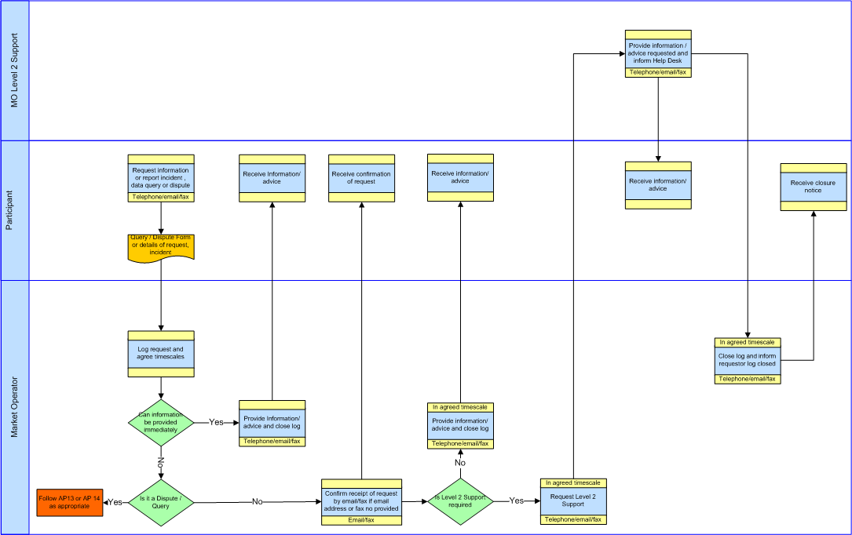

* 1. Problem Management
     1. Post Event Reporting

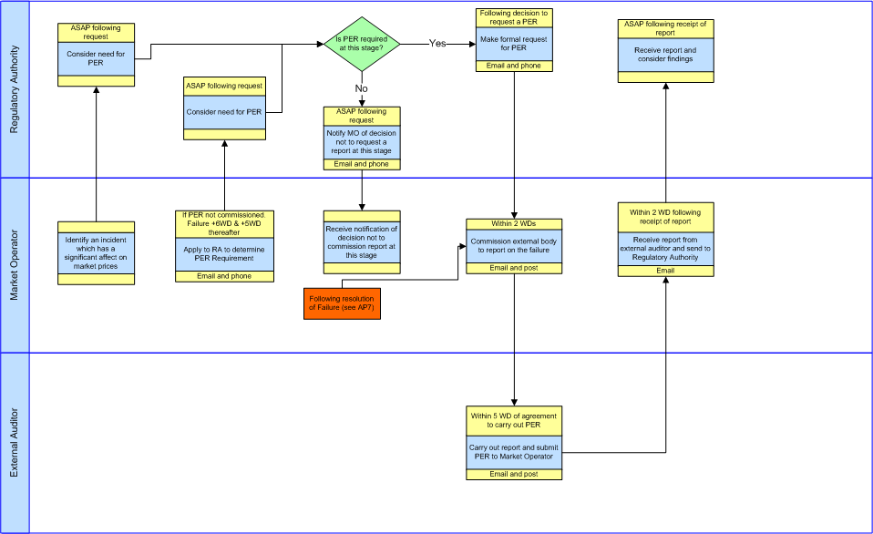

* 1. Authorised Persons
     1. Amendment to Authorised Persons

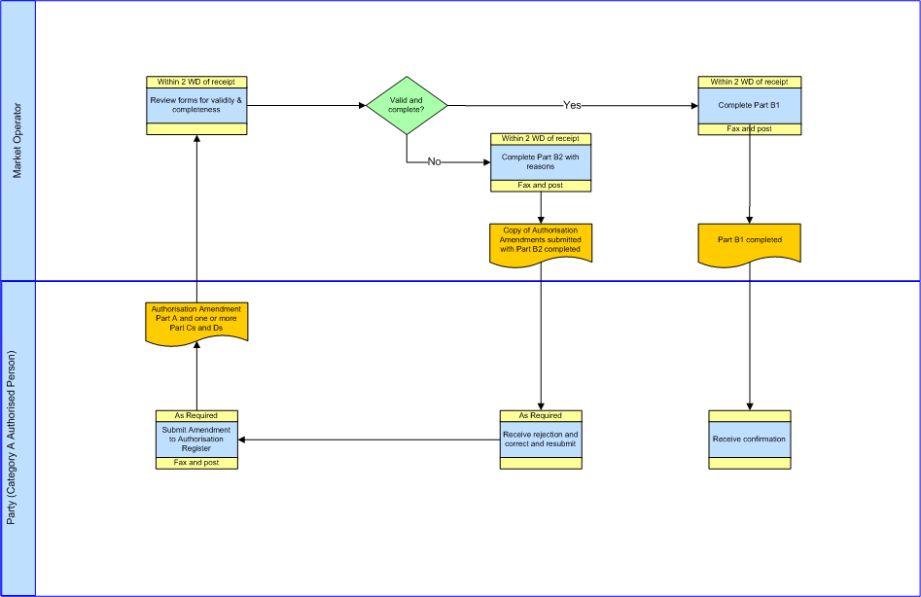

* + 1. Authorisation Register Annual Confirmation

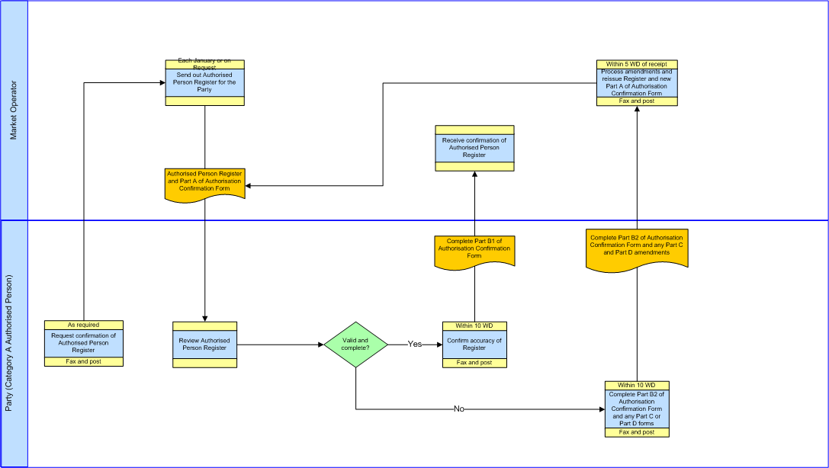

1. Procedural Steps
   1. Help Desk

| **#** | **Procedural Step** | **Timing** | **Method (as appropriate in accordance with Agreed Procedures)** | **From** | **To** |
| --- | --- | --- | --- | --- | --- |
| 1 | Contact the Market Operator Help Desk, either:   * requesting information; or * reporting an incident; or * raising a Data Query, Settlement Query, or Required Credit Cover Query; or * raising a Dispute. | Within the timescales appropriate for each issue | Telephone/email/fax | Party | Market Operator |
| 2 | On receipt of the telephone call, email or fax log the request on the Help Desk system. Contact the Participant that has raised the issue and agree timescales for its resolution. Record the agreed timescales on the Help Desk system   * If Help Desk Category 1 or 2 follow the process in the appropriate Agreed Procedure. * If information or advice necessary to resolve the issue can be provided immediately go to step 3. * If information or advice necessary to resolve the issue cannot be provided immediately but can be provided without reference to Level 2 support confirm the receipt by fax or email (if a fax number or email address is provided) and go to step 4. * If information or advice necessary to resolve the issue can be provided only with reference to Level 2 Support confirm the receipt by fax or email (if a fax number or email address is provided) and go to step 5. | If Help Desk Category 1 or 2 then timescales as set out in the appropriate Agreed Procedure. If Help Desk Category 3, 4 or 5 and initial contact by telephone– immediate. If Help Desk Category 3,4 or 5 and initial contact by email or fax – within 1 WD | Telephone/email/fax | Market Operator (Help Desk) | Party |
| 3 | Provide the Party with the necessary information or advice and close the log on the Help Desk system providing an explanation of the information or advice that has been given to the Participant.  Go to step 8. | Within 1 WD of Party contact with Help Desk | Telephone/email/fax | Market Operator (Help Desk) | Party |
| 4 | Provide the Participant with the necessary information or advice and close the log on the Help Desk system providing an explanation of the information or advice that has been given to the Participant.  Go to step 8. | In timescales previously agreed and recorded with the Party | By agreed method with the Party | Market Operator (Help Desk) | Party |
| 5 | Request Level 2 Support providing full details of the information or advice that has been requested of the Help Desk. | As soon as possible following assessment of the issue. | Telephone/email/fax | Market Operator (Help Desk) | Market Operator (Level 2 Support) |
| 6 | Consider the issue and provide the information or advice directly to the Participant. Inform the Help Desk once the information or advice has been imparted. | Within the timescales that have been agreed and recorded with the Participant | Telephone/email/fax | Market Operator (Level 2 Support) | Party |
| 7 | Close the logged Help Desk Request and inform the Participant that the log is now closed. | Within the timescales that have been agreed and recorded with the Participant | Telephone/email/fax | Market Operator (Help Desk) | Party |
| 8 | End of Process. |  |  |  |  |

* 1. Implementation Procedures
     1. Change Management For Scheduled Releases

| **#** | **Procedural Step** | **Timing** | **Method** | **From** | **To** |
| --- | --- | --- | --- | --- | --- |
| 1 | Issue High Level Impact Assessment (HLIA) | As required but at least 40 days prior to proposed release date | Email and General Public Website- | Market Operator | Participants, Meter Data Providers and System Operators |
| 2 | Provide comments on supplied documentation | Within 5 days of issue of HLIA | Email | Participants, Meter Data Providers and System Operators | Market Operator |
| 3 | Hold Consultation Workshop | Within 10 days of issue of HLIA | - |  |  |
| 4 | Consider comments and feedback |  |  | Market Operator |  |
| 5 | Issue revised High Level Impact Assessment (including revised release plan). | Within 10 days of issue of HLIA or no later than 5 working days after the Consultation Workshop | Email | Market Operator | Participants, Meter Data Providers and System Operators |
| 6 | If disagreement exists with release detail then objecting party can raise an Urgent Modification | Prior to release date | Fax or Post | Objecting Party | Modifications Committee |
| 7 | Issue Release Notification | At least 1 week prior to release date | Email and Type 2 Channel | Market Operator | Participants, Meter Data Providers and System Operators |

* + 1. Implementation Steps - Maintenance/Application Release/Emergency Release

|  |  |  |  |  |  |
| --- | --- | --- | --- | --- | --- |
| **#** | **Procedural Step** | **Timing** | **Method** | **From** | **To** |
| 1 | Perform Implementation.  If Market Operator’s Isolated Market System cannot return within the published timescales then go to step 2.  If the return to normal operation has completed successfully then go to step 3. | At published scheduled time, for Emergency Release when required | n/a | n/a | n/a |
| 2 | Initiate procedures under Agreed Procedure 7 “Emergency Communications” as a General Communication Failure. Inform Participants, Meter Data Providers and System Operators of the failure to complete the Implementation within published timescales. | As soon as is practicable | Fax or post, email, and Type 2 Channel | Market Operator | Participants, Meter Data Providers and System Operators |
| 3 | On return to normal operations inform Participants, Meter Data Providers and System Operators. | As soon as is practicable. | Email and Type 2 Channel | Market Operator | Participants, Meter Data Providers and System Operators |
| 4 | Participants, Meter Data Providers and System Operators invoke internal procedures to return to normal. | After Implementation. | n/a | Participants, Meter Data Providers and System Operators |  |

* 1. Problem Management

There are no procedural steps for Problem Management. Agreed Procedure 7 “Emergency Communications” details the process to be followed in the event of a General Communication Failure, a General System Failure and a Limited Communication Failure.

* + 1. Post Event Reporting

| **#** | **Procedural Step** | **Timing** | **Method** | **From** | **To** |
| --- | --- | --- | --- | --- | --- |
| 1 | If a General System Failure, General Communication Failure or MSP Failure has been rectified go to step 2.  If a General System Failure, General Communication Failure or MSP Failure has gone beyond 5 WDs go to step 4  If the Regulatory Authorities direct the MO to commission a report go to step 5. | n/a | n/a | n/a | n/a |
| 2 | Commission an external auditor to compile a report into the Failure. Go to step 6 | Within 2 WDs following the resolution of the fault | Email and post | Market Operator | External auditor |
| 3 | Make an application to the Regulatory Authorities to determine the need at this stage for a Post Event Report. | If Post Event Report not yet commissioned then on the 6th WD of a live failure and every 5 WD thereafter during the live failure | Email | Market Operator | Regulatory Authorities |
| 4 | Notify Market Operator whether there is a need at this stage for a Post Event Report.  If there is a need for a Post Event Report make a formal request and go to Step 5.  If there is not a need for a Post Event Report, inform MO. The process stops at this stage until a further trigger for a request for a report is forthcoming or a report is automatically triggered. | Within 1WD of request | Email | Regulatory Authorities | Market Operator |
| 5 | Commission an external auditor to compile a report into the Failure or into a Material Incident | Within 2 WDs of request from RA | Email and post | Market Operator | External auditor |
| 6 | Carry out the report and submit the completed Post Event Report to the Market Operator. | Within 5 WD of agreement to carry out a Post Event Report | Email and post | External auditor | Market Operator |
| 7 | Receive the report from the external auditor and send to the Regulatory Authorities. | Within 2 WDs of receipt of the Post Event Report from the external auditor | Email | Market Operator | Regulatory Authorities |

* 1. Authorised Persons
     1. Amendment to Authorised Persons

| **#** | **Procedural Step** | **Timing** | **Method** | **From** | **To** |
| --- | --- | --- | --- | --- | --- |
| 1 | Submit Authorisation Amendment Form Part A and the indicated numbers of Part C (New/Changes to Authorisation) and Part D (Cancellation Of Authorised Person). | As required | Fax or post | Party (Category A Authorised Person) | Market Operator |
| 2 | Review forms Submitted.  If valid and complete proceed from step 5.  If invalid or incomplete proceed from step 3. | - | - | Market Operator | - |
| 3 | Complete Part B2 of the Authorisation Amendment Form with explanation of invalidity of incompleteness. | With 5 WD of receipt | Fax or post | Market Operator | Party (Category A Authorised Person issuing the revision) |
| 4 | Correct errors and proceed from Step 1. | As required | Fax or post | Party (Category A Authorised Person) | Market Operator |
| 5 | Complete Part B1 of the Authorisation Amendment Form. | With 5 WD of receipt | Fax or post | Market Operator | Party (Category A Authorised Person issuing the revision) |

* + 1. Confirmation of Authorised Persons

| **#** | **Procedural Step** | **Timing** | **Method** | **From** | **To** |
| --- | --- | --- | --- | --- | --- |
| 1 | Request confirmation of Authorised Person Register. | As required |  | Party (Category A Authorised Person) | Market Operator |
| 2 | Send out Authorised Person Register and Authorisation Confirmation Form with Part A complete. | Within 5WD of receipt of request or in annual confirmation timescale each January | Fax or post | Market Operator | Party (Category A Authorised Person) |
| 3 | Review Authorised Person Register.  If valid and complete proceed from step 6.  If invalid or incomplete proceed from step 4. | - | - | Party (Category A Authorised Person) | - |
| 4 | Complete Authorisation Amendment Forms Part C and Part D as necessary to correct any errors and complete with Part B2 of the Authorisation Confirmation Form. | Within 10 WD | Fax or post | Party (Category A Authorised Person) | Market Operator |
| 5 | Process Authorisation Amendment Forms received and proceed from step 2 with a new Authorisation Confirmation Form. | With 5 WD of receipt | Fax or post | Market Operator | Party (Category A Authorised Person issuing the revision) |
| 6 | Complete Part B1 of the Authorisation Confirmation Form. | Within 10 WD | Fax or post | Party (Category A Authorised Person) | Market Operator |

1. Definitions and Abbreviations

Definitions

|  |  |
| --- | --- |
| **Administered Settlement** | As defined in the Code |
| **Agreed Procedure** | As defined in the Code |
| **Authorisation** | The process by which a person from a Party becomes authorised to communicate with the Market Operator. |
| **Authorisation Amendment Form** | The form which needs to be completed in order to add or remove Authorised Persons |
| **Authorisation Category** | Identifies the type of communication that an Authorised Person is authorised to make |
| **Authorisation Confirmation Form** | The form sent to (and returned by) Participants confirming their Authorised Persons |
| **Authorised Person** | Representative of a Party who is authorised by that Party to communicate with the Market Operator |
| **Authorised Person Register** | Register of Authorised Persons for each Party which is held by the Market Operator. |
| **Billing Timescales** | The timescales in which billing occurs |
| **Category A Authorised Person** | An Authorised Person who has been granted an Authorisation Category A |
| **Code** | As defined in the Code |
| **Commercial Offer Data** | As defined in the Code |
| **Communication Channel** | As defined in the Code |
| **Confirmation Notice** | As defined in the Code |
| **Market Operator Website** | As defined in Agreed Procedure 1 “Participant and Unit Registration and Deregistration” |
| **Data Query** | As defined in the Code |
| **Data Transaction** | As defined in the Code |
| **Detailed Impact Assessment** | Analysis carried out to identify the detailed implications of a change enabling the approval or otherwise of a change |
| **Dispute** | As defined in the Code |
| **Emergency Implementation** | Implementation of an Emergency Release |
| **Emergency Implementation Form** | Form sent to Participants, Meter Data Providers and System Operators to inform of an Emergency Release |
| **Emergency Release** | An upgrade in system software, a bug-fix or an Implementation of an Urgent Modification, where the Market Operator considers that there is a risk to the operation of the Single Electricity Market. |
| **Failure** | A General System Failure or MSP Failure or a failure of the MSP Software or a General Communication Failure or a Limited Communication Failure as the context implies |
| **Finance System** | Financial element of the Market Operator’s Isolated Market System |
| **Gate Window Closure** | As defined in the Code |
| **General Communication Failure** | As defined in the Code |
| **General System Failure** | As defined in the Code |
| **Help Desk** | Help Desk provided by the Market Operator where Parties can seek technical and operational advice |
| **Help Desk Category** | Category between 1 and 5 applied to a Help Desk Request |
| **Help Desk Request** | Request handled by the Help Desk |
| **High Level Impact Assessment** | Analysis carried out to identify the implications of a change |
| **Implementation** | Delivery of Releases on the production Market Operator’s Isolated Market System or Communication Channels |
| **Implementation Day** | Day of Implementation of a Release |
| **Interconnector Administrator** | As defined in the Code |
| **Interface Documentation Set** | Interface documentation, to include technical and functional details and data definitions.  It shall be under Market Operator version control. The listing shall not include the items’ version numbers but shall be under Market Operator version control. |
| **Isolated Market System** | As defined in the Code |
| **Level 2 Support** | Market Operator technical or business experts with the knowledge and expertise to assist / resolve issues and incidents with the Market Operator’s Isolated Market System or with the configuration of Communication Channels. |
| **Limited Communication Failure** | As defined in the Code |
| **Market Operator** | As defined in the Code |
| **Material Incident** | An incident which, in the opinion of the Market Operator, has had a material impact on market prices/SMP/MSQs. |
| **Meter Data Provider** | As defined in the Code |
| **Modification** | As defined in the Code |
| **Modification Proposal** | As defined in the Code |
| **Modifications Committee** | As defined in the Code |
| **MSP Failure** | As defined in the Code |
| **MSP Software** | As defined in the Code |
| **Offer Data** | As defined in the Code |
| **Participant** | As defined in the Code |
| **Party** | As defined in the Code |
| **Post Event Report** | An externally audited report produced in the event of a General Communication Failure, General System Failure or MSP Failure. |
| **Problem Management Function** | A single senior officer or a group of officers from the Market Operator who will develop interim solutions and prioritise the restoration of Market Operator Isolated Market Systems in the event of a Failure |
| **Registration Data** | As defined in the Code |
| **Regulatory Authorities** | As defined in the Code |
| **Release** | An update to the Market Operator Isolated Market Systems |
| **Required Credit Cover Query** | As defined in the Code. |
| **Scheduled Release** | As defined in the Code |
| **Secretariat** | As defined in the Code |
| **Settlement** | As defined in the Code |
| **Settlement Query** | As defined in the Code |
| **Settlement Reallocation** | As defined in the Code |
| **Settlement Reallocation Request** | As defined in the Code |
| **Settlement System** | Any software system used as part of the Settlement process |
| **Single Electricity Market** | As defined in the Code |
| **System Marginal Price** | As defined in the Code |
| **System Operator** | As defined in the Code |
| **Test Environment** | A non-production version of a Market Operator‘s Isolated Market System used for test purposes prior to a Release |
| **Type 2 Channel** | As defined in the Code |
| **Unit Registration** | As defined in the Code |
| **Urgent** | As defined in the Code |
| **Working Day** | As defined in the Code |

Abbreviations

|  |  |
| --- | --- |
| **AP1** | Agreed Procedure 1 “Participant and Unit Registration and Deregistration” |
| **AP4** | Agreed Procedure 4 “Transaction Submission and Validation” |
| **AP7** | Agreed Procedure 7 “Emergency Communications” |
| **AP9** | Agreed Procedure 9 “Credit Risk Management” |
| **AP10** | Agreed Procedure 10 “Settlement Reallocation” |
| **AP11** | Agreed Procedure 11 “Market System Operation, Testing, Upgrading and Support” |
| **AP12** | Agreed Procedure 12 “Modifications Committee Operation” |
| **AP13** | Agreed Procedure 13 “Query Generation” |
| **AP14** | Agreed Procedure 14 “Disputes” |
| **MO** | Market Operator |
| **MOIMS** | Market Operator Isolated Market System |
| **MSQ** | Market Schedule Quantities |
| **RA** | Regulatory Authorities |
| **SEM** | Single Electricity Market |
| **SMP** | System Marginal Price |
| **URL** | Uniform Resource Locator (i.e. website address) |
| **WD** | Working Day |
| **WSDL** | Web Service Definition Language |

1. Forms

Emergency Implementation Form

**Emergency Implementation Form**

**MO Implementation Ref:**

**Part 1 – Initial Notification**  **Date Sent:**

**Planned Date / Time of Implementation Commencement:**

**Planned Date / Time of Implementation Completion:**

**Implementations Details:**

**Change Requests** *(List all Change requests included in Release)***:**

**Name (Market Operator):**

**Signature:**

**Part 2 – Completion Notification Date Sent:**

**Date / Time of Implementation Completion:**

**Implementations Details:**

All Change Requests itemised in Part 1 except the following:

**Name (Market Operator):**

**Signature:**

Standard Implementation Proposal Form

Standard Implementation Notification Form

**Implementation Proposal Form**

**MO Implementation Ref:**

**Part 1 – Initial Notification Date Sent:**

**Planned Date / Time of Implementation Commencement:**

**Planned Date / Time of Implementation Completion:**

**Implementations Details:**

**Change Requests** *(List all Change requests included in Release)***:**

**Name (Market Operator):**

**Signature:**

**Part 2 – Participant Comments Date Sent:**

**Participant Id: Participant Name:**

**General Comments on Implementation:**

**Suggested alternative Implementation Dates / Times:**

**Name** *(Participant staff authorised to submit comment):*

**Signature:**

**Password:**

**Implementation Notification Form**

**MO Implementation Ref:**

**Part 1 – Revised Notification Date Sent:**

**Planned Date / Time of Implementation Commencement:**

**Planned Date / Time of Implementation Completion:**

**Implementations Details:**

**Change Requests** *(List all Change requests included in Release)***:**

**Name (Market Operator): Signature:**

**Part 3 – Completion Notification Date Sent:**

**Date / Time of Implementation Completion:**

**Implementations Details:**

All Change Requests itemised in Part 3 except the following:

**Name (Market Operator): Signature:**

**Part 2 – Confirmation Notification Date Sent:**

The Implementation listed above is proceeding,

Commencing on (Date/time)

Completing on (Date/time)

**Name (Market Operator): Signature:**

Level 3 Alternative Communication Form

**Alternative Communication Channel during Level 3 Implementation –**

**Notification**

**Market Operator Implementation Ref:**

**Party Id: Party Name:**

**Commencement of Alternative Communication:**

*(Date/Time or “On commencement of the Implementation”*

**Termination of Alternative Communication:**

*(Insert Date/Time or “On completion of Implementation”)*

**Name** *(Participant staff authorised to submit):*

**Signature:**

**Password:**

**Attachments: Transaction Notification Form (TNF) (see AP7 for TN Form)**

**Number of Pages of TNF attached:**

Authorisation Amendment Form

**Authorisation Amendment Form Part B2 Rejection Acknowledgement**

Reasons for rejection: *Provide reason and annotated copies of submitted Part Cs and Ds*

Market Operator Staff Name:

Signature: Date Sent:

**Authorisation Amendment Form Part A Authorisation**

*This section to be completed by a Category A Authorised Person and should be attached as affront sheet to completed Part(s) C and/or D as required.*

**Details of Category A Authorised Person completing this Form**

Party ID: Party Name:

Name of Authorised Person:

Email Address of Authorised Person:

Signature of Authorised Person:

Password of Authorised Person:

**Party Ref: Date Sent:**

**Market Operator Ref: Date Received:**

Page 1 of

**Number of New/Amended/Cancelled Authorisations attached**

Number of Part C Authorisation Amendments:

Number of Part D Authorisation Amendments:

**Authorisation Amendment Form Part B1 Acceptance Acknowledgement**

Market Operator Staff Name:

Signature: Date Sent:

**Authorisation Amendment Form Part C New/Changes to Authorisation**

*This section to be completed as necessary for each required new authorisation or amended authorisation application, with each application on a separate page. All authorisation level boxes must be completed with either a Yes or No*

**Effective From Date:**

Details of Person being Authorised:

**Name:**

**Position:**

**Telephone Number: Fax Number:**

**Signature:**

**Password (8 Character):**

**Email Address**

Is authorised for the following processes:

|  |  |  |
| --- | --- | --- |
| **Category** | **Description** | **Yes/No** |
| **A** | Change Authorisations |  |
| **B** | Submit Data Queries, Settlement Queries or Required Credit Cover Queries |  |
| **C** | Submit Settlement Disputes |  |
| **D** | Submit Settlement Reallocation Requests, Commercial Offer Data & Technical Offer Data |  |
| **E** | Declare Limited Communication Failure  Request/Agree Change in Communication Channel |  |
| **F** | Intermediary Authorisation |  |
| **G** | Ad-Hoc Report request |  |
| **H** | Submit/Modify Unit Registration and/or Interconnector Data |  |
| **I** | Request Return of Collateral |  |
| **J** | Person to be notified in event of General System Failure and/or General Communication Failure |  |
| **K** | Requesting Digital Certificates |  |

Page 1 of

**Authorisation Amendment Form Part D Cancellation of Authorisation**

*This section to be completed as necessary for each required cancellation, with each cancellation on a separate page.*

**Effective From Date:**

Details of Person whose Authorisation is being cancelled:

**Name:**

**Position:**

Authorisation Confirmation Form

**Details of Category A Authorised Person to whom this Confirmation Form is being sent.**

Party id: Party Name:

Category A Authorised Person Name:

Category A Authorised Person Position:

Page 1 of

**Authorisation Amendment Form Part B2 - Errors Acknowledgement**

Party Category A Authorised Person Name:

Signature: Date Sent:

Password:

Email Address:

**Number of New/Amended/Cancelled Authorisations attached**

Number of Part C Amendments:

Number of Part D Amendments:

**Authorisation Confirmation Form Part B1 - No Errors Acknowledgement**

Party Category A Authorised Person Name:

Signature: Date Sent:

Password:

Email Address:

**Authorisation Confirmation Form Part A**

Attached is the Authorisation Register for your Party. Pleased could you review and confirm the accuracy of the register by completing Part B1 below. If there are errors in the register please provide Authorisation Amendment Forms Part C and/or Part D for each Authorised Person whose details are incorrect and completed Part B2 below.

**Party Ref: Date Received:**

**Market Operator Ref: Date Sent:**

1. Potential Failures and Typical Corrective Actions

| **Failure Group** | **Failure** | **Action** | **Maximum Duration** |
| --- | --- | --- | --- |
| Participant Data Receipt | Unable to receive Data Transactions from Participants | Implement process for General Communication Failure outlined in Agreed Procedure 7 “Emergency Communications” | 5 Working Days |
|  | Unable to validate the Data Transactions from Participants | Implement a manual procedure for validating received Data Transactions and issue Confirmation Notices via fax | 5 Working Days |
|  | Unable to issue Data Transactions or the Confirmation Notices / failure for the received validated Data Transactions | Send Confirmation Notices via fax and for all other Data Transactions will use any method agreed under Type 1 Communication Channel | 5 Working Days |
| System Operators Communication Failure | Unable to extract Registration Data, Offer Data from the Market Operator Isolated Market System | Implement Administered Settlement | N/A |
|  | Unable to send Registration Data, Offer Data to the System Operators | Market Operator and each affected System Operator will agree an alternative secure method for transferring the data for each type of Data Transaction | 5 Working Days |
| MSP Failure | MSP Software cannot run, MSP Software fails to provide usable results or a Meter Data Provider is not able to produce the meter data | None (After 3 Working Days implement Administered Settlement) | 3 Working Days |
|  | Meter Data Providers/Interconnector Administrators are able to produce the meter data but unable to send it through a Communication Channel | Market Operator and each affected Meter Data Provider/Interconnector Administrator will agree an alternative secure method for transferring the data for each type of Data Transaction | 5 Working Days |
| Settlement Failure | Settlement cannot run  Or  Masterfile from Market Operator’s Isolated Market System to Settlements cannot e produced or transferred | None (After 3 Working Days implement Administered Settlement) | 3 Working Days |
| Finance System Failure | Finance System cannot run | Implement manual procedures to ensure payments are made to the relevant Participants | 5 Working Days |
|  | Data from Settlements System cannot be transferred to the Finance System | Use alternative data transfer methods or implement manual procedures to ensure payments are made to the relevant Participants | 5 Working Days |

1. Authorisation Categories

|  |  |  |
| --- | --- | --- |
| **Category** | **Description** | **Agreed Procedure** |
| **A** | Change Authorisations | AP11 |
| **B** | Submit Data Queries, Settlement Queries or Required Credit Cover Queries | AP13 |
| **C** | Submit Settlement Disputes | AP14 |
| **D** | Submit Settlement Reallocation Requests, Commercial Offer Data & Technical Offer Data | AP4, AP7, AP10 |
| **E** | Declare Limited Communication Failure  Request/Agree Change in Communication Channel | AP7, AP11 |
| **F** | Intermediary Authorisation | AP1 |
| **G** | Ad-Hoc Report request |  |
| **H** | Submit/Modify Unit Registration and/or Interconnector Data | AP1 |
| **I** | Request return of Collateral | AP9 |
| **J** | Person to be notified in event of General System Failure and/or General Communication Failure | AP7 |
| **K** | Requesting Digital Certificates | AP3 |