Trading and Settlement Code
Version 28.0

Part B Agreed Procedure 14: Disputes | August 18  2023

Contents

1. Introduction 1
1.1 Background and Purpose 1
1.2 Scope of Agreed Procedure 1
1.3 Definitions 1
1.4 Compliance with Agreed Procedure 2
2. Overview 3
2.1 Raising a Dispute 3
2.2 Referral to a Dispute Resolution Board 3
3. Procedural Steps 4
3.1 Raising a Dispute 4
3.2 Dispute Resolution Board Composition 11
3.3 Dispute Resolution Board Decision 15
APPENDIX 1: Definitions 19

Document History

Version | Date | Author | Comment
20.0 | 07/04/2017 | I-SEM Project Team | Baseline Documentation at V20.0
21.0 | 12/04/2019 | SEMO | Baseline Documentation to V 21.0
21.0 | 12/04/2019 | SEMO | Mod_35_18 Clarifications To Dispute Process
22.0 | 29/04/2020 | SEMO | Baseline Documentation to V 22.0
23.0 | 03/11/2020 | SEMO | Baseline Documentation to V 23.0
24.0 | 01/07/2021 | SEMO | Baseline Documentation to V24.0
24.0 | 01/07/2021 | SEMO | Mod_12_20 Amendments to the DRB process
24.0 | 01/07/2021 | SEMO | Mod_13_20 Transparency of DRB decisions
25.0 | 09/11/2021 | SEMO | Baseline Documentation to V25.0
26.0 | 17/05/2022 | SEMO | Baseline Documentation to V26.0
27.0 | 07/12/2022 | SEMO | Baseline Documentation to V27.0
28.0 | 18/08/2023 | SEMO | Baseline Documentation to V28.0

RELATED DOCUMENTS

Document Title | Version | Date | By
Trading and Settlement Code | 28.0 | 18/08/2023 | SEMO
Agreed Procedure 13 “Settlement Queries”
Agreed Procedure 15 “Settlement and Billing”

- Introduction
  - Background and Purpose
This Agreed Procedure supplements the Dispute Resolution Process set out at section B.19 of the Trading and Settlement Code (hereinafter referred to as the “Code”). It sets out procedures with which Parties to the Code must comply.

  - Scope of Agreed Procedure
This Agreed Procedure sets out the procedural steps for:
- the raising of a Dispute;
- the appointment of the Dispute Resolution Board to make a decision on a Dispute;
- the timescales / procedure associated with a decision of the Dispute Resolution Board; and
- the timelines to commence Court proceedings if Parties are dissatisfied with the decision taken by the Dispute Resolution Board.
This Agreed Procedure does not include the setting up of the Panel from which members of the Dispute Resolution Board are drawn. It does not make any statement regarding Court proceedings once they have begun.
This Agreed Procedure forms an annex to, and is governed by, the Code. This document sets out procedures to be followed, subject to the rights and obligations of Parties under the Code. In the event of any conflict between a Party’s obligations set out in the Code and this Agreed Procedure, the Code shall take precedence.
It is not intended that there be any inconsistency or conflict between section 2 “Overview” and section 3 “Procedural Steps”. However, in the event of any inconsistency or conflict, section 3 “Procedural Steps” shall take precedence.
In section 3 “Procedural Steps” a corresponding process flow diagram is included for each procedural steps table. Process flow diagrams are for illustrative purposes. It is not intended that there be any inconsistency or conflict between any procedural steps table and process flow diagram however, in the event of any inconsistency or conflict, a procedural steps table shall take precedence.
The provisions set out in this Dispute Resolution procedure shall not prejudice or restrict any Party’s entitlement to seek interim or interlocutory relief directly from the appropriate Court or Courts having competent jurisdiction.

  - Definitions
Words and expressions defined in the Code shall, unless the context otherwise requires or unless otherwise defined herein at Appendix 1 (Definitions), have the same meanings when used in this Agreed Procedure.
References to particular paragraphs relate internally to this Agreed Procedure unless otherwise specified.

  - Compliance with Agreed Procedure
Compliance with this Agreed Procedure is required under the terms of the Code.

- Overview
  - Raising a Dispute
A Dispute is raised under the Code where:
- one Party serves a Notice of Dispute within the applicable timeframes, as set out at paragraph B.19.1.3 of the Code; or
- a Dispute is deemed to arise under paragraph G.3.2.15 following a Settlement Query.
A Party shall serve a Notice of Dispute by completing and delivering the Notice of Dispute Form available on the Market Operator’s website signed by an Authorised Person. The Notice of Dispute shall include the following:
- details of the Dispute including the paragraphs of the Code relevant to the matters being disputed;
- additional supporting documentation;
- counterparties to the Dispute;
- the proposed negotiation timeframe; and
- any corrective actions sought.
Following the raising of a Dispute, the Market Operator will assign a unique identifier and will coordinate a meeting with the Disputing Parties in an attempt to resolve the Dispute by negotiation.

  - Referral to a Dispute Resolution Board
If a Dispute is not resolved by negotiation between the Dispute Counterparties within the timelines specified in section 3.1 below it may, subject to the provisions set out in the Code, be referred to a Dispute Resolution Board through the issuing of a Referral Notice by any Disputing Party.
A Referral Notice shall state:
- the section of the Code under which the Referral Notice is given;
- the Dispute identifier; and
- that the Dispute is being referred to the Dispute Resolution Board.
The procedures in relation to Dispute Resolution Board composition and Dispute Resolution Board decisions are set out in section 3.2 and section 3.3 below.

- Procedural Steps
  - Raising a Dispute
Step | Step Description | Timing | Method | From / By | To
1a | Pricing Dispute  Notify Market Operator of the Pricing Dispute by sending a completed Notice of Dispute Form (available on the Market Operator’s website). | Within 5 WD of the relevant Imbalance Settlement Price being published. | Email / Facsimile | Raising Party | Market Operator
1b | Dispute arising from a Settlement Query  Notify Market Operator of the Dispute by completing and sending a Notice of Dispute (available on the Market Operator’s website). | Within 5 WD of receipt of the Market Operator’s determination in respect of a Settlement Query. | Email / Facsimile | Raising Party | Market Operator
1c | Dispute arising from a claimed conflict between the Code and other Legal Requirements  Notify Market Operator of the Dispute by completing and sending a Notice of Dispute (available on the Market Operator’s website). | Within 5 WD of a request from the Regulatory Authorities or the Market Operator in accordance with paragraph B.22.2.3 of the Code | Email / Facsimile | Raising Party | Market Operator
1d | Dispute other than those referred to at step 1a, step 1b and step 1c  Notify Dispute Counterparty or Dispute Counterparties of the Dispute by sending a Notice of Dispute (available on the Market Operator’s website). | Within 20 WD of Disputing Party being aware of the Disputed Event and in any event within 2 years of the Disputed Event | Email / Facsimile | Raising Party | Dispute Counterparties
1e | Dispute automatically arising from failure by Market Operator to issue a resolution in respect of a Settlement Query.  Notice of Dispute is not required, go to step 3. | Dispute arises on the date on which the Market Operator was required to issue a resolution in respect of the Settlement Query under the Code | - | - | -
2 | Send a copy of the Notice of Dispute to the Market Operator. If the Market Operator is a Dispute Counterparty, send a copy of the Notice of Dispute to the Regulatory Authorities. | At the same time as step 1 | Email / Facsimile | Raising Party | Market Operator or Regulatory Authorities (as appropriate)
3 | If Dispute automatically arises under step 1e above, provide notification to the Dispute Counterparty and the Regulatory Authorities that the Dispute has arisen. | Within 5 WD of Dispute being deemed to arise | Email / Facsimile | Market Operator | Dispute Counterparty and Regulatory Authorities
4 | Market Operator identifies other potential Affected Participants and notifies them of the Dispute based on the high-level information set out in the Notice of Dispute. | Within 5 WD or as soon as the Affected Participant is clearly identified | Email / Facsimile | Market Operator | Affected Participants
5 | If the Dispute is a Pricing Dispute issue a Notice or otherwise identify to all Participants the relevant published Imbalance Settlement Price that is subject to the Pricing Dispute | As soon as practicable after receipt of the Notice of Dispute | Publish Notice and/or flag on published Imbalance Settlement Price | Market Operator | All Participants and Regulatory Authorities
6 | Hold a meeting and attempt to resolve the Dispute by negotiation.  For a General Dispute continue to step 7.  For a Pricing Dispute go to step 13.  For a Credit Cover Dispute go to step 11. | General Dispute: Within 10 WD of the date of receipt of the Notice of Dispute, or of the date of the Dispute arising under 1e above  Pricing Dispute:  Within 5 WD of the Notice of Dispute  Credit Cover Dispute:  Within 1 WD of the Notice of Dispute or otherwise as soon as practicable, but in any case within 5 WD of receipt of the Notice of Dispute or, if agreed by the market Operator and the Disputing Party,10 WD of the Notice of Dispute | Meeting or conference call | Market Operator | All Disputing Parties
7 | In the event that any of the Disputing Parties wishes to extend the timescales for negotiating a resolution to the Dispute then the relevant Disputing Party shall inform the other Disputing Parties of the period for which the Disputing Party wishes to extend the Negotiation Period.  If there are no requests for an extension, go to step 11. | Within 10 WD of the first meeting to resolve the Dispute under step 6 | Email / Facsimile | Disputing Party | Market Operator (or Regulatory Authorities) and  Dispute Counterparty(ies)
8 | Disputing Parties meet to determine whether Negotiation Period should be extended. | Within 2 WD of request to extend under step 7 or prior to expiry of the Negotiation Period, whichever is earlier | Meeting or conference call | Disputing Parties | -
9 | Minutes of this meeting shall be taken by the Market Operator (unless otherwise agreed) and circulated to Affected Participants. | As soon as possible following meeting in step 8 | Email / Facsimile | Market Operator (or as otherwise agreed) | Affected Participants
10 | If all Dispute Counterparties agree to extend the Negotiation Period, send a request to the Market Operator or, if the Market Operator is a Disputing Party, the Regulatory Authorities, asking for consent to the agreed extension of the Negotiation Period. If the Market Operator or the Regulatory Authorities (as appropriate) agree to the extension, the Negotiation Period shall be extended in accordance with that agreement. | On receipt of the confirmation from the Disputing Parties to extend the Negotiation Period | Email / Facsimile | Raising Party or, if agreed any other Disputing Party | Market Operator Regulatory Authorities
11 | If the attempt to resolve the Dispute has been successful during the Negotiation Period then notify the Market Operator, or, if the Market Operator is a Disputing Party, the Regulatory Authorities, by delivering a completed Dispute Resolution Form (available on the Market Operator’s website) signed by all Disputing Parties. Go to step 14. | Within 5 WD of resolution by negotiation | Email / Facsimile | Raising Party | Market Operator (Regulatory Authorities)  Dispute Counterparty or Dispute Counterparties
12 | If the attempt to resolve the Dispute within the Negotiation Period has been unsuccessful a Disputing Party may send a Referral Notice to the Market Operator (or the Regulatory Authorities where the Market Operator is a Disputing Party) and a copy to the Disputing Parties, go to step 16.  If the Dispute is not referred to the DRB by way of a Referral Notice, the Dispute is deemed to be withdrawn, end process. | General Dispute:  Within 20 WD of expiry of the Negotiation Period  Credit Cover Dispute:  Within 5 WD of the expiry of the Negotiation Period | Email / Facsimile | Any Disputing Party | Market Operator (Regulatory Authorities where the Market Operator is a Disputing Party) and a copy to the Dispute Counterparties
13 | Unless the Market Operator determines that a manifest error has occurred under paragraph E.3.8.1 of the Code, a Disputing Party may send a Referral Notice to the Market Operator with a copy to the Regulatory Authorities, continue to step 17.  If the Dispute is not referred to the DRB by way of a Referral Notice, the Dispute is deemed to be withdrawn, end process. | Within 8 WD of the issue of the Notice of Dispute | Email / Facsimile | Any Disputing Party | Market Operator and Regulatory Authorities
14 | If the Dispute resolution agreed between the Disputing Parties requires a Settlement Rerun, the Market Operator shall procure that an additional Settlement Rerun for the relevant Settlement Period shall be performed within the timeframe agreed with the Market Operator by the Disputing Parties. The Market Operator shall then proceed with invoicing as detailed in Agreed Procedure 15 “Settlement and Billing”. | On Dispute Resolution Form | - | Market Operator | -
15 | If the Dispute resolution agreed between the Disputing Parties requires a Settlement Rerun and this affects an Affected Participant, inform the Affected Participant of the outcome of the Dispute, end process | Within 5 WD of resolution by negotiation or as soon as the impact is clearly identified, whichever is later | Email / Facsimile | Market Operator | Affected Participants
16 | Provide supporting evidence to enable the DRB to assess the likelihood that the matter in dispute will, if the Dispute is upheld, satisfy the Price Materiality Threshold. | Together with the Referral Notice or as requested by the DRB | Email / Facsimile | Disputing Party that issued Referral Notice | DRB
17 | Forward the Referral Notice to the Chairperson. | On receipt of the Referral Notice | Email / Facsimile | Market Operator | Chairperson

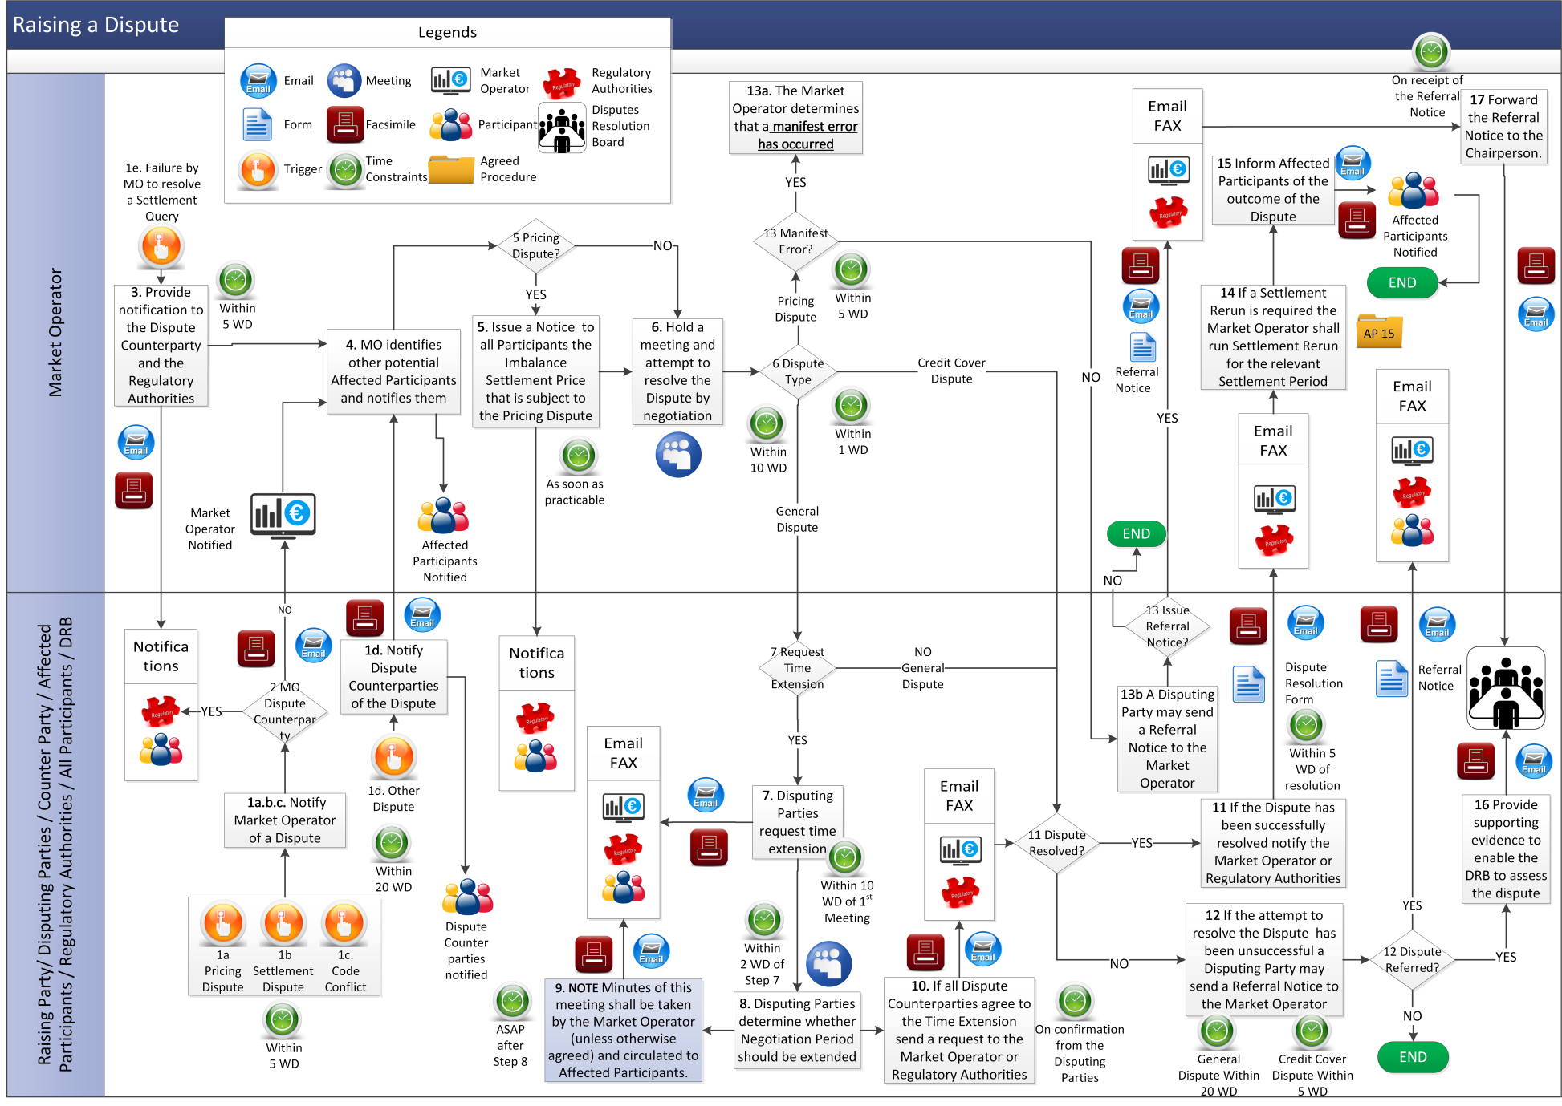
  - Dispute Resolution Board Composition
Step | Step Description | Timing | Method | From / By | To
 | If there are more than 2 Disputing Parties go to step 10. | - | - | - | -
 | Hold a meeting to decide the composition of the DRB. If agreement on the composition of the DRB is reached, go to step 4, otherwise, if agreement cannot be reached three DRB members should be appointed. | Within 10 WD of receipt of Referral Notice | Meeting | Disputing Parties | -
 | INTENTIONALLY BLANK
 | If the Disputing Parties agree to appoint a sole member DRB, go to step 6 | - | - | - | -
 | If the Disputing Parties agree to appoint a three member DRB go to step 8 | - | - | - | -
 | Agree the identity of the sole member of the DRB.  If agreement is reached notify the DRB member, the Chairperson, Market Operator and Regulatory Authorities.  If agreement is not reached, notify the Chairperson and go to step 7. | Within 5 WD of agreement at step 1 | Meeting and notification by Email / Facsimile | All Disputing Parties | DRB member, Chairperson, Disputing Parties, Market Operator, Regulatory Authorities
 | Chairperson shall nominate the sole member of the DRB from the Panel and shall notify the relevant persons of the appointment, go to step 12. | Within 10 WD of receipt of notification from Disputing Parties at step 6 | Email / Facsimile | Chairperson | DRB member, Disputing Parties, Market Operator, Regulatory Authorities
 | The Disputing Parties nominate one DRB member each and shall notify the relevant persons of the appointment. | Within 5 WD of agreement at step 1 | Meeting and notification by Email / Facsimile | Disputing Parties | DRB members, Chairperson, Market Operator, Regulatory Authorities
 | The DRB members appointed under step 8 nominate the third member of the DRB and notify the relevant persons of the appointment, go to step 12. | Within 5 WD of appointment at step 8 | Meeting and notification by Email / Facsimile | DRB members | DRB members, Chairperson, Market Operator, Regulatory Authorities
 | The Disputing Parties shall seek to agree the composition of the DRB and the identity or identities of the member(s) of the DRB.  If agreement is reached the Disputing Parties shall notify the relevant persons of the appointment, go to step 12.  If agreement is not reached, notify the Chairperson and go to step 11(three DRB members will be appointed in this case). | Within 10 WD of receipt of Referral Notice | Meeting and notification by Email / Facsimile | Disputing Parties | DRB members, Chairperson, Market Operator, Regulatory Authorities
 | Chairperson nominates the member(s) of the DRB and notifies the relevant persons | Within 10 WD of receipt of request from Disputing Parties at step 10 | Email / Facsimile | Chairperson | DRB members, Chairperson, Market Operator, Regulatory Authorities
 | Meet to finalise and execute Dispute Resolution Agreement in the form set out at Appendix B “Dispute Resolution Agreement” of the Code. | Within 15 WD of appointment of DRB | Meeting | DRB and Disputing Parties | -
 | If at any stage any member of DRB declines or is unable to act for reasons set out in the Code, that member must notify the Disputing Parties and the Chairperson. | Immediately following nomination, or if subsequent event gives rise to inability to act, immediately following that event | Email / Facsimile | DRB member | Chairperson and Disputing Parties
 | If at any stage the Disputing Parties terminate the appointment of any member of the DRB pursuant to paragraph B.19.7.2 of the Code, the Disputing Parties shall notify the Chairperson. | Immediately following unanimous agreement to terminate appointment | Email / Facsimile | Disputing Parties | Chairperson
 | Chairperson shall nominate and notify a replacement member and proceed with process in accordance with steps 1 to 11, or, if a Dispute Resolution Agreement is already executed, arrange for new member to execute in place of outgoing member. | Within 5 WD of notification at step 14 | Email / Facsimile | Chairperson | New DRB member and Disputing Parties
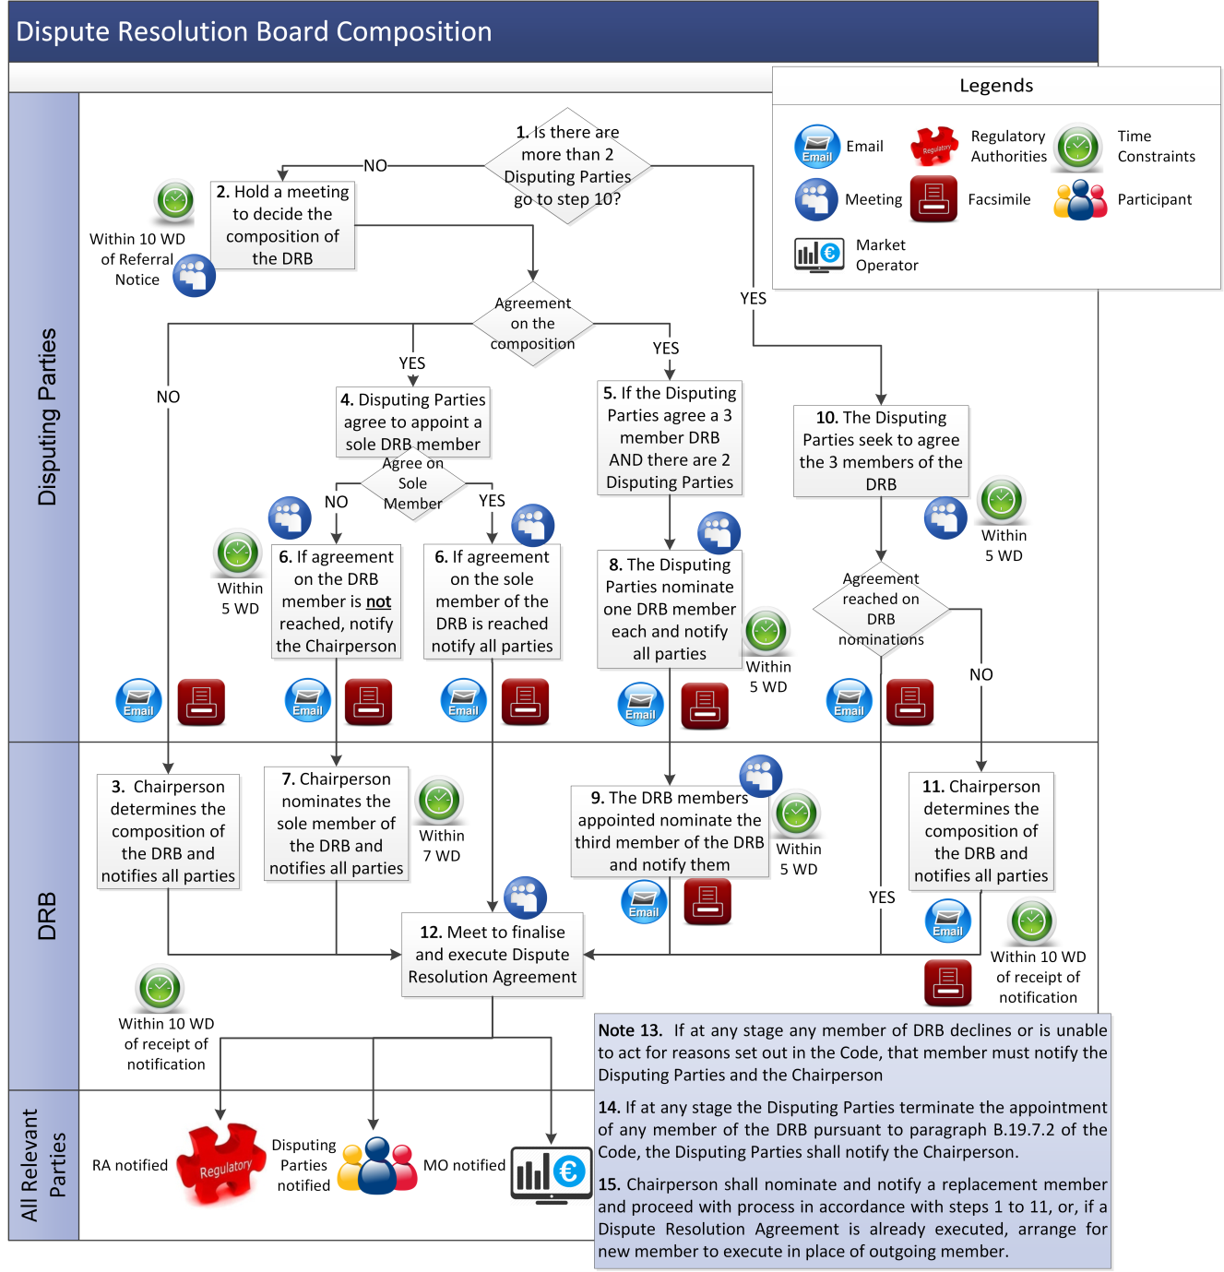
  - Dispute Resolution Board Decision
Step | Step Description | Timing | Method | From / By | To
1 | Provide the Dispute Resolution Board with all available information required to enable the DRB to make an informed decision. | As soon as possible following the appointment of DRB | Email / Facsimile | Disputing Parties | DRB
2 | For a Pricing Dispute, the DRB must advise the Disputing Parties of its assessment as to the likelihood that the matter disputed will, if the Dispute is upheld, satisfy the Price Materiality Threshold. | Within 5 WD after the appointment of the DRB or such longer time as may be agreed by the Disputing Parties | Email / Facsimile | DRB | Disputing Parties
3 | In the event that further information is required from the Disputing Parties to enable the DRB to make its decision, request this information from the Disputing Parties | Within the timescale constraints within which the DRB must make its decision | Email / Facsimile | DRB | Disputing Parties
4 | Provide the required information to the Dispute Resolution Board | Within the DRB’s specified timescales | Email / Facsimile | Disputing Parties | DRB
5 | If necessary, request additional time to make the decision on the Dispute. | As soon as possible and within 30 WD of appointment of the DRB for bilateral Disputes, or within 40 WD of the appointment of the DRB for multilateral Disputes | Email / Facsimile | DRB | Disputing Parties
6 | Disputing Parties determine whether they agree to extension of period and notify the DRB of decision (with copy to the Market Operator, or if the Market Operator is a Disputing Party, to the Regulatory Authorities). | Within 2 WD of request from DRB or prior to expiry of the period referred to in step 5, whichever is the earlier | Email / Facsimile | Disputing Parties | DRB, Market Operator or Regulatory Authorities
7 | DRB makes its decision having due regard to the objectives of the Dispute Resolution Process and notifies Disputing Parties in writing of its decision and reasons for its decision. If this decision includes a recommendation by the DRB for a proposed Modification to the Code, the Market Operator will raise this for discussion at the next Modifications Committee Meeting and outline proposed next steps (if any). | For bilateral Disputes, within 30 WD of appointment of DRB or such longer period as agreed by DRB and the Disputing Parties under step 6; or  For multilateral  Disputes, within 40 WD of appointment of DRB or such longer period as agreed by DRB and the Disputing Parties under step 6 | Email / Facsimile | DRB | Disputing Parties, Market Operator or Regulatory Authorities
8 | If any Disputing Party is dissatisfied with the decision / no decision of the DRB, give notice to the other Disputing Parties that it is dissatisfied with the decision / no decision together with reasons for dissatisfaction. Continue to step 9.  If all Parties satisfied with the decision of the DRB, complete Dispute Resolution Form (available from the Market Operator’s website) and go to step 11. | Within 15 WD of receipt of decision or there being no decision from the DRB | - | Any Disputing Party | -
9 | Attempt to settle the Dispute amicably. If the Dispute has been settled amicably, end process, otherwise continue to step 10. | Within 21 WD of notification of dissatisfaction at step 8 or as otherwise agreed | - | Disputing Parties |  | -
10 | If the Dispute has not been resolved amicably under step 9, and the dissatisfied Party has issued notification of dissatisfaction to all other Disputing Parties under step 8, then the Dispute may be settled through proceedings in a Court having competent jurisdiction. | Within 21 WD (or such longer period as agreed by all Disputing Parties) after notification of dissatisfaction received under step 8, even if no attempt at amicable settlement has been made | - | Disputing Parties | Disputing Parties
11 | If, following resolution of the Dispute, a Party believes that the other Party has not complied with the decision of the DRB, they may refer the matter to proceedings in a Court having competent jurisdiction. | Once decision of DRB has become final and binding in accordance with the Code | - | Any Disputing Party | -
12 | The DRB shall send a copy of its decision  to the Market Operator no later than 30 days  from the date that the DRB issued its decision to the Disputing Parties, unless a notice of dissatisfaction is raised | Once decision of DRB has become final and binding in  accordance with the Code | - | DRB | Disputing Parties and Market Operator
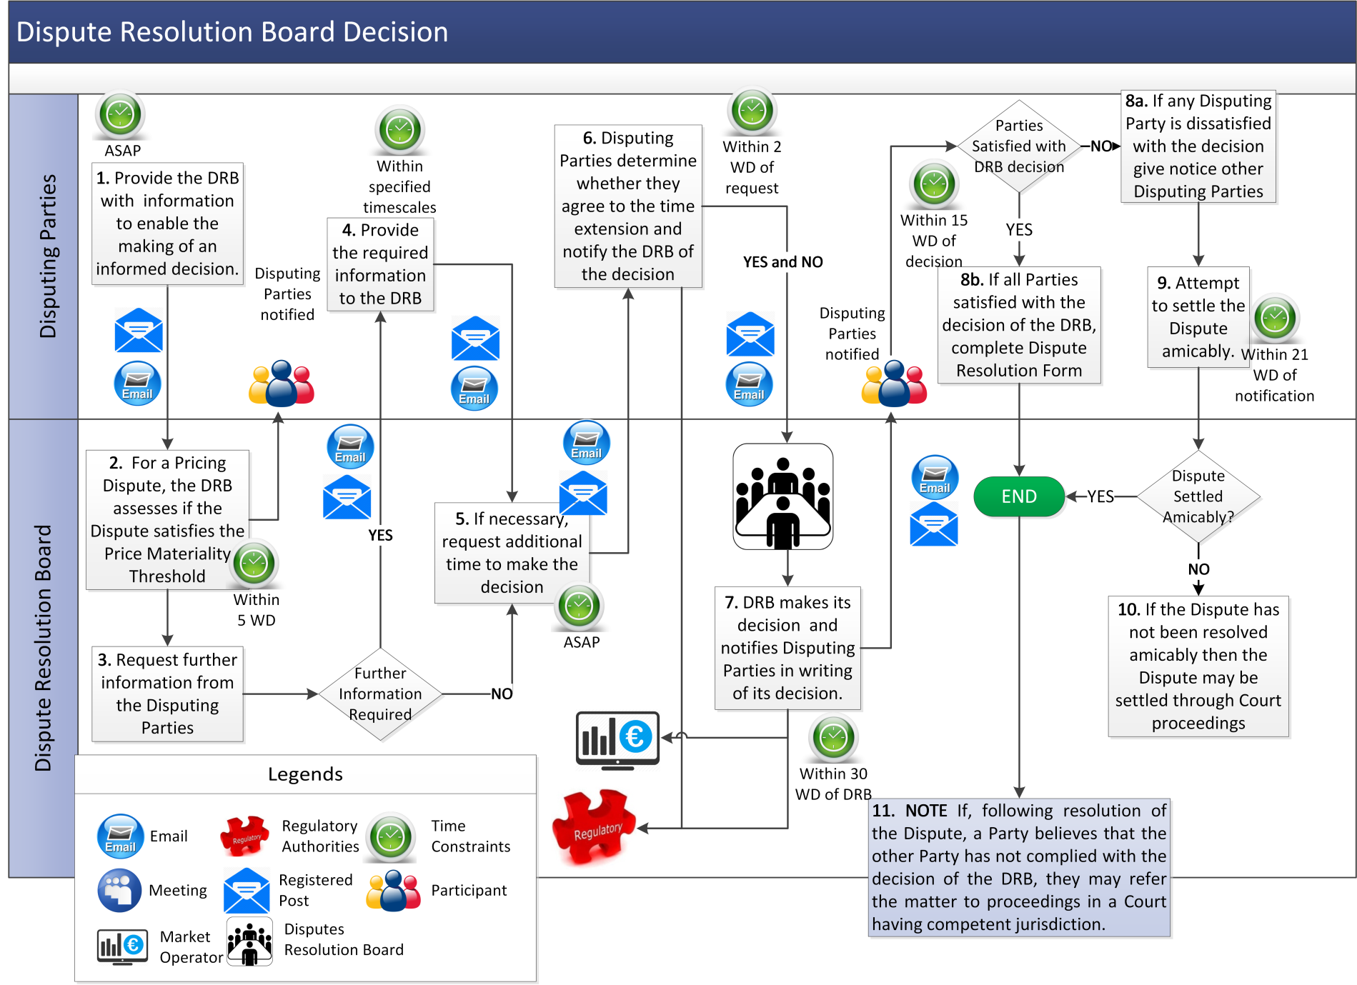

- Definitions

Authorised Person | means a representative of a Party who is authorised by that Party to communicate with the Market Operator as set out in Agreed Procedure 11 “Market System Operation, Testing, Upgrading and Support”.
Credit Cover Dispute | means, in accordance with paragraph B.19.2.1 of the Code, a Dispute concerning:  - the application of the provisions of the Code relating to Credit Cover Requirements and action is being taken under section G.2.6 or G.12.1 of the Code; or  - the non-acceptance of a Contracted Quantity under section G.12.3 of the Code.
Dispute Counterparty | means the Disputing Parties other than the Raising Party.
Dispute Resolution Form | means the form available on the Market Operator’s website to be completed on successful resolution of a Dispute.
Chairperson | means the chairperson for the time being of the Panel (referred to at B.19.6.4 of the Code) who is appointed by the Regulatory Authorities in accordance with the Code.
Negotiation Period | means the period in which Disputing Parties shall negotiate in good faith and use reasonable endeavours to resolve the Dispute in accordance with the Code.
Notice of Dispute Form | means the form available on the Market Operator’s website to be completed and delivered for the purposes of a Notice of Dispute.

