Part B Agreed Procedure 18: Suspension and Termination | August 18  2023
Trading and Settlement Code
Version 28.0

Contents

1. Introduction 1
1.1 Background and Purpose 1
1.2 Scope of Agreed Procedure 1
1.3 Definitions 1
1.4 Compliance with Agreed Procedure 1
2. Overview 2
2.1 Deregistration 2
2.2 Voluntary Termination 2
2.3 Default and Suspension 2
2.3.1 Default 2
2.3.2 Issue of a Suspension Order 2
2.4 Issuing of a Termination Order 3
2.5 Removal of an Intermediary 3
3. Procedural Steps 4
3.1 Deregistration 4
3.2 Voluntary Termination 7
3.3 Issuing a Suspension Order 9
3.3.1 Issue of a Suspension Order in accordance with paragraph B.18.3.1 of the Code 9
3.3.2 Issue of a Suspension Order pursuant to paragraph B.18.3.2 of the Code 13
3.4 Suspension 16
3.5 Issue of a Termination Order 18
3.6 Intermediary Removal 20
Appendix 1: Definitions 22

Document History

Version | Date | Author | Comment
20.0 | 07/04/2017 | SEMO | Baseline Documentation at V20.0
21.0 | 12/04/2019 | SEMO | Baseline Documentation at V21.0
21.0 | 12/04/2019 | SEMO | Mod_01_18 Notification of Suspension to SEM NEMOs
22.0 | 29/04/2020 | SEMO | Baseline Documentation at V22.0
23.0 | 03/11/2020 | SEMO | Baseline Documentation at V23.0
24.0 | 01/07/2021 | SEMO | Baseline Documentation at V24.0
25.0 | 09/11/2021 | SEMO | Baseline Documentation at V25.0
26.0 | 17/05/2022 | SEMO | Baseline Documentation at V26.0
27.0 | 07/12/2022 | SEMO | Baseline Documentation at V27.0
27.0 | 28/11/2022 | SEMO | Mod_14_22 Removal of the requirement to post De-registration Consent Orders
28.0 | 18/08/2023 | SEMO | Baseline Documentation at V28.0

Related Documents

Document Title | Version | Date | By
Trading and Settlement Code | 28.0 | 18/08/2023 | SEMO
Agreed Procedure 1 “Registration”

- Introduction
  - Background and Purpose
This Agreed Procedure supplements the rules set out in the Trading and Settlement Code (hereinafter referred as the “Code”) in relation to Default, Deregistration, Suspension and Termination. It sets out procedures with which Parties to the Code must comply.

  - Scope of Agreed Procedure
This Agreed Procedure sets out the procedures in relation to:
- Deregistration
- Voluntary Termination
- Suspension
- Issue of a Termination Order; and
- Intermediary removal
This Agreed Procedure forms an annex to, and is governed by, the Code. It sets out procedures to be followed subject to Parties’ rights and obligations are set out in the Code. In the event of any conflict between a Party’s obligations set out in the Code and this Agreed Procedure, the Code shall take precedence.
It is not intended that there be any inconsistency or conflict between section 2 “Overview” and section 3 “Procedural Steps”. However, in the event of any inconsistency or conflict, section 3 “Procedural Steps” shall take precedence.
In section 3 “Procedural Steps” a corresponding process flow diagram is included for each procedural steps table. Process flow diagrams are for illustrative purposes. It is not intended that there be any inconsistency or conflict between any procedural steps table and process flow diagram however, in the event of any inconsistency or conflict, a procedural steps table shall take precedence.

  - Definitions
Words and expressions defined in the Code shall, unless the context otherwise requires or unless otherwise defined herein at Appendix 1 “Definitions”, have the same meanings when used in this Agreed Procedure.
References to particular sections relate internally to this Agreed Procedure unless specifically noted.

  - Compliance with Agreed Procedure
Compliance with this Agreed Procedure is required under the terms as set out in the Code.

- Overview
  - Deregistration
The Deregistration procedure at section 3.1 below is applicable when a Participant seeks to voluntarily Deregister any Units registered to them.
A Participant may choose to Deregister any Unit registered in its name at any time by submitting a Deregistration Form to the Market Operator. The Market Operator shall review the Deregistration Form, in conjunction with the appropriate Meter Data Provider and / or System Operators and the Market Operator shall make a decision to approve or reject the Deregistration request in respect of the Unit(s). Once a decision has been made, the Market Operator shall notify the Participant by acknowledged email issuing a Deregistration Consent Order. The Market Operator will request confirmation of receipt from participants when the Deregistration Consent Order is issued.
If the provisions of the Metering Code have not been complied with, the Deregistration of Units shall be delayed until the relevant conditions are complied with, or until the Participant indicates that the Deregistration of those Units is no longer required.
All the processes under the Code applicable to the period when the Unit was registered continue. This includes market Settlement Rerun, Settlement Documents and Required Credit Cover.
Once the Deregistration request is approved for all Units registered to the Participants, the Participant is granted with the status ‘Deregistered’ and an effective end date.

  - Voluntary Termination
In accordance with section B.18.8 of the Code, a Party may apply to cease to be a Party at any time. The procedure in relation to Voluntary Termination is set out at section 3.2 below. In order to voluntary Terminate, a Party must provide 90 Working Days’ notice to the Market Operator of its intention to cease being a Party and obtain the consent of the Regulatory. The Market Operator issues a Voluntary Termination Consent Order specifying an effective date of Termination once all relevant criteria under the Code are met.

  - Default and Suspension
- Default
A Party shall be in Default where it is in material breach of any provision of the Code or the Framework Agreement. A Default Notice shall be issued by the Market Operator in accordance with paragraph B.18.2.3 of the Code.

- Issue of a Suspension Order
The Market Operator may suspend a Party from participation under the Code in respect of some or all of its registered Units in accordance with a Suspension Order.
The procedure in relation to the issue of a Suspension Order in accordance with paragraph B.18.3.1 of the Code is set out at section 3.3 below.

The procedure in relation to the issue of a Suspension Order in accordance with paragraph B.18.3.2 of the Code is set out at section 3.3 below.

A Suspension Order shall include the following information:
- The Units to which the Suspension Order shall apply;
- The terms of the suspension;
- Estimated date that registration of Supplier of Last Resort process will be initiated;
- The date and time that suspension shall take effect; and
- A copy of the relevant Default Notice.
Following the issue of a Suspension Order, a suspension will take effect in accordance with the procedure set out at section 3.4 below.

  - Issuing of a Termination Order
The procedure in relation to the issuing of a Termination Order is set out in section 3.5 below. The Market Operator may, with the prior approval of the Regulatory Authorities, issue a Termination Order to a Party in accordance with paragraph B.18.6.1 of the Code.

  - Removal of an Intermediary
The procedural steps for the removal of an Intermediary are set out at section 3.6 below for each of following circumstances:
- an Intermediary’s consent is revoked by the Regulatory Authorities, or the expiration of Form of Authority;
- an Intermediary wishes to voluntarily Deregister any or all of the Units; or
- an Intermediary ceases participating in respect of any Units without first voluntarily Deregistering the Units or the Unit Owner wishing to revoke the Intermediary.
The Market Operator will Deregister the applicable Units in all cases. In the event of an Intermediary removal the Unit Owner may either (subject to Regulatory Authority consent) procure a substitute Intermediary to reregister the Units or re-register the Units itself and become the Participant in respect of those Units, unless:
- the Unit is decommissioned; or
- the Unit is below de-minimis and the Unit Owner does not wish the Unit to be registered to a Participant in the SEM.
Note that in any event, the removed Intermediary continues to be bound by the enduring obligations of the Code in respect of the Deregistered Units. However, where the Intermediary had appointed the Market Operator to report REMIT Data on its behalf, this will cease on the date of removal.

- Procedural Steps
  - Deregistration
Step | Procedural Step Description | Timing | Method | By/From | To
1 | Submit completed Deregistration Form (available to download from the Market Operator website) | At least 60 WD in advance of the proposed Deregistration date | Market Operator website | Participant | Market Operator, Regulatory Authorities
2 | Submit appropriate Deregistration details to relevant System Operators and Relevant Meter Operator | Within 5 WD of receipt of Deregistration Form | Email / Registered Post | Market Operator | System Operators / Relevant Meter Operator
3 | Confirm compliance with paragraph B.12.1.2 of the Code and raise any issues with respect to the Deregistration, if applicable. | Within 20 WD of receipt of Deregistration details from Market Operator | Email / Registered Post | System Operators / Relevant Meter Operator | Market Operator
4 | Notify Participant of issues raised. | Within 5 WD | Email / Registered Post | Market Operator | Participant
5 | Participant co-ordinates resolution of the issues with System Operators / Relevant Meter Operator. | As required | Email / telephone / meetings | Participant, Market Operator, System Operators, Relevant Meter Operator
6 | Participant and Party raising issue confirm the outcome of the resolution and:  - if Deregistration of the Unit is no longer required, end process.  - if all outstanding issues resolved, continue to step 7. | Within 2 WD | Email | Participant, System Operators, Relevant Meter Operator | Market Operator
7 | Organise final Registration meeting with all relevant Parties to determine the Effective Date.  If Deregistration is no longer required, end process. | Within 2 WD of step 6 | Conference call / Meeting / Email | Market Operator | Participant, System Operators, Relevant Meter Operator
8 | Send Deregistration Consent Order to Participant, System Operators, Relevant Meter Operator, and Regulatory Authorities. | Before Deregistration date | Email | Market Operator | Participant, System Operators, Relevant Meter Operator, Regulatory Authorities
9 | Where Deregistration Consent Order has been issued, maintain and publish list of registered Units in accordance with Agreed Procedure 6 “Data Publication and Data Reporting”. | Before Deregistration date |  | Market Operator

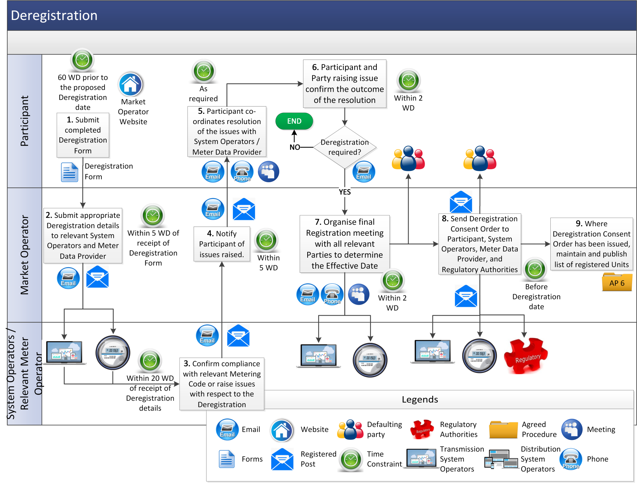
  - Voluntary Termination

Step | Step Description | Timing | Method | From / By | To
 | Notify of intention to cease being a Party and time and date upon which it is intended that this Termination will take effect by completing the Voluntary Termination Form. | At least 90 WD prior to the date upon which it is intended that the termination will take effect | Registered post /Facsimile | Party | Market Operator (with a copy to the System Operators and the Regulatory Authorities)
 | Issue a Voluntary Termination Consent Order | Following receipt of notification set out in step 1 above and once the relevant Party has complied with conditions set out in paragraph B.18.8.3 of the Code | Registered post /Facsimile | Market Operator | Relevant Party
 | Voluntary Termination takes effect (Party seeking Termination must remain in compliance with conditions set out in paragraph B.18.8.3 of the Code for Termination to take effect) | End of last Imbalance Settlement Period of the Trading Day specified by Market Operator in the Voluntary Termination Consent Order | - | Market Operator | -
 | The Market Operator Deregisters all of the Party’s Units. | Following Termination | - | Market Operator | -

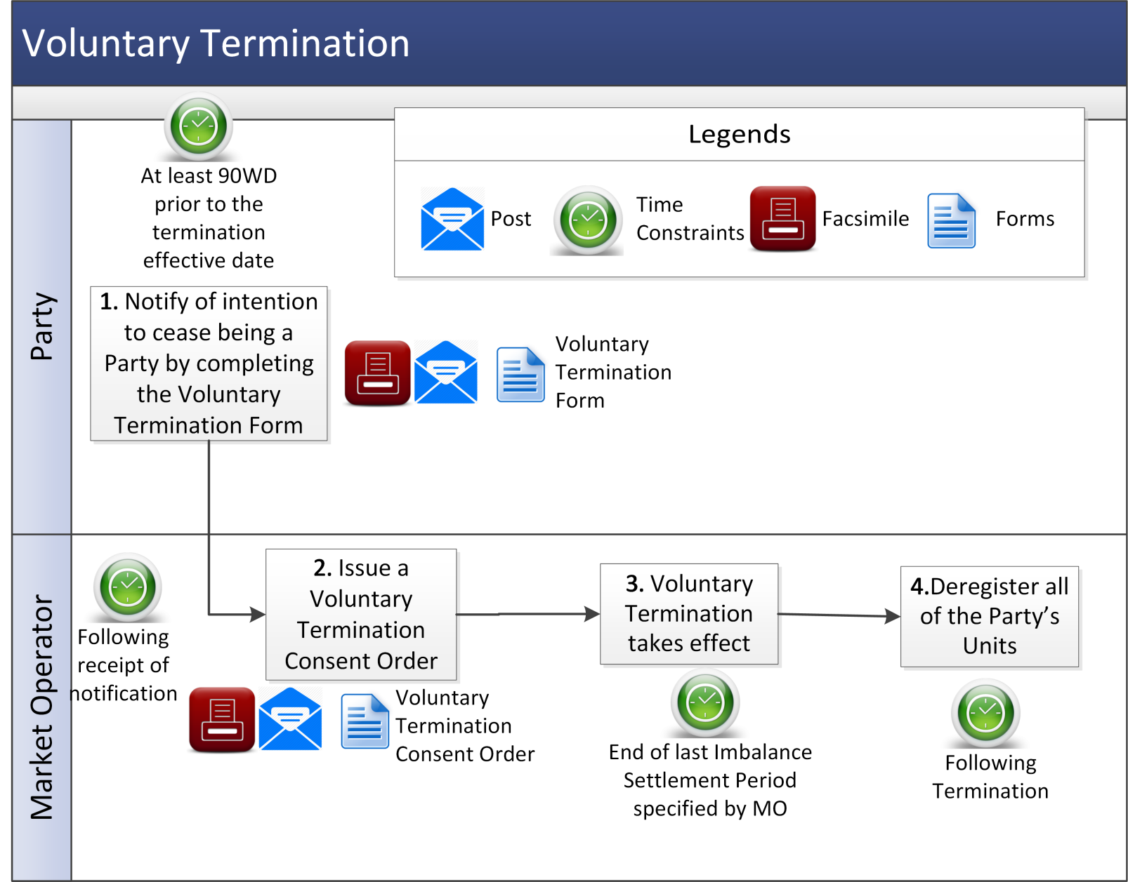

  - Issuing a Suspension Order
- Issue of a Suspension Order in accordance with paragraph B.18.3.1 of the Code
Step | Step Description | Timing | Method | From / By | To
 | In the circumstances set out in paragraph B.18.3.1, issue Default Notice in accordance with paragraph B.18.2.3 of the Code | (i) Immediately on becoming aware of a Default in relation to a Party; or (ii) if a Participant fails to comply with a Credit Cover Increase Notice, within 2 WD of its issue (or as agreed by the Regulatory Authorities in accordance with paragraph G.12.1.5 of the Code) | Registered post and a copy by email | Market Operator | Defaulting Party
 | Remedy the Default in compliance with the terms of the Default Notice | In accordance with the timelines set out in the Default Notice | - | Defaulting Party | Market Operator
 | Assess whether the Default has been remedied by the Defaulting Party. If the Default has been remedied, end process. If the Default has not been remedied, continue to step 4 | Within the timelines as set out in the Default Notice | - | Market Operator | -
 | The Market Operator may seek approval from Regulatory Authorities to issue Suspension Order in accordance with paragraph B.18.3.1 of the Code | As required | - | Market Operator | Regulatory Authorities with a copy to the Defaulting Party
 | Confirm whether the issue of a Suspension Order is approved. If issue of a Suspension Order is not approved, end process, otherwise continue to step 6 | Within 2 WD of step 4 | - | Regulatory Authorities | Market Operator
 | Issue Suspension Order | On receipt of approval in step 4 | Registered post | Market Operator | Defaulting Party
 | Send a copy of the Suspension Order | With step 6 | Facsimile / Email | Market Operator | Regulatory Authorities, System Operators, relevant Distribution System Operators, relevant SEM NEMO(s)
 | Publish Suspension Order | With step 6 | Market Operator website | Market Operator | Market Operator website
 | In the circumstances set out at paragraph B.18.4.7 of the Code, lift the Suspension Order by written notice to the Defaulting Party. If the Suspension Order is amended or lifted continue to step 10, otherwise end process | In the circumstances set out at paragraph B.18.4.7 of the Code | Registered post and email | Market Operator | Defaulting Party
 | Issue notification that the Suspension Order has been lifted or amended | As soon as practicable after Suspension Order is lifted | Email / Facsimile | Market Operator | Defaulting Party, Regulatory Authorities, System Operators, relevant Distribution System Operators, relevant SEM NEMO(s)
 | Publish notification that the Suspension Order has been lifted or amended | As soon as practicable after Suspension Order is lifted | Market Operator website | Market Operator | Market Operator website

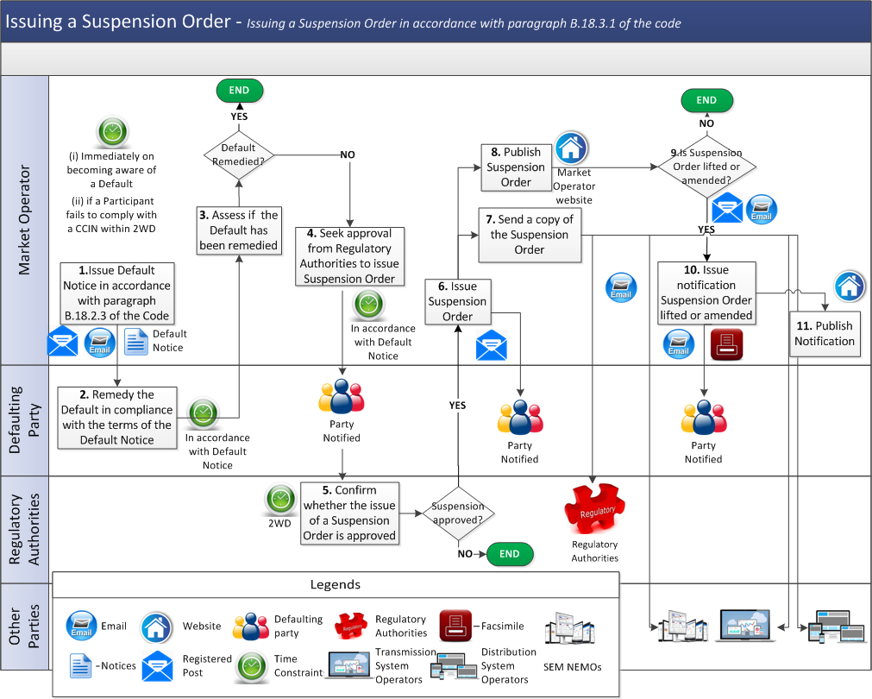

- Issue of a Suspension Order in accordance with paragraph B.18.3.2 of the Code

Step | Step Description | Timing | Method | From / By | To
 | In the circumstances set out in paragraph B.18.3.2 of the Code, issue a Default Notice in accordance with paragraph B.18.2.3 of the Code | (i) Immediately on becoming aware of a Default in relation to a Party; or (ii) if a Participant fails to comply with a Credit Cover Increase Notice, within 2 WD of its issue (or as agreed by the Regulatory Authorities in accordance with paragraph G.12.1.5 of the Code) | Registered post and a copy by email | Market Operator | Defaulting Party
 | Remedy the Default in compliance with the terms of the Default Notice or Credit Cover Increase Notice | In accordance with the timeline set out in the Default Notice | - | Defaulting Party | Market Operator
 | Issue Suspension Order | At the same time or any time following the issue of the relevant Default Notice | Registered post | Market Operator | Defaulting Party
 | Send a copy of the Suspension Order | Together with step 3 | Email | Market Operator | Regulatory Authorities, System Operators, relevant Distribution System Operators, relevant SEM NEMO(s)
 | Publish Suspension Order | Together with step 6 | Market Operator website | Market Operator | Market Operator website
 | In the circumstances set out at paragraph B.18.4.7 of the Code, lift the Suspension Order by written notice to the Defaulting Party. If the Suspension Order is amended or lifted continue to step 7, otherwise end process | As required | Registered post and Email | Market Operator | Defaulting Party
 | Issue notification that the Suspension Order has been lifted or amended | As soon as practicable after Suspension Order is lifted or amended | Email / Facsimile | Market Operator | Defaulting Party, Regulatory Authorities, System Operators, relevant Distribution System Operators, relevant SEM NEMO(s)
 | Publish notification that the Suspension Order has been lifted or amended | As soon as practicable after Suspension Order is lifted or amended | Market Operator website | Market Operator | Market Operator website

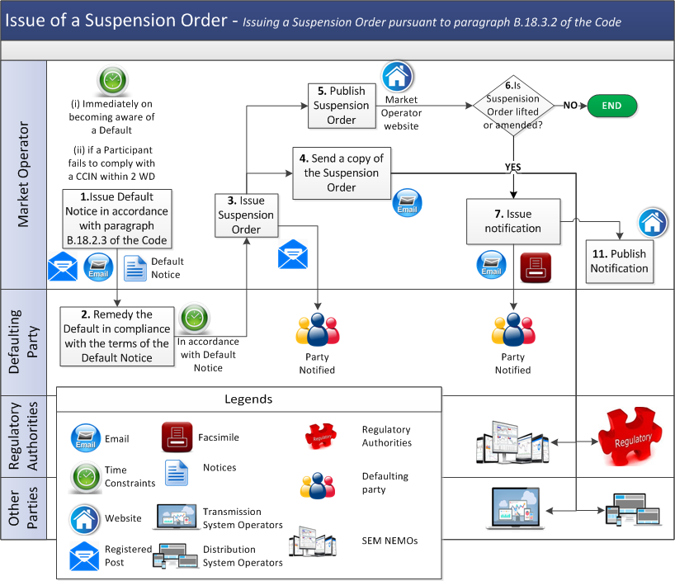
  - Suspension

Step | Step Description | Timing | Method | From / By | To
 | Subject to paragraph B.18.4.4 and paragraph B.18.4.8 of the Code,  - if a Supplier Unit go to step 2; or  - if a Generator Unit go to step 4. | On the date specified in the Suspension Order |  | Market Operator
 | Once a Supplier of Last Resort direction has been issued by the relevant Regulatory Authorities, commence procedure to activate Supplier of Last Resort as set out in Agreed Procedure 1 “Registration”. | Following direction of the Regulatory Authorities |  | Regulatory Authorities
 | Confirm wholesale market registration changes to Relevant Meter Operator as set out in Agreed Procedure 1 “Registration”. |  |  | Market Operator | Relevant Meter Operator
 | Confirm suspension has been given effect. |  |  | Market Operator | Impacted Party, Regulatory Authorities, System Operators, relevant Distribution System Operators, Meter Data Providers
 | Publish confirmation of suspension. |  |  | Market Operator | Market Operator website

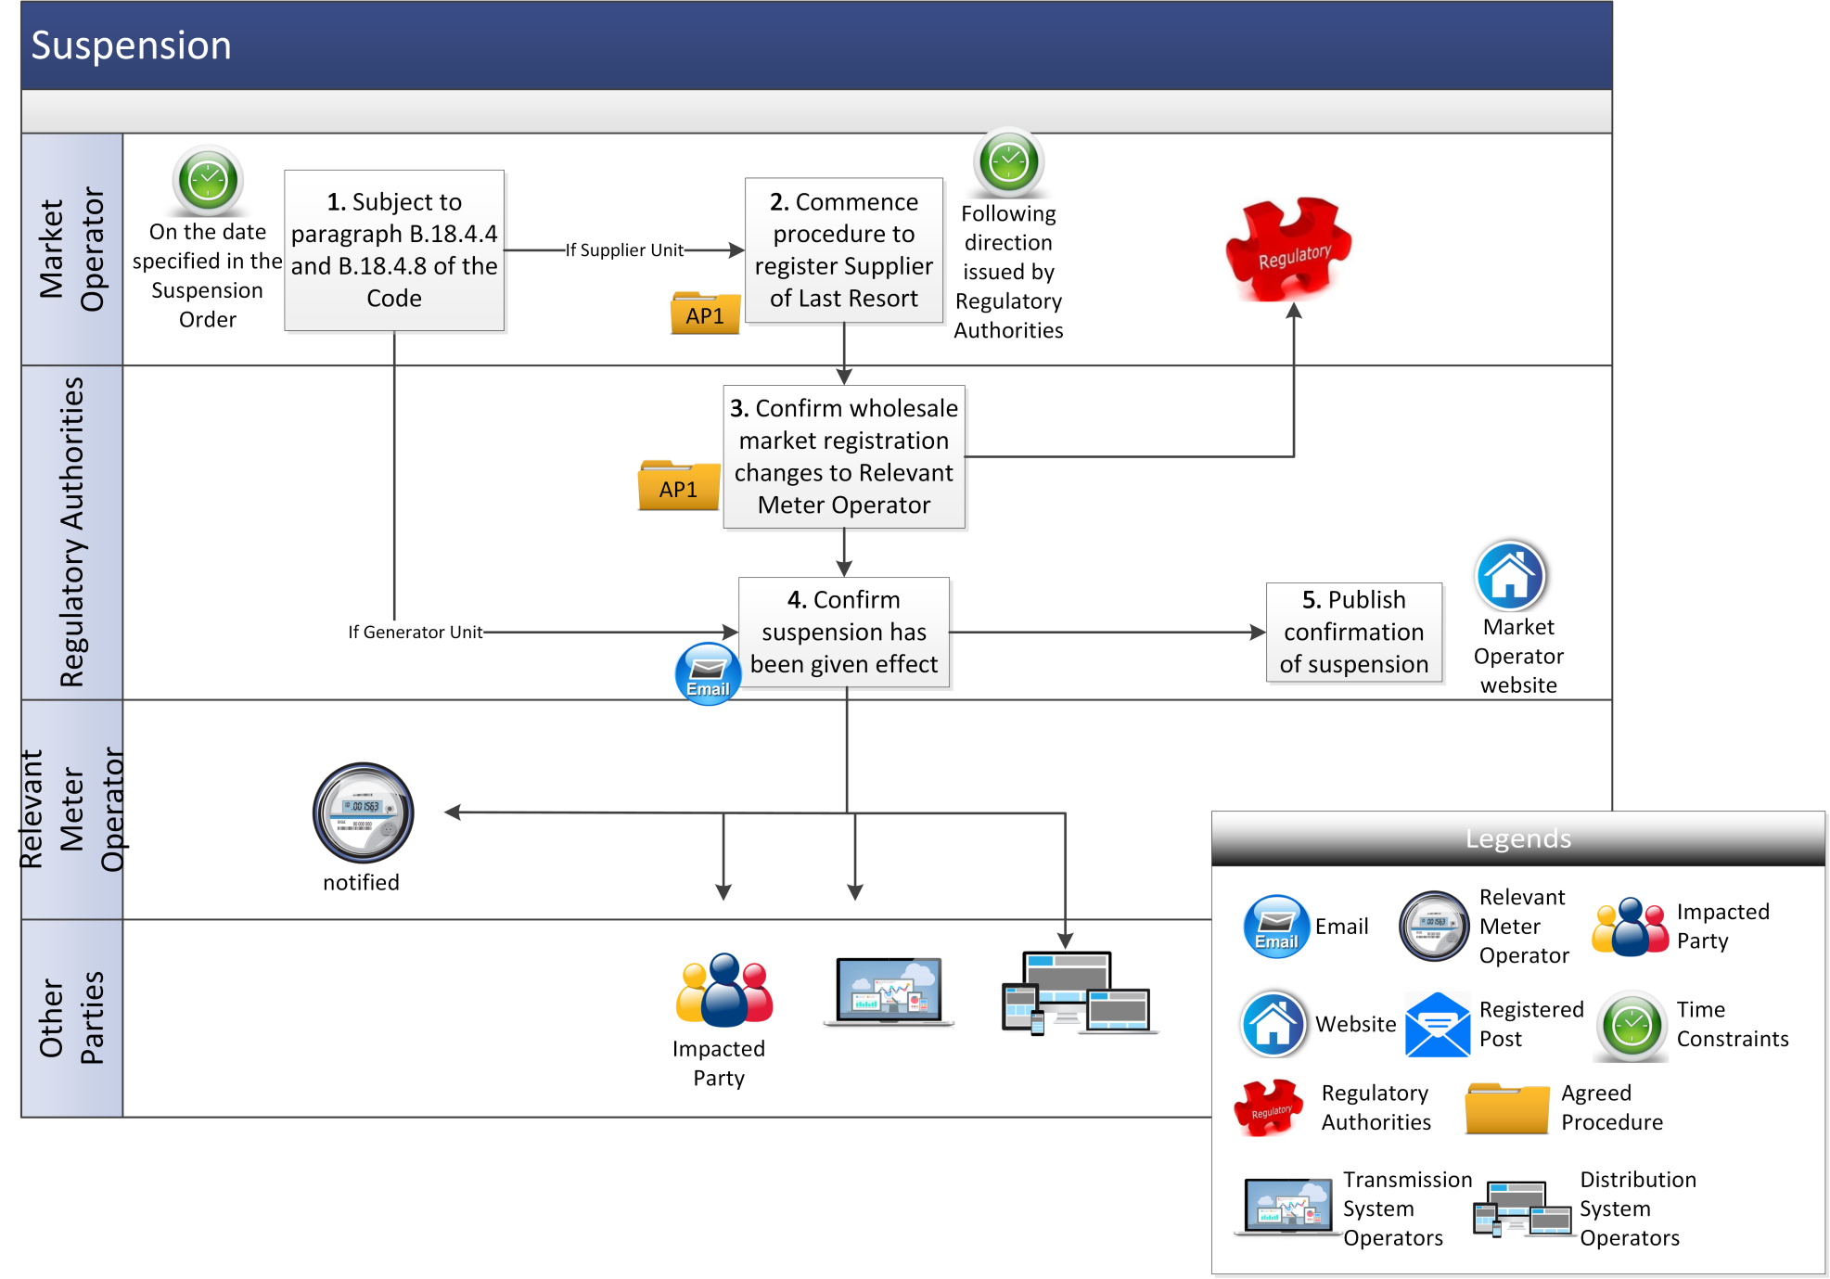
  - Issue of a Termination Order
Step | Step Description | Timing | Method | From / By | To
 | Seek written approval from Regulatory Authorities to issue Termination Order in accordance with paragraph B.18.6.1 of the Code. | As required | Registered post / Facsimile | Market Operator | Regulatory Authorities
 | If approval is received from Regulatory Authorities, issue Termination Order. | On completion of step 1 | Registered post | Market Operator | Party
 | Send copy of the Termination Order. | With step 2 | Facsimile / Email | Market Operator | Regulatory Authorities, System Operators, relevant Distribution System Operators
 | Publish Termination Order. | With step 2 | Market Operator website | Market Operator | Market Operator website
 | Termination takes effect. | In  accordance with the  timelines specified in the  Termination Order |  | Market Operator | Party
 | The Market Operator Deregisters all of the Party’s Units. | Following Termination | - | Market Operator | -

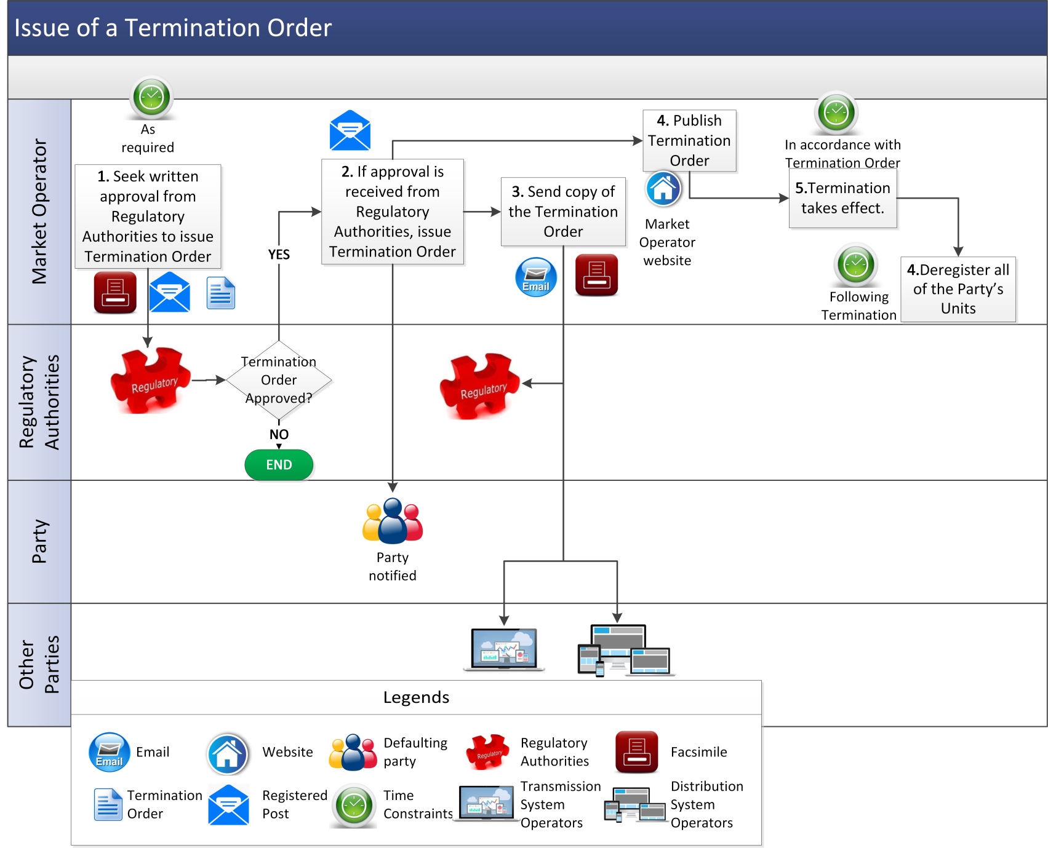
  - Intermediary Removal
Step | Procedural Step Description | Timing | Method | By/From | To
1a | Intermediary’s Form of Authority is revoked by Regulatory Authorities, or expiration of Form of Authority communicated to Market Operator. | As required, as soon as determined | - | Regulatory Authorities / Unit Owner | Market Operator
1b | Market Operator Deregisters Units registered to the removed Intermediary. | On the date of the Intermediary removal | - | Market Operator | -
2a | Form of Authority retrieved from Market Operator website (Appendix C “Form of Authority” of Code). | As required | - | Unit Owner | -
2b | Form of Authority completed and provided to Registering Party. | As required | Registered Post | Unit Owner | Registering Party (to become the Intermediary)
3 | Commence Unit registration procedure set out in Agreed Procedure 1 “Registration”. | 60 WD prior to revocation date of Form of Authority of old Intermediary, or prior to notification from Unit Owner of proposed effective date of removal of Intermediary | - | Registering Party | Market Operator
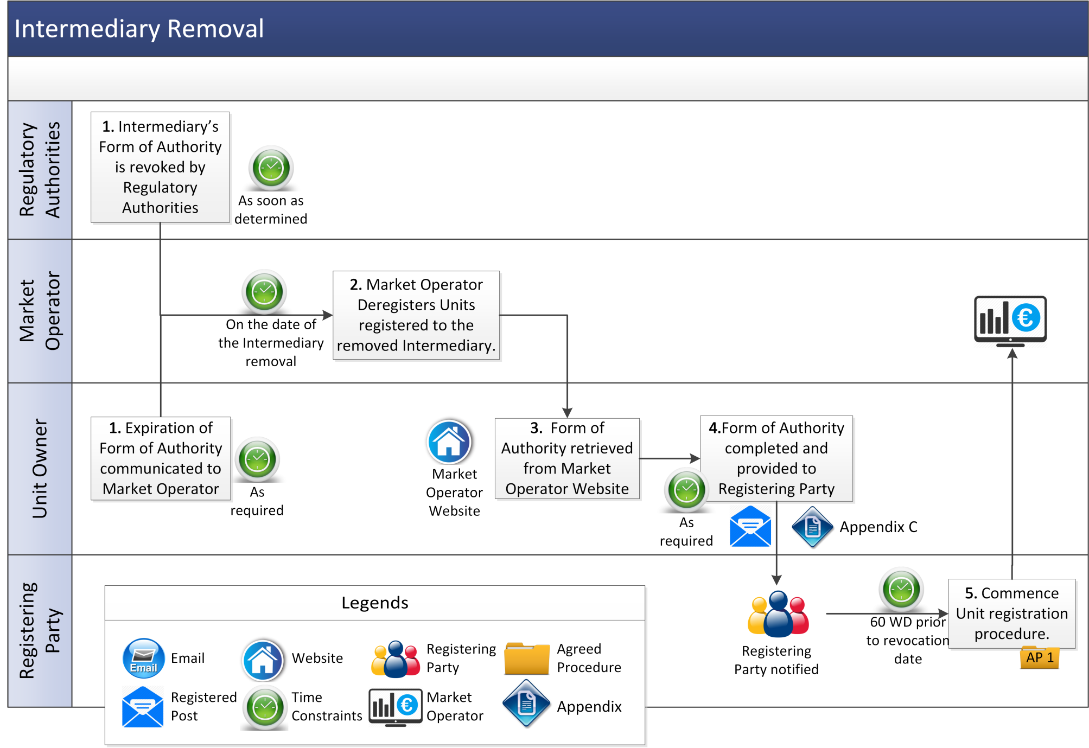

Appendix 1: Definitions

Deregistration Form | means the form available on the Market Operator website for the purposes of Deregistration.
Voluntary Termination Form | means the form available on the Market Operator website for the purposes of Voluntary Termination

