Capacity Market Code

CMC Agreed Procedure 2 - Default and Suspension | March 8  2024
Version 11.0
Contents
1. Introduction 4
1.1 Background and Purpose 4
1.2 Scope of Agreed Procedure 4
1.3 Definitions 4
1.4 Compliance with Agreed Procedure 4
2. Overview 5
2.1 Default and Suspension 5
2.1.1 Default 5
2.1.2 Suspension 5
2.2 Termination Orders 5
3. Procedural Steps 6
3.1 Suspension 6
3.1.1 Suspension pursuant to a Suspension Order issued in accordance with paragraph B.13.3.1 of the Code 6
3.1.2 Suspension pursuant to a Suspension Order issued in accordance with paragraph B.13.3.2 of the Code 9
3.2 Termination Orders 12

Document History
Version | Date | Author | Comment
1.0. | 31/05/2017 | I-SEM Project Team | Issued to the Regulatory Authorities
2.0 | 21/05/2019 | EirGrid & SONI | Capacity Market Code V2.0 update
3.0 | 10/10/2019 | EirGrid & SONI | Capacity Market Code V3.0 update
4.0 | 31/07/2020 | EirGrid & SONI | Capacity Market Code V4.0 update
5.0 | 16/04/2021 | EirGrid & SONI | Capacity Market Code V5.0 update
6.0 | 18/02/2022 | EirGrid & SONI | Capacity Market Code V6.0 update
7.0 | 12/08/2022 | EirGrid & SONI | Capacity Market Code V7.0 update
8.0 | 09/12/2022 | EirGrid & SONI | Capacity Market Code V8.0 update
9.0 | 01/09/2023 | EirGrid & SONI | Capacity Market Code V9.0 update
10.0 | 08/11/2023 | EirGrid & SONI | Capacity Market Code V10.0 update
11.0 | 08/03/2024 | EirGrid & SONI | Capacity Market Code V11.0 update

Related Documents
Document Title | Version | Date | By
Capacity Market Code | 11.0 | 08/03/2024 | EirGrid & SONI
Agreed Procedure 1 “Registration”

- Introduction
  - Background and Purpose
This Agreed Procedure supplements the rules set out in the Capacity Market Code (hereinafter referred as the “Code”) in relation to Default, Suspension and Termination Orders. It sets out procedures with which Parties to the Code must comply.
  - Scope of Agreed Procedure
This Agreed Procedure sets out the procedures in relation to:
- Suspension; and
- Termination Orders.
This Agreed Procedure forms an annex to, and is governed by the Code. It sets out procedures to be followed, subject to the rights and obligations of Parties under the Code. In the event of any conflict between a Party’s obligations set out in the Code and this Agreed Procedure, the Code shall take precedence.
It is not intended that there be any inconsistency or conflict between section 2 “Overview” and section 3 “Procedural Steps”. However, in the event of any inconsistency or conflict, section 3 “Procedural Steps” shall take precedence.
In section 3 “Procedural Steps” a corresponding process flow diagram is included for each procedural steps table. Process flow diagrams are for illustrative purposes. It is not intended that there be any inconsistency or conflict between any procedural steps table and process flow diagram however, in the event of any inconsistency or conflict, a procedural steps table shall take precedence.
  - Definitions
Words and expressions defined in the Code shall, unless the context otherwise requires or unless otherwise specified, have the same meanings when used in this Agreed Procedure.
References to sections relate to sections in this Agreed Procedure unless otherwise specified.
  - Compliance with Agreed Procedure
Compliance with this Agreed Procedure is required under the terms as set out in the Code.

- Overview
  - Default and Suspension
    - Default
In the event that a Party is in Default, a Default Notice shall be issued by the System Operators in accordance with paragraph B.13.2.3 of the Code.
    - Suspension
The System Operators may suspend a Party from participation under the Code in respect of some or all of its registered Capacity Market Units in accordance with a Suspension Order.
In the circumstances set out at paragraph B.13.3.1 of the Code the System Operators may, with the prior written approval of the Regulatory Authorities, issue a Suspension Order. The procedure for Suspension pursuant to a Suspension Order issued in accordance with paragraph B.13.3.1 of the Code is set out at section 3.1.1 below.
In accordance with paragraph B.13.3.2 of the Code, in the event that the Participant of a Party fails at any time to provide Performance Security as required under the Code, the System Operators shall issue a Suspension Order in respect of all of the relevant Party’s Capacity Market Units. The procedure for Suspension pursuant to a Suspension Order issued in accordance with paragraph B.13.3.2 of the Code is set out at section 3.1.2 below.
A Suspension Order shall include the following information:
- the Units to which the Suspension Order shall apply;
- the terms of the Suspension;
- the date and time that suspension shall take effect; and
- a copy of the relevant Default Notice.
  - Termination Orders
In the circumstances set out in paragraph B.13.6.1 of the Code the System Operators may, with the prior approval of the Regulatory Authorities, issue a Termination Order to a Party.
The Regulatory Authorities may instruct the System Operators to issue a Termination Order in accordance with paragraph B.13.6.2 of the Code.
The procedure for the issue of a Termination Order by the System Operators is set out in section 3.2 below.

- Procedural Steps
  - Suspension
    - Suspension pursuant to a Suspension Order issued in accordance with paragraph B.13.3.1 of the Code
Step | Step Description | Timing | Method | From / By | To
 | In the circumstances set out in paragraph B.13.2.3 of the Code, issue a Default Notice, otherwise go to step 4.  Note: the steps in this procedure may not necessarily occur sequentially. In the circumstances set out at paragraph B.13.3.1 of the Code the System Operators may seek approval from the Regulatory Authorities to issue a Suspension Order at any time. | Immediately on becoming aware of a Default in relation to a Party | Registered post and a copy by email | System Operators | Defaulting Party
 | Remedy the Default and comply with the terms of the Default Notice. | In accordance with the timelines set out in the Default Notice | - | Defaulting Party | System Operators
 | Assess whether the Default has been remedied by the Defaulting Party. If the Default has been remedied, end process. If the Default has not been remedied, continue to step 4. | In accordance with the timelines set out in the Default Notice | - | System Operators | -
 | The System Operators may seek approval from Regulatory Authorities to issue a Suspension Order in the circumstances set out in paragraph B.13.3.1 of the Code. | In accordance with paragraph B.13.3.1 of Code | - | System Operators | Regulatory Authorities with a copy to the Defaulting Party
 | Confirm whether the issue of a Suspension Order is approved. If issue of a Suspension Order is not approved, end process, otherwise continue to step 6. | Within 2 WD of request for approval | - | Regulatory Authorities | System Operators
 | Issue Suspension Order (including information specified in section 2.1.2 above). | On receipt of approval from Regulatory Authorities | Registered Post and a copy by email | System Operators | Defaulting Party
 | Send a copy of the Suspension Order. | With step 6 | Email | System Operators | Regulatory Authorities, Market Operator
 | Publish Suspension Order. | With step 6 | System Operators’ website | System Operators | System Operators website
 | In the circumstances set out in paragraph B.13.4.2 of the Code the Suspension Order shall be lifted.  The System Operators may amend the Suspension Order at any time by written notice to the Party in accordance with paragraph B.14.4.3 of the Code.  If the Suspension Order has been amended or lifted, continue to step 10, otherwise end process. | - | Registered post and copy by email | System Operators | Defaulting Party
 | Issue notification that the Suspension Order has been lifted or amended. | As soon as practicable after Suspension Order is lifted or amended | Email | System Operators | Defaulting Party, Regulatory Authorities, Market Operator
 | Publish notification that the Suspension Order has been lifted or amended. | As soon as reasonably practicable after Suspension Order is lifted or amended | System Operators’ website | System Operators | System Operators’ website

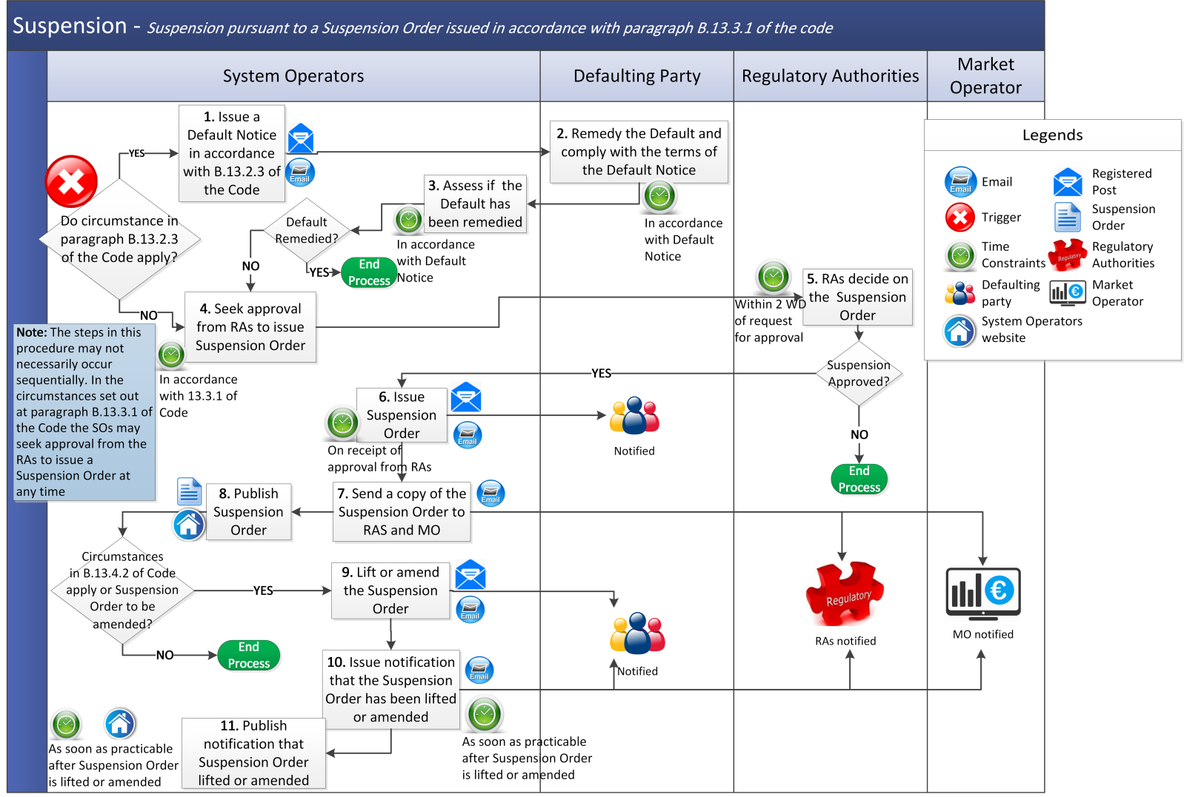
    - Suspension pursuant to a Suspension Order issued in accordance with paragraph B.13.3.2 of the Code
Step | Step Description | Timing | Method | From / By | To
 | In the event that a Party has failed to provide Performance Security under the Code, issue Default Notice in accordance with section B.13.2.3 of the Code. | Immediately on becoming aware of a Default in relation to a Party | Registered post and a copy by email | System Operators | Defaulting Party
 | Remedy the Default and / or comply with the terms of the Default Notice. | In accordance with the timeline set out in the Default Notice | - | Defaulting Party | System Operators
 | Assess whether the Default has been remedied by the Defaulting Participant. If the Default has been remedied, end process. If the Default has not been remedied, continue to step 4. | Within the timelines set out in the Default Notice | - | System Operators | -
 | In accordance with paragraph B.13.3.2 of the Code, issue a Suspension Order. | At the same time and / or in accordance with the terms of the Default Notice | Registered post and a copy by email | System Operators | Defaulting Party
 | Send a copy of the Suspension Order. | With step 4 | Email | System Operators | Regulatory Authorities, Market Operator
 | Publish Suspension Order. | With step 4 | System Operators’ website | System Operators | System Operators’ website
 | In the circumstances set out in paragraph B.13.4.2 of the Code the Suspension Order shall be lifted.  The System Operators may amend the Suspension Order at any time by written notice to the Party in accordance with paragraph B.14.4.3 of the Code.  If the Suspension Order is lifted or amended continue to step 8, otherwise end process. | - | Registered post and a copy by email | System Operators | Defaulting Party
 | Issue notification that the Suspension Order has been lifted or amended. | As soon as reasonably practicable after Suspension Order is lifted or amended | Email | System Operators | Impacted Party, Regulatory Authorities, Market Operator
 | Publish notification that the Suspension Order has been lifted or amended. | As soon as practicable after Suspension Order is lifted or amended | System Operators’ website | System Operators | System Operators’ website

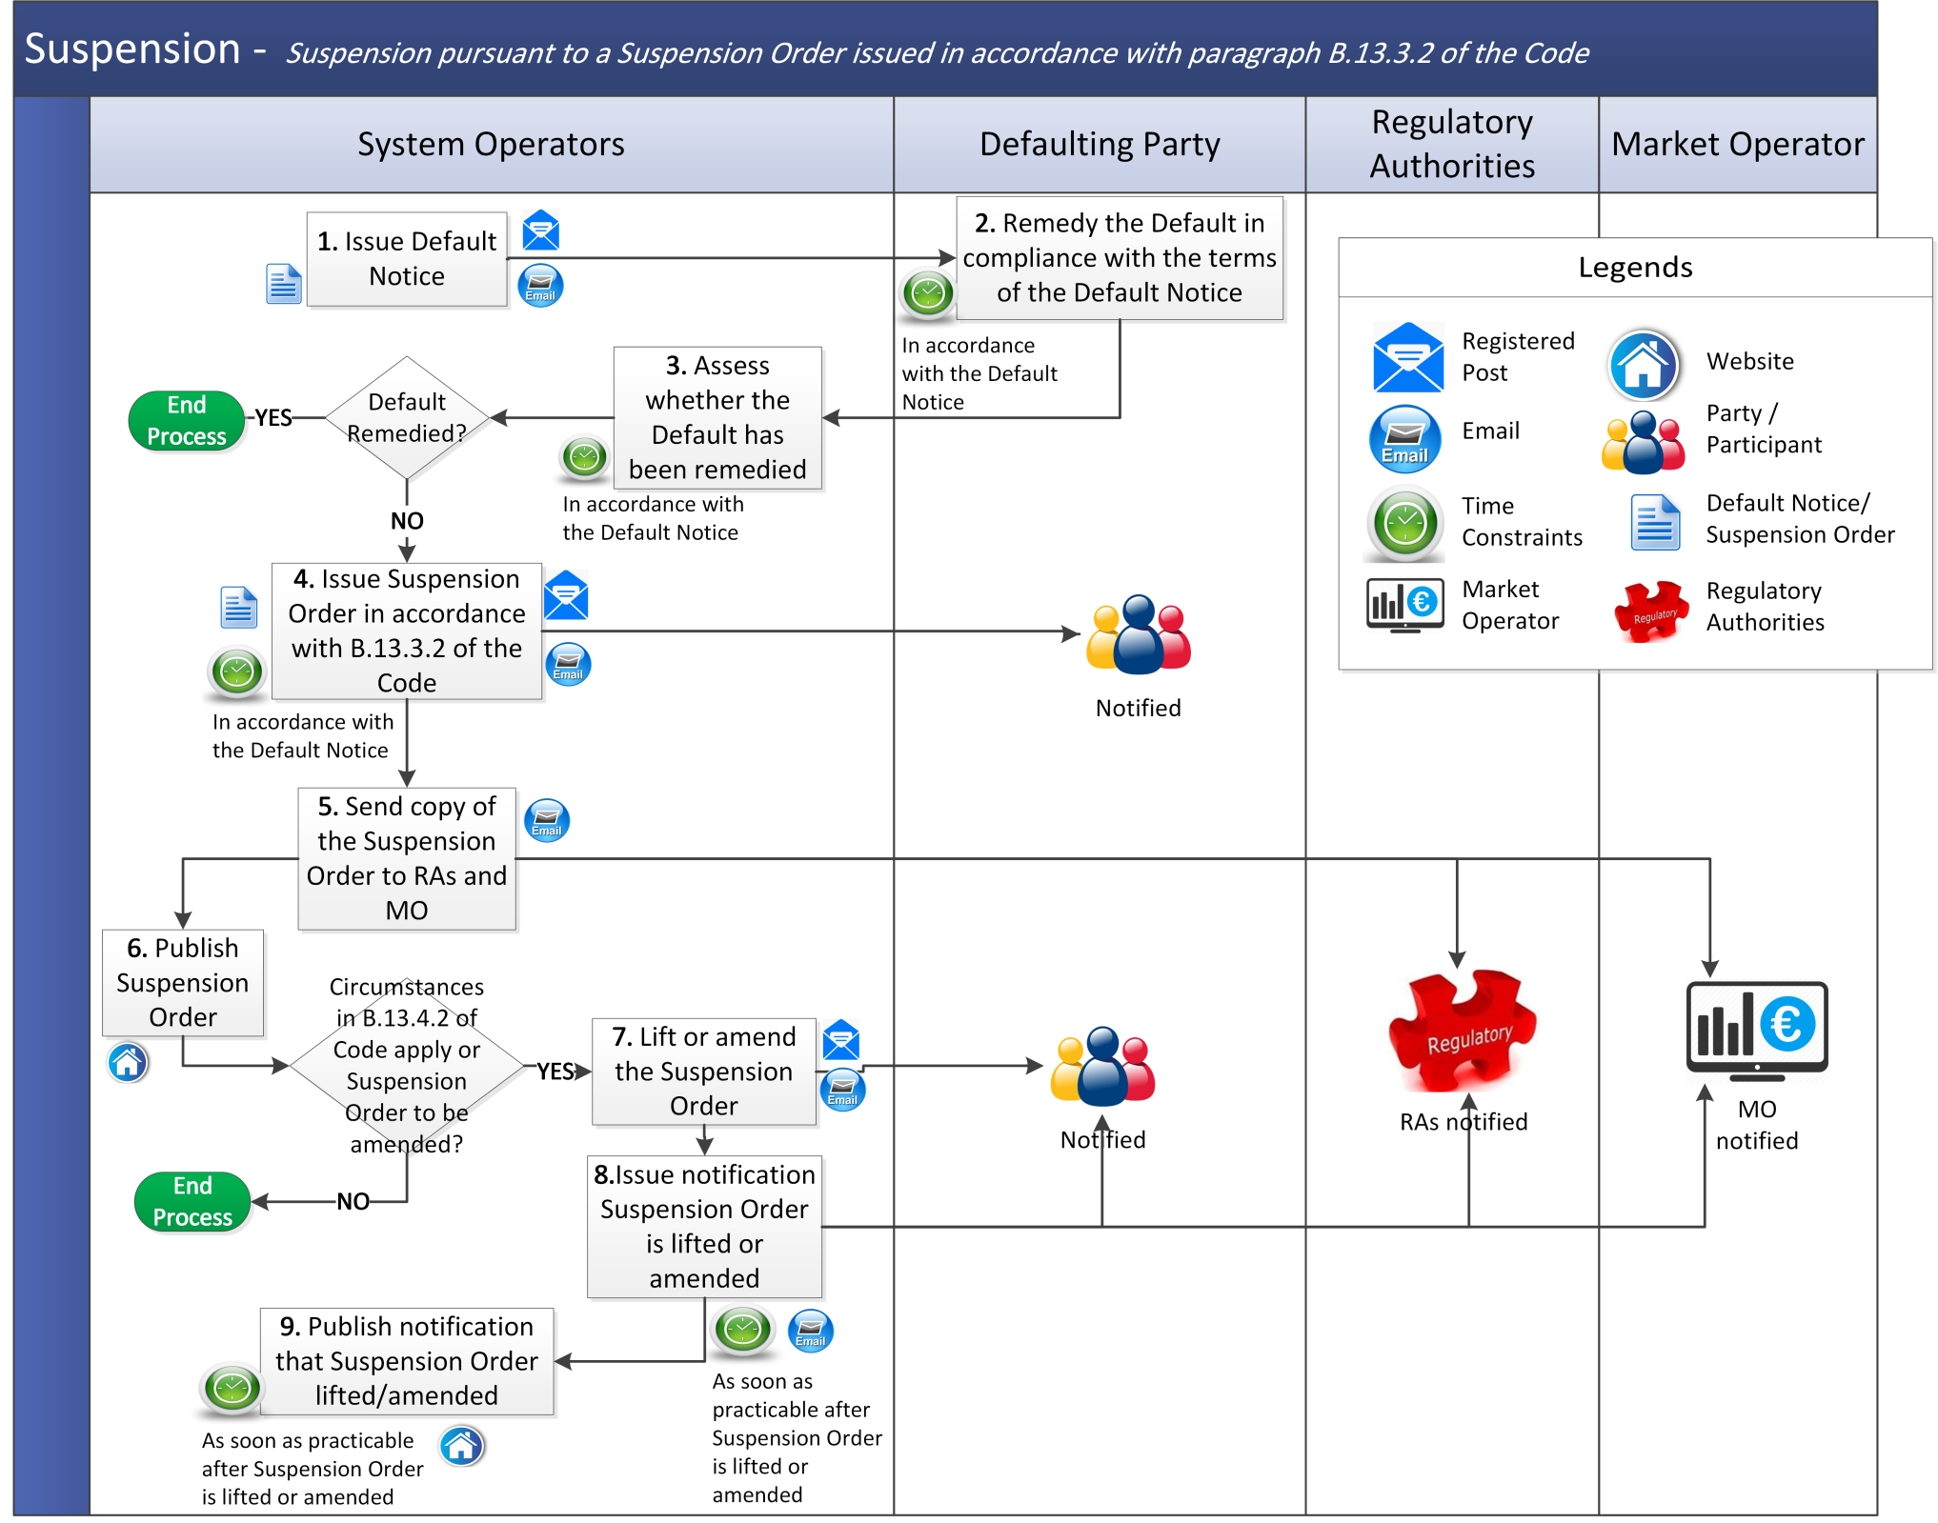

  - Termination Orders
Step | Step Description | Timing | Method | From / By | To
 | - In the circumstances set out in paragraph B.13.6.1 of the Code, the System Operators may seek written approval from Regulatory Authorities to issue a Termination Order, continue to step 2.  - If the Regulatory Authorities instruct the System Operators to issue a Termination Order in accordance with paragraph B.13.6.2 of the Code go to step 3. | As required | Email | System Operators | Regulatory Authorities
 | Notify System Operators of decision in relation to of the issue of a Termination Order. If the issue of a Termination Order is approved go to step 3, otherwise end process. | As soon as reasonably practicable | Email | Regulatory Authorities | System Operators
 | Issue Termination Order. | On receipt of approval / instruction from Regulatory Authorities | Registered post and copy by email | System Operators | Party
 | Send copy of the Termination Order to Regulatory Authorities and Market Operator. | With step 3 | Email | System Operators | Regulatory Authorities and Market Operator
 | Publish Termination Order. | With step 3 | System Operators’ website | System Operators | System Operators’ website
 | Termination takes effect. | In accordance with the time and date specified in the Termination Order | - | System Operators | Party
 | Deregister Capacity Market Units as applicable. | Following Termination | - | System Operators | -

