
Business Process

Fuel Mix Disclosure

Table of Contents
1 Process Context 3
1.1 Background 3
1.2 Process Scope 3
2 Business Objective 4
3 Process Overview 5
3.1 Process Overview 5
4 Roles and Responsibilities 12
5 Process Description 14
5.1 Process Swimlane 14
5.2 Process Steps 20
6 Process References 22
6.1 Process Rule Documents 22
6.2 Related Documents 23
7 Assumptions 24
8 Appendices 25
8.1 Glossary 25
8.2 Process Flowchart Key 26

Process Context

Background
Fuel mix disclosure is required by Article 3(6) of Directive 2003/54/EC, replaced by Article 3(9) of Directive 2009/72/EC. The transposing legislation in Ireland, S.I. number 60 of 2005, requires the Commission for Energy Regulation (“the CER”) to ensure Suppliers provide reliable fuel mix information on all bills and promotional materials issued to customers. In Northern Ireland the transposing legislation, Article 11A(9)(c) of the Electricity (NI) Order 1992 as amended by Article 14 of the Gas and Electricity (Internal Markets) Regulations (Northern Ireland) 2011, requires that licences issued by the Utility Regulator (“the UR”) include a condition requiring compliance with Article 3(6).
In April of 2009 the SEM Committee published the decision paper “High Level Methodology for the Calculation of Fuel Mix Disclosure in the SEM‟ (SEM/09/033). That paper set out the SEM Committee’s intention to use a certificate based methodology for fuel mix disclosure in the SEM. However, at the time of publication of that paper, Directive 2009/28/EC (the “Renewables Directive”) had not yet been finalised. As such, the detail of the methodology could not be set out in the absence of certainty regarding both the European legislation and the transposition of that legislation by the Oireachtas and the Northern Ireland Assembly. As Article 15 of the Renewables Directive has now been published and transposed in both jurisdictions, an enduring methodology can be achieved.
The SEM Committee decision paper SEM/11/095 outlined this enduring methodology. This replaces the interim arrangements outlined in the decision paper SEM/09/081. The interim arrangements applied to the disclosure years of 2008 to 2010. The enduring methodology applies to 2011 onwards. The key distinction between methodologies is the introduction of certificate based tracking of energy which conforms to proposed enduring methodology set out in SEM/09/033.
SEMO annually performs the Fuel Mix Disclosure calculations, on behalf of the Regulatory Authorities, according to this methodology. In conjunction with this, SEMO also calculates environmental impact information, covering both CO₂ and radioactive waste emissions. Both Fuel Mix and environmental impact information are calculated on an individual Supplier basis and on an All Island basis. Suppliers publish their own information, as well as the All Island information, on all bills and promotional materials.

Process Scope
This document describes the process whereby fuel mix information is calculated for each Supplier and on an All Island basis, on an annual basis, according to the enduring methodology. It also outlines how environmental impact information, covering CO₂ emissions and radioactive waste emissions, are calculated in conjunction with the Fuel Mix calculations.

It does not describe any of the following related processes:
- Any processes relating to Guarantees of Origin, Generator Attributes or Renewable Energy Guarantees of Origin
- The calculation of indicative rolling fuel mixes performed on a quarterly basis

Business Objective

The objective of this business process is to meet the obligations SEMO has, as calculating body, under the decision paper SEM/11/095.

These obligations derive from the obligations outlined under S.I. number 60 of 2005, namely:

25. (1) The Commission shall ensure that the public electricity Supplier and all licensed Suppliers furnish reliable information on or in bills or promotional materials sent to final customers as respects—
(a) the contribution of each energy source, expressed in accordance with Article 3.6 of the Directive, to the overall fuel mix of the Supplier concerned over the preceding year;
(b) details of any existing and publicly available reference sources which contain information on the environmental impact, at least in terms of carbon dioxide emissions, and the radioactive waste resulting from the electricity produced by such overall fuel mix over the preceding year.
(2) The Commission may direct holders of a licence under section 14 of the Act of 1999 to provide it with information relating to the matters referred to in paragraph (1).

This obligation is itself derived from the obligations outlined in Article 3(6) of the EU directive 2003/54/EC, namely:

6. Member States shall ensure that electricity Suppliers specify in or with the bills and in promotional materials made available to final customers:
(a) the contribution of each energy source to the overall fuel mix of the Supplier over the preceding year;
(b) at least the reference to existing reference sources, such as web-pages, where information on the environmental impact, in terms of at least emissions of CO2 and the radioactive waste resulting from the electricity produced by the overall fuel mix of the Supplier over the preceding year is publicly available.

With respect to electricity obtained via an electricity exchange or imported from an undertaking situated outside the Community, aggregate figures provided by the exchange or the undertaking in question over the preceding year may be used.

Member States shall take the necessary steps to ensure that the information provided by Suppliers to their customers pursuant to this Article is reliable.

Process Overview

Process Overview
Fuel Mix Disclosure encompasses a number of activities shown in Figure 2 below:
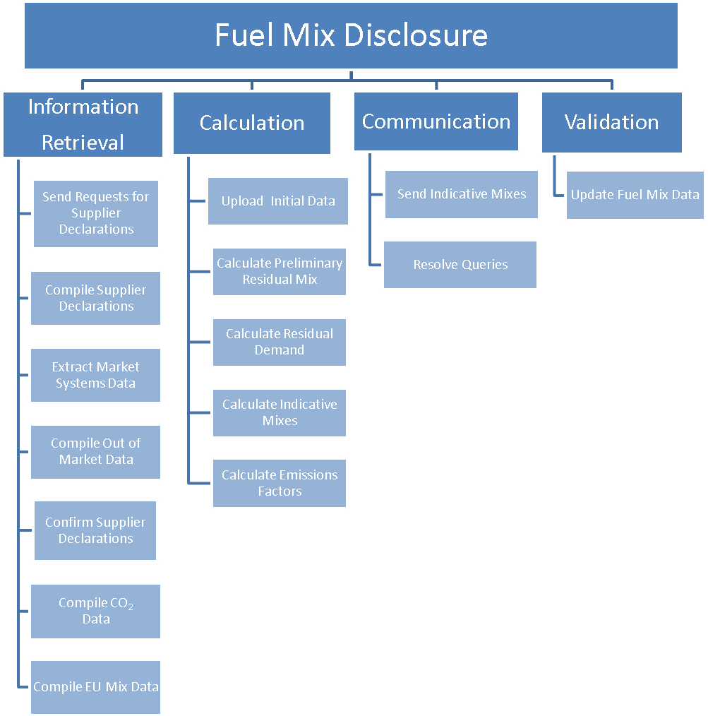
Fig.2 Fuel Mix Disclosure

The process is summarised in the four main activities described below:

Information Retrieval
The first activity involved in Fuel Mix Disclosure is to retrieve the relevant data. This data will be collected annually. Data is collected internally from SEMO’s market systems and externally from a number of sources. These sources include Suppliers, the Environmental Protection Agency (EPA), the Department of Energy and Climate Change (DECC), Meter Registration System Operator (MRSO), Northern Ireland Energy (NIE), Reliable Disclosure Systems for Europe (RE-DISS) and the Regulatory Authorities.
Though this is the first task involved, some of the information is scheduled to be received later in the process with no impact on the subsequent activities.

Details of these activities, including relevant deadlines, are provided below.

Send requests for Supplier Declarations
The Fuel Mix process is initiated when SEMO sends requests to Suppliers asking for Supplier Declaration forms. Requests are sent to all Suppliers registered with the SEM; however, Suppliers are not directly obligated to respond. Those who do not respond by the deadline will not have a Fuel Mix calculated. Note that where a Supplier has retail customers but no individual fuel mix, that Supplier must publish the Residual Mix as their Fuel Mix.

Requests are sent via post and email to Suppliers. A template document is included in the email for Suppliers to complete and submit to SEMO.

These requests are sent to Suppliers no later than the beginning of March each year, at least 4 weeks before the deadline for submission, the 31st of March.

Compile Supplier Declarations
Suppliers submit their Supplier Declarations according to a set template. This form contains information relating to all of the attributes a Supplier wishes to claim for the year. Suppliers are permitted to submit preliminary versions to SEMO, for review in advance of this deadline.

The deadline for submitting Supplier Declaration forms is the 31st of March each year. This is extended to the next working day where the 31st is a non-working day.

Compile out of market data
The metering for Out-of-SEM Generators is completed by MRSO and NIE. These units are not part of the SEM. Therefore SEMO has no sight of this information. As such it is necessary for SEMO to request the data from MRSO and NIE on an annual basis, in accordance with the timelines set out in the decision paper (SEM/11/095). This data is aggregated to annual volumes for each unit and contains non loss adjusted values as well as information showing to which Supplier each Generator’s energy was sold in the retail market.

This data is to be provided within 10 working days of the end of the first quarter.

Extract Market System data
The metered data of units registered in the SEM is stored in the Central Market Systems. At the end of the first quarter, SEMO will extract this data for use in Fuel Mix calculations.

This data is to be extracted within 10 working days of the end of the first quarter.

Confirm Supplier Declarations
Once SEMO receives a Supplier Declaration form, it must verify the attributes included therein. Once received, SEMO verifies that the form has been completed correctly and that the Supplier has the right to claim the energy included.

SEMO will co-ordinate with Suppliers where amendments to the form received are necessary and may require a new form to be submitted. The decision regarding whether a new form is required shall be made by SEMO.

SEMO will complete this step within 10 working days of the deadline for submission.

Compile CO₂ data
SEMO receives data on the CO₂ emissions of fossil fuelled Generators from the EPA and DECC via the Regulatory Authorities. This data is used to determine emissions factors for each fuel and an All Island emissions factor. These are then used to calculate an emissions factor for each Supplier.

Once received, SEMO will cross check submissions to ensure that all relevant units have been included in the dataset. SEMO will co-ordinate with the Regulatory Authorities to finalise the dataset in the event of omissions.

This data is typically received by SEMO by the 25th of May.

Compile EU Mix data
The European Residual Mix is a mix of unclaimed energy for Europe. It has been calculated by RE-DISS since 2009. It is used to assign a fuel type to any demand remaining after interconnector and certificate trading have been accounted for. The EU mix is typically prepared by the 15th of May.

The RE-DISS project will be winding down in October 2012 and may receive funding for a RE-DISS 2 project. It is currently unknown whether this will have an impact on the calculation of these figures. However, should this impact the calculation SEMO will seek clarification from the Regulatory Authorities on the appropriate next steps.

Calculation

The next activity involved in the process is to input the data received into the fuel mix database and perform the calculation. The final result of this activity will be the calculation of the overall All Island Mix as well as each Supplier’s individual mix. Environmental impact information will also be produced covering CO2 emissions and radioactive waste emissions. Details of the steps involved in this activity are outlined below.

Upload Initial Metered Data
The Fuel Mix Disclosure calculations require a number of different datasets compiled during the previous activity. These are uploaded to the databases involved and used in the calculation; however, due to external factors, some data is ready before other data. This initial data includes the SEM metered data, the out of market metered data and Supplier Declarations. These allow for the Preliminary Residual Mix to be calculated. Other data is uploaded as available and allows for the calculation of the final mixes and environmental impact information.

This step is completed 15 working days after the end of the first quarter.

Calculate Preliminary Residual Mix
The Preliminary Residual Mix is the first mix calculated each year. It is the mix of unclaimed generation, based on metered generation and Supplier Declarations only. It is this mix which provides inputs to the European Residual Mix calculation.

This is scheduled to be completed by the 30th of April each year.

Calculate Residual Demand
Each Supplier’s Residual Demand is the portion of their demand which is not covered by their claims. The Residual Mix is therefore used to assign generation to this demand. If a Supplier has claims in excess of their demand, and this cannot be netted against another related Supplier, this will be added to the final Residual Mix calculation in a subsequent step.

As part of this calculation, the Fuel Mix loss factor is calculated and applied to each Supplier’s demand.

This is scheduled to be completed 5 working days after the previous step.

Finalise Mixes
Once the environmental impact information and EU mix data has been received, indicative mixes are created. This includes an updated Residual Mix, an All Island Mix and individual Supplier Mixes. These mixes will be finalised after the Supplier query process, once confirmed by the Regulatory Authorities.

These mixes are scheduled to be calculated by the 1st of June each year.

Calculate Emissions Factors
The environmental impact information contains data on CO2 emissions for Ireland and Northern Ireland. The EU mix data contains emissions data on the EU Residual Mix which includes radioactive emissions data.

This data is uploaded to the database and divided by the relevant generation to produce emissions factors by fuel. These fuel emissions factors are used to calculate an All Island Emissions Factor and individual Supplier Emissions Factor based on the relevant fuel mix. Emissions Factors are calculated in this fashion for CO2 emissions and radioactive waste emissions.

All Emissions Factors are scheduled to be calculated by the 1st of June each year.

Communicate
Once calculated, the Indicative Mix and Emissions Factor information needs to be communicated to Suppliers and the Regulatory Authorities. Both parties are then given a chance to submit queries relating to the data to SEMO. The details of the steps involved are outlined below.

Send Indicative Mixes
Indicative Mixes are emailed to Suppliers and the Regulatory Authorities. They are provided to allow both parties to review and lodge any queries relating to the calculation with SEMO. If no queries are received for a particular mix, that require recalculation, the indicative mix will be the same as the final mix.

The detail of the Fuel Mix loss factor which was applied to Supplier demand in arriving at the Indicative Mix is also included.

Suppliers are sent their own Supplier Mix, their own Emissions Factors, which are all aggregated across jurisdictions if requested, and details of the All Island Mix and Emissions Factors for comparison. The Regulatory Authorities are sent details of all Suppliers Mixes, the All Island information and all Emission Factor values.

All Indicative Mix information is scheduled to be sent by the 1st of June each year.

Resolve Queries
After receiving their Indicative Mix, Suppliers have seven working days to submit any queries. SEMO will work to resolve any queries received before sending finalised figures to the Regulatory Authorities, if required.

The Regulatory Authorities may also submit queries to SEMO based on these Indicative Mixes. SEMO asks that the Regulatory Authorities also submit any queries in this seven working day window; however, if necessary, SEMO will accept queries from the Regulatory Authorities at any point before final publication.

The resolution of a query may have an indirect effect on all Suppliers and require a reissuing of new Indicative Mixes to all parties. If this is the case, it may be necessary to extend the deadline for queries to allow for analysis of this new information.

If any queries can not be resolved in this timeframe then a summary of unresolved queries will also be sent to the RAs along with the finalised mix information.

SEMO have an additional seven working days from the end of the Supplier deadline to resolve any queries, or seven working days from the date the Regulatory Authorities submit queries.

Validate
Once the query process has ended, a finalised set of mixes must be compiled. This new data is then sent to the Regulatory Authorities for review and, ultimately, publication. Unless there was a change to their mix as the result of a query, Suppliers are not sent new sets of data. Details of the steps involved are outlined below.

Update Fuel Mix Data
SEMO will update the dataset sent to the Regulatory Authorities with any changes resulting from the query process. SEMO will also, if necessary, prepare a summary of any unresolved queries at this time.

SEMO then sends this information to the Regulatory Authorities. Final publication of the Fuel Mix Disclosure data each year is the responsibility of the Regulatory Authorities and is outside of SEMO’s remit.

Updated Fuel Mix data is sent by SEMO to the Regulatory Authorities within 1 working day of the previous step. The Regulatory Authorities are scheduled to publish the Fuel Mix Disclosure data 18 working days after the Indicative Mix data is issued to Suppliers.

Roles and Responsibilities

SEMO Market Operations

SEMO is subject to all of the obligations placed on the calculating body under the decision paper SEM/11/095. The key obligations being:

- SEMO will calculate each Supplier’s fuel mix, an overall fuel mix and environmental impact information on an annual basis.
- SEMO will calculate the All Island Residual Mix and will provide this information to the relevant party by the 30th of April each year, in sufficient time for its inclusion in the European Residual Mix.
- SEMO will issue each Supplier their indicative Supplier Mix as well as the overall fuel mix by the 1st of June each year.
- SEMO will attempt to resolve all Supplier queries received within 7 working days of the indicative mixes being sent, before sending finalized mixes to the Regulatory Authorities for their review. If any queries are unresolved at this point SEMO will include a summary of unresolved queries with the final mixes.
- SEMO will calculate a loss factor specifically related to Fuel Mix Disclosure. This will be used to adjust demand to align with non-loss-adjusted metered generation and will only be used for Fuel Mix Disclosure. SEMO will inform Suppliers of this loss factor at the point where indicative Supplier Mixes are issued.

As the issuing body for Guarantees of Origin in Ireland, SEMO will also allow for the cancellation of any Guarantees of Origin, in the Irish registry, used for Fuel Mix Disclosure and ensure that there is no double counting of the associated Renewable attributes.

Meter Data providers

As per the decision paper, SEM/11/095, out of market meter data providers, namely MRSO in Ireland and NIE in Northern Ireland, provide SEMO with non-loss adjusted metered data for all out of market units.

These submissions are made within 10 working days of the end of the first quarter.

Suppliers

Suppliers are subject to all obligations placed on Suppliers by the decision paper SEM/11/095. A key obligation being that Suppliers will provide SEMO, as calculating body, with the following information:

- A list of all the Guarantees of Origin (GOs) the Supplier wishes to be used for the Disclosure Period.
- A list of all generation attributes assigned to the Supplier that the Supplier wishes to use for the Disclosure Period, including the relevant information outlined in this decision paper that is required relating to imported non-renewable generation.
- Any further information that may be required by the Calculating Body to verify the Supplier’s claims in relation to their fuel mix disclosure.

Suppliers are also obligated to publish Fuel Mix information on their bills and promotional material. This publication must take place no more than two months after publication of final Fuel Mix figures by the Regulatory Authorities.

Regulatory Authorities

The Regulatory Authorities, namely the CER in Ireland and UREG in Northern Ireland, are subject to all obligations placed on the Regulatory Authorities under the decision paper SEM/11/095. The key obligations in this regard are the following:

- The RAs will publish the final All Island Fuel Mix and each Supplier’s Final Fuel Mix. This publication will take place 18 working days from the date the Calculating Body issues the indicative Fuel Mixes to Suppliers.
- The RAs will facilitate provision of environmental impact information to SEMO from the relevant body. The relevant bodies are the EPA in Ireland and the DECC in Northern Ireland.
- The RAs will co-ordinate with Suppliers to ensure that Suppliers publish the relevant Fuel Mix information in the correct format within two months of publication of the final Fuel Mix figures.

Process Description

Process Swimlane

Process Steps

Step | Step Name | Step Description |  | Timing
Information Retrieval
1 | Send Requests for Supplier Declarations |  | SEMO sends requests for Supplier Declarations to all Suppliers registered in the SEM. The request is sent via post and email and a template is included for Suppliers to complete and return. | 1st of March
2 | Compile Supplier Declarations |  | SEMO receives and compiles Supplier Declarations from all Suppliers and notes any that did not make a submission. | 31st of March
3 | Extract Market Systems Data |  | SEMO extracts metered generation and metered demand data from the Central Market Systems and exports these to databases to be used in the calculation. | 10 working days after step 2
4 | Compile Out of Market Data |  | SEMO requests out of market metered generation values from the relevant MDPs. Once received, this data is checked for completeness and compiled into an out of market dataset | 10 working days after step 2
5 | Confirm Supplier Declarations |  | SEMO confirms that the Supplier Declaration forms received are completed correctly and that Suppliers have rights to the generation which they are claiming. | 10 working days after step 2
6 | Compile EU Mix Data |  | SEMO co-ordinates with the relevant calculating body to receive the European Residual Mix data. This data is then stored and entered into the calculation | 15th of May
7 | Compile CO₂ Data |  | SEMO receives and compiles CO₂ emissions data from the EPA and DECC, through the Regulatory Authorities. | 25th of May
Calculation
8 | Upload Initial Data |  | SEMO uploads the metered SEM data, the metered out of SEM data and the Supplier Declaration information to their database to allow its use in the calculations. | 5 working days after step 5
9 | Calculate Preliminary Residual Mix |  | SEMO calculates the Preliminary Residual Mix by subtracting Supplier claims from metered generation. | 30th of April
10 | Calculate Residual Demand |  | SEMO calculates each Supplier’s Residual Demand value as well as any excess generation claims which need to be factored into the Final Residual Mix calculation. | 5 working days after step 9
11 | Calculate Indicative Mixes |  | SEMO uses the Preliminary Residual Mix, EU Mix data, CO₂ data and Residual Demand data to calculate Indicative Mixes for the Residual Mix, All Island Mix and Supplier Mixes. | 1st of June
12 | Calculate Emissions Factors |  | SEMO uses mix data as well as emissions data and EU mix data to calculate Emissions Factors for each fuel. SEMO then uses these to calculate Emissions Factors for each Supplier and an All Island Emissions Factor. This is done for CO₂ and radioactive waste emissions. | 1st of June

Communication
13 | Send Indicative Mixes | Indicative Mixes are sent to all Suppliers and to the Regulatory Authorities. Suppliers are sent details of their own mix and Emissions Factors as well as the All Island values for comparison. The Regulatory Authorities are sent a complete set of data for all Suppliers and the All Island totals for both generation and emissions. | 1st of June
14 | Resolve Queries | Suppliers have a period of 7 working days where they may submit queries to SEMO about the Fuel Mix calculation. The queries may relate to any aspect of the process. The Regulatory Authorities may also submit queries. SEMO works to resolve these queries and if necessary sends updated mix information to affected parties. | 14 working days after step 13
Validation
15 | Update Fuel Mix Data | SEMO updates the Fuel Mix data with any amendments caused by the query process. SEMO collates this data and sends it to the Regulatory Authorities for their review. SEMO also includes a summary of any queries which could not be resolved during the query process. | 1 working day after step 14

Process References

Process Rule Documents

The following table provides references to the documents that govern the design of this business process:
Document | Title | Version | Section | Description
S.I. number 60 of 2005 | EUROPEAN COMMUNITIES (INTERNAL MARKET IN ELECTRICITY) REGULATIONS 2005 | n/a | Regulation 25 | Transposes EU directive 2003/54/EC Article 3(6) into law in Ireland.
Decision Paper CER/11/095 | Fuel-Mix Disclosure in the Single Electricity Market: Calculation Methodology Decision Paper | N/A | n/a | Decision paper outlining the process for Fuel Mix Disclosure under the enduring methodology.
Directive 2003/54/EC | DIRECTIVE 2003/54/EC OF THE EUROPEAN PARLIAMENT AND OF THE COUNCIL  of 26 June 2003  concerning common rules for the internal market in electricity and repealing Directive 96/92/EC | n/a | Article 3(6) | EU Directive stating the need for Suppliers to publish reliable Fuel Mix Disclosure information.

Directive 2009/28/EC | DIRECTIVE 2009/28/EC OF THE EUROPEAN PARLIAMENT AND OF THE COUNCIL  of 23 April 2009  on the promotion of the use of energy from renewable sources and amending and subsequently repealing Directives 2001/77/EC and 2003/30/EC | n/a | Article 15 | Replaces Directive 2003/54/EC, outlines the obligations for Suppliers in relation to Fuel Mix Disclosure. Defines the relationship between Fuel Mix Disclosure and Guarantees of Origin.
S.I. 1992 no.231(NI 1) Northern Ireland (as amended) | Electricity (NI) Order 1992 | n/a | Article 11A(9)(c) | Places obligations in Northern Ireland relating to Fuel Mix Disclosure.

Related Documents

The following table provides a list of documents that are related to this business process:
Document | Title | Version | Relationship | Description
SEMO Business Process Model | SEMO Business Process Overview | 1.0 | Parent Document | Overview of the model used for the SEMO Business Processes. Provides the context for where each business processes fits into SEMO.
S.I. number 147 of 2011 | European Communities (Renewable Energy) Regulations 2011 | N/A | Legislation Governing Related Process | Transposes EU Directive providing for Guarantees of Origin in Ireland.
Decision Paper CER/11/824 | Supervisory Framework for Administration of Guarantees of Origin | N/A | Decision Paper Governing Related Process | Establishes the Supervisory Framework for the administration of Guarantees of Origin in Ireland.

Assumptions

- SEMO will continue in its capacity as Calculating Body, and perform the Fuel Mix Disclosure calculation on behalf of the Regulatory Authorities, in perpetuity
- All information will be available to SEMO in sufficient time to allow for these timelines
- The European Residual Mix will continue to be calculated in sufficient time to be included in this calculation after the completion of the RE-DISS project
- All processes will be performed using existing SEMO systems no systems will be designed expressly for this function
- There will be sufficient resources in place in SEMO to allow for the concurrent running of the annual Fuel Mix Disclosure calculation and the GO Issuing process for quarter one each year, without impact on the timelines of either process
- At all times throughout this document, unless stated otherwise, quarter refers to calendar year quarters

Appendices

Glossary

Abbreviation | Definition
RAs | Regulatory Authorities
SEM | Single Electricity Market
T&SC | Trading and Settlement Code
WD | Working Day (Working Day ends at 5pm)
CER | Commission for Energy Regulation
S.I. | Statutory Instrument
GO | Guarantee of Origin
MDP | Meter Data Provider
REGO | Renewable Energy Guarantee of Origin
PSO | Public Service Obligation
NIE | Northern Ireland Energy
MRSO | Meter Registration System Operator
UREG | Utility Regulator for Electricity and Gas
FMD | Fuel Mix Disclosure
PPA | Power Purchase Agreement
EPA | Environmental Protection Agency
DECC | Department of Energy and Climate Change
RE-DISS | Reliable Disclosure Systems for Europe

Process Flowchart Key

flowchart Key
Process trigger
Process step
Process decision / question
Document
Manual Input / Update
Reference to another process
Another business process to be implemented following current step (current step is a trigger for another process)
Process end
System
Data
System File
Preparation

