
Business Process

Rolling Fuel Mix Disclosure

Table of Contents
1 Process Context 3
1.1 Background 3
1.2 Process Scope 4
2 Business Objective 5
3 Process Overview 6
3.1 Process Overview 6
4 Roles and Responsibilities 9
5 Process Description 10
5.1 Process Swimlane 10
5.2 Process Steps 13
6 Process References 14
6.1 Process Rule Documents 14
6.2 Related Documents 15
7 Assumptions 16
8 Appendices 17
8.1 Glossary 17
8.2 Process Flowchart Key 18

Process Context

Background
Fuel Mix Disclosure is required by Article 3(9) of Directive 2009/72/EC. The transposing legislation in Ireland, S.I. number 60 of 2005, requires the Commission for Energy Regulation (“the CER”) to ensure Suppliers provide reliable Fuel Mix information on all bills and promotional materials issued to customers. In Northern Ireland the transposing legislation, Article 11A(9)(c) of the Electricity (NI) Order 1992, as amended by Article 14 of the Gas and Electricity (Internal Markets) Regulations (Northern Ireland) 2011, requires that licences issued by the Utility Regulator (“the UR”) include a condition requiring compliance with Article 3(6).
In April of 2009 the SEM Committee published the decision paper “High Level Methodology for the Calculation of Fuel Mix Disclosure in the SEM‟ (SEM/09/033). That paper set out the SEM Committee’s intention to use a certificate based methodology for Fuel Mix Disclosure in the SEM. However, at the time of publication of that paper, Directive 2009/28/EC (the “Renewables Directive”) had not yet been finalised. As such, the detail of the methodology could not be set out in the absence of certainty regarding both the European legislation and the transposition of that legislation by the Oireachtas and the Northern Ireland Assembly. As Article 15 of the Renewables Directive has now been published and transposed in both jurisdictions, an enduring methodology can be achieved.
The SEM Committee decision paper SEM/11/095 outlined this enduring methodology. This replaces the interim arrangements outlined in the decision paper SEM/09/081. The interim arrangements applied to the disclosure years of 2008 to 2010 production. The enduring methodology applies to 2011 production onwards. The key distinction between methodologies is the introduction of certificate based tracking of energy which conforms to proposed enduring methodology set out in SEM/09/033.
SEMO annually performs the Fuel Mix Disclosure calculations, on behalf of the Regulatory Authorities, according to this methodology. Suppliers publish their own information, as well as the All Island information, on all bills and promotional materials.
In addition to this Annual Fuel Mix Disclosure, SEMO also publishes a rolling Fuel Mix Disclosure on a quarterly basis which gives Suppliers an estimate of their Fuel Mix for the year to date. This Rolling Fuel Mix Disclosure gives indicative figures which are based on the best available data at the time of calculating. The Rolling Fuel Mix is not intended for any other purpose other than to give an unofficial indication of a Fuel Mix position for that year to date. It is not to be used in Supplier publications.

Process Scope
This document describes how rolling Fuel Mix information is calculated for each Supplier and on an All Island basis, every quarter. The calculation is based on the best information available at the time and gives Suppliers an indicative view of their Fuel Mix for the year to date. It does not outline how environmental impact information, covering CO₂ emissions and radioactive waste emissions.

It does not describe any of the following related processes:
- Any processes relating to Guarantees of Origin, Generator Attributes or Renewable Energy Guarantees of Origin
- The calculation of Annual Fuel Mix information

Business Objective

The objective of this business process is to give Suppliers an indicative view of their Fuel Mix for the year to date. This is calculated on a quarterly basis after the GO issuing process. This process is not required under either European or Irish legislation. However, SEMO have undertaken, after discussion with the CER, to produce the Rolling Fuel Mix to give Suppliers an indicative overview of their current Fuel Mix position.

Process Overview

Process Overview
Fuel Mix Disclosure encompasses a number of activities shown in Figure 1 below:
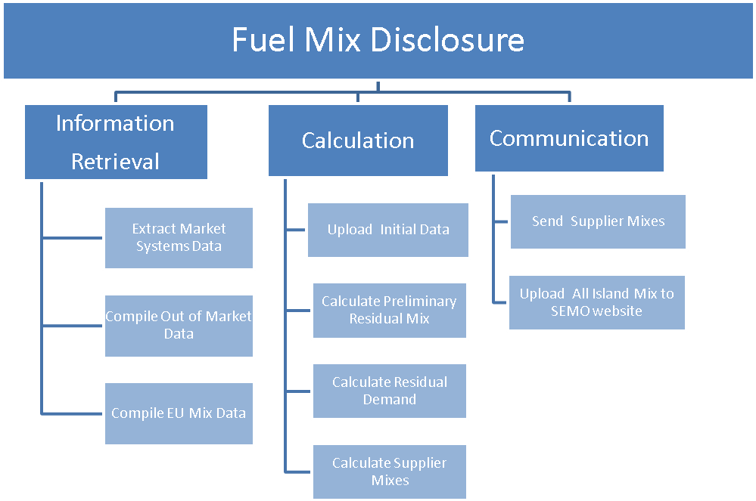
Fig.1 Rolling Fuel Mix Disclosure

The process is summarised in the three main activities described below:

Information Retrieval
The first activity involved in the Rolling Fuel Mix Disclosure is to retrieve the relevant data. This data is collected quarterly during the GO issuing process. Data is collected internally from SEMO’s market systems and externally from a number of sources. These sources include Meter Registration System Operator (MRSO) and Northern Ireland Energy (NIE) T&D.
Details of these activities, including relevant deadlines, are provided below.

Compile Out of Market data
The Meter Data Providers (MDPs) for Out-of-SEM Generators are MRSO and NIE. SEMO requests metered data from MRSO and NIE on a quarterly basis. This data is then appended to data from previous quarters, where applicable. All values included are non-loss adjusted and show to which Supplier each Generator’s energy was sold in the retail market.
This data is to be provided 10 working days after the end of the relevant quarter.

Extract Market System data
The metered data of units registered in the SEM is stored in the Central Market Systems. At the end of each quarter, SEMO will extract this data for use in Fuel Mix calculations.
This data is to be extracted within 10 working days of the end of each quarter.

Compile EU Mix data
The European Residual Mix is a mix of unclaimed energy for Europe which is calculated by the RE-DISS II project. This information is used to assign a fuel type to any demand remaining after interconnector and certificate trading have been accounted for. In the calculation of the Rolling Fuel Mix, SEMO will use the most up-to-date data available from RE-DISS II.

Calculation

The next activity involved in the process is to input the data received into the Fuel Mix database and perform the calculation. The final result of this activity will be the calculation of the overall All Island Mix as well as each Supplier’s individual mix.

Upload Initial Metered Data
Once datasets have been compiled for all relevant quarters, the data needs to be loaded into SEMO’s databases for use in the calculation. This step will begin following successful completion of the information retrieval process outlined in section 3.1.1.

Calculate Preliminary Residual Mix
The Preliminary Residual Mix is the first generation mix calculated each quarter. It is the mix of unclaimed generation, based on metered generation only.

Calculate Residual Demand
Each Supplier’s Residual Demand is the portion of their demand which is not covered by their claims. The Residual Mix is therefore used to assign generation to this demand. If a Supplier has claims in excess of their demand, and this cannot be netted against another related Supplier, this will be added to the final Residual Mix calculation in a subsequent step.
As part of this calculation, the Fuel Mix loss factor is calculated and applied to each Supplier’s demand. This is scheduled to be completed 5 working days after the previous step.

Finalise Mixes
Using the existing EU mix data available from the previous Annual Fuel Mix calculation, final Supplier mixes are created. This includes an updated Residual Mix, an All Island Mix and individual Supplier Mixes.
This step is to be completed 25 working days after the end of the quarter.

Communicate
Once calculated, the Supplier Mix needs to be communicated to Suppliers. The Supplier Mixes are emailed to the Suppliers’ Authorised Users.

Send Supplier Mixes
Supplier Mixes are emailed to Suppliers. Suppliers are sent their own Supplier Mix, which are aggregated across jurisdictions if requested, and details of the All Island Mix for comparison.
This step is to be completed 25 working days after the end of the quarter.

Upload All-Island Mix to SEMO Website.
All Island Mix data is published on the SEMO website. This information is open to all Suppliers and to the general public.
This step is to be completed 25 working days after the end of the quarter

Roles and Responsibilities

SEMO Market Operations

SEMO is subject to all of the obligations placed on the calculating body under the decision paper SEM/11/095. Although not expressly covered by the decision paper, SEMO will also calculate a Rolling Fuel Mix every quarter.

Meter Data providers

As per the decision paper, SEM/11/095, out of market meter data providers, namely MRSO in Ireland and NIE in Northern Ireland, provide SEMO with non-loss adjusted metered data for all out of market units. These are made available to SEMO on a quarterly basis.

These submissions are made within 10 working days of the end of each quarter.

Process Description

Process Swimlane

Process Steps

Step | Step Name | Step Description |  | Timing
Information Retrieval
1 | Compile Out of Market Data |  | SEMO requests out of market metered generation values from the relevant MDPs. Once received, this data is checked for completeness and compiled into an out of market dataset | Already available from GO issuing process
2 | Extract Market Systems Data |  | SEMO extracts metered generation and metered demand data from the Central Market Systems and exports these to databases to be used in the calculation. | Already available from GO issuing process
3 | Compile EU Mix Data |  | The most up-to-date data used for the previous Annual Fuel Mix is used. | Available from previous Annual Fuel Mix Disclosure.
Calculation
4 | Upload Initial Data |  | SEMO uploads the metered SEM data, the metered out of SEM data and the Supplier Declaration information to their database to allow its use in the calculations. | 20 working-days after end of quarter.
5 | Calculate Preliminary Residual Mix |  | SEMO calculates the Preliminary Residual Mix by subtracting Supplier claims from metered generation. | 25 working-days after end of quarter.
6 | Calculate Residual Demand |  | SEMO calculates each Supplier’s Residual Demand value as well as any excess generation claims which need to be factored into the Final Residual Mix calculation. | 25 working-days after end of quarter
7 | Calculate Supplier Mixes |  | SEMO uses the Preliminary Residual Mix, EU Mix data, and Residual Demand data to calculate Mixes for the Residual Mix, All Island Mix and Supplier Mixes. | 25 working days after end of quarter.
Communication
8 | Send Supplier Mixes | Supplier Mixes are sent to all Suppliers. Suppliers are sent details of their own mix as well as the All Island values for comparison. | 25 working-days after end of quarter.
9 | Upload All-Island Data to the SEMO Website. | Indicative Information of the All-Island Fuel Mix is made available to the public via the SEMO Website. | 25 working-days after end of quarter.

Process References

Process Rule Documents

The following table provides references to the documents that govern the design of this business process:
Document | Title | Version | Section | Description
S.I. number 60 of 2005 | EUROPEAN COMMUNITIES (INTERNAL MARKET IN ELECTRICITY) REGULATIONS 2005 | n/a | Regulation 25 | Transposes EU directive 2003/54/EC Article 3(6) into law in Ireland.
Decision Paper SEM/11/095 | Fuel-Mix Disclosure in the Single Electricity Market: Calculation Methodology Decision Paper | N/A | n/a | Decision paper outlining the process for Fuel Mix Disclosure under the enduring methodology.
Directive 2003/54/EC | DIRECTIVE 2003/54/EC OF THE EUROPEAN PARLIAMENT AND OF THE COUNCIL  of 26 June 2003  concerning common rules for the internal market in electricity and repealing Directive 96/92/EC | n/a | Article 3(6) | EU Directive stating the need for Suppliers to publish reliable Fuel Mix Disclosure information.

Directive 2009/28/EC | DIRECTIVE 2009/28/EC OF THE EUROPEAN PARLIAMENT AND OF THE COUNCIL  of 23 April 2009  on the promotion of the use of energy from renewable sources and amending and subsequently repealing Directives 2001/77/EC and 2003/30/EC | n/a | Article 15 | Replaces Directive 2003/54/EC, outlines the obligations for Suppliers in relation to Fuel Mix Disclosure. Defines the relationship between Fuel Mix Disclosure and Guarantees of Origin.
S.I. 1992 no.231(NI 1) Northern Ireland (as amended) | Electricity (NI) Order 1992 | n/a | Article 11A(9)(c) | Places obligations in Northern Ireland relating to Fuel Mix Disclosure.

Related Documents

The following table provides a list of documents that are related to this business process:
Document | Title | Version | Relationship | Description
SEMO Business Process Model | SEMO Business Process Overview | 1.0 | Parent Document | Overview of the model used for the SEMO Business Processes. Provides the context for where each business processes fits into SEMO.
S.I. number 147 of 2011 | European Communities (Renewable Energy) Regulations 2011 | N/A | Legislation Governing Related Process | Transposes EU Directive providing for Guarantees of Origin in Ireland.
Decision Paper CER/11/824 | Supervisory Framework for Administration of Guarantees of Origin | N/A | Decision Paper Governing Related Process | Establishes the Supervisory Framework for the administration of Guarantees of Origin in Ireland.

Assumptions

- SEMO will continue in its capacity as Calculating Body, and perform the Fuel Mix Disclosure calculation on behalf of the Regulatory Authorities, in perpetuity. It will also continue to produce the Rolling Fuel Mix on a quarterly basis.
- All information will be available to SEMO in sufficient time to allow for these deadlines.
- The European Residual Mix will continue to be calculated in sufficient time to be included in this calculation after the completion of the RE-DISS II project.
- All processes will be performed using existing SEMO systems no systems will be designed expressly for this function.
- At all times throughout this document, unless stated otherwise, quarter refers to calendar year quarters.

Appendices

Glossary

Abbreviation | Definition
RAs | Regulatory Authorities
SEM | Single Electricity Market
T&SC | Trading and Settlement Code
WD | Working Day (Working Day ends at 5pm)
CER | Commission for Energy Regulation
S.I. | Statutory Instrument
GO | Guarantee of Origin
MDP | Meter Data Provider
REGO | Renewable Energy Guarantee of Origin
PSO | Public Service Obligation
NIE | Northern Ireland Energy
MRSO | Meter Registration System Operator
UREG | Utility Regulator for Electricity and Gas
FMD | Fuel Mix Disclosure
PPA | Power Purchase Agreement
EPA | Environmental Protection Agency
DECC | Department of Energy and Climate Change
RE-DISS | Reliable Disclosure Systems for Europe

Process Flowchart Key

flowchart Key
Process trigger
Process step
Process decision / question
Document
Manual Input / Update
Reference to another process
Another business process to be implemented following current step (current step is a trigger for another process)
Process end
System
Data
System File
Preparation

A related Suppliers are where two or more Suppliers are part of the same parent company. For example, a Supply parent company with a business in Ireland and Northern Ireland.

