MODIFICATION PROPOSAL FORM
Submitted by: | Date Proposal received by Secretariat: |  | Type of Proposal  (delete as appropriate) |  | Number: (to be assigned by Secretariat)
TSO Day 1+ Project | 12 Feb 2009 |  | Standard |  | Mod_06_09_V2
Contact Details for Modification Proposal Originator
Name:  Sonya Twohig |  | Telephone number:  +353 123 70372 |  | e-mail address:  sonya.twohig@eirgrid.com
Modification Proposal Title: |  | Data Queries by External Data Providers
Trading and Settlement Code/ Agreed Procedure change |  |  |  |  |  | Section(s) affected by Modification Proposal
Code  Agreed Procedure 13 Query Generation |  |  |  |  |  | 4.5  3.2
Version Number of the Code/Agreed Procedure used in Modification drafting: |  |  |  |  |  | Code 4.5
Modification Proposal Description
Clearly show proposed code change using tracked changes, & include any necessary explanatory information
Data Queries

6.78 A Participant or an External Data Provider may raise a Data Query in respect of any Settlement Item or other elements of data which have an impact on the Settlement Items included in the Ex-Post Indicative Settlement Statement by giving notice to the Market Operator during the Data Verification Period and will use reasonable endeavours to raise any such Data Query as early as possible within the Data Verification Period before the production and issue of the Initial Settlement Statement.
6.83 The Market Operator shall procure that (i) SMP and Market Schedule Quantities will be recalculated for the relevant Trading Day(s), and (ii) a Settlement Rerun shall then be undertaken in the event that the Market Operator in resolving a Data Query determines that:
1. Meter Datahas been applied incorrectly; or
2. Market Schedule Quantity has been calculated incorrectly,
and that the correct application or calculation of any such amount would require it to change by more than the Settlement Recalculation Threshold

6.84 The Market Operator shall procure that the Ex-Post Loss of Load Probability Φ shall be recalculated in the event that the Market Operator in resolving a Data Query determines that Metered Generation has been applied incorrectly, and that the correct application would require it to change by more than the Settlement Recalculation Threshold.

Settlement Queries

  - A Participant or an External Data Provider may raise a Settlement Query in respect of the application of Metered Generation or the calculation of any of the following amounts:
- Metered Demand;
- Net Demand;
- Eligible Availability; or
- Actual Availability.
  - Notwithstanding any other provision of the Code, a Participant may raise a Settlement Query in the event of any difference between a Settlement Item on the Ex-Post Indicative Settlement Statement and the same item on the Initial Settlement Statement, without the Participant having filed a Data Query in relation to that Settlement Item.

GLOSSARY
Data Query | Means a query which may be required by a Participant or External Data Provider in relation to one or more Settlement Items in an Ex-Post Indicative Settlement Statement in accordance with paragraph 6.78 or 6.78A.
Metered Demand | means the Demand-related Meter Data with respect to a Supplier Unit
External Data Provider | A Meter Data Provider, System Operator or Interconnector Administrator that provides Meter data to the Market Operator
Settlement Query | means a query raised by a Party in accordance with paragraph 6.93.

Agreed Procedure 13 Query Generation

    - Processing Data Queries
- Where the data being queried is from or affects the data of another Participant (the “Affected Participant(s)”), the Market Operator shall also inform the Affected Participant(s). The Affected Participant(s) shall assist the Market Operator in a timely manner, dealing with the Data Query concerned.

- Where the Data Query is valid and is querying data from an External Data Provider (System Operator, Interconnector Administrator or Meter Data Provider) then the Market Operator shall pass the details to such External Data Provider to examine the queried data for an error. In this case, or where the Raising Party is an External Data Provider the External Data Provider shall inform the Market Operator of its discoveries and provide any revised data under the timescales indicated by the Market Operator to fulfil the Data Query resolution deadline. Where possible, any revised data should be provided in time for inclusion in the Initial Settlement Statement.

2.2.2 Processing Settlement Queries
The Market Operator has one month in which to resolve the Settlement Query. The Raising Party may extend this time, giving the Market Operator up to 10 Working Days’ extra time from the end of the initial month period to resolve the Settlement Query. The Market Operator may request this extra time. The Raising Party may give this additional time in writing by fax during the initial month.

If the Settlement Query is not resolved during the initial one month period, or during the extended 10WD period (if approved), the Settlement Query becomes a Settlement Dispute.

The Market Operator will log all Settlement Queries and validate that the Settlement Query has all mandatory information complete (see Appendix 3 for validation rules) and has been submitted within the correct timescales by a person authorised under Agreed Procedure 11 “Market System Operation, Testing, Upgrading and Support” to submit Settlement Queries on behalf of the Raising Party. The Market Operator will confirm the validity or otherwise of the Settlement Query to the Raising Party under the timelines in this Agreed Procedure.

Where the data being queried is from or effects the data of another Participant (the “Affected Participant(s)”), the Market Operator shall also inform the Affected Participant(s). The Affected Participant(s) shall assist the Market Operator in a timely manner, dealing with the Settlement Query concerned.

Where the Settlement Query is valid and is as a result of data from an External Data Provider (System Operator, Interconnector Administrator or Meter Data Provider) then the Market Operator shall pass the details to such External Data Provider. In this case or where the Raising Party is an External Data Provider,the External Data Provider shall provide any revised data within 15 Working Days of receipt of the Settlement Query

- Procedural Steps
  - Data Query

# |  | Procedural Step | Timing |  | Mechanism | By / From | To | Linkage
6 | Establish whose data is being queried  - If it is a Meter Data Provider, a System Operator or the Interconnector Administrator (an External Data Provider) continue from step 14  - If it is another Participant’s data (The Affected Participant(s)) continue from step 7  - If it is regarding the calculation of a data item continue from step 13  - If the Raising Party is an External Data Provider continue from step 17 |  | Within 1 WD of receiving the Data Query |  |  | Market Operator
17 | Process the Data Query andinform Market Operator of findings, if relevant Reissue any corrected data. |  | Within timescales specified by MO | Email / Fax / registered overnight mail (notification of determination) |  | External Data Provider | Market Operator | Potentially AP16 (for ad hoc Meter Data file send
18 | If Market Operator completes the examination of the Data Query within timeframe, inform the Raising Party and the Affected Participant(s) of the Market Operator’s determination, including any estimate of Materiality and the method of estimating that Materiality. Go to step 21  If not, go to step 19  If the Raising Party is an External Data Provider continue from step 27. |  | Within 10 WD | Email / Fax / registered overnight mail |  | Market Operator | Affected Participant(s)  Raising Party
27 | If Commercial Offer Data, Technical Offer Data, Actual Availability, Dispatch Quantity, Metered Generation or Market Schedule Quantity have been determined to be incorrect arising from the Data Query, subject to the Settlement Recalculation Threshold,SMP and MSQ shall be recalculated prior to the Settlement Rerun. |  | Within 1 month of determination | -Various |  | Market Operator

  - Settlement Query

# | Procedural Step |  | Timing | Mechanism |  |  | By / From |  | To | Linkage
6 | Establish whose data is being queried  - If it is a Meter Data Provider, a System Operator or the Interconnector Administrator (an External Data Provider) continue from step 14  - If it is another Participant’s data (The Affected Participant(s)) continue from step 7  - If it is regarding the calculation of a data item continue from step 13  If the Raising Party is an External Data Provider continue from step 13 | Within 1 WD of receiving the Settlement Query |  |  |  | Market Operator
13 | Make a determination on the Settlement Query, including estimation of Materiality of any change to Settlement Items taking into account any comments from the Affected Participant(s).  If determination can be made within the timescales agreed with the Raising Party continue from step 18 otherwise continue from Step 11  If Raising Party is an External Data Provider continue from Step 17 | Within timescales agreed with Raising Party |  |  |  | Market Operator |  | -
17 | Process the Settlement Query. Inform Market Operator of findings and potentially reissue any corrected data | Within timescales specified by MO |  |  | Email / Fax / registered overnight mail (notification of determination)  Communication Channel (revised data) | External Data Provider |  | Market Operator |  |  | Potentially AP16 (for ad hoc Meter Data file send)

AP13 Glossary Definition Correction

External Data Provider | A Meter Data Provider, System Operator or Interconnector Administrator.

SWIMLANES (AP 13 Data Query and Settlement Query)

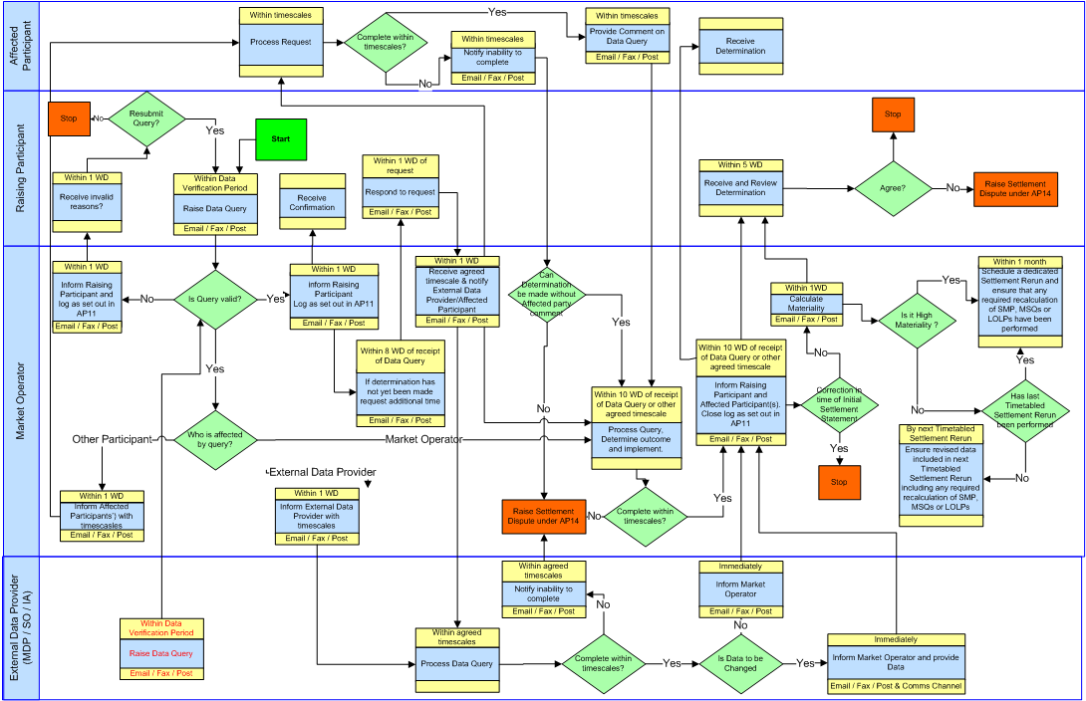

Fig 1 Data Query
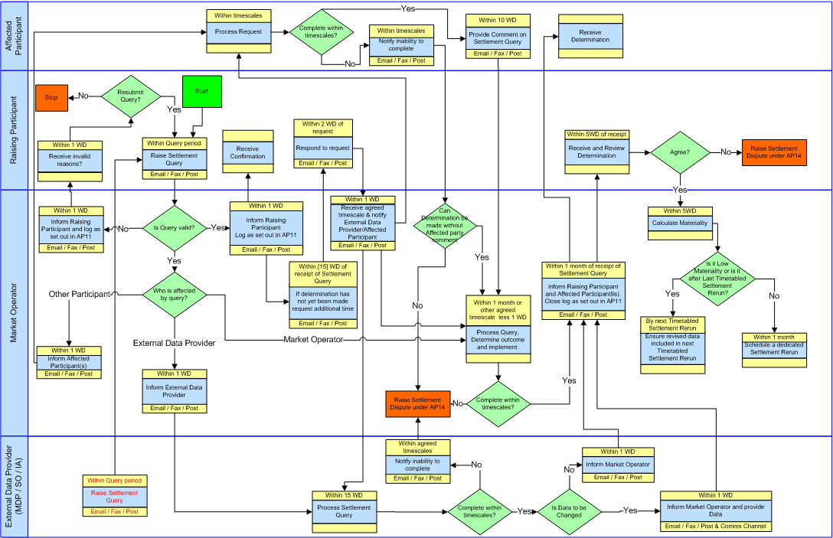
Fig 2 Settlement Query

Modification Proposal Justification
Clearly state the reason for the Modification & how it furthers the Code Objectives
Currently, the Code does not provide for a process around External Data Providers raising Data Queries or Issues, which would permit them to address issues with the data provided by them. More accurate data may be available, which may need to be processed by them, sent to MO and included in revised settlement calculations either within the Data Verification Period or afterwards.
This Modification aims to further Code Objective 1.3 (2) to ‘facilitate the efficient, economic and coordinated operation, administration and development of the Single Electricity Market in a financially secure manner'.

Implication of not implementing the Modification
Clearly state the possible outcomes should the Modification not be made , or how the Code Objectives would not be met

More accurate data may be available and there is no clear process by which External Data Providers can raise these with the MO.
Please return this form to Secretariat by e-mail to modifications@SEM-O.com

Notes on completing Modification Proposal Form:
- If a person submits a Modification Proposal on behalf of another person, that person who proposes the material of the change should be identified on the Modification Proposal Form as the Modification Proposal Originator.
- Any person raising a Modification Proposal shall ensure that their proposal is clear and substantiated with the appropriate detail including the way in which it furthers the Code Objectives to enable it to be fully considered by the Modifications Committee.
- Each Modification Proposal will include a draft text of the proposed Modification to the Code.
- For the purposes of this Modification Proposal Form, the following terms shall have the following meanings:

Code: means the Trading and Settlement Code for the Single Electricity Market
Modification Proposal: means the proposal to modify the Code as set out in the attached form
Derivative Work: means any text or work which incorporates or contains all or part of the Modification Proposal or any adaptation, abridgement, expansion or other modification of the Modification Proposal

The terms “Market Operator”, “Modifications Committee” and “Regulatory Authorities” shall have the meanings assigned to those terms in the Code.

In consideration for the right to submit, and have the Modification Proposal assessed in accordance with the terms of Section 2 of the Code (and Agreed Procedure 12), which I have read and understand, I agree as follows:

1. I hereby grant a worldwide, perpetual, royalty-free, non-exclusive licence:

to the Market Operator and the Regulatory Authorities to publish and/or distribute the Modification Proposal for free and unrestricted access;

to the Regulatory Authorities, the Modifications Committee and each member of the Modifications Committee to amend, adapt, combine, abridge, expand or otherwise modify the Modification Proposal at their sole discretion for the purpose of developing the Modification Proposal in accordance with the Code;

to the Market Operator and the Regulatory Authorities to incorporate the Modification Proposal into the Code;

1.4 to all Parties to the Code and the Regulatory Authorities to use, reproduce and distribute the Modification Proposal, whether as part of the Code or otherwise, for any purpose arising out of or in connection with the Code.

2. The licences set out in clause 1 shall equally apply to any Derivative Works.

3. I hereby waive in favour of the Parties to the Code and the Regulatory Authorities any and all moral rights I may have arising out of or in connection with the Modification Proposal or any Derivative Works.

4. I hereby warrant that, except where expressly indicated otherwise, I am the owner of the copyright and any other intellectual property and proprietary rights in the Modification Proposal and, where not the owner, I have the requisite permissions to grant the rights set out in this form.

5. I hereby acknowledge that the Modification Proposal may be rejected by the Modifications Committee and/or the Regulatory Authorities and that there is no guarantee that my Modification Proposal will be incorporated into the Code.

