MODIFICATION PROPOSAL FORM

Proposer  (Company) | Date of receipt  (assigned by Secretariat) |  | Type of Proposal  (delete as appropriate) |  | Modification Proposal ID  (assigned by Secretariat)
SEMO | 2nd June 2015 |  | Standard |  | Mod_07_15
Contact Details for Modification Proposal Originator
Name |  | Telephone number |  | Email address
Robin Keenan |  | - 2370575 |  | Robin.Keenan@sem-o.com
Modification Proposal Title
Amendment of AP7 to include the use of the SEMO public website and e-mail notification as the main communication channel in the event of a GCF.
Documents affected  (delete as appropriate) |  | Section(s) Affected |  | Version number of T&SC or AP used in Drafting
AP07 |  | 3.2.1, 4.1, 5.1, Appendix 2 |  | 16.0
Explanation of Proposed Change
(mandatory by originator)
It is proposed to amend AP7 to include the use of Market Messages on the Market Operator public website and e-mail alerts to replace the current emergency communication methods relating to a General Communication Failure. The methods set out in AP7 are fax, postal and telephony based.
Legal Drafting Change
(Clearly show proposed code change using tracked changes, if proposer fails to identify changes, please indicate best estimate of potential changes)
  - General Communication Failure
    - Overview
A “General Communication Failure” is a situation where the Market Operator’s Isolated Market System is operational but the normal communication interfaces between all Parties, (other than the System Operators or the Meter Data Providers) and the Market Operator are unavailable, leading to a failure of all such Parties to comply with the data submission requirements.
In the event of a General Communication Failure the Market Operator will notify each impacted Party of the General Communication Failure and issue instructions to each impacted Party how each relevant Data Transaction should be communicated to the Market Operator via a Market Message on the Market Operator’s website and an email alert. Additionally, the Market Operator will highlight those Data Transactions that are vital for Settlement and detail the allowed timeline for each of these Data Transactions (the “Emergency Transaction Timeline”).?
Where the failure also prevents the Market Operator receiving Data Transactions from the System Operators and Meter Data Providers, the Market Operator will also notify the System Operator and Meter Data Provider that submissions of Market Operator System Data Transactions and Meter Data Transactions will need to be submitted within 1 day of the specified submission deadline.
Following notification of a General Communication Failure the Market Operator will provide regular (i.e. not less than daily) status updates to all impacted Parties of the General Communication Failure. Each status update will include the original notification and will provide all impacted Parties of an estimate, if known, of when normal communication with the Market Operator’s Isolated Market System will be available again. Whenever the Market Operator receives information that significantly (in the opinion of the Market Operator) changes the expected time when normal communication will be restored, the Market Operator shall issue a status update.

  - Swimlane – General System Failure & General Communication Failure

- Procedural Steps
5.2 General Communication Failure# | Procedural Step | Timing | Method |  | By / From | To | Linkage
1 | Notify impacted Parties of the General Communication Failure using the notification communication method | Immediately following determination of a GCF | Market Operator’s website,  e-mail alert |  | Market Operator | All impacted Parties
2 | Where any questions arise, impacted parties will contact the Market Operator using the notification communication method |  | Emergency Operation’sTelephone, email or fax |  | All impacted Parties | Market Operator
3 | Announce the “Alternative Communication Method” and, if necessary, update the “Emergency Transaction Timeline” using the notification communication method |  | Market Operator’s website,  e-mail alert | Market Operator |  | All impacted Parties
 |  |  | -
4 | Notify all impacted Parties of best estimate of when the Market Operator Isolated Market System will be available using notification communication method | Following change to best estimate of recovery or at 17:00 hours each day | Market Operator’s website, e-mail alert |  | Market Operator | All impacted Parties
5 | Notify all impacted Parties of restoration of Communication Channels using Part 4 of the Emergency Communication Form and revoke the Transaction Notification Form. Communicate with impacted Parties using the notification communication method | Immediately following restoration of Communication Channels | Market Operator’s website,  e-mail alert |  | Market Operator | All impacted Parties
 |  |  | or email
6 | Commission an externally audited report in line with Agreed Procedure 11 “Market System Operation, Testing, Upgrading and Support” | Within timescales defined in AP11 | - |  | Market Operator |  | Agreed Procedure 11 “Market System Operation, Testing, Upgrading and Support”

Appendix 2: FORMS
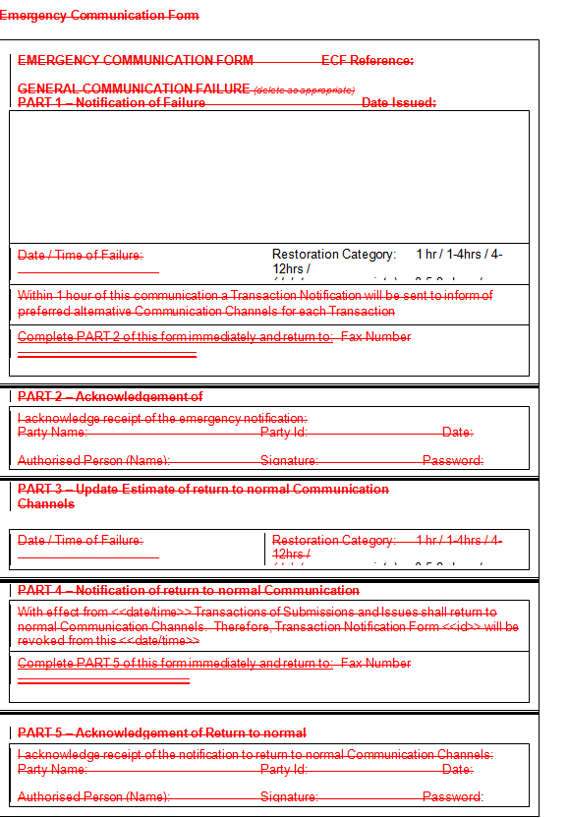

Modification Proposal Justification
(Clearly state the reason for the Modification)
The use of fax, post and telephone calls does not lead to efficient communication with affected parties in the event of a General Communication Failure whereas using the Market Operator public website and e-mail alerts is instant and the established participant communication method.
Code Objectives Furthered
(State the Code Objectives the Proposal furthers, see Section 1.3 of T&SC for Code Objectives)

- To facilitate the efficient discharge by the Market Operator of the obligations imposed upon it by its Market Operator Licences;
5. To provide transparency in the operation of the Single Electricity Market;
Implication of not implementing the Modification Proposal
(State the possible outcomes should the Modification Proposal not be implemented)
A lack of transparency will remain in the method of communication with Market Participants during a
General Communication Failure. The current process is difficult to implement and time-consuming.
Working Group  (State if Working Group considered necessary to develop proposal) |  |  | Impacts  (Indicate the impacts on systems, resources, processes and/or procedures)
No |  |  | Change in communication process for General Communication Failure.
Please return this form to Secretariat by email to modifications@sem-o.com

Notes on completing Modification Proposal Form:

- If a person submits a Modification Proposal on behalf of another person, that person who proposes the material of the change should be identified on the Modification Proposal Form as the Modification Proposal Originator.
- Any person raising a Modification Proposal shall ensure that their proposal is clear and substantiated with the appropriate detail including the way in which it furthers the Code Objectives to enable it to be fully considered by the Modifications Committee.
- Each Modification Proposal will include a draft text of the proposed Modification to the Code unless, if raising a Provisional Modification Proposal whereby legal drafting text is not imperative.
- For the purposes of this Modification Proposal Form, the following terms shall have the following meanings:

Agreed Procedure(s): means the detailed procedures to be followed by Parties in performing their obligations and functions under the Code as listed in Appendix D “List of Agreed Procedures”.
T&SC / Code: means the Trading and Settlement Code for the Single Electricity Market
Modification Proposal: means the proposal to modify the Code as set out in the attached form
Derivative Work: means any text or work which incorporates or contains all or part of the Modification Proposal or any adaptation, abridgement, expansion or other modification of the Modification Proposal

The terms “Market Operator”, “Modifications Committee” and “Regulatory Authorities” shall have the meanings assigned to those terms in the Code.

In consideration for the right to submit, and have the Modification Proposal assessed in accordance with the terms of Section 2 of the Code (and Agreed Procedure 12), which I have read and understand, I agree as follows:

1. I hereby grant a worldwide, perpetual, royalty-free, non-exclusive licence:

  - to the Market Operator and the Regulatory Authorities to publish and/or distribute the Modification Proposal for free and unrestricted access;

  - to the Regulatory Authorities, the Modifications Committee and each member of the Modifications Committee to amend, adapt, combine, abridge, expand or otherwise modify the Modification Proposal at their sole discretion for the purpose of developing the Modification Proposal in accordance with the Code;

  - to the Market Operator and the Regulatory Authorities to incorporate the Modification Proposal into the Code;

1.4 to all Parties to the Code and the Regulatory Authorities to use, reproduce and distribute the Modification Proposal, whether as part of the Code or otherwise, for any purpose arising out of or in connection with the Code.

2. The licences set out in clause 1 shall equally apply to any Derivative Works.

3. I hereby waive in favour of the Parties to the Code and the Regulatory Authorities any and all moral rights I may have arising out of or in connection with the Modification Proposal or any Derivative Works.

4. I hereby warrant that, except where expressly indicated otherwise, I am the owner of the copyright and any other intellectual property and proprietary rights in the Modification Proposal and, where not the owner, I have the requisite permissions to grant the rights set out in this form.

5. I hereby acknowledge that the Modification Proposal may be rejected by the Modifications Committee and/or the Regulatory Authorities and that there is no guarantee that my Modification Proposal will be incorporated into the Code.

