MODIFICATION PROPOSAL FORM

Proposer | Date of receipt |  | Type of Proposal |  | Modification Proposal ID
Electric Ireland | 25 February 2015 |  | Standard |  | Mod_09_14_v2
Contact Details for Modification Proposal Originator
Name |  | Telephone number |  | Email address
William Carr |  | 01 893 4530 |  | William.Carr@esb.ie
Modification Proposal Title
Amendment to Make Whole Payments for Interconnector Units
Documents affected |  | Section(s) Affected |  | Version number of T&SC or AP used in Drafting
T&SC |  | Section 4 |  | Version 15
Explanation of Proposed Change

The purpose of this Modification Proposal is to amend the Code so that Interconnector Users receive Make Whole Payments based on their aggregate position across all gate windows (EA1, EA2 & WD1) in which they have traded from the current Code wording where each gate window is considered separately for the calculation of Make Whole Payments.
Mod_09_14 v2 allows for a distinction to be made in the calculation of make whole payments for interconnector users based on the direction of the flow. The reason for introducing this distinction is to ensure, considering established market trends, that interconnector users who schedule trades in different directions in different trading windows for a given trading period continue to be protected from unrecovered costs by the make whole payment mechanism.

Legal Drafting Change
(Clearly show proposed code change using tracked changes, if proposer fails to identify changes, please indicate best estimate of potential changes)
Make Whole Payments
4.139 The purpose of Make Whole Payments is to make up any difference between the total Energy Payments to a Generator Unit (excluding Interconnector Units) or to an Interconnector User in a Billing Period, and the Schedule Production Cost within that Billing Period (where the difference is arithmetically positive calculated over the Billing Period), as set out algebraically below.
4.140 The Market Operator shall procure that Make Whole Payments shall be calculated on a Billing Period basis for each Generator Unit u that is not an Interconnector Unit in Billing Period b, as follows:
$$\text{MWPub}=\text{Max}$$
Where:
- MWPub is the Make Whole Payment for Generator Unit u in Billing Period b;
- MOPuh is the Market Offer Price of Generator Unit u in Trading Period h;
- SMPh is the System Marginal Price for Trading Period h;
- MSQLFuh is the Loss-Adjusted Market Schedule Quantity for Generator Unit u in Trading Period h;
- TPD is the Trading Period Duration;
- MNLCLFuh is the Loss-Adjusted Market No Load Cost for Generator Unit u in Trading Period h;
- MSQCCLFuh is the Loss-Adjusted Market Schedule Quantity Cost Correction for Generator Unit u in Trading Period h;
- MSUCLFuh is the Loss-Adjusted Market Start Up Cost for Generator Unit u in Trading Period h;
- the summation$\sum_{h \text{in} b}{}$ is over all Trading Periods h in Billing Period b excluding any Trading Periods h in which the Generator Unit is Under Test.
4.140 A The Market Operator shall procure that Make Whole Payments shall be calculated on a Billing Period basis for each Interconnector User i comprising Interconnector Units u in Billing Period b, as follows;

If MSQLFuh ≥ 0
then

  - else
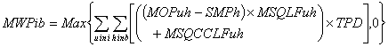

Where:
- MWPib is the Make Whole Payment for Interconnector User i in Billing Period b;
- MOPuh is the Market Offer Price of Interconnector Unit u in Trading Period h;
- SPh is the Shadow Price for Trading Period h
- SMPh is the System Marginal Price for Trading Period h;
- MSQLFuh is the Loss-Adjusted Market Schedule Quantity for Interconnector Unit u in Trading Period h;
- TPD is the Trading Period Duration;
- MSQCCLFuh is the Loss-Adjusted Market Schedule Quantity Cost Correction for Interconnector Unit u in Trading Period h;
- the summation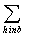 is over all Trading Periods h in Billing Period b;
- the summation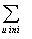 is over all Interconnector Units u for Interconnector User i.

$$\text{MWPib}=\text{Max}$$

- $\sum_{h \text{in} b}{}$
- $\sum_{u \text{in} i}{}$
- Glossary

Make Whole Payment | means a payment in respect of each Generator Unit and in respect of each Interconnector User, designed to make up any difference between the total Energy Payments for the Generator Unit in a Billing Period and the total of the Schedule Production Cost for that Generator Unit for each Trading Period within the Billing Period (where the difference is arithmetically positive calculated over the Billing Period) as set out in paragraph 4.140 or as otherwise specified in Section 5.

Modification Proposal Justification
(Clearly state the reason for the Modification)
A significant increase in SEM Make Whole Payments (MWPs) has been observed. The average total monthly MWP for the years 2011 and 2012 was under €14,000. However, beginning in April 2013 there has been a trend of increased Make Whole Payments with a monthly total of over €800,000 being observed in June 2014. Figure 1 gives the time-series of total monthly Make Whole Payments from 2011 to September 2014. Figure 2 gives the total Make Whole Payments for the first six months of the year for Interconnector Users (blue) and all other units (green). From this it can be seen that the increased Make Whole Payments are predominantly attributable to interconnector trading activity.

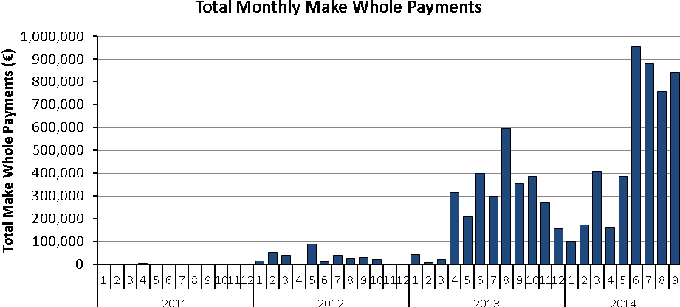
Figure 1: Time-series of Total Monthly Make Whole Payments from 2011 to September 2014
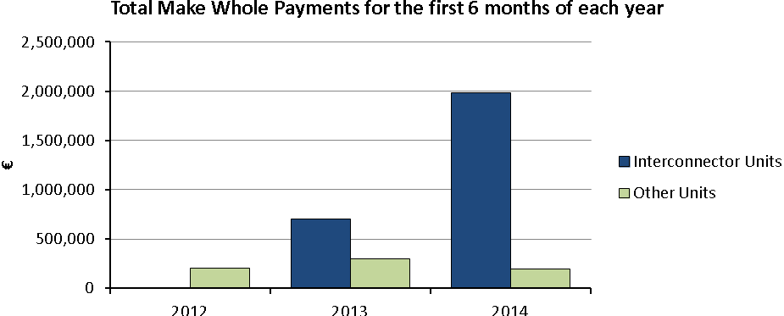
Figure 2: Total MWPs for Interconnector Users (blue) and all other units (green) for the first 6 months of the year

Make Whole Payments are included in the SEM design to account for the (foreseen to be rare) occasions when a generator’s Schedule Production Costs in any given Billing Week are not recovered through its total Energy Payments for the same period. For each Interconnector User Make Whole Payments are calculated separately for each gate window (EA1, EA2 and WD1). An Interconnector User trading in the different gates is assigned a different Interconnector Unit for each gate window it trades in. A Make Whole Payment is only made if the sum of MWP in the billing week is positive.
This means that an interconnector user could trade 100 MW of import in EA1 and 100 MW of export in EA2 resulting in a net flow of 0 MW. The EA2 unit could accrue a positive MWP that would be paid after the billing week so that this unit effectively trades at its bid price via the MWP mechanism. The EA1 unit could develop a negative MWP but this would not result in any payment to the market. Therefore; for a net flow of 0 MW, an Interconnector User could still receive a Make Whole Payment which results in export effectively charged at bid netted with import paid at SMP where SMP is greater than the export bid.

The proposer does not believe that the current situation in the Code should continue as it is now as it is resulting in a significant increase in Make Whole Payments which are paid by all suppliers through the Imperfections Charge. The proposer does not believe that the current situation in the Code is a necessary pre-requisite for efficient trading between SEM and BETTA and therefore does not believe that this will distort efficient cross border trade.

Where an interconnector user establishes a scheduled position by bidding long term rather then marginal costs and a differential between the energy payment to be received and the scheduled production cost is calculated. Then, where make whole payments are calculated on the aggregate basis across the three trading windows, the calculated differential could act as a barrier to the interconnector user reducing or reverse it’s established position in later trading gates by reducing the protection offered by the make whole payment mechanism.

There is an established trend in SEM whereby import bids are based on long term costs therefore to recognise this trend in the context of the proposed aggregation of the make whole payment calculation across the three trading windows, it is additional proposed that the scheduled production cost of imports for the proposes of the make whole payment calculation be calculated on the basis of the greater of the shadow price and unit’s market offer price in the respective trading period.

In this way, for imports, the differential between energy payment and scheduled product costs will be reduced to a marginal cost basis and the aggregation of make payment calculation across the three trading gates will not be erode interconnector user’s ability to utilise intra-day trading to modify their scheduled positions.

Code Objectives Furthered
(State the Code Objectives the Proposal furthers, see Section 1.3 of T&SC for Code Objectives)
- to ensure no undue discrimination between persons who are parties to the Code; and
- to promote the short-term and long-term interests of consumers of electricity on the island of Ireland with respect to price, quality, reliability, and security of supply of electricity.
Implication of not implementing the Modification Proposal
(State the possible outcomes should the Modification Proposal not be implemented)
If this Modification to the Code is not made the current situation with regards to Make Whole Payments will continue and may increase based on recent trends. This will continue to put upward pressure on the Imperfections Charge which is paid for by all suppliers and ultimately consumers.
Working Group  (State if Working Group considered necessary to develop proposal) |  |  | Impacts  (Indicate the impacts on systems, resources, processes and/or procedures)
The proposer does not consider this necessary. |  |  | SEMO has carried out an impact assessment which suggested that the estimated cost of implementing the proposed change detailed above in the SEM systems €61,030 based on 359 hours of chargeable time. However, this is based on the implementation being included in one of the periodic six monthly releases.
Please return this form to Secretariat by email to modifications@sem-o.com

Notes on completing Modification Proposal Form:

- If a person submits a Modification Proposal on behalf of another person, that person who proposes the material of the change should be identified on the Modification Proposal Form as the Modification Proposal Originator.
- Any person raising a Modification Proposal shall ensure that their proposal is clear and substantiated with the appropriate detail including the way in which it furthers the Code Objectives to enable it to be fully considered by the Modifications Committee.
- Each Modification Proposal will include a draft text of the proposed Modification to the Code unless, if raising a Provisional Modification Proposal whereby legal drafting text is not imperative.
- For the purposes of this Modification Proposal Form, the following terms shall have the following meanings:

Agreed Procedure(s): means the detailed procedures to be followed by Parties in performing their obligations and functions under the Code as listed in Appendix D “List of Agreed Procedures”.
T&SC / Code: means the Trading and Settlement Code for the Single Electricity Market
Modification Proposal: means the proposal to modify the Code as set out in the attached form
Derivative Work: means any text or work which incorporates or contains all or part of the Modification Proposal or any adaptation, abridgement, expansion or other modification of the Modification Proposal

The terms “Market Operator”, “Modifications Committee” and “Regulatory Authorities” shall have the meanings assigned to those terms in the Code.

In consideration for the right to submit, and have the Modification Proposal assessed in accordance with the terms of Section 2 of the Code (and Agreed Procedure 12), which I have read and understand, I agree as follows:

1. I hereby grant a worldwide, perpetual, royalty-free, non-exclusive licence:

  - to the Market Operator and the Regulatory Authorities to publish and/or distribute the Modification Proposal for free and unrestricted access;

  - to the Regulatory Authorities, the Modifications Committee and each member of the Modifications Committee to amend, adapt, combine, abridge, expand or otherwise modify the Modification Proposal at their sole discretion for the purpose of developing the Modification Proposal in accordance with the Code;

  - to the Market Operator and the Regulatory Authorities to incorporate the Modification Proposal into the Code;

1.4 to all Parties to the Code and the Regulatory Authorities to use, reproduce and distribute the Modification Proposal, whether as part of the Code or otherwise, for any purpose arising out of or in connection with the Code.

2. The licences set out in clause 1 shall equally apply to any Derivative Works.

3. I hereby waive in favour of the Parties to the Code and the Regulatory Authorities any and all moral rights I may have arising out of or in connection with the Modification Proposal or any Derivative Works.

4. I hereby warrant that, except where expressly indicated otherwise, I am the owner of the copyright and any other intellectual property and proprietary rights in the Modification Proposal and, where not the owner, I have the requisite permissions to grant the rights set out in this form.

5. I hereby acknowledge that the Modification Proposal may be rejected by the Modifications Committee and/or the Regulatory Authorities and that there is no guarantee that my Modification Proposal will be incorporated into the Code.

All monthly totals presented in this document refer to payments in invoices issued in that particular month

