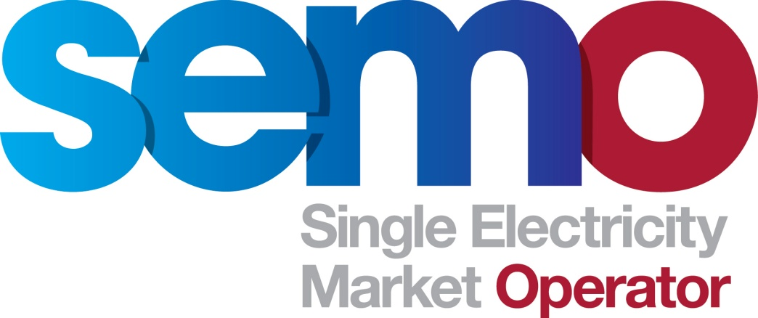

Single Electricity Market

Final REcommendation Report

Mod_10_14: make whole payments for interconnector units

27 march 2015

COPYRIGHT NOTICE
All rights reserved. This entire publication is subject to the laws of copyright. This publication may not be reproduced or transmitted in any form or by any means, electronic or manual, including photocopying without the prior written permission of EirGrid plc and SONI Limited.

DOCUMENT DISCLAIMER
Every care and precaution is taken to ensure the accuracy of the information provided herein but such information is provided without warranties express, implied or otherwise howsoever arising and EirGrid plc and SONI Limited to the fullest extent permitted by law shall not be liable for any inaccuracies, errors, omissions or misleading information contained herein.
Document History
Version | Date | Author | Comment
1.0 | 12 March 2015 | Modifications Committee Secretariat | Issued to Modifications Committee for review and approval
2.0 | 23 March 2015 | Modifications Committee Secretariat | Issued to Regulatory Authorities for final decision
3.0 | 27 March 2015 | Modifications Committee Secretariat | Updated version issued to Regulatory Authorities for final decision

Reference Documents
Document Name
Trading and Settlement Code
Mod_10_14 Make Whole Payments for ICUs
Meeting 58 Electroroute Slides
MWP Feedback and Responses
Electroroute Response to SEM C Letter
Participant Feedback on MWP and Proposals
Meeting 59 SEMO Slides
SEM C Response Letter to Electroroute
Electroroute Explanatory Note

Table of Contents
1. MODIFICATIONS COMMITTEE RECOMMENDATION 3
Recommended for rejection – unanimous Vote 3
2. Background 3
3. PURPOSE OF PROPOSED MODIFICATION 3
3A.) justification of Modification 3
3B.) Impact of not Implementing a Solution 3
3c.) Impact on Code Objectives 4
3. Working Group and/or Consultation 4
4. impact on systems and resources 4
5. Impact on other Codes/Documents 4
6. MODIFICATION COMMITTEE VIEWS 4
Meeting 58 – 3 december 2014 4
Meeting 59 – 12 february 2015 6
7. Proposed Legal Drafting 8
8. LEGAL REVIEW 8
9. IMPLEMENTATION TIMESCALE 8
Appendix 1: Mod_10_14 make whole payments for interconnector units 9

MODIFICATIONS COMMITTEE RECOMMENDATION

Recommended for rejection – unanimous Vote

Recommended for Rejection by Unanimous Vote
Áine Dorran | Generator Member | Rejected
Brian Mongan | Generator Member | Rejected
Connor Powell | Supplier Member | Rejected
Kevin Hannafin-Chair | Generator Member | Rejected
Mary Doorly | Generator Member | Rejected
Patrick Liddy | DSU Member | Rejected
William Carr | Supplier Member | Rejected
William Steele | Supplier Member | Rejected

Background
This Modification Proposal was raised by the RAs and was received by the Secretariat on 14 November 2014. The purpose of this Modification Proposal is to amend the Code so that Interconnector Units no longer receive Make Whole Payments in the market.
The Modification Proposal was discussed at Meeting 58 on 04 December 2014 and at Meeting 59 on 12 February 2015 where it was voted on.

PURPOSE OF PROPOSED MODIFICATION

3A.) justification of Modification
A significant increase in SEM Make Whole Payments (MWPs) has been observed. The average total monthly MWP for the years 2011 and 2012 was under €14,000. However, beginning in April 2013 there has been a trend of increased Make Whole Payments with a monthly total of over €800,000 being observed in June 2014. Figure 1 gives the time-series of total monthly Make Whole Payments from 2011 to September 2014. Figure 2 gives the total Make Whole Payments for the first six months of the year for Interconnector Users (blue) and all other units (green). From this it can be seen that the increased Make Whole Payments are predominantly attributable to interconnector trading activity.

3B.) Impact of not Implementing a Solution
If this Modification to the Code is not made the current situation with regards to Make Whole Payments will continue and may increase based on recent trends. This will continue to put upward pressure on the Imperfections Charge which is paid for by all suppliers and ultimately consumers.

3c.) Impact on Code Objectives
This modification aims to further Code Objective:
- to ensure no undue discrimination between persons who are parties to the Code; and
- to promote the short-term and long-term interests of consumers of electricity on the island of Ireland with respect to price, quality, reliability, and security of supply of electricity.

- Assessment of Alternatives
N/A

Working Group and/or Consultation
N/A

Working Group and/or Consultation
N/A

impact on systems and resources
The vendor has confirmed this proposal would cost €20,060.

Impact on other Codes/Documents
N/A

MODIFICATION COMMITTEE VIEWS

Meeting 58 – 3 december 2014
RA Member advised that more than 90% of Exports did not happen further advising that an IC unit can bid whatever they choose as this is not enshrined anywhere within the Code. Electroroute representative expressed the view that in terms of bidding to flow, IC activity has evolved that way over the duration of the market. Proposer further advised that Electroroute are not comfortable effectively hampering “free movement of goods between borders” as specified in Directive 2006/123/EC of the European Parliament and of the Council of 12 December 2006 on services in the internal market. Electroroute mentioned that they had started an internal legal review which supported this view. MO Member asked if this legal analysis could be shared with the Committee. The Electroroute replied that they are not ready to disclose this at this point.
MO Alternate reiterated RA view that Interconnector Users are not prohibited from representing costs within their bids and that it is Electroroute’s commercial decision to bid that way and ICs are not bound by the BCOP as traditional GUs are.
Observer questioned whether Interconnector bids, which currently seem not to reflect price differential between adjacent regions, would have a detrimental impact on the price coupling and efficient export flows. Observer expressed concern around the introduction of a market imbalance and of the impact on constraints if pay/paid as bid was introduced. Electroroute representative advised that constraints could happen but that it should not be viewed as a significant risk.
DSU Member stated that as over 90% of exports traded did not actually happen, were the dispatchers incorrect to have sold the power in the first instance. Electroroute representative expressed the view that they were not illegitimate trades and that this type of trading is frequently seen on the continent.
DSU member also asked if this indicated a flaw within the scheduling software. Observer advised that the market solver optimises Schedule Production Costs based on the bids submitted, and that MWPs are not visible to and are therefore not considered by the Pricing and Scheduling software. Generator Member expressed the view that there appears to be a discrepancy between export bids and SMP.In order for flows in both directions to be scheduled, the import bid would have to be less than Shadow Price and the export bid would have to be greater than Shadow Price..
Observer elaborated that trading with an import bid which is less than an export bid in a given period appeared counter-intuitive. This appears to indicate an intention to sell/import to the SEM at a lower price and buy/export from the SEM at a relatively higher price. This bidding approach appeared to be loss making when considered in isolation from the Make Whole Payment mechanism. Generator Member drew reference to Mod_ 09_14 Amendment to MWPs for IC Units stating that the user would be made whole and that the proposed aggregation of IC Users across all gate windows is not discriminatory if it brings IC Users in line with other GUs. Electroroute representative advised that in their view, ICs would not be aligned with GUs because they bid to flow and their import trading is overstated in the Make Whole Payment aggregation.
Observer reiterated previous point that the bid is at the ICs discretion whereas GUs must bid based on the requirement of the BCOP. Electroroute representative drew reference again to the potential hampering of cross border trading. Observer said that where the link between costs of adjacent markets and bidding behaviours is lost, then the price coupling effect may also be diminished.
Observer stated that opportunity for exports based on price spread between the two markets, are expected to be concentrated at night time, which limits the exposure to Uplift. This is because Uplift is higher during evening peak time. Currently exports are observed across the entire day, which appears contrary to the concept of efficient cross border flow and the social welfare gains it is intended to bring. Observer expressed the view that in their own analysis Exports without Make Whole Payments are possible. For a specific period, ElectroRoute accounted for only 40% of the Exports but 100% of the MWPs and emphasised that other exporters were not relying on the MWPs to recover costs. Observer expressed the view that it should be possible for Electroroute to continue to export without relying on MWPs. Electroroute representative expressed concern that there is a fundamental disjoint in the market and that there is a lack of clarity from the original design. Observer sought clarifications from Electroroute in relation to whether the problem is regarding different price signals resulting in netted import and export settling at different rates or Interconnector Users receiving make whole payments whenever already whole or better in aggregate across gate windows.
Electroroute representative advised that the issue is around the prices applied by the dispatcher. Observer reiterated concern that both the pay/paid as bid and removal of netted trading periods approaches could keep the Uplift exposure with the consumer as opposed to the trader who chose to make the trade and has control over the bids that govern it..
MO Alternate expressed the view that aggregating across the 3 gates may be a more appropriate course of action as Interconnector Units for individual Gates were only designed as a mechanism to implement IDT requirements. They also noted that prior to IDT it was not possible isolate trading periods with a positive contribution to MWP from those with a negative contribution to MWP. MO alternate added that there wasn’t an intention to introduce this scenario, but rather that this was a practicality of implementing IDT.
MO alternate stated their belief that the equivalent of a generator unit is an Interconnector User, not the Interconnector Unit. Electroroute representative expressed the view that in that case the trader would be liable to significant uncompensated risks. Observer reiterated that these would not be uncompensated, but they would be compensated only when necessary, due to not being whole in aggregate in relation to their bids, in line with all other Generator Units.
Electroroute representative advised that before IDT there was no export trading as there was only 1 trading window.
MO Alternate advised that removing periods of simultaneous Import/Export is against the principle of super positioning which was introduced into the IDT detailed design at the request of IC traders.
Removing those periods from the Make Whole Payment aggregation will create scenarios where trading periods with large import and minimal Export would be excluded and vice versa. This means that periods where MWP should apply are excluded from the recovery and the trader is exposed to Uplift. Vice versa, periods where the Interconnector Unit has already been made whole would not be considered in the MWP calculation, therefore resulting in an over recovery. This is different from other generator units and seems at odds with the proposer intention for the mod.

MO Alternate provided the IA results that had been procured by SEMO IT at the request of the Committee at the previous Modifications Committee Meeting:
- Mod_09_14 Amendment to MWPs for ICUs: Cost for the first proposal in isolation: €61,030
- Mod_10_14: Assessment for the change against the current Production system €20,060 hours
- Assessment for the change against the amended functionality (i.e. should the calculation amendment option be considered first and the removal after). €20,910 – (this would be in addition to the above estimate of €61,030 for Mod_09_14)
Discussion ensued in relation to whether a vote taking place in January would delay implementation of whichever proposal was approved. The Committee did not feel comfortable to vote on any of the four MWP proposals at the Meeting and requested further information on the proposals from the RAs and Electroroute.
Generator Member expressed the view to see the impact of the proposals in relation to whether exports could continue impact of curtailment of wind generation and further explanation of social welfare analysis presented by Electroroute. Generator Member expressed the need to see further RA analysis as to whether all of the MWPs are associated with exporting. Chair concluded the discussion advising that the issue must be urgently addressed and that more information on all of the proposals is necessary, prior to scheduling an extraordinary meeting/call with Participants in mid-January.

Meeting 59 – 12 february 2015
A number of members and observers expressed concern at the lack of detailed response from the RAs. RA Member advised that they have provided their rationale for the proposals and these are now within the domain of the Modifications Committee. It is up to the Committee to deliberate the issues and decide how best to proceed. RA Member welcomed Committee views on what the RAs could have done differently when submitting their two proposals on MWPs.
IC representative proposer expressed the view that there is a need for a higher level of engagement in the discussion from the RAs as proposer. Supplier Member expressed the view that what the RAs have done when raising the proposals is absolutely correct, however expressed the view of the necessity for the RAs to engage in the discussion as proposer of 2 of the MWP proposals. RA Member advised that some of the questions posed were fundamental market design issues, and that these concerns are best addressed by the Modifications Committee.
MO Member delivered a presentation covering the mechanism of Make Whole Payments (MWPs) in the SEM. This presentation covered the rationale behind the payment and also provided Market Operator comments regarding the four relevant modifications. MO Member advised that for the purposes of the Code, MWPs was intended to be an occasional payment in the exceptional circumstances where costs are not recovered, through energy payments and uplift. Units with Negative schedules, such as Pumped Storage or IC units exporting, are instead exposed to Uplift and they might not recover their costs; however the IC users is considered equivalent to a Generator Unit not the individual IC Gate Unit. Gate Units were created to respond to the IDT design need to firm schedule amount for IC in each Gate. MO Member further advised that the MWP amounts that are paid out on a weekly basis, are then recovered through the imperfections charge and provided examples of current payments for sample units. Questions were taken throughout and after the presentation addressing the various positions regarding these modifications with a separate afternoon session to continue the discussion.
Chair asked whether increases in MWP were due to IDT. MO member showed in the graph that the increase was not a direct consequence of IDT because it happened nearly one year after IDT went live. Chair suggested that this time lag does not necessarily rule out IDT as an explanatory factor. MO Member also explained the unusual nature of the highest payments all referring to the Ex-Ante 2 Gate of the same Party; MWP were not intended to be a regular payment stream.
MO alternate said that large increase of MWP seemed to coincide with increase in netting import and export volumes at different Gates. Observer replied this was due to the growth in the company.
DSU Member queried as to where constraint payments fit into the MWP mechanism. MO Member advised that constraints do not fit in to the MWP mechanism and that just the energy payments are taken in consideration.
Generator Member sought clarification in relation to unlimited exports of IC Users due to super positioning introduced by IDT, querying as to whether IC Users are limited as to the amount an IC User can import and export. MO Member advised that as long as there is enough capacity on the opposite side, IC Users are not limited by IC capacity due to super positioning.
IC representative proposer drew attention to disjointed price signals within the SEM and the significant ex-post price risk IC Units face when exporting however expressed agreement that there is an issue that needs to be addressed. MO Alternate drew attention to the issue of IC User’s bids import bids being lower than export bids. MO Member advised that other exporters on EWIC do that without the need for MWPs. GU member said that they were the 2nd largest exporter on IC and they did not get MWP. IC representative proposer expressed the view that it is the nature of the self-dispatch versus central dispatch aspect of the market and they would welcome a debate on this.
Discussion ensued in relation to netting volumes, IC representative proposer explained that the import would be paid SMP and the export paid via MWPs at a different lower rate, and that does amount to a difference in payments. MO member advised that this did not affected recovery of costs; netting would still allow MWP where necessary as demonstrated in the presentation graphs. Discussions continued on the nature of costs to be recovered via Uplift that are specific to standard Generator and whether IC Users should rely on MWP or they should find ways of edging their risks differently. Observer questioned whether Suppliers should be getting MWP as well given that IC users act as a Supplier when exporting.
In conclusion of the morning session the Committee rejected proposals MOD_10_14 Removal of MWPs for IC Units and MOD_11_14 Pay as bid/Paid as bid for IC Units on the basis that neither were considered viable solutions to the issue identified, leaving two remaining modifications for further discussion following the break, Mod_09_14 and Mod_12_14.
Chair drew reference to the issue of discrimination that had previously been raised by ElectroRoute, advising that as stated in the SEMO MWP slides, APTG, VPTG and PPTG’s do not receive MWPs and observer mentioned that it is common to have different rules for different unit types.
On the recommendation of the Chair, the afternoon session aimed to discuss the different variants between the two remaining modifications. Chair queried as to whether SEMO had a preference between the 2 proposals that remain open for discussion. MO Member expressed the view that it is up to the Committee to decide on the most suitable approach and the MO can facilitate any of the proposed MODs. IC representative proposer expressed IC representative proposer preference for Mod_12_14.

Supplier Member drew attention to the urgency of the necessity to address the issue. Chair agreed and expressed the view that the Committee have recognised the urgency. IC representative proposer advised that they welcome the debate and are of the view of a need for an appropriate forum with input from the RAs to be established for the relevant parties to deliberate the fundamental issues. Generator Member expressed the view that a Working Group would not be beneficial as there would be no additional information for this specific issue and that an Extraordinary meeting would be a more appropriate forum. Further advised that the SEMO presentation was very useful in assisting in understanding the background to MWPs. The Committee were in agreement that a WG would not be beneficial and agreed to convene an Extraordinary Meeting.

Supplier Member proposed suggestion of taking the shadow price instead of Market Offer Price in addition to the aggregation proposed in MOD_09_14 which may address IC Users concerns. Generator Member drew attention to potential amendments to Mod_12_14 on a trading period basis.
Chair requested inputs and comments from other IC users. Observer said that they were satisfied that MOD_10_09 had been rejected and that they would agree with either of the remaining options.
MO Alternate advised that the issue is that, removing TPs of simultaneous Import and Export, could carry an under or over-recovery that is then disregarded. Observer agreed with MO alternate that MOD_12_14 would undo IDT by limiting freedom of trades between Gates.
Observer advised that the trading of exports on the IC is a separate issue. Observer acknowledged that there are flaws within the SEM.
Following this discussion it was agreed by the Committee that the appropriate next steps would be to allow two weeks to develop the proposed alternative version of MOD_09_14 by Supply Member and a potential new version of Mod_12_14 by the proposer encompassing the suggestions discussed during the meeting. Both proposers have agreed to engage with SEMO in order to progress an Impact Assessment of the revised Mods and to discuss potential consequences of the changes. Before the next meeting an Extraordinary meeting will also be held to discuss the modifications with a view to progressing this issue. Actions are recorded under the respective Modification Proposals.

Proposed Legal Drafting
As set out in Appendix 1below.

LEGAL REVIEW
Complete

IMPLEMENTATION TIMESCALE
It is proposed that this Modification is not implemented as the Modifications Committee have Recommended it for Rejection.

Appendix 1: Mod_10_14 make whole payments for interconnector units
MODIFICATION PROPOSAL FORM

Proposer | Date of receipt |  | Type of Proposal |  | Modification Proposal ID
Regulatory Authorities | 14 November 2014 |  | Standard |  | Mod_10_14
Contact Details for Modification Proposal Originator
Name |  | Telephone number |  | Email address
Warren Deacon  Brian Mulhern |  | +353 1 4000800  +44 (0) 28 9031 1575 |  | wdeacon@cer.ie  Brian.Mulhern@uregni.gov.uk
Modification Proposal Title
Make Whole Payments for Interconnector Units
Documents affected |  | Section(s) Affected |  | Version number of T&SC or AP used in Drafting
T&SC |  | Section 4 |  | Version 15
Explanation of Proposed Change
(mandatory by originator)
The purpose of this Modification Proposal is to amend the Code so that Interconnector Units no longer receive Make Whole Payments in the market.
Legal Drafting Change
(Clearly show proposed code change using tracked changes, if proposer fails to identify changes, please indicate best estimate of potential changes)
5.38A Participants shall not receive Make Whole Payments in respect of their Interconnector Units.

Modification Proposal Justification
(Clearly state the reason for the Modification)
A significant increase in SEM Make Whole Payments (MWPs) has been observed. The average total monthly MWP for the years 2011 and 2012 was under €14,000. However, beginning in April 2013 there has been a trend of increased Make Whole Payments with a monthly total of over €800,000 being observed in June 2014. Figure 1 gives the time-series of total monthly Make Whole Payments from 2011 to September 2014. Figure 2 gives the total Make Whole Payments for the first six months of the year for Interconnector Users (blue) and all other units (green). From this it can be seen that the increased Make Whole Payments are predominantly attributable to interconnector trading activity.
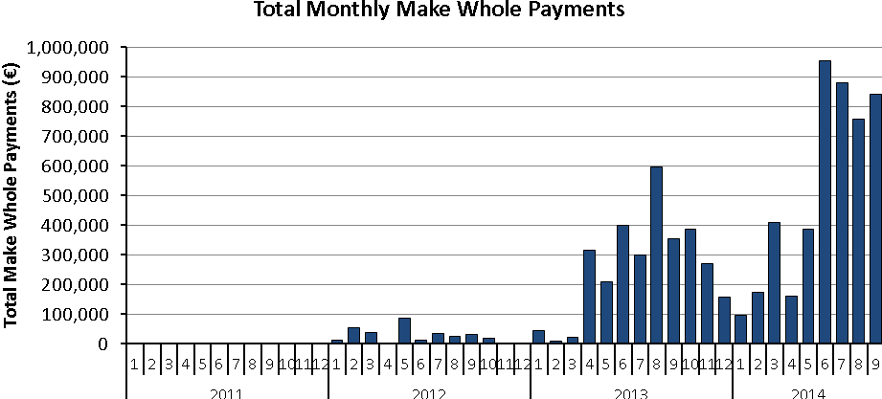
Figure 1: Time-series of Total Monthly Make Whole Payments from 2011 to September 2014
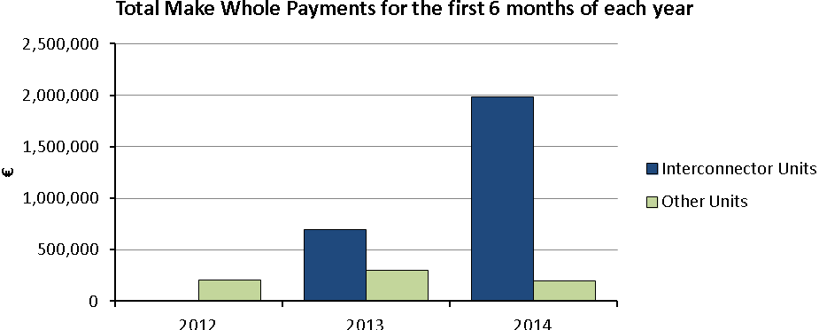
Figure 2: Total MWPs for Interconnector Users (blue) and all other units (green) for the first 6 months of the year
Make Whole Payments are included in the SEM design to account for the (expected to be rare) occasions when a generator’s Schedule Production Costs in any given Billing Week are not recovered through its total Energy Payments for the same period.

The Regulatory authorities have monitored the pattern of Make Whole Payments and are of the view that the levels currently being paid out should not continue. In light of this the Regulatory Authorities have raised a Modification Proposal to aggregate Make Whole Payments across an Interconnector User’s EA1, EA2 and WD1 Positions.

However, the Regulatory Authorities are also raising this Modification Proposal which would see a cessation of of Make Whole Payments for interconnector units. This Modification Proposal as an alternative to the other one raised (Amendment to Make Whole Payments for Interconnector Units). The reason for raising this Modification Proposal relates to potential concern around the effectiveness of raising the first Proposal (Amendment to Make Whole Payments for Interconnector Units).

The Regulatory Authorities are raising the two Modification Proposals to allow the Committee consider both versions and decide on what the best course of action is and to make their recommendation to the SEM Committee.

Code Objectives Furthered
(State the Code Objectives the Proposal furthers, see Section 1.3 of T&SC for Code Objectives)
- to ensure no undue discrimination between persons who are parties to the Code; and
- to promote the short-term and long-term interests of consumers of electricity on the island of Ireland with respect to price, quality, reliability, and security of supply of electricity.
Implication of not implementing the Modification Proposal
(State the possible outcomes should the Modification Proposal not be implemented)
If this Modification to the Code is not made the current situation with regards to Make Whole Payments will continue and may increase based on recent trends. This will continue to put upward pressure on the Imperfections Charge which is paid for by all suppliers and ultimately consumers.
Working Group  (State if Working Group considered necessary to develop proposal) |  |  | Impacts  (Indicate the impacts on systems, resources, processes and/or procedures)
The proposer does not consider this necessary. |  |  | An impact assessment will be required.
Please return this form to Secretariat by email to modifications@sem-o.com

All monthly totals presented in this document refer to payments in invoices issued in that particular month

