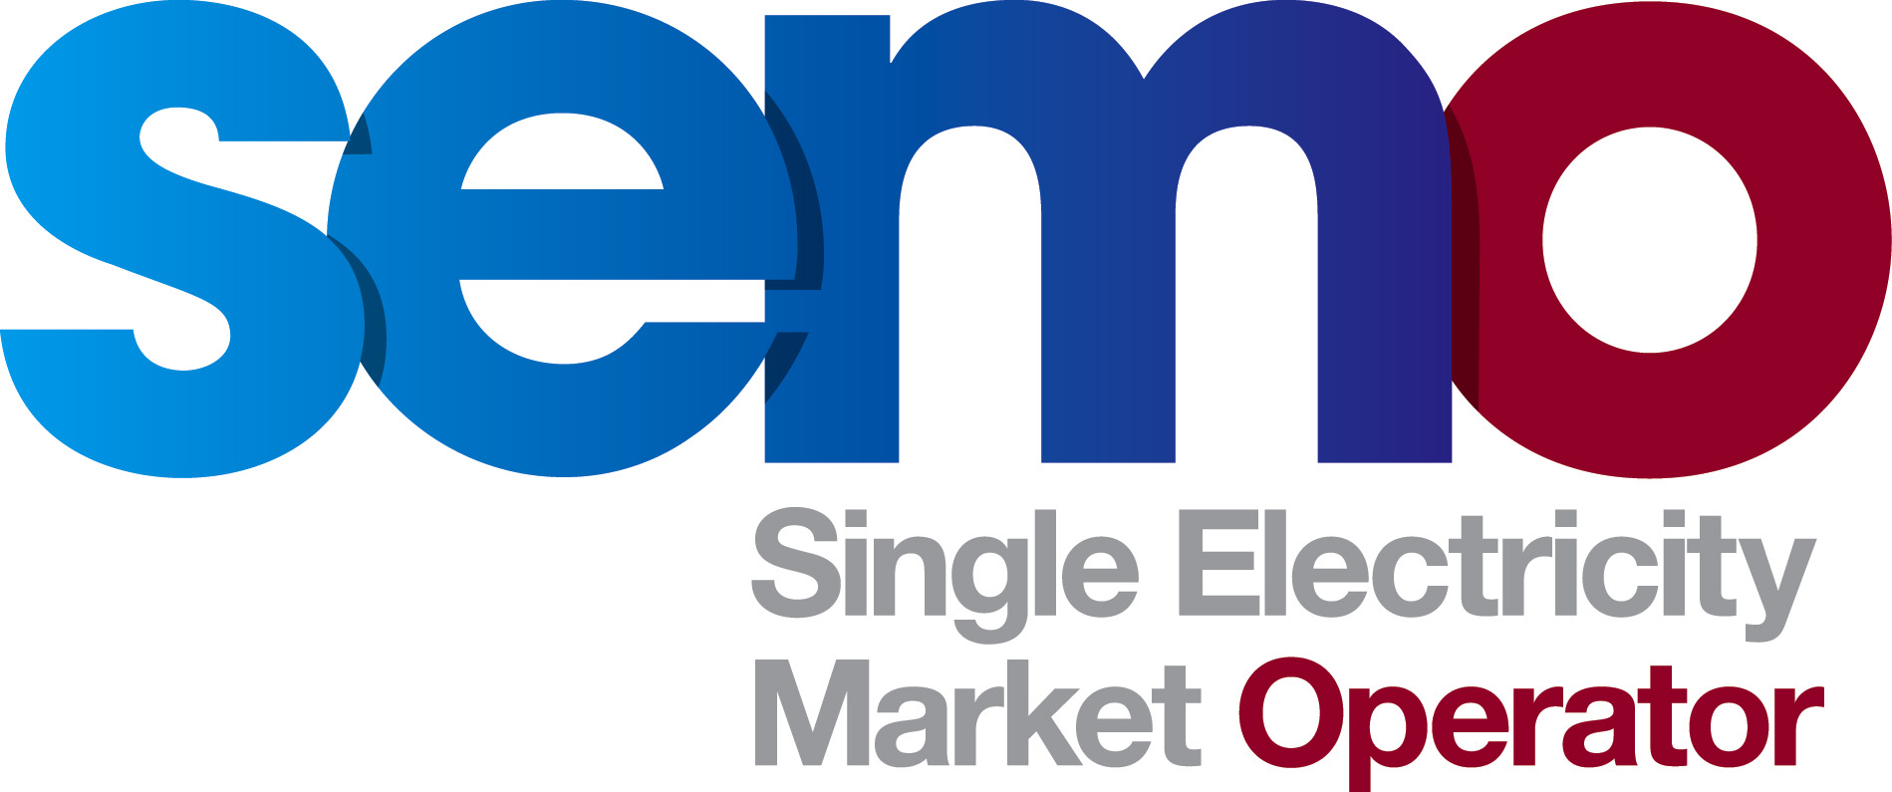
08 January 2014
Agreed Procedure Notification
Mod_14_13: Update of reference to the SEM Bank in AP17

Modifications Committee Meeting 52 Minutes
MO Member outlined proposal advising that as Northern Bank and National Irish Bank have been fully rebranded as Danske Bank since November 2012, the modification proposes removal of any references to these banks from AP17. MO Member advised that his modification proposal would not impact on any other areas of the Market Rules and Participants will not be affected by the change. The proposal was Recommended for Approval subject to legal drafting.

Notification
As per Section 2.223 of the T&SC, the Modifications Committee wish to notify the RAs of the effective date for Agreed Procedure Mod_14_13 Update of reference to the SEM Bank in AP17, to be Friday 10th January 2014.

Legal Drafting

As set out in Mod_14_13 Update of reference to the SEM Bank in AP17.

