

Trading & Settlement Code

Modifications Committee

Final Recommendation Report

for Mod_38_08
Definition of Data Verification Period

Version 2.0

14th January 2009

- Background

This Modification Proposal was raised by the TSO Day 1+ project on 13th August 2008 and presented at Meeting No: 16, on 30 September 2008. It was Recommended for Approval by unanimous vote at this Meeting.

- Purpose of Proposed Modification

The Modification is required because of the fact that:
- queries to Settlement Data can only happen during the Data Verification Period
- Data Verification process is the only mechanism, outside a dispute, for Participants to query or reopen market prices

Data Verification period duration commences (6.48.2) ‘at the time of issue of the Ex-Post Indicative Settlement Statements and ends at 17:00 on Settlement Day + 4WD’

Current Timing of Data Verification Period Start for Trading Day ≠Friday (See Figure 1)

The Data Verification Period start is currently linked to issue of the Ex-Post Indicative Settlement Statements, which occurs on Settlement Day+1 WD. This timeline is acceptable for a trading day that is not Friday or Saturday; there is no issue in this scenario because:

- Ex Ante Indicative MSP Software Run takes place on TD-1
- Data publication of inputs to the Ex Ante Indicative MSP Software Run, the Run of Ex Post Indicative SMP and MSQ’s occurs on TD+1 and the issue of the Ex-Post Indicative Settlement Statements (on SD+1) all happens on the same day (Friday) therefore Participants can launch a query on that data on the same day. In other words, there is no delay in the start of the Data Verification Period; the MO and SO can aim to get query addressed before the Ex Post Initial Run.

Figure 1 The Current Timing of Data Verification Period Start for Trading Day ≠ Friday

Figure 2 Current Timing of Data Verification Period Start for Trading Day = Friday/ Saturday
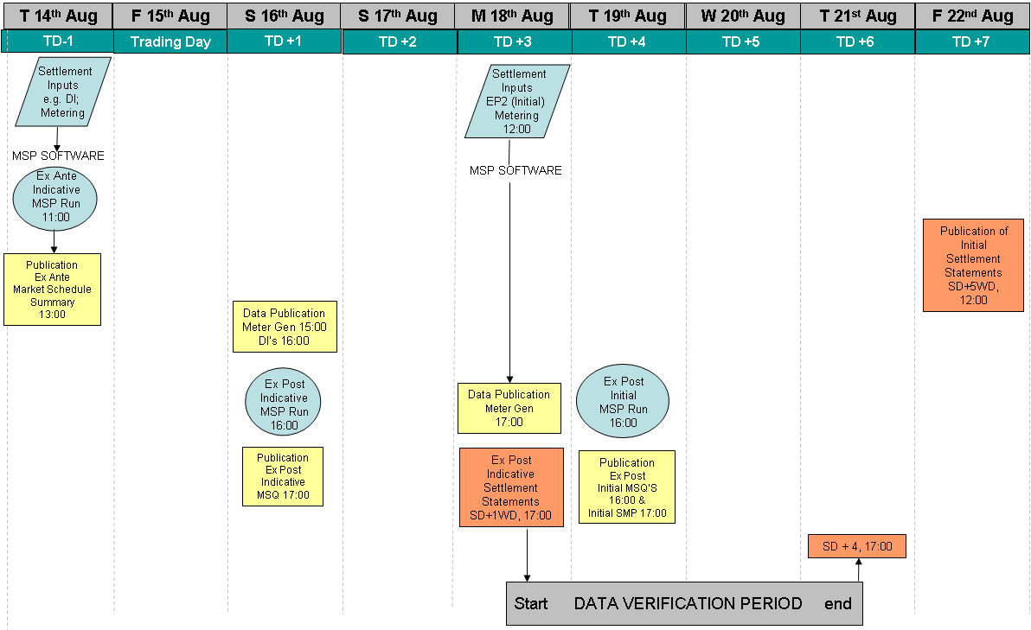

There is an issue with the Weekend scenario because (for a Friday Example):

Currently, the start of the Data Verification Period aligns with the publication of the Indicative Settlement Statement, due 1 Working Day after the Trading Day by 17:00. Due to the fact that data for calculating SMP (prices) and MSQ (schedules) is delivered on a Calendar Day (i.e. 7 day) basis, the rules mean that the Data Verification Period can only start on the next Working Day which is Monday (the day the Ex-Post Indicative Settlement Statements are issued).

KEY PROBLEM
- Participants may have enough data available on issue of Ex-Post Indicative MSQ at 17:00 D+1 to commence the query process. Now, there is a loss of two days in which potential data queries can be submitted and resolved;
- If the Trading Day is a Friday, by the time the query is raised, the data to be used to calculate the Ex Post Initial Run of MSP has been loaded into the system; therefore, it is too late to resolve the query before the Ex Post Initial Run (the query raised would be on the earlier dataset)
- The Data Verification Period can only start on the next Working Day which is Monday (the day the Ex-Post Indicative Settlement Statements are issued)
- 3 days remain for resolution of the query

Figure 3 Proposed Timing of Data Verification Period Start

The proposal is to change the trigger for the start of Data Verification Period, from the issue of the Ex-Post Indicative Settlement Statements to the issue of the Ex Post Indicative MSQ, which occurs on TD+1 (published at 1700) .

This means, on all days, if the data is subsequently proved to require amendment, the data can be adjusted before the Ex Post Initial run.

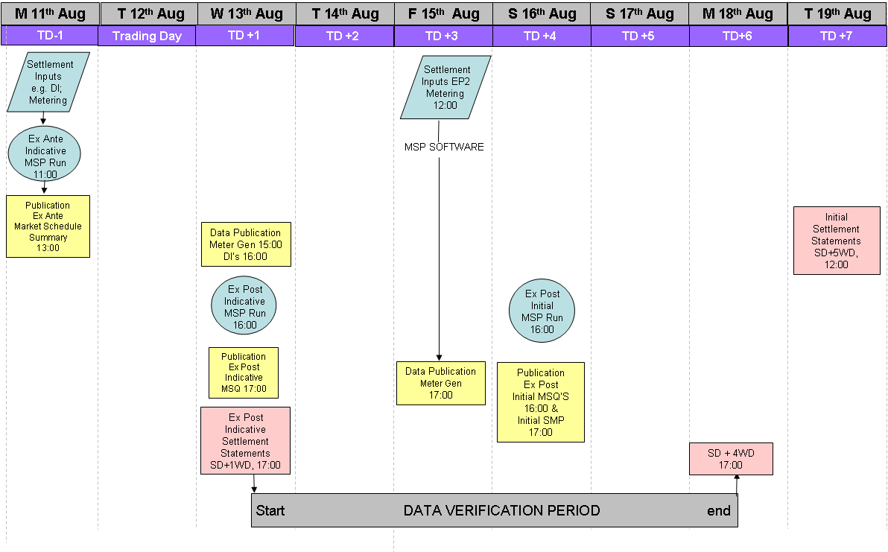

2a. Justification for Modification (from Original Modification Proposal Form)
  - This Modification will facilitate the achievement of the objectives 1.3.2 which aims to ‘facilitate the efficient, economic and coordinated operation, administration and development of the Single Electricity Market in a financially secure manner’;
The MO are required to ensure that the market quantities and prices are set, using the most accurate possible data set.

Participants queries should be allowed to be initiated as early as possible in the process. Initiating and clarifying data issues or resolving data queries should be performed in a timely manner, this contributes to accurate pricing and settlement being bedded down early and fewer Settlement reruns; leading to a more efficient market operation. From an SO perspective, it is desirable to address any data issues as early as possible.

2b. Impact of not implementing a solution

At the moment, the inevitable result of the current process occurring in Example 2 above is late identification and resolution of errors, for Friday Trading Days. Incurring unnecessary delays and costs in query resolution does not facilitate efficient or economic operation/administration of the SEM.

- Development Process

The Modification was proposed by TSO following discussions with the Market Operator. The Market Operator had observed instances whereby the current situation as regards Data Verification Period, and Participants were prevented from launching queries at weekends. The most effective route for resolution of this issue was determined to be the attached Modification Proposal.

- Assessment of Alternatives
No alternatives were considered.

- Consultation
This Modification was not subject to a consultation.

- Implementation Timescale, Costs and Resources

The proposed Implementation date is on the second Working Day after the day on which the RA Decision is made. It is proposed that this Modification is made on a Settlement Day basis. There are no system implications.

- Impact on Code Objectives

The Modification is required because of the fact that:
- queries to Settlement Data can only happen during the Data Verification Period
- Data Verification process is the only mechanism, outside a dispute, for Participants to query or reopen market prices

Benefits of the Proposal for:
a. Participants
- it allows for ‘early’ querying to occur over weekend if queries arise for example on Saturday they can be submitted on Saturday, and the same for Sunday.
b. SEM-O
- it would ensure queries are raised in a timely manner, before the Ex Post Initial data is loaded, before Ex Post Initial SMP is determined,
- would minimise/avoid Initial Settlement Re-runs
c. System Operators
- Issues or questions about data would be identified and dealt with as early as possible in the process
d. The Market
- any errors in data would be identified and resolved as early as possible over a weekend
- minimise and/or avoids re-runs of Initial Settlement and minimises necessity for disputes

Therefore the objectives that are fulfilled by this Modification are seen to be
- Greater Efficiency in Administration
- More Co-ordinated Operation
i.e. objectives 1.3.2 which aims to ‘facilitate the efficient, economic and coordinated operation, administration and development of the Single Electricity Market in a financially secure manner’;

- Impact on other Codes/Documents

The ‘Data Queries’ form which Participants use to submit queries is impacted, as outlined in the Proposed Modification. The updated form will need to be published by SEM-O and used by Participants.

- Modifications Committee views

This Modification was discussed at Meeting 16 of the Modifications Committee on Sep 30th 2008. The Committee were of the view that Participant queries should be allowed to be initiated as early as possible in the process. From an SO perspective it is desirable to address any data issues as early as possible.
The Committee felt that the Modification objectives were addressed.

The Minutes of Meeting 16 record the view from Alternate Member of BGE, who requested a new unique reference on the Query form; MD to follow up with MO and revise as necessary.

This was suggested to the Market Operator and the view that was expressed by the Market Operator was that the current form was adequate, they provided the clarification that the reference which should be used for a Settlement Query is ‘Settlement Statement reference’ and the reference which should be used for a Data Query is the Date of the Query in the format dd/mm/yyyy.

This Modification was ‘Recommended for Approval’ by the Modifications Committee Unanimously with a vote as follows:
T Gill, S Walsh, M Hayden, M Walsh, W Steele, E Chukwureh

Please see Section 6 for Implementation timescale.

- Proposed Legal Drafting
[Change-marked drafting for the relevant parts of the Code for the proposal that the Committee is recommending i.e. not necessarily that originally proposed OR the Alternative/Combined Proposal]

Note: There was a drafting error in the original Proposal whereby reference to ‘Issue of Ex-Post Indicative Market Schedule and indicative ex-post values for System Marginal Price’ should read ‘Issue of Ex-Post Indicative Market Schedule Quantities’ (published at 1700). The 2nd clause should be removed as the indicative ex-post values for System Marginal Price are published 1 hour earlier at 16:00 so the statement did not make sense as drafted.

It was then noted that the Alternative or Combined Proposal contained a definition not contained in the Glossary, i.e., the definition ‘Ex-Post Indicative Market Schedule Quantities’. Therefore the final legal drafting seeks to rectify both the original and the alternative proposal. It does not change the principle purpose of this Modification in any way but merely corrects a drafting error.

Trading and Settlement Code
Invoices, Self Billing Invoices and Debit Notes
6.48 The Market Operator shall produce and issue Invoices and Self Billing Invoices for Trading Payments and Trading Charges in accordance with Appendix G “Invoices and Settlement Statements” and the following:
- Ex-Post Indicative Settlement Statements for Trading Payments and Trading Charges shall, in respect of each Settlement Day in a Billing Period, be produced and issued to all Participants in respect of their Units by 17:00 on Settlement Day + 1WD;
- the Data Verification Period for Trading Payments and Trading Charges commences at the time of issue of the Market Schedule Quantity from the Ex-Post Indicative Market Schedule and ends at 17:00 on Settlement Day + 4WD

AP13:
2.1 Raising Data Queries
Data Queries must be raised with the Market Operator in the Data Verification Period. The Data Verification Period for Trading Payments and Trading Charges for a Settlement Day commences at the time ofissue of the Market Schedule Quantity from the Ex-Post Indicative Market Scheduleand ends at 17:00 on Settlement Day plus four Working Days. The Data Verification Period for Capacity Payments and Capacity Charges for a Capacity Period is up to four Working Days after the Capacity Period (i.e. CP+4WD).

Parties should make reasonable endeavours to raise Data Queries as soon as possible to facilitate resolution in advance of the publication of Initial Settlement Statement.

3 Procedural Steps
3.1 Data Query
# | Procedural Step | Timing | Mechanism | By / From | To | Linkage
1 | Raise Data Query (see form in Appendix 2) | Within Data Verification Period (For Trading Payments and Trading Charges: between TD+1D and SD+4WD; for Capacity Payments and Capacity Charges between CP+3WD and CP+6WD) | Email / Fax / registered overnight mail | Raising Party | Market Operator

PARTICIPANT INFORMATION
Participant Name
Participant id
SETTLEMENT STATEMENTQUERY DETAILS
Settlement Statement Number

(Only for Settlement Query)

Settlement Days in Statement

For Capacity month/year; For Energy dd/mm/yy to dd/mm/yy ; For Data Query dd/mm/yy
Run Type

(Only for Settlement Query – Delete as appropriate)
Initial / Rerun 1 / Rerun 2 / Adhoc
To be completed by Participant
Participant’s Query Ref

Date Sent
Descriptive Overview of Query
(Provide a description of what the issue is e.g. the Units affected, the data items concerned, the incorrect charges, whether it is input data or the calculation, the basis of the query(the evidence)
Additional Query Details
(Provide specific details of the items in the Settlement Statement being queried including where appropriate the Supplier/ Generator Unit, the meter ids, the half hours (day and half hour ending time), the specific charge item affected)
Additional Supporting
Documents provided:
Specify Title and number of pages for each supporting document
Title

No of Pages

Authorised Representative (on behalf of Participant)

Name
Signature
Password
Date
To be completed by Market Operator
Market Operator’s Query Ref

Date Received
Form Checked
Type of Query
SETTLEMENT / DATA
Delete as appropriate
SETTLEMENT / DATA QUERY FORM
11. Legal review

Legal comment was provided as follows:

The new proposed trigger for the Data Verification period is the "issue of the Ex-Post Indicative Market Schedule Quantities". The Code appears to define only "Ex-Post Market Indicative Schedule" by reference to Paragraph 4.63 that says the MO shall create the Ex-Post Indicative Market Schedule and the indicative ex-post values for SMP by 4.00pm on the day after the relevant trading day. Is the trigger point therefore clear?
The word ‘Quantities’ was removed to ensure compliance with Glossary Terms

The change to AP 13 defines the Data Verification period as being "Between TD+1D and SD+4WD". However, the MO has until 4.00pm to create the Ex-Post Market Indicative Schedule. The reference to "TD+1D" could imply that the period starts at the beginning of TD+1D.
The short formulation was removed to avoid any confusion

Appendix 1 – Original Proposal

MODIFICATION PROPOSAL FORM

Submitted by: | Date Proposal received by Secretariat: |  | Type of Proposal |  | Number: (to be assigned by Secretariat)
System Operators | August 13th 2008 |  | Standard |  | Mod_38_08
Contact Details for Modification Proposal Originator

Name:  Mary d’Arcy |  | Telephone number:  (00353 - 1) 23 70296 |  | e-mail address:  mary.d’arcy@eirgrid.com
Modification Proposal Title: |  | Definition of Data Verification Period
Trading and Settlement Code/ Agreed Procedure change? |  |  |  |  |  | Section(s) affected by Modification Proposal
Code  AP 13 |  |  |  |  |  | 6.48 (2)
Version Number of the Code/Agreed Procedure used in Modification drafting: |  |  |  |  |  | Code 4.3  AP
Modification Proposal Description
Clearly show proposed code change using tracked changes, & include any necessary explanatory information
This Modification Proposal seeks to put in place an improvement to the current process as regards Data Queries and the current Data Verification start date. :

Current Rules:
- Following the Ex-Post Indicative MSP Software Run & the issue of Ex-Post Indicative SMP and Schedule at 16:00 D+1 the Ex-Post Indicative Settlement Statement for the relevant Settlement Day is issued to each Participant in respect of their Units (at 17:00 D+1WD).
- The issue of this Statement triggers the start of the Data Verification Period, (during which time a Participant may raise a Data Query relating to any data included on the Settlement Statement).

Issue;
Participants may have enough data available on issue of Ex-Post Indicative SMP and Schedule at 16:00 D+1 to commence the query process, but at present this is not allowable under the Code. (Note: similar steps apply to Capacity Payments/Charges but no changes to the timing of this are proposed). This may lead to a delay in query commencement where the Trading day is Friday. This is explained in the following Scenario diagrams.

Scenario 1: The Timing of Data Verification Period Start for Trading Day ≠ Friday
- Currently, the start of the Data Verification Period is linked to the issue of the Ex-Post Indicative Settlement Statements. Figure 1 below shows why this timeline is acceptable for a day that is not Friday;
- There is no delay in the start of the Data Verification Period; publication of Ex Post Indicative SMP and Ex Post Indicative Market Schedule (TD+1D, 16:00) happens on the same day as Ex-Post Indicative Settlement Statements (Settlement Day + 1 WD, 17:00).

Figure 1 Current Situation: Trading Day ≠ Friday
(The Data Verification period or ‘query period’ can commence on the same day as the publication of Ex Post Indicative SMP and Schedule).

Scenario 2: Trading Day = Friday

- Publication of Ex Post Initial SMP and Ex Post Initial Schedule occurs on a Saturday (TD+1D, 16:00) for the previous Trading Day of Friday, whereby Participants may identify a queries;
- Data Verification Period can only start on the next Working Day (which is Monday) i.e. the day the Ex-Post Indicative Settlement Statements are issued. This means
  - a delay in the start of the query period over the weekend and as such, there is a loss of two days in which potential data queries can be submitted and resolved, and
  - Publication of Ex Post Initial SMP will take place before the MO have time to process the query and/or the SO’s can examine and resolve any data issues
- The aim of this Modification is that a Participant query may be sent in and resolved before the Ex Post Initial SMP is determined, to avoid re-runs of Initial Settlement. At the moment queries in this scenario are unlikely to be resolved before publication of the Ex Post Initial SMP.
- It would benefit all Participants, the MO and the SO to have any errors in data identified and resolved as early as possible

Figure 2 Data Verification Period Start is delayed by 2 days for Trading Day that is Friday

Scenario 3: Proposed Solution

The proposed change is as follows:

- Link the Data Verification Period Start to the Publication of Ex Post Initial SMP and Schedule.
- At this point, Participants should have sufficient information to enable them to launch an immediate query if this is required, see Figure 3 below:

Figure 3 Proposed Solution: Same Data Verification Period Start for all Trading Days

TRADING AND SETTLEMENT CODE

The following is the proposed modification to the Code:

Invoices, Self Billing Invoices and Debit Notes
6.48 The Market Operator shall produce and issue Invoices and Self Billing Invoices for Trading Payments and Trading Charges in accordance with Appendix G “Invoices and Settlement Statements” and the following:
- Ex-Post Indicative Settlement Statements for Trading Payments and Trading Charges shall, in respect of each Settlement Day in a Billing Period, be produced and issued to all Participants in respect of their Units by 17:00 on Settlement Day + 1WD;
the Data Verification Period for Trading Payments and Trading Charges commences at the time of issue of the Ex-Post Indicative Market Schedule and the indicative ex-post values for System Marginal Price and ends at 17:00 on Settlement Day + 4WD

AP13 QUERY GENERATION
The following is the proposed change to AP13:

2.1 Raising Data Queries
…..
Data Queries must be raised with the Market Operator in the Data Verification Period. The Data Verification Period for Trading Payments and Trading Charges for a Settlement Day commences on issue of the Ex-Post Indicative Market Schedule and the indicative ex-post values for System Marginal Price and ends at 17:00 on the Settlement Day plus four Working Days (i.e. Between TD+1D and SD+4D). The Data Verification Period for Capacity Payments and Capacity Charges for a Capacity Period is up to four Working Days after the Capacity Period (i.e. CP+4WD).

Parties should make reasonable endeavours to raise Data Queries as soon as possible to facilitate resolution in advance of the publication of Initial Settlement Statement.

- Procedural Steps
3.1 Data Query

# | Procedural Step | Timing | Mechanism | By / From | To | Linkage
1 | Raise Data Query (see form in Appendix 2) | Within Data Verification Period (For Trading Payments and Trading Charges: between TD+1D and SD+4WD; for Capacity Payments and Capacity Charges between CP+3WD and CP+6WD) | Email / Fax / registered overnight mail | Raising Party | Market Operator

Additional changes proposed to the Data Queries form, to make the form clearer:

To be completed by Market Operator
Market Operator’s Query Ref

Date Received
Form Checked
SETTLEMENT / DATA QUERY FORM
PARTICIPANT INFORMATION
Participant Name
Participant id
SETTLEMENT STATEMENTQUERY DETAILS
Settlement Statement Number

(Only for Settlement Query)

Settlement Days in Statement

For Capacity month/year; For Energy dd/mm/yy to dd/mm/yy ; For Data Query dd/mm/yy
Run Type

(Only for Settlement Query – Delete as appropriate)
Initial / Rerun 1 / Rerun 2 / Adhoc
Descriptive Overview of Query
(Provide a description of what the issue is e.g. the Units affected, the data items concerned, the incorrect charges, whether it is input data or the calculation, the basis of the query(the evidence)
Additional Query Details
(Provide specific details of the items in the Settlement Statement being queried including where appropriate the Supplier/ Generator Unit, the meter ids, the half hours (day and half hour ending time), the specific charge item affected)
Additional Supporting
Documents provided:
Specify Title and number of pages for each supporting document
Title

No of Pages

Authorised Representative (on behalf of Participant)

Name
Signature
Password
Date
Type of Query
SETTLEMENT / DATA
Delete as appropriate
To be completed by Participant
Participant’s Query Ref

Date Sent

Appendix 2 – Alternative & Combined Proposals

Appendix 3 – Working Group Report

Appendix 4 - Impact Assessments

Appendix 5 - Consultation Responses

Modification Proposal Justification
Clearly state the reason for the Modification & how it furthers the Code Objectives
  - This Modification will facilitate the achievement of the objectives 1.3.2 which aims to ‘facilitate the efficient, economic and coordinated operation, administration and development of the Single Electricity Market in a financially secure manner’;
The MO are required to ensure that the market quantities and prices are set, using the most accurate possible data set.

Participants queries should be allowed to be initiated as early as possible in the process. Initiating and clarifying data issues or resolving data queries should be performed in a timely manner, this contributes to accurate pricing and settlement being bedded down early and fewer Settlement reruns; leading to a more efficient market operation. From an SO perspective, it is desirable to address any data issues as early as possible.

Implication of not implementing the Modification
Clearly state the possible outcomes should the Modification not be made , or how the Code Objectives would not be met

At the moment, the inevitable result of the current process occurring in Example 2 above is late identification and resolution of errors, for Friday Trading Days. Incurring unnecessary delays and costs in query resolution does not facilitate efficient or economic operation/administration of the SEM.

Please return this form to Secretariat by e-mail to modifications@SEM-O.com

Appendix 2 – Alternative & Combined Proposals

MODIFICATION PROPOSAL FORM

Submitted by: | Date Proposal received by Secretariat: |  | Type of Proposal |  | Number: (to be assigned by Secretariat)
System Operators | August 13th 2008 |  | Standard |  | Mod_38_08
Contact Details for Modification Proposal Originator

Name:  Mary d’Arcy |  | Telephone number:  (00353 - 1) 23 70296 |  | e-mail address:  mary.d’arcy@eirgrid.com
Modification Proposal Title: |  | Definition of Data Verification Period
Trading and Settlement Code/ Agreed Procedure change? |  |  |  |  |  | Section(s) affected by Modification Proposal
Code  AP 13 |  |  |  |  |  | 6.48 (2)
Version Number of the Code/Agreed Procedure used in Modification drafting: |  |  |  |  |  | Code 4.3  AP
Modification Proposal Description
Clearly show proposed code change using tracked changes, & include any necessary explanatory information
This Modification Proposal seeks to put in place an improvement to the current process as regards Data Queries and the current Data Verification start date. :

Current Rules:
- Following the Ex-Post Indicative MSP Software Run & the issue of Ex-Post Indicative SMP and Schedule at 16:00 D+1 the Ex-Post Indicative Settlement Statement for the relevant Settlement Day is issued to each Participant in respect of their Units (at 17:00 D+1WD).
- The issue of this Statement triggers the start of the Data Verification Period, (during which time a Participant may raise a Data Query relating to any data included on the Settlement Statement).

Issue;
Participants may have enough data available on issue of Ex-Post Indicative SMP and Schedule at 16:00 D+1 to commence the query process, but at present this is not allowable under the Code. (Note: similar steps apply to Capacity Payments/Charges but no changes to the timing of this are proposed). This may lead to a delay in query commencement where the Trading day is Friday. This is explained in the following Scenario diagrams.

Scenario 1: The Timing of Data Verification Period Start for Trading Day ≠ Friday
- Currently, the start of the Data Verification Period is linked to the issue of the Ex-Post Indicative Settlement Statements. Figure 1 below shows why this timeline is acceptable for a day that is not Friday;
- There is no delay in the start of the Data Verification Period; publication of Ex Post Indicative SMP and Ex Post Indicative Market Schedule (TD+1D, 16:00) happens on the same day as Ex-Post Indicative Settlement Statements (Settlement Day + 1 WD, 17:00).

Figure 1 Current Situation: Trading Day ≠ Friday
(The Data Verification period or ‘query period’ can commence on the same day as the publication of Ex Post Indicative SMP and Schedule).

Scenario 2: Trading Day = Friday

- Publication of Ex Post Initial SMP and Ex Post Initial Schedule occurs on a Saturday (TD+1D, 16:00) for the previous Trading Day of Friday, whereby Participants may identify a queries;
- Data Verification Period can only start on the next Working Day (which is Monday) i.e. the day the Ex-Post Indicative Settlement Statements are issued. This means
  - a delay in the start of the query period over the weekend and as such, there is a loss of two days in which potential data queries can be submitted and resolved, and
  - Publication of Ex Post Initial SMP will take place before the MO have time to process the query and/or the SO’s can examine and resolve any data issues
- The aim of this Modification is that a Participant query may be sent in and resolved before the Ex Post Initial SMP is determined, to avoid re-runs of Initial Settlement. At the moment queries in this scenario are unlikely to be resolved before publication of the Ex Post Initial SMP.
- It would benefit all Participants, the MO and the SO to have any errors in data identified and resolved as early as possible

Figure 2 Data Verification Period Start is delayed by 2 days for Trading Day that is Friday

Scenario 3: Proposed Solution

The proposed change is as follows:

- Link the Data Verification Period Start to the Publication of Ex Post Initial SMP and Schedule.
- At this point, Participants should have sufficient information to enable them to launch an immediate query if this is required, see Figure 3 below:

Figure 3 Proposed Solution: Same Data Verification Period Start for all Trading Days

TRADING AND SETTLEMENT CODE

The following is the proposed modification to the Code:

Invoices, Self Billing Invoices and Debit Notes
6.48 The Market Operator shall produce and issue Invoices and Self Billing Invoices for Trading Payments and Trading Charges in accordance with Appendix G “Invoices and Settlement Statements” and the following:
- Ex-Post Indicative Settlement Statements for Trading Payments and Trading Charges shall, in respect of each Settlement Day in a Billing Period, be produced and issued to all Participants in respect of their Units by 17:00 on Settlement Day + 1WD;
the Data Verification Period for Trading Payments and Trading Charges commences at the time of issue of the Ex-Post Indicative Market Schedule Quantities and ends at 17:00 on Settlement Day + 4WD

AP13 QUERY GENERATION
The following is the proposed change to AP13:
2.1 Raising Data Queries
…..
Data Queries must be raised with the Market Operator in the Data Verification Period. The Data Verification Period for Trading Payments and Trading Charges for a Settlement Day commences on issue of the Ex-Post Indicative Market Schedule Quantities and ends at 17:00 on the Settlement Day plus four Working Days (i.e. Between TD+1D and SD+4D). The Data Verification Period for Capacity Payments and Capacity Charges for a Capacity Period is up to four Working Days after the Capacity Period (i.e. CP+4WD).

Parties should make reasonable endeavours to raise Data Queries as soon as possible to facilitate resolution in advance of the publication of Initial Settlement Statement.

- Procedural Steps
3.1 Data Query

# | Procedural Step | Timing | Mechanism | By / From | To | Linkage
1 | Raise Data Query (see form in Appendix 2) | Within Data Verification Period (For Trading Payments and Trading Charges: between TD+1D and SD+4WD; for Capacity Payments and Capacity Charges between CP+3WD and CP+6WD) | Email / Fax / registered overnight mail | Raising Party | Market Operator

Additional changes proposed to the Data Queries form, to make the form clearer:

To be completed by Market Operator
Market Operator’s Query Ref

Date Received
Form Checked
SETTLEMENT / DATA QUERY FORM
PARTICIPANT INFORMATION
Participant Name
Participant id
SETTLEMENT STATEMENTQUERY DETAILS
Settlement Statement Number

(Only for Settlement Query)

Settlement Days in Statement

For Capacity month/year; For Energy dd/mm/yy to dd/mm/yy ; For Data Query dd/mm/yy
Run Type

(Only for Settlement Query – Delete as appropriate)
Initial / Rerun 1 / Rerun 2 / Adhoc
Descriptive Overview of Query
(Provide a description of what the issue is e.g. the Units affected, the data items concerned, the incorrect charges, whether it is input data or the calculation, the basis of the query(the evidence)
Additional Query Details
(Provide specific details of the items in the Settlement Statement being queried including where appropriate the Supplier/ Generator Unit, the meter ids, the half hours (day and half hour ending time), the specific charge item affected)
Additional Supporting
Documents provided:
Specify Title and number of pages for each supporting document
Title

No of Pages

Authorised Representative (on behalf of Participant)

Name
Signature
Password
Date
Type of Query
SETTLEMENT / DATA
Delete as appropriate
To be completed by Participant
Participant’s Query Ref

Date Sent

Appendix 2 – Alternative & Combined Proposals

Appendix 3 – Working Group Report

Appendix 4 - Impact Assessments

Appendix 5 - Consultation Responses

Modification Proposal Justification
Clearly state the reason for the Modification & how it furthers the Code Objectives
  - This Modification will facilitate the achievement of the objectives 1.3.2 which aims to ‘facilitate the efficient, economic and coordinated operation, administration and development of the Single Electricity Market in a financially secure manner’;
The MO are required to ensure that the market quantities and prices are set, using the most accurate possible data set.

Participants queries should be allowed to be initiated as early as possible in the process. Initiating and clarifying data issues or resolving data queries should be performed in a timely manner, this contributes to accurate pricing and settlement being bedded down early and fewer Settlement reruns; leading to a more efficient market operation. From an SO perspective, it is desirable to address any data issues as early as possible.

Implication of not implementing the Modification
Clearly state the possible outcomes should the Modification not be made , or how the Code Objectives would not be met

At the moment, the inevitable result of the current process occurring in Example 2 above is late identification and resolution of errors, for Friday Trading Days. Incurring unnecessary delays and costs in query resolution does not facilitate efficient or economic operation/administration of the SEM.

Please return this form to Secretariat by e-mail to modifications@SEM-O.com

Appendix 3 – Working Group Report

No Working Group met on this Modification.

Appendix 4 - Impact Assessments

No Impact assessments performed on this Modification.

Appendix 5 - Consultation Responses

No Consultation was deemed necessary for this Modification.

