

T&SC Modifications Committee

Final Recommendation Report (FRR)

Mod_41_09:

Aggregated Generator Unit Capacity Change

Version 1.0
14 January 2010

- Background

The Modification Proposal was submitted by the TSOs to the Secretariat on 19 November 2009 and presented at Meeting 25 of the Modifications Committee on 3 December 2009.

- Purpose of Proposed Modification

2a. Justification for Modification

The Modification allows for a decrease or increase in the number of individual Generators into the Aggregated Generator Unit. Previously, only an increase was allowed for.

2b. Impact of not implementing a solution

If this Modification is not implemented a Participant will only be allowed to increase and not decrease the number of individual Generators into the Aggregated Generator Unit.

- Impact on Code Objectives

The Modification furthers Code Objective 1.3.2:

to facilitate the efficient, economic and coordinated operation, administration of the Single Electricity Market.

- Development Process

The Modification was presented and voted on at Meeting 25 of the Modifications Committee. The proposal puts forward changes to Section 5 of the Trading and Settlement Code and Agreed Procedure 4 to accommodate both an increase and decrease in the number of individual Generators within an Aggregated Generator Unit.

- Assessment of Alternatives

No alternatives were assessed.

- Working Group and/or Consultation

A working group or consultation was not deemed necessary for this Proposal.

- Impact on other Codes/Documents

No impact on other codes or documents.

- Impact on Systems and Resources

No impact on systems or resources.

- Modifications Committee views

The TSO Alternate presented the Modification Proposal to the Committee at Meeting 25 held on 3 December 2009. The Committee agreed that there was a need for the Modification as proposed, which would allow for the upward or downward movement in the number of individual Generators within an Aggregated Generator Unit. A Generator Alternate noted that there was an inconsistency in the wording of the proposal and suggested that the use of the word ‘for’ be changed to ‘within’ (as documented in Section 10 of this Report) in the interest of consistency between the modification of the Code and the associated AP. The Committee voted on the Modification at Meeting 25 on the basis that the Proposed Legal Drafting reflect the additional changes as proposed by the Generator Alternate.

Recommendation

This Modification was ‘Recommended for Approval’ by the Modifications Committee by Unanimous vote as follows:

Grainne O’Shea, Stephen Walsh, Jill Murray, William Steele, Garret Blaney, Iain Wright.

- Proposed Legal Drafting

Agreed Procedure 4 Section 2.2:

Where an update to Maximum Generation (Registered Capacity) for an Aggregated Generator Unit has arisen from the a change in the number of individual addition of a Generation Sites included within to the Unit in question, the process set out in Section 2.6 of Agreed Procedure 1 “Participant and Unit Registration and Deregistration” shall apply in advance of the process to alter the relevant Technical Offer Data Transaction described immediately above.

Legal Review

Complete.

- Implementation Timescale, Costs and Resources

The proposed implementation date is the next working day after the day on which the Regulatory Authority decision is made. It is proposed that this Modification is made on a Trading Day basis.

Appendix 1 – Original Proposal

MODIFICATION PROPOSAL FORM

Proposal Submitted by: | Date Proposal received by Secretariat: |  | Type of Proposal |  |  | Number:
TSO | 19 November 2009 |  | Standard |  |  | Mod_41_09
Contact Details for Modification Proposal Originator
Name:  Vivienne Price |  | Telephone number:  +44 (0)28 9070 7514 |  | e-mail address:  Vivienne.Price@soni.ltd.uk
Modification Proposal Title: Aggregated Generator Unit capacity change
Trading and Settlement Code and/or Agreed Procedure change? |  |  |  |  | T&SC & AP4
Section(s) affected by Modification Proposal: |  |  |  |  | T&SC 5.193  AP4 Section 2.2
Version Number of the Code/Agreed Procedure used in Modification drafting: |  |  |  |  | V6.0  AP4 V6.0
Modification Proposal Description
(Clearly show proposed code change using tracked changes & include any necessary explanatory information)
5.193 If a Participant submits a change to an Aggregated Generator Unit’s Maximum Generation or Registered Capacity under Agreed Procedure 4 “Transaction Submission and Validation” thatwhich is related to the inclusion of further a change in the number of Generators withinto the Aggregated Generator Unit, the Participant must first submit an update to the Aggregated Generator Unit’s Participation Notice which records the change in the number of Generators in the Generator Aggregator System Operator Agreement, under Agreed Procedure 1 “Participant and Unit Registration and Deregistration”

Agreed Procedure 4, Section 2.2

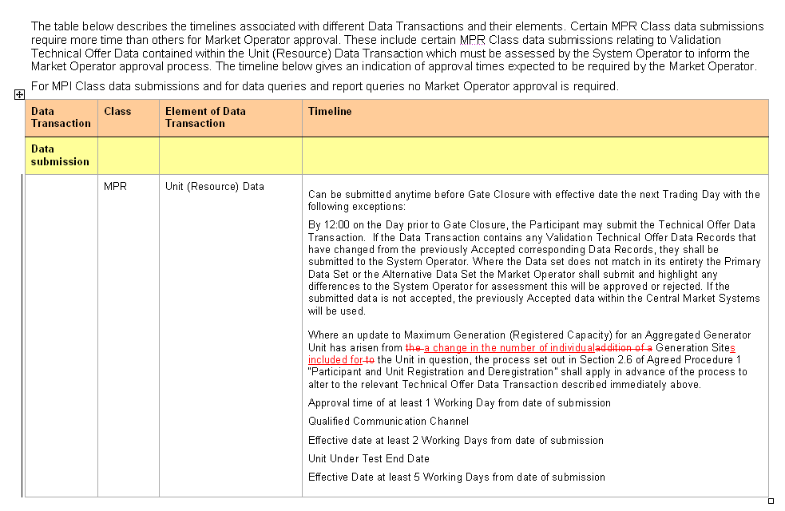

Modification Proposal Justification
(Clearly state the reason for the Modification & how it furthers the Code Objectives)
The modification allows for a decrease or increase in the number of individual Generators into the Aggregated Generator Unit which was previously not allowed for.

The modification furthers Code Objective 1.3.2 to facilitate the efficient, economic and coordinated operation, administration of the Single Electricity Market.
Implication of not implementing the Modification
(Clearly state the possible outcomes should the Modification not be made , or how the Code Objectives would not be met)
If this modification is not implemented a Participant will only be allowed to increase and not decrease the number of individual Generators into the Aggregated Generator Unit.
Please return this form to Secretariat by e-mail to modifications@sem-o.com

Appendix 2 – Alternative & Combined Proposals
N/A
Appendix 3 – Working Group Report
N/A
Appendix 4 - Impact Assessments
N/A
Appendix 5 - Consultation Responses
N/A

