The Single Electricity Market (SEM)
Agreed Procedure 13
Query Generation
Version 3.3

8th October 2007

SEM Agreed Procedure

Title | Agreed Procedure 13 : Query Generation
Version | 3.3
Date | 8th October 2007

Table of Contents
Table of Contents 3
1. Introduction 5
1.1 Background & Purpose 5
1.2 Scope Of Agreed Procedure 5
1.3 Definitions 5
1.4 Compliance With Agreed Procedure 5
2. Descriptive Overview 6
2.1 Data Queries 6
2.2 Settlement Queries 9
2.3 Consumption Adjustment Queries 11
3. Procedural Steps 14
3.1 Data Query 14
3.2 Settlement Query 19
3.3 Consumption Adjustment Query Resolution 24
3.4 Outside Settlement Determination run 29
4. Swimlanes 31
4.1 Data Query – Swim Lane 32
4.2 Settlement Query – Swim Lane 33
4.3 Consumption Adjustment Query – Swim Lane 35
4.4 Outside Settlement Determination Process – Swim Lane 37
APPENDIX 1: Definitions and Abbreviations 38
Definitions 38
Abbreviations 39
APPENDIX 2: Forms 40
Query Form 40
Affected Participant Notification Form 42
External Data Provider Notification Form 43
APPENDIX 3: Query Form Validation 44
APPENDIX 4: Outside Settlement Determination run criteria – Calculation Methods 45
Calculation of Consumption Materiality 45
Calculation of Cash Flow Impact 45
Percentage Impact 46
Invoiced Amounts for an Outside Settlement Determination Run 46

Document History
Version | Date | Author | Comment
2.0 | 03/11/06 | SEM Implementation Team | Issue to Regulators
3.0c | 18/05/07 | Regulatory Authorities | Consultation Version
3.0d | 21/05/07 |  | Data Query resolution period altered plus other minor corrections
3.2 | 25/06/07 | Regulatory Authorities | Approved for Go-Active by Regulatory Authorities and TSO/SEM Programme
3.3 | 08/10/07 | Regulatory Authorities | Consumption Adjustment CR

Related Documents
Document Title | Version | Date | By
Trading and Settlement Code | V2.0 | 30/05/2007 | Regulatory Authorities
Agreed Procedure 11 “Market System Operation, Testing, Upgrading and Support”
Agreed Procedure 14 "Disputes"

- Introduction
  - Background & Purpose
This Agreed Procedure sets out the specific procedures governing Query generation, with which Parties to the Trading and Settlement Code (the “Code”) must comply.

  - Scope Of Agreed Procedure
This Agreed Procedure defines the process for raising and processing Data Queries and Settlement Queries.
It forms an annexe to, and is governed by, the Code. This document is a statement of process and procedure. Parties’ rights and obligations are set out in the Code.

  - Definitions
Save as expressly defined, words and expressions defined in the Code shall have the same meanings when used in this Agreed Procedure.
References to particular sections relate internally to this Agreed Procedure unless specifically noted.

  - Compliance With Agreed Procedure
Compliance with this Agreed Procedure is required under the terms as set out in the Code.

- Descriptive Overview

  - Data Queries
    - Raising Data Queries
Where a Party identifies an issue within the Ex-Post Indicative Settlement Statements, it can raise a Data Query within the Data Verification Period. This Party (the “Raising Party”) shall submit the Data Query via the Market Operator’s Help Desk. Data Queries must be submitted on the standard Query form included at Appendix 2 of this Agreed Procedure, and may be submitted by registered overnight mail, fax or email. Data Queries will not be accepted by telephone. The Data Query shall specify the data being queried together with the reasons why it is being queried and any supporting evidence. Each Data Query can include more than one data item but can only be in relation to a single Ex-Post Indicative Settlement Statement. Ex-Post Indicative Settlement Statements for Trading Charges and Trading Payments are for each Settlement Day. Ex-Post Indicative Settlement Statements for Capacity Charges and Capacity Payments are for a Capacity Period (which is one calendar month). The data being queried may be Market Operator calculated data or input data from Participants, System Operators, Interconnector Administrator and/or Meter Data Providers.

Data Queries must be raised with the Market Operator in the Data Verification Period. The Data Verification Period for Trading Payments and Trading Charges for a Settlement Day is up to the Settlement Day plus four Working Days (i.e. SD+4WD). The Data Verification Period for Capacity Payments and Capacity Charges for a Capacity Period is up to four Working Days after the Capacity Period (i.e. CP+4WD).

Parties should make reasonable endeavours to raise Data Queries as soon as possible to facilitate resolution in advance of the publication of Initial Settlement Statement.

    - Processing Data Queries
The Market Operator has ten Working Days from the date of the Data Query being filed in which to resolve the Data Query. If the Data Query is not resolved within this time, the Raising Party may extend this time, giving the Market Operator up to 10 Working Days’ extra time from the end of the initial ten-day period to resolve the Data Query. The Market Operator may request this extra time. The Raising Party may give this additional time in writing by fax during the initial ten-day period.

If the Data Query is not resolved during the initial ten Working Days after the Data Query is filed, or during the extended 10WD period (if approved), the Data Query becomes a Settlement Dispute.

The Market Operator will log all Data Queries and validate that the Data Query has all mandatory information complete (see Appendix 3 for validation rules) and has been submitted within the Data Verification Period and by a person authorised under Agreed Procedure 11 “Market System Operation, Testing, Upgrading and Support” to submit Data Queries on behalf of the Raising Party. The Market Operator will confirm the validity or otherwise of the Data Query to the Raising Party underneath the timelines set out in this Agreed Procedure.

Where the data being queried is from or effects the data of another Participant (the “Affected Participant(s)”), the Market Operator shall also inform the Affected Participant(s). The Affected Participant(s) shall assist the Market Operator in a timely manner, dealing with the Data Query concerned.

Where the Data Query is valid and is querying data from an External Data Provider (System Operator, Interconnector Administrator or Meter Data Provider) then the Market Operator shall pass the details to such External Data Provider to examine the queried data for an error. The External Data Provider shall inform the Market Operator of its discoveries and provide any revised data under the timescales indicated by the Market Operator to fulfil the Data Query resolution deadline. Where possible, any revised data should be provided in time for inclusion in the Initial Settlement Statement. Where data is being queried because the calculation is incorrect or concerns data from an Affected Participant(s), then the Market Operator shall progress the examination of the queried data.

    - Determinations of Data Query Materiality
Where the corrections are not included in the Initial Settlement Statements, the Data Query will be placed into one of the two following categories:

- Change to Settlement Item with Low Materiality, i.e. Settlement change estimated to be under €50,000
- Change to Settlement Item with High Materiality, i.e. Settlement change estimated to be equal to or over €50,000

The Market Operator may utilise reasonable manual methods to determine the materiality of any changes to Settlement Items, using information and data provided manually from Participants, System Operators, Interconnector Administrator and/or Meter Data Providers. The Market Operator will communicate the workings of such determinations with the Raising Party. If the Raising Party disagrees with this estimation of materiality, the Raising Party may dispute this finding within 5 Working Days.

In the event that there is a change to Settlement Items with Low Materiality, the Market Operator shall procure that the revised corrected input data shall be used for the relevant Settlement Period for which Final Settlement has not occurred, and Settlement shall then take place on the next Timetabled Settlement Rerun. Two Timetabled Settlement Reruns exist for each given Billing Period and Capacity Period; the first taking place within the fourth month and the second within 13 months after the relevant Billing Period or Capacity Period.

In the event that there is a change to Settlement Items with Low Materiality resolved after the final Timetabled Settlement Rerun, the Market Operator will procure that an additional Settlement Rerun for the relevant Settlement Period will then be performed.

In the event that there is a change to Settlement Items with High Materiality, or there is a change to Settlement Items included in the Initial Settlement Statement for Capacity Payments or Capacity Charges, a dedicated Settlement Rerun will be performed within 1 month of the determination if the Raising Party has not disputed the Market Operator’s determination by raising a Dispute under Agreed Procedure 14 “Disputes”.

The Market Operator shall inform the Raising Party and the Affected Participant(s) (if any) of the determination and estimating the materiality within 1 WD of making the determination and estimating the materiality. If the Raising Party disagrees with the determination and/or estimate of materiality then it may raise a Settlement Dispute in accordance with Agreed Procedure 14 “Disputes”.

    - Corrective Actions
The Market Operator will procure that SMP and Market Schedule Quantities will be recalculated, and a Settlement Rerun will then be undertaken, in the event that the Market Operator in resolving a Data Query determines that:
- Commercial Offer Data or Technical Offer Data has been applied incorrectly, or incorrect data was provided;
- Actual Availability or Dispatch Quantity has been calculated incorrectly (or incorrect source data for these calculations provided).
3 Metered Generation has been applied or provided incorrectly; or
4 Market Schedule Quantity has been calculated incorrectly,
and that the correct application or calculation of any such amount would require it to change by more than the Settlement Recalculation Threshold for Metered Generation or Market Schedule Quantity.

The Market Operator will procure that the Ex-Post Loss of Load Probability Φ will be recalculated in the event that the Market Operator in resolving a Data Query determines that Metered Generation has been applied incorrectly and that the correct application would require a change by more than the Settlement Recalculation Threshold.

The Market Operator will procure that Capacity Payments and Capacity Charges will be recalculated in the event that the Market Operator in resolving a Data Query determines that:
- Commercial Offer Data or Technical Offer Data has been applied incorrectly; or
- any of Eligible Availability, Dispatch Quantity, Market Schedule Quantity, SMP or Ex-Post Loss of Load Probability Φ has been calculated incorrectly.

Where the resolution of a Data Query requires a Settlement Rerun, such Settlement Rerun will only be carried out in relation to the Settlement Day(s) that are the subject of the Data Query.

Where a Raising Party is not satisfied with the Market Operator’s determination in respect of a Data Query, the Raising Party may raise a Settlement Dispute under Agreed Procedure 14 “Disputes” within 5 Working Days of receipt of the Market Operator’s determination.

  - Settlement Queries
    - Raising Settlement Queries
A Settlement Query is a query in respect of the correctness of Metered Generation, Metered Demand, Net Demand, Eligible Availability or Actual Availability on an Initial Settlement Statement, on an Invoice or on a Self Billing Invoice. Each Settlement Query can include many data items and may span a number of Settlement Days (e.g. a metering fault affecting a number of meters over an extended period). Settlement Queries must be submitted on the standard Query form included at Appendix 2 of this Agreed Procedure, and may be submitted by registered overnight mail, fax or email. Settlement Queries will not be accepted by telephone. This Party (the “Raising Party”) shall submit the Settlement Query via the Market Operator’s Help Desk. The Settlement Query shall specify the data being queried together with the reasons why it is being queried and any supporting evidence. The reasons for the Settlement Query may be a concern with a calculation by the Market Operator or data provided from Participants, System Operators, Interconnector Administrator and/or Meter Data Providers.

The Settlement Query must be raised prior to 5 Working Days after the last Timetabled Settlement Rerun for that Billing Period.

    - Processing Settlement Queries
The Market Operator has one month in which to resolve the Settlement Query. The Raising Party may extend this time, giving the Market Operator up to 10 Working Days’ extra time from the end of the initial month period to resolve the Settlement Query. The Market Operator may request this extra time. The Raising Party may give this additional time in writing by fax during the initial month.

If the Settlement Query is not resolved during the initial one month period, or during the extended 10WD period (if approved), the Settlement Query becomes a Settlement Dispute.

The Market Operator will log all Settlement Queries and validate that the Settlement Query has all mandatory information complete (see Appendix 3 for validation rules) and has been submitted within the correct timescales by a person authorised under Agreed Procedure 11 “Market System Operation, Testing, Upgrading and Support” to submit Settlement Queries on behalf of the Raising Party. The Market Operator will confirm the validity or otherwise of the Settlement Query to the Raising Party under the timelines in this Agreed Procedure.

The Market Operator shall check if the Settlement Query issue has already been raised as a Consumption Adjustment Query. If this is the case, the Market Operator shall liaise with the Party raising the Settlement Query and the Party raising the Consumption Adjustment Query to agree under which process the issue is to be resolved. If the Parties agree to resolve the issue as Consumption Adjustment Query then the Party raising the Settlement Query shall withdraw the Settlement Query. If the two Parties cannot agree under which process to resolve the issue, the Party raising the Settlement Query shall raise a Dispute and the Settlement Query will be not be considered valid unless the resolution of Dispute is determined in the favour of the Party raising the Settlement Query. If the Parties agree to resolve the issue as a Settlement Query then the Party who raised the Consumption Adjustment Query shall withdraw the Consumption Adjustment Query. The timescales for resolving the Settlement Query shall commence on withdrawal of the Consumption Adjustment Query or on the resolution of the Dispute in favour of a Settlement Query.
Where the data being queried is from or effects the data of another Participant (the “Affected Participant(s)”), the Market Operator shall also inform the Affected Participant(s). The Affected Participant(s) shall assist the Market Operator in a timely manner, dealing with the Settlement Query concerned.

Where the Settlement Query is valid and is as a result of data from an External Data Provider (System Operator, Interconnector Administrator or Meter Data Provider) then the Market Operator shall pass the details to such External Data Provider. The External Data Provider shall provide any revised data within 15 Working Days of receipt of the Settlement Query.

    - Determinations of Settlement Query Materiality
Changes to Settlement resulting from the resolution by the Market Operator of a Settlement Query will be placed into one of the two following categories:

- Change to Settlement Item with Low Materiality, i.e. Settlement change estimated to be under €50,000
- Change to Settlement Item with High Materiality, i.e. Settlement change estimated to be equal to or over €50,000

The Market Operator may utilise reasonable manual methods to determine the materiality of any changes to Settlement Items, using information and data provided manually from Participants, System Operators, Interconnector Administrator and/or Meter Data Providers. The Market Operator will communicate the workings of such determinations with the Raising Party. If the Raising Party disagrees with this estimation of materiality, the Raising Party may dispute this finding within 5 Working Days.

In the event that there is a change to Settlement Items with Low Materiality, the Market Operator shall procure that the revised corrected input data shall be used for the relevant Settlement Period for which Final Settlement has not occurred, and Settlement shall then take place on the next Timetabled Settlement Rerun. Two Timetabled Settlement Reruns exist for each given Billing Period and Capacity Period; the first taking place within the fourth month and the second within 13 months after the relevant Billing Period or Capacity Period.

In the event that there is a change to Settlement Items with Low Materiality resolved after the final Timetabled Settlement Rerun, the Market Operator will procure that an additional Settlement Rerun for the relevant Settlement Period will then be performed.

In the event that there is a change to Settlement Items with High Materiality, a dedicated Settlement Rerun will be performed within 1 month of the determination if the Raising Party has not disputed the Market Operator’s determination by raising a Dispute under Agreed Procedure 14 “Disputes”.

The Market Operator shall inform the Raising Party and the Affected Participant(s) (if any) of the determination within 1 WD of receiving or making the determination. If the Raising Party disagrees with the determination then it may raise a Settlement Dispute in accordance with Agreed Procedure 14 “Disputes”.

    - Corrective Actions
Where the resolution of a Settlement Query requires a Settlement Rerun and an issue of an Invoice or Self-Billing Invoice, such Settlement Rerun will only be carried out in relation to the Settlement Day(s) that are the subject of the Settlement Query and within the scope of the Invoice or Self-Billing Invoice as appropriate. The result of that Settlement Rerun will be applied to all Participants.

In the event that the Raising Party is not satisfied with the Market Operator’s determination of a Settlement Query, the Raising Party may raise a Settlement Dispute under Agreed Procedure 14 “Disputes” within 5 Working Days of receipt of the Market Operator’s determination.

  - Consumption Adjustment Queries
    - Raising Consumption Adjustment Queries
A Consumption Adjustment Query is a query in respect of energy adjustments in Meter Data spanning more than one Invoice or Settlement Statement. If a Consumption Adjustment Query is raised against a Settlement Statement data item which is the subject of a Settlement Query, it is agreed between the two Raising Parties (Settlement Query and Consumption Adjustment Query) which query process is to be used.

Consumption Adjustment Queries are in relation of long-term errors in consumption Meter Data. Consumption Adjustment Queries may include any number of days which have been subject to an Initial Settlement Statement. These long-term errors have the potential not to be rectified through the Meter Data Provider aggregation and the subsequent settlement under Standard Settlement processes. Such errors can arise through:
- Illegal abstraction; both pre- and post- Final Timetabled Settlement Rerun
- Meter faults; both pre- and post- Final Timetabled Settlement Rerun
- Actual readings replacing estimates: post Final Timetabled Settlement Rerun only

Consumption Adjustment Queries must be submitted on the standard Query form included in Appendix 2 of this Agreed Procedure, and may be submitted by registered overnight mail, fax or email. Consumption Adjustment Queries will not be accepted by telephone. The Party (the “Raising Party”) shall submit the Consumption Adjustment Query via the Market Operator’s Help Desk. The Consumption Adjustment Query shall specify the data being queried together with the reasons why it is being queried along with any supporting evidence. Where a Consumption Adjustment Query is raised by a Meter Data Provider, the Meter Data Provider shall indicate whether it can provide the necessary assurances for the Consumption Adjustment Query to be resolved using the Outside Settlement Determination) method (see below, 2.3.4), subject to the Consumption Adjustment Query meeting the other criteria for Outside Settlement Determination (i.e. materiality, cash flow impact and percentage impact).

The Consumption Adjustment Query must be raised prior to 7 calendar years after the earliest Settlement Day affected by the Consumption Adjustment Query.

    - Processing Consumption Adjustment Queries
The Market Operator has one month in which to resolve the Consumption Adjustment Query. The Raising Party may extend this time, giving the Market Operator up to 1 month extra time from the end of the initial month period to resolve the Consumption Adjustment Query. The Market Operator may request this extra time. The Raising Party may give this additional time in writing by fax during the initial month.

If the Consumption Adjustment Query is not resolved during the agreed timescale, the Consumption Adjustment Query becomes a Settlement Dispute.

The Market Operator will log all Consumption Adjustment Queries and validate that the Consumption Adjustment Query has all mandatory information complete (see Appendix 3 for validation rules) and has been submitted within the correct timescales by a person authorised under Agreed Procedure 11 “Market System Operation, Testing, Upgrading and Support” to submit Consumption Adjustment Queries on behalf of the Raising Party. The Market Operator will confirm the validity or otherwise of the Consumption Adjustment Query to the Raising Party under the timelines in this Agreed Procedure.

The Market Operator shall check if the Consumption Adjustment Query issue has already been raised as a Settlement Query. If this is the case, the Market Operator shall liaise with the Party raising the Settlement Query and the Party raising the Consumption Adjustment Query to agree under which process the issue is to be resolved. If the Parties agree to resolve the issue as Settlement Query then the Party raising the Consumption Adjustment Query shall withdraw the Consumption Adjustment Query. If the two Parties cannot agree under which process to resolve the issue, the Party raising the Consumption Adjustment Query shall raise a Dispute and the Settlement Query will be not be considered valid unless the resolution of Dispute is determined in the favour of the Party raising the Consumption Adjustment Query. If the Parties agree to resolve the issue as a Consumption Adjustment Query then the Party who raised the Settlement Query shall withdraw the Settlement Query. The timescales for resolving the Consumption Adjustment Query shall commence on withdrawal of the Settlement Query or on the resolution of the Dispute in favour of a Consumption Adjustment Query.

Where the data being queried is from or affects the data of another Participant (the “Affected Participant(s)”), the Market Operator shall also inform the Affected Participant(s). The Affected Participant(s) shall assist the Market Operator in a timely manner, dealing with the Consumption Adjustment Query concerned.

Where the Consumption Adjustment Query is valid then the Market Operator shall pass the details to the relevant Meter Data Provider. The Meter Data Provider shall provide any revised data within 15 Working Days of receipt of the Consumption Adjustment Query or other timescale agreed by the Market Operator. At the same time the relevant Meter Data Provider shall indicate whether it can or cannot provide the necessary assurances to enable the Consumption Adjustment Query to be resolved using the Outside Settlement Determination method subject to the Consumption Adjustment Query meeting the other criteria for Outside Settlement Determination (i.e. materiality, cash flow impact and percentage impact).

    - Determinations of Consumption Adjustment Query Resolution method

Where the Meter Data Provider cannot provide assurances that the data will not be included in any future aggregations, the Market Operator shall utilise the next Timetabled Settlement Rerun for each of the affected Settlement Days to resolve the Consumption Adjustment Query. Where the Final Timetabled Settlement Rerun for an affected Settlement Period has already taken place, the Market Operator will procure that either an additional Settlement Rerun for the relevant Settlement Period will then be performed, or that an Outside Settlement Determination is performed (subject to the materiality thresholds described in the next paragraph). The Market Operator shall record that an Outside Settlement Determination has occurred without Meter Data Provider assurance that this data will not be included in future aggregations, and make appropriate adjustments to future post 13-month Resettlements that may occur arising from the Settlement Query process or the Dispute process.

Where the Meter Data Provider can provide assurances that the data will not be included in any future aggregations, the Market Operator shall calculate the materiality of each Consumption Adjustment Query and maintain a log of such Consumption Adjustment Queries containing the following information
- Date Consumption Adjustment Query raised
- Raising Party id
- Affected Participant id
- PES Participant id
- Date Consumption Adjustment Query resolved
- Materiality
- Date Consumption Adjustment Query resolution implemented

Twenty Working Days prior to a scheduled Outside Settlement Determination run, the Market Operator shall confirm with each relevant Meter Data Provider the validity of each Consumption Adjustment Query whose resolution has not been implemented and each Meter Data Provider shall confirm the assurances regarding the inclusion of the data in future aggregations. The Meter Data Providers shall provide their response with 5 Working Days.
On receipt of all the responses from the Meter Data Providers, the Market Operator shall assess whether the scheduled Outside Settlement Determination run should proceed by considering all the valid, resolved and non-implemented Consumption Adjustment Queries where the Meter Data Providers have provided the necessary assurance against the following criteria:

- The materiality of all the relevant Consumption Adjustment Queries is greater than €50,000 ; and
- the cash flow impact for any affected Participant has exceeded the threshold set by that Participant; and
- the percentage impact for any affected Participant is greater than 5%.

The method of calculating materiality, cash flow Impact and percentage impact is set out in Appendix 4.

Where the criteria for performing an Outside Settlement Determination run are met the Market Operator shall inform the relevant Meter Data Providers and Participants of the Consumption Adjustment Queries to be included in the Outside Settlement Determination run at least 10 Working Days prior to the Outside Settlement Determination run.

Where the criteria for performing an Outside Settlement Determination run are not met the Market Operator shall inform the relevant Meter Data Providers and Participants together with the date of the next scheduled Outside Settlement Determination run. Where a Consumption Adjustment Query resolution could be implemented using Timetabled Settlement Reruns prior to the next Outside Settlement Determination run, the Market Operator shall request the Meter Data Provider to provide the corrected data in the relevant aggregations for the Timetabled Settlement Reruns. Within 5 Working Days of the request, the Meter Data Provider shall confirm the relevant corrections shall be made to the aggregations or provide an explanation why this is not possible. The Market Operator shall inform the relevant Participants which Consumption Adjustment Queries will be included in the Timetabled Settlement Reruns.

The Market Operator and Meter Data Provider may agree that the portion of the Meter Data corrections for which a further Timetabled Settlement Rerun is scheduled may be handled using that Timetabled Settlement Rerun, and that the portion of the Meter Data Corrections for which another Timetabled Settlement Rerun is not scheduled may be managed through an Outside Settlement Determination.

    - Outside Settlement Determination run
The Market Operator shall schedule four Outside Settlement Determination runs each year and shall include the dates of such runs in the Settlement Calendar. An Outside Settlement Determination run shall be performed on the first Working Day of a Billing Period and results of the Outside Settlement Determination shall be included in an ad hoc Invoice or Self-Billing Invoice produced manually outside of the Central Market Systems. Within 1 Working Day of performing the Outside Settlement Determination run, the Market Operator shall send to the relevant Participants the relevant calculations and the amounts that will be included in the Invoices or Self-Billing Invoices.

The Outside Settlement Determination shall include the impact of the Consumption Adjustment Query on Trading Payments and Charges, Capacity Payments and Charges, Market Operator Charges, applicable interest, and applicable VAT.

The Outside Settlement Determination shall not impact the calculation of SMP, Credit Cover, Currency Cost, Market Schedule Quantities, or Ex-Post Loss of Load Probabilities.

- Procedural Steps
  - Data Query

# | Procedural Step | Timing | Mechanism | By / From | To | Linkage
1 | Raise Data Query (see form in Appendix 2) | Within Data Verification Period (For Trading Payments and Trading Charges: between SD+1WD and SD+4WD; for Capacity Payments and Capacity Charges between CP+3WD and CP+6WD) | Email / Fax / registered overnight mail | Raising Party | Market Operator
2 | Log Data Query in accordance with Agreed Procedure 11 “Market System Operation, Testing, Upgrading and Support”. Validate Data Query for completeness and from authorised person as set out in Appendix 3  - If valid continue from step 5  - If invalid continue from step 3 | Within 1 WD | - | Market Operator | -
3 | Close log in accordance with Agreed Procedure 11 “Market System Operation, Testing, Upgrading and Support” and inform Raising Party of reasons for invalidity | Immediately | Email / Fax / registered overnight mail | Market Operator | Raising Party
4 | Review invalidity reasons  - Correct and resubmit – Continue from step 1  - Do not resubmit – and continue from step 31 | As required |  | Raising Party
5 | Inform Raising Party of completeness of Data Query | Immediately | Email / Fax / registered overnight mail | Market Operator | Raising Party
6 | Establish whose data is being queried  - If it is a Meter Data Provider, a System Operator or the Interconnector Administrator (an External Data Provider) continue from step 14  - If it is another Participant’s data (The Affected Participant(s)) continue from step 7  - If it is regarding the calculation of a data item continue from step 13 | Within 1 WD of receiving the Data Query |  | Market Operator
7 | Inform the Affected Participant(s) of the Data Query requesting its comment on the validity | Within 1 WD of receiving the Data Query | Email / Fax / registered overnight mail | Market Operator | Affected Participant(s)
8 | Process Data Query request  If Query can be processed within requested timescales continue from step 12 otherwise continue from step 9 | Within timescales specified by MO | Email / Fax / registered overnight mail | Affected Participant(s)
9 | Notify inability to process Data Query request | Within timescales specified by MO | Email / Fax / registered overnight mail | Affected Participant(s) | Market Operator
10 | If Market Operator can make a determination without the Affected Participant information continue from step 13 otherwise continue from step 11 | Within timescales agreed with Raising Party | - | Market Operator
11 | Raise a Settlement Dispute in accordance with Agreed Procedure 14 “Disputes” because of inability to make determination within required timescales.  Continue from step 31 | After lapse of timescales agreed with Raising Party | In accordance with Agreed Procedure 14 “Disputes” | Market Operator
12 | Provide comments to Market Operator | Within timescales specified by MO | Email / Fax / registered overnight mail | Affected Participant(s) | Market Operator
13 | Make a determination on the Data Query, including estimation of Materiality of any change to Settlement Items taking into account any comments from the Affected Participant(s).  If determination can be made within the timescales agreed with the Raising Party continue from step 18 otherwise continue from Step 11 | Within timescales agreed with Raising Party |  | Market Operator | -
14 | Send Data Query to External Data Provider. Note that the Market Operator may request a manual communication of the estimation of the change to data items which are being queried, or may request a full formal update of all data from the External Data Provider over Communication Channel Type 2 or Type 3. | Within 1 WD of receiving the Data Query | Email / Fax / registered overnight mail | Market Operator | External Data Provider
15 | Process Data Query request  If Query can be processed within requested timescales continue from step 17 otherwise continue from step 16 | Within timescales specified by MO | Email / Fax / registered overnight mail | External Data Provider | - | )
16 | Notify inability to process Data Query request  Continue from step 11 | Within timescales specified by MO | Email / Fax / registered overnight mail | External Data Provider | Market Operator
17 | Process the Data Query. Inform Market Operator of findings and potentially reissue any corrected data. | Within timescales specified by MO | Email / Fax / registered overnight mail (notification of determination) | External Data Provider | Market Operator | Potentially AP16 (for ad hoc Meter Data file send
18 | If Market Operator completes the examination of the Data Query within timeframe, inform the Raising Party and the Affected Participant(s) of the Market Operator’s determination, including any estimate of Materiality and the method of estimating that Materiality. Go to step 21  If not, go to step 19 | Within 10 WD | Email / Fax / registered overnight mail | Market Operator | Affected Participant(s)  Raising Party
19 | Market Operator requests more time (up to 10 Working Days) from the Raising Party to resolve the Data Query | Within one Working Day of known non-completion of Data Query by Market Operator | Email / Fax / registered overnight mail | Market Operator | Affected Participant(s)  Raising Party
20 | If Raising Party agrees to extension and Data Query is resolved within the extended timeframes, go to step 21. Otherwise go to step 23 | Within 10WD | Email / Fax / registered overnight mail | Market Operator | Affected Participant(s)  Raising Party
21 | Inform the Raising Party and the Affected Participant(s) of the Market Operator’s determination, including any estimate of Materiality and the method of estimating that Materiality  Continue from step 22 and step 24 | Within timescales agreed with Raising Party | Email / Fax / registered overnight mail | Market Operator | Affected Participant(s)  Raising Party
22 | Receive and review the determination  - If not disputing the determination – do nothing and continue from Step 25  - If disputing with the determination (including the Market Operator’s estimation of Materiality) continue from Step 23 | Within 5WD of receipt of determination | - | Raising Party | -
23 | Raise a Settlement Dispute under Agreed Procedure 14 “Disputes” and inform the Market Operator and continue from Step 31 | Within 5WD of receipt of determination | In accordance with Agreed Procedure 14 “Disputes” | Raising Party | Market Operator
24 | If the Data Query has resulted in revised data which has all been included in the Initial Settlement Statement (including where necessary the recalculation of SMP and MSQs) continue from step 31 otherwise continue from step 25 | - | - | Market Operator | -
25 | If the Data Query has resulted in revised data which has not been included in the Initial Settlement Statement and the Raising Party is not disputing the determination and if the Materiality is High or if there are no more Timetable Settlement Reruns then continue from step 26 otherwise continue from step 30 | Within 5 WD of determination | - | Market Operator | -
26 | Schedule a dedicated Settlement Rerun Statement. Send a further External Data Provider Notification Form (see Appendix 2) to the External Data Provider if there are further data requirements. | Within 1 month of determination | -Various | Market Operator | External Data Providers | AP16 (for ad hoc Meter Data file send), AP15 (for Settlement Rerun)
27 | If Commercial Offer Data, Technical Offer Data, Actual Availability, Dispatch Quantity, Metered Generation or Market Schedule Quantity have been determined to be incorrect arising from the Data Query, subject to the Settlement Recalculation Threshold, SMP and MSQ shall be recalculated prior to the Settlement Rerun. | Within 1 month of determination | -Various | Market Operator
28 | If Metered Generation has been determined to be in error arising from the Data Query subject to the Settlement Recalculation Threshold, the Ex-Post Loss of Load Probability shall be recalculated prior to the Settlement Rerun. | Within 1 month of determination | -Various | Market Operator
29 | If Commercial Offer Data, Technical Offer Data, Eligible Availability, Dispatch Quantity, Market Schedule Quantity, SMP or Ex-Post Loss of Load Probability have been determined to be in error arising from the Data Query, the Capacity Payments and Capacity Charges shall be recalculated prior to the Settlement Rerun. | Within 1 month of determination | -Various | Market Operator
30 | Ensure revised data is used in next Timetabled Settlement Rerun Statement (including where necessary the recalculation of SMP and MSQs). | Prior to next Timetabled Settlement Rerun | - | Market Operator | -
31 | End process | - | - | - | -

  - Settlement Query

# | Procedural Step | Timing | Mechanism | By / From | To | Linkage
1 | Raise Settlement Query (see form in Appendix 2) | Prior to last Timetabled Settlement Rerun + 5 WD | Email / Fax / registered overnight mail | Raising Party | Market Operator
2 | Log Settlement Query in accordance with Agreed Procedure 11 “Market System Operation, Testing, Upgrading and Support”. Validate Settlement Query for completeness and from authorised person as set out in Appendix 3  - If valid continue from step 5  - If invalid continue from step 3 | Within 1 WD |  | Market Operator
3 | Close log in accordance with Agreed Procedure 11 “Market System Operation, Testing, Upgrading and Support” and inform Raising Party of reasons for invalidity | Immediately | Email / Fax / registered overnight mail | Market Operator | Raising Party
4 | Review invalidity reasons  - Correct and resubmit – Continue from step 1  - Do not resubmit – and continue from step 28 |  |  | Market Operator
5 | Check if the Settlement Query issue has already been raised as a Consumption Adjustment Query  If no relevant Consumption Adjustment Query has been raised go to step 6  If a relevant Consumption Adjustment Query has been raised go to step 29
6 | Inform Raising Party of completeness of Settlement Query | Immediately | Email / Fax / registered overnight mail | Market Operator | Raising Party
7 | Establish whose data is being queried  - If it is a Meter Data Provider, a System Operator or the Interconnector Administrator (an External Data Provider) continue from step 15  - If it is another Participant’s data (The Affected Participant(s)) continue from step 8  - If it is regarding the calculation of a data item continue from step 14 | Within 1 WD of receiving the Settlement Query |  | Market Operator
8 | Inform the Affected Participant(s) of the Settlement Query requesting its comment on the validity | Within 1 WD of receiving the Settlement Query | Email / Fax / registered overnight mail | Market Operator | Affected Participant(s)
9 | Process Settlement Query request  If Query can be processed within requested timescales continue from step 13 otherwise continue from step 10 | Within timescales specified by the MO | Email / Fax / registered overnight mail | Affected Participant(s)
10 | Notify inability to process Settlement Query request | Within timescales specified by the MO |  | Affected Participant(s) | Market Operator
11 | If Market Operator can make a determination without the Affected Participant information continue from step 14 otherwise continue from step 12 | Within timescales agreed with Raising Party | Email / Fax / registered overnight mail | Market Operator
12 | Raise a Settlement Dispute in accordance with Agreed Procedure 14 “Disputes” because of inability to make determination within required timescales.  Continue from step 28 | After lapse of timescales agreed with Raising Party | In accordance with Agreed Procedure 14 “Disputes”
13 | Provide comments to Market Operator | Within 15 WD of receipt from MO | Email / Fax / registered overnight mail | Affected Participant(s) | Market Operator
14 | Make a determination on the Settlement Query, including estimation of Materiality of any change to Settlement Items taking into account any comments from the Affected Participant(s).  If determination can be made within the timescales agreed with the Raising Party continue from step 19 otherwise continue from Step 12 | Within timescales agreed with Raising Party |  | Market Operator | -
15 | Send Settlement Query to External Data Provider. Note that the Market Operator may request a manual communication of the estimation of the change to data items which are being queried, or may request a full formal update of all data from the External Data Provider over Communication Channel Type 2 or Type 3. | Within 1 WD of receiving the Settlement Query | Email / Fax / registered overnight mail | Market Operator | External Data Provider
16 | Process Settlement Query request  If Query can be processed within requested timescales continue from step 18 otherwise continue from step 17 | Within timescales specified by MO | Email / Fax / registered overnight mail | External Data Provider | -
17 | Notify inability to process Settlement Query request  Continue from step 12 | Within timescales specified by MO | Email / Fax / registered overnight mail | External Data Provider | Market Operator
18 | Process the Settlement Query. Inform Market Operator of findings and potentially reissue any corrected data | Within timescales specified by MO | Email / Fax / registered overnight mail (notification of determination)  Communication Channel (revised data) | External Data Provider | Market Operator | Potentially AP16 (for ad hoc Meter Data file send)
19 | If Market Operator completes the examination of the Settlement Query within timeframe go to step 22  If not, go to step 20
20 | Market Operator requests more time (up to 10 Working Days) from the Raising Party to resolve the Settlement Query | Within one Working Day of known non-completion of Settlement Query by Market Operator | Email / Fax / registered overnight mail | Market Operator | Affected Participant(s)  Raising Party
21 | If Raising Party agrees to extension and Settlement Query is resolved within the extended timeframes, go to step 22. Otherwise go to step 24 | Within 10WD | Email / Fax / registered overnight mail | Market Operator | Affected Participant(s)  Raising Party
22 | Inform the Raising Party and the Affected Participant(s) of the Market Operator’s determination, including any estimate of Materiality and the method of estimating that Materiality | Within timescales agreed with Raising Party | Email / Fax / registered overnight mail | Market Operator | Affected Participant(s)  Raising Party
23 | Receive and review the determination  - If not disputing the determination – do nothing and continue from Step 25  - If disputing with the determination continue from Step 24 | Within 5WD of receipt of determination | - | Raising Party | -
24 | Raise a Settlement Dispute under Agreed Procedure 14 “Disputes” and inform the Market Operator and continue from Step 28 | Within 5WD of receipt of determination | In accordance with Agreed Procedure 14 “Disputes” | Raising Party | Market Operator
25 | If the Materiality is High or it is after the last Timetabled Settlement Rerun then continue from step 25 otherwise continue from step 27 | Within 5 WD of determination | - | Market Operator | -
26 | Schedule a dedicated Settlement Rerun Statement and continue from step 28. Send a further External Data Provider Notification Form (see Appendix 2) to the External Data Provider if there are further data requirements. | Within 1 month of determination | Various | Market Operator | External Data Provider | AP16 (for ad hoc Meter Data file send), AP15 (for Settlement Rerun)
27 | Ensure revised data is used in next Timetabled Settlement Rerun Statement (including where necessary the recalculation of SMP and MSQs). | Prior to next Timetabled Settlement Rerun | - | Market Operator | -
28 | End process | - | - | - | -
29 | Inform Raising Party of equivalent Consumption Adjustment Query and request Raising Party to liaise with Party who raised the Consumption Adjustment Query on which query to progress | Immediately | Email / Fax / registered overnight mail | Market Operator | Raising Party / Party who raising Consumption Adjustment Query
30 | If Settlement Query Raising Party and Consumption Adjustment Query Raising Party cannot agree then go to step 31  Otherwise if they agree to progress as a Settlement Query got to step 33  Or if they agree to progress as a Consumption Adjustment Query go to step 34 | - | - | Settlement Query Raising Party / Consumption Adjustment Query Raising Party
31 | Raise a Dispute using Agreed Procedure 14 “Disputes”  If Dispute resolution is to progress as a Settlement Query go to step 32  If Dispute resolution is to progress as a Consumption Adjustment Query go to step 34 | Within 5 Working Days | In accordance with Agreed Procedure 14 “Disputes”
32 | Market Operator informs Consumption Adjustment Query Raising Party of withdrawal of Consumption Adjustment Query  Go to step 6 | Within 1 Working Day | Email / Fax / registered overnight mail | Market Operator | Consumption Adjustment Query Raising Party
33 | Withdraw Consumption Adjustment Query  Go to step 6 | Within 5 Working Days | Email / Fax / registered overnight mail | Consumption Adjustment Query Raising Party | Market Operator
34 | Withdraw Settlement Query  Go to step 28 | Within 5 Working Days | Email / Fax / registered overnight mail | Settlement Query Raising Party | Market Operator
  - Consumption Adjustment Query Resolution

# | Procedural Step | Timing | Mechanism | By / From | To | Linkage
1 | Raise Consumption Adjustment Query (see form in Appendix 2) | Prior to 7 years after earliest Settlement Day in Consumption Adjustment Query | Email / Fax / registered overnight mail | Raising Party | Market Operator
2 | Log Consumption Adjustment Query in accordance with Agreed Procedure 11 “Market System Operation, Testing, Upgrading and Support”. Validate Consumption Adjustment Query for completeness and from authorised person as set out in Appendix 3  - If valid continue from step 5  - If invalid continue from step 3 | Within 1 WD |  | Market Operator
3 | Close log in accordance with Agreed Procedure 11 “Market System Operation, Testing, Upgrading and Support” and inform Raising Party of reasons for invalidity | Immediately | Email / Fax / registered overnight mail | Market Operator | Raising Party
4 | Review invalidity reasons  - Correct and resubmit – Continue from step 1  - Do not resubmit – and continue from step 30 |  |  | Raising Party
5 | Check if the Consumption Adjustment Query issue has already been raised as a Settlement Query  If no relevant Settlement Query has been raised go to step 6  If a relevant Settlement Query has been raised go to step 24 |  |  | Market Operator
6 | Inform Raising Party of completeness of Consumption Adjustment Query | Within 1WD | Email / Fax / registered overnight mail | Market Operator | Raising Party
7 | Send Consumption Adjustment Query to Meter Data Provider and request estimate of revised data | Within 1 WD of receiving the Consumption Adjustment Query | Email / Fax / registered overnight mail | Market Operator | Meter Data Provider
8 | Inform the Affected Participant(s) of the Consumption Adjustment Query requesting its comment on the validity | Within 1 WD of receiving the Consumption Adjustment Query | Email / Fax / registered overnight mail | Market Operator | Affected Participant(s)
9 | Process Consumption Adjustment Query request  If required liaise with relevant Meter Data Provider to assist in estimating revised data | Within 15 WD of receipt from MO or other timescale specified by MO | Email / Fax / registered overnight mail | Market Operator | Meter Data Provider
10 | Process Consumption Adjustment Query request  If Query can be processed within requested timescales continue from step 17 otherwise continue from step 11 | Within timescales specified by MO or other timescale specified by MO | Email / Fax / registered overnight mail | Meter Data Provider | -
11 | Notify inability to process Consumption Adjustment Query request | Within timescales specified by MO | Email / Fax / registered overnight mail | Meter Data Provider | Market Operator
12 | If timescales have already been extended by 1 month go to step 19  Otherwise go to step 13
13 | Market Operator requests more time (up to 1 calendar month) from the Raising Party to resolve the Consumption Adjustment Query | Within one Working Day of known non-completion of Consumption Adjustment Query by Market Operator | Email / Fax / registered overnight mail | Market Operator | Affected Participant(s)  Raising Party
14 | Raising Party responds to extension request | Within 1 Working Day of request | Email / Fax / registered overnight mail | Raising Party | Market Operator
15 | If Raising Party agrees to extension go to step 16 Otherwise go to step 19 | -
16 | Inform Meter Data Provider and Affected Participants of revised timescales  Go to step 9 | Within 1 Working Day of response | Email / Fax / registered overnight mail | Market Operator | Affected Participant(s)  Raising Party  Meter Data Provider
17 | Calculate Materiality and provide resolution to affected Participants. | Within agreed timescales | Email / Fax / registered overnight mail | Market Operator | Affected Participant(s)  Raising Party (if a Participant) | Potentially AP16 (for ad hoc Meter Data file send)
18 | Receive and review the determination  - If not disputing the determination – do nothing and continue from Step 20  If disputing with the determination continue from Step 19 | - | - | Raising Party (if a Participant), Affected Participant(s) | -
19 | Raise a Settlement Dispute under Agreed Procedure 14 “Disputes” and inform the Market Operator and continue from Step 30 | Within 5WD of receipt of determination | In accordance with Agreed Procedure 14 “Disputes” | Raising Party (if a Participant), Affected Participant(s) | Market Operator
20 | If the Meter Data Provider has not provided the necessary assurance and it is after the last Timetabled Settlement Rerun, and the Market Operator does not agree to include the impact of an Outside Settlement Determination on potential post 13-month Resettlement Rerun (as may occur under a Dispute or Settlement Query), then continue from step 21  If the Meter Data Provider has not provided the necessary assurance and it is before the last Timetabled Settlement Rerun then continue from step 22  If the Meter Data Provider has provided the necessary assurance, or the Market Operator agrees to include the impact of an Outside Settlement Determination on potential future post 13-month Resettlement Rerun (as may occur under a Dispute or Settlement Query) continue from step 23 | Within 5 WD of determination | - | Market Operator | -
21 | Send a further External Data Provider Notification Form (see Appendix 2) to the Meter Data Provider if there are further data requirements.  Inform the affected Participants of the method of implementation of the Consumption Adjustment Query resolution.  Schedule a dedicated Settlement Rerun Statement  Continue from step 30 | Within 5 WD of determination  Within 5 WD of determination  Within 1 month of determination | Email / Fax / registered overnight mail  Email / Fax / registered overnight mail | Market Operator  Market Operator  Market Operator | Meter Data Provider  Participants | AP16 (for ad hoc Meter Data file send), AP15 (for Settlement Rerun)
22 | Request Meter Data Provider to include data in the aggregation for the next Timetabled Settlement Rerun. Inform the affected Participants of the method of implementation of the Consumption Adjustment Query resolution.  Continue from step 30 | Within 5 WD of determination | Email / Fax / registered overnight mail | Market Operator | Affected Participant(s)  Raising Party  Meter Data Provider
23 | Log the Consumption Adjustment Query and its resolution on the Outside Settlement Determination log.  Inform the affected Participants of the method of implementation of the Consumption Adjustment Query resolution  Continue from step 30 | Within 5 WD of determination | Email / Fax / registered overnight mail | Market Operator | Affected Participant(s)  Raising Party  Meter Data Provider
24 | Inform Raising Party of equivalent Consumption Adjustment Query and request Raising Party to liaise with Party who raised the Consumption Adjustment Query on which query to progress | Immediately | Email / Fax / registered overnight mail | Market Operator | Raising Party / Party who raising Consumption Adjustment Query
25 | If Settlement Query Raising Party and Consumption Adjustment Query Raising Party cannot agree then go to step 26  Otherwise if they agree to progress as a Settlement Query got to step 28  Or if they agree to progress as a Consumption Adjustment Query go to step 29 | - | - | Settlement Query Raising Party / Consumption Adjustment Query Raising Party
26 | Raise a Dispute using Agreed Procedure 14 “Disputes”  If Dispute resolution is to progress as a Settlement Query go to step 27  If Dispute resolution is to progress as a Consumption Adjustment Query go to step 3 | Within 5 Working Days | In accordance with Agreed Procedure 14 “Disputes”
27 | Market Operator informs Consumption Adjustment Query Raising Party of withdrawal of Consumption Adjustment Query  Go to step 6 | Within 1 Working Day | Email / Fax / registered overnight mail | Market Operator | Consumption Adjustment Query Raising Party
28 | Withdraw Consumption Adjustment Query  Go to step 6 | Within 5 Working Days | Email / Fax / registered overnight mail | Consumption Adjustment Query Raising Party | Market Operator
29 | Withdraw Settlement Query | Within 5 Working Days | Email / Fax / registered overnight mail | Settlement Query Raising Party | Market Operator
30 | End process | - | - | - | -

  - Outside Settlement Determination run

# | Procedural Step | Timing | Mechanism | By / From | To | Linkage
1 | Request confirmation of the validity of each Consumption Adjustment Query which has been resolved but not implemented. | 20 WD prior to Outside Settlement Determination run | Email / Fax / registered overnight mail | Market Operator | Meter Data Provider
2 | Confirm validity or otherwise of each Consumption Adjustment Query | Within 5 WD | Email / Fax / registered overnight mail | Meter Data Provider | Market Operator
3 | Assess the Consumption Materiality, Cash Flow Impacts and Percentage Impacts to determine if an Outside Settlement Determination run is to be executed.  If an Outside Settlement Determination run is to be executed go to step 4  Otherwise go to step 7 | Within 5 WD receipt of all confirmations | - | Market Operator |  | Appendix 4
4 | Inform relevant Participants and Meter Data Providers that an Outside Settlement Determination run is to be performed and which Consumption Adjustment Queries will be implemented | At least 10 WD prior to the Outside Settlement Determination run | Email / Fax / registered overnight mail | Market Operator | Relevant Meter Data Providers / Participants
5 | Perform Outside Settlement Determination run | On the scheduled day of Outside Settlement Determination run | - | Market Operator
6 | Send calculated results to the relevant Participants  End of process | 1 WD after Outside Settlement Determination run | Email / Fax / registered overnight mail | Market Operator | Relevant Participants
7 | Inform relevant Participants and Meter Data Providers that an Outside Settlement Determination run is not to be performed together with the date of the next Outside Settlement Determination run | At least 10 WD prior to the Outside Settlement Determination run | Email / Fax / registered overnight mail | Market Operator | Relevant Meter Data Providers / Participants
8 | Where a Consumption Adjustment Query resolution could be implemented using Timetabled Settlement Reruns prior to the next Outside Settlement Determination run, request the Meter Data Provider to provide the corrected data in the relevant aggregations for the Timetabled Settlement Reruns. | Within 5 WD | Email / Fax / registered overnight mail | Market Operator | Relevant Meter Data Providers
9 | Confirm the relevant corrections shall be made to the aggregations or provide an explanation why this is not possible | Within 5 WD | Email / Fax / registered overnight mail | Relevant Meter Data Providers | Market Operator
10 | Inform relevant Participants which Consumption Adjustment Queries shall be included in the Timetabled Settlement Reruns  End of Process | Within 5 WD | Email / Fax / registered overnight mail | Market Operator | Relevant Meter Data Providers / Participants

- Swimlanes
These swimlanes are provided as an illustration of the Procedural Steps. The Procedural Steps take precedence, in the event of conflict between the swimlanes and the Procedural Steps.

  - Data Query – Swim Lane
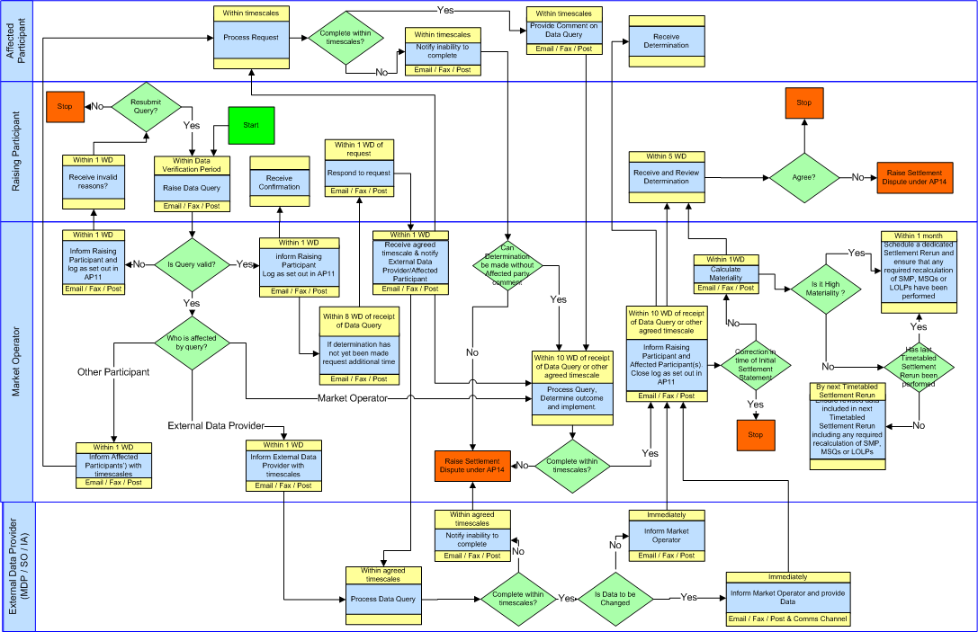
  - Settlement Query – Swim Lane

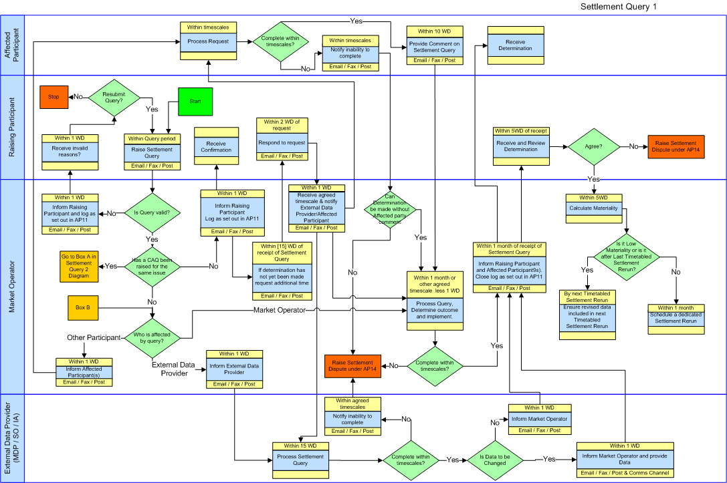

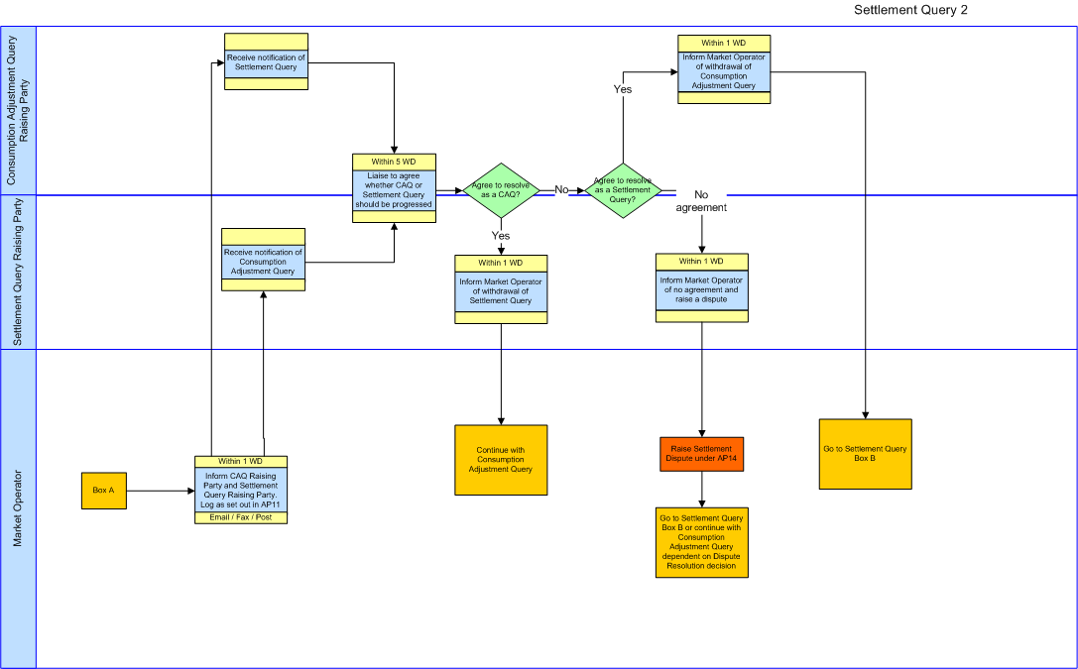
  - Consumption Adjustment Query – Swim Lane
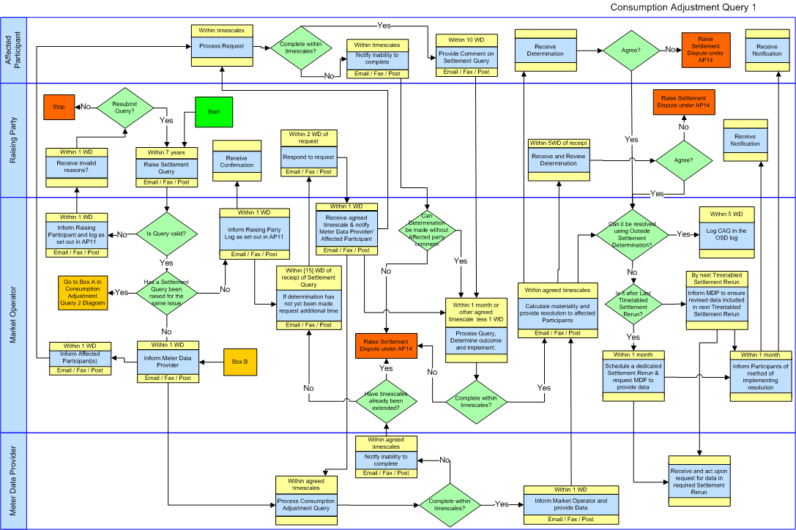

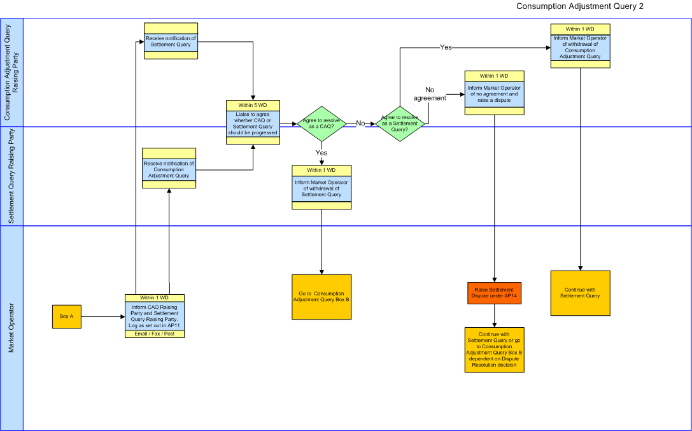
  - Outside Settlement Determination Process – Swim Lane
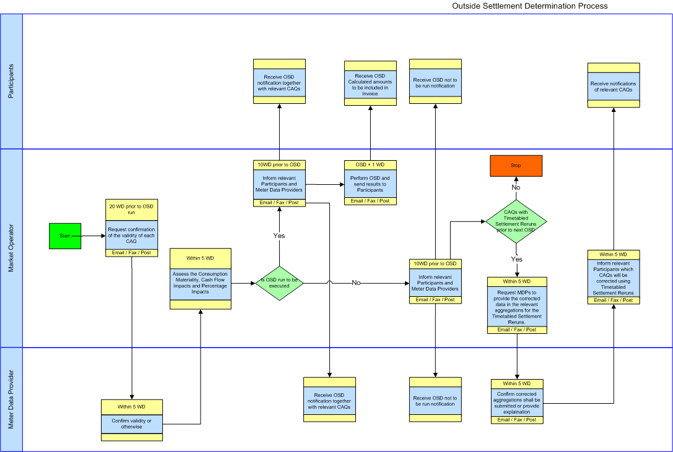
APPENDIX 1: Definitions and Abbreviations

Definitions
Actual Availability | As defined in the Code
Affected Participant | The Participant, not being the Raising Party, who has provided the data being queried or whose data is affected by the data being queried. (This is normally the Participant who has registered the Unit whose data is being queried (if he is not the Raising Party) and the Participant who owns the Error Supplier Unit in the Jurisdiction where the affected Unit is registered).
Billing Period | As defined in the Code
Capacity Charge | As defined in the Code
Capacity Payment | As defined in the Code
Capacity Period | As defined in the Code
Code | As defined in the Code
Consumption Adjustment Query | As defined in the Code
Commercial Offer Data | As defined in the Code
Communication Channel | As defined in the Code
Data Query | As defined in the Code
Data Verification Period | As defined in the Code
Dispatch Quantity | As defined in the Code
Dispute | As defined in the Code
Eligible Availability | As defined in the Code
Error Supplier Unit | As defined in the Code
Ex-Post Loss of Load Probability | As defined in the Code
External Data Provider | A Meter Data Provider, System Operators or Interconnector Administrator.
Help Desk | As defined in Agreed Procedure 11 "Market System Operation, Testing, Upgrading and Support"
High Materiality | As defined in the Code
Initial Settlement Statement | As defined in the Code
Interconnector Administrator | As defined in the Code
Jurisdiction | As defined in the Code
Low Materiality | As defined in the Code
Market Operator | As defined in the Code
Market Schedule Quantity | As defined in the Code
Meter Data Provider | As defined in the Code
Metered Demand | As defined in the Code
Metered Generation | As defined in the Code
Net Demand | As defined in the Code
Outside Settlement Determination | As defined in the Code
Participant | As defined in the Code
Query | A generic reference to a Settlement Query and a Data Query
Raising Party | The Party who raises the Query
Regulatory Authorities | As defined in the Code
Settlement | As defined in the Code
Settlement Day | As defined in the Code
Settlement Dispute | As defined in the Code
Settlement Item | As defined in the Code
Settlement Query | As defined in the Code
Settlement Rerun | As defined in the Code
Settlement Recalculation Threshold | As defined in the Code
System Operator | As defined in the Code
System Marginal Price | As defined in the Code
Technical Offer Data | As defined in the Code
Trading Charges | As defined in the Code
Trading Payments | As defined in the Code
Timetabled Settlement Rerun | As defined in the Code
Unit | As defined in the Code
Working Day | As defined in the Code

Abbreviations

CP | Capacity Period
MO | Market Operator
MSQ | Market Schedule Quantity
SD | Settlement Day
SMP | System Marginal Price
WD | Working Day

APPENDIX 2: Forms
Query Form
This section contains the Query Form. It is presented on the subsequent page.
SETTLEMENT / DATA / CONSUMPTION ADJUSTMENT QUERY FORM
PARTICIPANT INFORMATION
Participant Name
Participant id
SETTLEMENT STATEMENT DETAILS
Settlement Statement Number
Settlement Days in Statement
For Capacity month/year; For Energy dd/mm/yy to dd/mm/yy ; For Data Query dd/mm/yy
Run Type
(Only for Settlement Query – Delete as appropriate)
Initial / Rerun 1 / Rerun 2 / Adhoc
To be completed by Participant
Participant’s Query Ref

Date Sent
To be completed by Market Operator
Market Operator’s Query Ref

Date Received
Form Checked
Descriptive Overview of Query
(Provide a description of what the issue is e.g. the Units affected, the data items concerned, the incorrect charges, whether it is input data or the calculation, the basis of the query(the evidence)
Query Details
(Provide specific details of the items in the Settlement Statement being queried including where appropriate the Supplier/ Generator Unit, the meter ids, the half hours (day and half hour ending time), the specific charge item affected)
Additional Supporting
Documents provided:
Specify Title and number of pages for each supporting document
Title

No of Pages

Authorised Representative (on behalf of Participant)

Name
Signature
Password
Date
Type of Query
SETTLEMENT / DATA / CONSUMPTION ADJUSTMENT
Delete as appropriate
Accepted / Rejected
(delete as appropriate)

Affected Participant Notification Form
PART A – QUERY REFERENCE (to be completed by Market Operator)

MO Reference:Type of Query
Date:DATA / SETTLEMENT

Name (MO Staff):Signature:
PART B - AFFECTED PARTICIPANT DETAILS (To be completed by Market Operator)

Participant id:
Participant Name:

A Data/Settlement Query has been raised by another Party which has a direct affect on the data for your Unit. The Details of the Query are attached. Please submit any comments or views on the query, together with any evidence to support your comments, by the indicated date below.

Date Comments due:

PART C - AFFECTED PARTICIPANT RESPONSE (To be completed by Participant)
(Provide Comments here or on a separate paper document. Whether using a separate paper/document or including comments here, please complete name /authorisation details below)

Affected Party Query Notification Form

Attachments:
Specify Title and number of pages for each attachment

Title

No.of Pages

Authorised Representative
(on behalf of Affected Participant)

Date

Name

Signature

Password

External Data Provider Notification Form
PART A – QUERY REFERENCE (to be completed by Market Operator)

MO Reference: Type of Query
Date: DATA / SETTLEMENT / CONSUMPTION ADJUSTMENT
Data Query Timescale:
(Note settlement query is 15 days max)
Name (MO Staff): Signature:
PART B – EXTERNAL DATA PROVIDER DETAILS (To be completed by Market Operator)

Party id:
Party Name:
Party role: System Operator / Meter Data Provider / Interconnector Administrator

A Data/Settlement/Consumption Adjustment Query has been raised by another Party against the data that you have provided. The Details of the Query are attached. Please review the Query and if necessary resubmit any amended data. Please respond with the results of your analysis, together with any evidence to support your analysis if it is not in agreement with the raised Query.

The update is requested in the following format:
Manual Communication of Change to Specific Items □
Type 2 or Type 3 Communication Channel full resend of all Specific Items (as per Agreed Procedure 16 for Meter Data Providers) □

Date Comments due:

PART C - EXTERNAL DATA PROVIDER RESPONSE (To be completed by External Data Provider)
(Provide response here or on a separate paper document .If data is being resubmitted please indicate when this is expected to be sent using the normal communication channels Whether using a separate paper/document or including comments here, please complete name /authorisation details below)

EXTERNAL DATA PROVIDER NOTIFICATION FORM

Attachments:
Specify Title and number of pages for each attachment

Title

No.of Pages

Authorised Representative
(on behalf of External Data Provider)

Date

Name

Signature

Password

APPENDIX 3: Query Form Validation
The Query Form will have the follow items completed satisfactorily:

Item | Validation
Type of Query | One and only one of Settlement or Data should be struck out.
Participant Name | Must be a registered Participant
Participant id | Must be a registered Participant which aligns with the Participant Name
Settlement Statement Number  (Only used for Data / Settlement Query) | Must be valid Settlement Statement Number
Run Type  (Only used for Data / Settlement Query) | Where it is a Settlement Query then only one of the items must not be struck out. The Run Type must also align with the Settlement Statement Number.
Settlement Days in Statement  (Only used for Data / Settlement Query) | Must be completed as indicated depending on whether it is a Settlement Query for a Capacity Period (month/year) or Billing Period (dd/mm/yy to dd/mm/yy) or a Data Query (dd/mm/yy). The days must align with the Settlement Statement Number.
Descriptive Overview | This must provide information about what is being queried
Query Details | This must provide the specific data items being queried. This should be in sufficient detail to unambiguously allow the data being queried to be identified and where necessary allow a Meter Data Provider to identify the data.
Additional Supporting Documents | The list must align with the additional documents provided in terms of title. If the Query is being sent by fax or post then the number of pages for each document must also be correct. Where it is being emailed the number of pages in each document may be left blank.
Authorised Representative Details: Name | This must be a name of a person from the Participant who is authorised to submit the Form. (Authorisation is provided under Agreed Procedure 11 “Market System Operation, Testing, Upgrading and Support”)
Authorised Representative Details: Signature | If this form is being sent by post or Fax then this must contain the signature of the Authorised Person as registered under Agreed Procedure 11 “Market System Operation, Testing, Upgrading and Support”. If it is being emailed then this should be left blank.
Authorised Representative Details: Password | This must contain the password of the Authorised Person as registered under Agreed Procedure 11 “Market System Operation, Testing, Upgrading and Support”.
Authorised Representative Details: Date | This must be a valid date within the timescales allowed for raising the Query.

In addition the following will be checked:

- The date the form is received by the Market Operator must be within the timescales allowed for raising the Query

APPENDIX 4: Outside Settlement Determination run criteria – Calculation Methods
Calculation of Consumption Materiality
The objective of the materiality calculation is to approximate the materiality associated with the error. The volume error in each Trading Period is multiplied by the sum of the energy price (SMP), Market Operator Charge (MOC) and the Capacity Charge (CC). This is summed over the period of the Consumption Adjustment Query.
The algorithm is:
M = Σ (EVLFh x (SMPh +(IMPy x IMPFh) VMOPh +CCh)) for all Trading Periods h during the error period
h
Where:
- M is the materiality associated with the error;
- EVLFh is the loss adjusted error volume in Trading Period h provided by the Meter Data Provider, adjusted by the appropriate TLAF by the Market Operator;
- SMPh is the half-hourly SMP in Trading Period h
- VMOPh is the appropriate Variable Market Operator Charge in Trading Period h
- CCh is the Capacity Charge for Supplier Units, or the Capacity Payment for Generator Units converted to a MWh figure, as appropriate
- IMPy is the Imperfections Price for Year y
- IMPFh is the Imperfections Charge Factor for Trading Period h.

Calculation of Cash Flow Impact
The objective of the cash flow calculation is to quantify, in relative terms, the cash flow impact on a Participant of waiting until: the next Timetabled Settlement Rerun of each Settlement Day in the error duration to correct the error; or the next scheduled Outside Settlement Determination to correct the error (as appropriate).
The algorithm is:
CFI = Σ (DM x WDd) for all Settlement Days d during the error period
d
Where:
CFI is the relative quantification of the cash flow impact;
- DM is the daily materiality for each Settlement Day in the error duration (taking into account SMP, Market Operator Charges, and Capacity);
- WDd (“wait days”) is:
  - where the Settlement day has not had a Final Timetabled Settlement Run - the number of days between the next scheduled Outside Settlement Determination run and its next Timetabled Settlement Rerun
  - where an ad-hoc Settlement Rerun has been scheduled for a Settlement Day after the Final Timetabled Settlement Rerun - the number of days between the next scheduled Outside Settlement Determination run and the next ad-hoc Settlement Rerun for the Settlement Day
  - where the Settlement day has had a Final Timetabled Settlement Run and no further ad-hoc Settlement Rerun has been scheduled for that Settlement Day – 365 days

The diagram below shows a compressed settlement timetable by way of an example. Blue cells show where the error exists and the daily materiality is €10,000.
Settlement Day 8 has to wait 8 days for its next Timetabled Settlement Rerun, which happens to be the Final Timetabled Settlement Rerun; Settlement Day 9 has to wait 9 days and so on up to Settlement Day 23 that has to wait 23 days. Settlement Day 24 however has to wait 1 day for its next Timetabled Settlement Rerun, which happens to be the 1st Timetabled Settlement Rerun; Settlement Day 25 has to wait 2 days and so on up to Settlement Day 27 that has to wait 4 days.

Consequently the cash flow impact would be quantified as:
10,000 * [(8 + 9 + 10 + 11…..+ 23) + (1 + 2 +3 +4)] = 2,580,000 € days.

The default CFI threshold is set at 10,000,000 € days.

Percentage Impact
The percentage impact is calculated as the total error volume divided by the Participant’s correct total volume expressed as a percentage. This value is compared to the Percentage Impact (PI) figure.

Invoiced Amounts for an Outside Settlement Determination Run
The invoiced amounts calculated for an Outside Settlement Determination run shall utilise the method set out in paragraph 6.102G of the Code. Interest shall also be calculated between the Invoice date of the Initial Settlement Statement for that Settlement Day and the Invoice date of the Outside Settlement Determination run.

