Final Recommendation Report of the Modifications Committee
Report  Reference |  | FRR_03_07 |  | Modification Proposal Reference: |  | Mod_03_07  Appendix J – Change to Day  (SMO)
Date of Issue: |  | 24 August ‘07 |  | Category: |  | Urgent
Report Created By: |  | Modifications Committee |  | Meeting No(s): |  | Meeting 01, 27 July 2007
Reason for Issue: |  | For Regulatory Authority Decision
Section 1
(a) Summary of Modification Committee Recommendations
Mod_03_07 seeks to revise the Code in Appendix J – Change to Day section. The proposal is to remove the term ‘Working Day’ to ‘Day’, which would change the meaning of the term to calendar day.
J.3 The Market Operator shall submit to the System Operators within two Working Days of receipt from a Participant, but no later than 13:00 one Working Day before the Trading Day on which it is to become effective, any update to the Registration Data of any of that Participant's Units. Similarly, the Market Operator shall submit to the System Operators within two Working Days of receipt from the Interconnector Owner or the Interconnector Administrator as appropriate, but no later than 13:00 one Working Day before the Trading Day on which it is to become effective, any update to the Interconnector Registration Data of the relevant Interconnector.
Recommendation Summary
Having considered the Proposed Modification at the abovementioned Meeting, the Modification Committee recommends
- The Proposed Modification should be made
- Implementation date should be Sep 30th 2007
(b) Rationale behind Modification Committee Recommendations
- The SMO cannot deliver a process based on ‘1 Working day’ . If the request that 1 Working Day prevailed, this could mean that any update to the Registration Data of any of that Participant's Units information may have to be provided to TSO in advance of Gate Closure. A large proportion of registration data can be now be changed right up until gate closure.
- The requirement for the SMO to submit any changes to the TSO before 13:00 1 working day in advance of the Trading Day means, for example,
  - gate closure for a Trading Day on a Sunday is at 10:00 on the Saturday.
  - However, the working day prior to Sunday is Friday, at which stage the change in registration data may not have yet been submitted.
  - SMO can deliver a process based on ‘1 calendar day’.
- The SMO submits that the timelines in the Trading and Settlement Code are incorrect and that is why this change is necessary.
Section 2  (a) Summary of Impacted Parties |  |  |  |  | Detail of impact
Generators |  |  | N
Suppliers |  |  | N
TSO |  |  | N
MO |  |  | Y |  | If Approved, Secretariat must make the required Code Updates
PES |  |  | N
(b) Summary of Impacted Documents/Systems |  |  |  |  | Detail of impact
Code Provisions |  |  | Y |  | J.3 wording as detailed below
Business Processes |  |  | N
Legal requirements |  |  | N
Grid Code |  |  | N
Other |  |  | N
Systems |  |  | N |  | N/A if implemented, as the systems have been built to the Proposed Modified version of the Code
  - Proposed Modification (Original Draft)
This section contains the text of the original draft of the modification proposal
J.3 The Market Operator shall submit to the System Operators within two Working Days of receipt from a Participant, but no later than 13:00 one Working Day before the Trading Day on which it is to become effective, any update to the Registration Data of any of that Participant's Units. Similarly, the Market Operator shall submit to the System Operators within two Working Days of receipt from the Interconnector Owner or the Interconnector Administrator as appropriate, but no later than 13:00 one Working Day before the Trading Day on which it is to become effective, any update to the Interconnector Registration Data of the relevant Interconnector.

Modification Proposal Justification
Working day cannot be delivered. We can deliver 1 calendar day. One Working Day could mean that the information is supposed to be provided prior to Gate Closure.
Implication of not implementing the Modification
MSP Software will not be aligned with the Code.

(d) Proposed Modification (Recommended for Approval by Committee)
This section contains the text of the Approved version of the modification proposal (If different from above)
N/A – as above

(e) Details of Alternative proposal raised
If appropriate, a later version or a resubmitted Modification Proposal details should be entered here

N/A

(f) Dissenting or Other Opinions
This section contains a summary of any objections to the approved modification proposal/ if appropriate, or feedback from the following: MO, TSO, Industry Expert or Consultant opinions
The Implication of not implementing the Modification Proposal was stated as follows:
MSP Software will not be aligned with the Code.
Comment from G Blaney, Generator member was that: In principle the system should be aligned with the Code. The code should not change to reflect what the system does; the ‘Implications’ wording should be reworded in future Proposals so as not to imply that. MO to take this into consideration for future Mods.

Section 3
Results of Modification Consultation
Q. | Consultation Question |  |  |  |  | Yes | No | Neutral
 | N/A

Section 4
(a) Committee’s Final Recommendation to the Regulatory Authority
On the basis of the above discussions, the Committee agreed a UNANIMOUS/MAJORITY Recommendation to the RA’s that this Proposed Modification SHOULD/SHOULD NOT be made

On the basis of the Proposal which incorporates the ORIGINAL/REVISED wording as detailed in Section 2.

(b) The Committee Recommends the following Implementation Approach and Timelines
The Implementation Date of the Proposal should be: 30TH September 2007
Assuming the RA Decision is made on/before [DATE]: N/A
Or no earlier than: [DATE]
Or no later than: [DATE]
(c) Proposed Modification Implementations Cost
This section contains a summary of the cost associated with implementing the proposed modification.
Cost (€) | Vendor | SMO | Total Cost (€)
(d) Proposed Modification Estimated Effort Time
This section contains details of the effort time required to design and develop the proposed modification.Include Detailed description of long it will take to perform each change
Effort Time (man days)  (list each change below) | Vendor | SMO | Total Effort Time
Update the T and S Code |  | ½ day | ½ day
Please complete this form and return it to Secretariat by e-mail to Modifications@allislandmarket.com

Appendix 1 SMO Slides on Mod _03 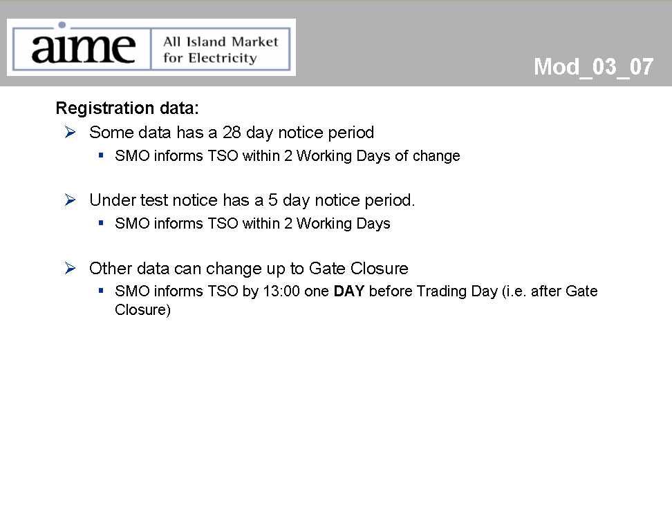
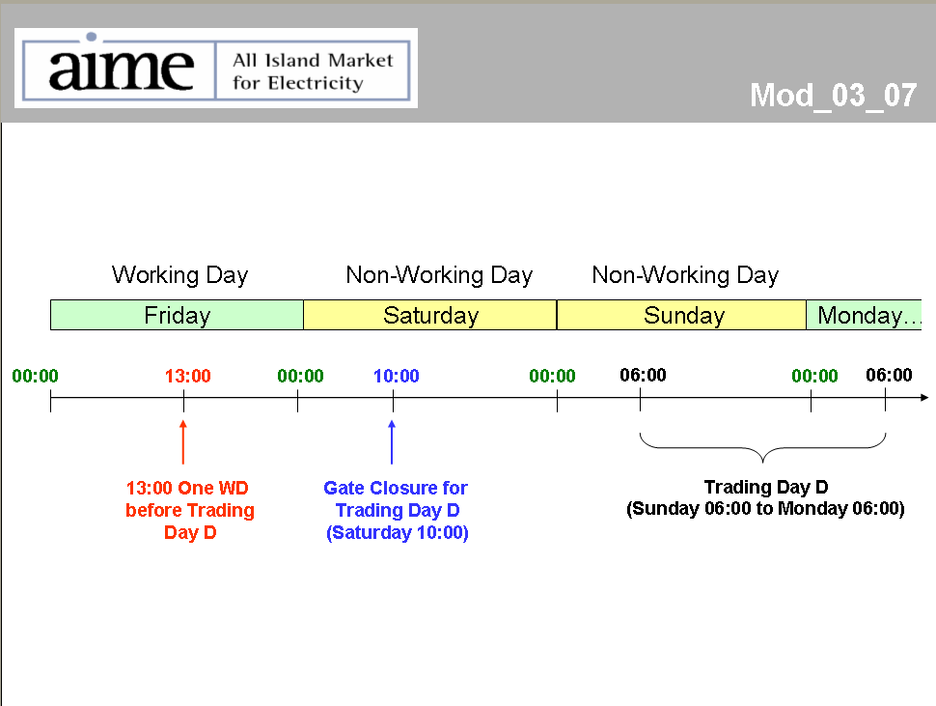

Note: These man days and costs may need to reflect a combination of Vendor costs and SMO additional costs. Any further modifications to the outline rules may have an impact both on the estimated costs and the estimated implementation date of the change.

