Final Recommendation Report of the Modifications Committee
Report  Reference |  | FRR_04_07 |  | Modification Proposal Ref: |  |  | Mod_04_07 Ex Ante Availability for Price Maker Units Derivation of Price Quantity Pairs (SMO)
Date of Issue: |  | 24 Aug. 07 |  | Category: |  |  | Urgent
Report Created By: |  | Modifications  Committee |  | Meeting No(s): |  |  | Meeting 01
Reason for Issue: |  | For Regulatory Authority Decision
Section 1
(a) Summary of Modification Committee Recommendations
Mod_04_07 seeks to revise the Code Sections N.37, N.47 as follows:

N.37 Modification: Ex-Ante Availability for Price maker Units
- The Accepted Forecast Availability Profile is used to set the values for Availability of Price Maker Wind Units. There is no calculation to set the availability equal to the minimum of this value and the forecast Output, as is currently stated in the T&SC.

  - Forecast Availability Profile for Price Maker Wind Generator Units is submitted by participant as TOD.

N.47 Modification: Derivation of Price Quantity Pairs for Interconnector Units
- The PQ pairs are used differently for Ex-Ante and Ex-Post runs of the MSP software, which is not currently stated in the T&SC. This modification is to clarify what is used for Ex-Ante and what is used for Ex-Post.

- In Ex-Ante, the PQ pairs used for the last 6 hours of the optimisation time horizon are PQ pairs associated with the corresponding TPs within the Trading day i.e. 24 hours earlier.

In Ex-Post, the PQ pairs used in the last 6 hours of the optimisation time horizon are PQ pairs submitted for the TD associated with those TPs, i.e. the PQ pairs submitted at Gate Closure for the following Trading Day.
Recommendation Summary
Having considered the Proposed Modification at the abovementioned Meeting, the Modification Committee recommends
- The Proposed Modification should be made
- With Implementation date of 30th September 2007

(b) Rationale behind Modification Committee Recommendations
1. N.37: The SMO systems are not in line with the Code. the Committee does not believe there was a material reason for now not to change the T&SC wording so that the System is aligned.

Availability for Price Maker Wind Units is set to the Forecast Availability Profile. The values used to calculate MSQs for Variable Price Taker Units that are Wind Power Units is defined in N.55.

2. N.47 The System treats the Price Quantity Pairs differently than is set out in the Code , but the treatment in the system is more correct than the Code. As a result, N.47 needs to be amended to reflect the correct treatment.
Section 2  (a) Summary of Impacted Parties |  |  |  |  | Detail of impact
Generators |  |  | N
Suppliers |  |  | N
TSO |  |  | N
MO |  |  | Y |  | If Approved, Secretariat must make the required Code Updates
PES |  |  | N
(b) Summary of Impacted Documents/Systems |  |  |  |  | Detail of impact
Code Provisions |  |  | Y |  | N.37, N.47 to be updated as requested
Business Processes |  |  | N
Legal requirements |  |  | N
Grid Code |  |  | N
Other |  |  | N
Systems |  |  | N |  | N/A if implemented, as the systems have been built to the Proposed Modified version of the Code
(c) Proposed Modification (Original Draft)
This section contains the text of the original draft of the modification proposal
N.37 For the purposes of each Ex-Ante Indicative MSP Software Run, the values of Availability for each Trading Period h in the Optimisation Time Horizon for all Price Maker Generator Units u that are not Under Test shall be set by the Market Operator to equal the Accepted Forecast Availability Profile values which are submitted as part of Technical Offer Data, except that:
- for Interconnector Units, the Availability in Trading Period h shall be set to be equal to the lesser of the Maximum Interconnector Unit Import Capacity and the Active Interconnector Unit Import Capacity Holding. If no Active Interconnector Unit Import Capacity Holding is available then a value of zero shall be used in its place;
- for Wind Power Units, the Availability in Trading Period h shall be set to equal the lesser of the accepted Forecast Availability Profile value and the forecast Output (based on the Wind Power Unit Forecast).

N.47 Subject to paragraph N.48, the Price Quantity Pairs to be used in each MSP Software Run shall be as follows:
- For an Interconnector Unit the relevant Price Quantity Pairs for each Trading Period in the Optimisation Time Horizon shall apply only over the range from the Minimum Stable Generation to the Availability in Trading Period h, where for each Trading Period h in the Optimisation Time Horizon:
- the Price of the first Price Quantity Pair to have a Quantity exceeding the Minimum Stable Generation shall apply between the Minimum Stable Generation and that Quantity;
- the Price of the last Price Quantity Pair to have a Quantity less than the Availability shall apply between that Quantity and the Availability,
where the relevant Price Quantity Pairs for Trading Period h within the first Trading Day of the Optimisation Time Horizon are the Accepted Price Quantity Pairs submitted in Commercial Offer Data for that Interconnector Unit and Trading Period, as modified in accordance with paragraph N.48,. The while the Price Quantity Pairs used for each Trading Period h in the Ending Overlap Optimisation Period for Ex Ante Indicative MSP Runs are the Price Quantity Pairs for that same Interconnector Unit and the corresponding Trading Period h in the Trading Day associated with the Optimisation Time Horizon. For all Ex Post MSP Runs, the submitted Price Quantity Pairs for the relevant Trading Period in the relevant Trading Day will be used.
- For Price Maker Generator Units that are not Under Test, other than Interconnector Units and Pumped Storage Units, the relevant Price Quantity Pairs for each Trading Period in the Optimisation Time Horizon shall apply only over the range from the Minimum Output to the Availability in Trading Period h, where for each Trading Period h in the Optimisation Time Horizon:
- the Price of the first Price Quantity Pair to have a Quantity exceeding zero is to apply between zero and that Quantity;
- the Price of the last Price Quantity Pair to have a Quantity less than the Availability is to apply between that Quantity and the Availability,
where the relevant Price Quantity Pairs for each Trading Period h in the Optimisation Time Horizon are to be the Price Quantity Pairs in Commercial Offer Data for that Generator Unit for the Trading Day, as modified in accordance with paragraph N.48.
Where for the avoidance of doubt, the values of Availability and Minimum Stable Generation for each MSP Software Run Type shall be as defined in paragraphs N.37 to N.39 and N.40 to N.42 as applicable.
Modification Proposal Justification
N.37:
The second clause of N.37 is not correct, as Availability for Price Maker Wind Units is set to the Forecast Availability Profile. The values used to calculate MSQs for Variable Price Taker Units that are Wind Power Units is defined in N.55.
N.47: Price Quantity Pairs are used differently in Ex Ante Indicative and Ex Post Indicative and Initial MSP Runs. As a result, N.47 needs to be amended to reflect the correct treatment.
Implication of not implementing the Modification
MSP Software will not be aligned with the Code.
(d) Proposed Modification (Recommended for Approval by Committee)
This section contains the text of the Approved version of the modification proposal
N/A – as above
(e) Details of Alternative proposal raised
If appropriate, a later version or a resubmitted Modification Proposal details should be entered here
N/A
(f) Dissenting or Other Opinions
This section contains a summary of any objections to the approved modification proposal/ if appropriate, or feedback from the following: MO, TSO, Industry Expert or Consultant opinions
The original implication of not implementing the Modification Proposal was stated as follows:
MSP Software will not be aligned with the Code. The comment from G Blaney, Generator member was that: : In principle the system should be aligned with the Code. The code should not change to reflect what the system does; the ‘Implications’ wording should be reworded in future Proposals so as not to imply that. MO to take this into consideration for future Mods.
The Chair does not believe the Code is incorrect. It is Committee’s intention to monitor whether a MOD is required post November 1st to change this back to the original wording.
Section 3
Results of Modification Consultation
Q. | Consultation Question |  |  |  |  | Yes |  | No | Neutral
 | N/A

Section 4
(a) Committee’s Final Recommendation to the Regulatory Authority
On the basis of the above discussions, the Committee agreed a UNANIMOUS/MAJORITY Recommendation to the RA’s that this Proposed Modification SHOULD/SHOULD NOT be made

On the basis of the Proposal which incorporates the ORIGINAL/REVISED wording as detailed in Section 2.

(b) The Committee Recommends the following Implementation Approach and Timelines
The Implementation Date of the Proposal should be: 30TH September 2007
Assuming the RA Decision is made on/before [DATE]: N/A
Or no earlier than: [DATE]
Or no later than: [DATE]
(c) Proposed Modification Implementations Cost
This section contains a summary of the cost associated with implementing the proposed modification.
Cost (€) | Vendor | SMO | Total Cost (€)
(d ) Proposed Modification Estimated Effort Time
This section contains details of the effort time required to design and develop the proposed modification.Include Detailed description of long it will take to perform each change
Effort Time (man days)  (list each change below) | Vendor | SMO | Total Effort Time
Update the T and S Code |  | ½ day | ½ day
Please complete this form and return it to Secretariat by e-mail to Modifications@allislandmarket.com

Appendix 1 SMO Slides

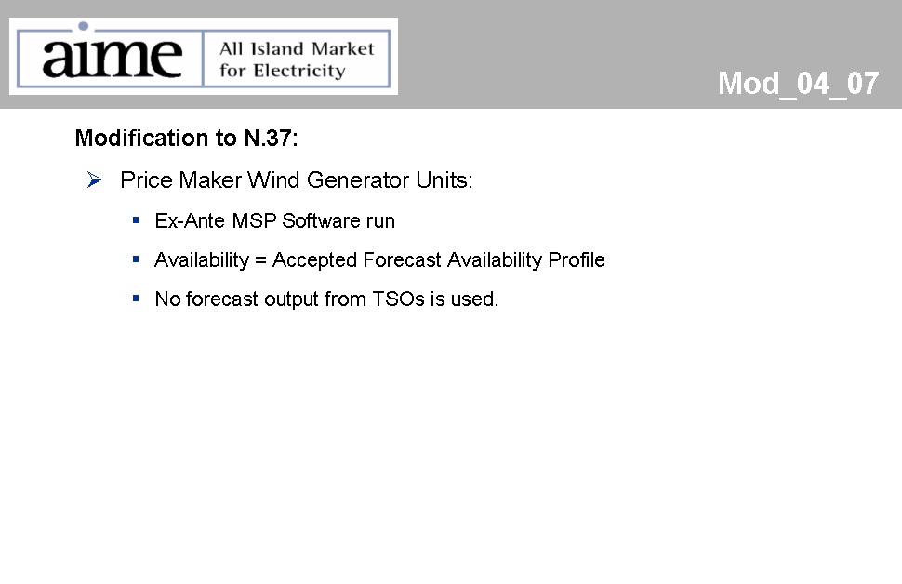
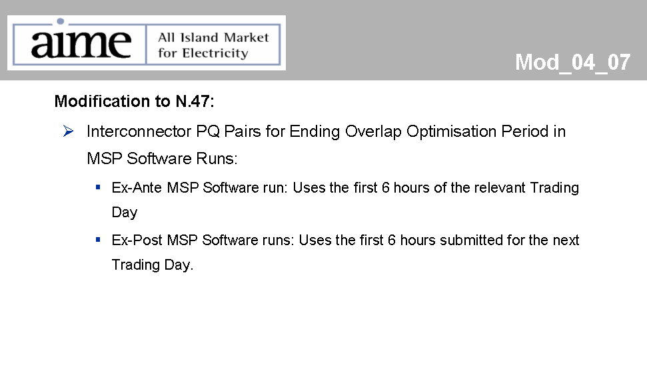
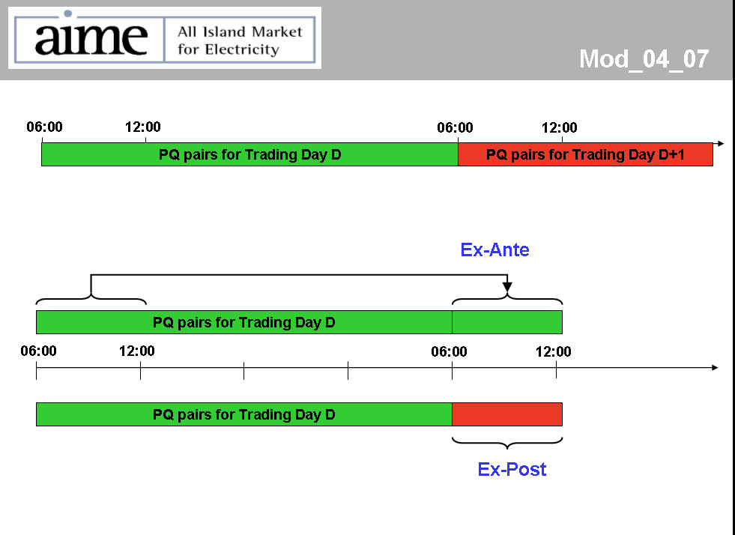

Note: These man days and costs may need to reflect a combination of Vendor costs and SMO additional costs. Any further modifications to the outline rules may have an impact both on the estimated costs and the estimated implementation date of the change.

