Final Recommendation Report of the Modifications Committee
Report  Reference |  | FRR_07_07 |  | Modification Proposal Reference: |  |  | Mod_07_07  Calculation of DOP, MOP, DQCC & MQCC  (SMO)
Date of Issue: |  | 28 Aug. 07 |  | Category: |  |  | Urgent
Report Created By: |  | Modification Committee |  | Meeting No(s): |  |  | Meeting 01
Reason for Issue: |  | For Regulatory Authority Decision
Section 1
(a) Summary of Modification Committee Recommendations
Mod_07_07 seeks to revise the Code Sections 4.133, 4.134, 4.137,4.137
- The associated offer price for any dispatch or market quantity is the price of the PQ pair with the closest quantity above that dispatch or market quantity.
E.g. if a generator has the following PQ pairs:
- P₁ = 10, Q₁=50
- P₂ = 20, Q₂ = 100
- P₃ = 30, Q₃ =150.
The offer price associated with a quantity of 120 is 30. The offer price associated with 80 is 20.
- In the T&SC at present, if the market or dispatch quantity exceeds the greatest quantity, there is no way of setting the associated offer price. This modification seeks to amend the Code by setting the associated price equal to the greatest price submitted in the PQ pairs.
- In the MSP software this is catered for in clause 4.14, but this does not refer to how it should be calculated for Settlements (which are not part of the MSP Software).
- Therefore, for the example above, the associated price for a dispatch or market quantity of 160 is 30.

Recommendation Summary
Having considered the Proposed Modification at the abovementioned Meeting, the Modification Committee recommends
- The Proposed Modification should be Made
- With Implementation date of 20th September 2007

(b) Rationale behind Modification Committee Recommendations
There is an ommission in the Code. The Modification proposed addresses the gaps in the appropriate section of the Code.
Section 2  (a) Summary of Impacted Parties |  |  |  |  | Detail of impact
Generators |  |  | N
Suppliers |  |  | N
TSO |  |  | N
MO |  |  | Y |  | If Approved, Secretariat must make the required Code Updates
PES |  |  | N
(b) Summary of Impacted Documents/Systems |  |  |  |  | Detail of impact
Code Provisions |  |  | Y |  | Sections 4.133, 4.134, 4.137,4.137
Business Processes |  |  | N
Legal requirements |  |  | N
Grid Code |  |  | N
Other |  |  | N
Systems |  |  | N |  | N/A if implemented, as the systems have been built to the Proposed Modified version of the Code
- Proposed Modification (Original Draft)
This section contains the text of the original draft of the modification proposal
  - The Market Operator shall calculate the Market Offer Price for Generator Unit u in Trading Period h (MOPuh) as follows:
if MSQuh ≤ Quh1, then MOPuh = Puh1,
else MOPuh = Puhi,
where i satisfies:
- the equation: Quh(i-1)< MSQuh ≤Quhi or
- MSQuh >Quhi, where Quhi is the Quantity of the last Price Quantity Pair to have a Quantity less than or equal to the Availability.
Where
- MSQuh is the Market Schedule Quantity for Generator Unit u in Trading Period h;
- Puhi is the ith Price Accepted for Generator Unit u applicable to Trading Period h;
- Quhi is the ith Quantity for Generator Unit u applicable to Trading Period h.

  - The Market Operator shall calculate the Dispatch Offer Price for Generator Unit u in Trading Period h (DOPuh) as follows:
if DQuh ≤ Quh1, then DOPuh = Puh1,
else DOPuh = Puhi,
where i satisfies:
- the equation Quh(i-1) < DQuh ≤ Quhi or
- DOuh >Quhi, where Quhi is the Quantity of the last Price Quantity Pair to have a Quantity less than or equal to the Availability.
Where
- DQuh is the Dispatch Quantity for Generator Unit u in Trading Period h;
- Puhi is the ith Price for Generator Unit u applicable to Trading Period h;
- Quhi is the ith Quantity for Generator Unit u applicable to Trading Period h.

  - The Market Operator shall calculate the Market Schedule Quantity Cost Correction (MSQCCuh) for Generator Unit u in Trading Period h as follows:
- Let n = the number of Accepted Price Quantity Pairs for Generator Unit u applicable to Trading Period h;
- The integer k is defined as the smallest integer such that Quhk is greater than zero. If Quhn is zero or negative, then k=n+1;
- Let:
$\text{CCXuhk}=0$
$\text{CCXuhn}=\text{CCXuh}(n+1)$(this equation is only required if k=n+1)
$\text{CCXuhi}=\text{CCXuh}(i−1)+(\text{Puh}(i−1)−\text{Puhi})×\text{Quh}(i−1)$, for each i in the range Max{2,k+1} ≤ i ≤ n in ascending order of i
$\text{CCXuh}(i−1)=\text{CCXuhi}−(\text{Puh}(i−1)−\text{Puhi})×\text{Quh}(i−1)$ for each i in the range Min{k,n} ≥ i ≥ 2 in descending order of i
if MSQuh ≤ Quh1 then MSQCCuh = CCXuh1
else $\text{MSQCCuh}=\text{CCXuhx}$
where x is an integer which satisfies:
  - the equation $\text{Quh}(x−1)<\text{MSQuh}≤\text{Quhx}$; or
  - MSQuh >Quhx, where Quhx is the Quantity of the last Price Quantity Pair to have a Quantity less than or equal to the Availability.
- The subscripts x and k are re-set after each value of MSQCCuh is determined. $\text{CCXuhi}$are local variables used for the determination of MSQCCuh.
  - The Market Operator shall calculate the Dispatch Quantity Cost Correction (DQCCuh) as follows:
- Let n = the number of Accepted Price Quantity Pairs for Generator Unit u applicable to Trading Period h;
- The integer k is defined as the smallest integer such that Quhk is greater than zero. If Quhn is zero or negative, then k=n+1;
- Let:
$\text{CCXuhk}=0$
$\text{CCXuhn}=\text{CCXuh}(n+1)$(this equation is only required if k=n+1)
$\text{CCXuhi}=\text{CCXuh}(i−1)+(\text{Puh}(i−1)−\text{Puhi})×\text{Quh}(i−1)$, for each i in the range Max{2,k+1} ≤ i ≤ n in ascending order of i
$\text{CCXuh}(i−1)=\text{CCXuhi}−(\text{Puh}(i−1)−\text{Puhi})×\text{Quh}(i−1)$, for each i in the range Min{k,n} ≥ i ≥ 2 in descending order of i
if DQuh ≤ Quh1 then DQCCuh = CCXuh1
else $\text{DQCCuh}=\text{CCXuhx}$,
where x is an integer which satisfies:
  - the equation$\text{Quh}(x−1)<\text{DQuh}≤\text{Quhx}$; or
  - DQuh >Quhx, where Quhx is the Quantity of the last Price Quantity Pair to have a Quantity less than or equal to the Availability.
- The subscripts x and k are re-set after each value of DQCCuh is determined. $\text{CCXuhi}$ are local variables used for the determination of DQCCuh.
Modification Proposal Justification
There appears to be a gap in the Code for the calculation of DOP, MOP, DQCC & MSQCC where MSQ > Quhi or DQ > Quhi, where i is the highest bid quantity.
Implication of not implementing the Modification
In the event that MSQ or DQ exceeds Quhi, MSP Software will not be aligned with the Code.
- Proposed Modification (Recommended for Approval by Committee)
This section contains the text of the Approved version of the modification proposal, if different from above
N/A- as above

- Details of Alternative proposal raised
If appropriate, a later version or a resubmitted Modification Proposal details should be entered here
N/A

- Dissenting or Other Opinions
This section contains a summary of any objections to the approved modification proposal/ if appropriate, or feedback from the following: MO, TSO, Industry Expert or Consultant opinions
N/A

Section 3
Results of Modification Consultation
Q. | Consultation Question |  |  |  |  | Yes |  | No | Neutral
 | N/A

Section 4
(a) Committee’s Final Recommendation to the Regulatory Authority
On the basis of the above discussions, the Committee agreed a UNANIMOUS/MAJORITY Recommendation to the RA’s that this Proposed Modification SHOULD/SHOULD NOT be made

On the basis of the Proposal which incorporates the ORIGINAL/REVISED wording as detailed in Section 2.

(b) The Committee Recommends the following Implementation Approach and Timelines
The Implementation Date of the Proposal should be on:30th September 2007
Assuming the RA Decision is made on/before [DATE]: N/A
Or no earlier than: [DATE]
Or no later than: [DATE]
(c) Proposed Modification Implementations Cost
This section contains a summary of the cost associated with implementing the proposed modification.
Cost (€) | Vendor | SMO | Total Cost (€)
(d) Proposed Modification Estimated Effort Time
This section contains details of the effort time required to design and develop the proposed modification.Include Detailed description of long it will take to perform each change
Effort Time (man days)  (list each change below) | Vendor | SMO | Total Effort Time
Update the T and S Code |  | ½ day | ½ day
Please complete this form and return it to Secretariat by e-mail to Modifications@allislandmarket.com

Appendix 1 – SMO Slides
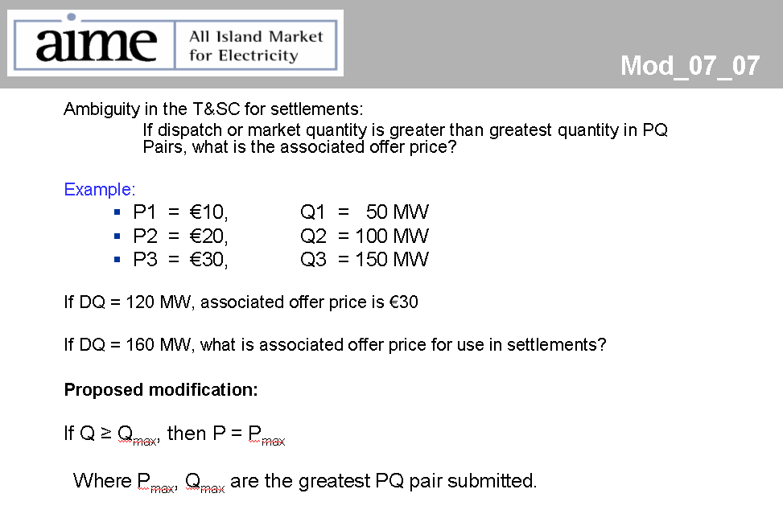

Note: These man days and costs may need to reflect a combination of Vendor costs and SMO additional costs. Any further modifications to the outline rules may have an impact both on the estimated costs and the estimated implementation date of the change.

