Final Recommendation Report of the Modifications Committee
Report  Reference |  | FRR_08_07 |  | Modification Proposal Reference: |  |  | Mod_08_07 Application of Pumped Storage Ramp Rates (SMO)
Date of Issue: |  | 27-Aug-07 |  | Category: |  |  | Urgent
Report Created By: |  | Modifications Committee |  | Meeting No(s): |  |  | Meeting 01, Meeting 02
Reason for Issue: |  | For Regulatory Authority Decision
Section 1
(a) Summary of Modification Committee Recommendations
Mod_08_07 seeks to revise the Code Section 5.121
- The MSP Software is based on the principle of convexity. This was agreed in discussions with participants in April/May 2006. In order to have a convex problem, a single ramp rate is implemented for each Generator Unit. The T&SC V2.0 caters for a single ramp rate being applied for Pumped Storage when the Unit is generating, and an infinite ramp rate being applied when the unit is Pumping. However, in order to have a convex problem, the single ramp rate is required to be implemented across the full range of the Pumped Storage Generator Unit.

- The T&SC at present only caters for a single ramp rate being applied in the MSP Software when the output from the pumped storage unit is positive. The systems do apply this single ramp rate, but it is applied to both positive and negative output. Therefore, there is one single ramp rate in the systems, and this ramp rate is applied when the unit is changing to/from pumping and increasing/decreasing generation.

- The generation ramp rate for a pumped storage unit is very high, so it will reasonably approximate the switching on and off of the pumps and it is very likely that this will have no impact on the outcome of the MSP Software over any 30 minute Trading Period.

- MO expert opinion stated that if as long as the Ramp Rate exceeds 5 MW/min, then it will have negligible impact on the MSP Software schedule.

- Participants required an impact assessment on MSP software and settlements. This was completed and circulated and will be included in this Final Recommendation report.

Recommendation Summary
Having considered the Proposed Modification at Meeting 1 and the SMO response to a request for Impact Analysis at Meeting 2, the Modification Committee recommends
- The Proposed Modification should be Made
- With Implementation date of 30th September 2007

(b) Rationale behind Modification Committee Recommendations
- The interpretation given to the Code in the Systems was in accordance with the Principle of Convexity, which was agreed in discussions with participants in April/May 2006. However, in order to have a convex problem, the single ramp rate is required to be implemented across the full range of the Pumped Storage Generator Unit.

- The MO Member conveyed the fact that the current System is built in accordance with the Proposed Modification and stated that to do a full Impact assessment to amend the current system. would require a Change request which would take 5-7 weeks to formulate through discussions with the RAs and the Participants, before giving to the Vendors, this would impact on Market Trial resources.

- SEM Paper has been drafted giving assurance that the MSQs will be unaffected by the application of the Single Ramp Up Rate or Single Ramp Down Rate.

Section 2  (a) Summary of Impacted Parties |  |  |  |  | Detail of impact
Generators |  |  | Y |  | See White Paper: there should be no impact on Participants or systems as long as systems are left as they were designed
Suppliers |  |  | N
TSO |  |  | N
MO |  |  | Y |  | Secretariat must make the required Code Updates
PES |  |  | N
(b) Summary of Impacted Documents/Systems |  |  |  |  | Detail of impact
Code Provisions |  |  | Y |  | 5.121
Business Processes |  |  | N
Legal requirements |  |  | N
Grid Code |  |  | N
Other |  |  | N
Systems |  |  | N |  | N/A if approved, as the systems have been built to the Proposed Modified version of the Code
- Proposed Modification (Original Draft)
This section contains the text of the original draft of the modification proposal
  - The Market Operator shall procure that within the Technical Offer Data or Generator Unit Technical Characteristics for each Pumped Storage Unit, the submitted values of Ramp Rate shall be applied within the MSP Software only to levels of Output that are positive or negative, other than for the calculation of Dispatch Quantities as part of Instruction Profiling.

Modification Proposal Justification

The MSP Software applies Pumped Storage Unit ramp rates differently in the calculation of MSQs (scheduling) and Dispatch Quantities (Instruction Profiling). This change clarifies the implementation.

Implication of not implementing the Modification

MSP Software will not be compliant with the Code.

- Proposed Modification (Recommended for Approval by Committee)
This section contains the text of the Approved version of the modification proposal, if different from above
N/A – As above
- Details of Alternative proposal raised
If appropriate, a later version or a resubmitted Modification Proposal details should be entered here
N/A
- Dissenting or Other Opinions
This section contains a summary of any objections to the approved modification proposal/ if appropriate, or feedback from the following: MO, TSO, Industry Expert or Consultant opinions
  - Participants noted that another Modification could be raised later with regard to this, should the Modification not meet their requirements at a later date.
- Comment from G Blaney on process; The code should not change to reflect what the system does; the software should in principle be compliant with the Code
Section 3
Results of Modification Consultation
Q. | Consultation Question |  |  |  |  | Yes |  | No | Neutral
 | N/A

Section 4
(a) Committee’s Final Recommendation to the Regulatory Authority
On the basis of the above discussions, the Committee agreed a UNANIMOUS/MAJORITY Recommendation to the RA’s that this Proposed Modification SHOULD/SHOULD NOT be made

On the basis of the Proposal which incorporates the ORIGINAL/REVISED wording as detailed in Section 2.

(b) The Committee Recommends the following Implementation Approach and Timelines
The Implementation Date of the Proposal should be on: 30th September 2007
Assuming the RA Decision is made on/before [DATE]: N/A
Or no earlier than: [DATE]
Or no later than: [DATE]
(c) Proposed Modification Implementations Cost
This section contains a summary of the cost associated with implementing the proposed modification.
Cost (€) | Vendor | SMO | Total Cost (€)
(d) Proposed Modification Estimated Effort Time
This section contains details of the effort time required to design and develop the proposed modification.Include Detailed description of long it will take to perform each change
Effort Time (man days)  (list each change below) | Vendor | SMO | Total Effort Time
Update the T and S Code |  | ½ day | ½ day
Please complete this form and return it to Secretariat by e-mail to Modifications@allislandmarket.com

Appendix 1 – SMO Slides

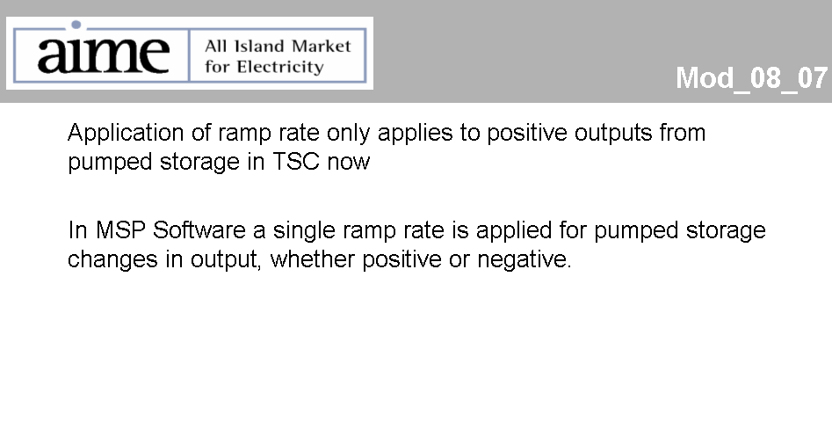
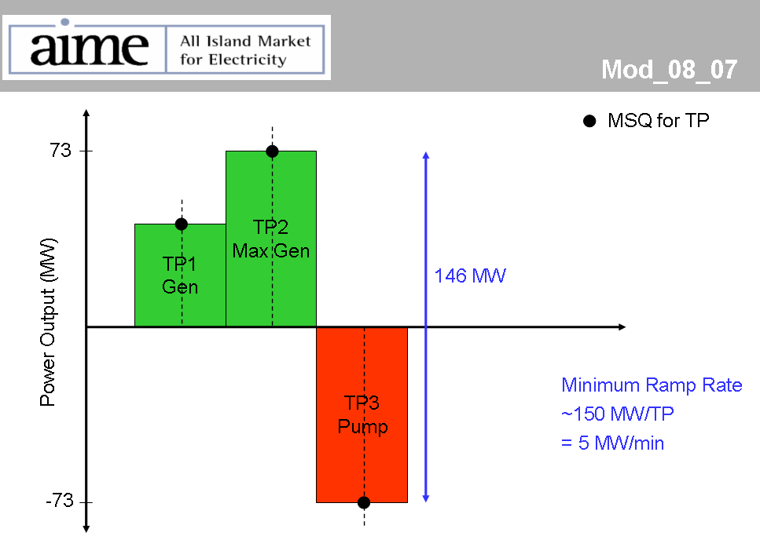

Appendix 2 Discussion Document – Pumped Storage Ramp Rates when Pumping

SEM Establishment Programme

Title: | Discussion Document – Pumped Storage Ramp Rates when Pumping
Version: | 1.0
Date: | 20 August 2007

Document History

Version | Date | Author | Comment
1.0 | 20-08-2007 | SEM Programme | Clarification of the application of Pumped Storage Unit ramp rates when pumping.

Related Documents

Document Title | Version | Date | By
Trading and Settlement Code | V2.0 | 31-05-2007 | Regulatory Authorities

Introduction

At the Modifications Committee meeting on 27 July 2007, modification MOD_08_07 was deferred to allow more information to be provided. This modification proposed a change to the Code, as the SEM systems apply ramp rates to Pumped Storage Units when generating and when pumping (via the application of a Single Ramp Rate or Single Ramp Down Rate as described in N.33).

Pumped Storage Units may operate at output levels greater than or equal to zero (generating) and less than or equal to zero (pumping). Such operating modes are required by dispatch instructions provided by the relevant TSO.

This paper provides clarification of the current SEM system design and the impact of the current design in relation to the MSP Software and settlement calculations.

Provisions of the Code in Relation to Technical Offer Data

The Code contains restrictions on the values that can be submitted for various Technical Offer Data and Commercial Offer Data by Market Participants in relation to Generator Units. This includes restrictions on the values for Pumped Storage Units.

In addition to specific restrictions and requirements in the Code, I.12 of the Code requires that: “Data shall be submitted in respect of a Generator Unit such that it is consistent with data submitted for that Unit under the applicable Grid Code, scaled, where appropriate, by the appropriate Distribution Loss Adjustment Factor as set out in paragraph 4.27”.

Current SEM Systems Implementation

Currently, the SEM systems apply the calculated Single Ramp Up Rate and Single Ramp Down Rate to all levels of output for pumped storage (including when pumping i.e. periods of consumption).

As a result, if the Single Ramp Up Rate and Single Ramp Down Rate are both calculated as 5MW per minute, the MSP Software will constrain ramping of Pumped Storage Units (at all levels) to 150MW per Trading Period. If the MW range from Maximum Generation to Maximum Pumping for the Pumped Storage Unit is less than 150 MW, then a ramp rate of 5 MW/min will result in no constraint on any change in output of the Pumped Storage Unit from one Trading Period to the next in the MSP Software.

Impact of Current SEM Systems Implementation

As currently designed, the changes in output between Trading Periods are constrained by the relevant Single Ramp Rate by the MSP Software. However, the MSP Software works only at a Trading Period resolution (i.e. it does not model within-period changes). Therefore, if the Single Ramp Rate exceeds the maximum change between adjacent Trading Periods, then the MSP Software will not be constrained by the ramp rate. The MSP Software calculates MSQ and SMPs, which are subsequently used in settlement. Hence, if the application of Ramp Rates for Pumped Storage Units does not affect the MSP Software, it will also not affect settlement.

As a result, changes in output greater than 7MW per minute would allow a Pumped Storage Unit to ramp from a Minimum Output level of -100MW and an Availability of 100MW between two consecutive Trading Periods without any ramping constraints being binding. Similarly, a Single Ramp Rate exceeding 10MW/min will allow a change in output of 300MW per Trading Period without ramping constraints becoming binding.

Using the published Regulatory Authority data being used for the “Market Simulation Model Validation”, then the limits of interest for pumped Storage Units and the implied ramping rates per Trading Period are as follows:

Unit ID | Minimum Output (assumed equal to the negative value of the Max Capacity) | Max Capacity (MW) | Ramp Rate Up MW/min | Calculated Time To Ramp From Minimum Output and Max Capacity
TH1 | -73 | 73 | 210 | 42 seconds
TH2 | -73 | 73 | 210 | 42 seconds
TH3 | -73 | 73 | 210 | 42 seconds
TH4 | -73 | 73 | 210 | 42 seconds

Conclusions

Assuming that the data used by the Regulatory Authority modelling is close to accurate, the MSQs of Pumped Storage Units or any other Generating Units will be unaffected by the application of the Single Ramp Up Rate or Single Ramp Down Rate for levels or Pumped Storage Unit output that are less than zero (i.e. pumping).

In fact, a Single Ramp Up Rate and Single Ramp Down Rate of 5MW per Trading Period or greater will ensure that the ramp constraint when pumping will not bind. Evidence from the data used in Market Trial confirms that it is extremely unlikely that this constraint will ever be binding, including after Go-Live.

It is suggested that this change does not need to be made at this stage. As such, it is recommended that the deferred Modification should be accepted.

Note: These man days and costs may need to reflect a combination of Vendor costs and SMO additional costs. Any further modifications to the outline rules may have an impact both on the estimated costs and the estimated implementation date of the change.
http://www.allislandproject.org/en/modelling-group-minutes-presentations.aspx?article=43618f97-6118-40f1-9b56-18c500592c70
Assuming that the published values of Max Capacity and the estimated value for Minimum Output are correct.

