Final Recommendation Report of the Modifications Committee
Report  Reference | FRR_11_07 | Modification Proposal Reference: | Mod_11_07  Calculation of Ex Post Energy Limits
Date of Issue: | 27-Aug-07 | Category: | Urgent
Report Created By: | Modifications Committee | Meeting No(s): | Meeting 01
Reason for Issue: | For Regulatory Authority Decision
Section 1
(a) Summary of Modification Committee Recommendations
Mod_ 11_07 seeks to revise the Code as follows:

T&SC Clause 5.101 compares the Energy Limit with the Actual Output.

The units of the Energy Limit are MWh and the units of Actual Output are MW. This clause says that the Ex Post Energy Limit will be max(Resubmitted Energy Limit from TSOs, Sum(Actual Output for Trading Day)). The problem is that the first part is in MWh and Actual Output is in MW. Both are converted to be in MWh for calculation within the MSP Software.

This modification proposes to multiply Actual Output by the Trading period duration to convert Actual Output into units of MWh.
In the systems, this calculation has been coded to be carried out in MWh.

Recommendation Summary
Having considered the Proposed Modification at the abovementioned Meeting, the Modification Committee recommends
- The Proposed Modification should be Made
- With Implementation date of 30th September 2007

(b) Rationale behind Modification Committee Recommendations
This Modification will correct a mistake in the Code. The systems have been built to an assumption that MWh are the correct units to be used in this case.

Section 2  (a) Summary of Impacted Parties |  |  | Detail of impact
Generators |  | N
Suppliers |  | N
TSO |  | N
MO |  | Y | Secretariat must make the required Code Updates
PES |  | N
(b) Summary of Impacted Documents/Systems |  |  | Detail of impact
Code Provisions |  | Y | 5.101
Business Processes |  | N
Legal requirements |  | N
Grid Code |  | N
Other |  | N
Systems |  | N | N/A if implemented, as the systems have been built to the Proposed Modified version of the Code
- Proposed Modification (Original Draft)
This section contains the text of the original draft of the modification proposal
5.101 Subject to the physical capability of the plant, the Energy Limit used by the Market Operator in the Ex-Post Initial MSP Software Runs, Ex-Post Indicative MSP Software Runs, and in Settlement shall be the greater of:
- either the Energy Limit for the Energy Limited Generator Unit u submitted as part of its Technical Offer Data or the re-submitted Energy Limit for the Energy Limited Generator Unit u submitted by the relevant System Operator in accordance with Appendix K “Market Data Transactions”, as appropriate for the relevant MSP Software Run; and
- the sum of the Actual Output values (AOuh) multiplied by the Trading Period Duration in each Trading Period h in the Trading Day for the Energy Limited Generator Unit u,
and the derivation of the values of Energy Limit used in Ex-Ante Indicative MSP Software Runs are detailed within Appendix N “Operation of the MSP Software”.
Modification Proposal Justification
This clause says that the Ex Post Energy Limit will be max(Resubmitted Energy Limit from TSOs, Sum(Actual Output for Trading Day)). The problem is that the first part is in MWh and Actual Output is in MW. Both are converted to be in MWh for calculation within the MSP Software.
Implication of not implementing the Modification
Code will be incorrect and will not match the SEM systems.

- Proposed Modification (Recommended for Approval by Committee)
This section contains the text of the Approved version of the modification proposal, if different from above
N/A

- Details of Alternative proposal raised
If appropriate, a later version or a resubmitted Modification Proposal details should be entered here
N/A

- Dissenting or Other Opinions
This section contains a summary of any objections to the approved modification proposal/ if appropriate, or feedback from the following: MO, TSO, Industry Expert or Consultant opinions
N/A

Section 3
Results of Modification Consultation
Q. | Consultation Question |  |  | Yes | No | Neutral
 | N/A

Section 4
(a) Committee’s Final Recommendation to the Regulatory Authority
On the basis of the above discussions, the Committee agreed a UNANIMOUS/MAJORITY Recommendation to the RA’s that this Proposed Modification SHOULD/SHOULD NOT be made

On the basis of the Proposal which incorporates the ORIGINAL/REVISED wording as detailed in Section 2.

(b) The Committee Recommends the following Implementation Approach and Timelines
The Implementation Date of the Proposal should be on: 30TH September 2007
Assuming the RA Decision is made on/before [DATE]: N/A
Or no earlier than: [DATE]
Or no later than: [DATE]
(c) Proposed Modification Implementations Cost
This section contains a summary of the cost associated with implementing the proposed modification.
Cost (€) | Vendor | SMO | Total Cost (€)
(d) Proposed Modification Estimated Effort Time
This section contains details of the effort time required to design and develop the proposed modification.Include Detailed description of long it will take to perform each change
Effort Time (man days)  (list each change below) | Vendor | SMO | Total Effort Time
Update T & S Code |  | ½ day | ½ day
Please complete this form and return it to Secretariat by e-mail to Modifications@allislandmarket.com

Appendix 1 - SMO slide
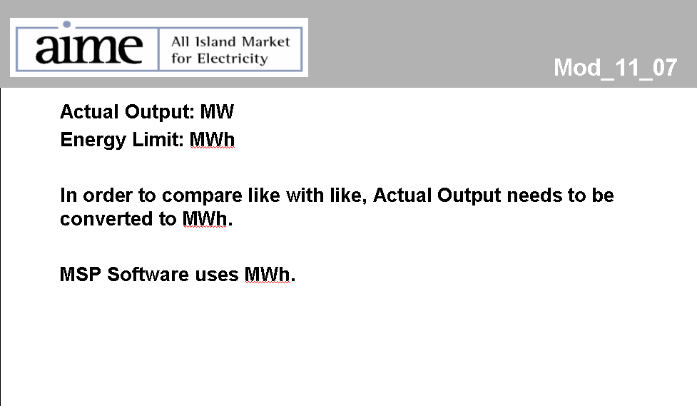

Note: These man days and costs may need to reflect a combination of Vendor costs and SMO additional costs. Any further modifications to the outline rules may have an impact both on the estimated costs and the estimated implementation date of the change.

