Final Recommendation Report of the Modifications Committee
Report  Reference | FRR_15 | Modification Proposal Reference: | Mod_15_07  Amendment to LOLP Table mathematical formulation (RA)
Date of Issue: | 03 Sep. 07 | Category: | Urgent
Report Created By: | Modifications Committee | Meeting No(s): | Meeting 01
Reason for Issue: | For Regulatory Authority Decision
Section 1
(a) Summary of Modification Committee Recommendations
Mod_15_07 seeks to revise the Code as follows:
This modification amends the calculation of the Loss of Load Probability Table. The modification reformats the equations, splitting them in two and removing the constraint conditions. Complete re-written versions of M.37 and M.39 are designed to replace the current text in those respective sections of the Code.
Recommendation Summary
Having considered the Proposed Modification at the abovementioned Meeting, the Modification Committee recommends
- The Proposed Modification should be Made
- With Implementation date to of September 18th 2007

(b) Rationale behind Modification Committee Recommendations
The mathematical formulation in the current relevant sections, if interpreted literally, would lead to errors in the Loss of Load Probability table. These errors would result in incorrect distribution of Capacity Payments across the trading periods, which would conflict with the mandated function of the market as set out in the Trading and Settlement Code.

Section 2  (a) Summary of Impacted Parties |  |  | Detail of impact
Generators |  | N
Suppliers |  | N
TSO |  | Y | TSO is responsible for the calculation of LOLP curves. The TSO calculation engine outputs LOLP values which are used by both the TSO and SEM systems. If this Modification proposal is approved, the TSO calculation needs to be modified to take account of the revised logic in the equation.
MO |  | Y | Secretariat is required to implement this change in the Code
PES |  | N
(b) Summary of Impacted Documents/ Systems |  |  | Detail of impact
Code Provisions |  | Y | Appendix M sections M.37 and M.39
Business Processes |  | N
Legal requirements |  | N
Grid Code |  | N
Other |  | N
Systems |  | Y | See ‘TSO Impact’ section in 2(a)
- Proposed Modification (Original Draft)
This section contains the text of the original draft of the modification proposal
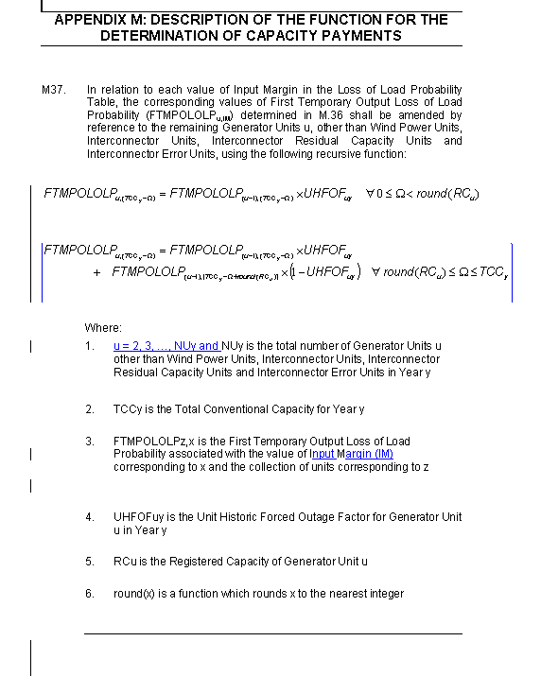

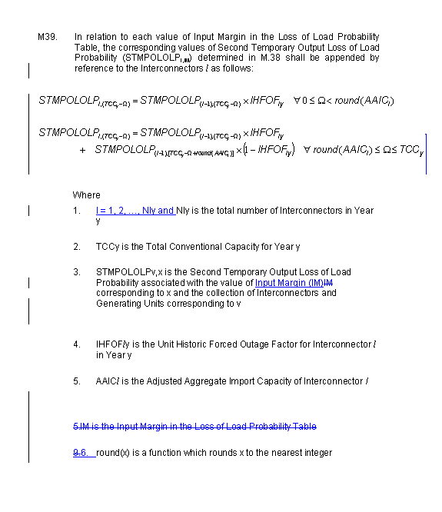
Modification Proposal Justification
The mathematical formulation in the current relevant sections, if interpreted literally, would lead to errors in the Loss of Load Probability table. These errors would result in incorrect distribution of Capacity Payments across the trading periods, which would conflict with the mandated function of the market as set out in the Trading and Settlement Code. The Regulatory Authorities consider this modification to be urgent within the meaning of 8.53 of the TSC as an obviously material error or inconsistency.
Implication of not implementing the Modification
If the Modification is not implemented as an Urgent change, the error would then be more costly to correct at a later time as the central systems programming would need to be changed. This is due to the fact that the coding in central systems for the relevant logic has not yet commenced, and so by fixing the problem now, there will be a significant saving of cost and resources compared to a change implemented after the programming was finished.
- Proposed Modification (Recommended for Approval by Committee)
This section contains the text of the Approved version of the modification proposal, if different from above
N/A

- Details of Alternative proposal raised
If appropriate, a later version or a resubmitted Modification Proposal details should be entered here
N/A

- Dissenting or Other Opinions
This section contains a summary of any objections to the approved modification proposal/ if appropriate, or feedback from the following: MO, TSO, Industry Expert or Consultant opinions
Comment at Meeting 01 (G Blaney): the mathematics in the Code is not clear; the change is required however he was of the view that two signs in the formula were still incorrect e.g. for FTMPOLOLP should be – not +. RA’S: J Corbett confirmed with Paul Bell (Proposer) that a correction to the signs did not to be incorporated in the equations. It was confirmed by email via Modifications Committee Secretariat as follows on 07/08/07.
‘The modification for Appendix M (Mod 15) was approved with a caveat that Garrett Blaney be satisfied with the mathematics in the submitted amendment, or if found incorrect, that the mathematics would be changed. The mathematics in the Modification as submitted to the panel on Friday 27/7 have been reviewed and confirmed to be correct. As such the version of the Modification that the panel reviewed on Friday is the final, approved version. ‘

Section 3
Results of Modification Consultation
Q. | Consultation Question |  |  | Yes | No | Neutral
 | N/A

Section 4
(a) Committee’s Final Recommendation to the Regulatory Authority
On the basis of the above discussions, the Committee agreed a UNANIMOUS/MAJORITY Recommendation to the RA’s that this Proposed Modification SHOULD/ SHOULD NOT be made

On the basis of the Proposal which incorporates the ORIGINAL/REVISED wording as detailed in Section 2.
(b) The Committee Recommends the following Implementation Approach and Timelines
The Implementation Date of the Proposal should be on: 18th Sep 07 (in time for unscripted phase of Market Trial if possible) if an the RA Decision is received on /before : 4th Sep 07.
These timelines will be adjusted should an RA decision be received after this date.
Or no earlier than: [DATE]
Or no later than: [DATE]
(c) Proposed Modification Implementations Cost
This section contains a summary of the cost associated with implementing the proposed modification.
Cost (€) | Vendor | SMO | Total Cost (€)
(d) Proposed Modification Estimated Effort Time
This section contains details of the effort time required to design and develop the proposed modification.Include Detailed description of long it will take to perform each change
Effort Time (man days)  (list each change below) | Vendor | SMO | Total Effort Time
Update to Trading and Settlement Code |  | ½ day | ½ day
TSO to perform calculation revision based on revised Code, unit testing, integration testing, results verification. |  | 10 days | 10 days
 |  |  | 10.5 days
Please complete this form and return it to Secretariat by e-mail to Modifications@allislandmarket.com

Note: These man days and costs may need to reflect a combination of Vendor costs and SMO additional costs. Any further modifications to the outline rules may have an impact both on the estimated costs and the estimated implementation date of the change.

