Final Recommendation Report of the Modifications Committee
Report  Reference | FRR_31_07 | Modification Proposal Reference: | Mod_31_07 Technical Offer Data – Cooling Boundary Data (MO)
Date of Issue: | 28-Aug-07 | Category: | Urgent
Report Created By: | Modification Committee | Meeting No(s): | Meeting 02
Reason for Issue: | For Regulatory Authority Decision
Section 1
(a) Summary of Modification Committee Recommendations
This Modification was proposed to ensure Appendix I is a complete list of what is required from Participants. They are in Clause 120. I.12 should be updated to reflect the full list of requirements, as regards Technical Offer Data – Cooling Boundary Data

Recommendation Summary
Having considered the Proposed Modification at the abovementioned Meeting, the Modification Committee recommends
- The Proposed Modification should be Made
- With Implementation date of 30th September 2007
- SEM Systems/MPUD should be in line with the Approved Modifications and the MO will look at getting an internal MPUD change control process in place, see Impacts/Estimate section.

(b) Rationale behind Modification Committee Recommendations
- SEM systems are expecting these values to be submitted from Participants to ensure correct results from the MSP Software.
- The omission of these values from the Appendix I would mean there was inconsistency in the Code between Appendix I and Clause 120.

Section 2  (a) Summary of Impacted Parties |  |  | Detail of impact
Generators |  | N
Suppliers |  | N
TSO |  | N
MO |  | Y | If Approved, Secretariat must make the required Code Updates
PES |  | N
(b) Summary of Impacted Documents/Systems |  |  | Detail of impact
Code Provisions |  | Y | I.12
Business Processes |  | N
Legal requirements |  | N
Grid Code |  | N
Other |  | N | MPUD and Participant Registration Pack should be updated as appropriate [Note on this: As per MO member, all required updates are complete as of 30 August 2007]
Systems |  | N | N/A if approved, as the systems have been built to the Proposed Modified version of the Code
- Proposed Modification (Original Draft)
This section contains the text of the original draft of the modification proposal
I.12 Each Participant shall submit Technical Offer Data to the Market Operator in respect of each of its Generator Units in accordance with the following provisions, subject to the exceptions outlined in paragraphs I.13 to I.18 inclusive:
- Technical Offer Data shall be submitted before Gate Closure for the Trading Day to which the data relates, as set out in paragraph 4.4 and no more that 28 days before Gate Closure;
- Data shall be submitted to reflect the real capabilities of the relevant Generator Unit net of Unit Load as set out in paragraph 4.26;
- Data shall be submitted in respect of a Generator Unit such that it is consistent with data submitted for that Unit under the applicable Grid Code, scaled, where appropriate, by the appropriate Distribution Loss Adjustment Factor as set out in paragraph 4.27;
- A Forecast Availability Profile shall be submitted in accordance with paragraph 4.28;
- A Forecast Minimum Output Profile shall be submitted in accordance with paragraph 4.29;
- A Forecast Minimum Stable Generation Profile shall be submitted in accordance with paragraph 4.30;
- A Short-Term Maximisation Capability, a Minimum Generation (which shall not be used under the Code) and a Maximum Generation shall be submitted. The Maximum Generation shall be submitted equal to the Registered Capacity of the Generator Unit; and
- In addition, for Generator Units, the relevant Participant shall submit the following data items :
- Minimum On Time,
- Minimum Off Time,
- Maximum On Time,
- Synchronous Start Up Time Hot,
- Synchronous Start Up Time Warm,
- Synchronous Start Up Time Cold,
- Block Load Cold,
- Block Load Hot,
- Block Load Warm,
- Deload Break Point,
- Deloading Rate 1,
- Deloading Rate 2,
- Dwell Time 1,
- Dwell Time 2,
- Dwell Time 3,
- Dwell Time Trigger Point 1,
- Dwell Time Trigger Point 2,
- Dwell Time Trigger Point 3,
- End Point of Start Up Period,
- Load Up Break Point Cold (1),
- Load Up Break Point Cold (2),
- Load Up Break Point Hot (1),
- Load Up Break Point Hot (2),
- Load Up Break Point Warm (1),
- Load Up Break Point Warm (2),
- Loading Rate Cold (1),
- Loading Rate Cold (2),
- Loading Rate Cold (3),
- Loading Rate Hot (1),
- Loading Rate Hot (2),
- Loading Rate Hot (3),
- Loading Rate Warm (1),
- Loading Rate Warm (2),
- Loading Rate Warm (3),
- Ramp Down Break Point 1,
- Ramp Down Break Point 2,
- Ramp Down Break Point 3,
- Ramp Down Break Point 4,
- Ramp Down Rate 1,
- Ramp Down Rate 2,
- Ramp Down Rate 3,
- Ramp Down Rate 4,
- Ramp Down Rate 5,
- Ramp Up Break Point 1,
- Ramp Up Break Point 2,
- Ramp Up Break Point 3,
- Ramp Up Break Point 4,
- Ramp Up Rate 1,
- Ramp Up Rate 2,
- Ramp Up Rate 3,
- Ramp Up Rate 4,
- Ramp Up Rate 5,
- Soak Time Cold (1),
- Soak Time Cold (2),
- Soak Time Trigger Point Cold (1),
- Soak Time Trigger Point Cold (2),
- Soak Time Hot (1),
- Soak Time Hot (2),
- Soak Time Trigger Point Hot (1),
- Soak Time Trigger Point Hot (2),
- Soak Time Warm (1),
- Soak Time Warm (2),
- Soak Time Trigger Point Warm (1),
- Soak Time Trigger Point Warm (2),
- Start of Restricted Range 1,
- End of Restricted Range 1,
- Start of Restricted Range 2, and
- End of Restricted Range 2.,
- Hot Cooling Boundary, and
- Warm Cooling Boundary.
Each Participant shall not submit individual Ramp Up Rates that will result in a Single Ramp Up Rate less than or equal to zero in the MSP Software and each Participant shall not submit individual Ramp Down Rates that will result in a Single Ramp Down Rate less than or equal to zero in the MSP Software.
Modification Proposal Justification
SEM systems require additional data for Hot Cooling Boundary and Warm Cooling Boundary. These are vital in Instruction Profiling and the MSP Software, as they are used to determine the warmth state of Units. If values are not submitted, may cause incorrect results from the MSP Software.
Implication of not implementing the Modification
SEM systems require these values to be submitted to ensure correct results from the MSP Software. Change to systems required to remove these values.

- Proposed Modification (Recommended for Approval by Committee)
This section contains the text of the Approved version of the modification proposal, if different from above
N/A

- Details of Alternative proposal raised
If appropriate, a later version or a resubmitted Modification Proposal details should be entered here
N/A
- Dissenting or Other Opinions
This section contains a summary of any objections to the approved modification proposal/ if appropriate, or feedback from the following: MO, TSO, Industry Expert or Consultant opinions
Participants require that there should be alignment between the Approved Modifications, the MPUD and other Systems.

Section 3
Results of Modification Consultation
Q. | Consultation Question |  |  | Yes | No | Neutral
 | N/A

Section 4
(a) Committee’s Final Recommendation to the Regulatory Authority
On the basis of the above discussions, the Committee agreed a UNANIMOUS/MAJORITY Recommendation to the RA’s that this Proposed Modification SHOULD/ SHOULD NOT be made
On the basis of the Proposal which incorporates the ORIGINAL/REVISED wording as detailed in Section 2.
(b) The Committee Recommends the following Implementation Approach and Timelines
The Implementation Date of the Proposal should be on: 30th September 2007
Assuming the RA Decision is made on/before [DATE]: N/A
Or no earlier than: [DATE]
Or no later than: [DATE]
(c) Proposed Modification Implementations Cost
This section contains a summary of the cost associated with implementing the proposed modification.
Cost (€) | Vendor | SMO | Total Cost (€)
(d) Proposed Modification Estimated Effort Time
This section contains details of the effort time required to design and develop the proposed modification.Include Detailed description of long it will take to perform each change
Effort Time (man days)  (list each change below) | Vendor | SMO | Total Effort Time
Update T & S Code |  | ½ day | ½ day
Update MPUD |  | N/A : Complete as of 30 August 2007
Get internal MPUD change control processes in place for alignment of mods and MPUD |  | N/A : There is a process in place for this (G Lalor)
Update the Participant Registration Pack |  | N/A : Complete as of 30 August 2007
Please complete this form and return it to Secretariat by e-mail to Modifications@allislandmarket.com

Appendix 1: White Paper Clarification – Requirement for Hot and Warm Cooling Boundary data

SEM Establishment Programme

Title: | Clarification – Requirement for Hot and Warm Cooling Boundary data
Version: | 1.0
Date: | 28th August 2007

Document History

Version | Date | Author | Comment
1.0 | 28-08-07 | SEM Programme | Drafted for clarification.

Related Documents

Document Title | Version | Date | By
Trading and Settlement Code | V2.0 | 31-05-2007 | Regulatory Authorities

Introduction

Modification MOD 31_07 was discussed at the last Modifications Committee meeting. This Modification was approved, subject to confirmation that the data is required by the MPUD and Registration Data require this field.

Confirmation

The Registration Data collected requires these two fields as follows:

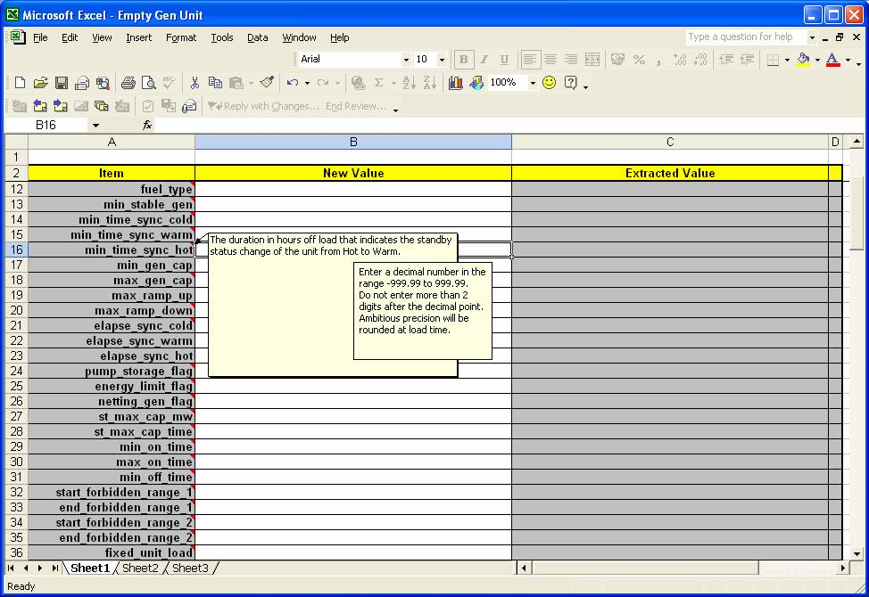 | 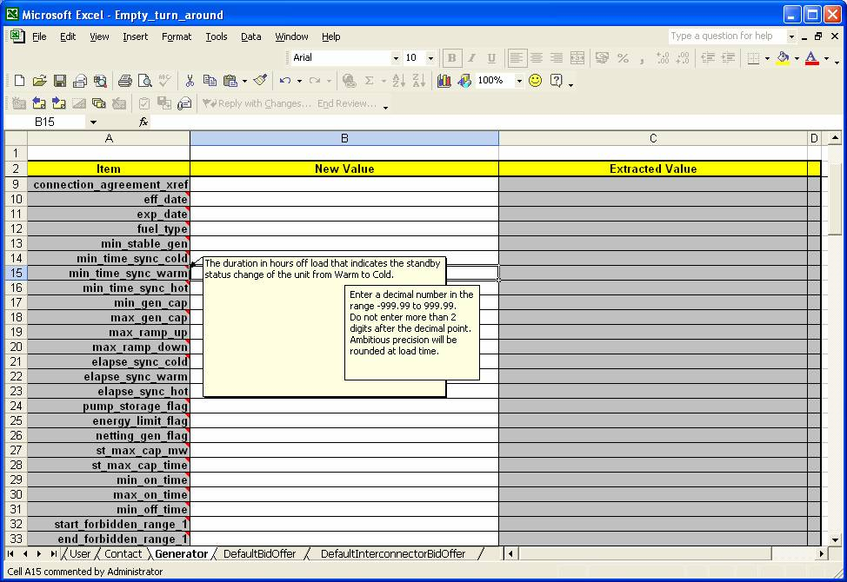

In addition, the following is an extract from the MPUD document, showing that the information is required.

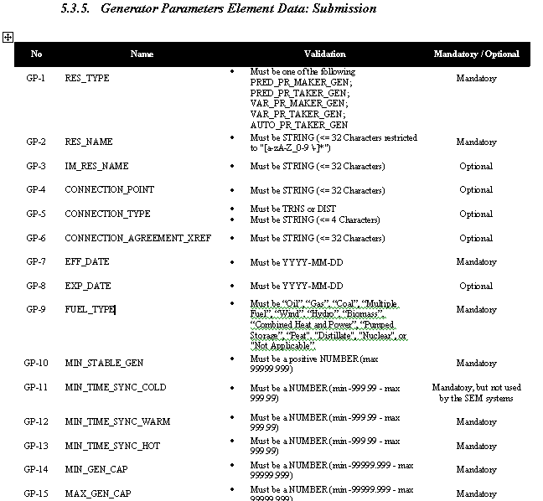

Note: These man days and costs may need to reflect a combination of Vendor costs and SMO additional costs. Any further modifications to the outline rules may have an impact both on the estimated costs and the estimated implementation date of the change.

