MODIFICATION PROPOSAL FORM
MODIFICATION PROPOSAL - SUBMISSION FORM
Modification Proposal submitted by | Date of Submitting Proposal: | Type of Proposal (delete as appropriate) | Modification Proposal Number: (to be assigned by Secretariat)
Stephen Walsh, ESB PG | 21/09/07 | Urgent | Mod_44_07 version 3
Contact Details for Modification Proposal Originator ( if not a member)
Name: Stephen Walsh, |  | Telephone number: 01 - 7027638
Address: ET&R B5 ESB Head Office, 27 Lower Fitzwilliam Street, Dublin 2.

e-mail address: stephen.walsh@esb.ie
Modification Proposal Title; | Required strengthening of procedure to modify banking details.
Trading and Settlement Code section(s) affected by Modification Proposal
AP 4 and AP 1
Modification Proposal Description Clearly state the desired amendment and all text formula changes to the code and/or Attach further information if necessary
At present, AP 4 allows for any user, who has access to make registration updates for an MP using the MPR, to modify bank account details. AP4 (Page 8) makes reference to ‘approval time of up to 2 Working Days from date of submission’ for such updates, however, no further interaction with the MP is detailed.

A manual step should be introduced to the Agreed Procedure where a user in the SMO must contact the Market Participant organisation and obtain two named signatories to confirm this change in writing before it is applied.

Detailed Changes to AP4

The current rules for banking details are as follows;

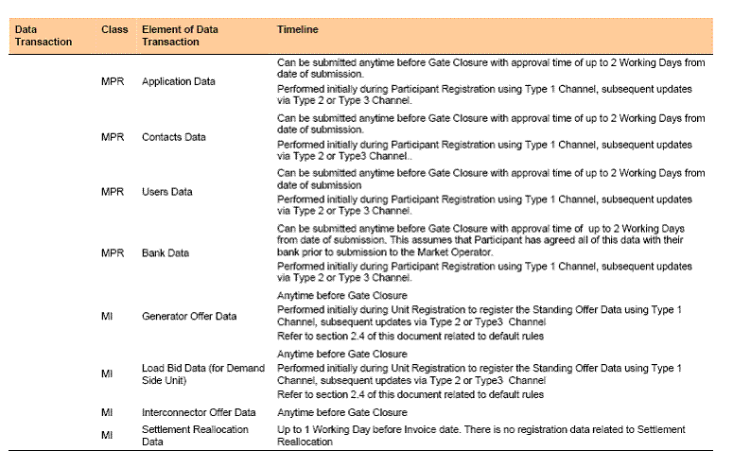

The proposed change to the table entry for MPR is;

Can be submitted anytime before Gate Closure with approval time of up to 5 Working Days
from date of receipt of confirmation. This assumes that Participant has agreed all of this data with their
bank prior to submission to the Market Operator. Additionally the Market Operator must confirm the authorisation to change the details by completing the steps in table 1A – Authorisation to change Banking Details.
Performed initially during Participant Registration using Type 1 Channel, subsequent updates
via Type 2 or Type 3 Channel, which will be confirmed via Type 1 Channel by MO and verified by MP by way of a hard copy submission. Initial Authorised signatories will be notified to MO during Participant Registration, changes to authorised signatories will be notified with the submission of a hard copy and the format specified in Appendix 4 and the steps outlined in Table 1A will be followed.

Insert new Table 1A – Authorisation to change Banking Details

Step | MO Action | MP Action
Step 1 |  | MP sends in revised banking details using type 2 or type 3 channel
Step 2 | MO faxes the proposed revised banking details, to the fax number specified in the appendix 4 document, for authorisation to MP using type 1 channel (template fax in Appendix 3)
Step 3 |  | MP verifies that banking details on fax match revised banking details by adding A and B signatures of authorised personnel and submits this document in its original form to MO by registered post.
Step 4 | MO verifies that signatures on fax (returned by registered post) match their copy of authorised signatures  (hardcopy of template in Appendix 4)
Step 5 | MO faxes or emails MP (as specified on Appendix 4) to confirm Banking details have been verified and will be changed on the effective date provide in the banking details.
Step 6 | MO changes Banking details within 5 working days of the banking details being verified. With effect from the effective date provided in the banking detail changes.
Step 7 |  | If MP wants to change Authorised signatories then they must re-submit the details with the form shown in Appendix 4 by submitting it in its original form by registered post.
Step 8 | MO faxes or emails MP (as specified on Appendix 4) to confirm receipt of updated Authorised signatories. MO uses latest authorised signatures for any future change to banking details.

Insert new Appendix 3

Template of fax for MO to request authorisation to change in banking details from MP as per step 2 of table 1A.

MARKET OPERATOR HEADED PAPER
Screen / T&SC Name | Copy of revised Banking Details element
Bank Name
Bank Number
Bank Account Name
Account Number
Bank Account Description
Bank Branch Type
Bank Branch Name
Bank Branch Number of Sort Code
Bank Branch Description
Bank Branch Address line 1
Bank Branch Address line 2
Bank Branch City
Bank Branch County
Bank Branch Postal Code
Bank Branch Country
Bank Branch Phone
Bank Branch Fax
SWIFT BIC
IBAN
Bank Account Currency jurisdiction
Notification Comment
External ID
Effective Start Date
Expiration Date

Authorised Signatures;

__________________ _____________________

Authorised Signatory A Authorised Signatory B
Date: Date:

Please confirm the implementation of changes having received and verified this signed fax (as a hardcopy) by contacting us in the manner specified (fax and/or email) on the list of Authorised Signatories.

Insert new Appendix 4

COMPANY HEADED PAPER

To: Market Operator

We hereby confirm that two of the following can authorise instructions (one signature from Panel A and one signature from Panel B) to the MO to amend the bank account details. Proof of identity is supplied with this documentation for each Signature (Copy of Passport and recent Utility Bill certified by a practicing solicitor).

Implementation of instructions to amend bank account details by the Market Operator is contingent on receiving the original signature of two personnel, one from Panel A and one signature Panel B listed below on the fax request from the Market Operator that details the proposed bank account amendments.

The request for this authorisation is sent by fax to the following fax number:
Primary fax number +
Secondary fax number +

PANEL A:
Personnel Authorised To Amend Bank Account Details (Block Capitals) | Sample Signature

COMPANY HEADED PAPER

PANEL B
Personnel Authorised To Amend Bank Account Details (Block Capitals) | Sample Signature

The Market Operator has agreed to implement changes within 5 working days of receiving the appropriate confirmation. Having verified the proposed changes to bank account information the accepted changes must be confirmed by the Market Operator by fax/email communication to the contact details below two business days before implementation. Any future changes to this list of authorised signatories must also be confirmed by fax/email to the contact details below.

Primary Fax +
Secondary Fax +
Email 1
Email 2
Email 3
Email 4

__________________ _____________________

Authorised Signatory Authorised Signatory
Date: Date:

Market Operator Guidelines for Authorised Signatories:

In the case of limited companies, reasonable evidence of authority should be provided which would include a certified copy of a board minute of a company naming certain individuals as having authority with respect to banking arrangements. This could be a power of attorney granted to certain individuals with respect to banking arrangements. This could be a standing authority of the board (which would have to be produced by way of a certified copy of the relevant resolution setting up the authority) showing that certain officers in the company have authority to conduct business including the operation of company bank accounts. In the case of an individual, then evidence of that individual’s identity should be sufficient.

Modification Proposal Justification Clearly state the reason for the Modification. Attach further information if necessary
This proposal is considered urgent by ESB and there is evidence this is also true for a number of other participants. The main reason why it is so urgent is because good internal governance procedures and standards simply would not permit ESB to enter into the market on 1st November under the present arrangements which could allow events to occur that could expose us to very significant (and unhedge-able) financial risks appertaining to potential erroneous or more to the point criminal acts by employees, which might even be prompted or made more likely by an awareness that fraudulent changing of bank account details could under the present proposed arrangements be hidden for some time - long enough for serious financial loss to be incurred.

Good governance procedures are fundamental to SEM, failure to implement this modification will threaten the ability to deliver a properly functioning market for the Market Start Date. In addition if the banking details are changed in an unauthorised manner a party may fail to make or receive payments, thus putting that party being in breach of this Code, on or after the Market Start Date due to systems limitation on banking security procedures.

This modification is therefore urgent and the Modifications Committee is the only forum where this change can be made.

Implication of not implementing the Modification
Concern that Bank Account details will be updated incorrectly causing significant impact to the MP and subsequently to the Market as a whole.
Please return this form to Secretariat - e-mail ( modifications@allislandmarket.com ), fax ( tbc ), postal address ( tbc )

Notes on completing Modification Proposal Form:
- If a person submits a Modification Proposal on behalf of another person, that person who proposes the material of the change should be identified on the Modification Proposal Form as the Modification Proposal Originator.
- Any person raising a Modification Proposal shall ensure that their proposal is clear and substantiated with the appropriate detail including the way in which it furthers the Code Objectives to enable it to be fully considered by the Modifications Committee.
- Each Modification Proposal will include a draft text of the proposed Modification to the Code.
- For the purposes of this Modification Proposal Form, the following terms shall have the following meanings:

Code: means the Trading and Settlement Code for the Single Electricity Market
Modification Proposal: means the proposal to modify the Code as set out in the attached form
Derivative Work: means any text or work which incorporates or contains all or part of the Modification Proposal or any adaptation, abridgement, expansion or other modification of the Modification Proposal

The terms “Market Operator”, “Modifications Committee” and “Regulatory Authorities” shall have the meanings assigned to those terms in the Code.

In consideration for the right to submit, and have the Modification Proposal assessed in accordance with the terms of Sections xx of the Code, which I have read and understand, I agree as follows:

1. I hereby grant a worldwide, perpetual, royalty-free, non-exclusive licence:

  - to the Market Operator and the Regulatory Authorities to publish and/or distribute the Modification Proposal for free and unrestricted access;

  - to the Regulatory Authorities, the Modifications Committee and each member of the Modifications Committee to amend, adapt, combine, abridge, expand or otherwise modify the Modification Proposal at their sole discretion for the purpose of developing the Modification Proposal in accordance with the Code;

  - to the Market Operator and the Regulatory Authorities to incorporate the Modification Proposal into the Code;

1.4 to all Parties to the Code and the Regulatory Authorities to use, reproduce and distribute the Modification Proposal, whether as part of the Code or otherwise, for any purpose arising out of or in connection with the Code.

2. The licences set out in clause 1 shall equally apply to any Derivative Works.

3. I hereby waive in favour of the Parties to the Code and the Regulatory Authorities any and all moral rights I may have arising out of or in connection with the Modification Proposal or any Derivative Works.

4. I hereby warrant that, except where expressly indicated otherwise, I am the owner of the copyright and any other intellectual property and proprietary rights in the Modification Proposal and, where not the owner, I have the requisite permissions to grant the rights set out in this form.

5. I hereby acknowledge that the Modification Proposal may be rejected by the Modifications Committee and/or the Regulatory Authorities and that there is no guarantee that my Modification Proposal will be incorporated into the Code.

