Final Recommendation Report of the Modifications Committee
Report  Reference | FRR_58_07 | Modification Proposal Reference: | Mod_58_07  Appendix K – Market Data Transactions  Section 7.31 & 7.32
Date of Issue: | 28 September 2007 | Category: | Urgent
Mod Originator : | SMO | Meeting No(s): | Meeting 04
Reason for Issue: | For Regulatory Authority Decision
Section 1
(a) Summary of Modification Committee Recommendations
Mod_58_07 seeks to revise Appendix K - Section 7.31 & 7.32 of the Code

Recommendation Summary
Having considered the Proposed Modification at the abovementioned Meeting, the Modification Committee recommends
- The Proposed Modification should be made
- With Implementation date of November 1st, 2007

(b) Rationale behind Modification Committee Recommendations
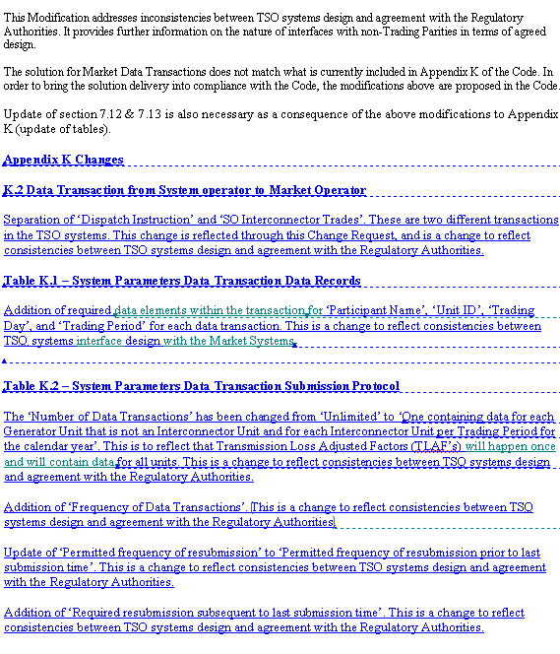
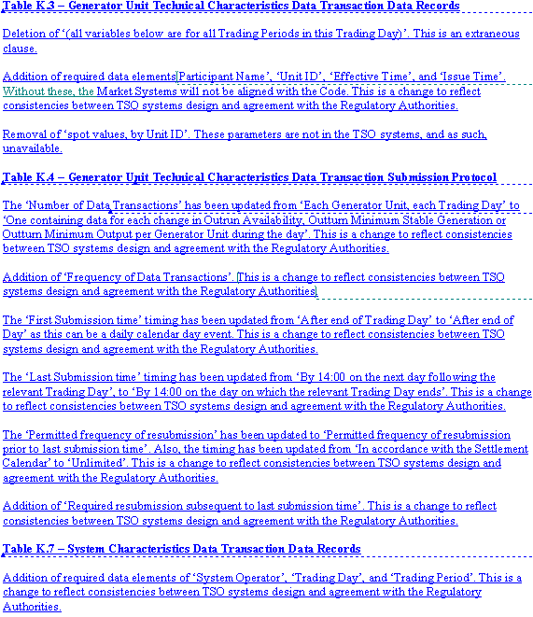
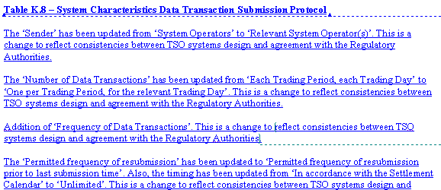
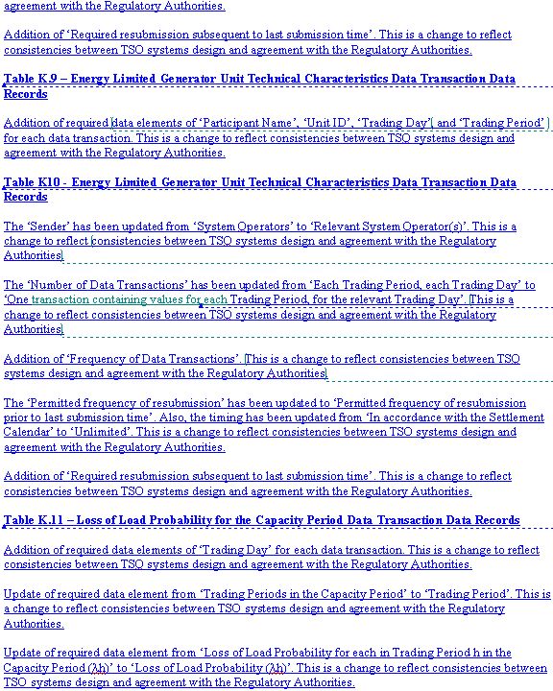
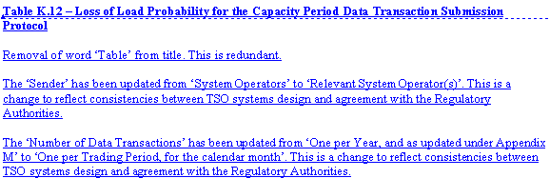
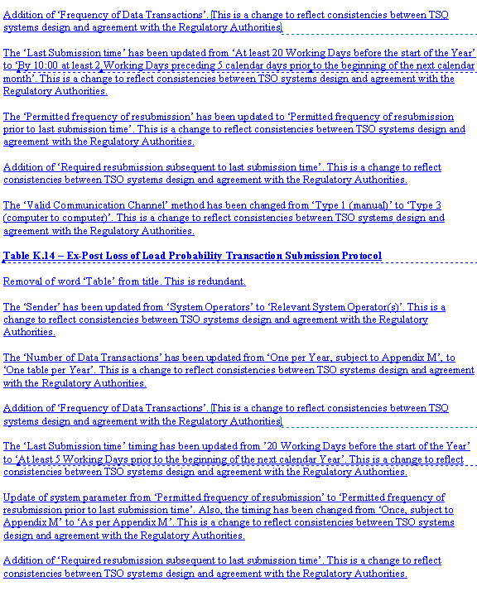
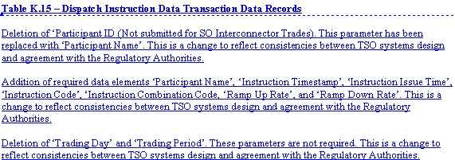
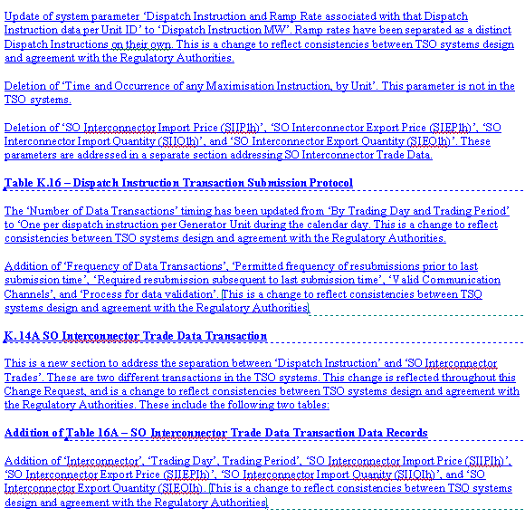
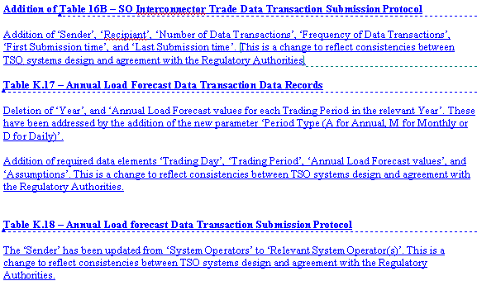
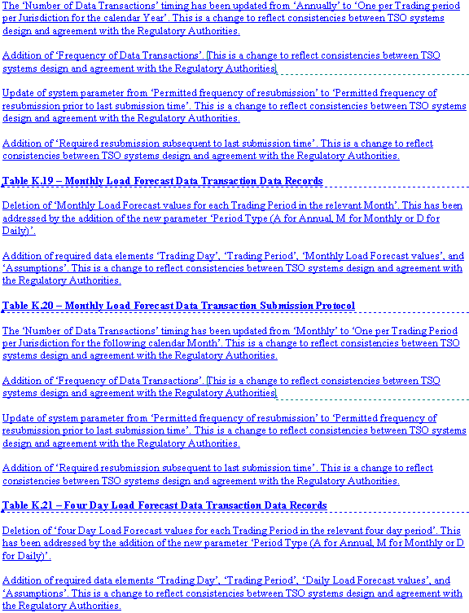
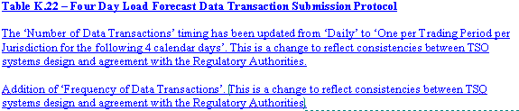
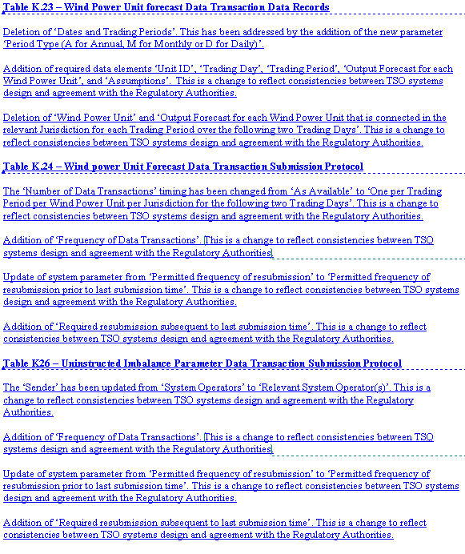
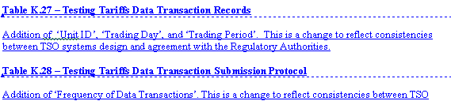
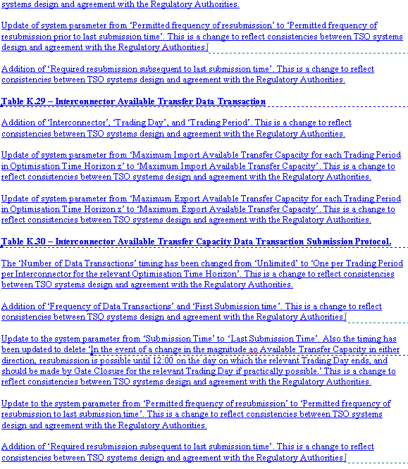
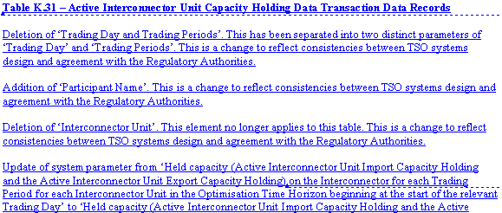
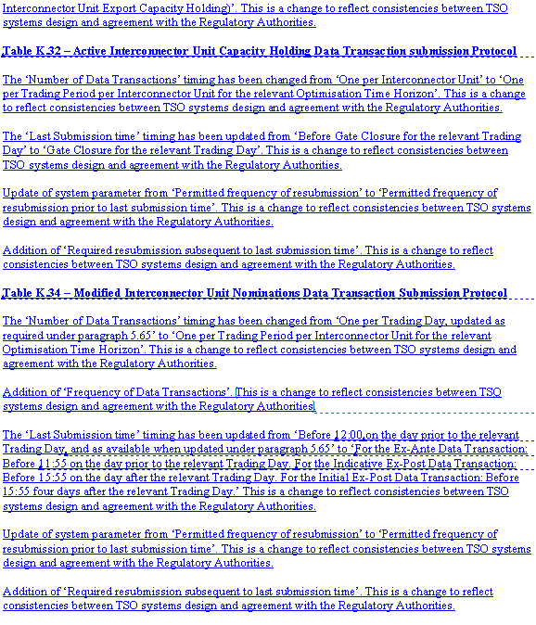
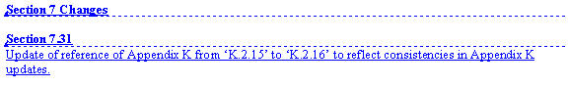

Section 2  (a) Summary of Impacted Parties |  |  |  | Detail of impact
Generators |  | Y/N |  | Stephen Walsh to confirm lack of impact on ESB PGEN
Suppliers |  | N
TSO |  | N
MO |  | Y |  | Secretariat is required to implement this change in the Code  MO to confirm that Mod reflects what is built in the systems.
PES |  | N
(b) Summary of Impacted Documents/Systems |  |  |  | Detail of impact
Code Provisions |  | Y |  | Appendix K - Section 7.31 & 7.32
Business Processes |  | N
Legal requirements |  | N
Grid Code |  | N
Other |  | N
Systems |  | N
- Proposed Modification (Original Draft)
This section contains the text of the original draft of the modification proposal
  - The Data Transactions in this Appendix include:
Data Transactions from System Operator to Market Operator
1. System Parameters
2. Generator Unit Technical Characteristics
3. Demand Control
4. System Characteristics
5. Energy Limited Generator Unit Technical Characteristics
6. Loss of Load Probability for the Capacity Period
7. Ex-Post Loss of Load Probability Table
8. Dispatch Instruction and SO Interconnector Trades
9. SO Interconnector Trades
10. Annual Load Forecast
11. Monthly Load Forecast
12. Four Day Load Forecast
13. Wind Power Unit Forecast
14. Uninstructed Imbalance Parameters
15. Testing Tariffs
Data Transactions from Interconnector Administrator to Market Operator
16. Interconnector Available Transfer Capacity
17. Active Interconnector Unit Capacity Holding
Data Transactions from Market Operator to Interconnector User
  - Modified Interconnector Unit Nominations
DATA TRANSACTION AND ITS DATA RECORDS
System Parameters Data Transaction
K.7 The Data Records for the System Parameters Data Transaction are described in Table K.1, and the Submission Protocol in Table K.2.
Table K.1 - System Parameters Data Transaction Data Records
Participant Name
Unit ID
Trading Day
Trading Period
Transmission Loss Adjustment Factors, TLAFuh
Table K.2 - System Parameters Data Transaction Submission Protocol
Sender | System Operators
Recipient | Market Operator
Number of Data Transactions | Unlimited One containing data for each Generator Unit that is not an Interconnector Unit and for each Interconnector Unit per Trading Period for the calendar year.
Frequency of Data Transactions | Annually
First Submission time | As available
Last Submission time | At least two months prior to the start of each Year, or prior to the registration of a new Generator Unit
Permitted frequency of resubmission prior to last submission time | Unlimited
Required resubmission subsequent to last submission time | Updates only
Valid Communication Channels | Type 3 (computer to computer)
Process for data validation | None
Generator Unit Technical Characteristics Data Transaction
K.8 The Data Records for the Generator Unit Technical Characteristics Data Transaction are described in Table K.3 and the Submission Protocol in Table K.4.
Table K.3 - Generator Unit Technical Characteristics Data Transaction Data Records
Trading Day (all variables below are for all Trading Periods in this Trading Day)
Participant Name
Unit ID
Effective Time
Issue Time
Outturn Availability, spot values, by Unit ID
Outturn Minimum Stable Generation, spot values, by Unit ID
Outturn Minimum Output, spot values, by Unit ID
Table K.4 - Generator Unit Technical Characteristics Data Transaction Submission Protocol
Sender | System Operators
Recipient | Market Operator
Number of Data Transactions | Each Generator Unit, each Trading Day  One containing data for each change in Outturn Availability, Outturn Minimum Stable Generation or Outturn Minimum Output per Generator Unit during the day
Frequency of Data Transactions | Daily
First Submission time | After end of Trading Dday
Last Submission time | By 14:00 on the next day on the day on which the relevant Trading Day ends following the relevant Trading Day  As required to resolve a Data Query where the Data Records in the Transaction are discovered to be in error
Permitted frequency of resubmission prior to last submission time | In accordance with the Settlement Calendar  Unlimited
Required resubmission subsequent to last submission time | By 14:00, 2 days after the relevant Trading Day ends
Valid Communication Channels | Type 3 (computer to computer)
Process for data validation | None

System Characteristics Data Transaction
K.10 The Data Records for the System Technical Characteristics Data Transaction are described in Table K.7 and the Submission Protocol in Table K.8.
Table K.7 - System Characteristics Data Transaction Data Records
System Operator
Trading Day
Trading Period
Average System Frequency in Trading Period h, AVGFRQh
Nominal System Frequency in Trading Period h, NORFRQh
Table K.8 - System Characteristics Data Transaction Submission Protocol
Sender | Relevant System Operator(s)
Recipient | Market Operator
Number of Data Transactions | Each One per Trading Period, each for the relevant Trading Day
Frequency of Data Transactions | Daily
First Submission time | After end of Trading Day
Last Submission time | By 14:00 on the next Working Day following the relevant Trading Day
Permitted frequency of resubmission prior to last submission time | Unlimited
Required resubmission subsequent to last submission time | None
Valid Communication Channels | Type 3 (computer to computer)
Process for data validation | None

Energy Limited Generator Unit Technical Characteristics Data Transaction
K.11 The Data Records for the Energy Limited Generator Unit Technical Characteristics Data Transaction are described in Table K.9 and the Submission Protocol in Table K.10.
Table K.9 - Energy Limited Generator Unit Technical Characteristics Data Transaction Data Records
Participant Name
Unit ID
Trading Day
Re-declared value of Energy Limit, SELut
Table K.10 - Energy Limited Generator Unit Technical Characteristics Data Transaction Submission Protocol
Sender | Relevant System Operator(s)
Recipient | Market Operator
Number of Data Transactions | Each One transaction containing values for each Energy Limited Generator Unit, each for the relevant Trading Day
Frequency of Data Transactions | Daily
First Submission time | After end of Trading Day
Last Submission time | By 14:00 on the day on which the relevant Trading Day ends on the day following the end of the relevant Trading Day
Permitted frequency of resubmission prior to last submission time | Unlimited
Required resubmission subsequent to last submission time | None
Valid Communication Channels | Type 3 (computer to computer)
Process for data validation | None

Loss of Load Probability for the Capacity Period Data Transaction
K.12 The Data Records for the Loss of Load Probability for the Capacity Period Data Transaction are described in Table K.11 and the Submission Protocol in Table K.12.
Table K.11 - Loss of Load Probability for the Capacity Period Data Transaction Data Records
Trading Day
Trading Periods in the Capacity Period
Loss of Load Probability for each in Trading Period h in the Capacity Period (λh)

Table K.12 - Loss of Load Probability Table for the Capacity Period Data Transaction Submission Protocol
Sender | Relevant System Operator(s)
Recipient | Market Operator
Number of Data Transactions | One per Year, and as updated under Appendix M  One per Trading Period for the calendar month
Frequency of Data Transactions | Monthly
First Submission time | As available
Last Submission time | At least 20 Working Days before the start of the Year  By 10:00 at least 2 Working Days preceding 5 calendar days prior to the beginning of the next calendar month
Permitted frequency of resubmission prior to last submission time | Unlimited
Required resubmission subsequent to last submission time | None
Valid Communication Channels | Type 1 (manual)  Type 3 (computer to computer)
Process for data validation | None
Ex-Post Loss of Load Probability Table Data Transaction
K.13 The Data Records for the Ex-Post Loss of Load Probability Table Data Transaction are described in Table K.13 and the Submission Protocol in Table K.14.
Table K.13 - Ex-Post Loss of Load Probability Table Transaction Data Records
Input Margin (IM) MW values, from 0MW to Total Conventional Capacity (TCCy)
Output Loss of Load Probability (OLOLPIM) for all MW values from 0MW to Total Conventional Capacity (TCCy)
Table K.14 - Ex-Post Loss of Load Probability Table Transaction Submission Protocol
Sender | Relevant System Operator(s)
Recipient | Market Operator
Number of Data Transactions | One table per Year, subject to Appendix M
Frequency of Data Transactions | Annually
First Submission time | As available
Last Submission time | 20 Working Days At least 2 Working Days prior to the beginning of the next calendar before the start of the Year
Permitted frequency of resubmission prior to last submission time | Once, subject to As per Appendix M
Required resubmission subsequent to last submission time | None
Valid Communication Channels | Type 1 (manual)
Process for data validation | None
Dispatch Instruction and SO Interconnector Trades Data Transaction
K.14 The Data Records for the Dispatch Instruction and SO Interconnector Trades Data Transaction are described in Table K.15 and the Submission Protocol in Table K.16.
Table K.15 - Dispatch Instruction and SO Interconnector Trades Data Transaction Data Records
Participant ID (Not submitted for SO Interconnector Trades)
Participant Name
Unit ID
Instruction Timestamp
Instruction Issue Time
Instruction Code
Instruction Combination Code
Ramp Up Rate
Ramp Down Rate
Trading Day
Trading Period
Dispatch Instruction MWand Ramp Rate associated with that Dispatch Instruction data per Unit ID
Time and Occurrence of any Maximisation Instructions, by Unit
SO Interconnector Import Price (SIIPlh)
SO Interconnector Export Price (SIEPlh)
SO Interconnector Import Quantity (SIIQlh)
SO Interconnector Export Quantity (SIEQlh)

Table K.16 - Dispatch Instruction Data and SO Interconnector Trades Transaction Submission Protocol
Sender | System Operators
Recipient | Market Operator
Number of Data Transactions | By Trading Day and Trading Period  One per dispatch instruction per Generator Unit during the calendar day
Frequency of Data Transactions | Daily
First Submission time | After end of Trading Day
Last Submission time | By 14:00 on the day on which the relevant Trading Day ends  As required to resolve a Data Query where the Data Records in the Transaction are discovered to be in error
Permitted frequency of resubmission prior to last submission time | Unlimited
Required resubmission subsequent to last submission time | By 14:00, 2 days after the relevant Trading Day ends
Valid Communication Channels | Type 3 (computer to computer)
Process for data validation | None
SO Interconnector Trade Data Transaction
K.14A The Data Records for the SO Interconnector Trade Data Transaction are described in Table K.16A and the Submission Protocol in Table K.16B.
Table K.16A - SO Interconnector Trade Data Transaction Data Records
Interconnector
Trading Day
Trading Period
SO Interconnector Import Price (SIIPIh)
SO Interconnector Export Price (SIEPIh)
SO Interconnector Import Quantity (SIIQIh)
SO Interconnector Export Quantity (SIEQIh)

Table K.16B - SO Interconnector Trade Data Transaction Submission Protocol
Sender | Relevant System Operator(s)
Recipient | Market Operator
Number of Data Transactions | Once containing data for each Trading Period per Interconnector for the relevant Optimisation Time Horizon
Frequency of Data Transactions | Daily
First Submission time | After end of Trading Day
Last Submission time | By 14:00 on the day on which the relevant Trading Day ends  As required to resolve a Data Query where the Data Records in the Transaction are discovered to be in error
Permitted frequency of resubmission prior to last submission time | Unlimited
Required resubmission subsequent to last submission time | By 14:00, 2 days after the relevant Trading Day ends (only required if changed from indicative submission)
Valid Communication Channels | Type 3 (computer to computer)
Process for data validation | None
Annual Load Forecast Data Transaction
K.15 The Data Records for the Annual Load Forecast Data Transaction are described in Table K.17 and the Submission Protocol in Table K.18.
Table K.17 - Annual Load Forecast Data Transaction Data Records
Year
Annual Load Forecast values for each Trading Period in the relevant Year
Period Type (A for Annual, M for Monthly or D for Daily)
Trading Day
Trading Period
Jurisdiction
Annual Load Forecast values
Assumptions
Table K.18 – Annual Load Forecast Data Transaction Submission Protocol
Sender | Relevant System Operator(s)
Recipient | Market Operator
Number of Data Transactions | Annually  One per Trading Period per Jurisdiction for the calendar Year
Frequency of Data Transactions | Annually
First Submission time | As available
Last Submission time | Four months before the start of the Year
Permitted frequency of resubmission prior to last submission time | Unlimited
Required resubmission subsequent to last submission time | None
Valid Communication Channels | Type 3 (computer to computer)
Process for data validation | None
Monthly Load Forecast Data Transaction
K.16 The Data Records for the Monthly Load Forecast Data Transaction are described in Table K.19 and the Submission Protocol in Table K.20.
Table K.19 - Monthly Load Forecast Data Transaction Data Records
Monthly Load Forecast values for each Trading Period in the relevant Month
Period Type (A for Annual, M for Monthly or D for Daily)
Trading Day
Trading Period
Jurisdiction
Monthly Load Forecast values
Assumptions
Table K.20 – Monthly Load Forecast Data Transaction Submission Protocol
Sender | System Operators
Recipient | Market Operator
Number of Data Transactions | Monthly  One per Trading Period per Jurisdiction for the following calendar Month
Frequency of Data Transactions | Monthly
First Submission time | Four Working Ddays before the start of Month
Last Submission time | One Working Dday before the start of Month
Permitted frequency of resubmission prior to last submission time | Unlimited
Required resubmission subsequent to last submission time | None
Valid Communication Channels | Type 3 (computer to computer)
Process for data validation | None
Four Day Load Forecast Data Transaction
K.17 The Data Records for the Four Day Load Forecast Data Transaction are described in Table K.21 and the Submission Protocol in Table K.22.
Table K.21 - Four Day Load Forecast Data Transaction Data Records
Four Day Load Forecast Data Records
Four Day Load Forecast values for each Trading Period in the relevant four day period
Period Type (A for Annual, M for Monthly or D for Daily)
Trading Day
Trading Period
Jurisdiction
Daily Load Forecast values
Assumptions
Table K.22 - Four Day Load Forecast Data Transaction Submission Protocol
Sender | System Operators
Recipient | Market Operator
Number of Data Transactions | Daily  One per Trading Period per Jurisdiction for the following 4 calendar days
Frequency of Data Transactions | Daily
First Submission time | As available
Last Submission time | Before 09:30, D-1 on the day prior to the start of the relevant Trading Day
Permitted frequency of resubmission prior to last submission time | Unlimited
Required resubmission subsequent to last submission time | None
Valid Communication Channels | Type 3 (computer to computer)
Process for data validation | None
Wind Power Unit Forecast Data Transaction
K.18 The Data Records for the Wind Power Unit Forecast Data Transaction are described in Table K.23 and the Submission Protocol in Table K.24.
Table K.23 - Wind Power Unit Forecast Data Transaction Data Records
Dates and Trading Periods
Period Type (A for Annual, M for Monthly or D for Daily)
Unit ID
Trading Day
Trading Period
Jurisdiction
Wind Power Unit
Output Forecast for each Wind Power Unit
Assumptions
Output Forecast for each Wind Power Unit that is connected in the relevant Jurisdiction for each Trading Period over the following two Trading Days,
Table K.24 - Wind Power Unit Forecast Data Transaction Submission Protocol
Sender | System Operators
Recipient | Market Operator
Number of Data Transactions | As available  One per Trading Period per Wind Power Unit per Jurisdiction for the following two Trading Days
Frequency of Data Transactions | Every 6 hours
First Submission time | As updated
Last Submission time | As updated  00:10 on the day prior to Gate Closure for the relevant Trading Day
Permitted frequency of resubmission prior to last submission time | Unlimited  Updated every 6 hours
Required resubmission subsequent to last submission time | None
Valid Communication Channels | Type 3 (computer to computer)
Process for data validation | None
Uninstructed Imbalance Parameter Data Transaction
K.19 The Data Records for the Uninstructed Imbalance Parameter Data Transaction are described in Table K.25 and the Submission Protocol in Table K.26.
Table K.25 – Uninstructed Imbalance Parameter Data Records
Engineering Tolerance (ENGTOL)
MW Tolerance (MWTOLt) for each Trading Day t
System per Unit Regulation parameter (UREG)
Discount for Over Generation (DOGuh) for each Generator Unit u in each Trading Period h
Premium for Under Generation (PUGuh) for each Generator Unit u in each Trading Period h
Table K.26 - Uninstructed Imbalance Parameter Data Transaction Submission Protocol
Sender | Relevant System Operator(s)
Recipient | Market Operator
Number of Data Transactions | Once per Year, and within Year with the approval of the Regulatory Authorities
Frequency of Data Transactions | Annually
First Submission time | As available
Last Submission time | On receipt of the Regulatory Authorities' determination on the values of the Uninstructed Imbalance Parameters and no later than two months before the start of the Year or within 5 Working Days of receipt whichever is the later
Permitted frequency of resubmission prior to last submission time | Unlimited
Required resubmission subsequent to last submission time | None
Valid Communication Channels | Type 1 (manual)
Process for data validation | None
Testing Tariffs Data Transaction
K.20 The Data Records for the Testing Tariffs Data Transaction are described in Table K.27 and the Submission Protocol in Table K.28.
Table K.27 - Testing Tariffs Data Transaction Records
Unit ID
Trading Day
Trading Period
Testing Tariff (TTARIFFuh) applicable to Generator Unit Under Test u in Trading Period h, for all Generator Units within the Currency Zone of the System Operator
Table K.28 - Testing Tariffs Data Transaction Submission Protocol
Sender | System Operators
Recipient | Market Operator
Number of Data Transactions | Once per Year, and within Year with the approval of the Regulatory Authorities
Frequency of Data Transactions | Annually
First Submission time | As available
Last Submission time | On receipt of the Regulatory Authorities' determination on the values of the Testing Tariffs and no later than two months before the start of the Year or within 5 Working Days of receipt whichever is the later
Permitted frequency of resubmission prior to last submission time | Unlimited
Required resubmission subsequent to last submission time | None
Valid Communication Channels | Type 1 (manual)
Process for data validation | None
Interconnector Available Transfer Capacity Data Transaction
K.21 The Data Records for the Interconnector Available Transfer Capacity Data Transaction are described in Table K.29 and the Submission Protocol in Table K.30.
Table K.29 - Interconnector Available Transfer Capacity Data Transaction Data Records
Interconnector
Trading Day
Trading Period
Maximum Import Available Transfer Capacity for each Trading Period in Optimisation Time Horizon z
Maximum Export Available Transfer Capacity for each Trading Period in Optimisation Time Horizon z
Table K.30 - Interconnector Available Transfer Capacity Data Transaction Submission Protocol
Sender | Interconnector Administrator
Recipient | Market Operator
Number of Data Transactions | One per Trading Period per Interconnector for the relevant Optimisation Time Horizon  Unlimited
Frequency of Data Transactions | Daily
First Submission time | As available
Last Submission Time | On the day prior to Gate Closure for that Trading Day, before 09:30.  In the event of a change in the magnitude ao Available Transfer Capacity in either direction, resubmission is possible until 12:00 on the day on which the relevant Trading Day ends, and should be made by Gate Closure for the relevant Trading Day if practically possible.
Permitted frequency of resubmission prior to last submission time | Unlimited
Required resubmission subsequent to last submission time | In the event of a change in the magnitude of Available Transfer Capacity in either direction, resubmission is possible until 12:00 on the day on which the relevant Trading Day ends, and should be made by Gate Closure for the relevant Trading Day if practically possible
Valid Communication Channels | Type 3 (computer to computer)
Process for data validation | None
Active Interconnector Unit Capacity Holding Data Transaction
K.22 The Data Records for the Active Interconnector Unit Capacity Holding Data Transaction are described in Table K.31 and the Submission Protocol in Table K.32.
Table K.31 – Active Interconnector Unit Capacity Holding Data Transaction Data Records
Trading Day and Trading Periods
Participant Name
Interconnector
Interconnector Unit
Trading Day
Trading Period
Held capacity (Active Interconnector Unit Import Capacity Holding and the Active Interconnector Unit Export Capacity Holding) on the Interconnector for each Trading Period for each Interconnector Unit in the Optimisation Time Horizon beginning at the start of the relevant Trading Day

Table K.32 – Active Interconnector Unit Capacity Holding Data Transaction Submission Protocol
Sender | Interconnector Administrator
Recipient | Market Operator
Number of Data Transactions | One per Interconnector Unit  One per Trading Period per Interconnector Unit for the relevant Optimisation Time Horizon
Frequency of Data Transactions | Daily
First Submission time | After completion of all appropriate Active Interconnector Unit Capacity Holding allocations
Last Submission time | Before Gate Closure for the relevant Trading Day
Permitted frequency of resubmission prior to last submission time | Unlimited
Required resubmission subsequent to last submission time | None
Valid Communication Channels | Type 3 (computer to computer)
Process for data validation | None
Modified Interconnector Unit Nominations Data Transaction
K.23 The Data Records for the Modified Interconnector Unit Nominations Data Transaction are described in Table K.33 and the Submission Protocol in Table K.34.
Table K.33 - Modified Interconnector Unit Nominations Data Transaction Data Records
Participant Name
Interconnector
Interconnector Unit
Trading Day
Trading Period
Modified Interconnector Unit Nomination for all Interconnector Units registered to that Participant for all Trading Periods in the Optimisation Time Horizon starting on the relevant Trading Day
Table K.34 - Modified Interconnector Unit Nominations Data Transaction Submission Protocol
Sender | Market Operator
Recipient | Each Interconnector User in respect of its Interconnector Unit(s)
Number of Data Transactions | One per Trading Day, updated as required under paragraph 5.65  One per Trading Period per Interconnector Unit for the relevant Optimisation Time Horizon
Frequency of Data Transactions | Daily
First Submission time | As available
Last Submission time | For the Ex-Ante Data Transaction: Before 12:00 11:55 on the day prior to the relevant Trading Day, and as available when updated under paragraph 5.65  For the Indicative Ex-Post Data Transaction: Before 15:55 on the day after the relevant Trading Day  For the Initial Ex-Post Data Transaction: Before 15:55 four days after the relevant Trading Day
Permitted frequency of resubmission prior to last submission time | Unlimited
Required resubmission subsequent to last submission time | Updated as required by paragraph 5.65
Valid Communication Channels | Type 3 (computer to computer)
Process for data validation | None
  - Until the date that is 12 months after the Market Start Date, paragraphs K.2.156, K.5 and K.6 of Appendix K “Market Data Transactions” shall be replaced with:
“K.2.156 Interconnector Available Transfer Capacity, which is a transaction from the relevant System Operator to the Market Operator.
K.5 Intentionally blank.
K.6 Intentionally blank.”
  - Until the date that is 12 months after the Market Start Date, the first line of Table K.30 in Appendix K “Market Data Transactions” shall be replaced with:
Sender | Relevant System Operator

- Proposed Modification (Recommended for Approval by Committee)
This section contains the text of the Approved version of the modification proposal, if different from above
N/A

- Details of Alternative proposal raised
If appropriate, a later version or a resubmitted Modification Proposal details should be entered here
N/A

- Dissenting or Other Opinions
This section contains a summary of any objections to the approved modification proposal/ if appropriate, or feedback from the following: MO, TSO, Industry Expert or Consultant opinions
All in Favour, subject to confirmation of lack of impact on ESB PGEN & MO.

Section 3
Results of Modification Consultation
Q. | Consultation Question |  |  |  | Yes | No |  | Neutral
 | N/A
Section 4
(a) Committee’s Final Recommendation to the Regulatory Authority
On the basis of the above discussions, the Committee agreed a UNANIMOUS/MAJORITY Recommendation to the RA’s that this Proposed Modification SHOULD/ SHOULD NOT be made

On the basis of the Proposal which incorporates the ORIGINAL/REVISED wording as detailed in Section 2.

(b) The Committee Recommends the following Implementation Approach and Timelines
The Implementation Date of the Proposal should be on: November 1st, 2007.
Assuming the RA Decision is made on/before [DATE] N/A
Or no earlier than: [DATE] N/A
Or no later than: [DATE] N/A
(c) Proposed Modification Implementations Cost
This section contains a summary of the cost associated with implementing the proposed modification.
Cost (€) |  |  | Vendor |  | SMO |  | Total Cost (€)
 |  |  | N/A
(d) Proposed Modification Estimated Effort Time
This section contains details of the effort time required to design and develop the proposed modification.Include Detailed description of long it will take to perform each change
Effort Time (man days)  (list each change below) |  |  | Vendor |  | SMO |  | Total Effort Time
Update to Trading and Settlement Code |  |  |  |  | ½ day |  | ½ day
Please complete this form and return it to Secretariat by e-mail to Modifications@allislandmarket.com

Note: These man days and costs may need to reflect a combination of Vendor costs and SMO additional costs. Any further modifications to the outline rules may have an impact both on the estimated costs and the estimated implementation date of the change.

