Final Recommendation Report of the Modifications Committee
Report  Reference | FRR_60_07 | Modification Proposal Reference: | Mod_60_07 Agreed Procedure 6 – Appendix 2, Reports Listing, Data Reports table
Date of Issue: | 28 September 2007 | Category: | Urgent
Mod Originator : | SMO | Meeting No(s): | Meeting 04
Reason for Issue: | For Regulatory Authority Decision
Section 1
(a) Summary of Modification Committee Recommendations
Mod_60_07 seeks to revise AP6 - Appendix 2 Reports Listing, Data Reports table of the Code

Recommendation Summary
Having considered the Proposed Modification at the abovementioned Meeting, the Modification Committee recommends
- The Proposed Modification should be made
- With Implementation date of November 1st, 2007.

(b) Rationale behind Modification Committee Recommendations
AP6 Appendix 2, Reports Listing, Data Reports table
The Market Participant Interface will have reports made available as outlined in the change request.

The ‘Participant and Unit Detailed Information Registration Data Transaction’ report does not exist and is effectively replaced by the three reports above it and by the website publication that will be provided.

The ‘Daily Load Forecast Summary’ is a report that is generated daily pre gate closure so the timing indication on the report was incorrect in AP6. This would lead to significant confusion to participants and represented a double meaning which could not be interpreted.

The ‘Ex-Ante Interconnector User Nominations’ and ‘Ex-Ante Market Schedule Detail’ reports are created, Daily, post gate closure and before Trading Day, by 12:00 hrs and by 13:00 hours respectively in the systems and in the MPUD v4.0 document. If there were to continue to be a different timing in the AP6 document, it would lead to significant confusion to participants. In addition, the name of the report ‘Ex-Ante Market Schedule Detail’ is correct rather than by participant as these reports are private to participants and will not show other participants details.

The ‘Ex-Ante Interconnector User Nominations’ was entered twice in the section ‘E’ in the table. This has been removed as is duplicate and showed different timing from what the systems are configured to provide and hence represents an urgent requirement as the MO will be unable to meet the 11:00 timeframe indicated.

Interconnector Flows report is deleted as it is a non-existent report and the ‘Interconnector Flows and Residual Capacity’ contains the information that is expected instead.

The ‘Indicative Daily Jurisdiction Error Supply’ and ‘Initial Daily Jurisdiction Error Supply’ reports are removed as they are not going to be provided to participants as they do not contain any additional information than what is currently provided as part of the Participant Information Reports.

The report ‘Modified Interconnector User Nominations’ published on D-1 at 13:00 is incorrect and represents a duplicate report being published at the wrong timeframe. The correct publication is ‘Daily, post gate closure and before Trading Day by 12:00’.

The ‘Ex-Post Indicative Market Schedule by Participant’ is deleted as it is a duplicate report and was being generated at the incorrect time and participants would already have the information by this time. See ‘Daily Indicative Ex-Post Market Schedule by Market Participant’ and added the ‘uh’ and text in the validity field.

The ‘Daily Meter Data Detail D+1 (Price Effecting)’ and ‘Daily Meter Data Detail D+3 (Price Effecting)’ report naming had to be changed as they indicated the wrong contents in the earlier versions which had D-1 and D-3. This was a vendor naming convention which would lead to confusion and difficulty for participants going forward.

The ‘Daily Ex-Ante Interconnector Nominations’ report that is to member private in ex-post is a non-existent report and had to be removed.

The ‘Ex-Post Initial Energy Payments to Generator Units’ and ‘Ex-Post Initial Energy Charges to Supplier Units’ are available earlier than indicated in the AP6 timing and the timing has been changed to clarify this.

The ‘Settlement Reallocation Data’ report can not be provided to participants until ‘Five Working Days after end of Billing Period, at 12:00’ the ‘Report validity is only determined as part of the invoice generation’

The ‘Revised Modified Interconnector Unit Modifications’ report is removed as it is already provided in table 5.2

The word ‘schedele’ remains spelt incorrectly as this is considered to be a non urgent modification and can be corrected in a future modification request.

Implication of not implementing the Modification

Agreed Procedure 6
Market Operator systems will not be able to meet the requirements as set out in Agreed Procedure 6, Appendix 2, Data Reports table. Agreed Procedure 6 was previously inconsistent with the Market Participant Interface. In addition, Agreed Procedure 6 had a number of timing, content and naming errors which have been addressed by this Change Request.

Section 2  (a) Summary of Impacted Parties |  |  |  | Detail of impact
Generators |  | N
Suppliers |  | N
TSO |  | N
MO |  | Y |  | Secretariat is required to implement this change in the Code
PES |  | N
(b) Summary of Impacted Documents/Systems |  |  |  | Detail of impact
Code Provisions |  | Y |  | AP6 - Appendix 2 Reports Listing, Data Reports table
Business Processes |  | N
Legal requirements |  | N
Grid Code |  | N
Other |  | N
Systems |  | N
- Proposed Modification (Original Draft)
This section contains the text of the original draft of the modification proposal
AP6 Appendix 2, Reports Listing, Data Reports table
The Market Participant Interface will have reports made available as outlined in the change request.

The ‘Participant and Unit Detailed Information Registration Data Transaction’ report does not exist and is effectively replaced by the three reports above it and by the website publication that will be provided.

The ‘Daily Load Forecast Summary’ is a report that is generated daily pre gate closure so the timing indication on the report was incorrect in AP6. This would lead to significant confusion to participants and represented a double meaning which could not be interpreted.

The ‘Ex-Ante Interconnector User Nominations’ and ‘Ex-Ante Market Schedule Detail’ reports are created, Daily, post gate closure and before Trading Day, by 12:00 hrs and by 13:00 hours respectively in the systems and in the MPUD v4.0 document. If there were to continue to be a different timing in the AP6 document, it would lead to significant confusion to participants. In addition, the name of the report ‘Ex-Ante Market Schedule Detail’ is correct rather than by participant as these reports are private to participants and will not show other participants details.

The ‘Ex-Ante Interconnector User Nominations’ was entered twice in the section ‘E’ in the table. This has been removed as is duplicate and showed different timing from what the systems are configured to provide and hence represents an urgent requirement as the MO will be unable to meet the 11:00 timeframe indicated.

Interconnector Flows report is deleted as it is a non-existent report and the ‘Interconnector Flows and Residual Capacity’ contains the information that is expected instead.

The ‘Indicative Daily Jurisdiction Error Supply’ and ‘Initial Daily Jurisdiction Error Supply’ reports are removed as they are not going to be provided to participants as they do not contain any additional information than what is currently provided as part of the Participant Information Reports.

The report ‘Modified Interconnector User Nominations’ published on D-1 at 13:00 is incorrect and represents a duplicate report being published at the wrong timeframe. The correct publication is ‘Daily, post gate closure and before Trading Day by 12:00’.

The ‘Ex-Post Indicative Market Schedule by Participant’ is deleted as it is a duplicate report and was being generated at the incorrect time and participants would already have the information by this time. See ‘Daily Indicative Ex-Post Market Schedule by Market Participant’ and added the ‘uh’ and text in the validity field.

The ‘Daily Meter Data Detail D+1 (Price Effecting)’ and ‘Daily Meter Data Detail D+3 (Price Effecting)’ report naming had to be changed as they indicated the wrong contents in the earlier versions which had D-1 and D-3. This was a vendor naming convention which would lead to confusion and difficulty for participants going forward.

The ‘Daily Ex-Ante Interconnector Nominations’ report that is to member private in ex-post is a non-existent report and had to be removed.

The ‘Ex-Post Initial Energy Payments to Generator Units’ and ‘Ex-Post Initial Energy Charges to Supplier Units’ are available earlier than indicated in the AP6 timing and the timing has been changed to clarify this.

The ‘Settlement Reallocation Data’ report can not be provided to participants until ‘Five Working Days after end of Billing Period, at 12:00’ the ‘Report validity is only determined as part of the invoice generation’

The ‘Revised Modified Interconnector Unit Modifications’ report is removed as it is already provided in table 5.2

The word ‘schedele’ remains spelt incorrectly as this is considered to be a non urgent modification and can be corrected in a future modification request.

- Proposed Modification (Recommended for Approval by Committee)
This section contains the text of the Approved version of the modification proposal, if different from above
See below

- Details of Alternative proposal raised
If appropriate, a later version or a resubmitted Modification Proposal details should be entered here
Please refer to the Appendix to this FRR (below) which displays the Mark-Up to AP6.

- Dissenting or Other Opinions
This section contains a summary of any objections to the approved modification proposal/ if appropriate, or feedback from the following: MO, TSO, Industry Expert or Consultant opinions
N/A

Section 3
Results of Modification Consultation
Q. | Consultation Question |  |  |  | Yes | No |  | Neutral
 | N/A
Section 4
(a) Committee’s Final Recommendation to the Regulatory Authority
On the basis of the above discussions, the Committee agreed a UNANIMOUS/MAJORITY Recommendation to the RA’s that this Proposed Modification SHOULD/ SHOULD NOT be made

On the basis of the Proposal which incorporates the ORIGINAL/REVISED wording as detailed in Section 2.

(b) The Committee Recommends the following Implementation Approach and Timelines
The Implementation Date of the Proposal should be on: November 1st, 2007.
Assuming the RA Decision is made on/before [DATE] N/A
Or no earlier than: [DATE] N/A
Or no later than: [DATE] N/A
(c) Proposed Modification Implementations Cost
This section contains a summary of the cost associated with implementing the proposed modification.
Cost (€) |  |  | Vendor |  | SMO |  | Total Cost (€)
 |  |  | N/A
(d) Proposed Modification Estimated Effort Time
This section contains details of the effort time required to design and develop the proposed modification.Include Detailed description of long it will take to perform each change
Effort Time (man days)  (list each change below) |  |  | Vendor |  | SMO |  | Total Effort Time
Update to Trading and Settlement Code |  |  |  |  | ½ day |  | ½ day
Please complete this form and return it to Secretariat by e-mail to Modifications@allislandmarket.com

APPENDIX
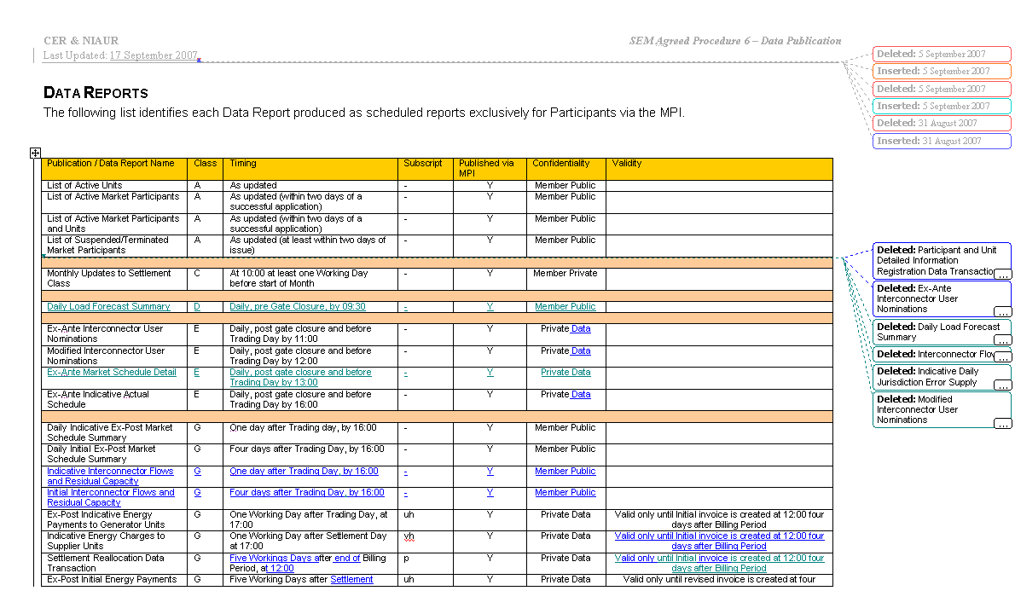
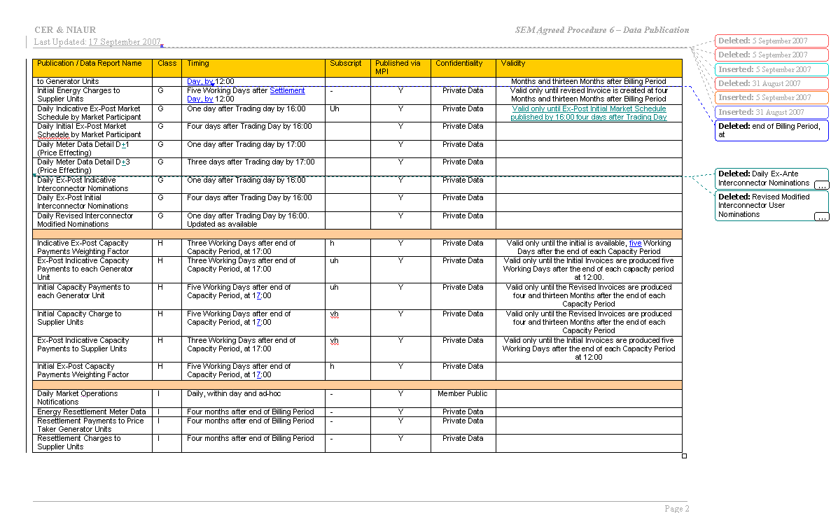

Note: These man days and costs may need to reflect a combination of Vendor costs and SMO additional costs. Any further modifications to the outline rules may have an impact both on the estimated costs and the estimated implementation date of the change.

