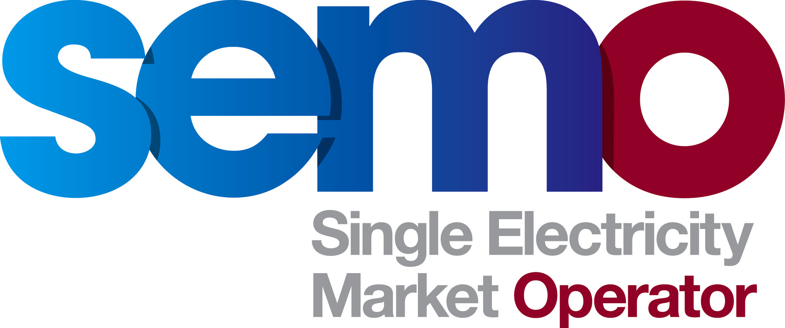

Single Electricity Market

Terms of Reference
Working Group

Mod_04_19
running indicative settlement on all days

COPYRIGHT NOTICE
All rights reserved. This entire publication is subject to the laws of copyright. This publication may not be reproduced or transmitted in any form or by any means, electronic or manual, including photocopying without the prior written permission of EirGrid plc and SONI Limited.

DOCUMENT DISCLAIMER
Every care and precaution is taken to ensure the accuracy of the information provided herein but such information is provided without warranties express, implied or otherwise howsoever arising and EirGrid plc and SONI Limited to the fullest extent permitted by law shall not be liable for any inaccuracies, errors, omissions or misleading information contained herein.

Distribution List

Name | Organisation
Modifications Committee Members | Modifications Committee
Modifications Proposer | IWEA

Reference Documents

Document Name
Trading and Settlement Code Part A
Trading and Settlement Code Part B
Mod_04_19 Running indicative settlement on all days
Mod_04_19 Presentation
Minutes - Meeting 89
Minutes - Meeting 90
Minutes - Meeting 92

INTRODUCTION

Modification Proposal Mod_04_19 Running indicative settlement on all days was presented by IWEA at Meeting 89 of the Modifications Committee on 20th February 2019. The proposal sought to have indicative settlement run on working and non-working days. Currently it is not run on non-working days. The aim is to reduce the collateral requirement on participants, who currently have to post collateral to cover 5 days of elevated Traded Not Delivered Exposure due to delayed Indicative Settlement Runs on a Christmas or Easter period, when there are 4 consecutive non-working days.
.
SEMO and the proposers have been looking at a number of alternative options to address this issue without introducing non-working day Indicative Settlement Runs. At Meeting 92 the Committee agreed to the establishment of a working group to provide the level of discussion and analysis needed to progress this modification proposal. The Terms of Reference has been devised following consultation with Committee Members and the proposer via existing Modifications Committee meetings.

Objectives

The objectives of the Modification Working Group are to:

- to provide an overview of the background as to why the proposal was raised and to tease out all options and analysis to resolve the issue
- to discuss and review the 6 suggested solution options
- to discuss Participant issues pertaining to the Modification Proposal as currently drafted
- to consider any alternatives to that of Mod_04_19
- to identify and suggest any necessary amendments to the legal drafting text of Mod_04_19
- to make a recommendation to the Modifications Committee

Scope

The scope of the Working Group will be limited to:

- Mod_04_19 – drafting and justification
- The Trading and Settlement Code rules for the ISEM (Part B) as related to Mod_04_19
- Impacts on affected stakeholders, eg Meter Data Providers, Market Participants, SEMO etc.

Deliverables

- Working Group report detailing the discussion and outcome of the meeting
- Recommendation to the Modifications Committee of which option is most feasible
- Finalised drafting of the Modification Proposal

Stakeholders

Market Participants, potential new entrants to the market, Market Operator, System Operators, Regulatory Authorities. Meter Data Providers and IWEA.

Roles and Responsibilities

- Working Group Chair – to be confirmed in advance of Meeting (as stated in section 7)
- Any stakeholders as outlined above to participate to achieve the objectives as per Section 2
- Proposer to look at the impacts of both options 3 and 6 in particular (please refer to options in the presentation above)
- SEMO to provide an analysis of Credit default examples after weekends or bank holidays
- Working Group to assess at high level the timing and implications of the various options
- Secretariat to draft report and update Modifications Committee.
- Proposer to update and submit revised version of modification, if appropriate

Resources

- Chair to be confirmed in advance of meeting
- Secretariat
- Proposer
- Market Participant representatives
- SO representatives
- MO representatives
- RA representatives
- Potential new entrants

Work Breakdown Structure

- Discussion of potential options
- Assessment of the various options in terms stated in the objectives
- SEMO Secretariat to produce Working Group report to Modifications Committee

Schedule

An initial half day Working Group meeting is proposed for 19th September 2019 to address the objectives of the meeting.

If further meetings are required to address the objectives in full, the timeline for further engagement will be defined at the initial meeting.

Risks and Restraints

There is a risk that the Working Group discussions may creep away from the defined scope of exploring the most feasible options to resolve this issue. If such a discussion occurs, the Chairperson will refer parties to the objectives and the scope of the Working Group.

There is a risk that any solution may be too impactful (in terms of system changes or resources required to deliver it relative to the size of the issue it aims to resolve) to justify its implementation. Working Group attendees will ensure that any recommendation to the Modifications Committee is not inappropriately impactful.

